Feasibility of Artificial Intelligence-Driven Analysis
in the Context of the Nepalese Legal Domain
A Proposed Judicial AI Framework for Nepal
Concept and Technical Paper | Er. Pukar Thapa (thapapukar123@gmail.com)

1. Abstract
Nepal is gradually digitizing laws, judgments, case information and judicial services, but legal information is still spread across different systems, formats and languages. Finding a relevant document is only one part of legal research. A reliable system must also know whether the source is official, whether the law was in force on the required date, whether a judgment has the right authority, and whether an AI-generated statement is actually supported by the cited source. This paper studies the feasibility of an AI-assisted Judicial AI platform for Nepal. The proposed framework combines verified legal-data ingestion, legal metadata, hybrid information retrieval, Authority-Aware Retrieval-Augmented Generation (RAG), large language models (LLMs), citation verification, security controls and human oversight. The system is designed as a research and decision-support tool, not as an autonomous judge. The paper reviews international Judicial AI practice and legal-AI research, identifies Nepal-specific data and institutional gaps, presents a practical system architecture, and evaluates technical, data, operational, legal and ethical feasibility. The main conclusion is that a limited and governed Judicial AI prototype is technically feasible for Nepal if it starts with verified public legal sources, clear authority and version rules, measurable evaluation, and strong human control.
Keywords: Judicial AI; Nepal Judiciary; Legal RAG; Large Language Models; Legal Information Retrieval; Authority-Aware Retrieval; Legal Metadata; Human Oversight.

2. Introduction and Background
Artificial intelligence is increasingly used to search, classify, summarize and explain large collections of documents. In law, these abilities are useful because legal research depends on large volumes of statutes, regulations, judgments, amendments and procedural material. However, law is different from ordinary document search. A text can be similar to the user’s question but still be legally weak, outdated, outside the proper jurisdiction, or incomplete. For this reason, a Judicial AI system needs more than a general-purpose chatbot.
Retrieval-Augmented Generation (RAG) offers a practical starting point because it allows an LLM to use external documents instead of relying only on information stored in model parameters [1]. Legal-domain language models also show that domain adaptation can improve performance on legal tasks [2]. Yet neither RAG nor a legal LLM alone can determine legal authority, amendment history, precedent status, confidentiality or institutional permission. These controls must be designed around the model.

2.1 Nepalese Judiciary and Legal Domain
Nepal has a constitutional judiciary led by the Supreme Court, followed by High Courts and District Courts. Legal information is also produced and maintained by institutions such as the Nepal Law Commission and other public bodies. The Nepal Law Commission publishes the Constitution, Acts, rules and other legal materials through its official repository [3]. The Supreme Court provides judgments, case information and other judicial services through its digital systems. The Fifth Five-Year Strategic Plan of the Judiciary also continues the broader direction of judicial modernization and improved use of information systems [4].
The Nepalese legal domain is multilingual and structurally complex. Nepali is the main language of many statutes and judgments, while lawyers, researchers and citizens may search in English or use mixed legal terminology. Legal meaning may depend on a section, subsection, proviso, explanation, schedule, amendment, effective date or later judgment. A useful AI system must preserve these relationships rather than treat every document as plain text.

2.2 Current Legal Information Challenges
Nepal already has valuable online legal sources, but legal research still requires significant manual effort. Important challenges include:
- Legal materials are spread across different websites, databases, PDFs and scanned documents.
- Search works best when the user already knows an exact case number, section, party name or legal term.
- Some older documents have OCR, font, formatting or Unicode problems.
- Amendments and historical versions are difficult to follow in one continuous view.
- A relevant judgment may not be binding, may have been distinguished or overruled, or may relate to a different legal period.
- Users may ask questions in Nepali, English or mixed language while the source exists in only one language.
- Existing systems do not always provide one evidence package that connects the rule, exception, amendment, precedent and exact cited paragraph.

2.3 Motivation for AI-Assisted Legal Analysis
The motivation is therefore not to replace judges or lawyers. It is to reduce the time spent on document discovery, legal comparison and repetitive analysis while keeping the final legal responsibility with people. A well-designed system could support legal search, case summarization, citation checking, amendment tracking, multilingual access and research preparation. International guidance from UNESCO and the Council of Europe similarly supports human-led, rights-respecting use of AI in justice systems [5][6].

3. Problem Statement and Research Objectives
The main problem is that a general LLM can produce fluent legal language without reliably knowing whether the source is authoritative, current or applicable. Ordinary RAG improves grounding but usually ranks text mainly by relevance. In judicial work, relevance is not enough. The system must also understand legal source, court hierarchy, jurisdiction, time, precedent treatment and evidence support.
The research question is: How feasible is an AI-assisted Judicial AI platform for Nepal that can retrieve and analyse legal information while preserving authority, temporal validity, citation support, security and human accountability?
The objectives of this paper are to:
- Describe the Nepalese legal-information problem and the opportunity for AI-assisted research.
- Review key technical foundations and international Judicial AI initiatives.
- Identify the Nepal-specific research and implementation gap.
- Propose a practical Judicial AI concept, scope and system architecture.
- Assess technical, data, operational, legal and ethical feasibility.
- Define an implementation roadmap, governance model and safety constraints.
- Identify major challenges, limitations and future research needs.

4. Literature Review and Technical Foundations

4.1 Artificial Intelligence in Legal Systems
AI in the legal field is used for tasks such as document classification, legal search, translation, summarization, prediction, drafting support and administrative workflow. Successful judicial deployments usually begin with narrow support tasks rather than autonomous decision-making. Brazil’s Supreme Federal Court uses the VICTOR system to assist with initial classification of cases linked to general repercussion [7]. Singapore has deployed generative AI tools for translation and case-document summarization in its Small Claims Tribunals, including support for self-represented users [8]. India’s Supreme Court also operates digital and AI-assisted services, including its SuSahayak assistant, while emphasizing that original court records remain controlling [9].
These examples show a common pattern: AI is more acceptable when the task is bounded, the data source is controlled, the output can be checked, and a human remains responsible. This pattern is directly relevant to Nepal.

4.2 LLMs, RAG and Legal Information Retrieval
LLMs are strong at language generation, summarization and general reasoning, but they can hallucinate, use outdated information, or produce citations that appear correct but are not supported. RAG reduces this problem by retrieving external evidence before generation [1]. In legal work, however, the retrieval stage must handle more than semantic similarity. Exact terms, section numbers, case names, dates and legal phrases remain important, so a hybrid approach that combines keyword search and vector search is more suitable.
Legal NLP research also supports domain-specific models and evaluation. LEGAL-BERT demonstrated the value of training or adapting models on legal corpora [2]. Legal information-retrieval competitions such as COLIEE have shown that prior-case retrieval and legal entailment are difficult tasks that need dedicated benchmarks. More recent legal RAG research further shows that retrieval quality, evidence coverage and citation support can become the limiting factors in final answer quality. These findings support a system in which retrieval, authority checking and verification are evaluated separately rather than hidden inside one overall LLM score.

4.3 International Judicial AI Initiatives
International practice provides useful lessons but no single model should be copied directly. Brazil shows the value of narrow high-volume classification. Singapore shows controlled use of generative AI for translation and summarization. India is relevant because of multilingual legal information and public judicial digital services. The Council of Europe’s CEPEJ Ethical Charter states that AI can improve justice services but should respect fundamental rights, non-discrimination, quality, transparency and user control [6]. UNESCO’s 2025 Guidelines for the Use of AI Systems in Courts and Tribunals provide a global operational framework centered on human oversight, local governance, transparency and responsible use [5].

4.4 Nepal-Specific Research Gap
Existing research covers legal RAG, legal language models, court technology, citation checking and AI governance. However, these areas are often studied separately. For Nepal, the main gap is the absence of a complete published framework that brings together verified legal ingestion, bilingual search, legal metadata, authority-aware retrieval, temporal legal validity, precedent relationships, grounded LLM analysis, claim-level citation verification, security, governance and human review.
This paper therefore does not claim that RAG or legal AI is new. Its contribution is the Nepal-specific integration of these components into one implementable and testable framework.

5. Proposed Judicial AI Concept and Scope
The proposed Judicial AI platform is an assistive legal-information and research system. It is designed to connect official Nepalese legal sources, process them into a structured knowledge base, retrieve relevant and legally applicable evidence, and use an LLM to explain that evidence in clear language. The LLM is one component of the system, not the authority of the system.
The initial scope should focus on public legal information and professional legal research. Suitable functions include:
- searching statutes, regulations and judgments in Nepali and English;
- finding related precedents and legal provisions;
- showing amendments and historical versions;
- summarizing judgments and comparing authorities;
- checking whether a citation exists and supports a claim;
- creating a structured evidence package for legal research;
- providing plain-language public legal information with clear limitations.
The system should not independently determine guilt or liability, write final judgments, impose sentences, assess witness credibility, or exercise judicial discretion. High-risk functions should require explicit institutional policy and human review.

6. Proposed Architecture and System Design
The architecture uses clear layers so that legal rules and governance cannot be bypassed by a fluent model response. Figure 1 shows the proposed design.
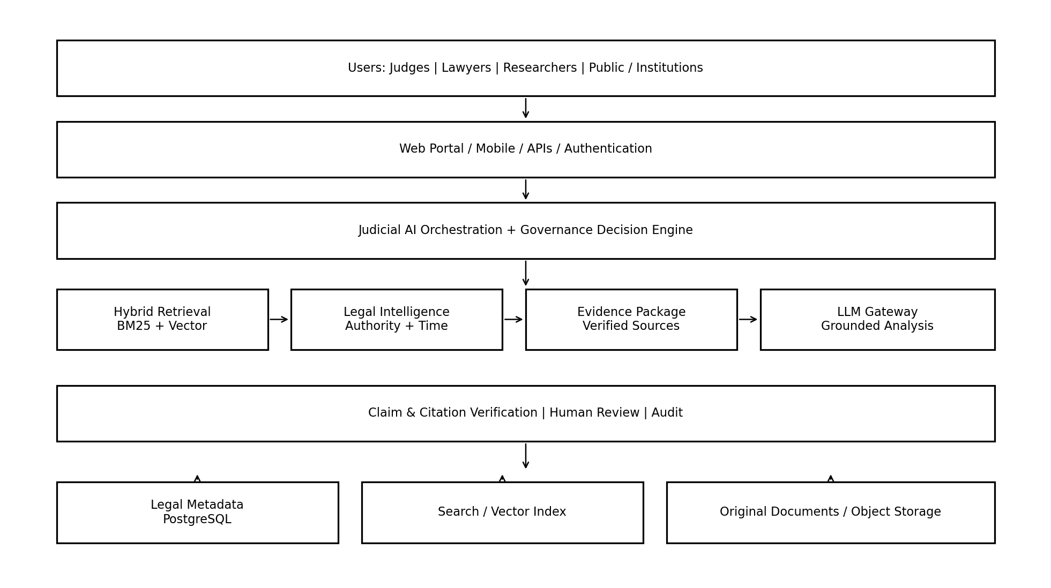
Figure 1. Proposed high-level Judicial AI architecture for Nepal.

6.1 Data Sources and Digitization
Priority data should come from authoritative public sources such as the Nepal Law Commission, Supreme Court repositories, official judgments, the Constitution, Acts, regulations, amendments and approved judicial publications [3][4]. The original file must always be preserved. Each document should receive a permanent internal identifier, source reference, file hash, verification status and version information.
Scanned documents require OCR, but OCR output should not automatically become authoritative text. Critical fields such as case number, court, date, section number and amendment date need stronger validation. Low-quality pages should be flagged for human review.

6.2 Legal Document Processing
Legal documents should be processed according to their structure. Statutes should preserve Act, Chapter, Section, Subsection, Proviso, Explanation and Schedule. Judgments should preserve page and paragraph references and, where possible, sections such as facts, issues, arguments, reasoning, holding and order. This structure-aware approach reduces the risk of retrieving a sentence while losing the exception or context around it.
The ingestion flow is: source registration -> file capture -> hashing -> OCR/Unicode normalization -> structure detection -> metadata extraction -> citation extraction -> human validation -> legal chunking -> indexing -> embedding -> controlled publication.

6.3 Knowledge / Metadata Layer
The metadata layer gives legal meaning to the documents. It should store document type, title, court or issuing authority, jurisdiction, case number, decision date, publication date, effective date, language, legal status, source, verification status, cited laws, cited judgments and document structure. It should also keep relationships such as amendment-of, cites, followed-by, overruled-by, related-provision and historical-version-of.
A relational database such as PostgreSQL can serve as the main source of truth. Original files can be stored in object storage. Search indexes and vector indexes are derived stores that can be rebuilt from verified source data.

6.4 Retrieval and RAG Layer
The retrieval layer should use both exact and meaning-based search. BM25 or similar keyword retrieval is useful for case numbers, legal phrases and exact provisions. Vector retrieval is useful when the user describes an issue in different words. The results should then be fused and reranked.
The proposed Authority-Aware RAG adds legal checks before evidence reaches the LLM. It asks two separate questions: Is this text relevant? Is it legally applicable? The second question may consider jurisdiction, court hierarchy, precedent status, effective date, amendment history, source verification and conflicts.
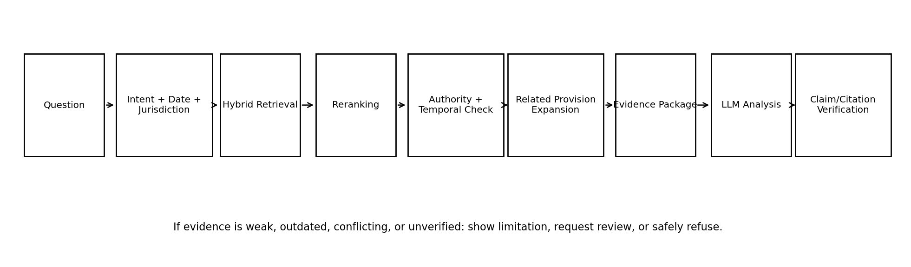
Figure 2. Proposed Authority-Aware Judicial RAG flow.
When a provision is retrieved, the system should also look for definitions, exceptions, provisos, schedules, cross-references, regulations, amendments and relevant judicial interpretations. Repealed law should remain available for historical questions but should not appear as current law by default.

6.5 LLM Analysis Layer
The LLM receives a small structured evidence package rather than unrestricted access to the whole database. The package should contain the question, jurisdiction, relevant date, selected provisions, judgments, authority labels, conflicts and known gaps. The model can then summarize or explain the material.
A separate verification step should check each material claim. Citation verification should test at least four points: the source exists, the cited text is represented faithfully, the source applies to the claim, and the source was valid for the relevant legal period. If evidence is incomplete, the system should show the limitation or safely refuse instead of guessing.

6.6 User Interface and APIs
The user interface should show the answer and the evidence together. A user should be able to open the exact source page or paragraph, see whether a source is current or historical, and understand when a translation is unofficial. Professional and public modes may use different language and detail levels while relying on the same verified evidence.
A practical implementation can use an Angular or similar web interface, ASP.NET Core for enterprise APIs, identity and workflow, and Python/FastAPI for AI processing. Versioned REST APIs can connect ingestion, search, research, verification and review services. The design should remain model-independent so that LLM providers can be changed without redesigning the full platform.

6.7 Security and Governance
Security and governance must be designed from the beginning. Users should be separated into public, professional, judicial, administrative and audit roles. Sensitive records should use strong authentication, least-privilege access, encryption, audit logs and controlled retention. Prompts, retrieved evidence and generated outputs may themselves contain confidential information and must be protected.
The governance service, not the LLM, should decide whether a request is allowed, whether external model use is permitted, whether human review is required, and whether an answer is returned, blocked or sent for further review. NIST’s AI Risk Management Framework provides a useful general model for governing, mapping, measuring and managing AI risks [10], while UNESCO and CEPEJ provide justice-specific principles [5][6].

7. Feasibility Analysis
Feasibility should be assessed across technology, data, institutions, law and ethics. A system may be technically possible but still fail because official data is incomplete, governance is weak or users do not trust it.

7.1 Technical Feasibility
The main technical components already exist: OCR, multilingual embeddings, search engines, vector databases, rerankers, LLMs, API frameworks, identity systems and monitoring tools. A prototype can be built using standard open-source and commercial technologies. The difficult part is not basic software availability; it is reliable legal integration, evaluation and governance.
A practical prototype can start with PostgreSQL/pgvector, OpenSearch, object storage, ASP.NET Core, Python/FastAPI and container-based deployment. More complex technologies such as dedicated graph databases, specialized vector clusters, Kubernetes or fine-tuned local LLMs should be introduced only when testing shows a real need.

7.2 Data Feasibility
Nepal has enough public legal material to build a limited research prototype. The Constitution, selected statutes, amendments and a controlled set of Supreme Court judgments can form the first dataset. The larger challenge is data quality. Historical scans, inconsistent formatting, missing metadata and unclear amendment relationships will require human validation. Therefore, data feasibility is moderate to high for a bounded prototype but lower for immediate national-scale coverage.

7.3 Operational / Institutional Feasibility
Operational feasibility depends on institutional ownership. A successful pilot needs legal experts, court IT staff, data engineers, AI engineers, security specialists and evaluators. Legal experts must be involved in metadata design, benchmark creation, authority rules and error analysis, not only at the final review stage. Integration with existing court and law repositories should happen through controlled APIs rather than creating another isolated system.

7.4 Legal and Ethical Feasibility
An assistive Judicial AI system is more feasible than an autonomous decision system. Legal and ethical feasibility improves when the system uses public or authorized data, keeps a complete audit trail, explains sources, protects privacy, separates information from judicial decision-making, and requires human responsibility for high-risk use. Nepal’s Privacy Act and Electronic Transactions Act are relevant to data handling and electronic systems, while future judicial AI policy may add more specific requirements. International guidance also strongly supports human oversight and transparent use [5][6].

Area | Current Feasibility | Main Strength | Main Risk
Technical | High for prototype | Mature RAG, search and API tools | Legal reliability and multilingual evaluation
Data | Moderate | Official public sources exist | OCR, metadata, versions and completeness
Operational | Moderate | Existing judicial digital systems | Ownership, staffing and workflow adoption
Legal/Ethical | Moderate-High for assistive use | Human-led research support is controllable | Privacy, bias, overreliance and accountability
Table 1. Summary feasibility assessment for a bounded Judicial AI prototype.

8. Implementation Roadmap, Governance and Safety Constraints
The safest implementation path is gradual. The project should prove the quality of its data and retrieval before adding complex generative functions.
- Governance and scope: define permitted uses, prohibited uses, data owners, user roles and success criteria.
- Verified legal-data foundation: ingest the Constitution, selected statutes, amendments and 50-100 verified Supreme Court judgments.
- Baseline search: implement exact, filtered and keyword search and establish measurable retrieval results.
- Hybrid retrieval: add multilingual vector search, result fusion and reranking.
- Legal Intelligence: add jurisdiction, court hierarchy, temporal validity, precedent status and related-provision rules.
- Grounded generation: provide the LLM with a controlled evidence package and require citations.
- Verification and safety: add claim checking, citation validation, attack testing, audit and human review.
- Controlled pilot: test with a limited group of judicial researchers or legal professionals before wider integration.
- Scale only after evidence: expand datasets, integrations and infrastructure after independent evaluation.
Safety constraints should be explicit. The system should not invent citations, should not present unverified OCR as authoritative, should not silently use repealed law for a current question, should not expose confidential material to unapproved model providers, and should not independently make judicial decisions. Where evidence is weak or conflicting, the correct system behaviour is to show uncertainty or require review.

9. Challenges and Limitations
The proposed framework has important limitations. First, this paper presents a concept and architecture, not a completed production system. The proposed scores, rules, thresholds and technologies still require prototype testing. Second, Nepal does not yet have a large public benchmark for bilingual legal retrieval, authority classification, historical-law questions and claim-level citation checking. Third, legal data quality may be inconsistent, especially for older documents.
Legal authority is also difficult to automate completely. A judgment may be relevant but distinguishable on facts or procedure. Precedent treatment can depend on bench composition, later cases and professional interpretation. Translation may change legal nuance. Even a correct source can be applied incorrectly by a language model. For these reasons, the architecture can reduce risk but cannot remove the need for legal judgment.
Other challenges include institutional resistance, cost of data cleaning, cybersecurity, privacy, vendor dependency, model change, uneven Nepali-language performance and automation bias. A polished AI answer may appear more reliable than it really is. The interface and training program must therefore encourage source checking rather than passive trust.

10. Discussion
The main design decision in this paper is to treat Judicial AI as a complete legal-information system rather than an LLM application. This changes where trust is created. Trust does not come from the model sounding confident. It comes from verified sources, legal metadata, retrieval quality, authority checks, version control, citation verification, audit and human responsibility.
This approach creates extra complexity and some additional response time. However, the extra steps also make errors easier to locate. If an answer fails, the team can ask whether the problem came from OCR, metadata, retrieval, authority classification, law-version selection, generation or verification. This is more useful than treating every problem as a generic hallucination.
The architecture also fits Nepal’s practical situation. Nepal does not need to train a national foundation model before it can start Judicial AI research. A small, well-governed RAG prototype can use existing models while keeping legal knowledge outside the model in controlled repositories. Fine-tuning or local models can be considered later if benchmark results show a clear benefit.
International experience supports the same cautious direction. Brazil, Singapore and India show that courts obtain value from classification, translation, summarization and controlled digital assistance [7][8][9]. The proposed Nepal framework extends this approach by making legal authority, temporal validity and citation verification explicit architectural components.

11. Conclusion and Future Work
This paper finds that AI-assisted legal analysis is feasible for Nepal at the level of a controlled research prototype and, with institutional support, a later judicial pilot. Nepal already has important digital legal sources and a continuing judicial modernization direction. Modern search, RAG and LLM technologies are mature enough to build a useful prototype. The main barriers are legal-data quality, authority and version modelling, multilingual evaluation, governance, security and sustained expert participation.
The proposed Judicial AI platform therefore uses a layered design: verified legal data -> structured metadata -> hybrid retrieval -> authority and temporal checks -> evidence package -> grounded LLM analysis -> claim and citation verification -> human review and audit. The system is intended to assist legal research, not replace judicial discretion.
Future work should build a Nepal-specific benchmark and prototype. The benchmark should include Nepali-English paired questions, current and historical law, related provisions, conflicting judgments, fake citations, unanswerable questions and adversarial document changes. The prototype should compare keyword, vector, hybrid, reranked and authority-aware retrieval. Later research can study precedent graphs, domain-adapted models, privacy-preserving deployment, public-facing legal information, institutional adoption and national-scale integration.
The central principle is simple: legal trust should come from verified evidence and accountable process, not from confident AI writing.

References
[1] Lewis, P. et al. (2020). Retrieval-Augmented Generation for Knowledge-Intensive NLP Tasks. NeurIPS. https://arxiv.org/abs/2005.11401
[2] Chalkidis, I. et al. (2020). LEGAL-BERT: The Muppets Straight Out of Law School. Findings of EMNLP. https://aclanthology.org/2020.findings-emnlp.261/
[3] Nepal Law Commission. Official legal repository and prevailing laws. https://lawcommission.gov.np/
[4] Supreme Court of Nepal. Fifth Five-Year Strategic Plan for the Judiciary, 2081/82-2085/86, and official judicial services. https://supremecourt.gov.np/
[5] UNESCO. (2025). Guidelines for the Use of AI Systems in Courts and Tribunals. https://www.unesco.org/en/articles/guidelines-use-ai-systems-courts-and-tribunals
[6] European Commission for the Efficiency of Justice (CEPEJ). European Ethical Charter on the Use of Artificial Intelligence in Judicial Systems and their Environment. https://www.coe.int/en/web/cepej/cepej-european-ethical-charter-on-the-use-of-artificial-intelligence-ai-in-judicial-systems-and-their-environment
[7] Supreme Federal Court of Brazil. VICTOR artificial intelligence system and case classification in general repercussion analysis. https://portal.stf.jus.br/internacional/content.asp?id=488133&idioma=en_us&ori=1
[8] Singapore Judiciary. (2025). Generative AI-powered case summarisation tool for the Small Claims Tribunals. https://www.judiciary.gov.sg/news-and-resources/news/news-details/media-release--new-generative-ai-powered-case-summarisation-tool-to-help-small-claims-tribunals-users
[9] Supreme Court of India. Official digital services and SuSahayak AI Assistant. https://www.sci.gov.in/
[10] NIST. (2023). Artificial Intelligence Risk Management Framework (AI RMF 1.0). https://www.nist.gov/itl/ai-risk-management-framework
[11] NIST. (2024). Artificial Intelligence Risk Management Framework: Generative Artificial Intelligence Profile. https://www.nist.gov/publications/artificial-intelligence-risk-management-framework-generative-artificial-intelligence
[12] Competition on Legal Information Extraction/Entailment (COLIEE). Legal information retrieval and entailment benchmark series. https://sites.ualberta.ca/~rabelo/COLIEE2025/
[13] OWASP. Top 10 for Large Language Model Applications / GenAI Security Project. https://genai.owasp.org/
[14] Government of Nepal. Privacy Act, 2075 (2018). https://lawcommission.gov.np/
[15] Government of Nepal. Electronic Transactions Act, 2063 (2006). https://lawcommission.gov.np/

