Characterizing diffusive growth by
uncertainty quantification
Paul Pukite, Steve Bankes, Dan Challou
BAE Systems

Abstract: Environmental models by their nature contain a great deal of uncertainty. Since the underlying behavior of the model is rarely controlled by an ordered process, any model characteristics will carry along with it a level of aleatory uncertainty governed by the natural disorder. This paper applies novel uncertainty quantification approaches to classes of diffusion problems which illustrate the benefit of assuming natural variability.

Introduction
Modeling with uncertainty quantification has application to such phenomena as oxidation, corrosion, thermal response, and particulate growth. These fall into the classes of phenomena governed substantially by diffusional processes. At its most fundamental, diffusion is a model of a random walk. Without a strong convection or advection term to guide the process (e.g. provided by an electric or gravitational field), the kinetic mechanism of a particle generates a random trajectory that is well understood based on statistical physics principles. The standard physics approach is to solve a master diffusion equation under transient conditions. This turns into a kernel solution that we can apply to an arbitrary forcing function, such as provided by an input material flux or thermal impulse.
Yet, the environment that the particle resides in may not be as homogeneous as the ideal diffusion model would imply. Enough uncertainty in the essential diffusion parameters may exist that we need to ask some fundamental questions:
- Why do we assume the diffusion coefficient is a constant?
- How can we know the diffusional interface so precisely?
Within a heterogeneous media, the characteristic diffusion coefficient does not have to remain a fixed value. Varying material composition and amounts of defects can modulate the natural hopping rate and thus smear the diffusion coefficient well beyond the narrow tolerance that is typically assumed. In general, the assumption of a single diffusion coefficient works well for many behaviors ─ as the observed results are already smeared due to diffusion, while a greater level of uncertainty will not change the mean value of the diffused measures. This mean value approximation works well as a result of applying the central limit theorem of statistics.
Yet, under certain circumstances, the uncertainty in the diffusion coefficient or uncertainty in the experimental geometry will have a subtle yet measurable impact on the diffusional transient behavior. This departure from ideality usually occurs over the short initial growth time, but will also manifest itself via the application of a modified impulse response function.
As an example, if we consider the heat equation, which models the thermal evolution of a transient heat impulse, we immediately note that the standard solution admits an infinite speed of propagation of the initial thermal transient, due to a singularity in the kernel solution expression. That first random walk step is instantaneous according to the math, yet we need to either integrate this transient out or invoke a model such as relativistic diffusion to account for the real system behavior. Furthermore, and just as plausibly, the initial transient is likely modified by unaccounted natural uncertainty and disorder in the thermal characteristics and environment, i.e. within the thermal context.
This uncertainty also manifests itself in other diffusion models. Deviations from the expected Fickian diffusional growth model lead to the Deal-Grove model for Si oxide growth as a practical yet non-ideal heuristic.
In this paper, we apply straight-forward uncertainty quantification. The essential idea is to admit some uncertainty in the diffusion coefficient and in the interface location. By propagating the uncertainty into the diffusion response, certain issues disappear. For example, the infinite speed becomes finite and the kernel solution comes out very clean. This becomes part of the initial condition uncertainty that we know must exist in practice.
In the following work we apply two levels of uncertainty
- Vary the diffusion coefficient to maximum uncertainty with known mean
- Vary the diffusional interface to maximum uncertainty with known mean
As a result we generate a simple diffusion kernel that is much easier to reason with, and can explain several subtle anomalous diffusion behaviors
Example: SiO₂ growth
We first consider the well-known characterization of silicon dioxide, SiO2 as an example of dispersive growth. Originally characterized by Bruce Deal and Andrew Grove in the 1960’s, a careful application of a diffusion-based oxide growth model partially enabled the semiconductor revolution. As illustrated in Figure 1, the Deal-Grove model works as a heuristic model in so far as a rigorous first-principles derivation does not exist.
Figure 1: Chemical simulation of oxidation of silicon. A large degree of disorder is evidenced by the mixture of pure Si, SiO₂, and SiO and as indicated in the histograms by light gray bars, green bars, and red bars, respectively. Black and red arrows indicate the growth direction of the oxidized and silica (SiO) layers, respectively (from [Khalilov 2011] )
The following derivation improves on the Deal-Grove model by assuming that the diffusion coefficient and location of the growing oxide layer is smeared by a maximum entropy amount; i.e. we can estimate the mean but we leave higher-order moments to vary to maximize the entropy.

Diffusion Solution.
The standard approach for solving diffusion problems starts from master diffusion equation
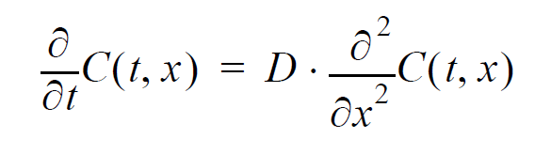 | (1)
also known as Fokker-Planck, this is a one-dimensional representation and only lacks the convective or drift term from the general formulation of Fokker-Planck. We also assume that D does not change with respect to spatial coordinates.
We can easily derive the solution of the response function if we think of the diffusion from a planar source outward. The kernel solution gives:
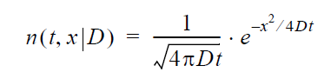 | (2)
We place an impulse of reactants at x=0 and want to watch the evolution of the concentration, n, with time. As the concentration drops, we assume that the diffused material from that amount contributes to the growth of the oxide layer.
Figure 2: Mechanism for diffusion (from [Uematsu 2002])
Consider first that the kernel function represents a one-dimensional concentration profile, in units of number of atomic elements per thickness. The expression n(t,x) describes how quickly the atomic concentration decreases from its initial value. So the accumulated concentration, representing the growth outward from the interface, is the spatial integral of the concentration density. Early on we assume that the region of the interface is spread over a width X.
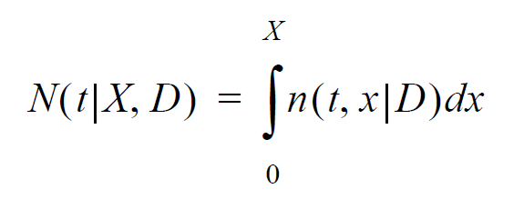 | (3)

The average flux of atoms outward from the interface, J(t|X, D), is proportional to the gradient of n, and we apply the diffusion coefficient as the standard proportionality term at position X:
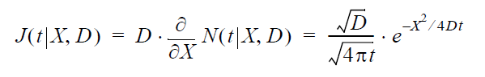 | (4)
Next, suppose we have an idea of a mean value for the diffusion coefficient, D, but don’t know how much it varies. Lacking that information, we apply a maximum entropy estimate for the variance assuming a mean value D₀.
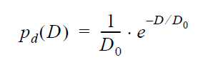 | (5)

We can then integrate the concentration across the diffusion probability density function, and the solution reduces to:
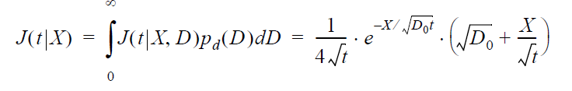 | (6)

We also need to consider that for a highly disordered layer, we should place a maximum uncertainty around the value of X.
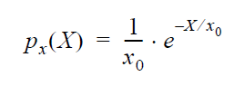 | (7)
Once again we can apply a probability density function, this time to the flux, which marginalizes X according to the following integration:
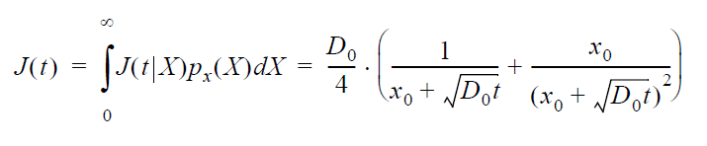 | (8)
As a last step, we need to integrate the average flux over time to arrive at the growing width, W, of the oxide layer:
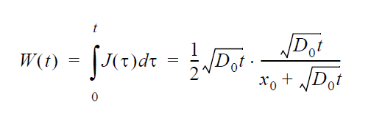 | (9)

The time integral of this flux is the accumulated concentration of material with a constant inflow of material (i.e. molecular or elemental oxygen) from the surroundings. By integrating the diffusional response, we can demonstrate how the step input transiently supplies reactants to the growing interface. The second factor is the newly realized suppressive effect due to disorder. For small t, this compensates the lead term to provide a linear growth factor, which is the original heuristic in the Deal-Grove growth law.
In summary, we applied a two step maximum entropy estimation process to model the disorder in the growing oxide layer. Without any knowledge about the distribution of D and X, apart from asserting that they must exist, we applied the following series of transforms:
(10)

This provides a diffusional response due to a continuously applied step concentration to model a growing thickness. For oxide growth, a step input of oxygen is supplied from one side of the interface, and the substrate supplies silicon atoms, see Figure 2. The figure below provides a model fit to recent data from a set of SiO₂ growth experiments.
Figure 3: Comparison of dispersive diffusion model against the convention Deal- Grove model (empirical dotted) and a detailed simulation based on reaction kinetics. For silicon, an immediate oxide layer is formed which generates a baseline thickness of about 1 nanometer (data and simulation from [Uematsu 2002]³)
Over time, the response will attain a square root growth law, indicative of the Fick's law regime of what is often referred to as parabolic growth. The larger the mean diffusion coefficient or the smaller the uncertainty level x₀, the more quickly that the response will diverge from the short-term linear growth regime.
Figure 4: In the Fickian growth regime, the dispersive diffusion formulation follows a square root time dependence, and can be confirmed with an online SiO₂ growth calculator http://www.cleanroom.byu.edu/ OxideThickCalc.phtml
General Applicability.
The uncertainty quantification proposed here has more general applicability than just to oxide growth on silicon. Any diffusional process that contains a degree of uncertainty in its parameters is a candidate for this simplification.
The general dispersed response to an impulse at the smeared origin is generated by the marginalization of Eq. 2 with Eq.5 and Eq.7 with the result:
$$n\left(t\right)=\frac{2}{x_{0}+\sqrt{Dt}}$$ | (11)
This describes the damping of the peak concentration profile with time, cast in terms of a one-dimensional density. Alternatively, by scaling with a time constant, the impulse response can be normalized:
$$n\left(t\right)=\frac{1}{1+\sqrt{\frac{t}{τ}}}$$ | (12)
Here, $τ$ is a diffusional time constant, indicating how slowly the concentration disperses from the origin. This is also a measure of the persistence of a material to remain localized (see [Pukite 2011]). The scaling implications are important to allow us to generalize the behavior over a range of conditions [de Almeida 1999].
In fact, the dispersive formulation can extend to mathematically related behaviors such as corrosion and particulate growth. Corrosion acts very similar to oxidation in that the rate of the corrosive materials has to depend on diffusion of the reacting species with the replenishment of fresh substrate. Further, we can evaluate how well this applies to thermal diffusion, which uses the heat equation in a mathematical formulation very similar to particle diffusion.
Example: Thermal Dispesive Diffusion
The master model for thermal diffusion is referred to as the heat equation. This has the same formulation as Eq(1) with the role of material concentration played by temperature (which represents the local thermal excitation). In many practical applications, we may want to know the dissipation of heat from a source. In the case of a planar source of heat such as the surface of a CPU, we can use a one-dimensional model to illustrate the principle. Or we can demonstrate the flow of heat through a rod for different thermal conductivities (see Figure 5).
The ideal non-disordered impulse response should follow
$$ΔT\left(t\right)=\frac{C}{\sqrt{Dt}}ⅇ^{\frac{-x^{2}}{Dt}}$$ | (13)

The disordered variation of this is
$$ΔT\left(t\right)=\frac{C}{\sqrt{Dt}}ⅇ^{\frac{-x}{\sqrt{Dt}}}{\left(1+\frac{x}{\sqrt{Dt}} \right)}_{ }$$ | (14)
Since each of the rods consists of a uniform homogeneous metal, one would expect that the response should be near to what theory predicts, and that is the case. [Sullivan 2008]⁷
For each of the materials of Figure 5, the idealized impulse response works well (Eq. 13), while the disordered variant (Eq. 14) reveals a larger dispersive spread.

Figure 5: Experimentally measure thermal diffusion profiles for various metals showing excellent agreement with ordered diffusion. The dispersed diffusion profile is shown alongside.
Where we would like to apply the disordered response is to an interface that has a thermal stimulus on one side and an outlet on the other, which turns out to be a realization of a compartmental or box model for thermal dynamics.
Figure 6: A box model for thermal dynamics assumes a stimulus representing an initial transient (1) convolved against a dissipative transfer function (2) to produce a modulated response (3).
The role of the box model is to model a thermal input along with a response which will allow an alternate path for dissipation of heat. In Figure 6, the input stimulus is a unit step which immediately creates a Fickian square root buildup near the interface (subgraph 1). This gets dissipated by a smeared impulse response function (subgraph 2) and the result is shown as a modulated response (subgraph 3) showing a slower buildup than the square root rise. The modulated reduction results from heat that is dissipated from non-specific paths as described in [Sullivan 2008], described by Figure 7.
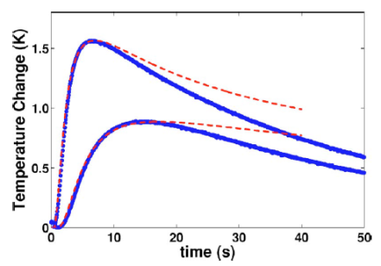
Figure 7: Red lines indicate the theoretical profile under a non-lossy thermal environment.
To analyze the thermal response we use the concept of a convolution to drive the response from a combination of input delta temperature change and the transfer function representing heat dissiation following secondary paths.
$$Response\left(t\right)=Input\left(t\right)⊗Transfer\left(t\right)$$ | (15)
At the origin of the thermal impulse, the smeared diffusive response is:
$$ΔT\left(t\right)=\frac{1}{1+\sqrt{t/τ}}$$ | (16)
This agrees with measurements from experiments, as shown in Figure 8.
.
Figure 8: Impulse response from a unit step thermal stimulus applied to an earthen mass (data from [Witte 2002] ).
If we take a strong dispersive diffusive decline and convolve with a Fickian growth curve to model the loss:
$$Response\left(t\right)=\sqrt{t}- \sqrt{t}⊗\frac{d}{dt}\left(\frac{1}{1+\sqrt{t/τ}}\right)$$ | (17)
The result is a modulated response:
$$t>τ$$ | $$Response\left(t\right)= π-\frac{2{\cosh^{-1}\left(\sqrt{t/τ}\right)}}{\sqrt{\frac{t}{τ}-1}}$$ | (18)
$$t<τ$$ | $$Response\left(t\right)= π-\frac{2{\cos^{-1}\left(\sqrt{t/τ}\right)}}{\sqrt{1-\frac{t}{τ}}}$$
A contour of the response surface is shown in Figure 9.
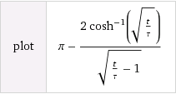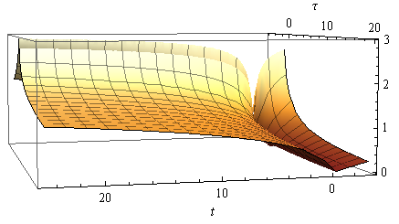
Figure 9: Response surface of the dissipative dispersion function
This formulation accounts for the dispersed heat losses arising from diffusion through dispersed paths.

Figure 10: Dispersed impulse response measured away from the stimulus. Note the crossover point separating the acosh and acos behavior
(from http://www.groenholland.com/nl/consultancy/site_testing_and_characterisation/trial_borehole_and_trt.php ).
By applying a sequence of thermal impulse steps we can demonstrate how to model piecewise transients (see Figure 11).
Figure 11: Series of hot and cold unit step impulses applied to an earthen mass measured as a transient response (data from [Witte 2005] to a groundwater (GW) or reference sink.
In addition to the utility for large scale geothermal transients as just described, we can also apply this dispersive thermal approach to smaller scale contexts, such as a component or subsystem heat sink. Figure 12 shows typical thermal transients observed under various dissipation paths for a powered-up CPU card. Depending on whether the environment contains a well defined heat sink and cased enclosure, the transient will display markedly different apparent time constants. This by itself is not too surprising, but the dispersive diffusion response allows us a simple model to match up with the empirical results. In particular, where we have uncertainty in the environment, this approach excels, as it only requires a mean value estimate for the composite thermal diffusion coefficient or conductivity.
Figure 12: Thermal transients observed within a CPU housing.
Example: Corrosive Growth
The salient principle behind the corrosion of metals is that rust growth mirrors that of the oxide growth of silicon. The number of random environmental factors involved in corrosion suggests that it would make an ideal candidate to apply the dispersive diffusion model. In the oxidation of steel, several different varieties of oxide are involved with varied atmospheric levels of corrosive reagents.
Figure 13 and Figure 14 show an oxide growth model and the results of experimental measurements for a steel composed structure left to weather under different climatic conditions. The behavior specified in Eq(7) was applied directly to the data with assumed mean values for an effective diffusion coefficient.
Uncontrolled rusting also has the propensity for peeling off, thus exposing fresh layers which will start the oxidation process over again. That tendency makes allows the possibility for a growth power law of ½ combining with a linear growth law leading to the 0.7 power law. This is the same rate observed for the dispersive diffusion model within the transition zone during the early oxidation process.
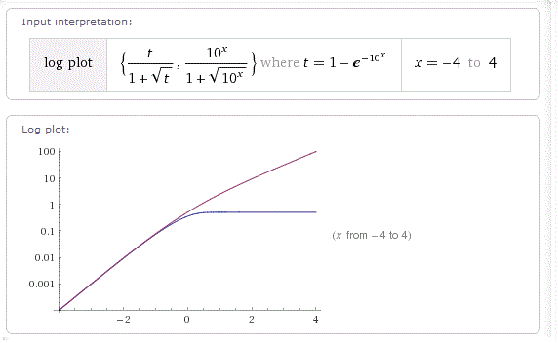
Figure 13

Figure 14: Corrosion growth rates on a linear scale
The dynamic range is limited but the rate of growth suggests and initial linear regime, which bends into a power law growth.

Figure 15: Corrosion growth rates on log scale compared against data from [de la Fuente 2011].

Conclusions.
We have presented a series of physics-inspired models that approximate assorted diffusion phenomena well enough to be useful for model based engineering, providing significant advantages over both physical testing and reliance solely on data tables drawn from past testing. It should be noted that the question of when an approximate model is sufficiently accurate for a specific use depends upon the requirements that intended use places upon the model.
The statistician George E.P. Box wrote a famous quote concerning the validity of models. Box’s oft-quoted statement of “All models are wrong, but some are useful” can be (and at times has been) misinterpreted. The original quote in full, drawn from the book “Empirical Model-Building and Response Surfaces” by Box and Draper, provides useful context:
“The fact that the polynomial is an approximation does not necessarily detract from its usefulness because all models are approximations. Essentially, all models are wrong but some are useful. However, the approximate nature of the model must always be borne in mind.”

On the rest of that page, Box and Draper present a concise description of the differences between epistemic and aleatoric uncertainty, which is a crucial distinction for understanding the range of valid use for the models we present here. Epistemic uncertainties are the systematic errors (model uncertainty) that one can introduce in a statistical model, while aleatoric errors are those that are fundamental in the natural behavior itself (parametric uncertainty), be it noise or some other random effect.
The distinction between epistemic and aleatory uncertainty is central to understanding the scope of applicability of the oxide growth and thermal modeling described in this paper, and of the validity of environmental models in general. We can understand the basic mechanisms of oxide growth over many orders of magnitude via the parabolic Fickian diffusion law, but we may miss important details in how we choose to numerically model the fundamental equations. To remedy this situation, we treated the diffusion coefficient and the Si/SiO₂ interface location with the correct amount of aleatory uncertainty. Epistemic uncertainty remains potentially effecting the validity of the model we applied, which is addressed in accurately we can measure against the empirical observations.
The decision on whether a specific model is valid for a given use thus depends on how closely the problem at hand corresponds to data against which the model has been compared. Were the situation identical to available data sets, the use of a model would not be necessary. If the case at hand is a serious extrapolation from past experience, careful consideration must be made of what effects the model may be neglecting and whether these effects could make the model’s behavior misleading for the extrapolated case. Between the situations where a model is unnecessary and one where it is inappropriate are a range of valid uses where the question at hand is how much error should be expected in model outputs. Our treatment of aleatory uncertainty provides a means to estimate expected error, when the question of model uncertainty has been appropriately addressed.
So, Box essentially described a stance towards appropriate care in determining appropriate use of models and for estimating numerical errors in statistical modeling. To interpret Box’s quote as questioning the validity of using models in the first place would clearly be an incorrect argument — look at how far mathematical engineering based on models has gotten us! The Deal-Grove model essentially allowed oxidation processes to become well characterized and predictable, which was central to revolutionizing the integrated circuit manufacturing process. The dispersive diffusion model derived in this paper should be taken in that spirit, a pragmatic model that could become useful in characterizing a fundamental physical process.

References

[Deal 1965] Deal, B.E. and Grove, A.S., "General Relationship for the Thermal Oxidation of Silicon", Journal of Applied Physics, 1965, 36 (12): 3770–3778. doi:10.1063/1.1713945
[Khalilov 2011] Khalilov, U., Neyts, E. C., Pourtois, G. and van Duin, A.C.T., “Can We Control the Thickness of Ultrathin Silica Layers by Hyperthermal Silicon Oxidation at Room Temperature?”, J. Phys. Chem. C, 2011, 115 (50), pp 24839–24848 doi:10.1021/jp2082566 http://webhost.ua.ac.be/plasma/pdf_papers/jpcc11can.pdf
[Uematsu 2002] Uematsu, M., Kageshima, H, and Shraishi, K., “Microscopic mechanism of thermal oxide growth”, Computational Materials Science, 2002. http://www.sciencedirect.com/science/article/pii/S0927025602001994
Parabolic growth is somewhat of a misnomer because the actual growth is a square root with time. In other words it is parabolic with respect to the inverse.
[Pukite 2011] Pukite, P., “The Oil Conundrum”, ISBN 9780964474116 , DAINA, 2011, http://books.google.com/books/about/The_Oil_Conundrum.html?id=mmmWZwEACAAJ
[de Almeida 199] de Almeida, R M C ; Gonçalves, S ; Baumvol, I J R ; Stedile, F C, “Diffusion-reaction in thermal growth of silicon oxide films on Si”, 1999. http://arxiv.org/pdf/cond-mat/9901335.pdf
[Sullivan 2008] Sullivan, M. C.; Thompson, B. G.; Williamson, A. P., “An experiment on the dynamics of thermal diffusion”, American Journal of Physics, Volume 76, Issue 7, pp. 637-642 (2008). http://www.compadre.org/advlabs/tcal/files/SullivanM9Paper.pdf
[Witte 2002] Witte, HJL, Van Gelder, GJ , Spitler, J.D. "In situ measurement of ground thermal conductivity: a Dutch perspective", ASHRAE Transactions, Vol. 8, No. 1, 2002 http://www.groenholland.nl/download/Ashrae-108-1.pdf
[Witte 2006] Witte, H.J.L., van Gelder, A.J., “Geothermal Response Tests Using Controlled Multi-Power Level Heating And Cooling Pulses (Mpl-Hcp): Quantifying Ground Water Effects On Heat Transport Around A Borehole Heat Exchanger”. https://intraweb.stockton.edu/eyos/energy_studies/content/docs/FINAL_PAPERS/10A-3.pdf
[de la Fuente 2011] de la Fuente, D., Díaz, I., Simancas, J., Chico, B., Morcillo, M., "Long-term atmospheric corrosion of mild steel", Corrosion Science, Volume 53, Issue 2, February 2011, Pages 604–617 http://www.sciencedirect.com/science/article/pii/S0010938X10005160
[Box 1987 ] Box, GEP and Draper, N. “Empirical Model-Building and Response Surfaces”, Wiley (1987). Other refs, IBM diffusion and scaling

