Knowledge Based Environmental Modeling
This paper covers the detailed modeling we will require to produce environmental contexts for C2M2L. For critical reviews, please mark up and send to paul.pukite@baesystems.com … in progress
Abstract: This paper describes a modeling architecture based on logical bulding-blocks well suited for comprehensive environmental modeling.

Introduction
The design of ruggedly complex systems such as advanced ground vehicles requires knowledge of the environmental contexts that occur during operational deployment. For example, the nominal and extreme terrain and weather conditions have an impact on the details of the vehicle design. A vehicle has to endure and even thrive in extreme conditions to earn the title of ruggedized.
The approach that we outline below extends from research describing the elements necessary to create workflow architectures for vehicle design. In particular, the building blocks that originated from design-centric semantic web and knowledge-based reasoning were deemed general enough to find applicability to environmental modeling.
Based on the general approach to design, we applied the same knowledge-based facets to environmental modeling (see Table 1 below). Starting from the modeling level, we consider abstractions, organization, search, and reasoning to improve the convenience and usability across the suite of models.
As models are quantitative and often statistical, we employ a concise descriptive language to declaratively specify their behavior. Simulation abstractions allow us to transition between purely data-driven and probabilistic views of models. The convenience of automated searching and reasoning benefited from the semantic-based organization of the underlying knowledge-base.

Table 1 : Knowledge-based modeling facets
 |  | Examples | Benefits
Domain Specific Language |  | Statistical, complex, and matrix math. | Concise, symbolic, declarative, with formal representations
Abstraction Levels |  | Local/global spatial levels, probability distributions | Comprehensive views of environmental contexts
Organization |  | Semantic web ontologies such as SWEET | Classification, maintenance, library curation
Searching |  | Linked data elements, keyword and classification | Models discovered through requirements linkage, etc
Reasoning |  | Workflow and parametric modeling | Guided model generation and usage

The supplemental view is a dynamic context server (DCS) which provides an environment for handling interactive applications such as guided workflows, artifact viewing, and reusable web services. OSCAR’s capabilities will not overlap with the dynamic server’s capabilities and in fact the two complement each other. The two views can be integrated through a conventional web-service front-end.
The DCS has been prototyped with a breadth-first view first to make sure that we have all the semantic, ontological, logical, and mathematical capabilities in place.

General Architecture of a Dynamic Context Server

Integration with triple-store semantic data
  - RDF and simple formats such as Turtle used as input files for data and knowledge
  - SWEET provides ontological classification where possible

Knowledge-based logic formulation
  - Rules interact with the triple-store description logic
  - Entailment – creating rules that abstractly appear as triple store

Semantic Web servicing
  - Queries as model services
  - Queries to generate algorithms and code
  - Queries to generate artifacts and metrics

Workflows
  - Query-based search and navigation
  - Guided workflow starting from requirements

Architecture Features

Pattern architecture
  - Many context models have similar representation or archetypes
    - e.g. PDF patterns use functional mapping on lists
    - Similar format allows reusable artifacts, such as graphs
  - Models calibrated via parameters for different locales
  - Declarative programming facilitates pattern-matching

Graphing of artifacts
  - From models or data
    - PDF and CDF
    - Power Spectral Density
    - Expected value plots
      - Annual, diurnal
      - Growth curves
  - Linear or log scales
  - Noise filtering
  - Inspection of data points
  - Panning and scaling

Domain-specific language for list processing
  - List of X-Y pairs
  - List of X-Y1,Y2,.. n-tuples
  - Math operations on lists
    - Constructors
      - Linear range
      - Log range
  - Dot product
  - Mapping on lists
    - Functions
    - Scaling
  - Convolution
  - Pair Correlation / Auto-correlation
  - Z-difference
  - Integral / Derivative
  - Histogram
  - Direct translation of tuple-lists to graphs

Domain-specific language for complex-number processing
  - Arithmetic
    - Infix operators for multiply, addition, division, power, etc
    - Used for concise semi-Markov terrain profile modeling
  - Built-in FFT for PSD calculation

Integration with general statistical functions
  - R statistics package
    - Uses similar format for mapping against data lists
    - i.e. Statistical operators act on the entire list
  - Provides access to less common functions such as Bessel

Random number generation
  - PDF generators for
    - Uniform
    - Exponential
    - Bessel
    - Rayleigh
    - Fat-tail
  - Profile generators
    - Random walk based
      - Markov
      - Semi-markov
    - Superposition of sines

Reference and citation knowledge capture
  - Integration with Zotero citation management system
    - SWEET keyword categorization
    - Generation of RDF stores

Rules for searching and presenting knowledge
  - Based on ontological terms
  - General content search
  - Custom input and output data processing
    - XML and HTML
    - JSON
    - CSV

Diagramming
  - AT&T Graphviz compatibility with SVG
  - Closure of rules as a directed graph.
  - Hierarchy and cloud diagrams

Generators for code production and data
  - Tabulation of data, i.e. connectors for spreadsheet
  - Symbolic representations of algorithms
    - Used for on-line calculation
    - Translated to C-code, Python, etc

GUI development
  - Uses definite clause grammars (DCG) to generate valid HTML
  - Declarative style of programming, similar but much more concise and powerful than XSLT

Portability
  - Windows
  - Linux
  - Cloud environment

Maintenance of library
  - Browsing
  - Site roadmap
  - Documentation
  - Statistical usage
  - Password control for administration of repository

Physical Domains

List of physical domains
  - Land
  - Atmosphere
  - Aquatic

Deterministic and stochastic representations
  - Stochastic terrains characterized by PSD’s
  - Deterministic obstacles

Installation

Source Code
All source code is available on SVN under the context branch
browser: https://babelfish.arc.nasa.gov/trac/avm_performers/browser/context
checkout: https://babelfish.arc.nasa.gov/svn/avm_performers/

Packages Required
- SWI Prolog for Linux, Windows, or Mac http://www.swi-prolog.org/Download.html
- R Statistics package http://www.r-project.org/
- AT&T Graphviz graphics package http://www.graphviz.org/
- Firefox preferred, but Google Chrome adequate as a browser. Internet Explorer won't work.
- (possible) Geospatial indexing library http://www.swi-prolog.org/pldoc/package/space.html
Make sure to install all the add-on packages for SWI. The prolog runtime will need to know the path to R and Graphviz. The geospatial indexing package needs to be added to the SWI Prolog build to work.
Once the SVN is checked-out, go to context\Ontology\reasoners\prolog\proto_context_server directory to start the Dynamic Context Server.
- run.pl (Windows registered)
- run.sh (Linux command line)
- nohup-run-cloud (running on a Cloud server as a job)
The port is 3020 for local clients and 80 for cloud configured. If you have the DCS set up on the machine you are using to access this Wiki then click on the following link:
http://localhost:3020
An authorization login is required to load the ontological context data (menu item Repository/Load Context Data). This can be reset by removing the users.db file in the store directory.

Cloud computing. Server.

T
.
Table 2: The set of Domain Specific Language elements for environmental modeling covers math and logic functionality
Functionality | Terms | Description | Examples
complex math | isx (evaluation)  & (constructor) | Manipulating complex numbers used for generating PSD curves. |  | Num isx 1&2 * 2&1
array math | dot (scalar result)  mapdot (array result)  -> (apply function) | High-level array manipulation. |  | Z dot Array1 * Array2,  Amp mapdot sqrt -> PSD * Sx
statistical | <- (translate to R ) | Interface to the R statistical |  | y <- BesselK(1.0,0.0),  Y <- y
geospatial | shape  point  line | Description of geometric shapes and lines |  | shape(point(52.3325,4.8673))
markup | html | Definite clause grammar for generating markup |  | table([border(1)], [tr([th('Mean'),th('Sampled')]), tr([td(Mean_Slope), td(S)])])
semantic | rdf | Library for interfacing to RDF and OWL knowledge |  | rdf(U, dcterms:’URI’, Link)
symbolic logic | Prolog terms | Overall logic programming, dimensional checking, etc. |  | Distance = 10.0 * meters
ordinary math | is (evaluation)  Prolog terms
a
a
a
a
a
The geospatial functionality is very useful for inferring information. For example, say that temperature statistics are not known for a particular area, but data from nearby locations is available. A geospatial engine can aggregate and select data from weather stations in close proximity and use that to interpolate the statistics.

Knowledge Based Representations
.

Summary
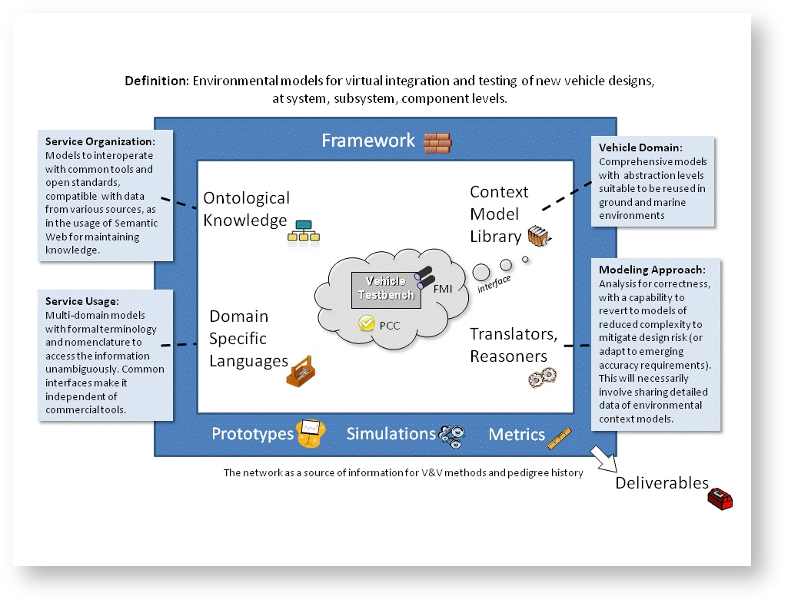

AA
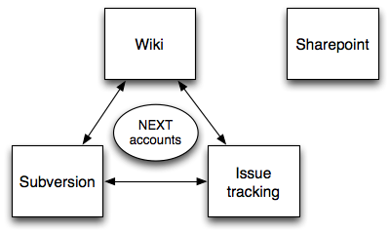
.

References

S. Bankes et al., META Adaptive, Reflective, Robust Workflow (ARRoW), Final Report, Phase 1B (BAE Systems, 2011), http://www.darpa.mil/Our_Work/TTO/Programs/AVM/AVM_Meta_Final_Deliverables.aspx.

