Characterization of Charge and Discharge Regimes in Lithium-Ion Batteries
Paul R. Pukite

Introduction
Modeling with uncertainty quantification has application to such phenomena as oxidation, corrosion, thermal response, and particulate growth. These fall into the classes of phenomena governed substantially by diffusional processes. At its most fundamental, diffusion is a model of a random walk. Without a strong convection or advection term to guide the process (e.g. provided by an electric or gravitational field), the kinetic mechanism of a particle generates a random trajectory that is well understood based on statistical physics principles. The standard physics approach is to solve a master diffusion equation under transient conditions. This turns into a kernel solution that we can apply to an arbitrary forcing function, such as provided by an input material flux or thermal impulse. In the case of a rechargeable battery, such as Li+, the flux is charged ions under the influence of an electric field.

Dispersive Diffusion in Lithium-Ion Batteries
Modern rechargeable battery technology still relies on the principles of electro-chemistry and a reversible process, which hasn’t changed in fundamental terms since the first lead-acid battery came to market in the early 1900’s. What has changed is the combination of materials that make a low-cost, lightweight, and energy-efficient battery which will serve the needs of demanding applications such as electric and hybrid-electric vehicles (EV/HEV).
As energy efficient operation is dependent on the properties of the materials being combined, it is well understood that characterizing the materials is important to advancing the state-of-the-art (and in increasing EV acceptance).
Of vital importance is the characterization of diffusion in the electrode materials, as that is the rate-limiting factor in determining the absolute charging and discharging speed of the material-specific battery technology. Unfortunately, because of the competitive nature of battery producers, many of the characteristics are well-guarded and treated as trade secrets. For example, it is very rare to find diffusion coefficient characteristics on commercial battery specification sheets, even though this kind of information is vital for optimizing battery management schemes [1][2].
In comparison to the relatively simple diffusional mechanisms of silicon oxide, the engineered structure of well-designed battery cell presents a significant constraint to the diffusional behavior. In Figure 1 below we show a schematic of a single lithium-ion cell and the storage particles that charge and discharge. The disordered nature of the storage particles shown in the right figure is often described by what is referred to as a tortuosity measure [3] of local imperfections and inhomogeneities.
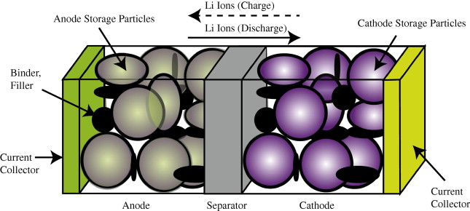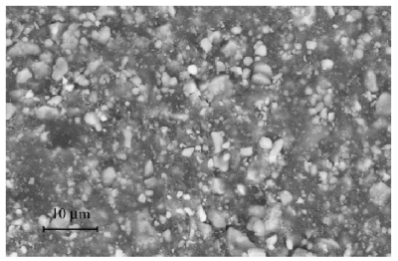
Figure 1: (Left) Exaggerated three-dimensional view of a lithium-ion battery cell and the direction of current flow during charging and discharging
(Right) Realistic view of the heavily disordered nature of the LiFePO₄ storage particles [4].
The constraints on the diffusion limit the scale to that of the radius of the storage particle. The length scale is limited essentially to the values L to L_{max} shown in Figure 2 below. The lithium -ion charge is spread throughout this particle and can only enter the electrolyte by diffusing outward from the inner region of this volume.
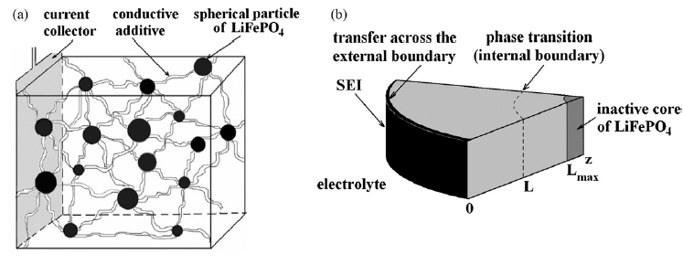
Figure 2: Diffusion of ions takes place through the radial shell of the LiFePO4 spherical particle [1]. During the discharge phase, the ions need to migrate outward through shell and through the SEI barrier before reaching the electrolyte. At this point they can contribute to current flow [4].
The size of the particles also varies as shown in Figure 3 below. The two Lithium-ion materials under consideration, LiFePO₄ and LiFeSO₄F, have different materials properties but are structurally very similar (matrixed particles of mixed size) so that we can use a common analysis approach. This essentially allows us to apply uncertainty in the diffusion coefficient and uncertainties in the particle size to establish a common diffusional behavior formulation.
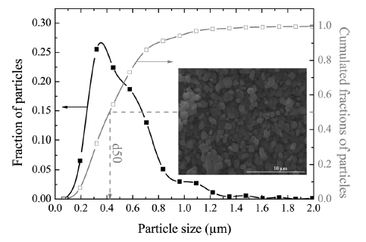
Figure 3: Particle size distribution of FeSO4F spherical granules [2]. The variation in lengths and material diffusivities opens the possibility of applying uncertainty quantification to a model of diffusive growth [5].
Dispersive Diffusion Analysis of Discharging: The diffusion of ions through the volume of a spherical particle does have similarity to classical regimes such as the diffusion of silicon through silicon dioxide. That process (as described elsewhere) leads to the familiar Fick's law of diffusion, whereby the growing layer of oxide follows a so-called parabolic growth law with a thickness proportional to $\sqrt{time}$.
In a similar formulation that we used earlier for oxide and corrosive growth, the model that we can use for Li+ diffusion derives from the classic solution to the Fokker-Planck equation of continuity (neglecting any field driven drift).
$$\frac{∂C(t,x)}{∂t}-D{∙∇}^{2}C\left(t,x\right)=0$$
Here C is the lithium -ion concentration and D is the spatial diffusion coefficient. Ignoring the spherical orientation of a particle, we can assume a solution along a radial one-dimensional outward axis, x:
$$C\left(t,x\right|D)= \frac{1}{\sqrt{4πDt}}e^{-x^{2}/4Dt}$$
This is a marginal probability which depends on the diffusion coefficient. Since we do not know the variance of the diffusivity, we can apply a maximum entropy distribution across D.
$$p\left(D\right)=\frac{1}{D_{0}}e^{-D/D_{0}}$$
This simplifies the representation to the following workable formulation.
$$C\left(t,x\right)=\frac{1}{2\sqrt{D_{0}t}}e^{-x/\sqrt{D_{0}t}}$$
We now have what is called a kernel solution (i.e. Green's function) that we can apply to specific sets of initial conditions and forcing functions, the latter solved via convolution.
Fully Charged Initial Conditions
Assume the spherical particle is uniformly distributed with a charge density C(0, x) at time t = 0.
Discharging Transient
For every point along the dimensions of the particle of size L, we calculate the time it takes to diffuse to the outer edge, where it can enter the electrolytic medium. This is simply an integral of the C(t, x) term for all points starting from x' = d to L, where d is the inner core radius from Figure 2.
$$C\left(t\right)= \int_{d}^{L}{C\left(t, L-x\right)dx}$$
This integrates straightforwardly to this concise representation:
$$C\left(t\right)=C_{0} \frac{1-e^{-(L-d)/\sqrt{D_{0}t}}}{L-d}$$
Note that this does not quite approximate the distribution of charge; in reality a spherical particle will have more matter closer to the surface than near the core, in proportion to r², but this is a starting point which can be more fully refined as needed (the integration is not difficult for a spherical representation, and the diffusion exponential is retained [6]).
The voltage of the cell is essentially the amount of charge available, so as this charge depletes, the voltage decreases proportionally.
We can test the model on two data sets corresponding to a LiFePO₄ cell [4] and a LiSO₄F cell [5]. In Figure 4 below, we show the model fit for LiFePO₄ as the red dotted line. This should be level-compared to the data designated by the solid black line labeled 1. The other curves labeled 2,3,4,5 are alternative diffusional model approximations applied by Churikov et al [4] that clearly do not work as well as the dispersive diffusion formulation derived above.
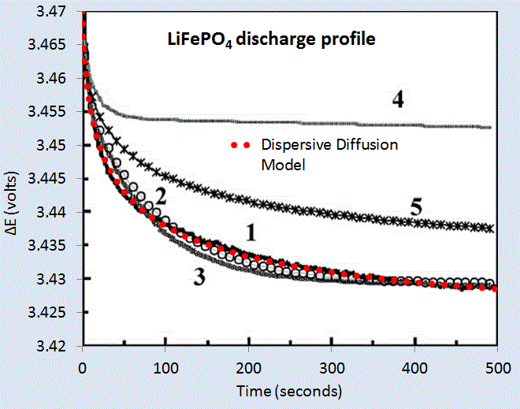
Figure 4: Discharge profile of LiFePO4 battery cell [4], with the red dotted line showing the parameterized dispersive diffusion model. The curves labeled 1 through 5 show alternative models that the authors applied to fit the data. Only the dispersive diffusion model duplicates the fast drop-off and long-time scale decline.
Figure 6 below shows the fit to voltage characteristics of a LiFeSO₄F cell, drawn as a red dotted line above the light gray data points. In this case the diffusional model by Delacourt [5]shown in solid black is well outside acceptable agreement.
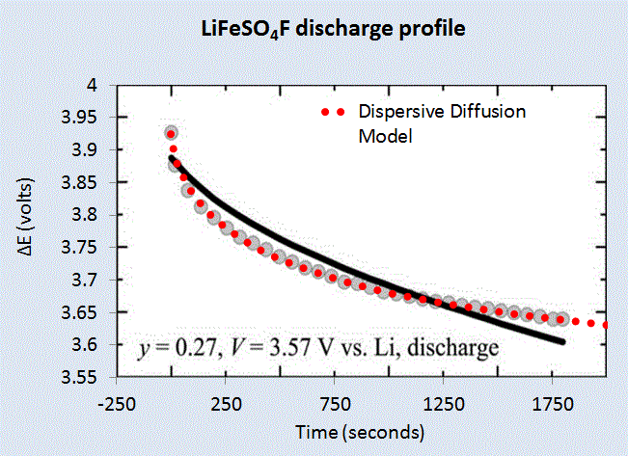
Figure 5: Discharge profile of LiFeSO4F battery cell [5], with the red dotted line showing the parameterized dispersive diffusion model. The black curve shows the model that the authors applied to fit the data.
Constant Current Discharge
Instead of assuming that the particle size is fixed at L, we can assume that the L is an average value and apply the same maximum-entropy as a spread in sizes. The PDF is now a damped exponential range of particle sizes, and we integrate the time it takes to traverse the size.
$$C\left(t\right)= \int_{0}^{∞}{C\left(t, x\right)\frac{1}{L}e^{-x/L}dx}$$
This integrates straightforwardly to this concise representation, similar to that used earlier to describe oxide and corrosive growth:
$$C\left(t\right)=C \frac{1}{L+\sqrt{D_{0}t}}$$
In addition to perhaps act as a better model of the disorder, the reason we do this is to allow us to recursively define the change in charge to a current. In this case, to get current we need to differentiate the charge with respect to time.
$$I\left(t\right)= \frac{dC(t)}{dt}$$
This differentiates to the following expression
$$I\left(t\right)= - \frac{C_{0}}{{(L+\sqrt{D_{0}t})}^{2}} \frac{1}{2\sqrt{t}}$$
But note that we can insert C(t) back in to the expression
$$I\left(t\right)= \frac{C(t)}{L+\sqrt{D_{0}t}} ∙\frac{1}{2\sqrt{t}}$$
Finally, since I(t) is a constant and we can set that to a value of I_{const}. Then the charge has the following profile:
$$C\left(t\right)= C\left(0\right)-k_{c} I_{const}∙\left(L+\sqrt{D_{0}t}\right)∙2\sqrt{t}$$
Or we can represent it as a voltage decline since stored charge is proportional to voltage:
$$V\left(t\right)= V\left(0\right)-k_{v} I_{const}∙\left(L+\sqrt{D_{0}t}\right)∙2\sqrt{t}$$
For a set of constant current values, we can compare this formulation against experimental data [7] for LiFePO₄ (shown as gray open circles) shown in Figure 6 below. A slight constant current offset (which may arise from unspecified shunting and/or series elements) was required to allow for the curves to align proportionally. Even with that, it is clear that the dispersive diffusion formulation works better than the conventional model (solid black lines) except where the discharge is nearing completion as it depletes the initial storage of charge.
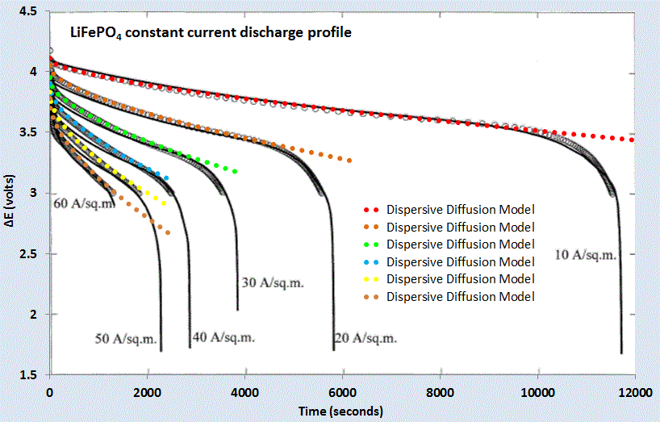
Figure 6: Constant current discharge profile [7]. Superimposed as dotted lines are the set of model fits which use the current value as a fixed parameter.
The question is why does this simple formulation work so well for these open circuit and constant current discharge profiles? As with many similar cases of characterizing disordered material (see e.g. dispersive transport in photovoltaic semiconductors), the fundamentally derived solution needs to be adjusted to take into account the uncertainty in the parameter space. However, this step is not routinely performed for battery models (see for example [8]) ; and adding modeling details to try to make up for a initially poor fit works only as a cosmetic heuristic. In contrast, by performing the uncertainty quantification on a simplified model, as done here by stochastically varying the diffusion coefficient and particle size, the first-order solution works surprisingly well with less need for the additional detail.
We can also model battery charging [9] but the lack of information on the charging profile makes the discharge behavior a simpler study, and one that demonstrates the application of dispersed diffusion and uncertainty quantification to a parametric model.

References

[1] “Hybrid and Electric Vehicle Engineering Academy.” SAE Course Material, 19-May-2013.
[2] M. Park, X. Zhang, M. Chung, G. B. Less, and A. M. Sastry, “A review of conduction phenomena in Li-ion batteries,” Journal of Power Sources, vol. 195, no. 24, pp. 7904–7929, Dec. 2010.
[3] D. Kehrwald, P. R. Shearing, N. P. Brandon, P. K. Sinha, and S. J. Harris, “Local tortuosity inhomogeneities in a lithium battery composite electrode,” Journal of The Electrochemical Society, vol. 158, no. 12, pp. A1393–A1399, 2011.
[4] A. Churikov, A. Ivanishchev, I. Ivanishcheva, V. Sycheva, N. Khasanova, and E. Antipov, “Determination of lithium diffusion coefficient in LiFePO< sub> 4 electrode by galvanostatic and potentiostatic intermittent titration techniques,” Electrochimica Acta, vol. 55, no. 8, pp. 2939–2950, 2010.
[5] C. Delacourt, M. Ati, and J. Tarascon, “Measurement of Lithium Diffusion Coefficient in Li y FeSO4F,” Journal of The Electrochemical Society, vol. 158, no. 6, pp. A741–A749, 2011.
[6] J. Crank, The mathematics of diffusion. Oxford university press, 1979.
[7] P. M. Gomadam, J. W. Weidner, R. A. Dougal, and R. E. White, “Mathematical modeling of lithium-ion and nickel battery systems,” Journal of Power Sources, vol. 110, no. 2, pp. 267–284, 2002.
[8] J. Christensen and J. Newman, “A mathematical model for the lithium-ion negative electrode solid electrolyte interphase,” Journal of The Electrochemical Society, vol. 151, no. 11, pp. A1977–A1988, 2004.
[9] Q. Wang, H. Li, X. Huang, and L. Chen, “Determination of chemical diffusion coefficient of lithium ion in graphitized mesocarbon microbeads with potential relaxation technique,” Journal of The Electrochemical Society, vol. 148, no. 7, pp. A737–A741, 2001.

