 | Dynamic Context Server
4/24/2013 | Integration Report
 | The Dynamic Context Server (DCS) is a semantic web application that provides ontologically-organized environmental modeling artifacts to users. The DCS can be hosted on a local personal computer or via a remotely served location. This report describes the steps needed to integrate the DCS within an Amazon Cloud environment.

Dynamic Context Server
Integrating the DCS on the cloud
The development version of the DCS resides on either a Windows or Linux personal computer. To make it accessible to either larger or more geographically dispersed design teams, the plan was to eventually host it on a site such as Vehicle Forge (http://VehicleForge.net). In practical terms, Vehicle Forge duplicates the available cloud-hosted platform such as Amazon Web Services (http://aws.amazon.com/) allowing us to generalize the installation to an all-purpose hosting platform. As we see no loss of capability, for this integration report we describe the steps needed to import and deploy the DCS on a typical AWS node.
The first step is to obtain a web services account, select an EC2 operating system image, and start an instance according to the most recent instructions. Note the IP address selected for you. Interactive tools such as the EC2 Management Console are available to check the health of the instance session (see Figure 1)
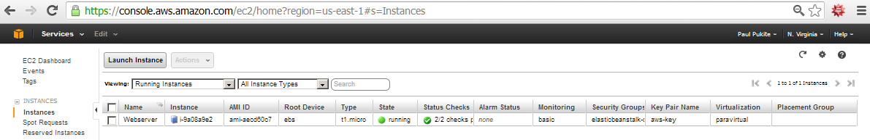
Figure 1: EC2 Management Console showing the named session
Once started, open a terminal session on your local computer, and login to the EC2 instance by using ssh or its equivalent:
local> ssh user_name@host_address

The code for the DCS is available from either the delivered compressed archive, or from a subversion repository located here
https://babelfish.arc.nasa.gov/trac/avm_performers/browser/context/
Preliminary to the installation, unpack the archives or checkout the source from the subversion account.
Prerequisites for the installation are described in Annex 3 (titled “Installation”) of Appendix D of the C2M2L final report. This includes a short list of necessary open source supporting packages (swipl, R, graphviz).
These support applications needed by DCS may or may not be available as part of the ECS instance. If something is not available, we use the yum package management software to install the requisite apps.
To execute the DCS application, we have a choice to run it as a background daemon or as a no-hang-up (nohup) job, which will remain operational when we log out of the session. Since the latter is very convenient, we have provided an example nohup script called nohup-run-cloud. If launched from the main context directory, this will handle all the startup parameters.
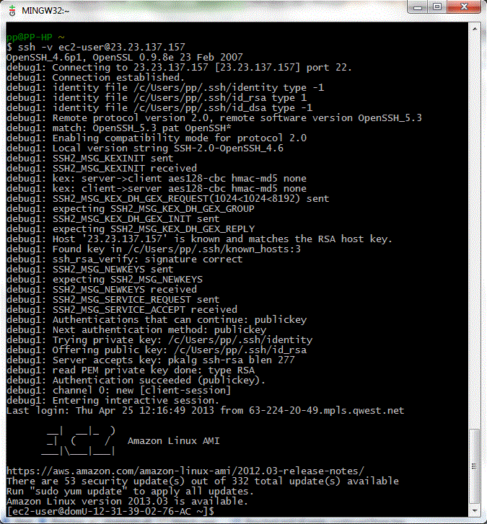
Figure 2: Logging into an AWS session using a terminal emulator and SSH.
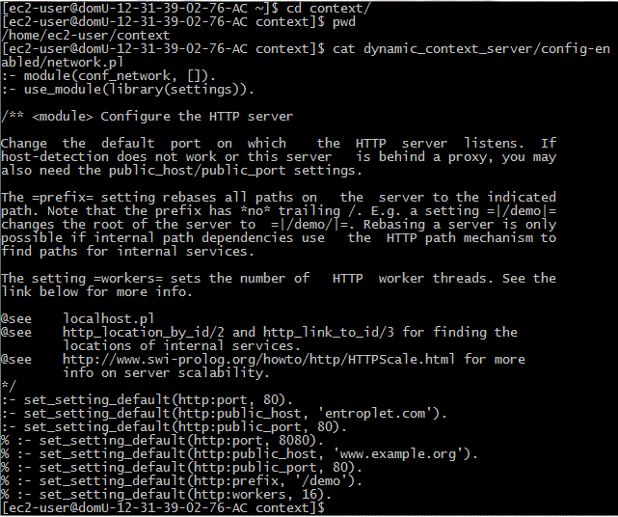
Figure 3 : The file network.pl is modified to use port 80 and a specific domain name.
The script is launched from the dynamic_context_server subdirectory (see Figure 4). As a convenience, we execute as root to get access to port 80. Other methods are available to acquire that port without assuming root privileges, which is recommended to increase security.
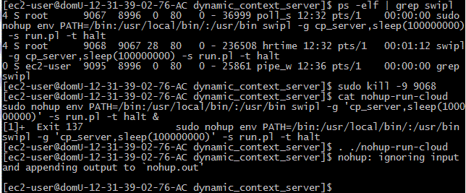
Figure 4 : To run a DCS application, we first terminate any existing apps identified by “swipl” and then launch the “nohup-run-cloud” script. The script is essentially a one-liner which will run the application in the background and save output to a log file.

To terminate a session, use the kill command on the launched process id (PID). Use the commands ps or top to identify the PID of the server. There are no mechanisms for restarting a DCS session, other than to terminate and relaunch via the script. Monitoring of the application output is available through tailing the nohup.out log file (see Figure 5).

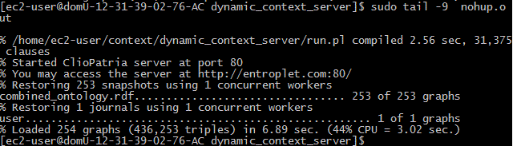
Figure 5 : The output of the log file can be monitored via “tail –f”.
Otherwise, it is safe to log out from the EC2 session at this point and the app will continue to execute.

To verify a successful integration, navigate to the IP address of the AWS EC2 instance using a Firefox, Chrome, or recent Internet Explorer browser (see Figure 6).
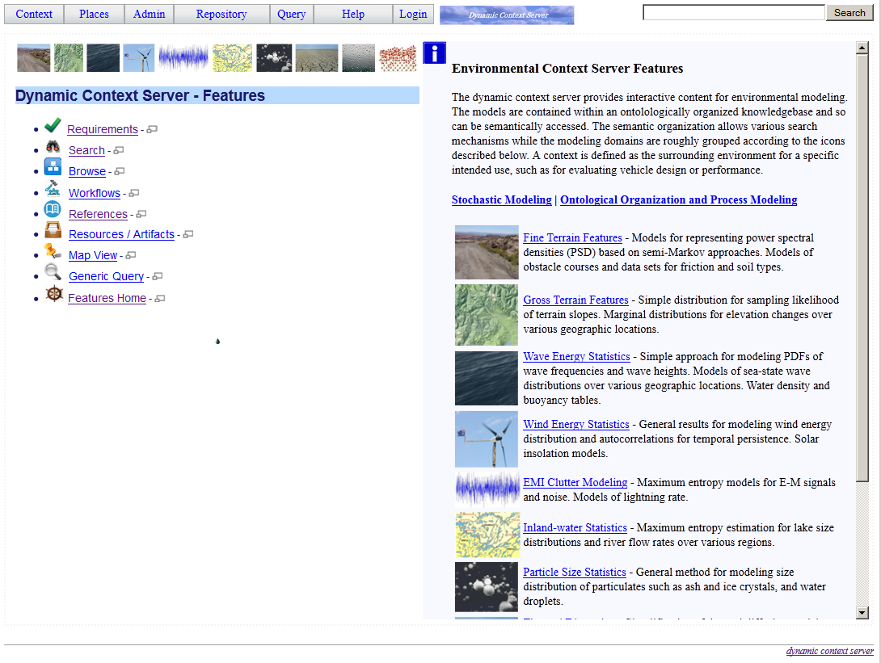
Figure 6: Home screen of the Dynamic Context server
As delivered, the default DCS administrative user name is pp, and password pukite. This is required to load the repository context data, via the menu command shown in Figure 7.
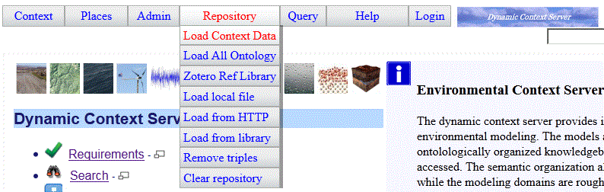
Figure 7 : As a one-time step, the semantic context data needs to be loaded administratively. This will normally take a few seconds at most. Regular users can not access the repository functionality.
The EC2 platform features support such as fail-over whereby a session will automatically restart should it terminate unexpectedly.
That concludes a description of the steps needed to integrate the Dynamic Context Server onto a cloud-based Amazon EC2 platform. Users can then access the DCS by navigating to the chosen IP.

