SIMATS ENGINEERING
ASSESSMENT TOOL 2
COURSE NAME: Artificial Intelligence COURSE CODE: CSA17
COURSE OUTCOME COVERED
CO5: Design AI-based systems using PySpark, RDD operations, and intelligent agent architectures, using scalable systems and integrate components in distributed AI applications. (BTL 5)
Assessment Tool Weightage: 50%
QUESTIONS: 5 Duration: 1 Hour Total Marks: 50
Annexure A
Technical Presentation

Code of Conduct:
I P. Dinesh Karthik (Reg No: 192525268) certify that this submission is my original work and that I have adhered to the guidelines specified for this assessment.
I understand that any violation of academic integrity rules will result in disciplinary action.
Signature of the student: P. Dinesh Karthik

Technical Presentation — Content

.
5. Multi-Agent System for Disaster Management



1. Introduction
A Multi-Agent System (MAS) for disaster management uses multiple specialized, autonomous agents that collaborate to detect disasters and coordinate an effective response, rather than relying on a single centralized decision-maker. Each agent has a distinct role and they communicate to reach a shared, accurate understanding of the situation.
The main objective is early, reliable disaster detection and fast, well-coordinated emergency response across multiple regions.
2. What is a Multi-Agent System?
A multi-agent system consists of several agents that:
- Operate autonomously, each responsible for a specific task or data source.
- Communicate and share information with other agents.
- Coordinate their actions to achieve a shared goal that no single agent could achieve alone.
- Can operate in parallel across many regions, improving scalability and response speed.
3. Agent Roles
- Sensor Agents: Monitor seismic sensors, flood-level sensors, weather stations, and satellite feeds; report raw readings and local anomaly scores.
- Communication Agents: Relay data between sensor agents, decision agents, and response units; ensure synchronized, low-latency information sharing across the network.
- Decision Agents: Fuse data from multiple sensor agents, apply consensus checks to rule out false alarms, and decide when/where to issue an alert.
- Response-Coordination Agents (optional extension): Assign response resources (emergency teams, evacuation routes) once a decision agent confirms an event.
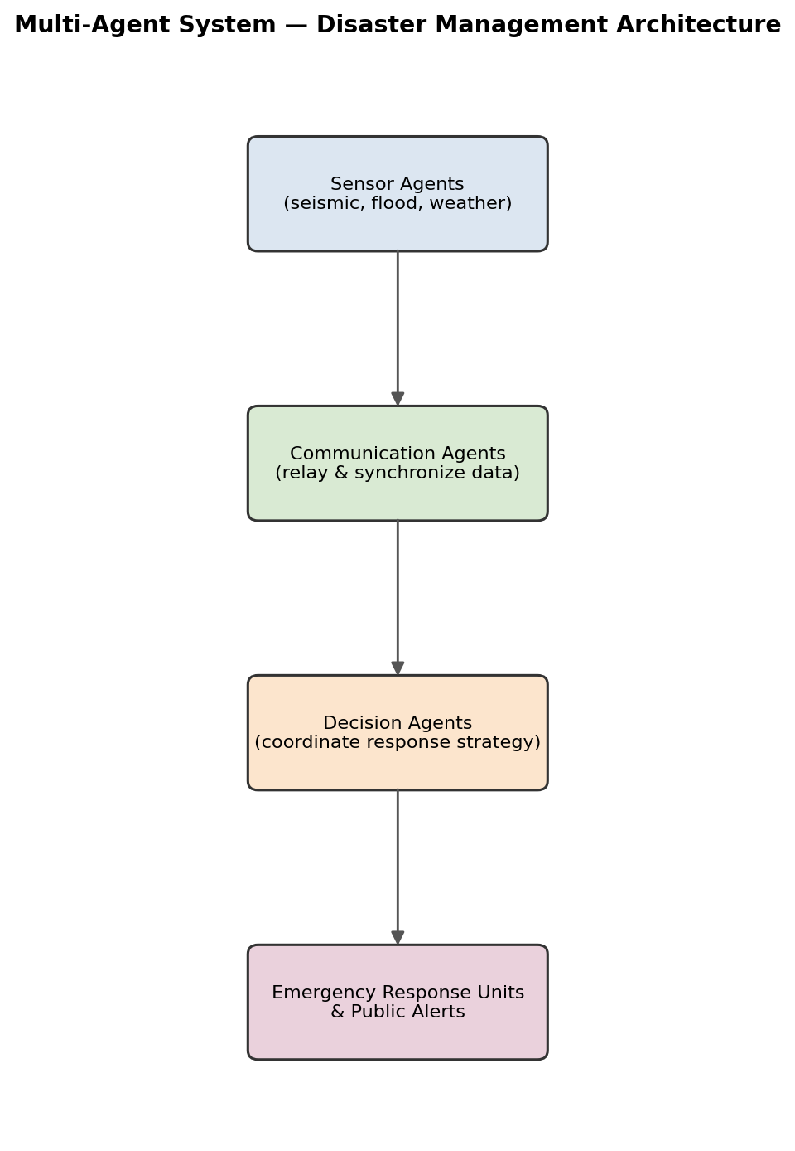
Figure 5.1 — Multi-agent system architecture for disaster detection and response.
4. Coordination Strategies
- Consensus-Based Coordination: A decision agent only raises an alert after multiple sensor agents (or neighboring regions) corroborate the same anomaly, reducing false positives from a single faulty sensor.
- Publish-Subscribe Communication: Sensor agents publish readings to a shared channel; communication agents route relevant updates to the decision agents subscribed to that region.
- Hierarchical Coordination: Local decision agents handle region-level decisions, escalating to a higher-level coordination agent only when the event affects multiple regions.
5. Sample Coordination Table
Agent | Role | Example Action
Sensor Agent (Region R-014) | Monitor river water level | Reports rising level, local anomaly score 0.86
Communication Agent | Relay&synchronize | Forwards R-014 reading + neighboring region data to Decision Agent
Decision Agent | Fuse&confirm | Confirms flood risk after cross-checking 3 sensor agents; issues alert
Response Agent | Coordinate response | Dispatches evacuation notice and emergency teams to R-014

6. Data Sharing&Real-Time Decision-Making
Agents exchange time-stamped, region-tagged messages over the communication network so that decision agents always fuse data from the same time window. A distributed streaming pipeline (e.g., PySpark Structured Streaming) processes incoming sensor-agent messages in micro-batches, allowing decision agents to reach a confirmed alert decision within seconds of a real anomaly appearing across multiple sources.
7. Advantages
- Scalable — new regions can be added by deploying more sensor/decision agents without redesigning the whole system.
- Robust — consensus-based coordination reduces false alarms and tolerates individual agent/sensor failures.
- Faster response — parallel, localized decision-making avoids the bottleneck of a single central controller.
8. Limitations
- Requires reliable, low-latency communication between agents; network failure can delay coordination.
- Coordinating many autonomous agents adds design complexity compared to a single centralized system.
9. Conclusion
By dividing responsibility across specialized sensor, communication, and decision agents that coordinate through consensus and shared data, the multi-agent system achieves faster, more reliable disaster detection and response than any single agent could provide alone.

