SIMATS ENGINEERING
ASSESSMENT TOOL 3
COURSE NAME: Artificial Intelligence
COURSE CODE: CSA17
COURSE OUTCOME COVERED
CO5: Design AI-based systems using PySpark, RDD operations, and intelligent agent architectures, using scalable systems and integrate components in distributed AI applications. (BTL 5)
Assessment Tool Weightage: 20%
Duration: 1 Hour
Questions: 5
Total Marks: 50
Annexure A
Reverse Engineering
Code of Conduct
I P. Dinesh Karthik (Reg. No: 192525268) certify that this submission is my original work and that I have adhered to the guidelines specified for this assessment.
I understand that any violation of academic integrity rules will result in disciplinary action.
Signature of the student: P. Dinesh Karthik
Name / Reg. No.: P. Dinesh Karthik / 192525268

Question 1: Reverse Engineering a Recommendation System
Marks: 10

Problem Statement
A large-scale e-commerce platform provides highly accurate product recommendations using real-time data. The task is to analyze the system from the outside (its observable behaviour and outputs) and reverse engineer its likely internal architecture using PySpark and RDD operations, identifying how data is collected, processed and transformed, and inferring the role of intelligent agents in dynamically updating recommendations.

1. Observed Behaviour (Black-Box Analysis)
- Real-time responsiveness: Recommendations change within seconds of a user viewing, clicking, or purchasing a product.
- Hybrid signal: Recommendations combine 'similar users bought' and 'similar items to this one' patterns.
- Fallback logic: Cold-start users still receive reasonable recommendations based on trending/category data.
- Online learning: Recommendation quality improves gradually as more interaction data accumulates for a session.

2. Reverse-Engineered Architecture
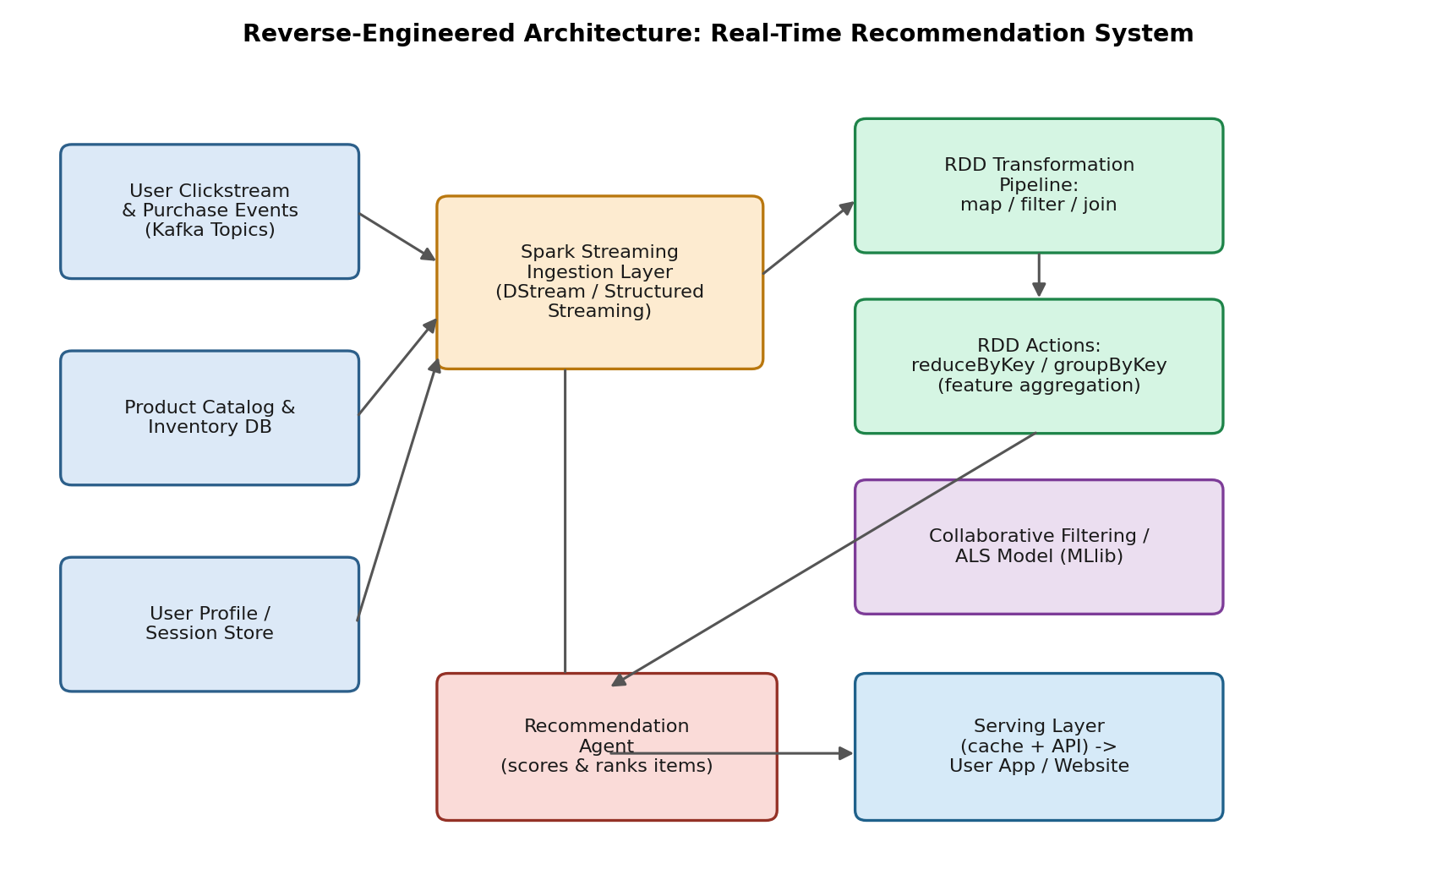
Figure 1.1: Inferred distributed architecture of the recommendation engine.

3. Data Pipeline: Collection, Processing and Transformation
Pipeline Stage | PySpark / RDD Operation | Purpose / Inference
Data Collection | Kafka producers stream clickstream, add-to-cart and purchase events into topics consumed by Spark Structured Streaming. | Captures user behaviour with millisecond-level freshness.
RDD Ingestion | sc.textFile() / streaming DStream converted into RDDs of (userId, itemId, eventType, timestamp). | Provides fault-tolerant, distributed in-memory representation of raw events.
Transformation - map() | events.map(lambda e: (e.userId, (e.itemId, weight(e.eventType)))) | Converts raw events into weighted (user, item) interaction pairs.
Transformation - filter() | interactions.filter(lambda x: x[1][1] > threshold) | Removes noisy or low-signal events (e.g., accidental clicks).
Transformation - join() | interactions.join(catalogRDD) | Enriches interactions with product metadata (category, price, stock).
Action - reduceByKey() | userItemRDD.reduceByKey(lambda a,b: a+b) | Aggregates interaction strength per (user, item) to build an implicit rating matrix.
Action - groupByKey() | ratings.groupByKey() | Groups interactions per user to feed the collaborative-filtering model.
Model Training | ALS.train(ratingsRDD, rank, iterations) (Spark MLlib) | Learns latent user/item factors for collaborative filtering, retrained on a rolling window.

4. Illustrative PySpark Snippet
events_rdd = stream_rdd.map(lambda e: (e['userId'], (e['itemId'], weight(e['eventType']))))
filtered = events_rdd.filter(lambda x: x[1][1] > 0.3)
enriched = filtered.join(catalog_rdd)
agg = enriched.map(lambda x: (x[0], x[1])).reduceByKey(combine_scores)
top_n = agg.groupByKey().mapValues(lambda scores: sorted(scores, reverse=True)[:10])

5. Role of Intelligent Agents
- Recommendation Agent: Continuously listens to the RDD action outputs (reduceByKey aggregates) and re-ranks the candidate list for the active session in near real time.
- Cold-Start Agent: Detects a lack of history for a user/session and swaps in trending or category-popular items computed from a separate RDD aggregation.
- Feedback / Learning Agent: Monitors click-through on served recommendations and feeds implicit reward signals back into the ALS retraining cycle, closing the feedback loop.

6. Why This Design Fits the Constraints
RDD-based processing gives the pipeline in-memory speed and automatic lineage-based fault recovery, which is essential when millions of events per minute must be aggregated without data loss. The multi-agent layer separates concerns — ranking, cold-start handling and feedback — so each concern can scale and fail independently, which matches the platform's observed resilience and near-instant personalization.

Question 2: Reverse Engineering a Smart Traffic Management System
Marks: 10

Problem Statement
A city-wide traffic system adapts signals in real time based on vehicle density and congestion patterns. The task is to reverse engineer the underlying AI system by describing the data pipeline using RDD-based streaming, identifying agent interactions, and explaining how decisions are made under strict time constraints.

1. Observed Behaviour (Black-Box Analysis)
- Real-time adaptation: Signal timings shift within a few seconds of a sudden increase in vehicle density at a junction.
- Coordinated response: Congestion at one junction visibly influences the green-light duration at neighbouring junctions a few minutes later.
- Fault tolerance: The system continues operating (in a degraded mode) even when a subset of sensors goes offline.

2. Reverse-Engineered Architecture
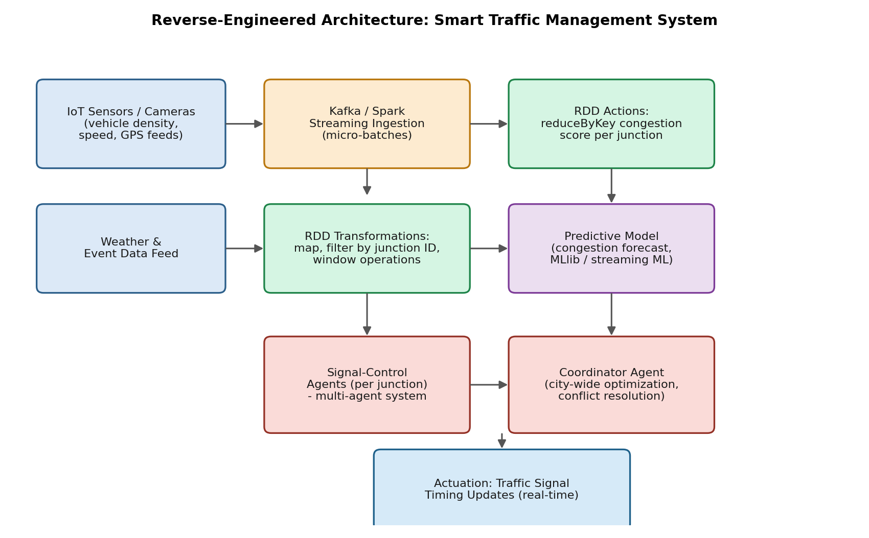
Figure 2.1: Inferred multi-agent, RDD-streaming architecture for adaptive traffic control.

3. RDD-Based Streaming Data Pipeline
Pipeline Stage | PySpark / RDD Operation | Purpose / Inference
Ingestion | IoT camera/loop-sensor feeds pushed into Spark Streaming as micro-batch RDDs every 1-5 seconds. | Keeps the state of every junction fresh within a bounded latency window.
map() | sensorRDD.map(lambda s: (s.junctionId, s.vehicleCount)) | Associates each raw reading with its junction for downstream aggregation.
filter() | readings.filter(lambda x: x[1] >= 0) | Discards malformed or sensor-fault readings.
window() / DStream window | streamingRDD.window(windowLength=30s, slideInterval=5s) | Smooths bursty readings into a rolling congestion estimate.
reduceByKey() | windowed.reduceByKey(lambda a,b: a+b) | Computes a per-junction congestion score for the current window.
Broadcast variables | sc.broadcast(signal_plan) | Efficiently shares the current city-wide signal plan to every worker node.

4. Illustrative PySpark Snippet
readings = sensor_stream.map(lambda s: (s['junctionId'], s['vehicleCount']))
clean = readings.filter(lambda x: x[1] >= 0)
windowed = clean.window(30, 5)
congestion = windowed.reduceByKey(lambda a, b: a + b)
congestion.foreachRDD(lambda rdd: dispatch_to_agents(rdd.collect()))

5. Agent Interactions and Decision-Making Under Time Constraints
- Signal-Control Agents: One lightweight agent per junction consumes the local congestion score and adjusts green-light duration within a bounded decision loop (typically under one second) so the signal never stalls waiting on a network round-trip.
- Coordinator Agent: Aggregates scores across junctions and resolves conflicts (e.g., two adjacent junctions both requesting extended green in the same direction), applying city-wide optimization rules such as 'green wave' corridors.
- Time-Bounded Fallback: Local agents act on the latest cached congestion score if the coordinator is unreachable, guaranteeing bounded worst-case latency and graceful degradation.

6. Why This Design Fits the Constraints
A sliding-window RDD pipeline bounds memory use while still reacting within seconds, and RDD lineage lets Spark recompute lost partitions instead of stalling on hardware failure — matching the observed resilience. Splitting control into local, fast-acting agents plus a slower coordinating agent lets the system meet hard real-time deadlines at the junction level while still achieving city-wide optimization over a longer horizon.

Question 3: Reverse Engineering a Fraud Detection Pipeline
Marks: 10

Problem Statement
A banking system flags fraudulent transactions within milliseconds. By observing its outputs and behaviour, the task is to reconstruct the distributed AI pipeline using PySpark RDDs and to explain how feature extraction, anomaly detection, and agent-based alert mechanisms are likely implemented.

1. Observed Behaviour (Black-Box Analysis)
- Ultra-low latency decisioning: A transaction is approved, held for verification, or blocked before the payment terminal times out (well under one second).
- Personalized risk baseline: A transaction that is unusual for a specific customer (e.g., a large purchase in a new country) is flagged even though it may be normal in aggregate.
- Human-in-the-loop: Flagged cases are escalated to a human analyst dashboard rather than always being auto-blocked.

2. Reverse-Engineered Architecture
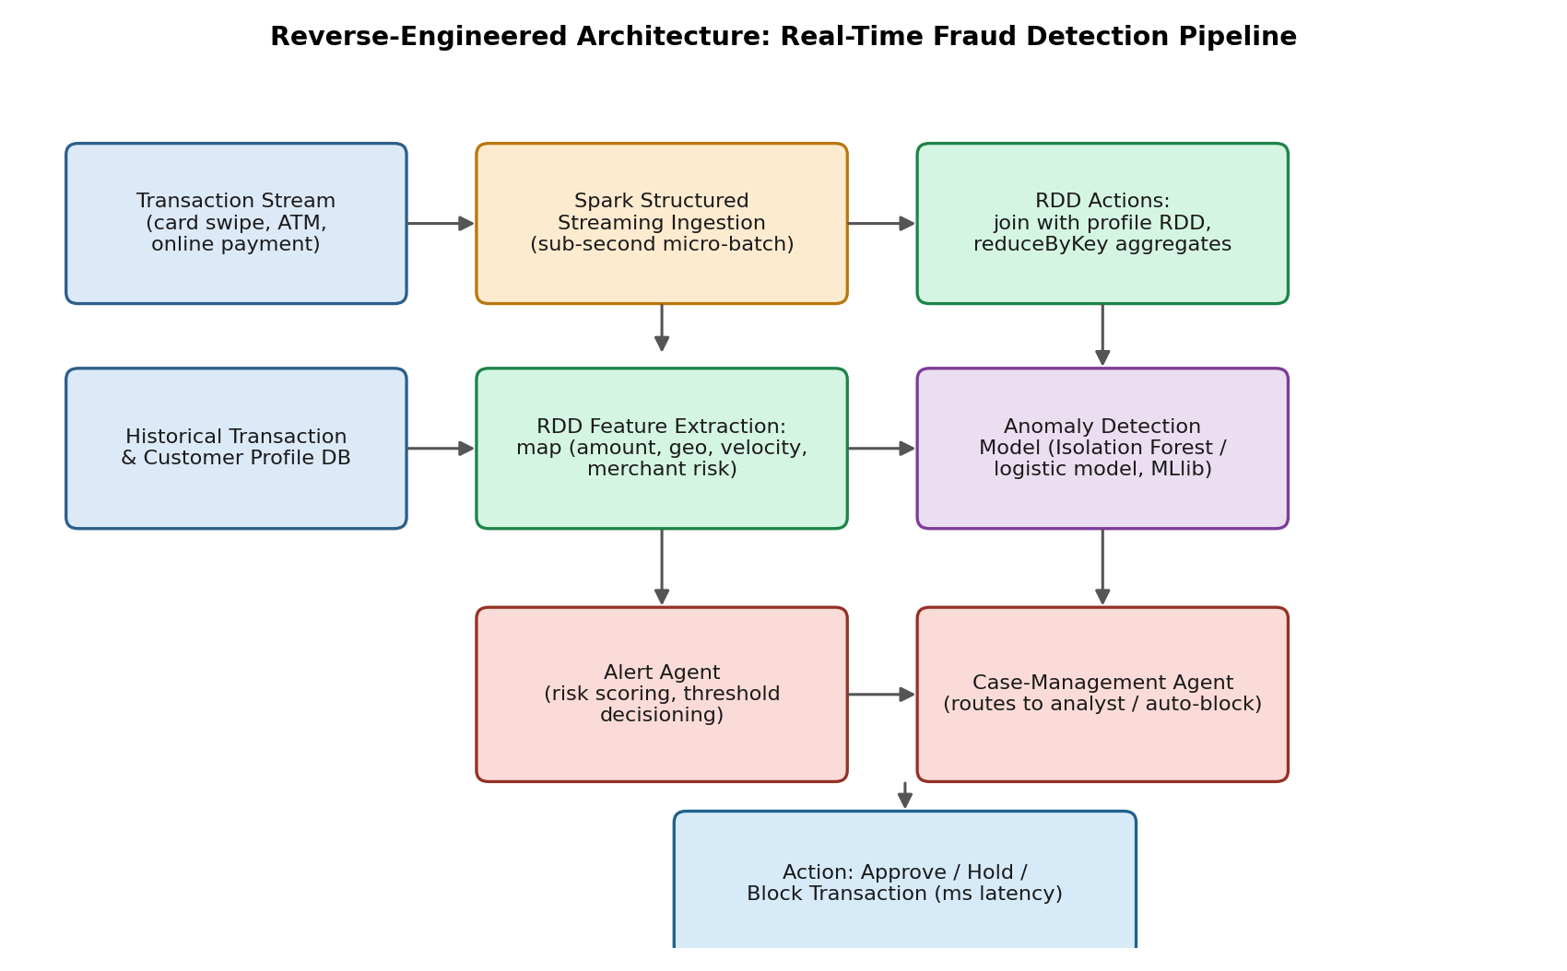
Figure 3.1: Inferred distributed fraud-detection pipeline.

3. Feature Extraction and Processing via RDDs
Pipeline Stage | PySpark / RDD Operation | Purpose / Inference
Ingestion | Each card-swipe / online-payment event streamed as a micro-batch RDD of raw transaction records. | Sub-second exposure of new transactions to the pipeline.
map() - feature extraction | txRDD.map(lambda t: (t.txId, extract_features(t))) | Derives features: amount, merchant category, geo-distance from last transaction, transaction velocity.
join() | features.join(customerProfileRDD) | Attaches the customer's historical spending baseline for personalized comparison.
reduceByKey() | velocity = txRDD.map(lambda t:(t.cardId,1)).reduceByKey(add) | Computes transaction velocity per card over a short time window (a classic fraud signal).
Broadcast join | sc.broadcast(blacklist_merchants) | Cheaply checks every transaction against a known-bad-merchant list without shuffling data.
Model scoring | model.predict(featureRDD) using an Isolation Forest / logistic model in MLlib. | Produces a real-time anomaly / risk score per transaction.

4. Illustrative PySpark Snippet
features = tx_rdd.map(lambda t: (t['txId'], extract_features(t)))
enriched = features.join(profile_rdd)
velocity = tx_rdd.map(lambda t: (t['cardId'], 1)).reduceByKey(lambda a,b: a+b)
scored = enriched.mapValues(lambda f: model.predict(f))
alerts = scored.filter(lambda x: x[1] > RISK_THRESHOLD)

5. Agent-Based Alert Mechanisms
- Alert / Risk-Scoring Agent: Converts the anomaly score into a decision (approve / step-up authentication / block) using per-customer thresholds derived from their historical baseline.
- Case-Management Agent: Receives high-risk cases, packages supporting evidence (features, similar past cases) and routes them either to auto-block rules or to a human analyst queue.
- Feedback Agent: Learns from analyst decisions (confirmed fraud vs. false positive) and feeds this back to periodically retrain the anomaly model.

6. Why This Design Fits the Constraints
In-memory RDD transformations avoid disk I/O, and broadcast variables avoid expensive shuffles for lookups such as merchant blacklists — both are necessary to stay within a millisecond decision budget. Separating scoring (fast, automated) from case management (slower, human-involved) explains the observed behaviour where only some flags result in an instant block while others are queued for review.

Question 4: Reverse Engineering a Personalized Learning System
Marks: 10

Problem Statement
An online learning platform adapts content difficulty based on student performance and engagement. The task is to reverse engineer the system design by identifying how learner data is processed using RDD transformations, and to explain how intelligent agents contribute to adaptive learning and feedback mechanisms.

1. Observed Behaviour (Black-Box Analysis)
- Adaptive difficulty: Question difficulty increases after a streak of correct answers and decreases after repeated mistakes, within the same session.
- Engagement-aware intervention: Hints and worked examples appear when a learner spends unusually long on one question.
- Multi-signal personalization: Two learners with identical scores can be routed to different next modules based on differing time-on-task and hint usage.

2. Reverse-Engineered Architecture
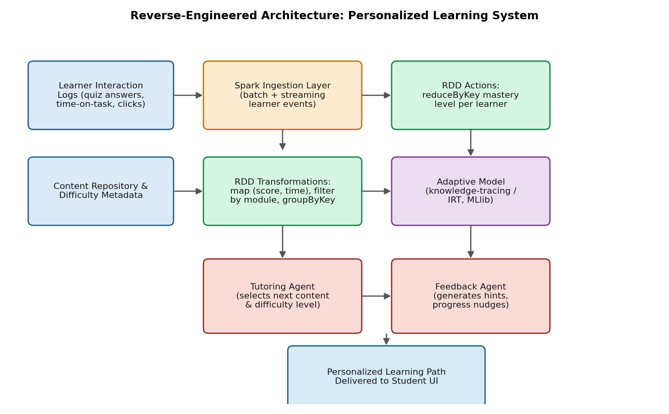
Figure 4.1: Inferred RDD-based pipeline for adaptive learning.

3. RDD-Based Processing of Learner Data
Pipeline Stage | PySpark / RDD Operation | Purpose / Inference
Ingestion | Clickstream of quiz submissions, time-on-task and video interactions streamed into batch/streaming RDDs. | Captures both performance and engagement signals, not just correctness.
map() | eventsRDD.map(lambda e: (e.studentId, (e.moduleId, e.score, e.timeSpent))) | Structures raw events into per-student learning records.
filter() | records.filter(lambda x: x[1][1] is not None) | Removes incomplete or abandoned attempts before analysis.
groupByKey() | records.groupByKey() | Groups all attempts per student to compute a mastery trajectory.
reduceByKey() | moduleScores.reduceByKey(lambda a,b: combine(a,b)) | Aggregates a rolling mastery estimate per (student, topic).
Model scoring | Knowledge-tracing / Item-Response-Theory model (MLlib or custom) run over the aggregated RDD. | Predicts the probability a student will answer the next-level question correctly.

4. Illustrative PySpark Snippet
records = events_rdd.map(lambda e: (e['studentId'], (e['moduleId'], e['score'], e['timeSpent'])))
clean = records.filter(lambda x: x[1][1] is not None)
grouped = clean.groupByKey()
mastery = grouped.mapValues(lambda attempts: knowledge_trace(list(attempts)))
next_item = mastery.mapValues(lambda m: select_next_difficulty(m))

5. Role of Intelligent Agents
- Tutoring Agent: Reads the mastery estimate from the RDD pipeline and selects the next question's difficulty and topic in real time.
- Feedback / Engagement Agent: Watches time-on-task and hint requests to decide when to intervene with a hint, worked example, or encouragement message.
- Content-Calibration Agent: Aggregates outcomes across many students to periodically recalibrate item difficulty ratings used by the Tutoring Agent.

6. Why This Design Fits the Constraints
RDD grouping and reduction let the platform maintain a per-student mastery state that updates incrementally rather than recomputing from scratch, which is why difficulty visibly adapts within a single session. Splitting tutoring (content selection) from feedback (engagement intervention) explains why two learners with the same score can receive different next steps — the two agents act on different, only partially overlapping, signals.

Question 5: Reverse Engineering a Cloud-Based AI Monitoring System
Marks: 10

Problem Statement
A cloud platform automatically scales resources and detects system anomalies in real time. The task is to reverse engineer the architecture by analyzing how PySpark processes large-scale logs, how RDD operations support fault tolerance, and how intelligent agents coordinate monitoring, scaling, and anomaly response.

1. Observed Behaviour (Black-Box Analysis)
- Elastic auto-scaling: Additional compute instances appear within seconds to a minute of a sustained traffic spike, and are released once load subsides.
- Fault-tolerant pipeline: The monitoring dashboard continues reporting metrics even when individual log-collector nodes fail.
- Context-aware anomaly detection: Alerts distinguish between a genuine anomaly (unusual error-rate spike) and an expected pattern (scheduled batch job load).

2. Reverse-Engineered Architecture
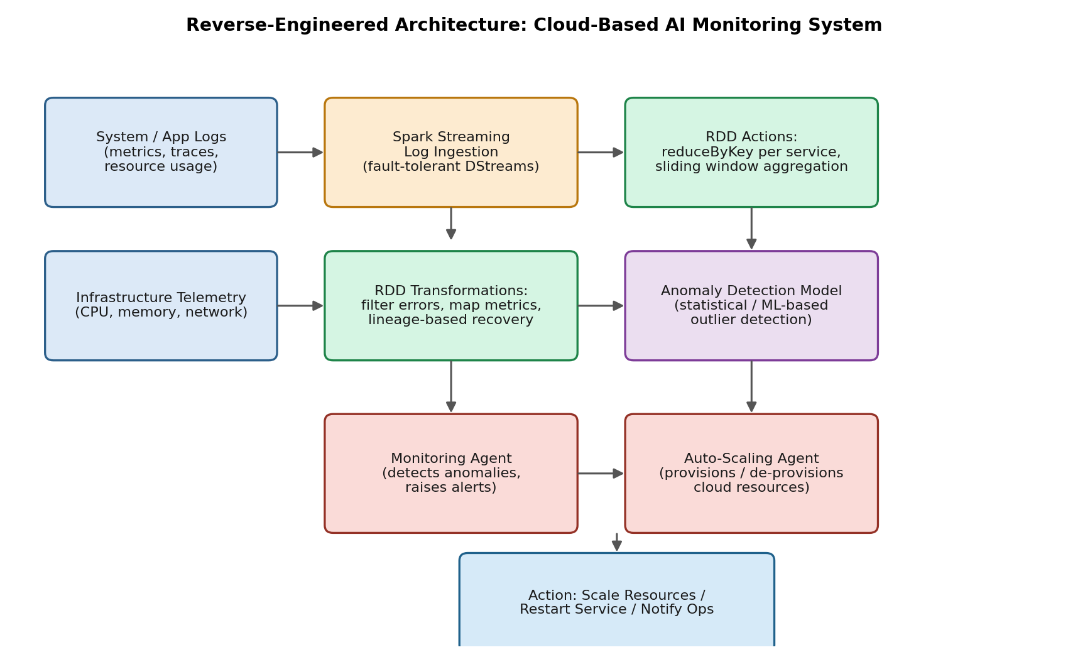
Figure 5.1: Inferred fault-tolerant, agent-coordinated cloud monitoring architecture.

3. PySpark Log Processing and RDD-Based Fault Tolerance
Pipeline Stage | PySpark / RDD Operation | Purpose / Inference
Ingestion | Application and infrastructure logs streamed from every node into Spark Streaming as DStream micro-batch RDDs. | Handles very high log volume across thousands of nodes with horizontal scalability.
filter() | logsRDD.filter(lambda l: l.level in ('ERROR','WARN')) | Reduces volume early by discarding routine INFO-level noise.
map() | errors.map(lambda l: (l.service, parse_metric(l))) | Extracts structured metrics (latency, error type) keyed by service.
reduceByKey() / window() | errors.reduceByKey(lambda a,b: a+b) over a sliding window | Produces a per-service error-rate trend used for anomaly comparison.
RDD Lineage / re-computation | Spark automatically recomputes lost partitions from lineage instead of replaying from disk. | This is the core fault-tolerance mechanism: no checkpoint-and-restart delay, so monitoring keeps flowing when a node fails.
Checkpointing | streamingContext.checkpoint(dir) for stateful sliding-window aggregates. | Bounds lineage length for long-running streaming jobs and speeds recovery further.

4. Illustrative PySpark Snippet
errors = log_rdd.filter(lambda l: l['level'] in ('ERROR', 'WARN'))
metrics = errors.map(lambda l: (l['service'], parse_metric(l)))
rates = metrics.reduceByKey(lambda a, b: a + b)
anomalies = rates.filter(lambda x: is_anomalous(x[1]))
anomalies.foreachRDD(lambda rdd: notify_agents(rdd.collect()))

5. How Intelligent Agents Coordinate Monitoring, Scaling and Response
- Monitoring Agent: Continuously compares the RDD-derived error/latency trend against a learned baseline and raises an anomaly event when the deviation is statistically significant.
- Auto-Scaling Agent: Consumes resource-utilization aggregates and issues scale-out / scale-in commands to the cloud orchestrator (e.g., Kubernetes) ahead of saturation.
- Coordination / Context Agent: Cross-references anomaly alerts with the scaling agent's recent actions and scheduled-job calendar to suppress false alarms caused by expected load.

6. Why This Design Fits the Constraints
RDD lineage-based recovery is exactly what allows the dashboard to keep reporting metrics through node failures, since Spark rebuilds lost partitions from their transformation history rather than needing a full replay. Separating monitoring, scaling and context-correlation into distinct agents explains the observed ability to tell a genuine anomaly apart from expected load: each agent contributes one signal, and the coordination agent resolves them jointly before an alert or scaling action is taken.

Rubrics for Calculation
Criteria | Weight | How This Submission Meets It
Understanding of Industry Problem | 20% | Each question opens with a problem statement that frames the real-world system, its scale, and its operating constraints (latency, accuracy, throughput) before any technical design is proposed.
Application of Engineering Concepts | 25% | PySpark, RDD transformations/actions, distributed processing, and multi-agent architectures are applied consistently and correctly across all five systems.
Solution Design | 25% | Each reverse-engineered architecture is presented as an end-to-end pipeline (ingestion -> transformation -> intelligence -> agent action -> output) that is feasible and aligned with real industry practice.
Use of Tools | 15% | Concrete PySpark/RDD operations (map, filter, reduceByKey, groupByKey, join) and MLlib components are named and mapped to specific pipeline stages, with illustrative code snippets.
Analysis | 10% | Each answer explains why a design choice would be used (fault tolerance, in-memory lineage, dynamic scaling) rather than only describing what it does.
Professionalism | 5% | Structured with headings, diagrams, tables, and consistent formatting suitable for formal academic submission.

