Q1:

**Question 1**

The following is a list of 10 students ages:

ages = [19, 22, 19, 24, 20, 25, 26, 24, 25, 24]

• Sort the list and find the min and max age

• Add the min age and the max age again to the list

• Find the median age (one middle item or two middle items divided by two)

• Find the average age (sum of all items divided by their number)

• Find the range of the ages (max minus min)

import statistics

ages = [19, 22, 19, 24, 20, 25, 26, 24, 25, 24]

L1 = sorted(ages)

#1 sorting the given list and storing into a new list and displaying minimum and max age

print("Sorted list:",L1)

print("Min age =",sorted_ages_list[0],"Max age =",sorted_ages_list[-1])

min = L1[0]

max = L1[-1]

#2 adding min and max to the list

L1.append(min)

L1.append(max)

length = len(sorted_ages_list)

print("After appending the elements: ",sorted_ages_list)

#Finding the median

print('median =',statistics.median(ages))

print('mean =',statistics.mean(ages))

#finding the sum

length = len(sorted_ages_list)

sum = 0

for i in L1:

sum += i

# finding the average

average = sum/length

print("Average :",average)

# finding the range

Range = sorted_ages_list[-1] - sorted_ages_list[0]

print("Range :",Range)

output:

Sorted list: [19, 19, 20, 22, 24, 24, 24, 25, 25, 26]

Min age = 19 Max age = 26

After appending the elements: [19, 19, 20, 22, 24, 24, 24, 25, 25, 26, 19, 26]

median = 24.0

mean = 22.8

Average : 60.25

Range : 7

**Question 2:**

• Create an empty dictionary called dog

• Add name, color, breed, legs, age to the dog dictionary

• Create a student dictionary and add first_name, last_name, gender, age, marital status, skills, country, city and address as keys for the dictionary

• Get the length of the student dictionary

• Get the value of skills and check the data type, it should be a list

• Modify the skills values by adding one or two skills

• Get the dictionary keys as a list

• Get the dictionary values as a list

Sourcecode:

# Question 2

# empty dictionary called dog

dog = {}

#Adding the keys name, color, breed, legs, age to the dog dictionary

dog = {"name":'Pug', "color":"grey", "breed":'pugs', "legs":4, "age":5}

print(dog)

#Create a student dictionary and add first_name, last_name, gender, age, marital status,skills, country, city and address as keys for the dictionary

student = {

"first_name":'Mahi',

"last_name":'Pulagam',

"gender":'Female',

"age":'22',

"marital status": 'Unmarried',

"skills":['Cooking','Dancing','reading books'],

"country":'United states',

"city":'Overland park',

"address":'8112w,pointroyale'

}

#length of the student dictionary

print("\nThe length of Student dictionary is : ",len(student))

#value of skills and check the data type

print("\nType :",type(student['skills']))

#Modify the skills values by adding one or two skills

student['skills'].append("team lead")

print("\nThe skills are adding an extra skill:",student['skills'])

#Get the dictionary keys as a list

print("\nThe keys in student dictionary :",student.keys())

#Get the dictionary values as a list

print("\nThe values in student dictionary :",student.values())

output:

{'name': 'Pug', 'color': 'grey', 'breed': 'pugs', 'legs': 4, 'age': 5}

The length of Student dictionary is : 9

Type : <class 'list'>

The skills are adding an extra skill: ['Cooking', 'Dancing', 'reading books', 'team lead']

The keys in student dictionary : dict_keys(['first_name', 'last_name', 'gender', 'age', 'marital status', 'skills', 'country', 'city', 'address'])

The values in student dictionary : dict_values(['Mahi', 'Pulagam', 'Female', '22', 'Unmarried', ['Cooking', 'Dancing', 'reading books', 'team lead'], 'United states', 'Overland park', '8112w,pointroyale'])

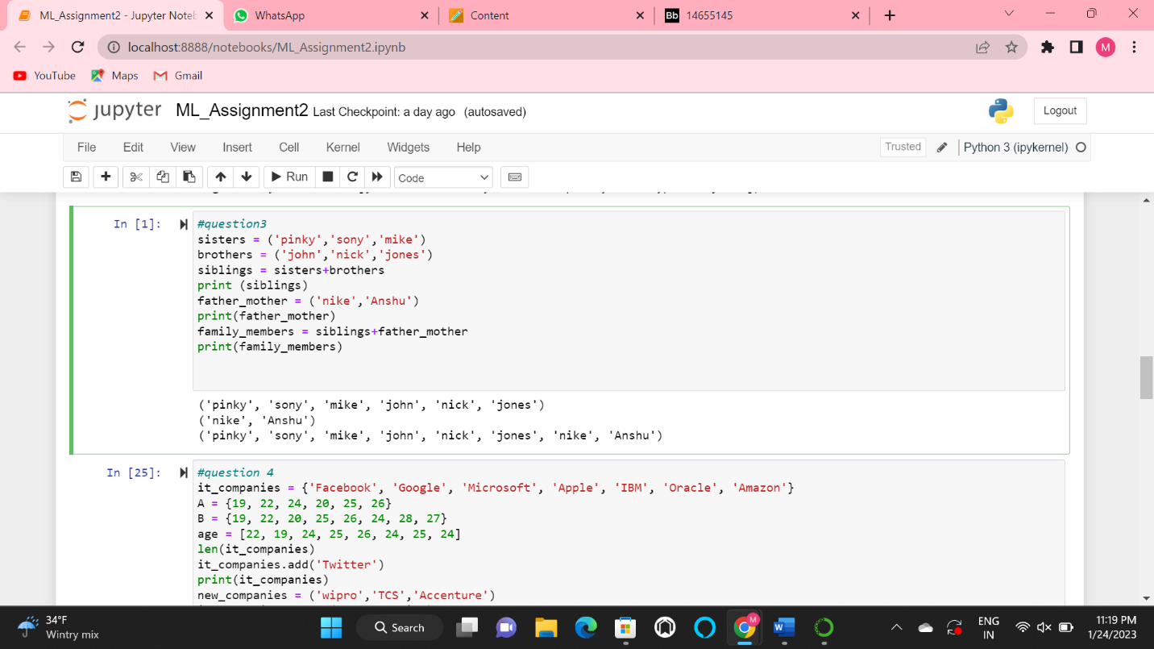

#question3

sisters = ('pinky','sony','mike')

brothers = ('john','nick','jones')

siblings = sisters+brothers

print (siblings)

father_mother = ('nike','Anshu')

print(father_mother)

family_members = siblings+father_mother

print(family_members)

output

('pinky', 'sony', 'mike', 'john', 'nick', 'jones')

('nike', 'Anshu')

('pinky', 'sony', 'mike', 'john', 'nick', 'jones', 'nike', 'Anshu')

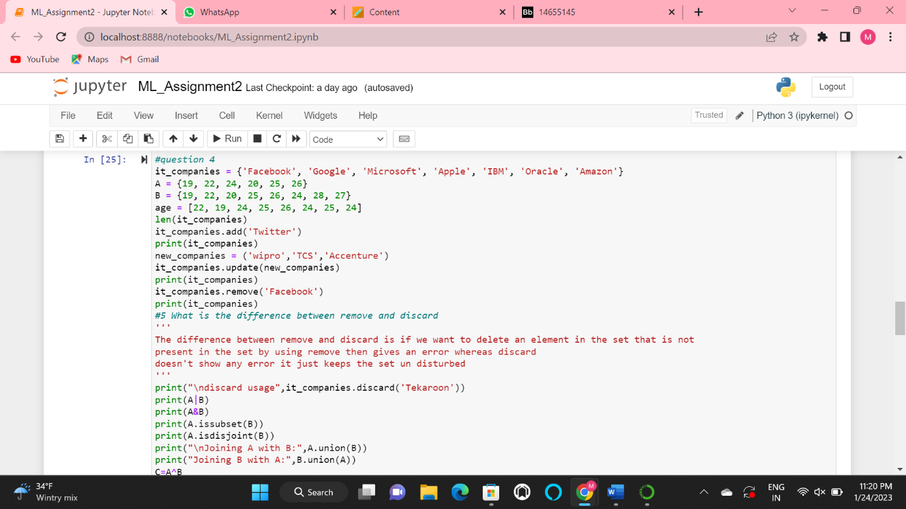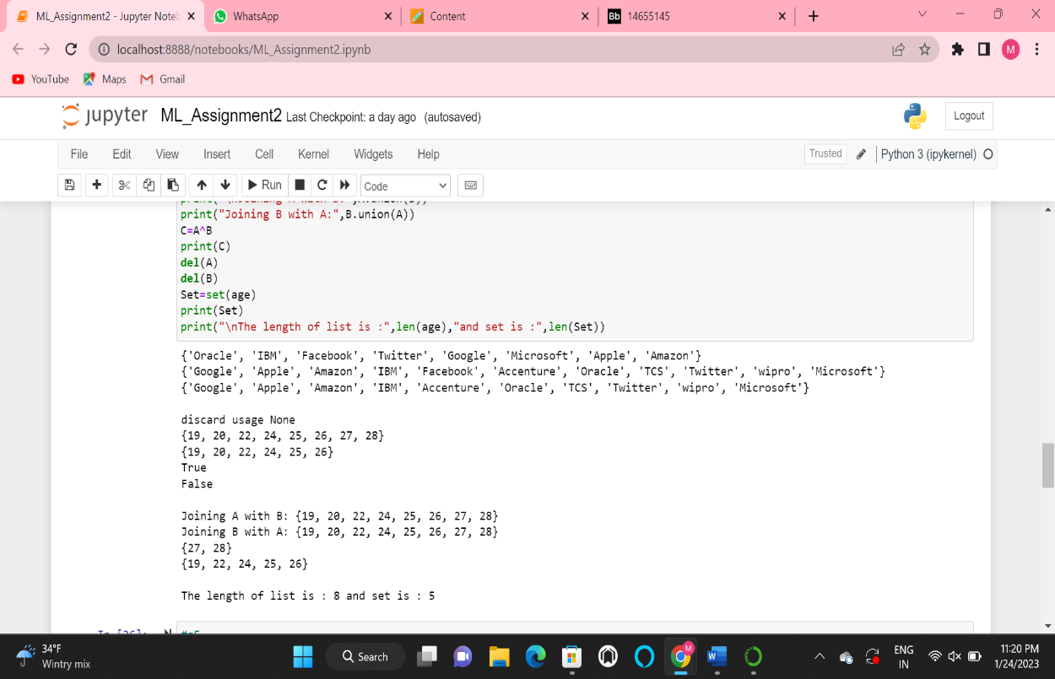

#question 4

it_companies = {'Facebook', 'Google', 'Microsoft', 'Apple', 'IBM', 'Oracle', 'Amazon'}

A = {19, 22, 24, 20, 25, 26}

B = {19, 22, 20, 25, 26, 24, 28, 27}

age = [22, 19, 24, 25, 26, 24, 25, 24]

len(it_companies)

it_companies.add('Twitter')

print(it_companies)

new_companies = ('wipro','TCS','Accenture')

it_companies.update(new_companies)

print(it_companies)

it_companies.remove('Facebook')

print(it_companies)

#5 What is the difference between remove and discard

'''

The difference between remove and discard is if we want to delete an element in the set that is not

present in the set by using remove then gives an error whereas discard

doesn't show any error it just keeps the set un disturbed

'''

print("\ndiscard usage",it_companies.discard('Tekaroon'))

print(A|B)

print(A&B)

print(A.issubset(B))

print(A.isdisjoint(B))

print("\nJoining A with B:",A.union(B))

print("Joining B with A:",B.union(A))

C=A^B

print(C)

del(A)

del(B)

Set=set(age)

print(Set)

print("\nThe length of list is :",len(age),"and set is :",len(Set))

{'Oracle', 'IBM', 'Facebook', 'Twitter', 'Google', 'Microsoft', 'Apple', 'Amazon'}

{'Google', 'Apple', 'Amazon', 'IBM', 'Facebook', 'Accenture', 'Oracle', 'TCS', 'Twitter', 'wipro', 'Microsoft'}

{'Google', 'Apple', 'Amazon', 'IBM', 'Accenture', 'Oracle', 'TCS', 'Twitter', 'wipro', 'Microsoft'}

discard usage None

{19, 20, 22, 24, 25, 26, 27, 28}

{19, 20, 22, 24, 25, 26}

True

False

Joining A with B: {19, 20, 22, 24, 25, 26, 27, 28}

Joining B with A: {19, 20, 22, 24, 25, 26, 27, 28}

{27, 28}

{19, 22, 24, 25, 26}

The length of list is : 8 and set is : 5

#q5

import math

constant = math.pi

radius = 30

#Area of a circle Finding

area_of_circle = constant * radius * radius

print("Area :",area_of_circle)

Output

Area : 2827.4333882308138

Circumference : 188.49555921538757

Enter the radius value: 90

for given radius = 90.0

Area : 25446.900494077327

#q6

sentence = "I am a teacher and I love to inspire and teach people"

#splitting the string for getting the individual elements

Split = sentence.split(" ")

sp_set = set(Split)

print("Set: ",sp_set)

print("Number of unique words: ",len(sp_set))

output

Set: {'people', 'to', 'am', 'teacher', 'love', 'teach', 'inspire', 'I', 'a', 'and'}

Number of unique words: 10

#q7

print("Name\tAge\tCountry\tCity\nAsabeneh\t250\tFinland\tHelsinki")

output

Name Age Country City

Asabeneh 250 Finland Helsinki

Q8

#q8

radius = 10

area = 3.14 * radius ** 2

print('The area of circle with radius {} is {} meters square.'.format(radius, area))

output

The area of circle with radius 10 is 314.0 meters square.

#q9

import math

Num = int(input("Number of students:"))

Lbs=[]

Wts=[]

for i in range(Num):

Lbs.append(int(input()))

for b in Lbs:

a=(math.floor((b/2.2046) * 100 ) )/ 100;

Wts.append(a)

print(Wts)

output:

Number of students:1

2

[0.9]