Basic Survival

Firstly, eliminate all the cases that can lead to self deaths (walls, bodies, head-to-head collision,self trap).
Keep eating pearls.
X = x+dx % w, y = y+dy %h.
if edge is kelp, cant pass, if portal -> neighbour is the exit of the portal.
$A<L+2$ trap !!!.
BFS from a target tile to check if it is a trap.
Keep splitting if len>4. Feed one big snake.

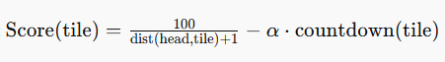
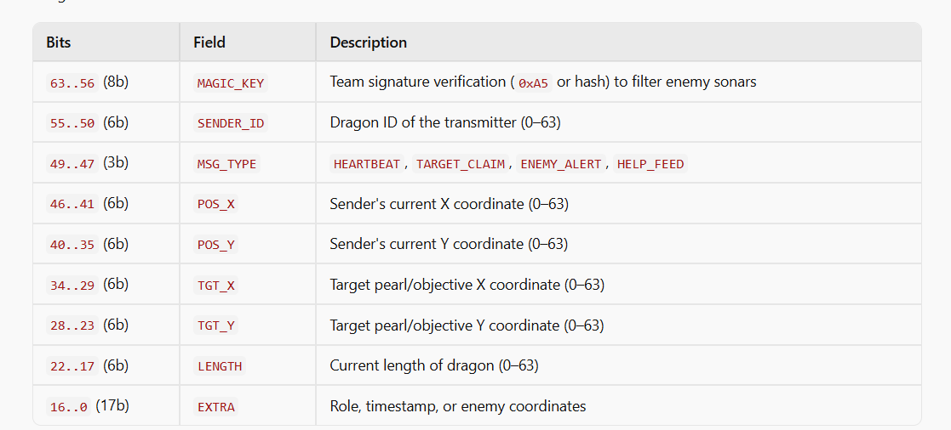
If a teammate who is closer to a target claims a pearl, other dragons will prioritise other targets now.

Attack and defence mechanism
Dragon with length $L≥4$can execute multi-step moves (e.g., MOVE NNE = 3 steps, costs 2 length).
If an enemy dragon is moving towards a choke point or pearl, sprint 2–3 tiles to occupy the space ahead of them, forcing them into a body crash.
Head-to-head collisions destroy both dragons.
Favorable trade rule: If an expendable ally of length 2 collides head-on with an enemy of length 15+, the enemy loses their carry dragon and drops 8 pearls for nearby teammates!
Regions with the highest density of pearls would be the regions where dragons die. Rush there

