**Project Design Phase-II**

**Data Flow Diagram & User Stories**

|  |  |
| --- | --- |
| Date | 17 June 2025 |
| Team ID | LTVIP2025TMID29152 |
| Project Name | SmartSDLC – AI-Enhanced Software Development Lifecycle |
| Maximum Marks | 4 Marks |

**Data Flow Diagrams:**

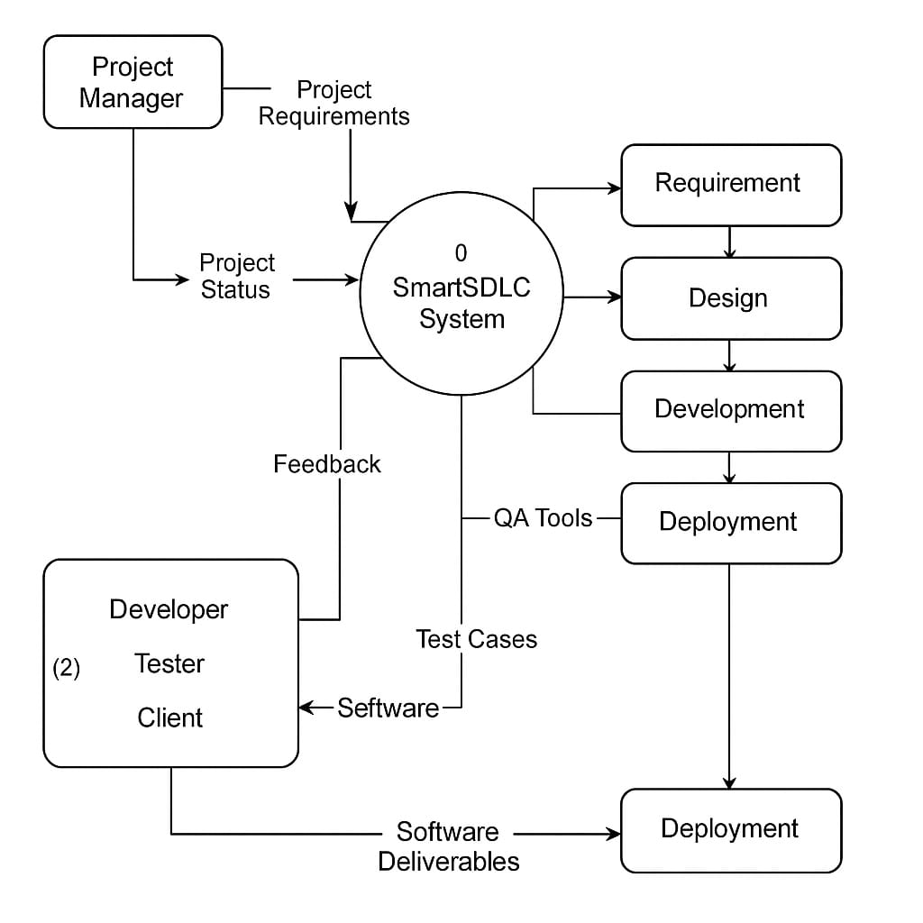A Data Flow Diagram (DFD) is a traditional visual representation of the information flows within a system. A neat and clear DFD can depict the right amount of the system requirement graphically. It shows how data enters and leaves the system, what changes the information, and where data is stored.

**Internal entities:**

* Requirement module
* Design module
* Development module
* Testing module

**External entities:**

* Project manager
* Developer
* Tester
* client

**User Stories :**

| **User Type** | **Functional Requirement (Epic)** | **User Story Number** | **User Story / Task** | **Acceptance criteria** | **Priority** | **Release** |
| --- | --- | --- | --- | --- | --- | --- |
| Customer (Mobile user) | Registration  Or login | USN-1 | As a user, I can register/login using email credentials. | I can access my account . | High | Sprint-1 |
| Customer (Mobile user) | Upload and Classify PDF | USN-2 | As a user, I can upload a PDF than SmartSDLC classifies the PDF into functionalities. | I can receive classification of functionalities. | High | Sprint-1 |
| Customer (Mobile user) | Chat Assistant | USN-3 | As a user, I can ask questions via chat and receive AI responses. | I get context-ware responses from the SmartSDLC AI model. | Low | Sprint-2 |
| Customer (Mobile user) | AI code Generator | USN-4 | As a user,I can ask code then generate it. | It can generate basic code. | Medium | Sprint-1 |
| Customer (Mobile user) | Code Summarizer | USN-5 | As a user, it can be analyze and provides a human readable summary | It can generate a summarized version of written code. | High | Sprint-1 |
| Customer (Mobile user) | Bug Fixer | USN-6 | As a user,I can submit code and receive bug fixed suggestions. | The app returns the same code with suggestions inline. | High | Sprint-2 |
| Customer (Mobile user) | Test case Generator | USN-7 | As a user,I can upload code and get automatically generated test cases. | SmartSDLC generates and displays valid test cases for the submitted code. | Medium | Sprint-2 |
| Customer (Mobile user) | Feedback | USN-8 | As a user,I can submit feedback through a form in the app. | II see a confirmation message and feedback is stored in SmartSDLC system. | Medium | Sprint-3 |