Exercise 1: Implementing the Singleton Pattern

Code:

public class SingletonPatternExample {

static class Logger {

private static Logger instance;

private Logger() {

System.out.println("Logger initialized");

}

public static Logger getInstance() {

if (instance == null) {

instance = new Logger();

}

return instance;

}

public void log(String message) {

System.out.println("Log: " + message);

}

}

public static void main(String[] args) {

Logger logger1 = Logger.getInstance();

logger1.log("First log message from logger1.");

Logger logger2 = Logger.getInstance();

logger2.log("Second log message from logger2.");

if (logger1 == logger2) {

System.out.println("Both logger1 and logger2 refer to the same instance.");

} else {

System.out.println("Different instances exist!");

}

}

}

Output:

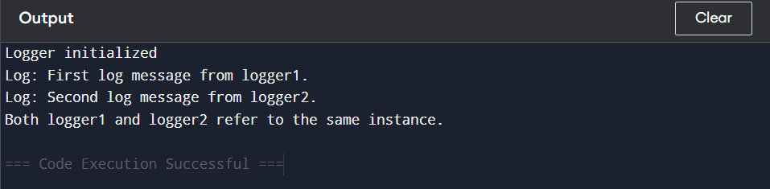

Exercise 2: Implementing the Factory Method Pattern

Code:

public class FactoryMethodPatternExample {

interface Document {

void open();

String getType();

}

static class WordDocument implements Document {

public void open() {

System.out.println("Opening Word document...");

}

public String getType() {

return "Word";

}

}

static class PdfDocument implements Document {

public void open() {

System.out.println("Opening PDF document...");

}

public String getType() {

return "PDF";

}

}

static class ExcelDocument implements Document {

public void open() {

System.out.println("Opening Excel document...");

}

public String getType() {

return "Excel";

}

}

static abstract class DocumentFactory {

public abstract Document createDocument();

}

static class WordDocumentFactory extends DocumentFactory {

public Document createDocument() {

System.out.println("Creating Word document via WordDocumentFactory.");

return new WordDocument();

}

}

static class PdfDocumentFactory extends DocumentFactory {

public Document createDocument() {

System.out.println("Creating PDF document via PdfDocumentFactory.");

return new PdfDocument();

}

}

static class ExcelDocumentFactory extends DocumentFactory {

public Document createDocument() {

System.out.println("Creating Excel document via ExcelDocumentFactory.");

return new ExcelDocument();

}

}

public static void main(String[] args) {

DocumentFactory wordFactory = new WordDocumentFactory();

Document wordDoc = wordFactory.createDocument();

System.out.println("Document Type: " + wordDoc.getType());

wordDoc.open();

System.out.println();

DocumentFactory pdfFactory = new PdfDocumentFactory();

Document pdfDoc = pdfFactory.createDocument();

System.out.println("Document Type: " + pdfDoc.getType());

pdfDoc.open();

System.out.println();

DocumentFactory excelFactory = new ExcelDocumentFactory();

Document excelDoc = excelFactory.createDocument();

System.out.println("Document Type: " + excelDoc.getType());

excelDoc.open();

}

}

Output:

