**9. ReactJS-HOL**

**Program:**

Open the command prompt to execute the task given.

**Step 1:** create a cricketapp folder using the command

**npx create-react-app cricketapp**

**Step 2:** now navigate to cricketapp folder using command

**cd cricketapp**

**Step 3:** Type **code .** command in terminal so that Visual Studio opens with cricketapp folder.

**Step 4:** Now in cricketapp folder open src folder and in that src folder create 2 new files named

**ListofPlayers.js**

**IndianPlayers.js**

**Step 5:** open ListofPlayers.js file and place the below code in file.

**Code:**

// src/ListofPlayers.js

import React from 'react';

const ListofPlayers = () => {

const players = [

{ name: 'Virat', score: 85 },

{ name: 'Rohit', score: 60 },

{ name: 'Rahul', score: 45 },

{ name: 'Dhoni', score: 90 },

{ name: 'Jadeja', score: 72 },

{ name: 'Bumrah', score: 66 },

{ name: 'Shami', score: 55 },

{ name: 'Kohli', score: 100 },

{ name: 'Gill', score: 30 },

{ name: 'Surya', score: 77 },

{ name: 'Pant', score: 40 },

];

const filteredPlayers = players.filter(p => p.score < 70);

return (

<div>

<h2>All Players</h2>

<ul>

{players.map((p, i) => (

<li key={i}>{p.name} - {p.score}</li>

))}

</ul>

<h2>Players with Score below 70</h2>

<ul>

{filteredPlayers.map((p, i) => (

<li key={i}>{p.name} - {p.score}</li>

))}

</ul>

</div>

);

};

export default ListofPlayers;

**Step 6:** open IndianPlayers.js file and place below code in file.

**Code:**

// src/IndianPlayers.js

import React from 'react';

const IndianPlayers = () => {

const players = ['Virat', 'Rohit', 'Rahul', 'Bumrah', 'Shami', 'Gill'];

const [odd1, even1, odd2, even2, odd3, even3] = players;

const oddTeam = [odd1, odd2, odd3];

const evenTeam = [even1, even2, even3];

const T20 = ['Dhoni', 'Surya'];

const Ranji = ['Jadeja', 'Pant'];

const mergedPlayers = [...T20, ...Ranji];

return (

<div>

<h2>Odd Team</h2>

<ul>

{oddTeam.map((p, i) => <li key={i}>{p}</li>)}

</ul>

<h2>Even Team</h2>

<ul>

{evenTeam.map((p, i) => <li key={i}>{p}</li>)}

</ul>

<h2>Merged T20 + Ranji Players</h2>

<ul>

{mergedPlayers.map((p, i) => <li key={i}>{p}</li>)}

</ul>

</div>

);

};

export default IndianPlayers;

**Step 7:** open App.js file and replace the code in file with below mentioned code.

**Code:**

import React from 'react';

import './App.css';

import ListofPlayers from './ListofPlayers';

import IndianPlayers from './IndianPlayers';

function App() {

const flag = true; // Change to false to show IndianPlayers

return (

<div className="App">

<h1>🏏 Cricket App</h1>

{flag ? <ListofPlayers /> : <IndianPlayers />}

</div>

);

}

export default App;

**Step 8:** open terminal and type command

npm start

The app will open at http://localhost:3000 in your browser as follows: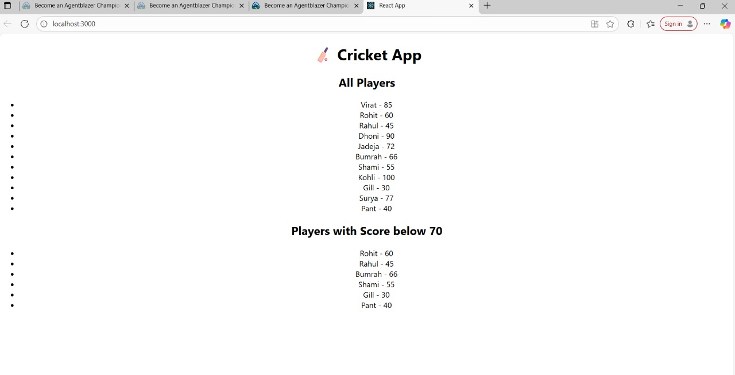

**10. ReactJS-HOL**

**Program:**

Open the command prompt in order to execute the task given.

**Step 1:** create a folder named officespacerentalapp using command

**npx create-react-app officespacerentalapp**

**Step 2:** As the folder is now created now navigate to folder using command

**cd officespacerentalapp**

**Step 3:** Type **code .** command in terminal so that the folder now opens in visual studio

**Step 4:** In officespacerentalapp folder go to src folder and in that folder open App.js file and replace the code with the below code.

**Code:**

import React from 'react';

function App() {

  // Single office object with your provided image

  const office = {

    name: "Urban Hub",

    rent: 45000,

    address: "Plot 21, Tech City, Bangalore",

    image: "https://t4.ftcdn.net/jpg/03/84/55/29/360_F_384552930_zPoe9zgmCF7qgt8fqSedcyJ6C6Ye3dFs.jpg"

  };

  // List of multiple office spaces (add your own or duplicate)

  const officeList = [

    {

      name: "WorkNest",

      rent: 75000,

      address: "1st Street, Hyderabad",

      image: "https://elements-resized.envatousercontent.com/envato-dam-assets-production/EVA/TRX/37/76/1b/39/a2/v1_E10/E105MCPD.jpeg?w=500&cf_fit=scale-down&mark-alpha=18&mark=https%3A%2F%2Felements-assets.envato.com%2Fstatic%2Fwatermark4.png&q=85&format=auto&s=4ca7c4f93f9de46ad31ff58143860b052f64e483093d69b2cc1ac8304733ad35"

    },

    {

      name: "Startup Space",

      rent: 55000,

      address: "MG Road, Chennai",

      image: "https://t4.ftcdn.net/jpg/03/84/55/29/360_F_384552930_zPoe9zgmCF7qgt8fqSedcyJ6C6Ye3dFs.jpg"

    },

    {

      name: "InnoWork",

      rent: 60000,

      address: "Indira Nagar, Bangalore",

      image: "https://t4.ftcdn.net/jpg/03/84/55/29/360_F_384552930_zPoe9zgmCF7qgt8fqSedcyJ6C6Ye3dFs.jpg"

    }

  ];

  // Function to set rent color

  const getRentStyle = (rent) => {

    return {

      color: rent < 60000 ? 'red' : 'green',

      fontWeight: 'bold'

    };

  };

  return (

    <div style={{ padding: '20px', fontFamily: 'Arial' }}>

      <h1>🏢 Office Space Rental Portal</h1>

      <h2>{office.name}</h2>

      <img

        src={office.image}

        alt={office.name}

        style={{ width: '300px', height: '200px', borderRadius: '8px' }}

      />

      <p><strong>Rent:</strong> <span style={getRentStyle(office.rent)}>{office.rent}</span></p>

      <p><strong>Address:</strong> {office.address}</p>

      <hr />

      <h2>Available Office Listings</h2>

      {officeList.map((item, index) => (

        <div key={index} style={{ marginBottom: '30px' }}>

          <img

            src={item.image}

            alt={item.name}

            style={{ width: '300px', height: '200px', borderRadius: '8px' }}

          />

          <h3>{item.name}</h3>

          <p><strong>Rent:</strong> <span style={getRentStyle(item.rent)}>{item.rent}</span></p>

          <p><strong>Address:</strong> {item.address}</p>

          <hr />

        </div>

      ))}

    </div>

  );

}

export default App;

**Step 5:** open terminal and type command

**npm start**

so that the recat application opens in a new browser and output is as follows:

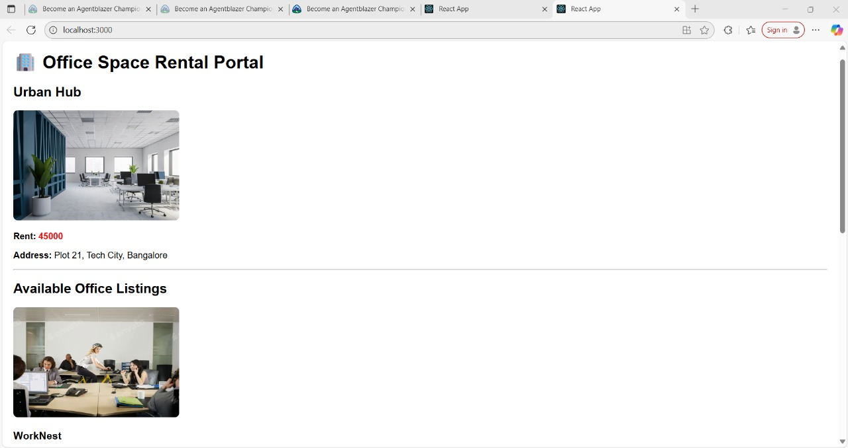

**11. ReactJS-HOL**

**Program:**

Open command prompt to execute the task given.

**Step 1:** create a folder named eventexamplesapp using command

**npx create-react-app eventexamplesapp**

**Step 2:** Now navigate to folder created using command

**cd eventexamplesapp**

**Step 3:** Type **code .** command in terminal so that the folder is opened in visual studio.

**Step 4:** Now in eventexamplesapp folder go to src folder and create a file named **CurrencyConvertor.js**

**Step 5:** Open CurrencyConvertor.js file and type the following code.

**Code:**

import React, { useState } from 'react';

function CurrencyConvertor() {

const [rupees, setRupees] = useState('');

const [euros, setEuros] = useState('');

const handleSubmit = () => {

const result = parseFloat(rupees) * 0.011;

setEuros(result.toFixed(2));

};

return (

<div style={{ marginTop: '20px' }}>

<h2>Currency Converter: INR ➝ Euro</h2>

<input

type="number"

placeholder="Enter Rupees"

value={rupees}

onChange={(e) => setRupees(e.target.value)}

/>

<button onClick={handleSubmit}>Convert</button>

{euros && (

<p>

<strong>In Euros:</strong> € {euros}

</p>

)}

</div>

);

}

export default CurrencyConvertor;

**Step 6:** Open App.js file and replace code using below code.

**Code:**

import React, { Component } from 'react';

import CurrencyConvertor from './CurrencyConvertor';

class App extends Component {

constructor(props) {

super(props);

this.state = {

count: 0

};

}

increment = () => {

this.setState({ count: this.state.count + 1 });

};

sayHello = () => {

alert('Hello! This is a static message.');

};

decrement = () => {

this.setState({ count: this.state.count - 1 });

};

sayWelcome = (message) => {

alert(message);

};

handlePress = (event) => {

alert("I was clicked (Synthetic Event)");

};

handleBoth = () => {

this.increment();

this.sayHello();

};

render() {

return (

<div style={{ padding: '20px', fontFamily: 'Arial' }}>

<h1>React Event Handling Lab</h1>

<h2>Counter: {this.state.count}</h2>

<button onClick={this.handleBoth}>Increment & Say Hello</button>{' '}

<button onClick={this.decrement}>Decrement</button>

<br /><br />

<button onClick={() => this.sayWelcome("Welcome to React!")}>Say Welcome</button>

<br /><br />

<button onClick={this.handlePress}>Click Me (Synthetic Event)</button>

<br /><br />

<CurrencyConvertor />

</div>

);

}

}

export default App;

**Step 7:** open terminal and type

**npm start**

so that the react application opens in a new browser and output is as follows:

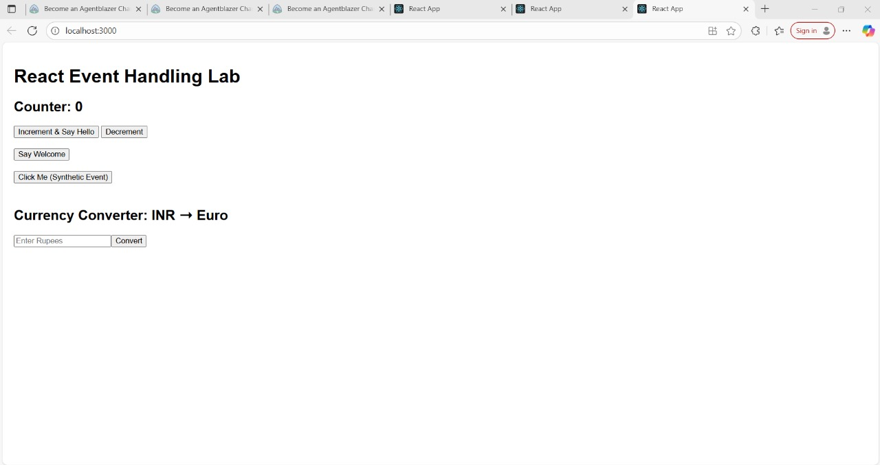

**12. ReactJS-HOL**

**Program:**

Open command prompt to execute the task given

**Step 1:** create a folder named ticketbookingapp using command

**npx create-react-app ticketbookingapp**

**Step 2**: Navigate to the created folder using command

**cd ticketbookingapp**

**Step 3:** Type **code .** command in terminal so that the folder now opens in Visual Studio.

**Step 4:** In ticketbookingapp folder navigate to src folder and open App.js file.

Replace the code in file using the below code.

**Code:**

import React, { useState } from 'react';

function App() {

  const [isLoggedIn, setIsLoggedIn] = useState(false);

  const loginHandler = () => setIsLoggedIn(true);

  const logoutHandler = () => setIsLoggedIn(false);

  const flightDetails = [

    { id: 1, from: 'Delhi', to: 'Mumbai', price: 3500 },

    { id: 2, from: 'Bangalore', to: 'Hyderabad', price: 2500 },

    { id: 3, from: 'Chennai', to: 'Kolkata', price: 4000 },

  ];

  const FlightList = () => (

    <div>

      <h3>Flight Details</h3>

      <ul>

        {flightDetails.map(flight => (

          <li key={flight.id}>

            {flight.from} → {flight.to} - ₹{flight.price}

            {isLoggedIn && <button style={{ marginLeft: '10px' }}>Book Ticket</button>}

          </li>

        ))}

      </ul>

    </div>

  );

  return (

    <div style={{ padding: '20px', fontFamily: 'Arial' }}>

      <h1>✈️ Ticket Booking Portal</h1>

      {isLoggedIn ? (

        <div>

          <p>Welcome, Logged-in User!</p>

          <button onClick={logoutHandler}>Logout</button>

        </div>

      ) : (

        <div>

          <p>Welcome, Guest! Please login to book tickets.</p>

          <button onClick={loginHandler}>Login</button>

        </div>

      )}

      <hr />

      <FlightList />

    </div>

  );

}

export default App;

**Step 5:** Open terminal and execute the command

**npx start**

and then the react application opens in a new browser and output is as follows:

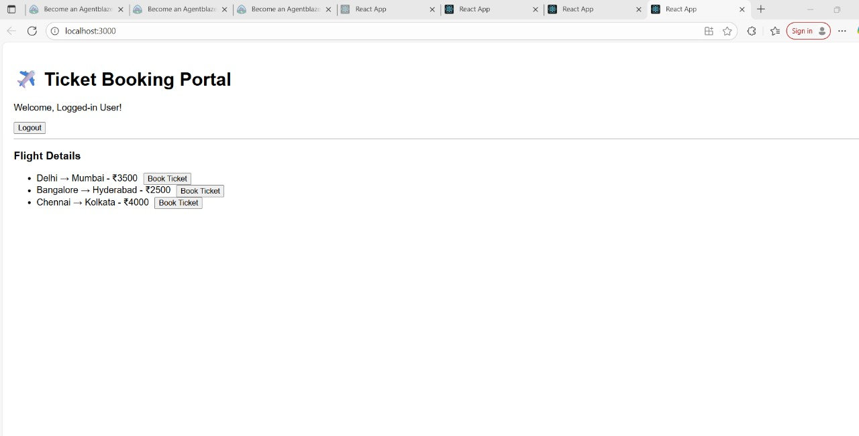

**13. ReactJS-HOL**

**Program:**

Open command prompt to execute the task given

**Step 1:** create a folder named bloggerapp using commad

**npx create-react-app bloggerapp**

**Step 2:** Now navigate to created folder using command

**cd bloggerapp**

**Step 3:** Type **code .** command in terminal so that the folder opens in Visual studio.

**Step 4:** In bloggerapp folder go to src folder and create three new files named

**BookDetails.js , BlogDetails.js , CourseDetails.js**

**Step 5:** In BookDetails.js type the code.

**Code:**

import React from 'react';

const BookDetails = () => {

const books = [

{ id: 1, title: "React in Action", author: "Mark T." },

{ id: 2, title: "Learning React", author: "Alex B." }

];

return (

<div>

<h3>Book Details</h3>

<ul>

{books.map(book => (

<li key={book.id}>{book.title} - {book.author}</li>

))}

</ul>

</div>

);

};

export default BookDetails;

**Step 6:** In BlogDetails.js type the below code.

**Code:**

import React from 'react';

const BlogDetails = () => {

const blogs = [

{ id: 1, title: "React Hooks Deep Dive" },

{ id: 2, title: "Component Reusability in React" }

];

return (

<div>

<h3>Blog Details</h3>

<ul>

{blogs.map(blog => (

<li key={blog.id}>{blog.title}</li>

))}

</ul>

</div>

);

};

export default BlogDetails;

Step 7: In CourseDetails.js type the below code.

Code:

import React from 'react';

const CourseDetails = () => {

const courses = [

{ id: 1, name: "Fullstack Development" },

{ id: 2, name: "Frontend with React" }

];

return (

<div>

<h3>Course Details</h3>

<ul>

{courses.map(course => (

<li key={course.id}>{course.name}</li>

))}

</ul>

</div>

);

};

export default CourseDetails;

**Step 8:** In App.js replace the code using the below code.

**Code:**

import React, { useState } from 'react';

import BookDetails from './BookDetails';

import BlogDetails from './BlogDetails';

import CourseDetails from './CourseDetails';

function App() {

const [view, setView] = useState('book'); // book | blog | course | none

let componentToRender;

if (view === 'book') {

componentToRender = <BookDetails />;

} else if (view === 'blog') {

componentToRender = <BlogDetails />;

} else if (view === 'course') {

componentToRender = <CourseDetails />;

} else {

componentToRender = <p>Please select a view.</p>;

}

return (

<div style={{ padding: '20px', fontFamily: 'Arial' }}>

<h1>📚 Blogger App</h1>

<div>

<button onClick={() => setView('book')}>Show Book Details</button>

<button onClick={() => setView('blog')}>Show Blog Details</button>

<button onClick={() => setView('course')}>Show Course Details</button>

<button onClick={() => setView('none')}>Clear View</button>

</div>

<hr />

{/* Method 1: if-else rendering */}

{componentToRender}

{/* Method 2: ternary operator rendering */}

{/* {view === 'book' ? <BookDetails /> : view === 'blog' ? <BlogDetails /> : view === 'course' ? <CourseDetails /> : <p>No view selected</p>} */}

{/* Method 3: logical && rendering */}

{/* {view === 'book' && <BookDetails />} */}

</div>

);

}

export default App;

**Step 9:** open the terminal and type

**npm start**

and then the react application opens in a new browser and output is as follows:

