**Week 2**

**Exercise 1: Control Structures**

**Code:**

DECLARE

v_salary NUMBER := 72000;

v_category VARCHAR2(20);

v_review_count NUMBER := 1;

v_bonus NUMBER := 0;

BEGIN

IF v_salary < 30000 THEN

v_category := 'Low';

ELSIF v_salary <= 60000 THEN

v_category := 'Medium';

ELSE

v_category := 'High';

END IF;

DBMS_OUTPUT.PUT_LINE('Salary Category: ' || v_category);

CASE v_category

WHEN 'Low' THEN v_bonus := 2000;

WHEN 'Medium' THEN v_bonus := 1500;

WHEN 'High' THEN v_bonus := 1000;

ELSE v_bonus := 500;

END CASE;

DBMS_OUTPUT.PUT_LINE('Bonus Assigned: ' || v_bonus);

FOR i IN 1..3 LOOP

DBMS_OUTPUT.PUT_LINE('FOR LOOP - Review #' || i);

END LOOP;

WHILE v_review_count <= 2 LOOP

DBMS_OUTPUT.PUT_LINE('WHILE LOOP - Follow-up #' || v_review_count);

v_review_count := v_review_count + 1;

END LOOP;

DECLARE

v_log_message VARCHAR2(100);

BEGIN

v_log_message := 'Bonus of ' || v_bonus || ' assigned to high salary bracket.';

IF v_category = 'High' THEN

DBMS_OUTPUT.PUT_LINE('[LOG]: ' || v_log_message);

END IF;

END;

END;

/

**Output:**

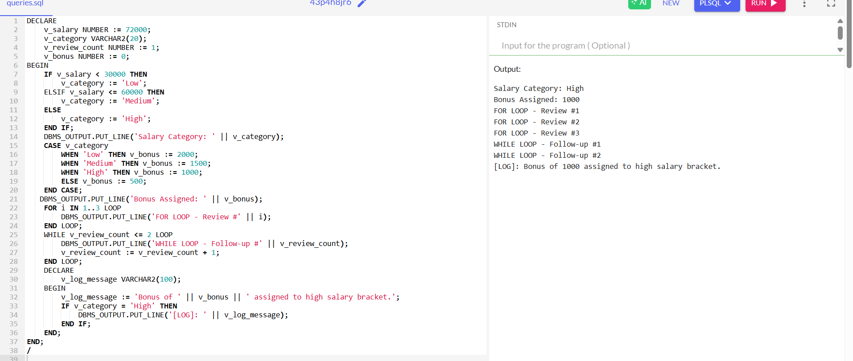

**Exercise 3: Stored Procedures**

**Code:**

CREATE TABLE employees (

emp_id NUMBER PRIMARY KEY,

emp_name VARCHAR2(100),

salary NUMBER

);

INSERT INTO employees (emp_id, emp_name, salary) VALUES (101, 'Alice', 50000);

INSERT INTO employees (emp_id, emp_name, salary) VALUES (102, 'Bob', 60000);

COMMIT;

CREATE OR REPLACE PROCEDURE get_employee_details (

p_emp_id IN employees.emp_id%TYPE,

p_emp_name OUT employees.emp_name%TYPE,

p_salary OUT employees.salary%TYPE

)

IS

BEGIN

SELECT emp_name, salary

INTO p_emp_name, p_salary

FROM employees

WHERE emp_id = p_emp_id;

EXCEPTION

WHEN NO_DATA_FOUND THEN

p_emp_name := 'Not Found';

p_salary := 0;

END;

/

DECLARE

v_name employees.emp_name%TYPE;

v_salary employees.salary%TYPE;

BEGIN

get_employee_details(101, v_name, v_salary);

DBMS_OUTPUT.PUT_LINE('Name: ' || v_name);

DBMS_OUTPUT.PUT_LINE('Salary: ' || v_salary);

END;

/

**Output:**

