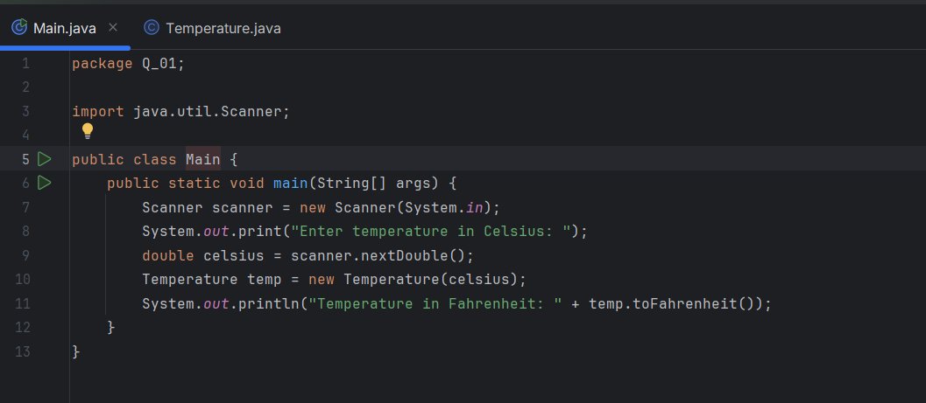**01.code**

**output**

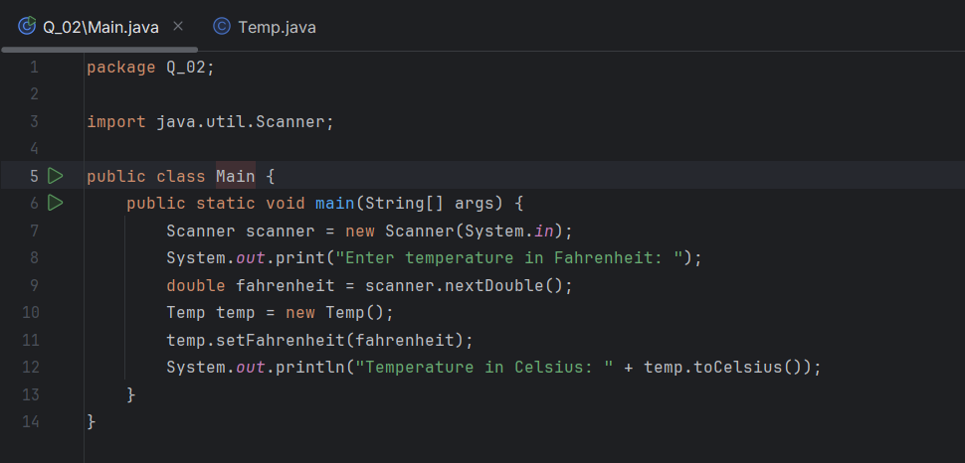**02.code**

**output**

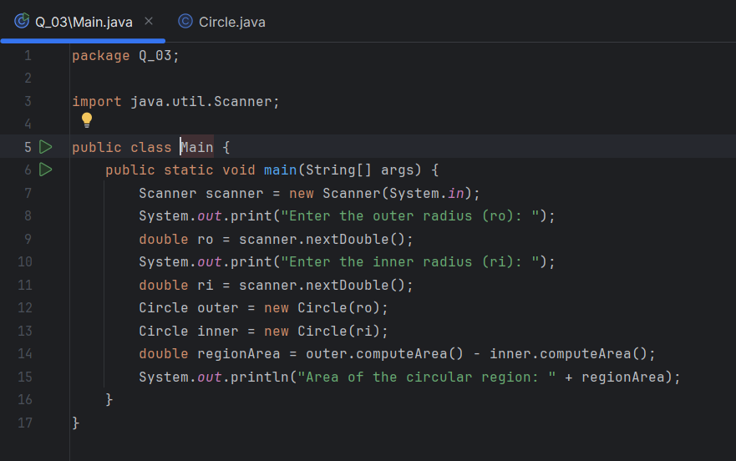**03.code**

**output**

**04.code**

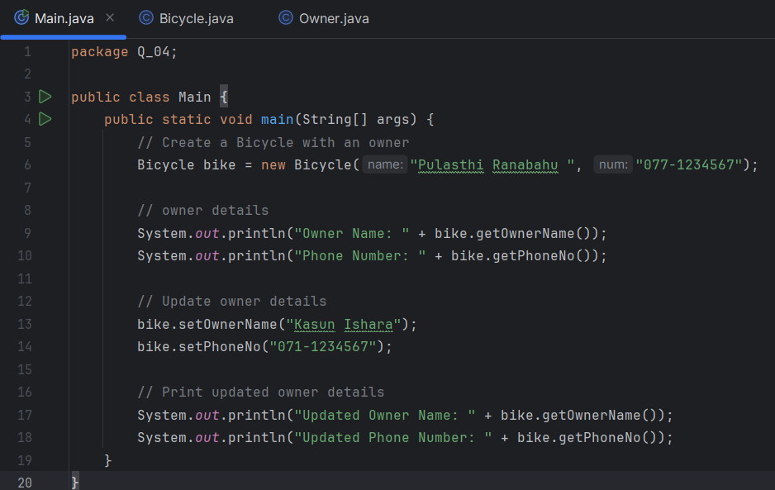

**output**

**05.code**

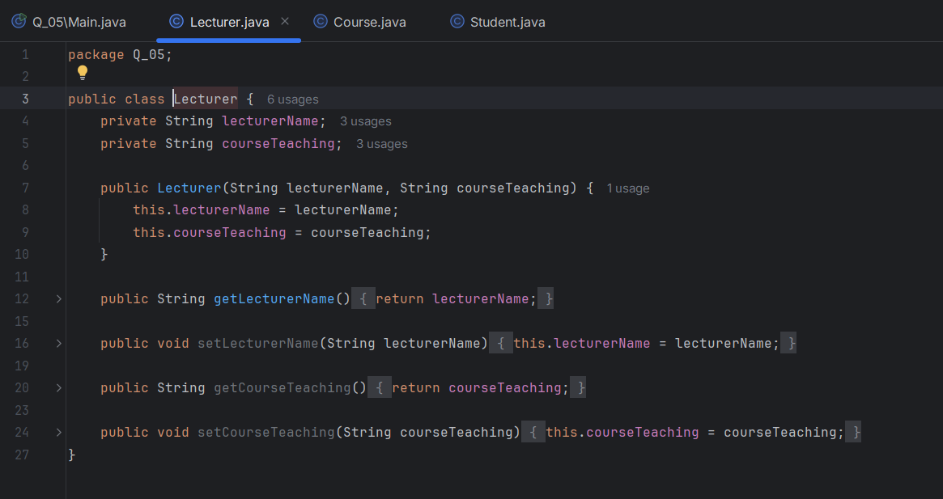

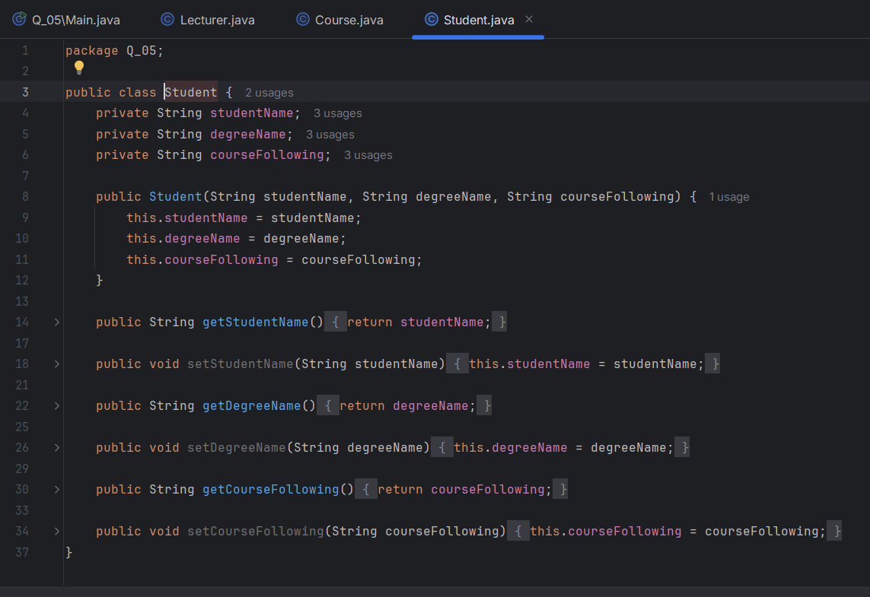**output**