Q01.

Code:

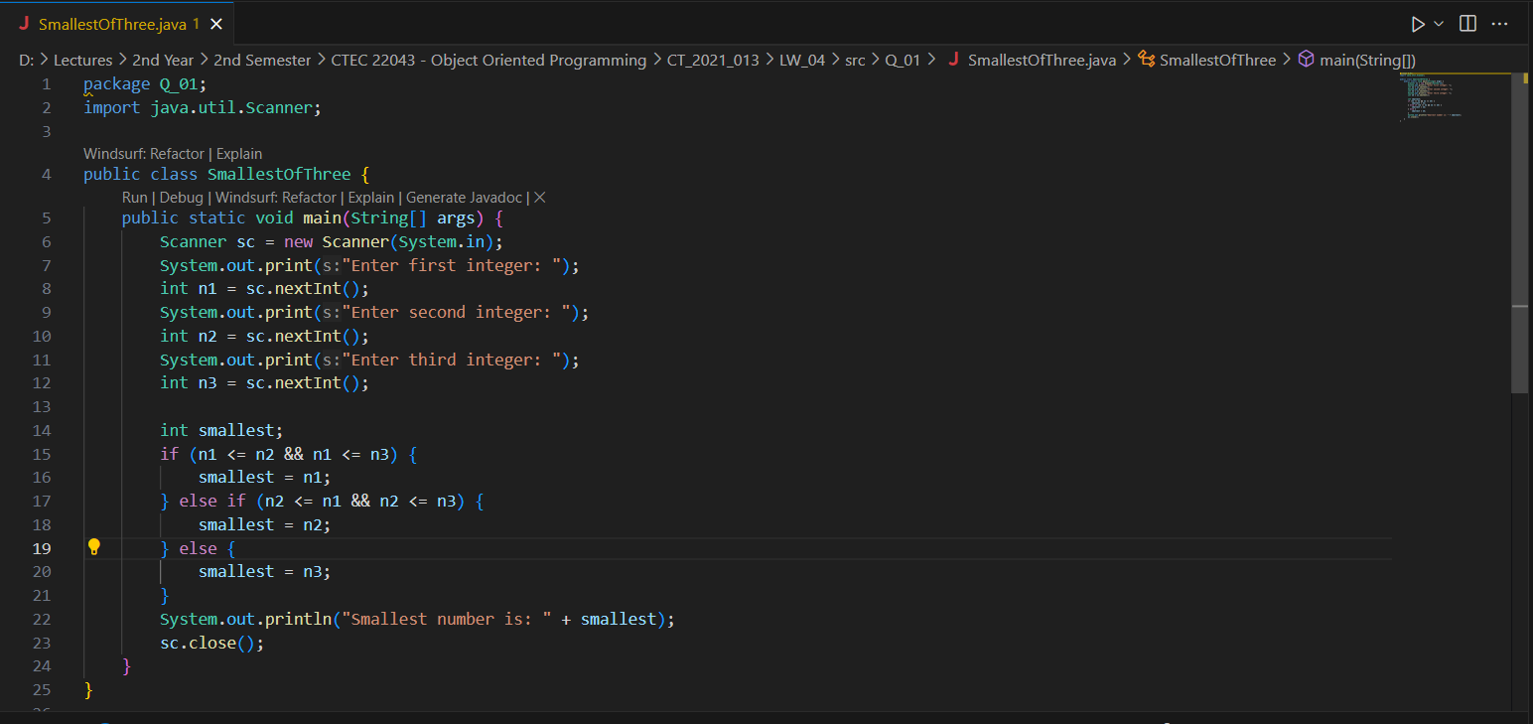

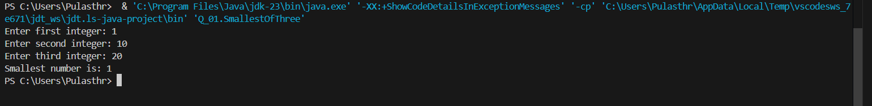Output:

Q02.

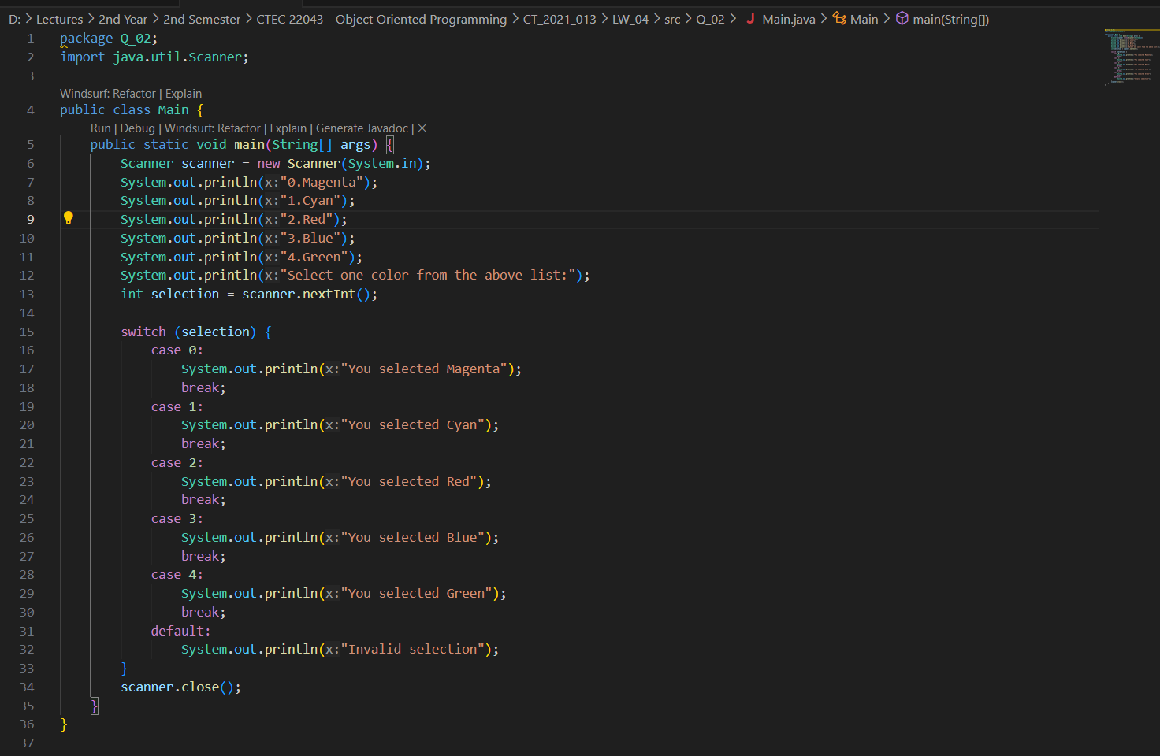Code:

Output:

Q03.

Code:

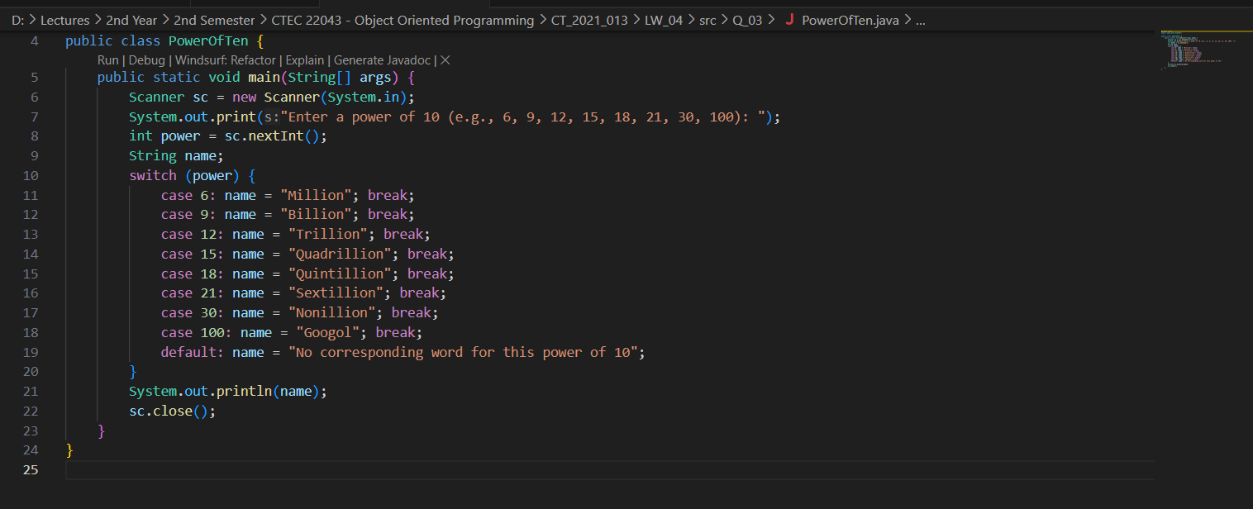

Output:

Q04.

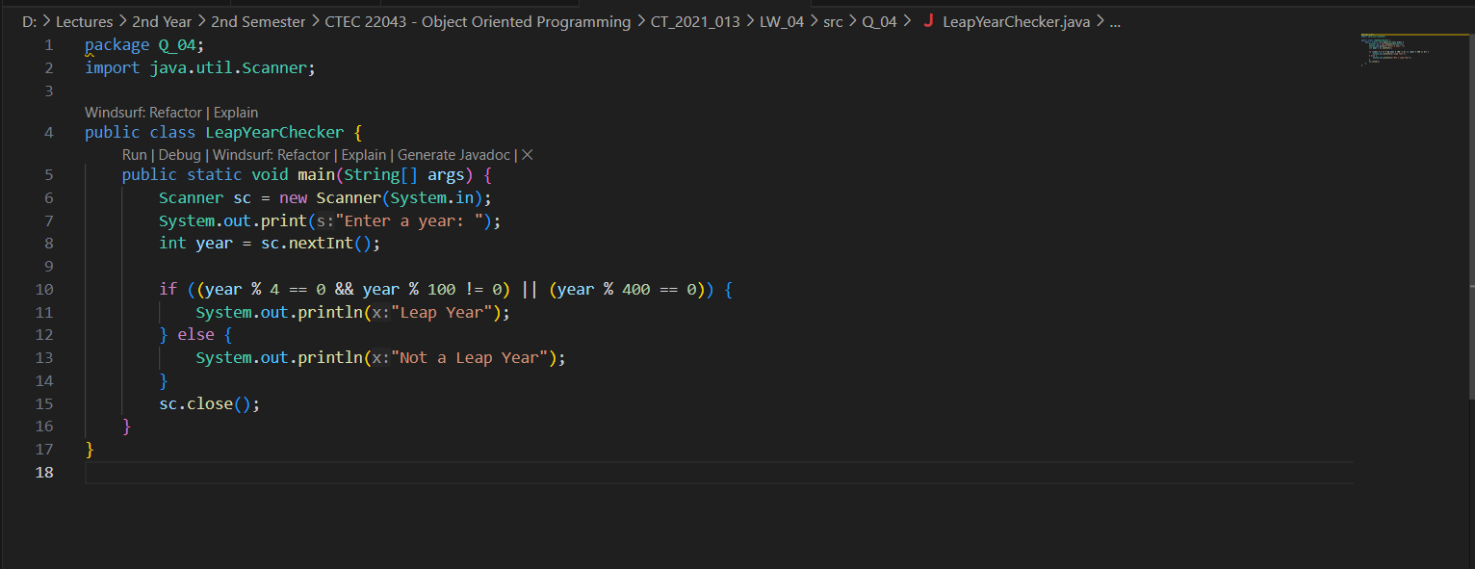Code:

Output:

Q05.

Code:

package Q_05;

import java.util.Scanner;

public class BurgerMenu {

    public static void main(String[] args) {

        Scanner sc = new Scanner(System.in);

        String[] entrees = {"Tofu Burger", "Cajun Chicken", "Buffalo Wings", "Rainbow Fillet"};

        double[] entreePrices = {3.49, 4.59, 3.99, 2.99};

        String[] sides = {"Rice Cracker", "No-Salt Fries", "Zucchini", "Brown Rice"};

        double[] sidePrices = {0.79, 0.69, 1.09, 0.59};

        String[] drinks = {"Cafe Mocha", "Cafe Latte", "Espresso", "Oolong Tea"};

        double[] drinkPrices = {1.99, 1.90, 2.49, 0.99};

        System.out.println("Entree Menu:");

        for (int i = 0; i < entrees.length; i++) {

            System.out.printf("%d. %s ($%.2f)%n", i+1, entrees[i], entreePrices[i]);

        }

        System.out.print("Select an entree (1-4): ");

        int entreeChoice = sc.nextInt() - 1;

        System.out.println("\nSide Dish Menu:");

        for (int i = 0; i < sides.length; i++) {

            System.out.printf("%d. %s ($%.2f)%n", i+1, sides[i], sidePrices[i]);

        }

        System.out.print("Select a side dish (1-4): ");

        int sideChoice = sc.nextInt() - 1;

        System.out.println("\nDrink Menu:");

        for (int i = 0; i < drinks.length; i++) {

            System.out.printf("%d. %s ($%.2f)%n", i+1, drinks[i], drinkPrices[i]);

        }

        System.out.print("Select a drink (1-4): ");

        int drinkChoice = sc.nextInt() - 1;

        double total = entreePrices[entreeChoice] + sidePrices[sideChoice] + drinkPrices[drinkChoice];

        System.out.println("\nYour Order:");

        System.out.printf("Entree: %s ($%.2f)%n", entrees[entreeChoice], entreePrices[entreeChoice]);

        System.out.printf("Side: %s ($%.2f)%n", sides[sideChoice], sidePrices[sideChoice]);

        System.out.printf("Drink: %s ($%.2f)%n", drinks[drinkChoice], drinkPrices[drinkChoice]);

        System.out.printf("Total: $%.2f%n", total);

        sc.close();

    }

}

Output:

