Q01.

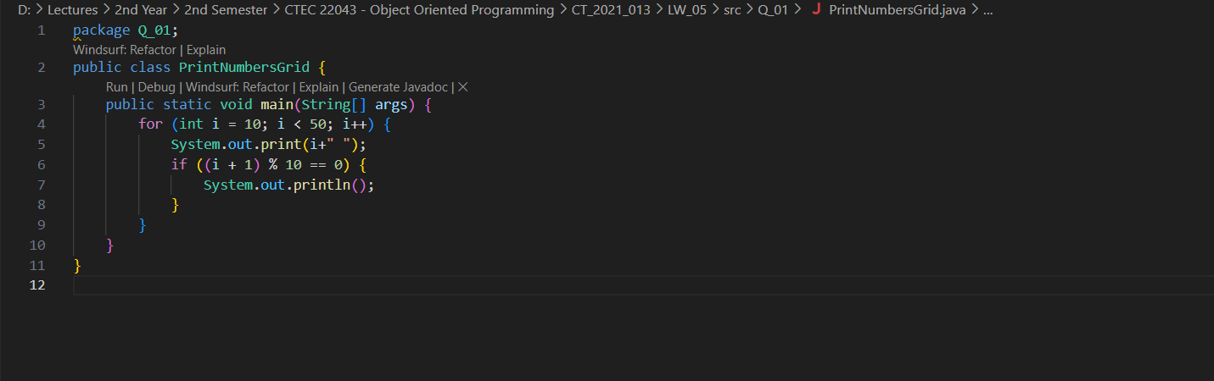Code:

Output:

Q02.

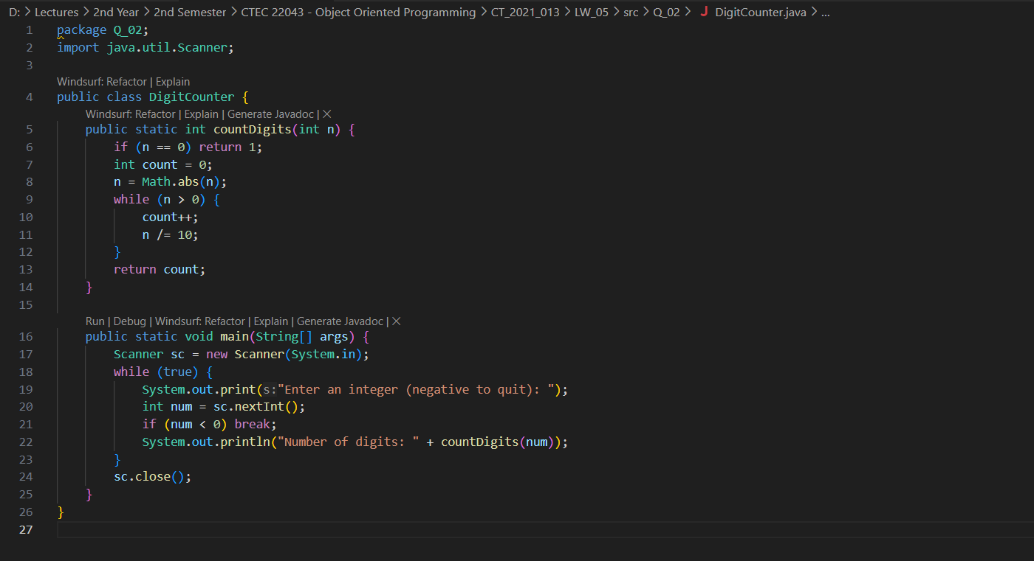Code:

Output:

Q 03.

Code:

Output:

Q 04.

Code:

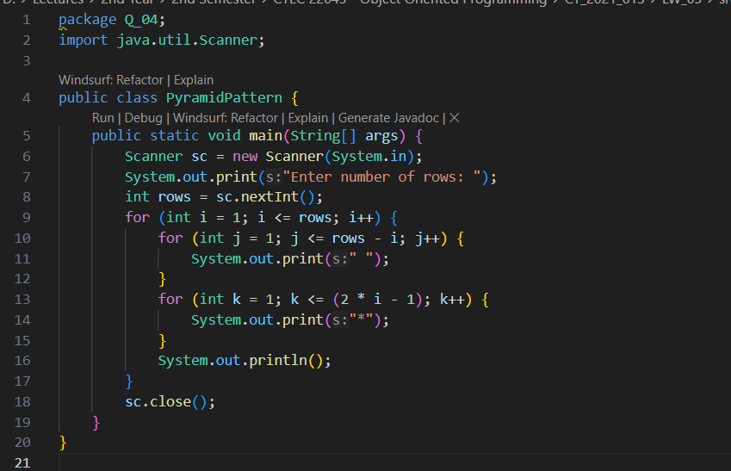

Output:

Q 05.

Code:

Output:

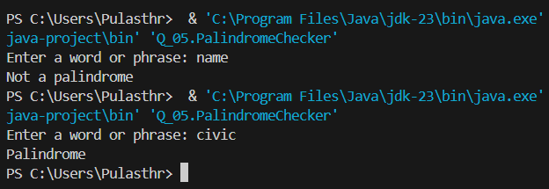

Q 06.

Code:

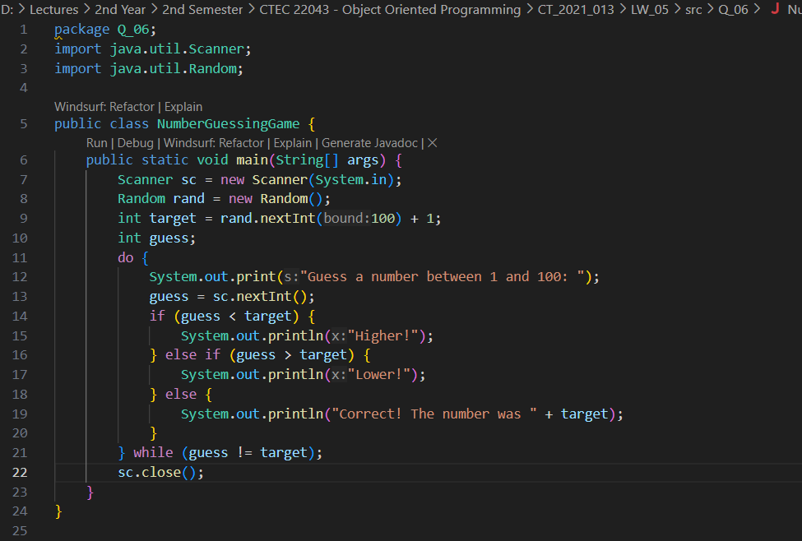

Output:

Q 07.

Code:

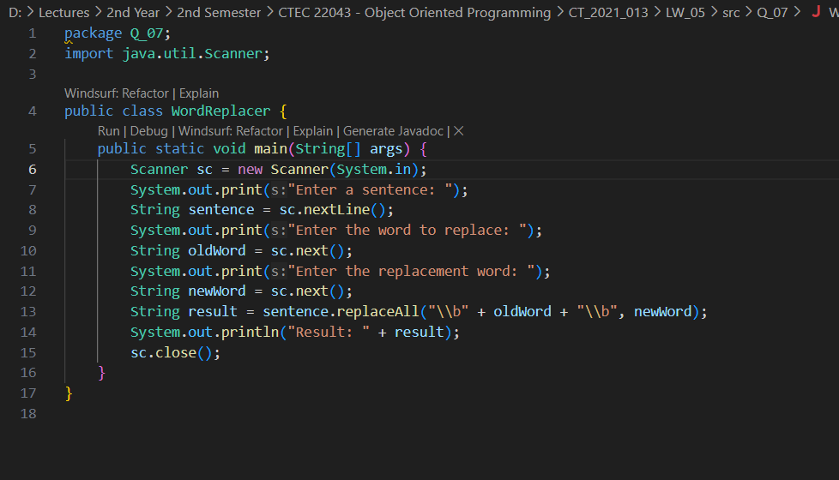

Output:

