Prereqs:

1. If you are working locally on a 32-bit OS, perform a complete install of Visual Studio 2008. In particular, you want to make sure the 64-bit compilers are installed, which gives you the option to re-compile apps for native deployment on HPC Server 2008 (a 64-bit platform). If the 64-bit compilers are not installed, you can still build and run the provided applications, just be aware that any mention of the “x64” platform in Visual Studio will not apply in your case.

2. To build and run the applications, you will need to install 3 things: (1) the Parallel Extensions to .NET Framework (http://msdn.microsoft.com/en-us/concurrency/default.aspx), (2) MPI.NET (http://www.osl.iu.edu/research/mpi.net/), and (3) the SDK for HPC Server Pack (best located via an internet search). Make note of where you install the SDK. If the SDK is already installed, confirm the install directory: look in C:\Program Files\Microsoft HPC...\, and ensure this directory contains two sub-folders named "Include\" and "Lib\".

3. Once the SDK is installed, your Visual Studio environment needs to be configured (once) so that the necessary MPI-related files can be located. Let’s assume the SDK was installed into C:\Program Files\Microsoft HPC Pack 2008 SDK\. Startup Visual Studio, Tools menu, Options, and select "VC++ Directories" in the window that appears (see snapshot below). If you are working under a 32-bit OS, add the following configuration information:

Platform Show Dirs for Value
Win32 Include Files C:\Program Files\Microsoft HPC Pack 2008 SDK\Include
Win32 Library Files C:\Program Files\Microsoft HPC Pack 2008 SDK\Lib\i386
x64 Include Files C:\Program Files\Microsoft HPC Pack 2008 SDK\Include
x64 Library Files C:\Program Files\Microsoft HPC Pack 2008 SDK\Lib\amd64

The values are added by clicking the small folder icon:

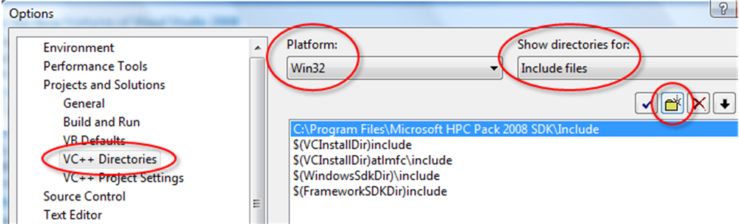

These settings allow you to develop under 32-bit, then recompile for 64-bit and deploy to a Windows HPC Server cluster. If you are working under a 64-bit OS, configure as follows:

Platform Show Dirs for Value
x64 Include Files C:\Program Files\Microsoft HPC Pack 2008 SDK\Include
x64 Library Files C:\Program Files\Microsoft HPC Pack 2008 SDK\Lib\amd64

You are now ready to start building MPI-based apps for Windows HPC Server.

Build and Run Instructions:

To build any of the applications, open the provided Visual Studio solution (.sln file), select your target platform (Win32 or x64), select the type of build (debug or release), and build. If the build fails ("unable to find mpi.h" or "unresolved symbols"), then either the SDK is not installed (prereq #2) or your Visual Studio environment was not configured correctly (prereq #3).

Once the program is successfully built, the sequential version can be run by pressing F5 or ctrl+F5 (the latter leaves the console window open when the app finishes so you can see the output). The MPI-based versions must be run outside Visual Studio using mpiexec. Minimize Visual Studio, open a command window (Start, cmd.exe), and navigate to the folder containing the .EXE you built. For example, if you built a 64-bit release version of MPIMandelbrot, then you would do:

cd MPIMandelbrot
cd x64
cd release

To run, launch your app using mpiexec:

mpiexec -n 4 MPIMandelbrot.exe

This runs the application with 4 MPI processes. That’s it, enjoy!

If you cannot see file extensions in Windows Explorer, do the following: Organize menu, Folder and Search options, View tab, uncheck “Hide extensions for known file types”. While you’re there, I would also select the option for “Show hidden files and folders”.

