ZAP SAML 2.0 Extension

Introduction
The OWASP Zed Attack Proxy (ZAP) is an easy to use integrated penetration testing tool for finding vulnerabilities in web applications. It is open-source under Apache License 2.0 and widely used by the computer security community.

SAML is an XML-based federated single sign-on (FSSO) protocol that uses security tokens containing assertions to pass information about a principal between a SAML authority (an identity provider), and a SAML consumer (a service provider). It enables web-based authentication and authorization scenarios including cross-domain single sign-on (SSO).

ZAP did not have the facility to identify the HTTP SAML Requests/Responses (The HTTP requests with SAML assertions). It treated them as a usual HTTP request. That limit their ability to read the contents(The SAML assertions), Edit them in a human-friendly way, and simulate the related attacks.

The ZAP SAML 2.0 Extension overcomes those issues related to HTTP SAML requests. It allows to identify, View, Edit/Fuzz, and resend the SAMLRequests.

Installation

Using the binary ZAP file
- Download the “.zap” file for the extension
- Place the zap file under the “plugins” directory of ZAP installation
- Start ZAP

Using ZAP Marketplace
To be updated once the extension is added to the marketplace.

Usage

View SAML Assertions of the requests.
- In the history tab, select a request that contains a SAML message in it. (Can be identified by the 'SAMLRequest' or 'SAMLResponse' parameters). Following is an example of such message in the history tab.
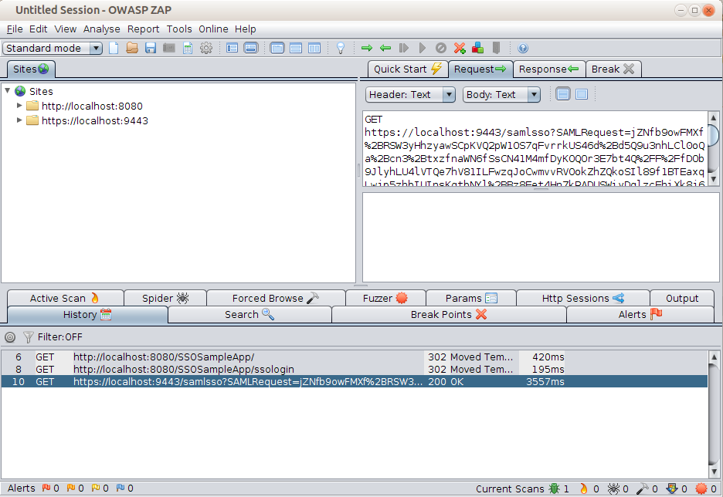
- Right click on the request and select “SAML Actions → Resend”. If it's a valid SAML request, a Window will be shown as below. It will consist of two tabs for requst and response. Request tab will have 2 parts. The decoded SAML message from the HTTP request in the XML format will be shown in the top part. The bottom part will show some of the common attributes/values in the message. The user can edit the request from either of the places.
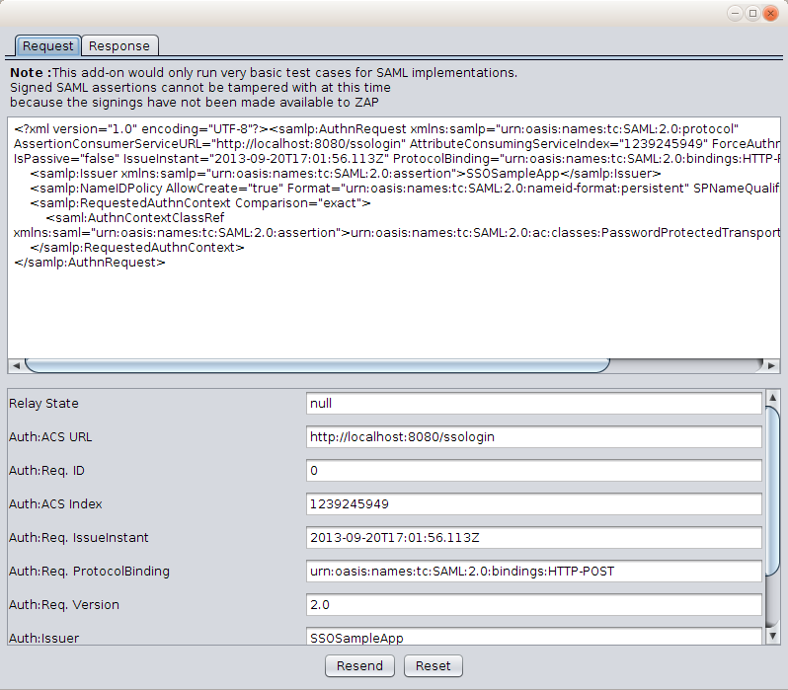

If the request doesn't have a SAML message it will show a error message as follows. (The request selected here is a usual http request to google)

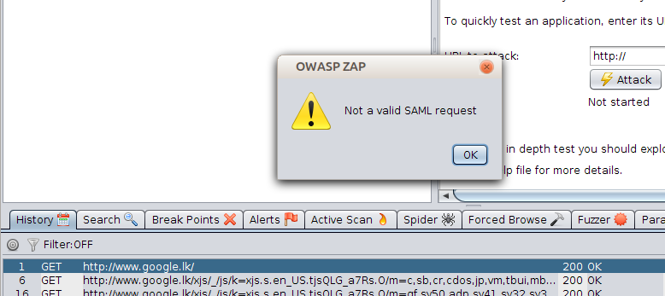

Replay SAML Assertions changing its Attribute values
- Follow the steps in 3.1 to view the Desired message
- At the view window, edit the message as needed. You may use the bottom section to change specific attributes easily. The changes to any of XML view and attributes will update the other automattically
- Once the request is edited as needed, the edited request can be sent to the end-point and see the response from the endpoint.

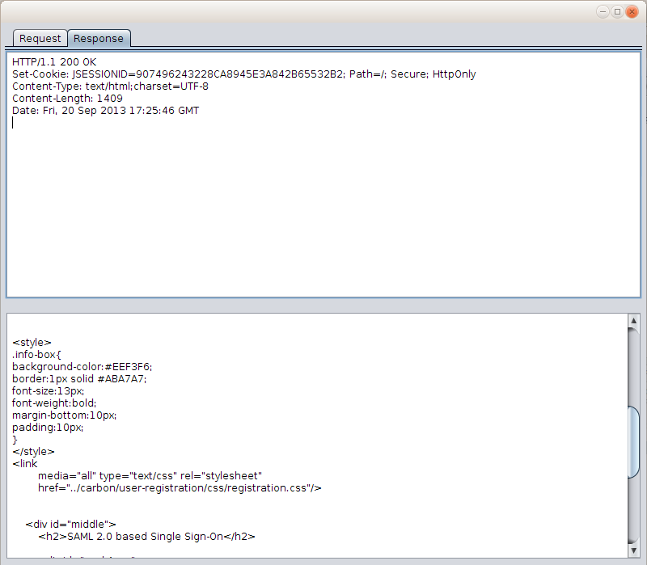

Change the requests before sending them to the endpoint with pre-defined values.

- This is setting window (Tools - > SAML Settings) of the extension.
- You will find a list of currently configured attributes to change their values automatically. They are listed under “Auto Change Attributes and Values”
- Add more attribute/value pairs as needed (see later section for details)
- Make Sure that “Enable Passive Scanner” is checked at the global settings section.
- Following is a part of a message that was automatically changed the Subject's NameID parameter to “fakeUser”.

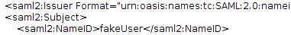

- If the end-point fails to do the security checks like signature validation, it will accept the changed parameters which will allow the attacks. Following is an example how a sample SP who doesn't validate the requests can be attacked. First one is the actual behavior where it should be as second one without the change.
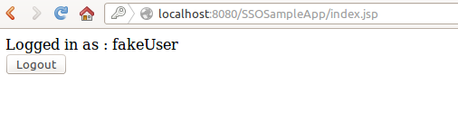Figure 1: The actual outcome due to change
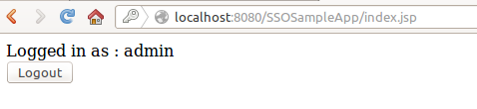Figure 2: The Expected outcome

Add/Edit attributes and values to change automatically
- Go to the setting window as detailed in 3.3
- See whether the value is already there in the auto change section. If it's there use the “Add/Edit values” button next to attribute name, to edit its value.
- If it's not available click the “Add auto change attributes” button to get the dialog box where you can select the attribute name and a value which should be assigned to that attribute.
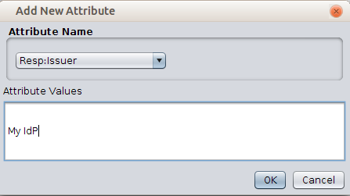
- Once they are added they will be displayed as follows, they can be removed or edited again if needed
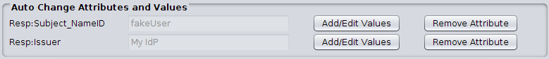
- Save the changes and initiate a valid SAML request from the browser, and the attributes that were set to change will change before the message is sent to the endpoint.

Configure New/Custom attributes
The extension allow to add new and custom attributes other than the built-in ones. You need to give 4 parameters when a new one is added
- Name : To identify the attribute
- View Name : A String with less than 30 characters. This will be the attribute name shown to the user.
- Xpath : The Xpath value of attribute. This is used to find and edit the value of the attribute from an assertion (XML string) if it exists.
- Value type : The value type of the attribute. Will be validated (If enabled) when setting a value
To add attributes,
- Go to setting window.
- Click the “Add SAML Attributes” button at the bottom.
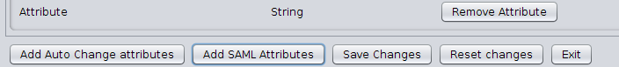
- Give the parameters described above and It will be added at the “Configured attributes” section

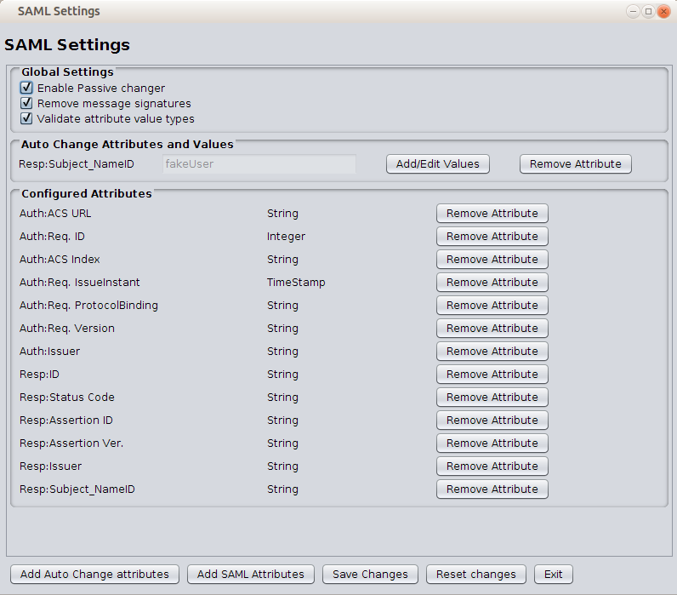

Remove Signature from Assertions (If any)
- Go to Settings window
- Check the “Remove Message Signature” check-box. (And make sure passive change is also enabled)
The signatures will be removed from the message now.

