Project Name : OWASP ZAP SAML 2.0 Support
Student : Pulasthi Mahawithana
Mentors : Prasad Shenoy, Kevin Wall
Wiki Page: https://www.owasp.org/index.php/GSoC2013_Ideas/OWASP_ZAP_SAML_Support
Project code : https://github.com/pulasthi7/zap-saml-extension (hosted at github temporarily and will be moved to ZAP code repository once finished)
Pre-releases : https://github.com/pulasthi7/zap-saml-extension/releases

Following is a brief description of ZAP SAML extension, which is done as a Google Summer of Code project.

The extension is capable of identifying the SAML requests and add/edit/delete the attributes and values of the SAML request. This can be done in 2 different ways.

Change the requests before sending them to the endpoint with pre-defined values.

- This is setting window (Tools - > SAML Request Editor) of the extension. Click “Add more attributes” button to get the dialog box where you can select the attribute name and a value which should be assigned to that attribute.
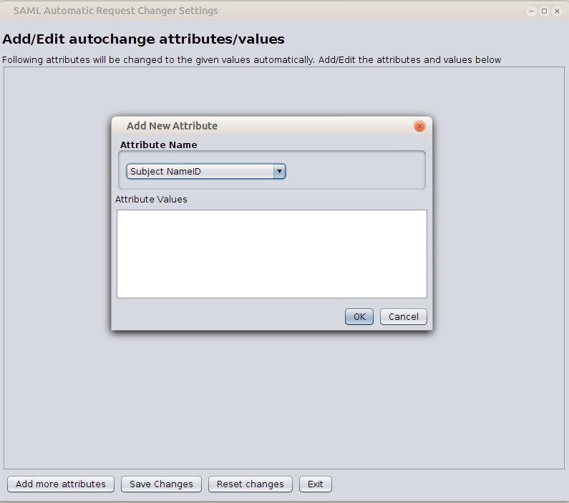
- Once they are added they will be displayed as follows, they can be removed or edited again if needed
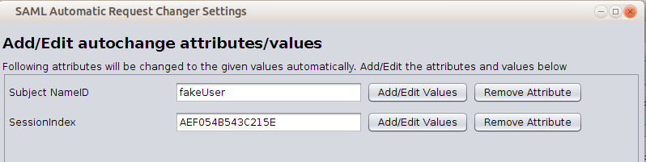
- Save the changes and initiate a valid SAML request from the browser, and the attributes that were set to change will change before the message is sent to the endpoint. Following is a part of a message that were automatically changed as given in above settings

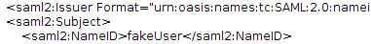

- If the end-point fails to do the security checks like signature validation, it will accept the changed parameters which will allow the attacks. Following is an example how a sample SP who doesn't validate the requests can be attacked. First one is the actual behavior where it should be as second one without the change.
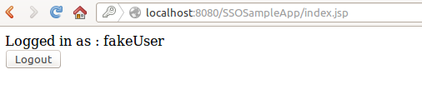
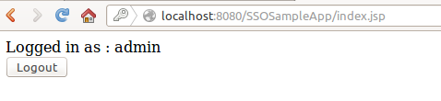

Replay already sent requests with changes to the SAML Message

- In the history tab, select a request that contains a SAML message in it. (Can be identified by the 'SAMLRequest' or 'SAMLResponse' parameters). Following is an example of such message in the history tab.
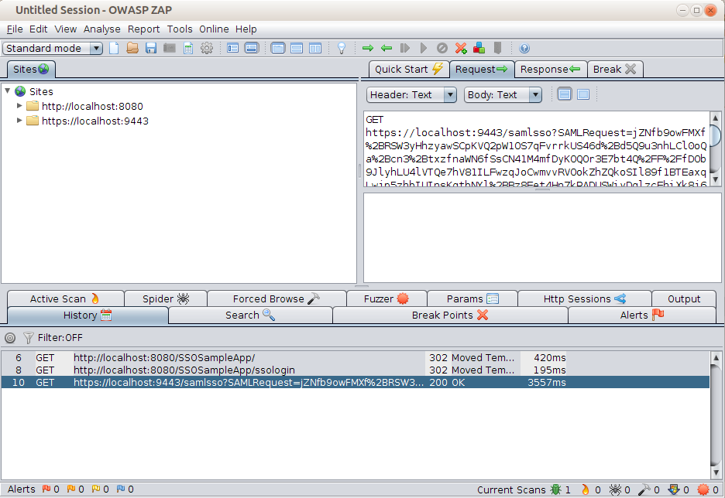
- Right click on the request and select “SAML Actions → Resend”. If it's a valid SAML request, a Window will be shown as below. It will consist of two tabs for requst and response. Request tab will have 2 parts. The decoded SAML message from the HTTP request in the XML format will be shown in the top part. The bottom part will show some of the common attributes/values in the message. The user can edit the request from either of the places.
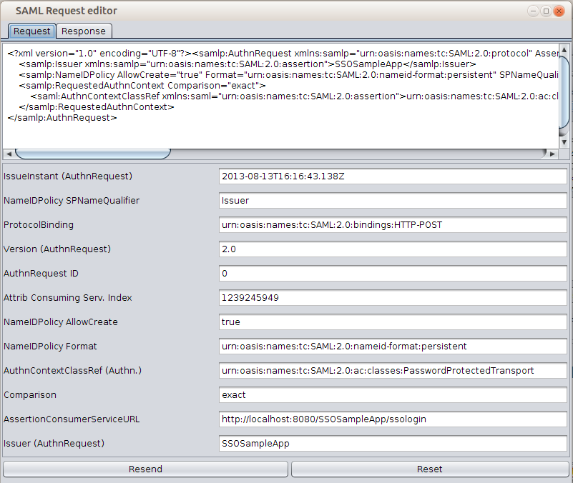

If the request doesn't have a SAML message it will show a error message as follows. (The request selected here is a usual http request to google)

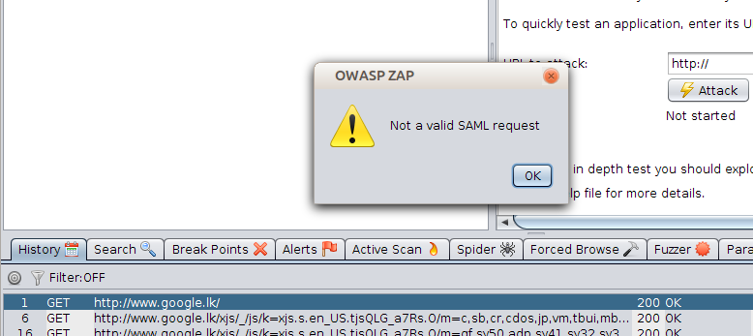

- Once the request is edited as needed, the edited request can be sent to the end-point and see the response from the endpoint. Following is a edited request (Note the AssertionConsumerServiceURL is changed to some fake value) and response for it.

