**The importance of automatic determination of the normalized vegetation index in efficient use of agricultural land**

This project will analyze the quality of field from the data of several years of NDVI(normalized difference of vegetation index) indices. Till now we have designed desktop application that calculates the NDVI and provide the result in the image format. Python code fragment will import that data in RED and NIR(near infrared) format and will calculate field parameters and it will predict the quality of field. This is a work-in-progress model of the planned platform.

**General info/intro**

This project is designed to study the factors associated with the potential susceptibility of a geographic region and determine soil productivity. This helps to predict the future condition of the field and prevent crop from upcoming damages. This project intended to help the farmer to identify the health of the crop and to increase the harvest rate.

The project intended to provide its services both for the customers(farmers, land owners etc.) and for the government.

At first stage of the production project is intended to use the images from the satellites(using free web tools like Google Earth Engine, EarthExplorer, Copernicus etc) and in the second and next stages it is planned to use the images from paid tools like([WorldView-3](https://innoter.com/sputniki/worldview-3/), [SuperView-1](https://innoter.com/sputniki/superview-1/)) the drones and aircraft which will enormously increase the accuracy of the data.

**Status – in progress**

Effective field.v1 is intended to provide functions like check the quality of the crop. I will add the functions like:

* Calculating the NDVI and provide the result in image format
* Monitor and predict agricultural production
* Classify the result and brief explanation of the soil and crop formation
* Map desert encroachment
* Increase the production of the harvest

**Technologies**

For making the MVP we have used Python 3.9 and packages: numpy, earthpy, matplotlib, glob and os   
But for the future we have arranged to have both mobile and web version of the project. Which means we would need particular programming languages for frontend, backend of the web and mobile applicationand Matlab for graphical representations.

**Features:**

The first version of the project will be in with limited features which include the features like:

* Easy interface and maintenance for ordinary users
* To increase the efficient use of the land
* To detect illegally planted crops and inform the government
* Free to use for every user(in limited usage)
* Monitor and analyze the soil
* To prevent from usage of extra fertilizer which will lead to land pollution
* Efficient water usage

**Examples and the screenshots of in-progress project**

We have taken red and nir images from the satellite and using python code calculated the NDVI and took the result graphical image.

**Red image**

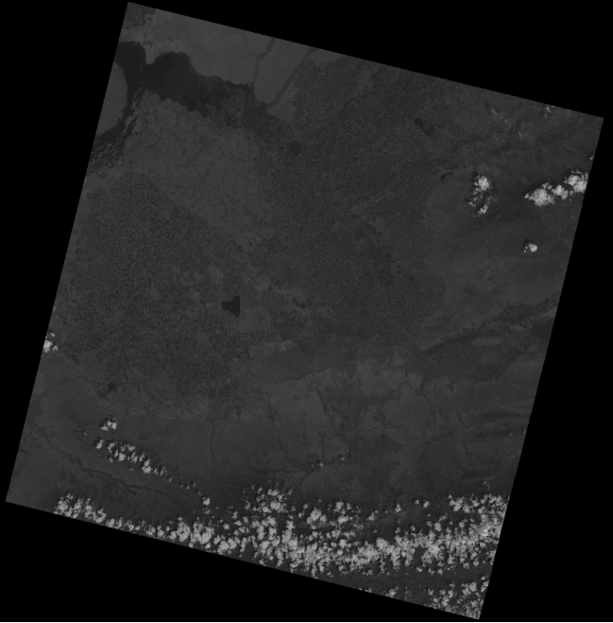

**NIR image**

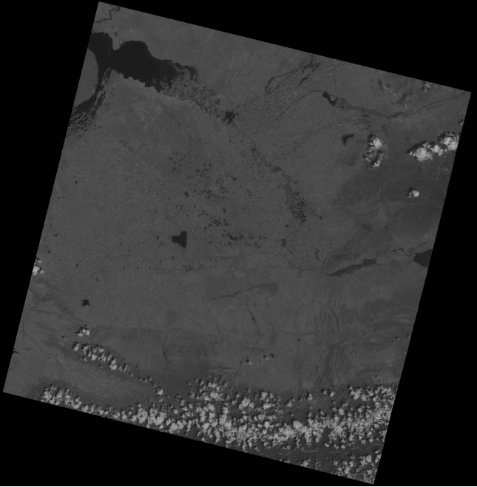

**Output**

Hence, you can see the draft of the calculation of the NDVI using our project. According to the formulae the range is between -1 till 1. The greener the fields are the more productive and healthier the crop is. The more functions would be added furthermore.

