Fall Semester 2025–2026
Digital System Design with FPGA
Lab-8, 9, 10 Report
Blues Piano Using Terasic DE2-115 Development Board
Course Code: MAVLD503
Slot: L25 + L26
Submitted to:
Dr. Jagannadha Naidu K
Submitted by:
Name | Reg. No.
Spandan Bhaduri | 26MVD0062
Pulavarti Yogesh | 26MVD0064
Chinmayananda R Sharma | 26MVD0080

1. Objectives / Specifications

1.1 Objectives
The aim of this project is to design and implement a Blues Piano on the Terasic DE2-115 FPGA development board using Verilog HDL. The piano plays the notes of a D-flat blues scale and the objectives are:
- To design a synthesizable Verilog system that reads an eight-key push-button keyboard and plays the selected note as a square wave on a speaker.
- To resolve simultaneous key presses with a priority encoder so that only one note is played at a time.
- To generate the required note frequencies from the 50 MHz board clock using PLL-derived clocks and binary up-counters acting as frequency dividers.
- To display the note being played (note letter and flat sign) on the two on-board seven-segment displays.
- To verify the design through simulation with a Verilog testbench and then implement it on hardware through pin assignment of the DE2-115 GPIO header.

1.2 Specifications
Parameter | Specification
Development board | Terasic DE2-115 (Altera Cyclone IV E FPGA)
Hardware description language | Verilog HDL
System clock | 50 MHz on-board clock (rawclk), multiplied/divided using PLLs
Inputs | Eight push-button keys (active-low), connected through the 40-pin GPIO header (GPIO 5, 7, 9, 11, 13, 15, 17, 19)
Audio output | Square wave on one GPIO pin, fed to a speaker through an audio jack
Display output | Two on-board seven-segment displays (note letter and flat sign)
Notes played | Eight keys covering the D-flat blues scale: D♭, E, G♭, G, A♭, B, and the upper-octave D♭ and E
Polyphony | Monophonic – one note at a time, highest-numbered key pressed has priority
Tools | Intel Quartus (synthesis, pin assignment) and ModelSim – Intel FPGA Starter Edition 2020.1 (simulation)

1.3 Key-to-Note Mapping
Key | Priority | Note | Display (HEX2 HEX1)
keys[7] | Highest | D♭ | D ♭
keys[6] |  | E | E
keys[5] |  | G♭ | G ♭
keys[4] |  | G | G
keys[3] |  | A♭ | A ♭
keys[2] |  | B | b
keys[1] |  | D♭ (octave up) | D ♭
keys[0] | Lowest | E (octave up) | E

1.4 Components Required
- DE2-115 Terasic development board
- 40-pin breakout ribbon cable with header connector
- Breadboard
- Eight push-button switches (keyboard keys)
- Eight 2 kΩ resistors (or resistors of similar value)
- Eight 0.022 µF capacitors (optional)
- One or two 10 µF capacitors
- Audio jack and speaker

2. Architecture / Block or Sub-block Diagram
The DE2-115 board is connected to a breadboard carrying the push-button keyboard and the audio-jack circuit through a 40-pin ribbon cable. The eight keys are connected to the GPIO header, and the audio output is taken from another GPIO pin and passed to the speaker. Figure 1 shows the complete hardware setup.
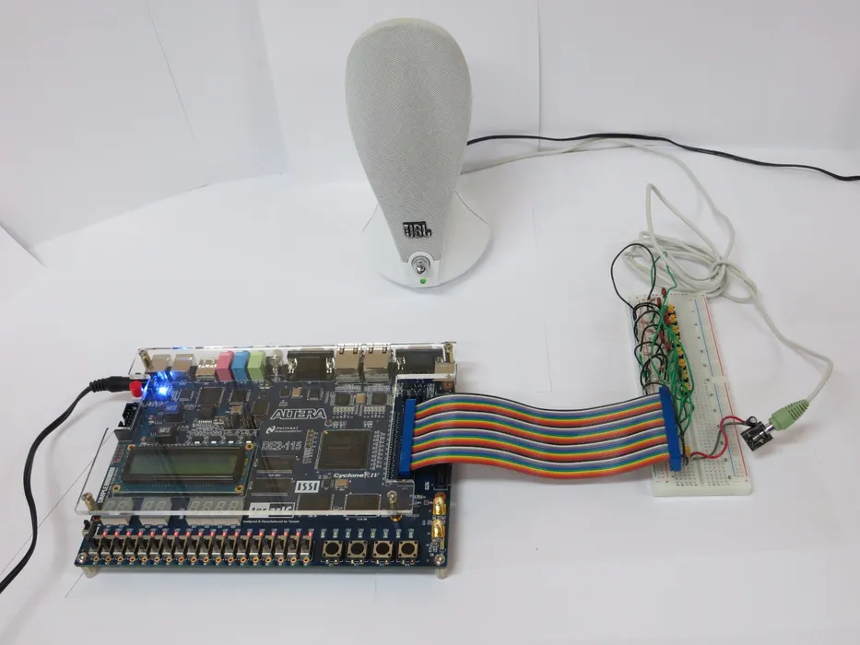
Figure 1: Hardware setup – DE2-115 board, breadboard keyboard and speaker
The Verilog design is organised hierarchically. The top-level module (Main) calls the Keyboard module to find out which note, if any, should be played, and passes this information on to the Seven Segment Display module and to the Tone Maker module. The Tone Maker selects one of the divided clock signals produced by the Clock Scheme Array, which is driven by PLLs and up-counters. Figure 2 shows the block diagram of the design.
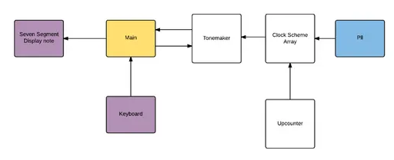
Figure 2: Block diagram of the Blues Piano Verilog modules

2.1 Module Description
Module | Function
Main (projectmaint) | Top-level module. Inverts the active-low key inputs and instantiates the keyboard, tonemaker and seven-segment modules, connecting the 4-bit note state between them.
Keyboard | Priority encoder that converts the eight key inputs into a 4-bit note code (0–7); code 15 means no key is pressed.
Tone Maker | Uses the note code to select one bit of the appropriate divided-clock counter and drives it to the speaker output as a square wave. Outputs 0 when no key is pressed.
Clock Scheme Array | Collects the PLL clock outputs and feeds each one to its own 32-bit up-counter, giving six independent frequency sources.
PLL | Generates the required higher-rate clocks from the 50 MHz input. Each on-board PLL can provide up to five output clock signals; the design uses two PLL instances (pll and pll2) created with the Quartus megafunction library.
Up-counter (upcounter32) | 32-bit binary counter. Each counter bit toggles at half the rate of the previous bit, so tapping a particular bit gives a divided square-wave clock.
Seven Segment Display note | Decodes the note code into the seven-segment patterns for the note letter (HEX2) and the flat sign (HEX1).

2.2 Working Principle
Each note is produced by dividing a PLL clock with a 32-bit counter. The counter bit chosen in the Tone Maker sets the output frequency; selecting the next lower bit doubles the frequency, which is how the upper-octave notes are obtained from the same counters. The note-to-clock selection used in the design is given below.
Note code | Note | Speaker source | Key
0 | D♭ | clkarray0[15] | keys[7]
1 | E | clkarray1[15] | keys[6]
2 | G♭ | clkarray2[15] | keys[5]
3 | G | clkarray3[15] | keys[4]
4 | A♭ | clkarray4[15] | keys[3]
5 | B | clkarray5[15] | keys[2]
6 | D♭ (octave up) | clkarray0[14] | keys[1]
7 | E (octave up) | clkarray1[14] | keys[0]
15 | No key (off) | Speaker = 0 | None pressed

Note: the Tone Maker also decodes code 8 (G♭ octave up, clkarray2[14]); this code is not generated by the keyboard module in this eight-key version.

3. Verilog Design Code
The design file (projectmaint.v) contains the top-level module and all sub-modules. The PLL modules (pll, pll2) are Quartus megafunction (IP) blocks generated in the Quartus project and are instantiated, not defined, in this file.
/* Main Control */
module projectmaint(
input rawclk, // 50MHz clock signal
input [7:0] keys, // Array of key inputs. Default HIGH.
output speaker, // Audio output (Square wave)
output [6:0] hex1, // Seven segment display output (Note letter)
output [6:0] hex2 // Seven segment display output (Accidental)
);

wire [3:0] statevalue;
wire [7:0] gkeys;

// Invert buttons so active-low becomes active-high
assign gkeys = ~keys;

// Module calls
tonemaker tonemakerinst1(
.rawclk(rawclk),
.statevalue(statevalue),
.speaker(speaker)
);

keyboard keyinstance1(
.key(gkeys),
.out(statevalue)
);

sevsegdisplaynote disnoteinstance1(
.out1(hex2),
.out2(hex1),
.note(statevalue)
);

endmodule

/* ########################################################################## */
/* Clock Scheme Array Module */
module clockschemearray(
input rawclk,
output [31:0] clkarray0,
output [31:0] clkarray1,
output [31:0] clkarray2,
output [31:0] clkarray3,
output [31:0] clkarray4,
output [31:0] clkarray5
);
wire slwclk0, slwclk1, slwclk2, slwclk3, slwclk4, slwclk5;
wire plllocked;

// Upcounters functioning as clock dividers
upcounter32 counterinstance0(slwclk0, clkarray0);
upcounter32 counterinstance1(slwclk1, clkarray1);
upcounter32 counterinstance2(slwclk2, clkarray2);

// Quartus PLL Megafunction Instantiations
pll pllinstance1(0, rawclk, slwclk0, slwclk1, slwclk2, plllocked);

upcounter32 counterinstance3(slwclk3, clkarray3);
upcounter32 counterinstance4(slwclk4, clkarray4);
upcounter32 counterinstance5(slwclk5, clkarray5);

pll2 pllinstance2(rawclk, slwclk3, slwclk4, slwclk5);

endmodule

/* ########################################################################## */
/* Tone Generation Selection Module */
module tonemaker(
input rawclk,
input [3:0] statevalue,
output reg speaker
);
wire [31:0] clkarray0;
wire [31:0] clkarray1;
wire [31:0] clkarray2;
wire [31:0] clkarray3;
wire [31:0] clkarray4;
wire [31:0] clkarray5;

// Fixed sensitivity list to avoid simulator lockups
always @(*) begin
case(statevalue)
4'd0: speaker = clkarray0[15]; // Dflat
4'd1: speaker = clkarray1[15]; // E
4'd2: speaker = clkarray2[15]; // Gflat
4'd3: speaker = clkarray3[15]; // G
4'd4: speaker = clkarray4[15]; // Aflat
4'd5: speaker = clkarray5[15]; // B
4'd6: speaker = clkarray0[14]; // Dflat Octave Up
4'd7: speaker = clkarray1[14]; // E Octave Up
4'd8: speaker = clkarray2[14]; // Gflat Octave Up
default: speaker = 1'b0; // Output Off
endcase
end

clockschemearray clkarrayinstance1(rawclk, clkarray0, clkarray1, clkarray2, clkarray3, clkarray4, clkarray5);

endmodule

/* ########################################################################## */
/* Binary Upcounter Module */
module upcounter32(
input ww,
output reg [31:0] Qq
);
// Safe initialization value for hardware registers
initial Qq = 32'b0;

always @(posedge ww) begin
Qq <= Qq + 1'b1;
end
endmodule

/* ########################################################################## */
/* Keyboard Priority Encoder Module */
module keyboard(
input [7:0] key,
output reg [3:0] out
);
always @(*) begin
casex(key)
8'b1xxxxxxx: out = 4'b0000; // Dflat
8'b01xxxxxx: out = 4'b0001; // E
8'b001xxxxx: out = 4'b0010; // G flat
8'b0001xxxx: out = 4'b0011; // G
8'b00001xxx: out = 4'b0100; // A flat
8'b000001xx: out = 4'b0101; // B
8'b0000001x: out = 4'b0110; // Dflat up
8'b00000001: out = 4'b0111; // E up
default : out = 4'b1111; // No keys pressed
endcase
end
endmodule

/* ########################################################################## */
/* Seven Segment Display Driver Module */
module sevsegdisplaynote(
output reg [6:0] out1, // Note letter
output reg [6:0] out2, // Accidental (b)
input [3:0] note
);
always @(*) begin
case(note)
4'b0000: begin out1 = 7'b0000001; out2 = 7'b1100000; end // Dflat
4'b0001: begin out1 = 7'b0110000; out2 = 7'b1111111; end // E
4'b0010: begin out1 = 7'b0100001; out2 = 7'b1100000; end // G flat
4'b0011: begin out1 = 7'b0100001; out2 = 7'b1111111; end // G
4'b0100: begin out1 = 7'b0001000; out2 = 7'b1100000; end // A flat
4'b0101: begin out1 = 7'b0000000; out2 = 7'b1111111; end // B
4'b0110: begin out1 = 7'b0000001; out2 = 7'b1100000; end // Dflat up
4'b0111: begin out1 = 7'b0110000; out2 = 7'b1111111; end // E up
default: begin out1 = 7'b1111111; out2 = 7'b1111111; end // Off
endcase
end
endmodule

4. Verilog Testbench Code
The testbench (tb_projectmaint.v) generates a 50 MHz clock (20 ns period), applies each of the eight keys in turn (active-low) followed by a release of all keys, and prints the key state, speaker output and both seven-segment outputs using $monitor.
`timescale 1ns/1ps

module tb_projectmaint;

// Inputs
reg rawclk;
reg [7:0] keys;

// Outputs
wire speaker;
wire [6:0] hex1;
wire [6:0] hex2;

// Instantiate the Unit Under Test (UUT)
projectmaint uut (
.rawclk(rawclk),
.keys(keys),
.speaker(speaker),
.hex1(hex1),
.hex2(hex2)
);

// Generate 50MHz clock (20ns period)
initial begin
rawclk = 0;
forever #10 rawclk = ~rawclk;
end

// Stimulus and Monitoring
initial begin
// Default state: all keys released (active-HIGH input, so 8'hFF)
keys = 8'hFF;

// Print header
$display("==================================================================");
$display(" Time (ns) | Keys (Active-Low) | Speaker | Hex1 | Hex2 | Note");
$display("==================================================================");

// Continuous monitoring using text output with a music note symbol
$monitor("%0t ns | %b | %b | %b | %b | ♫",
$time, keys, speaker, hex1, hex2);

// Cycle through all 8 keys one by one (active-low pulls individual bits to 0)
#100 keys = 8'b01111111; // Tests Key 7 (State 0: Dflat)
#200 keys = 8'b10111111; // Tests Key 6 (State 1: E)
#200 keys = 8'b11011111; // Tests Key 5 (State 2: Gflat)
#200 keys = 8'b11101111; // Tests Key 4 (State 3: G)
#200 keys = 8'b11110111; // Tests Key 3 (State 4: Aflat)
#200 keys = 8'b11111011; // Tests Key 2 (State 5: B)
#200 keys = 8'b11111101; // Tests Key 1 (State 6: Dflat Up)
#200 keys = 8'b11111110; // Tests Key 0 (State 7: E Up)
#200 keys = 8'b11111111; // Release all keys (Default / Off)
#200;

$display("==================================================================");
$display("Test completed successfully.");
$finish;
end

endmodule

5. Simulation
The design was simulated in ModelSim – Intel FPGA Starter Edition 2020.1 using the testbench above. Figure 3 shows the waveform window and the transcript output.
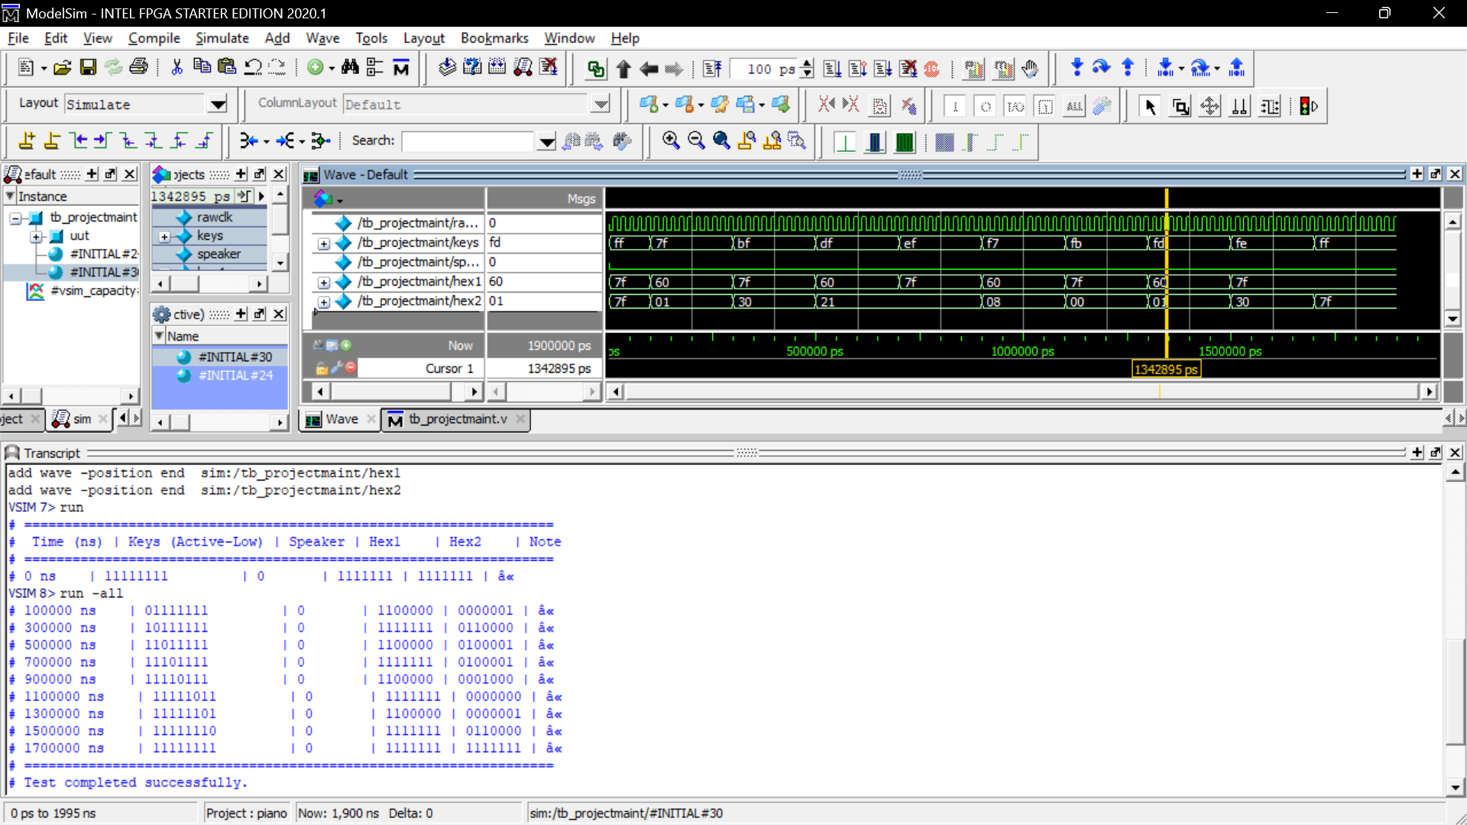
Figure 3: ModelSim waveform and transcript of tb_projectmaint
Observations from the simulation (key values are active-low):
Time (ns) | keys | hex1 (flat sign) | hex2 (note letter)
0 | 11111111 | 1111111 | 1111111
100 | 01111111 | 1100000 | 0000001
300 | 10111111 | 1111111 | 0110000
500 | 11011111 | 1100000 | 0100001
700 | 11101111 | 1111111 | 0100001
900 | 11110111 | 1100000 | 0001000
1100 | 11111011 | 1111111 | 0000000
1300 | 11111101 | 1100000 | 0000001
1500 | 11111110 | 1111111 | 0110000
1700 | 11111111 | 1111111 | 1111111

The seven-segment outputs change correctly for every key: keys that select a flat note (D♭, G♭, A♭) show the flat sign on hex1, natural notes leave hex1 blank, and releasing all keys turns both displays off. The transcript ends with “Test completed successfully.” at 1900 ns.

6. Pin Assignment / .tcl File
The keyboard inputs are taken from GPIO 5, 7, 9, 11, 13, 15, 17 and 19 of the JP5 40-pin header, and the speaker output is taken from a GPIO pin of the same header. Figure 4 shows the GPIO pin planner of the header connector.
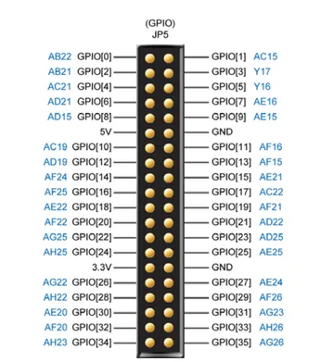
Figure 4: DE2-115 GPIO (JP5) header pin planner

6.1 Pin Assignment Table
Signal | FPGA Pin | Connected to | Description
rawclk | PIN_Y2 | CLOCK_50 | 50 MHz clock
keys[7] | PIN_Y16 | GPIO[5] | Key – D♭
keys[6] | PIN_AE16 | GPIO[7] | Key – E
keys[5] | PIN_AE15 | GPIO[9] | Key – G♭
keys[4] | PIN_AF16 | GPIO[11] | Key – G
keys[3] | PIN_AF15 | GPIO[13] | Key – A♭
keys[2] | PIN_AE21 | GPIO[15] | Key – B
keys[1] | PIN_AC22 | GPIO[17] | Key – D♭ (octave up)
keys[0] | PIN_AF21 | GPIO[19] | Key – E (octave up)
speaker | PIN_AE25 | GPIO[25] | Audio output
hex1[0..6] | G18, F22, E17, L26, L25, J22, H22 | HEX0 | Flat sign
hex2[0..6] | M24, Y22, W21, W22, W25, U23, U24 | HEX1 | Note letter

6.2 Tcl Script (piano.tcl)
# Pin assignments (Quartus Prime Tcl script)
# Usage: quartus_sh -t pin_assignments.tcl
# or in Quartus: Tools > Tcl Scripts... > select this file > Run
#
# Change PROJECT_NAME to match your .qpf project name.

load_package project

set PROJECT_NAME "your_project_name"

if {[is_project_open]} {
set opened_here 0
} else {
project_open $PROJECT_NAME
set opened_here 1
}

# { node_name pin_location }
set pin_list {
{hex1[0] PIN_G18}
{hex1[1] PIN_F22}
{hex1[2] PIN_E17}
{hex1[3] PIN_L26}
{hex1[4] PIN_L25}
{hex1[5] PIN_J22}
{hex1[6] PIN_H22}

{hex2[0] PIN_M24}
{hex2[1] PIN_Y22}
{hex2[2] PIN_W21}
{hex2[3] PIN_W22}
{hex2[4] PIN_W25}
{hex2[5] PIN_U23}
{hex2[6] PIN_U24}

{keys[0] PIN_AF21}
{keys[1] PIN_AC22}
{keys[2] PIN_AE21}
{keys[3] PIN_AF15}
{keys[4] PIN_AF16}
{keys[5] PIN_AE15}
{keys[6] PIN_AE16}
{keys[7] PIN_Y16}

{rawclk PIN_Y2}
{speaker PIN_AE25}
}

foreach entry $pin_list {
set node [lindex $entry 0]
set pin [lindex $entry 1]

# Location
set_location_assignment $pin -to $node

# I/O standard (2.5 V for all pins)
set_instance_assignment -name IO_STANDARD "2.5 V" -to $node
}

# Current strength / slew rate are left at their defaults (8mA, slew 2),
# so no explicit assignments are needed. To set them explicitly, uncomment:
# foreach entry $pin_list {
# set node [lindex $entry 0]
# set_instance_assignment -name CURRENT_STRENGTH_NEW "8MA" -to $node
# }

export_assignments

if {$opened_here} {
project_close
}

puts "Pin assignments applied successfully."

7. Output / Result

8. GitHub Repository Link

