Customization

Most customization is available from the the Tools menu.

Tools>Options>Export

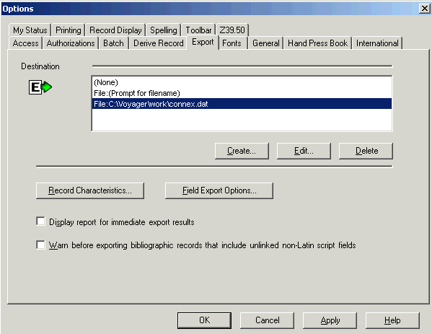

Click to choose fields to eliminate when exporting records to Voyager

Copy & paste these: 938,952,994,948,852,029,901,907,910,980,990,799 and add more if you like

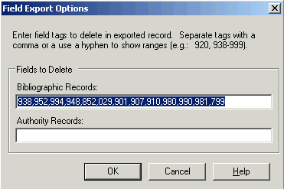

Click or press <Enter> to apply the settings and close the Options window.
Or
Click to apply the settings without closing the window.
Or
Click to cancel changes.

Tools>Options>Fonts

Records Lists
Display size: to suit Display size: to suit
Print size: no smaller than 12 Print size: no smaller than 12

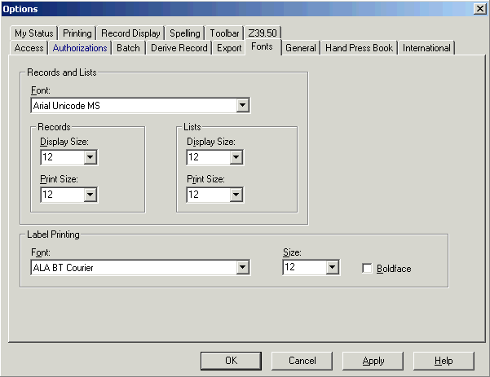

Click or press <Enter> to apply the settings and close the Options window.
Or
Click to apply the settings without closing the window.
Or
Click to cancel changes.

Tools>Options>Record Display
Element:
Bibliographic window changes the background window
Bibliographic text changes the text
Bibliographic field changes the bib. record field backgrounds

Choose element 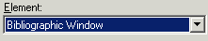

Click

Click on color (or define a custom color)

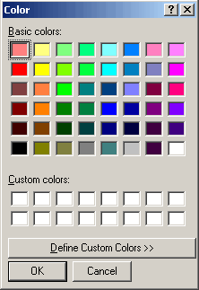 Click

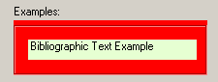 will show you how your color looks.

If you like it, click

If not, click

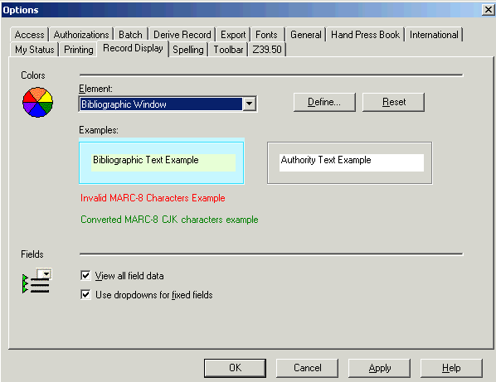

Tools>Options>Toolbar

Button sizes choose radio box Standard or Large

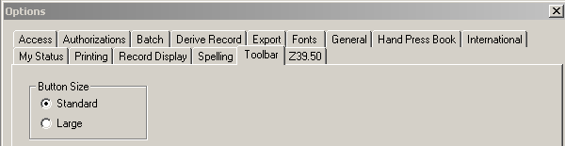

(must logoff and logon again to make change show)

Toolbar (OCLC documentation)

To display icons in 2 rows:

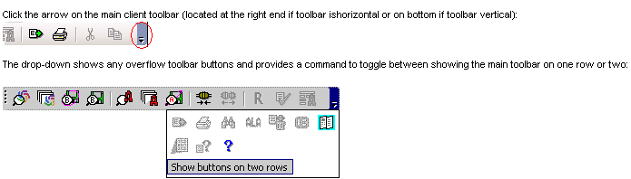

Default toolbar display: Main client toolbar (with command-equivalent buttons)

WorldCat quick search tool (for command line searching)

Text strings list and Manage command to open the Text Strings window:
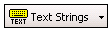
User tools list and Manage command to open the User Tools window:
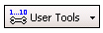

Re-position toolbars
Use drag and drop to re-position toolbars:
- Horizontally at the top or bottom (above the status bar, if the status bar is displayed) or vertically at the right or left of the client window (default position: top).
- In relation to each other within the top, bottom, right, or left location.
1. Move the cursor over the "grab bar" of a toolbar. If a toolbar is at the top or bottom of the client window, the grab bar is on the left; for example, If a toolbar is at the right or left, the grab bar is at the top.
2. When the cursor becomes a 4-pointed arrow, click and hold the grab bar, and then drag and drop the toolbar to a different position.
(The client retains the positions of toolbars when you close and reopen the program and when you upgrade to a new version.)

Tools>Toolbar Editor

To customize the main client toolbar (OCLC documentation)

Icons are in order by categories from the main OCLC menu: Action, Authorities, Batch, Cataloging, Edit, File, Help, Tools, View, and Window.

To add icon to toolbar:
On the Tools menu, click Toolbar Editor

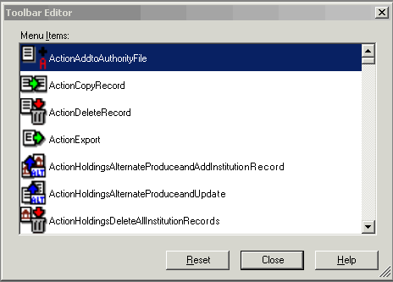

Open the Toolbar Editor window (Tools > Toolbar Editor)
Scroll the Menu Items list. When you find a button you want to add, click and hold it, and then drag and drop it where you want it to appear on the toolbar.
The image of the button also remains in the Toolbar Editor list, but you cannot add the button to the toolbar again.
When finished, click Close, or press <Enter>.

To remove icon from toolbar:
Open the Toolbar Editor window (Tools > Toolbar Editor). Click the button you want to remove and hold it, and then drag and drop it into the Toolbar Editor.
When finished, click Close, or press <Enter>.

To reposition toolbar buttons:
Press and hold the <Alt> key while you drag and drop a button in the toolbar to a new location.

Show or hide toolbars
By default, all toolbars are displayed. To toggle between hiding or re-displaying:
Click View > Toolbars, and then click Client or WorldCat Quick Search or Quick Tools.
A check mark indicates which toolbar(s) are displayed.

Customizing Search results

Types of lists (OCLC documentation)

The way search results are displayed depends on the number of records found.
1 The full record
2-5 Brief list: each entry represents a record; 2-line description
6-100 Truncated list: 1-line entry for each record; sort order depmnds on index you searched
101-1,500 Group list: each entry represents a group, sorted by type of material
Over 1,500 Error message

Brief List:
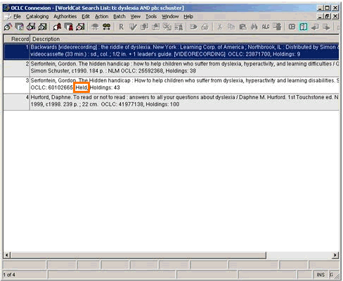

Truncated List:
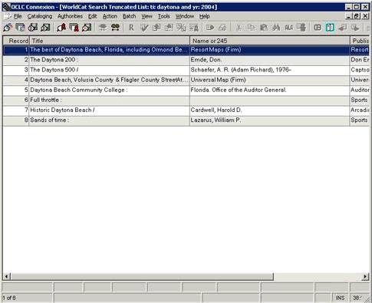

To toggle between Brief & Truncated lists— View>List type>Brief
View>List type>Truncated

The default display of the Search Results Screen is based on the result set size. If the set contains 2-5 records, a brief list displays. If there are 6-100 records, in the set the default display is a truncated list.

To toggle between brief and truncated displays, open the menu bar, from the View menu, select List Type, and click either Brief or Truncated.

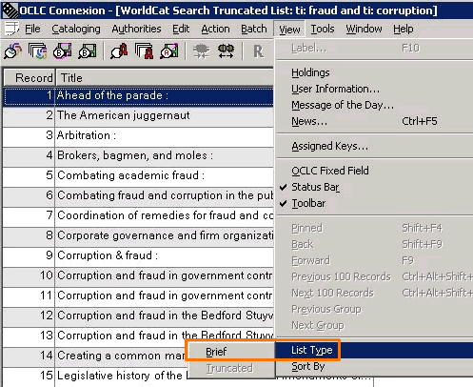

Group List:
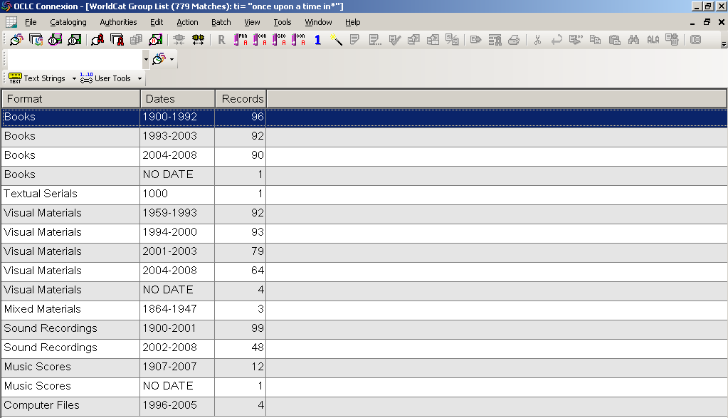

Use right-click menu to customize lists
You may want to hide columns or change the order to show data that is most important to you without having to scroll horizontally
Right-click anywhere in a list, and on the pop-up menu, click List Settings.
The Column Settings window appears:

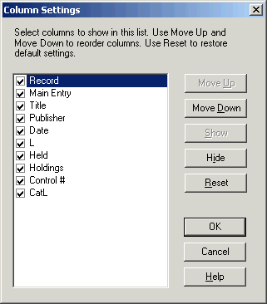

To hide a column:
In the Column Settings window, select a column by its name and click Hide.
Or
Double-click a column to clear the check box next to its name.
To display a hidden column:
Select the column and click Show.
Or
Double-click to select the check box next to the column name. A check mark indicates that the column displays.

To change the order of columns:
Select each column you want to move, one by one, and click Move Up or Move Down until it is in the position you want.
Or use the mouse to drag and drop columns in the order you need them:
You can drag and drop columns using the mouse instead of using the right-click menu to change the order of columns:
- Place the cursor over the column heading of the column you want to move.
- Hold down <Ctrl>, left-click and drag the column heading.
Or
Right-click, hold and drag the column heading.
While you drag, the cursor becomes a rectangle.
- Drop the rectangle on top of the border between two columns where you want to place the column you are dragging.

Resize columns
Move the cursor over the right-hand border of the heading for the column you want to resize until the cursor becomes . Then click and hold while you drag the border to a new position.

Important columns to understand:
L: one-character code indentifying contributing library type; 3 of the 8 types: D=LC (DLC)
P=PCC
G=GPO
Held: the word “Held” indicates the item is held by your library

Re-sort a list
Click any column heading to sort the list by that column (see list of columns above).
Or
On the View menu, click Sort by > [item]. Various record characteristics are available, depending on the type of list.

Quick tools in toolbar:

Text strings (OCLC documentation)

Create a text string of data you use frequently to insert in records.

Create a text string:
Click Tools > Text Strings (or in the text strings quick tool on the toolbar, or <Alt><T><S>)

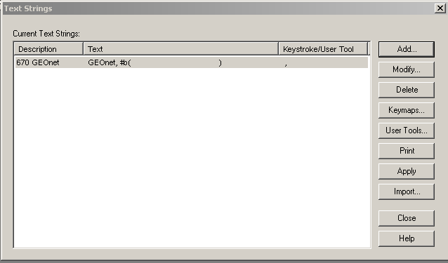

In the Text Strings window, click Add.
In the Add/Modify Text Strings window, in the Description box, enter a unique description for the text string you want to create.
In the Text box, enter the text.

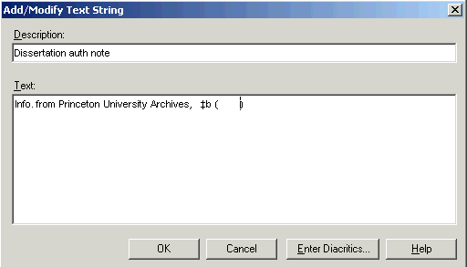

Click

Use a text string:
Click Tools > Text Strings (or in the text strings quick tool on the toolbar,or <Alt><T><S>)
Choose the text string you want
Click

User Tools (OCLC documentation)

Assign up to 10 generic user tools to:
- Insert a character
- Run a macro
- Issue a menu command
- Insert a text string
To assign user tool:
Click Tools > User Tools > Assign, or press <Alt><T><T><A>.
Or
Click the icon and name on the user tools quick tool, , or click the arrow to the right of the icon and name to expand a list, and then click Manage.
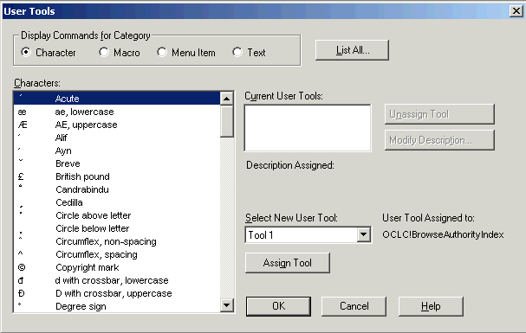
Different categories make different choices appear

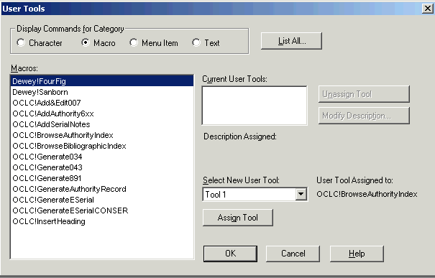
•Select an item in the list. The list below the Display Commands for Category will show the available selections for that category.
•In the Select New User Tool list, click a user tool number you want to assign.

•Click Assign.
The client assigns the user tool and supplies a default description of the tool.
- The description displays under Description Assigned in the User Tools window.
- The Tools > User Tools menu also displays descriptions for each assigned user tool.
Note: You must click Assign Tool. If you only click OK, the user tool is not assigned. After you click Assign Tool, the OK button becomes a Close button.
•To view all current user tool assignments, click List All.

•When finished, click OK or Close press <Enter> to close the window.
Or
Click Cancel to cancel changes you made before using the Assign Tool button and close the window.

To use a user tool:
Click Tools > User Tools and the tools already assigned will appear. Choose one.
or
Use the quick tool
Click the arrow and select a user tool in the list, or click Manage ... to open the User Tools window

Macros
OCLC allows one to write macros (OCLC documentation) but also provides OCLC-supplied macros. You can run these macros from Tools > Macros > Manage.

The macro window appears:

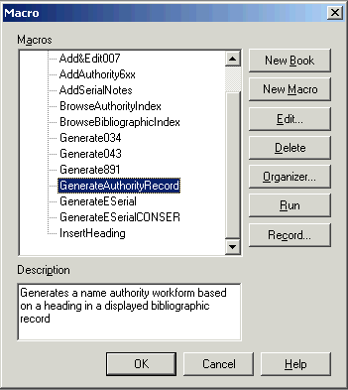

Choose a macro to run
Click or <Alt><R> (you’ll get an error message if there’s no bib. or auth. Record to apply the macro to)

There’s a ToolsMacrosManage icon in Toolbar Editor that you can add to your toolbar

Documentation, including Quick References:
http://www.oclc.org/support/documentation/connexion/client/cataloging/

