Catalogers not doing approval work 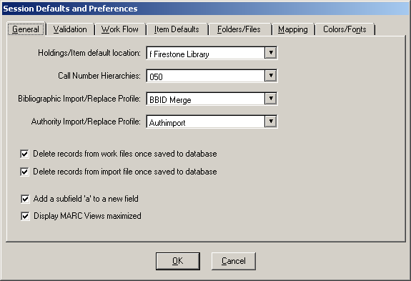

Doing approval work or creating orders
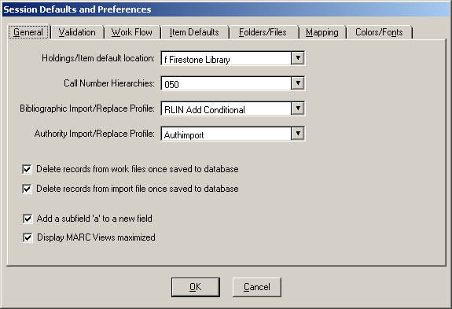

CAT DIV - professional catalogers and G-levels
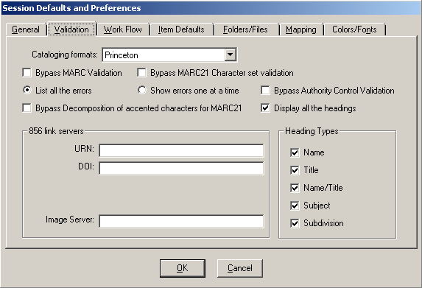

CAT DIV - F-levels
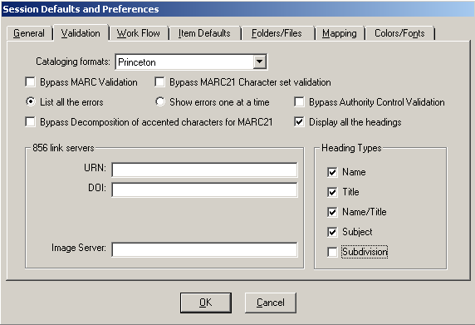

ORDER DIV (not including Binding staff doing shelf ready)
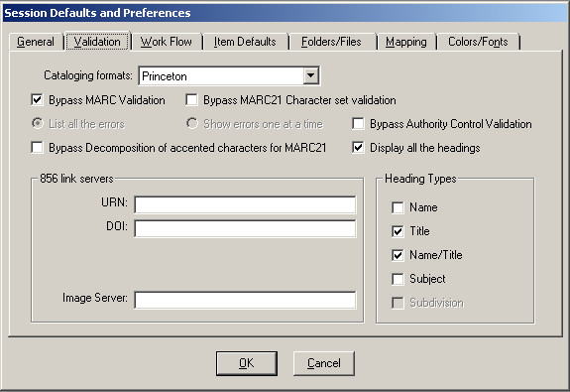
ORDER DIV -- Binding staff doing shelf ready
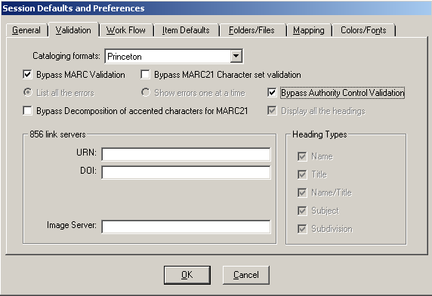

Everyone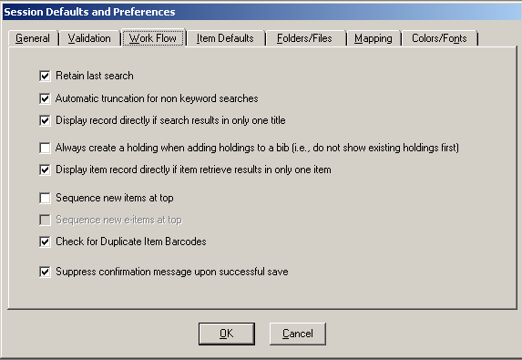

Non-approval catalogers
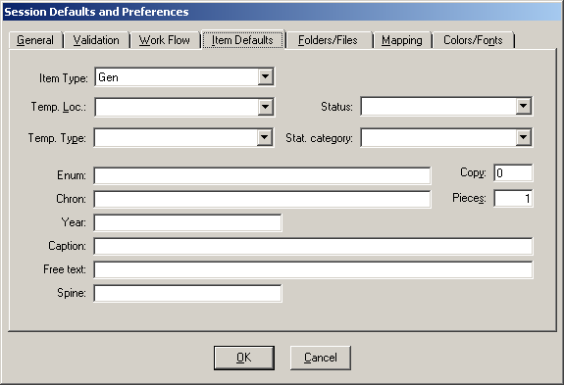

Doing approval work or creating orders
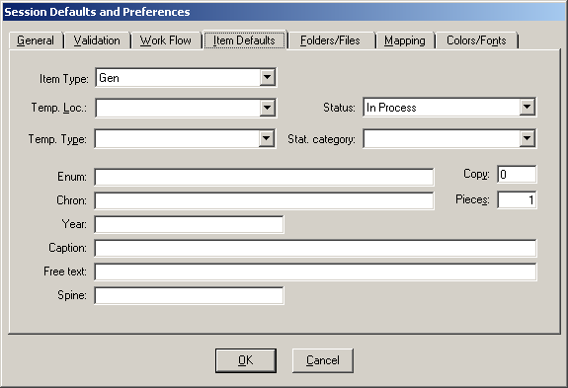

Cataloging and approval
(templates: bib=“brief.tem” hldg=”blank hol.tem”and auth=“auth.tem”)
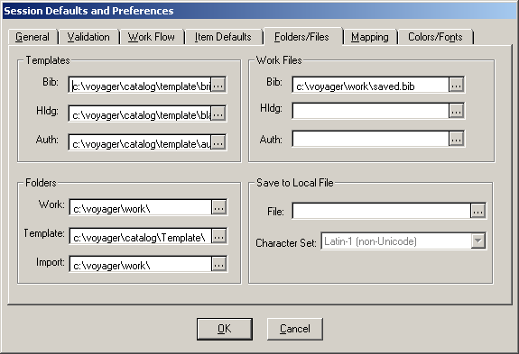

Order Div (templates: bib=“order book.tem” hldg=”hold.tem” and auth=“auth.tem”)
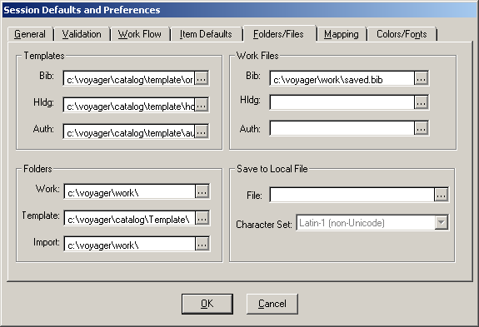

Everyone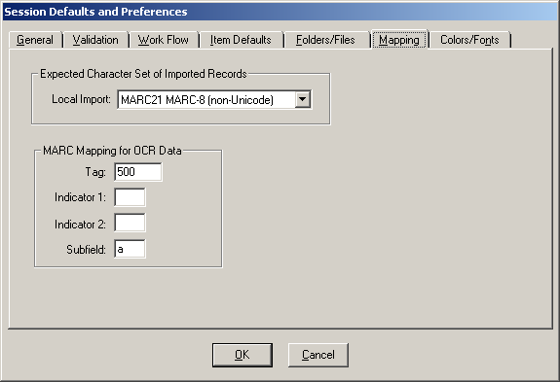

Colors/Fonts tab -- defaults for everyone (variable according to personal preference)
