Wynberg Test Drive Test Document

Areas in main test drive sequence

* Office - While in priority 2
* Polly (twice) –Always, Priorit 1, Trigger count 2
* DayOfWeek - Monday
* TimeOfDay - 9-11am
* Seq1 – Seq 2 is slave
* Seq2 – Seq 1 is master, Seq 3 is slave
* Seq3 – Seq 2 is master
* South - 160 +- 45deg
* Delay 20s
* SeqDirec1 –Seq master - Direction 270
* SeqDirec2 – Seq child - Direction 270
* Exit
* AlwaysPriority1
* Entry

Drive 1 Route Details

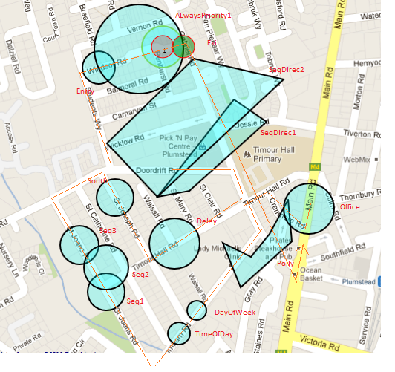

Drive 1 Test Sheet

Directions

* Start at office – drive South
* Turn right into Cranmere road
* Left into Timour Hall Road
* Left into Gabriel Road
* Right into Burnham
* 3rd right into St Joans
* Right into Doordrift
* 2nd right into St Josephs
* Left into Timour Hall
* 2nd Left into Gabriel
* First Left into Doordrift
* Right into Students Way
* 4th Right Windsor
* Right Gabriel
* Left in Main road
* Stop at office

Date and Time of Test : ………………………..

|  |  |  |  |  |  |
| --- | --- | --- | --- | --- | --- |
| Step | Where | Result Expected | Result | Rule 1 | Rule 2 |
| 1 | Start | Office.mp3 plays |  | Always |  |
| 2 | Cranmere road | Polly.mp3 plays |  | Entry | Priority |
| 3 | Burnham Road + 20m | Polly.mp3 plays |  | Entry | Trigger 2 |
| 4 | Burnham road + 50m | DayOfWeek.mp3 |  | Entry | Timed Area |
| 5 | Burnham Road + 100m | TimeOfDay.mp3 |  | Entry | Timed Area |
| 6 | St Joans Road + 40m | Seq1.mp3 plays |  | Sequence |  |
| 7 | St Joans Road + 80m | Seq2.mp3 plays |  | Sequence |  |
| 8 | St Joans Road + 120m | Seq3.mp3 plays |  | Sequence |  |
| 9 | St Josephs road + 20m | South.mp3 plays |  | Direction |  |
| 10 | Doordrift Road + 20m | SeqDirec1.mp3 plays |  | Direction | Sequence |
| 11 | Doordrift road + 40m | SeqDirec2.mp3 plays |  | Direction | Sequence |
| 12 | Start Windsor | Entry.mp3 plays |  | Entry |  |
| 13 | Middle Windsor | AlwaysPriority1.mp3 interrupts Entry.mp3 |  | ALways | Prority 1 |
| 14 | End Windsor | Exit.mp3 plays |  | Exit | Prioity 1 finished |
| 15 | Gabriel start | nothing |  | Direction | Sequence |
| 16 | Gabriel end | Nothing (no Polly) |  | Trigger count |  |
| 17 | Main | Office.mp3 |  | Entry |  |

Drive 2 Route Details

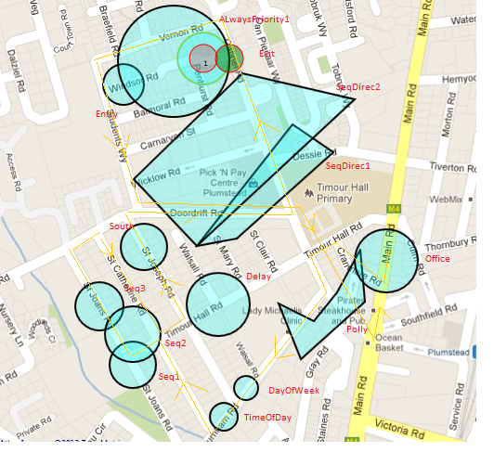

Drive 2 Test Sheet

Directions

* Start at office – drive South
* Turn right into Cranmere road
* Left into Timour Hall Road
* Left into Gabriel Road
* Right into Burnham
* 2nd right into St Catherine
* Left into Timour Hall
* Right into St Joans
* Right into Doordrift
* Right into St Catherines
* Left into Timour hall
* Left into St Josephs
* Right into Doordrift
* Left into Gabriel
* Left into Vernon
* Left Into Students way
* Left into Doordrift
* Right into Gabriel
* Left into Maik
* Route ends at Office
* Date and Time of Test : ………………………..

|  |  |  |  |  |  |
| --- | --- | --- | --- | --- | --- |
| Step | Where | Result Expected | Result | Rule 1 | Rule 2 |
| 1 | Start | Office.mp3 plays |  | Always |  |
| 2 | Cranmere road | Polly.mp3 plays |  | Entry | Priority |
| 3 | Burnham Road + 20m | Polly.mp3 plays |  | Entry | Trigger 2wice |
| 4 | Burnham road + 50m | DayOfWeek.mp3 |  | Entry | Timed Area |
| 5 | Burnham Road + 100m | TimeOfDay.mp3 |  | Entry | Timed Area |
| 6 | Corner Catherine + Timour Hall | None |  | Sequence |  |
| 7 | Timour + 20m | Seq1.mp3 plays |  | Sequence |  |
| 8 | Corner Timour and St Joans | Seq2.mp3 plays |  | Sequence |  |
| 9 | St Joans road + 20m | Seq3.mp3 plays |  | Sequence |  |
| 10 | Catherines road | nothing |  | Sequence |  |
| 11 | St Josephs | Nothing |  | Direction |  |
| 12 | Doordrift | Nothing |  | Sequence | Direction |
| 13 | Gabriel | Nothing |  | Sequence | Direction |
| 14 | Windsor entry | AlwaysPriority1 |  | ALways | Priority |
| 15 | Windsor end | Nothing |  | Superceded |  |
| 16 | Doordrift | Nothing |  | Sequence | Direction |
| 17 | Gabriel | Nothing |  | Trigger count |  |
| 18 | Main road | Office.mp3 |  | Always |  |
| 19 |  |  |  |  |  |
| 20 |  |  |  |  |  |
| 21 |  |  |  |  |  |