Absolutely. Here are your short notes for everything we completed so far. Keep these as your FoodHub React Day 1 notes.
🍔 FoodHub — Day 1 Short Notes
1. Project Setup
We created the React project using:
npm create vite@latest foodhub
Technology selected:
React
JavaScript
ESLint
Project location:
D:\project\foodhub
Run the project:
npm run dev
Browser:
http://localhost:5173

2. React Project Structure
Important files:
src/
├── components/
├── App.jsx
├── App.css
├── index.css
└── main.jsx
App.jsx
Main application component.
function App() {
return (
<h1>Hello FoodHub</h1>
)
}

export default App
main.jsx
Starts React and renders App.
main.jsx
↓
App.jsx
↓
Browser

3. React Component
A component is a reusable piece of UI.
Example:
function Navbar() {
return (
<nav>
FoodHub
</nav>
)
}
We created:
Navbar.jsx
and imported it into App.jsx:
import Navbar from './components/Navbar'
Then used:
<Navbar />

4. JSX
JSX allows us to write HTML-like code inside JavaScript.
Example:
<h1>Hello FoodHub</h1>
Important:
HTML:
class="logo"
React JSX:
className="logo"

5. React State — useState
We learned:
import { useState } from 'react'
Example:
const [menuOpen, setMenuOpen] = useState(false)
Meaning:
menuOpen
→ current value

setMenuOpen()
→ changes the value
Initial value:
false

6. Event Handling
We used:
onClick={() => setMenuOpen(!menuOpen)}
Meaning:
When the button is clicked, change the menu state.
false → true
true → false

7. Conditional Rendering
We used:
{menuOpen && (
<div className="mobile-menu">
...
</div>
)}
Meaning:
menuOpen = false
↓
Menu hidden

menuOpen = true
↓
Menu displayed

8. CSS
We created:
Navbar.css
and connected it using:
import './Navbar.css'
Important CSS concepts learned:
display: flex
justify-content
align-items
gap
padding
margin
position
transition
:hover

9. Responsive Design
We used a media query:
@media (max-width: 768px) {
...
}
Meaning:
Screen > 768px
→ Desktop design

Screen ≤ 768px
→ Mobile design
Desktop:
Logo | Home | Veg | Non-Veg | Desserts | Drinks | Search | Login | Cart
Mobile:
🍔 FoodHub ☰ 🛒

10. Mobile Hamburger Menu
We created:
{menuOpen ? '✕' : '☰'}
So:
Menu closed → ☰
Menu open → ✕
This gives users a clear way to open/close the mobile menu.

11. Current FoodHub Structure
FoodHub
│
├── Navbar
│ ├── Logo
│ ├── Home
│ ├── Veg
│ ├── Non-Veg
│ ├── Desserts
│ ├── Soft Drinks
│ ├── Search
│ ├── Login
│ └── Cart
│
└── Hello FoodHub

12. What We Have Completed
Node.js ✅
React + Vite ✅
Project setup ✅
App.jsx ✅
Components ✅
Navbar ✅
CSS ✅
Responsive design ✅
useState ✅
onClick ✅
Conditional rendering ✅
Mobile menu ✅
Current position
React Setup
↓
Navbar ✅
↓
🏠 Home Page ← NEXT
↓
Search
↓
Categories
↓
Food Cards
↓
Cart
↓
Spring Boot
↓
MySQL
↓
Login + OTP
↓
Orders
↓
Admin
Day 1 is complete. 🎯
Next we'll start Day 2 → Home Page, where we'll build the search bar, food categories, and the first attractive FoodHub UI.
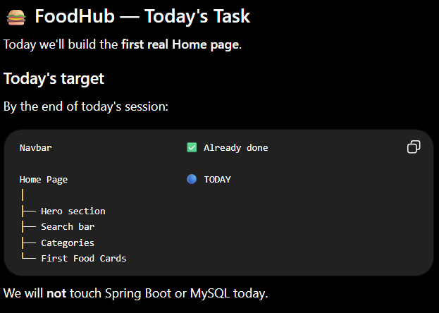
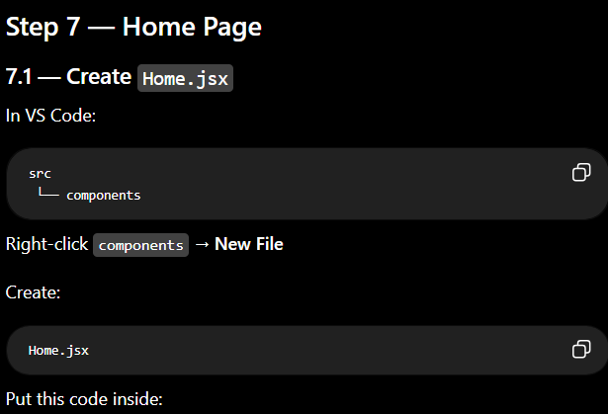
function Home() {
return (
<main className="home">

<h1>Welcome to FoodHub 🍔</h1>

<p>Delicious food delivered to your doorstep.</p>

</main>
)
}

export default Home
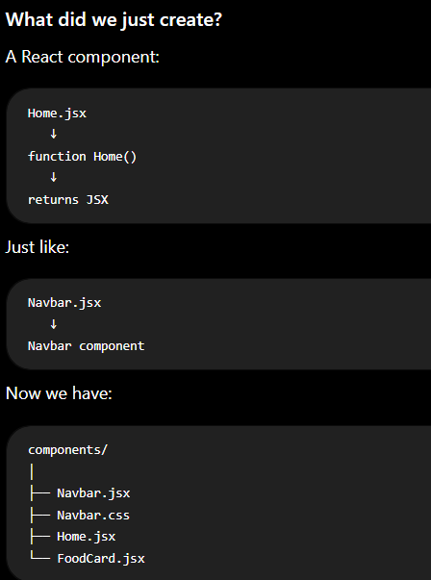

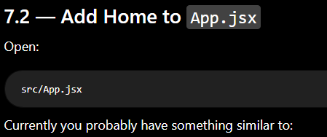
import Navbar from './components/Navbar'

function App() {
return (
<>
<Navbar />
<h1>Hello FoodHub</h1>
</>
)
}

export default App

Change it to:
import Navbar from './components/Navbar'
import Home from './components/Home'

function App() {
return (
<>
<Navbar />
<Home />
</>
)
}

export default App
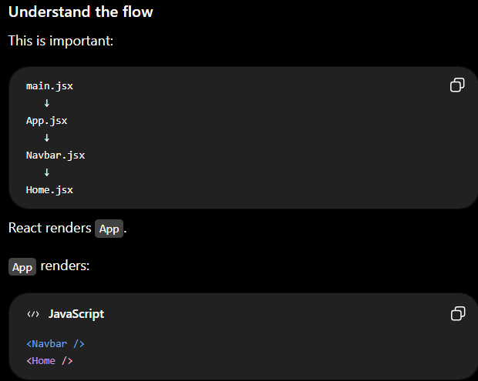

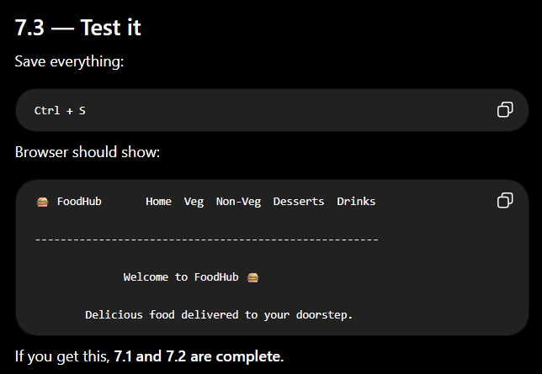

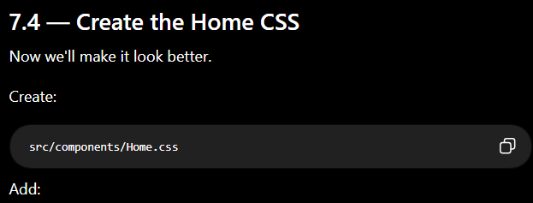
.home {
min-height: 500px;
padding: 70px 20px;
text-align: center;
}

.home h1 {
font-size: 42px;
margin-bottom: 15px;
}

.home p {
font-size: 18px;
color: #666666;
}

Then open Home.jsx and add:

import './Home.css'

So:

import './Home.css'

function Home() {
return (
<main className="home">

<h1>Welcome to FoodHub 🍔</h1>

<p>Delicious food delivered to your doorstep.</p>

</main>
)
}

export default Home
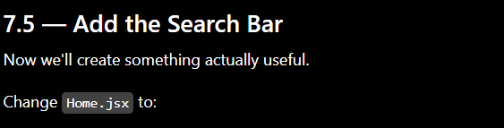
import './Home.css'

function Home() {
return (
<main className="home">

<h1>Welcome to FoodHub 🍔</h1>

<p>Delicious food delivered to your doorstep.</p>

<div className="search-box">
<input
type="text"
placeholder="Search for food..."
/>

<button>🔍 Search</button>
</div>

</main>
)
}

export default Home

Add this to Home.css:
.search-box {
display: flex;
justify-content: center;
margin-top: 30px;
}

.search-box input {
width: 400px;
padding: 14px 18px;

border: 1px solid #dddddd;
border-radius: 8px 0 0 8px;

font-size: 16px;
outline: none;
}

.search-box input:focus {
border-color: #e23744;
}

.search-box button {
padding: 14px 20px;

border: none;
border-radius: 0 8px 8px 0;

background-color: #e23744;
color: white;

font-size: 16px;
cursor: pointer;
}
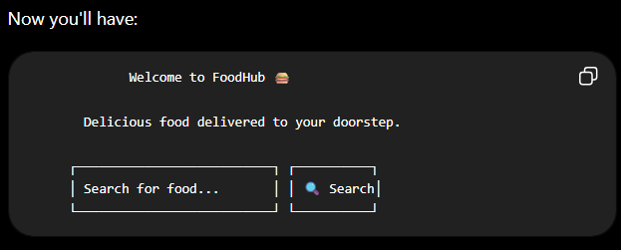

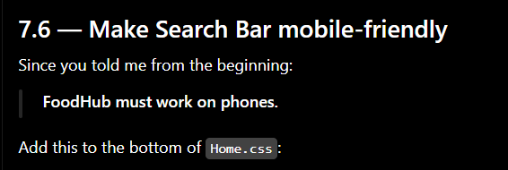

@media (max-width: 768px) {

.home {
padding: 50px 15px;
}

.home h1 {
font-size: 30px;
}

.home p {
font-size: 16px;
}

.search-box {
width: 100%;
}

.search-box input {
width: 70%;
}

.search-box button {
width: 30%;
padding: 14px 8px;
}
}

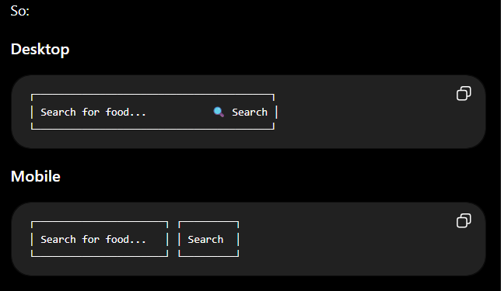

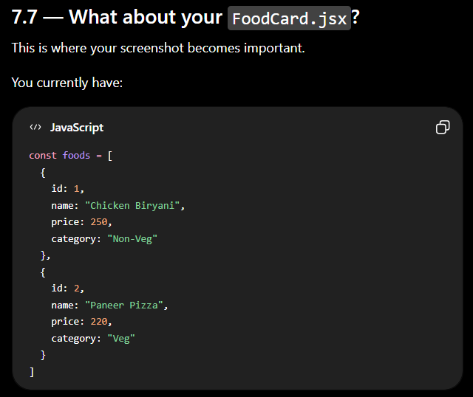

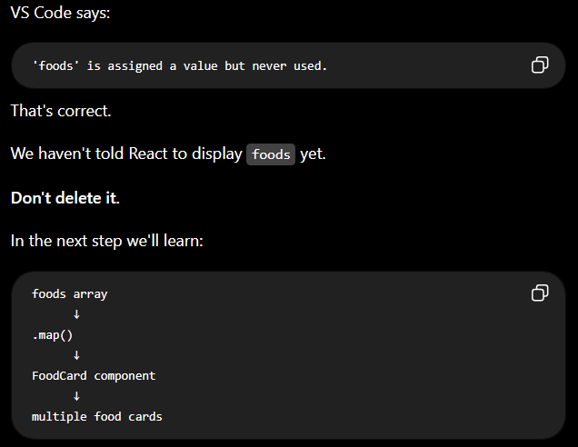

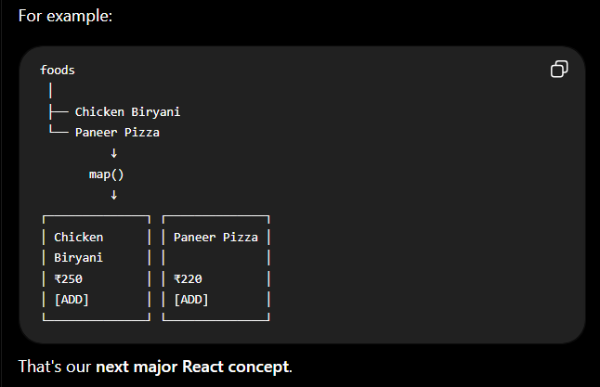

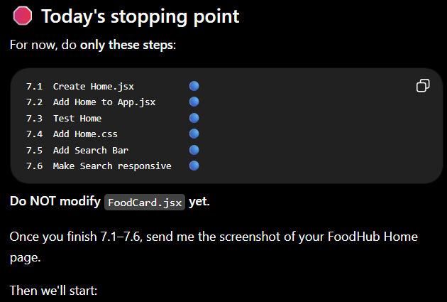

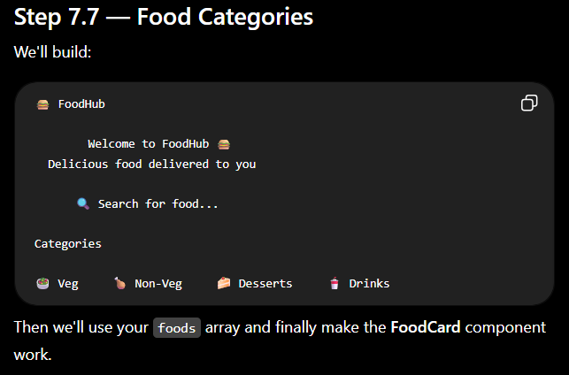

The output be like:

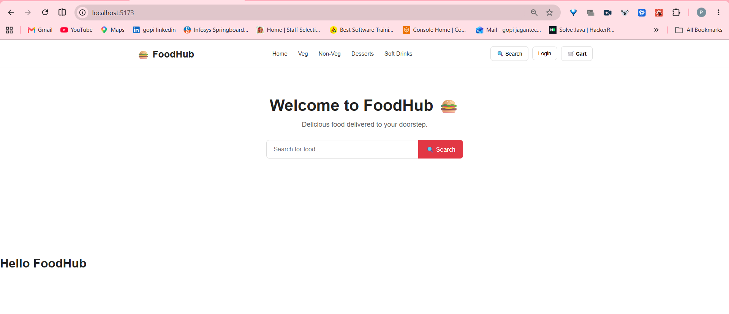
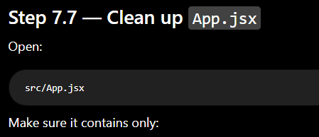

import Navbar from './components/Navbar'
import Home from './components/Home'

function App() {
return (
<>
<Navbar />
<Home />
</>
)
}

export default App

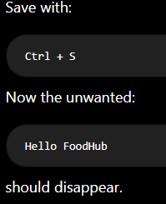

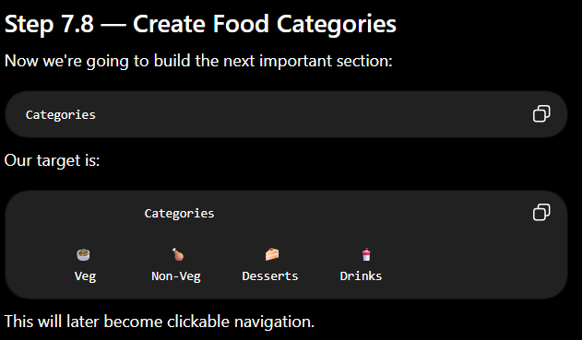

<section className="categories">

<h2>Explore Categories</h2>

<div className="category-list">

<div className="category-card">
<div className="category-icon">🥗</div>
<h3>Veg</h3>
</div>

<div className="category-card">
<div className="category-icon">🍗</div>
<h3>Non-Veg</h3>
</div>

<div className="category-card">
<div className="category-icon">🍰</div>
<h3>Desserts</h3>
</div>

<div className="category-card">
<div className="category-icon">🥤</div>
<h3>Soft Drinks</h3>
</div>

</div>

</section>

Your Home.jsx should now look like:
import './Home.css'

function Home() {
return (
<main className="home">

<h1>Welcome to FoodHub 🍔</h1>

<p>Delicious food delivered to your doorstep.</p>

<div className="search-box">
<input
type="text"
placeholder="Search for food..."
/>

<button>🔍 Search</button>
</div>

<section className="categories">

<h2>Explore Categories</h2>

<div className="category-list">

<div className="category-card">
<div className="category-icon">🥗</div>
<h3>Veg</h3>
</div>

<div className="category-card">
<div className="category-icon">🍗</div>
<h3>Non-Veg</h3>
</div>

<div className="category-card">
<div className="category-icon">🍰</div>
<h3>Desserts</h3>
</div>

<div className="category-card">
<div className="category-icon">🥤</div>
<h3>Soft Drinks</h3>
</div>

</div>

</section>

</main>
)
}

export default Home
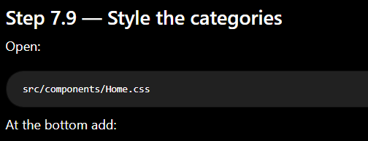
.categories {
margin-top: 70px;
}

.categories h2 {
font-size: 28px;
margin-bottom: 30px;
}

.category-list {
display: flex;
justify-content: center;
gap: 25px;
flex-wrap: wrap;
}

.category-card {
width: 150px;
padding: 25px 15px;

background-color: white;
border: 1px solid #eeeeee;
border-radius: 12px;

text-align: center;

cursor: pointer;

transition: transform 0.2s ease,
box-shadow 0.2s ease;
}

.category-card:hover {
transform: translateY(-5px);

box-shadow: 0 8px 20px rgba(0, 0, 0, 0.1);
}

.category-icon {
font-size: 45px;
margin-bottom: 10px;
}

.category-card h3 {
margin: 0;
font-size: 17px;
}
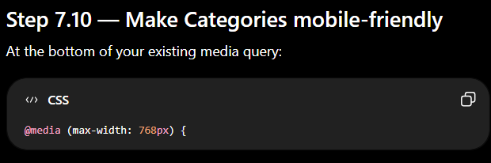
add:
.categories {
margin-top: 50px;
}

.categories h2 {
font-size: 24px;
}

.category-list {
display: grid;
grid-template-columns: repeat(2, 1fr);
gap: 15px;
}

.category-card {
width: auto;
padding: 20px 10px;
}

.category-icon {
font-size: 38px;
}
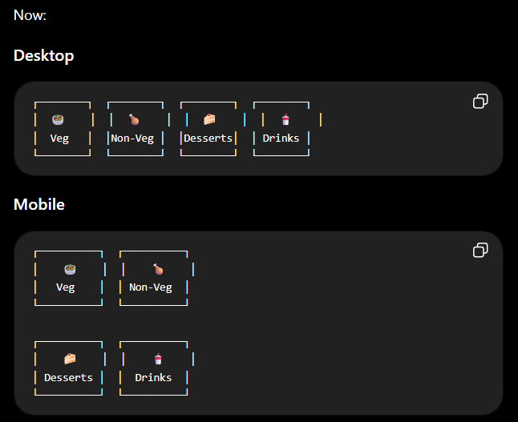

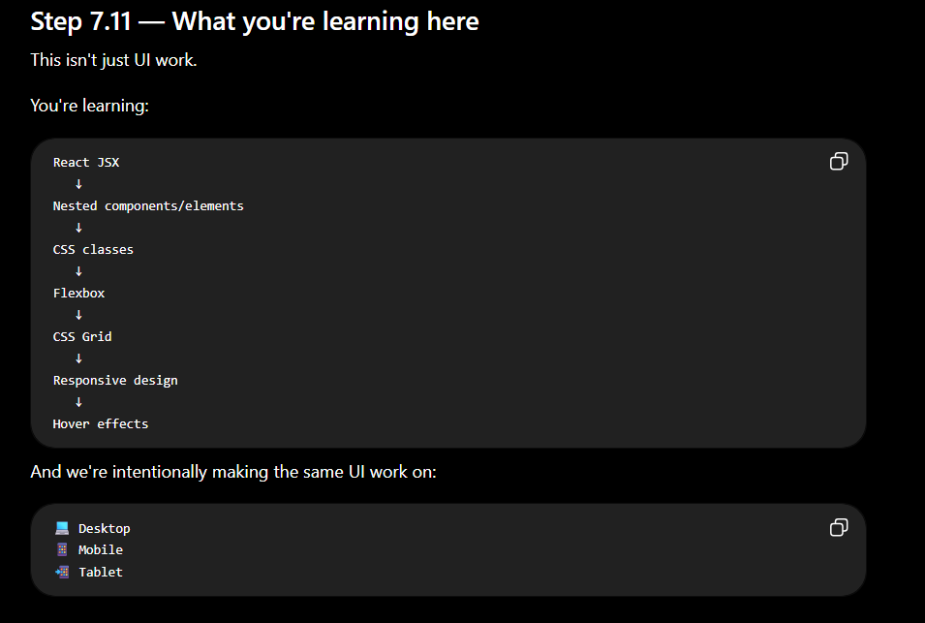

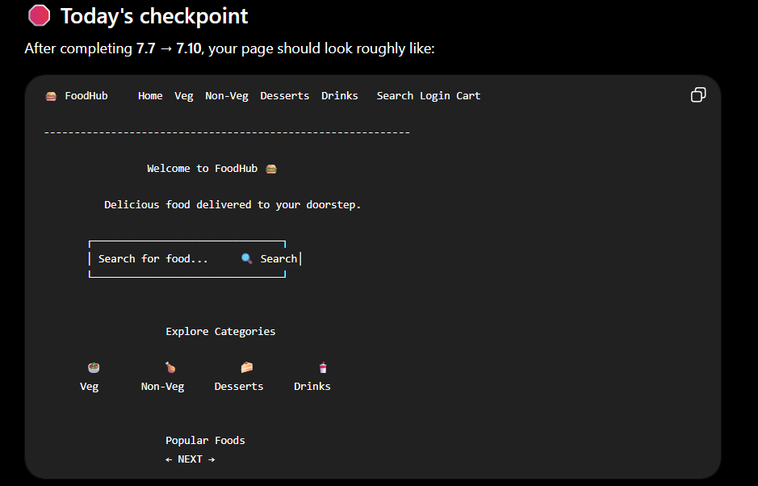

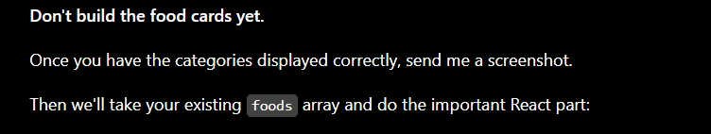

output:
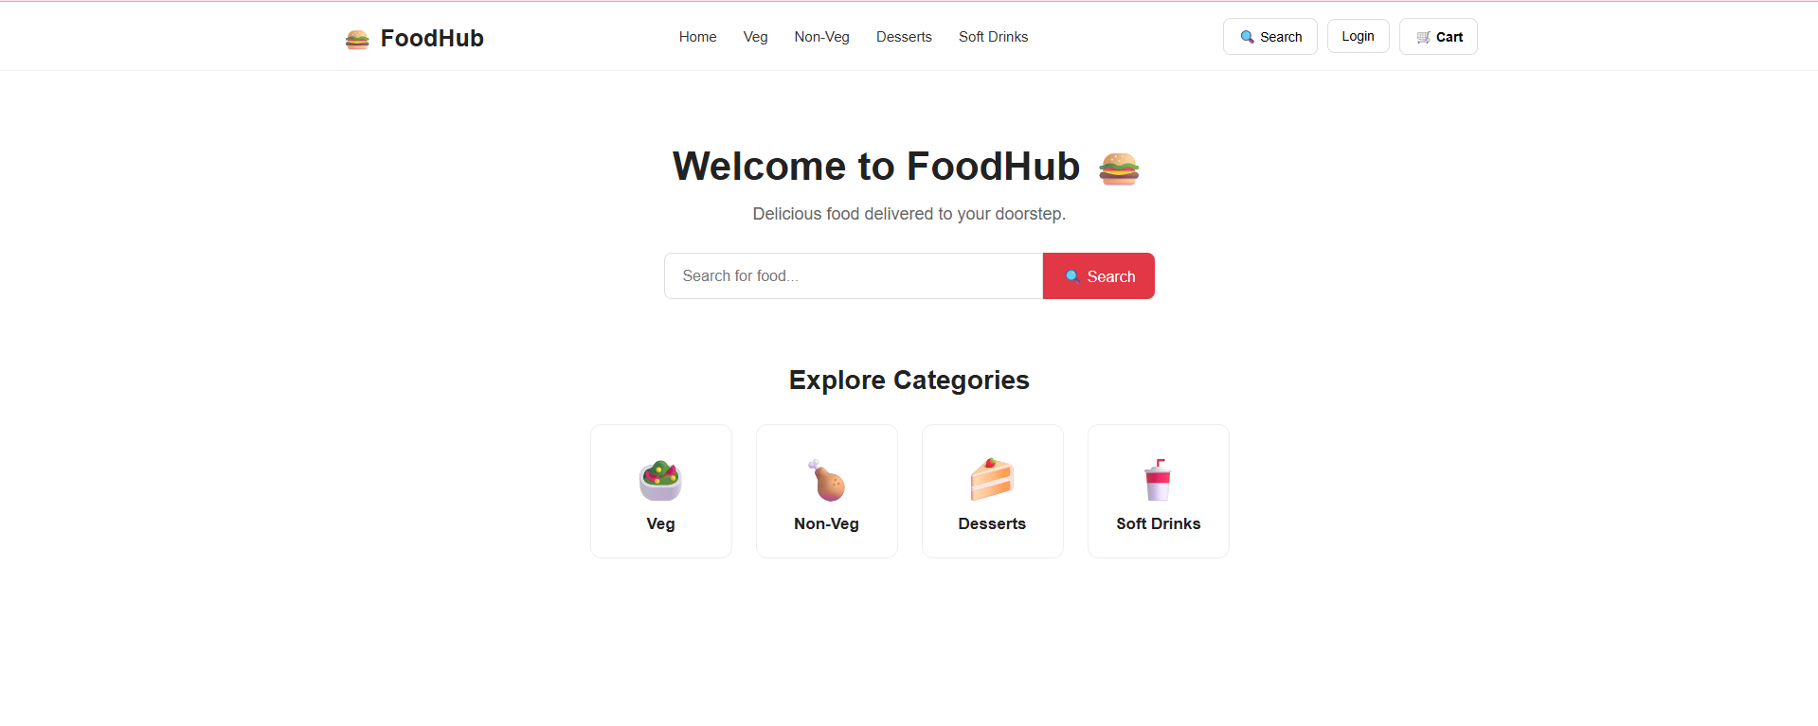
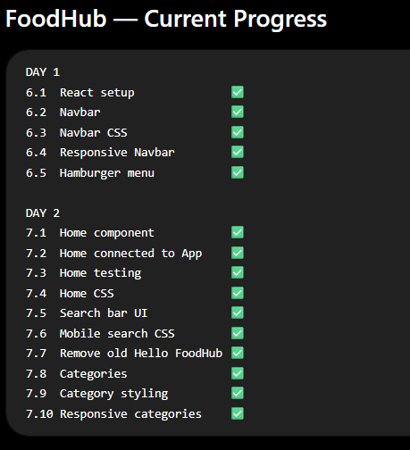
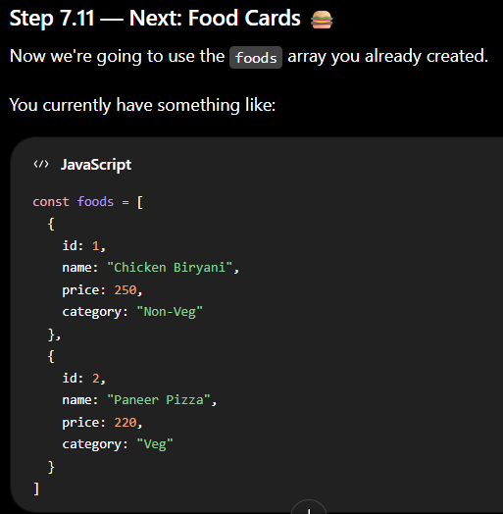

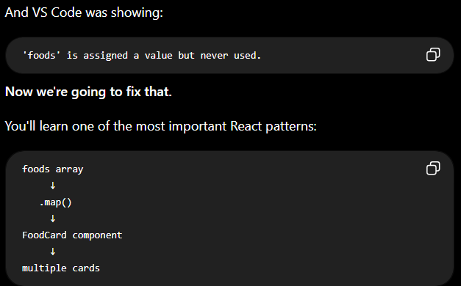

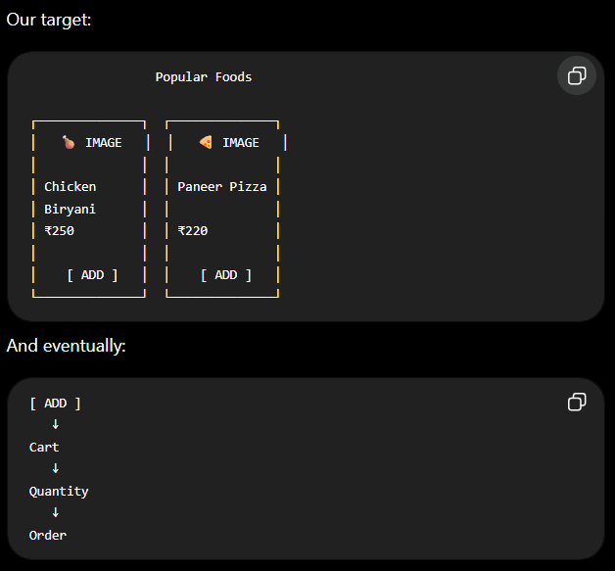

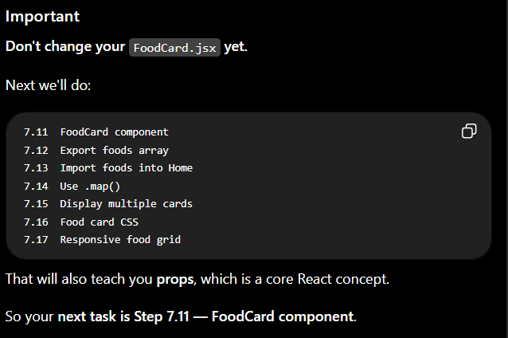

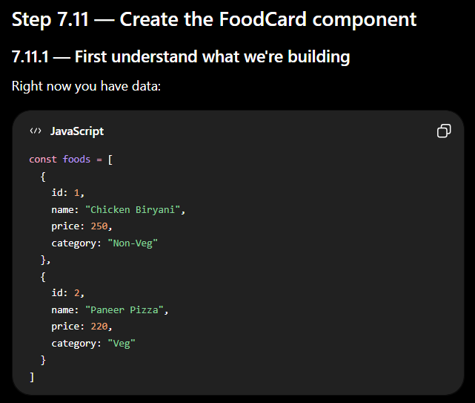

Data alone doesn't appear on the screen.
We need a component that takes one food and displays it.
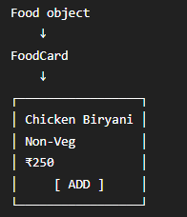
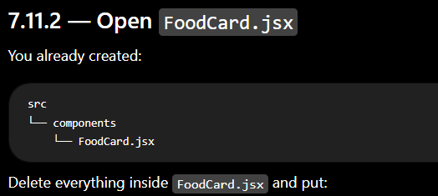

function FoodCard({ food }) {

return (
<div className="food-card">

<div className="food-image">
🍽️
</div>

<div className="food-info">

<h3>{food.name}</h3>

<p>{food.category}</p>

<div className="food-bottom">

<span>₹{food.price}</span>

<button>Add</button>

</div>

</div>

</div>
)
}

export default FoodCard

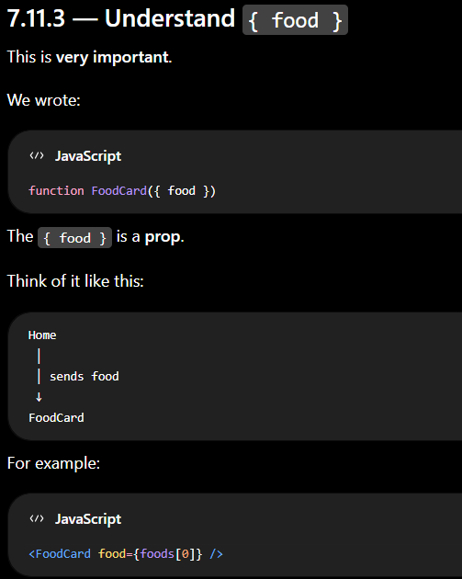

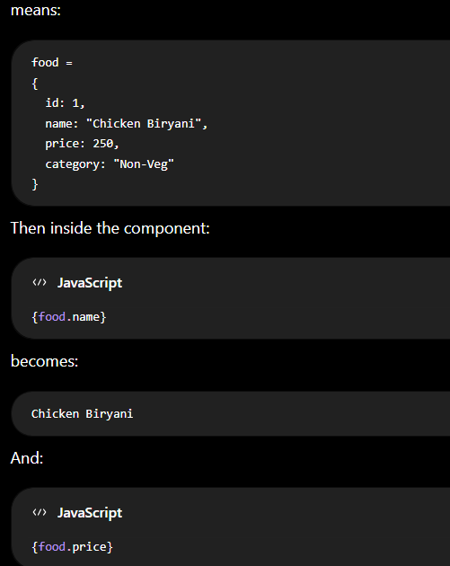

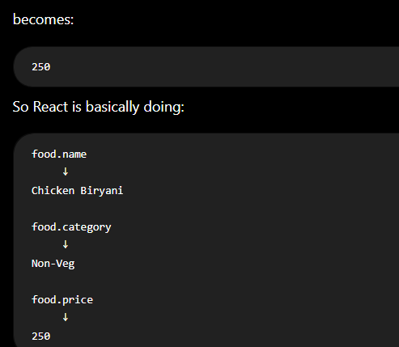

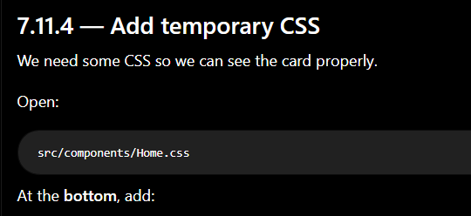

.food-card {
width: 250px;
background-color: white;
border: 1px solid #eeeeee;
border-radius: 12px;
overflow: hidden;
}

.food-image {
height: 170px;

display: flex;
align-items: center;
justify-content: center;

background-color: #f7f7f7;

font-size: 70px;
}

.food-info {
padding: 15px;
}

.food-info h3 {
margin: 0 0 6px;
font-size: 18px;
}

.food-info p {
margin: 0 0 15px;
color: #777777;
}

.food-bottom {
display: flex;
align-items: center;
justify-content: space-between;
}

.food-bottom span {
font-size: 18px;
font-weight: 700;
}

.food-bottom button {
border: none;
background-color: #e23744;
color: white;

padding: 8px 15px;
border-radius: 6px;

cursor: pointer;
}
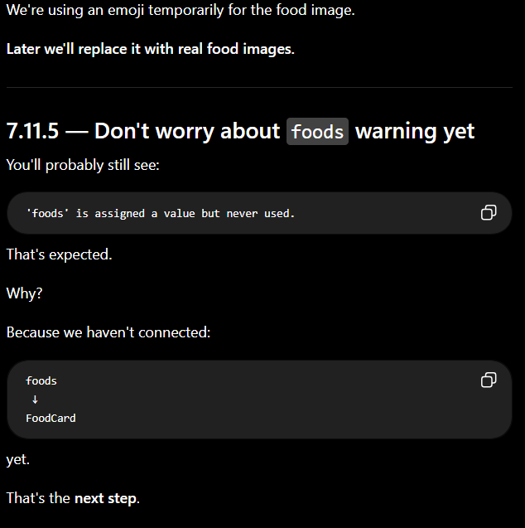

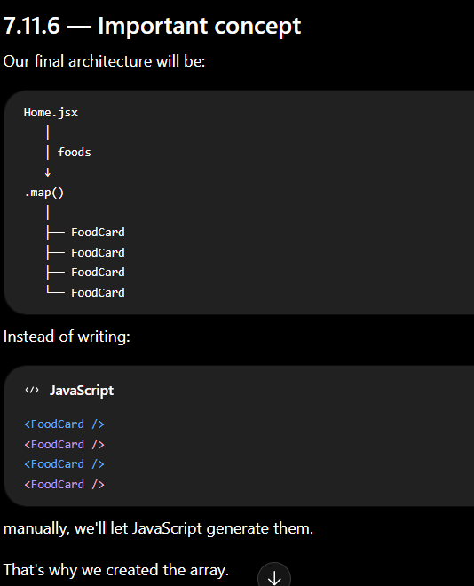

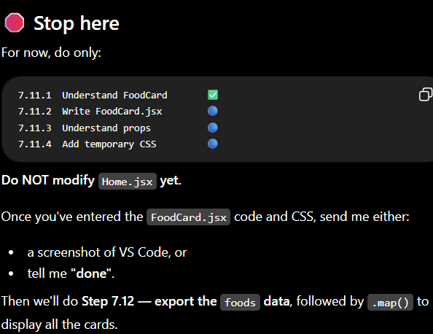
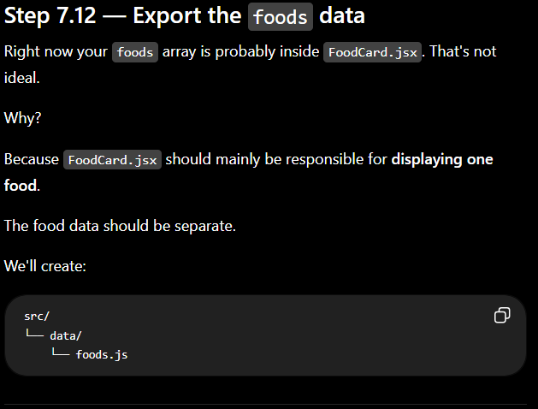

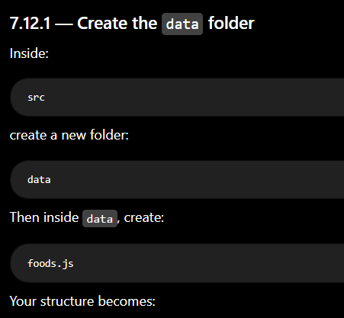

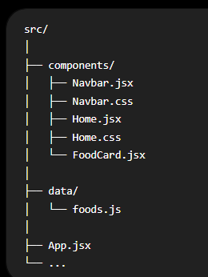

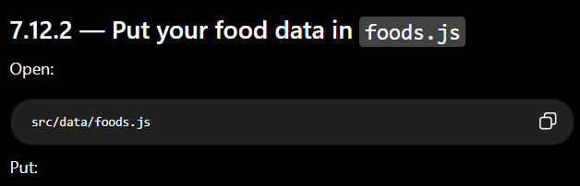

const foods = [
{
id: 1,
name: "Chicken Biryani",
price: 250,
category: "Non-Veg"
},

{
id: 2,
name: "Paneer Pizza",
price: 220,
category: "Veg"
},

{
id: 3,
name: "Chicken Burger",
price: 180,
category: "Non-Veg"
},

{
id: 4,
name: "Gulab Jamun",
price: 100,
category: "Desserts"
}
]

export default foods
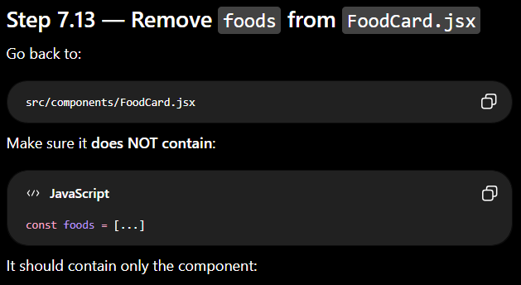

function FoodCard({ food }) {

return (
<div className="food-card">

<div className="food-image">
🍽️
</div>

<div className="food-info">

<h3>{food.name}</h3>

<p>{food.category}</p>

<div className="food-bottom">

<span>₹{food.price}</span>

<button>Add</button>

</div>

</div>

</div>
)
}

export default FoodCard

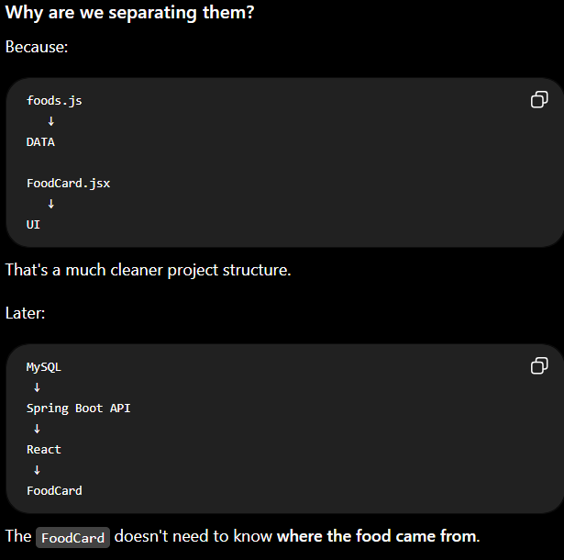

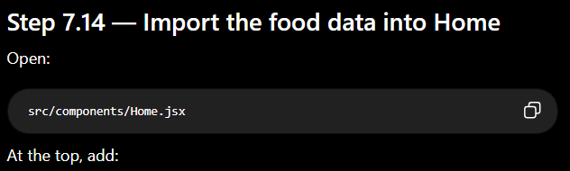

import FoodCard from './FoodCard'
import foods from '../data/foods'

So your imports become:

import './Home.css'
import FoodCard from './FoodCard'
import foods from '../data/foods'

Now Home.jsx has access to:
foods

which contains:
Chicken Biryani
Paneer Pizza
Chicken Burger
Gulab Jamun

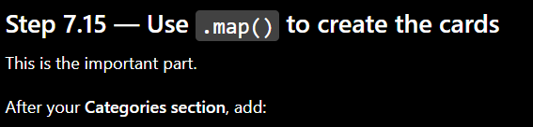

<section className="popular-foods">

<h2>Popular Foods</h2>

<div className="food-list">

{foods.map((food) => (
<FoodCard
key={food.id}
food={food}
/>
))}

</div>

</section>

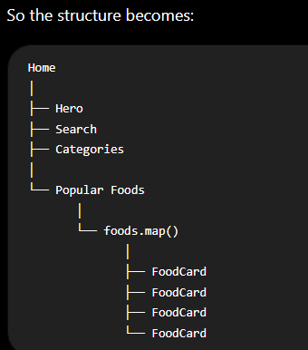

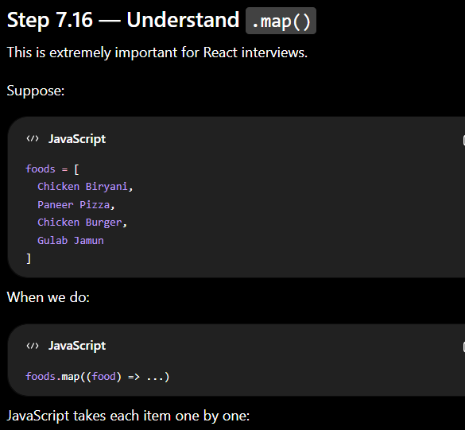

Iteration 1
food = Chicken Biryani
↓
FoodCard

Iteration 2
food = Paneer Pizza
↓
FoodCard

Iteration 3
food = Chicken Burger
↓
FoodCard

Iteration 4
food = Gulab Jamun
↓
FoodCard

So React generates four cards.

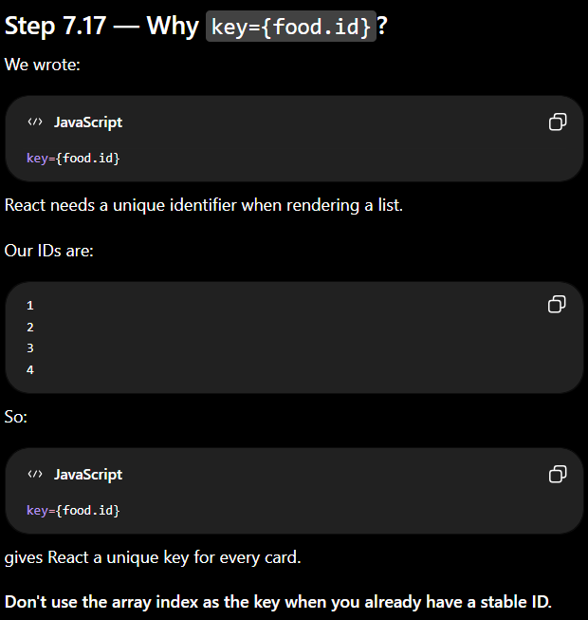

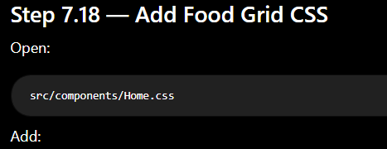

.popular-foods {
margin-top: 70px;
padding-bottom: 60px;
}

.popular-foods h2 {
font-size: 28px;
margin-bottom: 30px;
}

.food-list {
display: grid;

grid-template-columns: repeat(4, 250px);

justify-content: center;

gap: 25px;
}
Then add this inside your existing mobile media query:
.popular-foods {
margin-top: 50px;
}

.popular-foods h2 {
font-size: 24px;
}

.food-list {
grid-template-columns: repeat(2, 1fr);
gap: 15px;
}

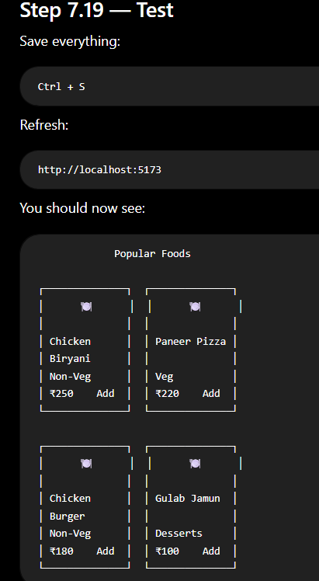

🎯 This is your first data-driven React UI.

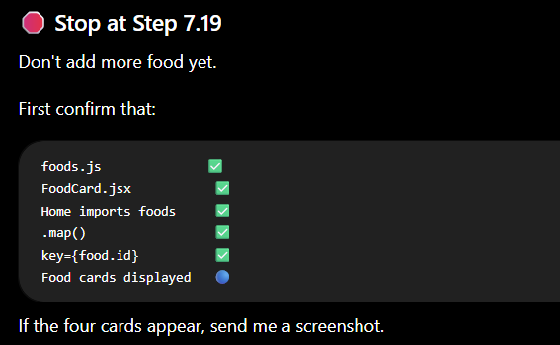

output:
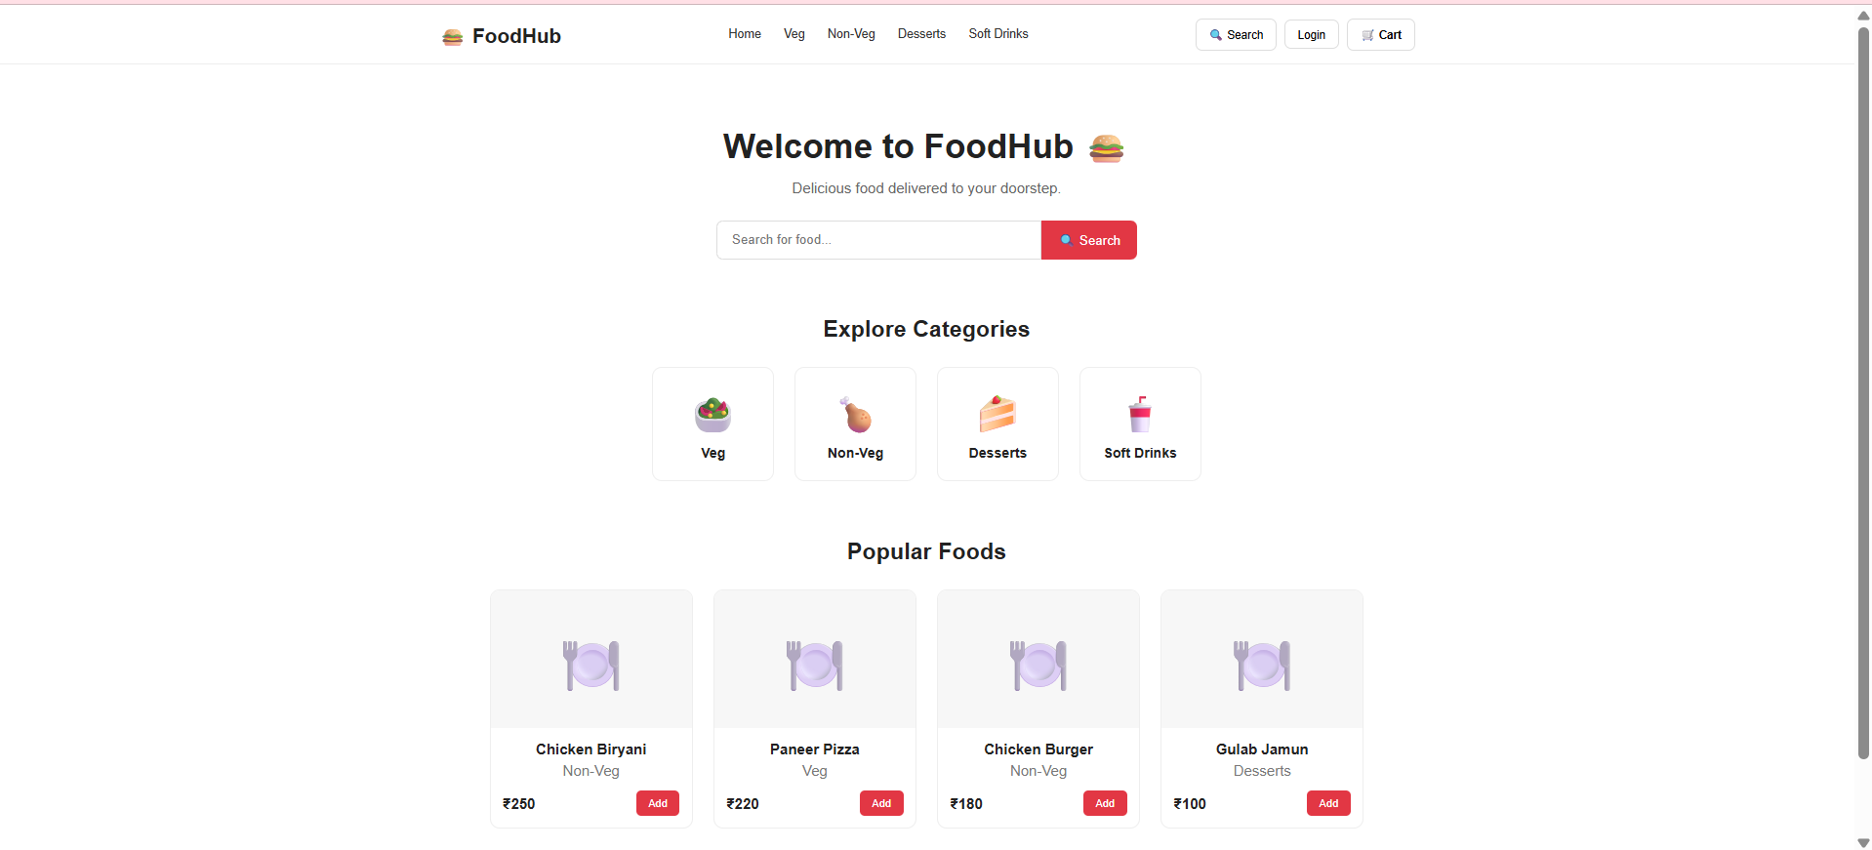

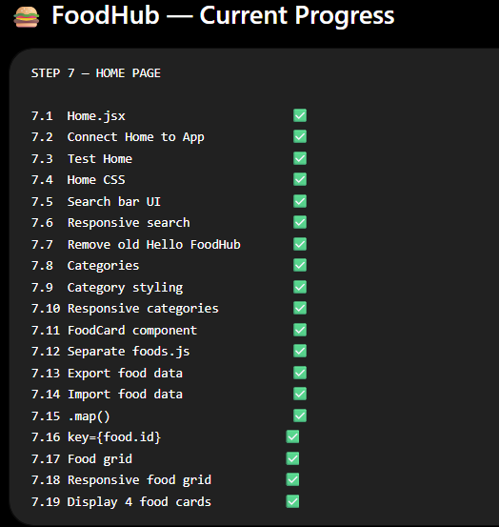

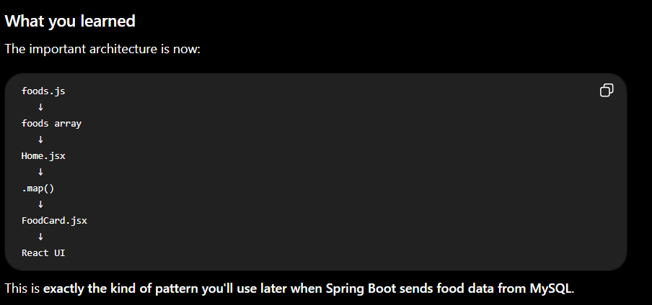

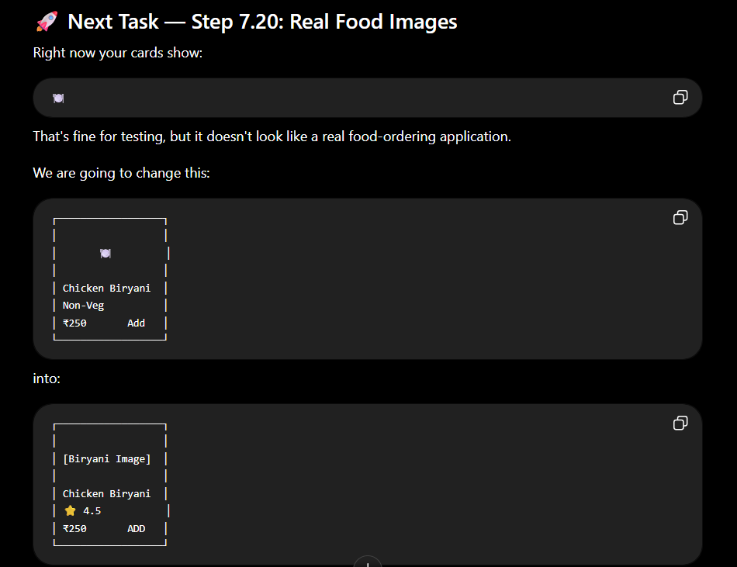

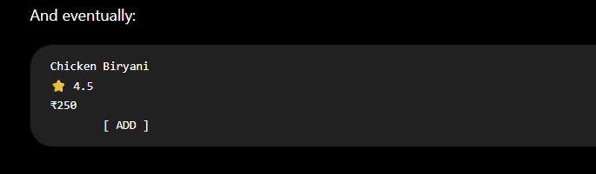

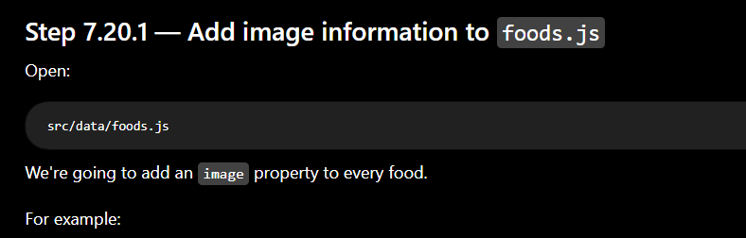
{
id: 1,
name: "Chicken Biryani",
price: 250,
category: "Non-Veg",
image: "..."
}
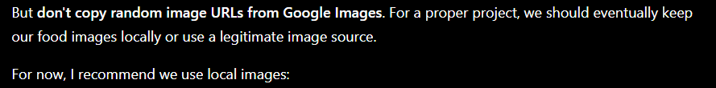

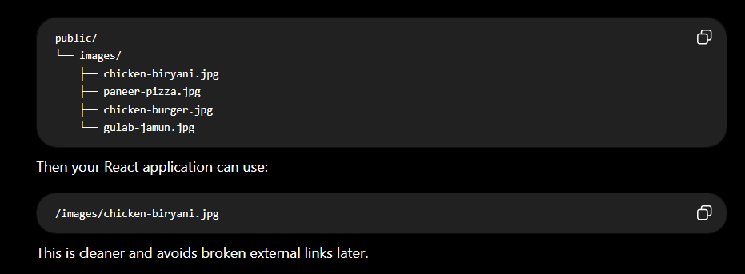

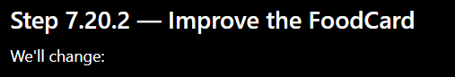 25-08-2026
<div className="food-image">
🍽️
</div>
to:
<div className="food-image">
<img src={food.image} alt={food.name} />
</div>
Now the image comes from the food data.
That's another important React concept:
food.image
↓
<img src={food.image} />

Step 7.20.3 — Then we'll improve the card
After images, we'll add:
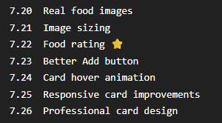

Then the Home page will start looking much more like an actual food-delivery application.

⚠️ One thing I don't want you to do yet
Don't start:
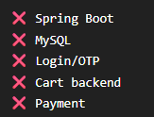
yet.
We're deliberately building the frontend first.
Our next major checkpoint will be:
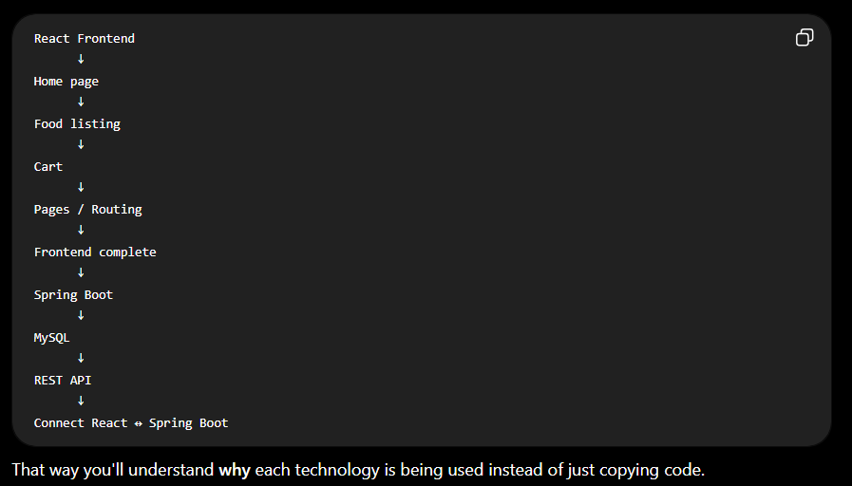

Yes. We can add real 6-digit SMS OTP authentication to FoodHub. But there is one important architecture decision before we code it.
1. How FoodHub OTP should actually work
We should not generate the OTP in React.
The correct production flow is:
React
↓
User enters phone number
↓
Spring Boot
↓
OTP service (Firebase/Twilio/etc.)
↓
SMS → User's phone
↓
User enters 6-digit OTP
↓
Spring Boot / OTP provider verifies it
↓
User authenticated
↓
FoodHub account/session
For example:
User enters:
+91 9876543210

↓

[ Send OTP ]

↓

SMS:
"Your FoodHub verification code is 482731"

↓

User enters:
4 8 2 7 3 1

↓

[ Verify OTP ]

↓

✅ Login successful
Firebase officially supports web phone authentication with SMS OTP and a verification step; it also uses reCAPTCHA/app verification to reduce abuse. (Firebase)
Twilio Verify is another option and explicitly supports sending a six-digit SMS verification code and checking that code. (Twilio)
For our FoodHub project
Because you specifically want:
React JS
+
Java Spring Boot
+
MySQL
I recommend that we build the authentication flow through Spring Boot, rather than hiding the authentication completely inside React.
That will make this a much better Java Full Stack project for your resume/interviews.

2. What we are going to build
We'll divide authentication into small tasks.
STEP 8 — Authentication

8.1 Login page UI
8.2 Phone number input
8.3 Send OTP button
8.4 OTP input screen
8.5 6-digit OTP UI
8.6 Verify OTP button
8.7 Resend OTP
8.8 OTP expiry
8.9 Spring Boot authentication API
8.10 SMS OTP provider
8.11 MySQL user table
8.12 Create/find user
8.13 Authentication response
8.14 Login state in React
8.15 Logout
8.16 Protect user features
But we won't do all of that today.
We'll build it incrementally.

3. First task today — Login UI
Before Spring Boot, we need the React interface.
When the user clicks:
Login
we want:
┌──────────────────────────────┐
│ │
│ 🍔 FoodHub │
│ │
│ Login / Sign Up │
│ │
│ +91 [ 9876543210 ] │
│ │
│ [ Send OTP ] │
│ │
└──────────────────────────────┘
After clicking Send OTP:
┌──────────────────────────────┐
│ │
│ Verify your number │
│ │
│ OTP sent to +91 9876... │
│ │
│ [ 4 ] [ 8 ] [ 2 ] [ 7 ] │
│ [ 3 ] [ 1 ] │
│ │
│ [ Verify OTP ] │
│ │
│ Resend OTP │
│ │
└──────────────────────────────┘

4. Step 8.1 — Create Login component
In VS Code:
src
└── components
├── Navbar.jsx
├── Home.jsx
├── FoodCard.jsx
└── Login.jsx ← CREATE
Create:
Login.jsx
Put this simple first version:
import { useState } from 'react'
import './Login.css'

function Login() {

const [phone, setPhone] = useState('')
const [otpSent, setOtpSent] = useState(false)

const handleSendOtp = () => {

if (phone.length !== 10) {
alert('Please enter a valid 10-digit phone number')
return
}

setOtpSent(true)
}

return (
<div className="login-page">

<div className="login-box">

{!otpSent ? (

<>
<h2>Login / Sign Up</h2>

<p>Enter your mobile number</p>

<div className="phone-input">

<span>+91</span>

<input
type="tel"
placeholder="Enter mobile number"
value={phone}
onChange={(e) => setPhone(e.target.value)}
maxLength="10"
/>

</div>

<button onClick={handleSendOtp}>
Send OTP
</button>
</>

) : (

<>
<h2>Verify OTP</h2>

<p>
OTP sent to +91 {phone}
</p>

<input
type="text"
placeholder="Enter 6-digit OTP"
maxLength="6"
/>

<button>
Verify OTP
</button>

<p className="resend">
Resend OTP
</p>
</>

)}

</div>

</div>
)
}

export default Login

5. Understand the important React part
We introduced:
const [phone, setPhone] = useState('')
This stores the phone number.
When the user types:
9876543210
React stores:
phone = "9876543210"
Then:
setOtpSent(true)
changes:
otpSent
false
↓
true
And this:
{!otpSent ? (...) : (...)}
decides which UI to display.
So:
otpSent = false
↓
Phone number screen

otpSent = true
↓
OTP screen
This is conditional rendering, which you already learned with your mobile Navbar.

6. Important: This is NOT real OTP yet
At this stage:
Send OTP
↓
React changes screen
No SMS is being sent.
That's intentional.
We're first building the frontend flow.
Later:
Send OTP
↓
React
↓
Spring Boot API
↓
OTP provider
↓
Real SMS
And then:
Verify OTP
↓
Spring Boot
↓
OTP provider
↓
✅ Authentication
Don't put code like:
const otp = Math.floor(...)
in React for production authentication. The browser is not a trustworthy place to keep a secret OTP.

7. One more important thing about your foods.js
Your current file:
const foods = [
{
id: 1,
name: "Chicken Biryani",
price: 250,
category: "Non-Veg"
},
{
id: 2,
name: "Paneer Pizza",
price: 220,
category: "Veg"
},
{
id: 3,
name: "Chicken Burger",
price: 180,
category: "Non-Veg"
},
{
id: 4,
name: "Gulab Jamun",
price: 100,
category: "Desserts"
}
]

export default foods
is completely fine. Don't change it for authentication.
Later, those foods will come from:
MySQL
↓
Spring Boot
↓
REST API
↓
React
So we're keeping your current frontend data while we build the UI.

8. Today's checkpoint
Do only Step 8.1 now:
8.1 Create Login.jsx 🔵
8.2 Create Login.css ⏳
8.3 Connect Login to Navbar ⏳
8.4 Test phone → OTP screen ⏳
Once the basic Login component works, we'll make the UI beautiful and responsive, then we'll start the Spring Boot OTP backend.
And one key point: for real SMS delivery we'll choose an OTP provider after the UI works. Firebase can handle phone-number SMS authentication directly, while Twilio Verify provides a dedicated verification API; either can be integrated into a serious application. (Firebase)

Now we'll do only Step 8.2 — style the Login page. Don't connect it to the Navbar yet.
Step 8.2 — Create Login.css
Create:
src/
└── components/
└── Login.css
Put this code inside:
.login-page {
min-height: calc(100vh - 72px);

display: flex;
justify-content: center;
align-items: center;

background-color: #f8f8f8;

padding: 30px 15px;
}

.login-box {
width: 100%;
max-width: 400px;

background-color: white;

padding: 35px;

border-radius: 12px;

box-shadow: 0 8px 25px rgba(0, 0, 0, 0.08);

text-align: center;
}

.login-box h2 {
margin-bottom: 10px;

font-size: 26px;
}

.login-box p {
color: #666666;

margin-bottom: 25px;
}

.phone-input {
display: flex;

border: 1px solid #dddddd;

border-radius: 8px;

overflow: hidden;

margin-bottom: 20px;
}

.phone-input span {
padding: 13px 12px;

background-color: #f5f5f5;

color: #444444;

font-weight: 600;
}

.phone-input input {
flex: 1;

border: none;

outline: none;

padding: 13px;

font-size: 15px;
}

.login-box > button {
width: 100%;

border: none;

padding: 13px;

border-radius: 8px;

background-color: #e23744;

color: white;

font-size: 15px;

font-weight: 600;

cursor: pointer;

transition: background-color 0.2s ease;
}

.login-box > button:hover {
background-color: #c92d39;
}

.resend {
margin-top: 18px;

color: #e23744 !important;

cursor: pointer;

font-weight: 600;
}

Step 8.2.1 — Add mobile CSS
At the bottom of Login.css, add:
@media (max-width: 768px) {

.login-page {
min-height: calc(100vh - 64px);

padding: 20px 15px;
}

.login-box {
padding: 25px 20px;
}

.login-box h2 {
font-size: 23px;
}
}
Now the Login page works on both:
💻 Desktop
📱 Mobile

Step 8.2.2 — Test
For now, the Login component isn't connected to your Navbar.
So don't worry if you can't reach it from the website yet.
We will test it properly in the next step.
Your project should now look like:
src/
│
├── components/
│ ├── Navbar.jsx
│ ├── Navbar.css
│ ├── Home.jsx
│ ├── Home.css
│ ├── FoodCard.jsx
│ ├── Login.jsx ✅
│ └── Login.css ✅
│
├── data/
│ └── foods.js
│
├── App.jsx
└── main.jsx
Next: Step 8.3
After this we'll connect:
Navbar
↓
Login button
↓
Login page
↓
Phone number
↓
Send OTP
↓
6-digit OTP screen
Then we'll make the OTP UI properly.
For now, finish 8.2, save the file, and tell me done.

Good. ✅ Step 8.2 is complete.
Now let's connect the Login button in the Navbar to the Login page.
Step 8.3 — Connect Navbar → Login Page
For now, we will not install React Router. We'll keep the project simple and understand the React concept first.
Our flow will be:
Navbar
↓
Click Login
↓
App changes state
↓
Login component appears
Later, when we have several pages, we'll introduce React Router.

8.3.1 — Modify App.jsx
Open:
src/App.jsx
Replace it with:
import { useState } from 'react'
import Navbar from './components/Navbar'
import Home from './components/Home'
import Login from './components/Login'

function App() {

const [showLogin, setShowLogin] = useState(false)

return (
<>
<Navbar onLoginClick={() => setShowLogin(true)} />

{showLogin ? (
<Login />
) : (
<Home />
)}
</>
)
}

export default App
Understand this
We created:
const [showLogin, setShowLogin] = useState(false)
Initially:
showLogin = false
Therefore:
Home is displayed
When Login is clicked:
setShowLogin(true)
Then:
showLogin = true
↓
Login is displayed
This is conditional rendering again.

8.3.2 — Modify Navbar.jsx
Open:
src/components/Navbar.jsx
Find your Login button.
It probably looks similar to:
<button className="login-btn">
Login
</button>
Change it to:
<button
className="login-btn"
onClick={onLoginClick}
>
Login
</button>
But we also need to receive onLoginClick.
At the top of your component, you probably have:
function Navbar() {
Change it to:
function Navbar({ onLoginClick }) {
So the beginning should look like:
function Navbar({ onLoginClick }) {

// your existing Navbar code

}

8.3.3 — What is happening?
App.jsx sends a function to Navbar:
<Navbar onLoginClick={() => setShowLogin(true)} />
Think of it as:
App
│
│ onLoginClick
↓
Navbar
│
│ user clicks Login
↓
onLoginClick()
│
↓
setShowLogin(true)
│
↓
Login page
This is called passing a function as a prop.
Very important React concept.

8.3.4 — Test it
Save:
Ctrl + S
Your normal page should appear:
🍔 FoodHub

Home Veg Non-Veg Desserts Soft Drinks

Search Login Cart

Welcome to FoodHub 🍔
Now click:
Login
You should get:
┌──────────────────────────────┐
│ │
│ Login / Sign Up │
│ │
│ Enter your mobile number │
│ │
│ +91 │ Enter mobile number │
│ │
│ [ Send OTP ] │
│ │
└──────────────────────────────┘

8.3.5 — Test the OTP screen
Enter any 10-digit number for testing, for example:
9876543210
Click:
Send OTP
You should see:
Verify OTP

OTP sent to +91 9876543210

[ Enter 6-digit OTP ]

[ Verify OTP ]

Resend OTP
Important ⚠️
At this stage no real SMS is sent.
We are only testing the React UI flow:
Phone number
↓
Send OTP
↓
OTP screen
Real SMS comes later through:
React
↓
Spring Boot
↓
OTP service
↓
SMS

8.3.6 — One thing we should improve
There is currently no way to go back from Login to Home.
We'll add that shortly.
But don't add it yet.
First confirm that:
8.3.1 App state ✅
8.3.2 Navbar Login click ✅
8.3.3 Function passed as prop ✅
8.3.4 Login page opens 🔵
8.3.5 OTP screen appears 🔵
🛑 Stop here
Test:
Home → Login → enter number → Send OTP → OTP screen
Then send me a screenshot or tell me exactly what happened.
After that we'll do Step 8.4 — build a proper 6-digit OTP input, including:
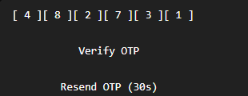
And we'll make it mobile-friendly.
output:

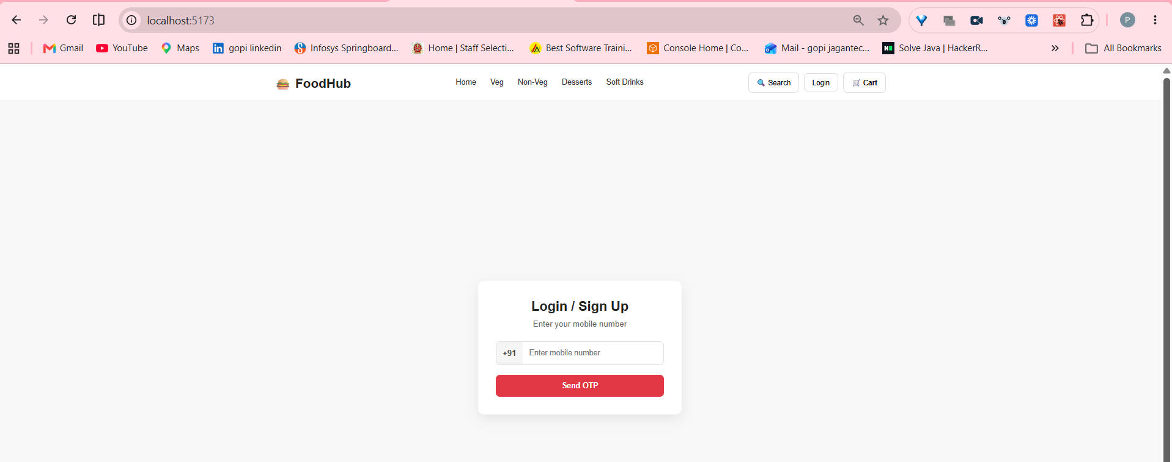

Yes — this is working correctly. ✅
Your screenshot confirms:
Home
↓
Click Login
↓
Login / Sign Up screen
↓
Phone number input
↓
Send OTP button
So Step 8.3 is complete.
Step 8.4 — Build the proper 6-digit OTP UI
Right now you have one input:
[ Enter 6-digit OTP ]
We're going to make it more user-friendly:
Enter OTP

OTP sent to +91 9876543210

[ 4 ][ 8 ][ 2 ][ 7 ][ 3 ][ 1 ]

[ Verify OTP ]

Resend OTP
And on mobile:
┌─────────────────────┐
│ Verify OTP │
│ │
│ OTP sent to │
│ +91 9876543210 │
│ │
│ [4][8][2][7][3][1] │
│ │
│ [ Verify OTP ] │
│ │
│ Resend OTP │
└─────────────────────┘

8.4.1 — Update Login.jsx
Open:
src/components/Login.jsx
We need to add OTP state.
At the top, you already have:
import { useState } from 'react'
Inside Login() you currently have:
const [phone, setPhone] = useState('')
const [otpSent, setOtpSent] = useState(false)
Add:
const [otp, setOtp] = useState('')
So:
function Login() {

const [phone, setPhone] = useState('')
const [otpSent, setOtpSent] = useState(false)
const [otp, setOtp] = useState('')

// ...
}

8.4.2 — Change the OTP input
Find your current OTP input:
<input
type="text"
placeholder="Enter 6-digit OTP"
maxLength="6"
/>
Replace it with:
<input
type="text"
placeholder="Enter 6-digit OTP"
value={otp}
onChange={(e) => setOtp(e.target.value.replace(/\D/g, ''))}
maxLength="6"
/>
Why this?
This:
.replace(/\D/g, '')
removes non-numbers.
For example:
123456
✅ accepted
12ab56
becomes:
1256
So our OTP field accepts digits only.

8.4.3 — Add OTP validation
Create this function inside Login():
const handleVerifyOtp = () => {

if (otp.length !== 6) {
alert('Please enter a 6-digit OTP')
return
}

alert('OTP verified successfully!')
}
Then change:
<button>
Verify OTP
</button>
to:
<button onClick={handleVerifyOtp}>
Verify OTP
</button>

8.4.4 — Test
Enter:
123
Click Verify.
You should get:
Please enter a 6-digit OTP
Enter:
123456
Click Verify.
You should get:
OTP verified successfully!
⚠️ Important
This is only frontend validation.
123456 will currently be accepted because we're not connected to a real OTP service yet.
Later:
User
↓
Spring Boot
↓
Real OTP service
↓
SMS
↓
User enters OTP
↓
Spring Boot verifies
↓
MySQL user
↓
Authentication
We will not consider authentication complete until the backend verifies the OTP.

Step 8.4.5 — Add better OTP CSS
In Login.css, add:
.otp-input {
width: 100%;

box-sizing: border-box;

padding: 13px;

border: 1px solid #dddddd;

border-radius: 8px;

outline: none;

font-size: 18px;

text-align: center;

letter-spacing: 6px;

margin-bottom: 20px;
}

.otp-input:focus {
border-color: #e23744;
}
Then add the class to your input:
<input
className="otp-input"
type="text"
placeholder="Enter OTP"
value={otp}
onChange={(e) =>
setOtp(e.target.value.replace(/\D/g, ''))
}
maxLength="6"
/>

One correction to our plan
You asked for:
user gives number → user gets 6 digit OTP
For a real application, we should not build our own SMS system from scratch.
We'll eventually use a proper OTP provider such as Firebase Phone Authentication or Twilio Verify, with Spring Boot handling our application-side user/account logic. Firebase documents web phone authentication with SMS verification and anti-abuse app verification; Twilio Verify provides SMS verification workflows.
For learning, however, we're doing this in the right order:
STEP 1
React UI ✅

STEP 2
Phone → OTP screen ✅

STEP 3
OTP input + validation 🔵 NOW

STEP 4
Spring Boot API ⏳

STEP 5
Real SMS OTP provider ⏳

STEP 6
MySQL user ⏳

STEP 7
Real OTP verification ⏳

STEP 8
Login/session ⏳
🛑 Your task now
Complete only:
8.4.1 OTP state 🔵
8.4.2 OTP input 🔵
8.4.3 OTP validation 🔵
8.4.4 Test 🔵
8.4.5 OTP CSS 🔵
Then send me the screenshot.
After that, we'll do Step 8.5 — separate six OTP boxes with automatic cursor movement, like:
[ 4 ] [ 8 ] [ 2 ] [ 7 ] [ 3 ] [ 1 ]
That's the point where the login UI will start feeling like a real food-delivery app.

output:
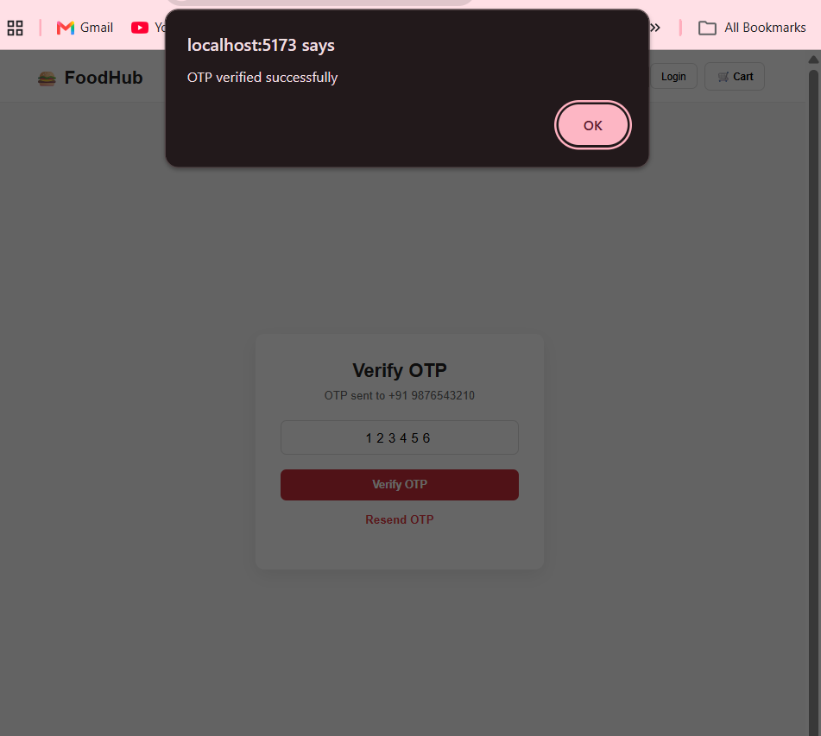

Yes — Step 8.4 is working, but I noticed one issue in your screenshot that we should fix before moving on.
What your screenshot confirms
Phone number
↓
Send OTP
↓
OTP screen
↓
Enter 6 digits
↓
Verify OTP
↓
"OTP verified successfully"
So:
8.4.1 OTP state ✅
8.4.2 OTP input ✅
8.4.3 OTP validation ✅
8.4.4 Verification test ✅
8.4.5 OTP styling ⚠️
⚠️ One problem in your screenshot
I can see two OTP-looking inputs:
123456 ← old input
┌──────────────┐
│ 1 2 3 4 5 6 │ ← styled input
└──────────────┘
You should have only one.
Check Login.jsx
Inside the OTP section, keep only this:
<input
className="otp-input"
type="text"
placeholder="Enter 6-digit OTP"
value={otp}
onChange={(e) =>
setOtp(e.target.value.replace(/\D/g, ''))
}
maxLength="6"
/>
Delete any other OTP <input> from that section.
After that, you should see only:
Verify OTP

OTP sent to +91 9876543210

┌─────────────────────┐
│ 1 2 3 4 5 6 │
└─────────────────────┘

[ Verify OTP ]

Resend OTP

🚀 Next: Step 8.5 — Professional 6-Digit OTP
Once the duplicate input is removed, we're going to improve it from:
┌─────────────────────┐
│ 123456 │
└─────────────────────┘
to:
┌───┐ ┌───┐ ┌───┐ ┌───┐ ┌───┐ ┌───┐
│ 4 │ │ 8 │ │ 2 │ │ 7 │ │ 3 │ │ 1 │
└───┘ └───┘ └───┘ └───┘ └───┘ └───┘
And we'll make it behave properly:
Type 4
↓
automatically move to box 2

Type 8
↓
move to box 3

...

Type 1
↓
OTP complete
We'll also handle:
Backspace
Paste 123456
Only numbers
6-digit limit
Mobile responsive
One important distinction
Your current:
OTP verified successfully
does not mean real authentication is working yet.
Right now React is simply checking:
otp.length === 6
So even:
123456
is accepted.
That's intentional for the frontend stage.
Eventually we'll replace this with:
React
↓
Spring Boot
↓
Generate/request OTP
↓
SMS Provider
↓
Real SMS
↓
User enters OTP
↓
Spring Boot verifies
↓
MySQL user
↓
Authenticated ✅
First remove the duplicate OTP input. Then we'll start Step 8.5 — six separate OTP boxes.

Current status
8.1 Login component ✅
8.2 Login CSS ✅
8.3 Navbar → Login ✅
8.4 Phone → OTP screen ✅
8.5 6-digit OTP validation ✅
But visually, we're still using one input box. Let's now make it professional.
Step 8.5 — Six Separate OTP Boxes
Target:
Verify OTP

OTP sent to +91 9876543210

[ 4 ] [ 8 ] [ 2 ] [ 7 ] [ 3 ] [ 1 ]

[ Verify OTP ]

Resend OTP
And when the user types:
4 → box 1
8 → box 2
2 → box 3
7 → box 4
3 → box 5
1 → box 6
The cursor should automatically move to the next box.

8.5.1 — Change OTP state
Open:
src/components/Login.jsx
Find:
const [otp, setOtp] = useState('')
Replace it with:
const [otp, setOtp] = useState(['', '', '', '', '', ''])
Now OTP is stored as six values:
['', '', '', '', '', '']
After entering 482731:
['4', '8', '2', '7', '3', '1']

8.5.2 — Add OTP handler
Inside Login() add:
const handleOtpChange = (value, index) => {

if (!/^\d?$/.test(value)) {
return
}

const newOtp = [...otp]

newOtp[index] = value

setOtp(newOtp)
}
This allows:
0–9 ✅
letters ❌
multiple digits in one box ❌

8.5.3 — Replace the current OTP input
Delete your current:
<input
className="otp-input"
...
/>
Replace it with:
<div className="otp-container">

{otp.map((digit, index) => (
<input
key={index}
className="otp-box"
type="text"
inputMode="numeric"
maxLength="1"
value={digit}
onChange={(e) =>
handleOtpChange(e.target.value, index)
}
/>
))}

</div>
What is happening?
You already learned .map() with food cards.
Now we're using the same concept:
otp array
↓
.map()
↓
6 input boxes
This is a nice bit of React practice.

8.5.4 — Update Verify OTP
Your current verification probably has:
if (otp.length !== 6)
That won't work correctly anymore because otp is an array.
Use:
const handleVerifyOtp = () => {

const enteredOtp = otp.join('')

if (enteredOtp.length !== 6) {
alert('Please enter a 6-digit OTP')
return
}

alert('OTP verified successfully!')
}
join('') converts:
['4', '8', '2', '7', '3', '1']
into:
"482731"

8.5.5 — Add CSS
In Login.css, replace the old .otp-input CSS with:
.otp-container {
display: flex;
justify-content: center;
gap: 10px;
margin-bottom: 25px;
}

.otp-box {
width: 45px;
height: 50px;

border: 1px solid #dddddd;
border-radius: 8px;

text-align: center;

font-size: 20px;
font-weight: 600;

outline: none;
}

.otp-box:focus {
border-color: #e23744;
}
For mobile, add:
@media (max-width: 768px) {

.otp-container {
gap: 6px;
}

.otp-box {
width: 40px;
height: 45px;
}
}

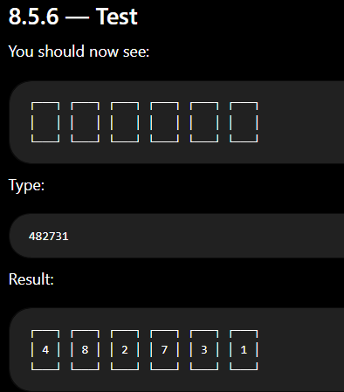
One limitation for this step
The boxes will not automatically move the cursor yet. We'll add that next because it requires React useRef.
So today's progression is:

8.5.1 OTP array 🔵
8.5.2 OTP handler 🔵
8.5.3 Six input boxes 🔵
8.5.4 Verify OTP 🔵
8.5.5 CSS 🔵
8.5.6 Test 🔵

Step 8.6 — automatic cursor movement + backspace + paste 482731, which will make this OTP input behave like a real application.

output:
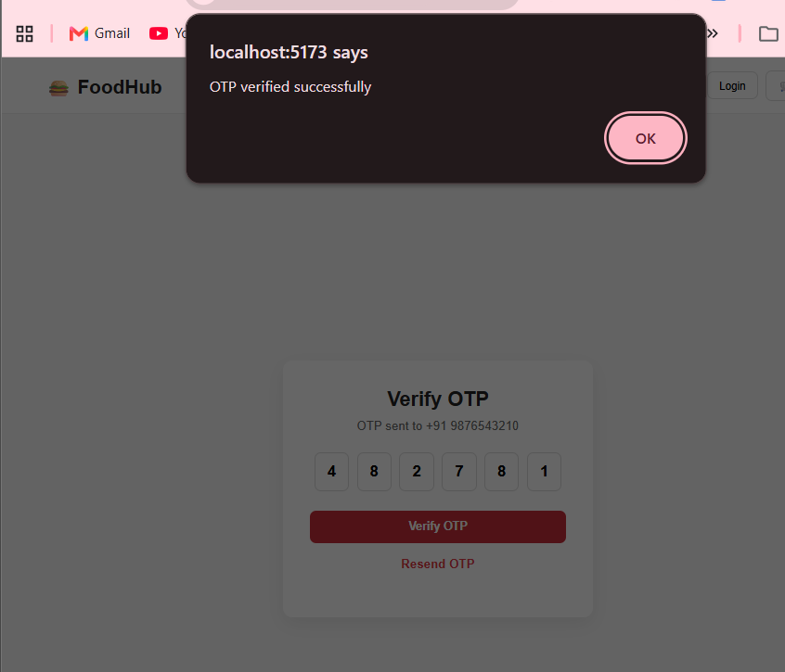

Current Authentication Progress
8.1 Login component ✅
8.2 Login CSS ✅
8.3 Navbar → Login ✅
8.4 Phone → OTP screen ✅
8.5 Six OTP boxes ✅
Now we make the OTP input behave like a real application.
Step 8.6 — Automatic Cursor Movement
Currently, after typing:
4
you probably have to manually click the second box.
We want:
Type 4
↓
[4] [ ] [ ] [ ] [ ] [ ]
↑ cursor automatically here

Type 8
↓
[4] [8] [ ] [ ] [ ] [ ]
↑

Type 2
↓
[4] [8] [2] [ ] [ ] [ ]
We'll also support:
- ✅ Automatic movement to next box
- ✅ Backspace movement to previous box
- ✅ Paste a complete 6-digit OTP
- ✅ Numbers only
- ✅ Mobile-friendly

8.6.1 — Import useRef
At the top of Login.jsx, currently you have:
import { useState } from 'react'
Change it to:
import { useState, useRef } from 'react'

8.6.2 — Create references for the six inputs
Inside Login() after your state variables, add:
const otpRefs = useRef([])
So you have:
const [phone, setPhone] = useState('')
const [otpSent, setOtpSent] = useState(false)
const [otp, setOtp] = useState(['', '', '', '', '', ''])

const otpRefs = useRef([])
What is useRef?
It lets React keep a reference to an actual HTML element.
Here:
otpRefs
↓
Input 1
Input 2
Input 3
Input 4
Input 5
Input 6
Then we can tell the browser:
otpRefs.current[1].focus()
Meaning:
Put the cursor in OTP box 2.

8.6.3 — Replace handleOtpChange
Currently you have:
const handleOtpChange = (value, index) => {

if (!/^\d?$/.test(value)) {
return
}

const newOtp = [...otp]

newOtp[index] = value

setOtp(newOtp)
}
Replace it with:
const handleOtpChange = (value, index) => {

if (!/^\d?$/.test(value)) {
return
}

const newOtp = [...otp]

newOtp[index] = value

setOtp(newOtp)

if (value && index < 5) {
otpRefs.current[index + 1].focus()
}
}
The important part is:
if (value && index < 5) {
otpRefs.current[index + 1].focus()
}
Example:
Box 1
↓
index = 0

0 + 1 = 1

↓

Box 2 gets focus

8.6.4 — Add ref to each input
Your current input should look something like:
<input
key={index}
className="otp-box"
type="text"
inputMode="numeric"
maxLength="1"
value={digit}
onChange={(e) =>
handleOtpChange(e.target.value, index)
}
/>
Add:
ref={(element) => (otpRefs.current[index] = element)}
So the complete input becomes:
<input
key={index}
ref={(element) => (otpRefs.current[index] = element)}
className="otp-box"
type="text"
inputMode="numeric"
maxLength="1"
value={digit}
onChange={(e) =>
handleOtpChange(e.target.value, index)
}
/>
Now React knows which HTML input belongs to which OTP position.

8.6.5 — Test it
Refresh the page.
Enter:
4
The cursor should automatically move:
[4] [ ] [ ] [ ] [ ] [ ]
↑
Then:
8
[4] [8] [ ] [ ] [ ] [ ]
↑
Continue:
482781
You should be able to type the entire OTP without clicking each box.

Step 8.6.6 — Add Backspace
Now let's make:
[4] [8] [2] [7] [ ] [ ]
If you're in box 5 and press Backspace, we want:
[4] [8] [2] [7] [ ] [ ]
↑
and another Backspace should move back to box 4.
Add this function inside Login():
const handleOtpKeyDown = (e, index) => {

if (e.key === 'Backspace' && !otp[index] && index > 0) {
otpRefs.current[index - 1].focus()
}
}
Then add this to the input:
onKeyDown={(e) => handleOtpKeyDown(e, index)}
Your complete input becomes:
<input
key={index}
ref={(element) => (otpRefs.current[index] = element)}
className="otp-box"
type="text"
inputMode="numeric"
maxLength="1"
value={digit}
onChange={(e) =>
handleOtpChange(e.target.value, index)
}
onKeyDown={(e) =>
handleOtpKeyDown(e, index)
}
/>

Step 8.6.7 — Test these cases
Test 1 — Normal typing
482781
Expected:
[4] [8] [2] [7] [8] [1]
Test 2 — Letters
Try:
a
Nothing should happen.
Test 3 — Backspace
Enter:
482
Go back and delete.
The cursor should move backward appropriately.

Important checkpoint
After this, your frontend OTP component will be quite solid:
8.6
├── Automatic next-box focus ✅
├── Backspace navigation ✅
├── Numbers only ✅
├── Six-digit limit ✅
└── Mobile keyboard ✅
But it is still NOT real authentication.
The next major stage is where things get serious:
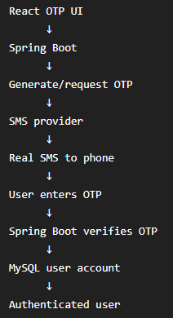
We'll tackle that after the frontend OTP behavior is finished.
output:
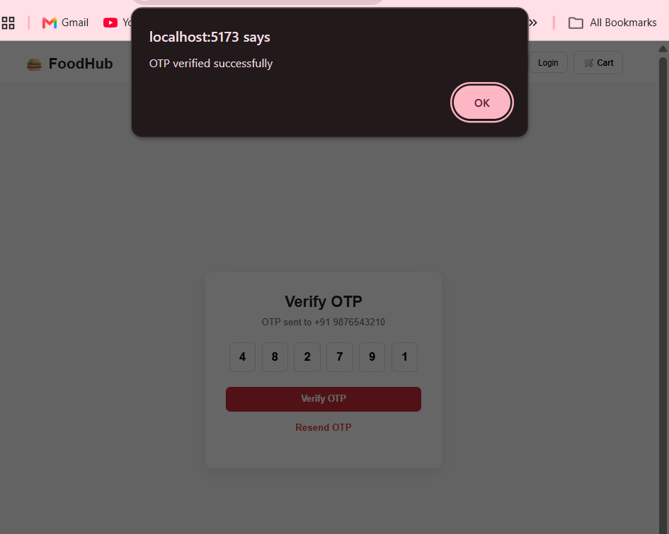

You now have:
8.1 Login component ✅
8.2 Login styling ✅
8.3 Navbar → Login ✅
8.4 Phone → OTP screen ✅
8.5 Six OTP boxes ✅
8.6 Auto-focus + Backspace ✅
Your OTP flow is now:
Enter phone number
↓
Send OTP
↓
6 OTP boxes
↓
Type digit
↓
Automatically moves next
↓
Backspace moves previous
↓
Verify OTP
One thing I want to fix before the next step
Your phone input currently accepts letters because you have:
onChange={(e) => setPhone(e.target.value)}
For example, a user could enter:
98765abc10
So let's fix that now, before adding the resend timer.
Change:
onChange={(e) => setPhone(e.target.value)}
to:
onChange={(e) =>
setPhone(e.target.value.replace(/\D/g, ''))
}
Now only numbers are accepted.

Step 8.7 — Resend OTP + Countdown Timer
This is our next task.
Currently you have:
Resend OTP
but clicking it does nothing.
A real OTP flow should behave like:
OTP sent to +91 9876543210

[ 4 ] [ 8 ] [ 2 ] [ 7 ] [ 9 ] [ 1 ]

Verify OTP

Resend OTP in 30s
After 30 seconds:
Resend OTP
Then clicking it starts another countdown:
OTP sent again

Resend OTP in 30s
Why are we doing this?
Because otherwise users could repeatedly request OTPs without restriction. In the real backend, we'll also add server-side rate limiting. The frontend timer is only a user-interface control; it is not a security mechanism.

8.7.1 — Add state
At the top of Login() add:
const [resendTimer, setResendTimer] = useState(30)
So your states become:
const [phone, setPhone] = useState('')
const [otpSent, setOtpSent] = useState(false)
const [otp, setOtp] = useState(['', '', '', '', '', ''])
const [resendTimer, setResendTimer] = useState(30)

const otpRefs = useRef([])

8.7.2 — Add useEffect
Change:
import { useState, useRef } from 'react'
to:
import { useState, useRef, useEffect } from 'react'
Then inside Login() add:
useEffect(() => {

if (!otpSent || resendTimer === 0) {
return
}

const timer = setInterval(() => {
setResendTimer((previous) => previous - 1)
}, 1000)

return () => clearInterval(timer)

}, [otpSent, resendTimer])
What this does
When OTP is sent:
30
↓
29
↓
28
↓
27
↓
...
↓
1
↓
0
useEffect() manages the timer.

8.7.3 — Create resend function
Add:
const handleResendOtp = () => {

if (resendTimer > 0) {
return
}

setOtp(['', '', '', '', '', ''])

setResendTimer(30)

alert('OTP sent again')
}

8.7.4 — Change your Resend button
Currently:
<p className="resend">
Resend OTP
</p>
Replace it with:
{resendTimer > 0 ? (

<p className="resend disabled">
Resend OTP in {resendTimer}s
</p>

) : (

<p
className="resend"
onClick={handleResendOtp}
>
Resend OTP
</p>

)}
Now the UI changes automatically.

8.7.5 — Test
Click Send OTP.
You should see:
Resend OTP in 30s
Then:
29s
28s
27s
...
After reaching zero:
Resend OTP
Click it.
You should see:
OTP sent again
and the timer starts again:
30s
The six OTP boxes should also become empty.

Current project position
We're getting close to finishing the frontend authentication UI:
8.1 Login page ✅
8.2 Login styling ✅
8.3 Navbar integration ✅
8.4 OTP screen ✅
8.5 Six OTP boxes ✅
8.6 Auto-focus + Backspace ✅
8.7 Resend + countdown 🔵 NOW
8.8 Login success state ⏳
8.9 React Router ⏳
8.10 Backend connection ⏳
Important checkpoint
Do not start Spring Boot yet.
First finish 8.7 and test the timer. Then we'll make 8.8 — successful login state, where instead of an alert("OTP verified successfully"), FoodHub will actually show the logged-in user state.
After that we'll move into the big part:
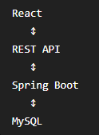
That's where your FoodHub becomes a real full-stack project, rather than just a frontend demo.
we need to start 8.7 onwards , ctrl+F for find , and starts from on wards
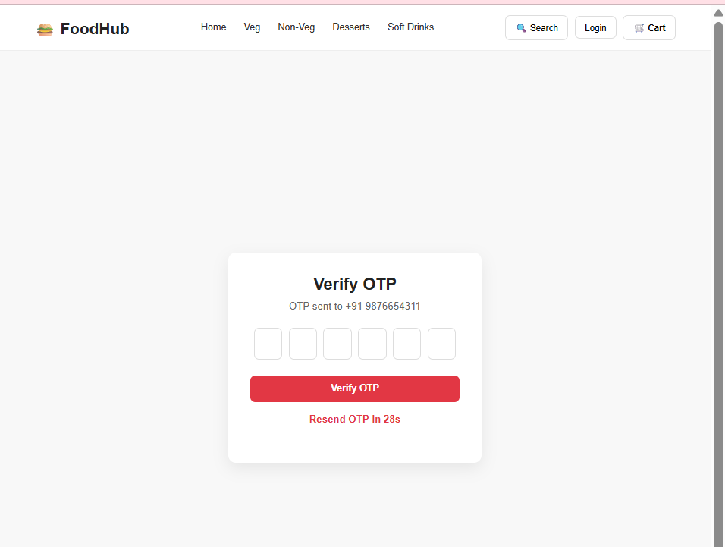
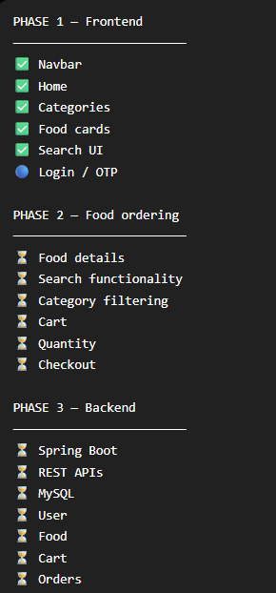
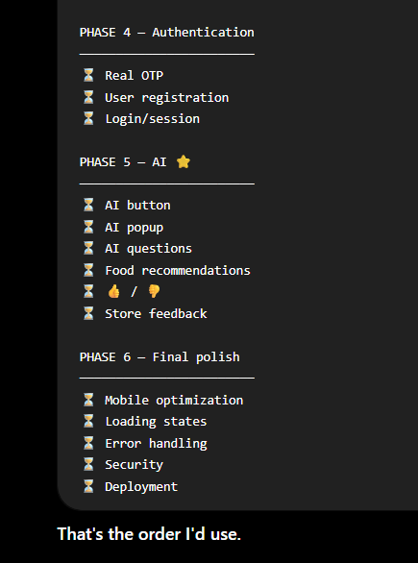

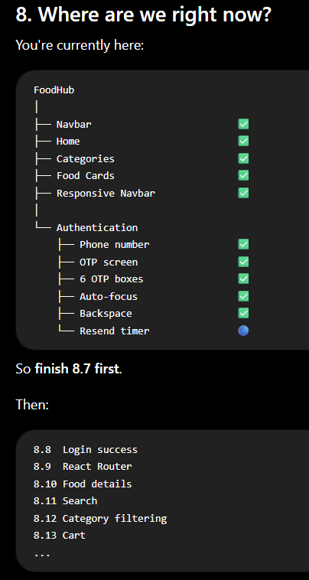

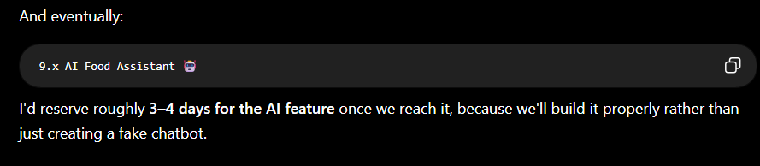

9. What AI technology should we use?
For this project, we can use an external AI API through your Spring Boot backend. OpenAI's current API supports model-based text generation, and API usage is billed based on model/token usage, so this part isn't necessarily free.
For your first implementation, I recommend:

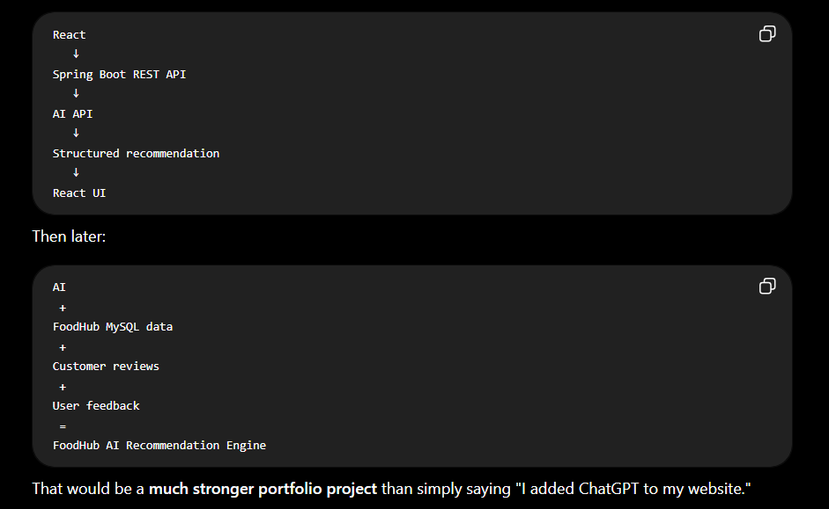

My recommendation
Yes, add it. But don't start it yet.
Finish the OTP frontend → food browsing → search/filter → cart → Spring Boot/MySQL → real authentication. Then we'll build the AI assistant as a dedicated feature.
And when we reach it, I'll break it down exactly like you've been doing:
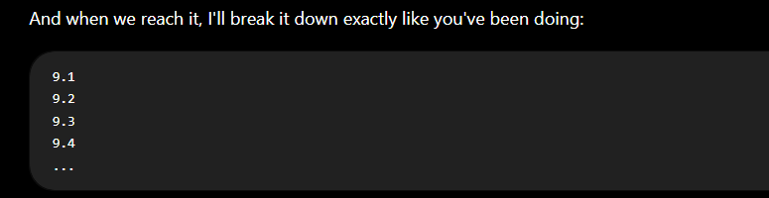so you can build it slowly and understand what, why, and how, rather than just copying an AI chatbot into the project.

