**A MAJOR PROJECT REPORT**

**on**

|  |
| --- |
| **A MACHINE LEARNING BASED APPROACH FOR**  **WINE QUALITY PREDICTION** |

**BACHELOR OF TECHNOLOGY**

**in**

**COMPUTER SCIENCE AND ENGINEERING**

**Submitted by**

**(MP-A27)**

|  |  |
| --- | --- |
| **P SAITEJA** | **207Y5A0504** |
| **S ANIL KUMAR** | **207Y5A0505** |

**Under the Guidance**

**of**

**Mr. CH.V Krishna Mohan**

**Associate Professor**

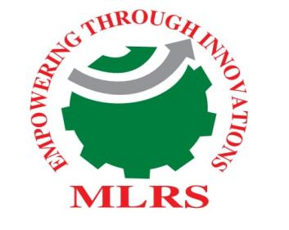

**DEPARTMENT OF COMPUTER SCIENCE AND ENGINEERING**

**MARRI LAXMAN REDDY**

**INSTITUTE OF TECHNOLOGY AND MANAGEMENT**

**(AUTONOMOUS)**

**(Affiliated to JNTU-H, Approved by AICTE New Delhi and Accredited by NBA & NAAC With ‘A’ Grade)**

**APRIL 2023**