LOGISTICS DATA ANALYST INTERNSHIP
WEEK 3
Advanced Data Analysis and Visualization in Logistics
A reproducible shipment-level simulation with Python
Submitted by: Pulipati Keerthana
Programme: B.Tech — CSE (AI & ML)
Institution: Geethanjali Institute of Science and Technology
Scenario: Fictional regional road-logistics operator
Dispatch period: January–June 2026
Dataset: 3,000 simulated shipments × 19 variables
Reproducibility: NumPy seed 2026
Data-integrity declaration
Every shipment, rate and operational pattern in this report is hypothetical. Numerical findings are computed from the included simulation, not observed company records. The scenario is new Week 3 work and does not represent a continuation of the DataCo records used in Week 2.
Deliverables: runnable Python scripts, dataset, eight chart outputs, EDA tables, 15 tests and this Word report.

1. Executive findings and analytical questions
The pipeline generated and validated 3,000 unique shipments carrying 1,55,954 units. 2,243 shipments met their promised transit time: an on-time rate of 74.77%. Mean delivery time was 2.00 days, with a median of 2 days and a 90th percentile of 3 days. These are executed simulation results, not performance estimates for an employer.
Total hypothetical transportation cost was INR 92,35,792.37; mean cost was INR 3,078.60 per shipment and the aggregate cost-to-volume ratio was INR 59.22 per unit. The programmed distance component accounted for 74.49% of total cost.
Express averaged 1.71 days versus 2.13 for Standard, but its on-time rate was lower (46.44% versus 87.16%). This is not contradictory: Express promises a tighter deadline. The result demonstrates why delivery speed and promise adherence must be reported separately.
East had the highest mean dwell (20.00 hours) and late rate (42.19%). The simulator intentionally adds 12 hours of East-region dwell, so this is a demonstration of how EDA exposes a designed bottleneck—not an independently discovered real-world cause.

Questions guiding the analysis
Question | Measure and decision use
How does volume change? | Monthly shipment count and units; discuss staffing and capacity scenarios.
How consistent is delivery? | Mean, median, spread, tails and service-specific distribution.
Does the premium service keep promises? | Compare cost and on-time percentage against service-specific targets.
What relates to cost and delays? | Distance-cost scatter, correlation matrices, dwell and regional SLA tables.
What action should be investigated? | Prioritize deadline design, dwell audit and distance-cost verification.

Report map: Sections 2–3 define the simulation and EDA; Section 4 interprets eight figures; Sections 5–7 give recommendations, reproducibility and evaluation evidence.

2. Hypothetical dataset and collection simulation
The fictional operator uses North, South, East and West service regions and offers Standard and Express road delivery. One row represents one shipment; shipment_units counts goods carried, not additional shipments. There are no cancellations, split shipments, observed routes or company identifiers. This deliberately clean schema supports Week 3 analysis rather than repeating Week 2 preprocessing.
Collection is simulated as a dispatch-system extract. A shipment identifier, dispatch date, service and region represent booking data; distance and weight represent manifest measurements; dwell represents time before line-haul movement; delivery date represents completion. In a real project these fields would require joins between the transport-management system, warehouse events and cost ledger, with reconciled units and timestamps. Here they are generated in Python and exported to CSV.
Variable group | Fields and interpretation
Identity and timing | shipment_id; dispatch_date; delivery_date. Dispatch dates run 1 January–30 June 2026; some June shipments arrive by 3 July.
Segmentation | region (North/South/East/West); service (Standard/Express).
Load and route | distance_km; shipment_units (integer); weight_kg.
Operational performance | warehouse_dwell_hours; promised_days; delivery_days; delay_days; late_flag.
Cost components (INR) | cost_fixed_inr; cost_distance_inr; cost_weight_inr; cost_handling_inr; cost_variation_inr.
Total (INR) | transport_cost_inr = sum of five components. Rates are entirely illustrative.

The dataset has 19 columns: 3 identity/date fields, 2 categorical fields, 3 route/load fields, 5 operational fields and 6 cost fields. No external dataset is portrayed as the source. The source is simulation.py plus simulation_assumptions.json.
Monthly sampling weights are 1.0, 1.0, 1.1, 1.2, 1.4 and 1.6. Because sampling occurs across individual calendar days, month length also affects expected counts. Region probabilities are 28%, 26%, 22% and 24%; Express probability is 30%. Realized counts need not exactly equal these proportions.

2.1 Transparent generative assumptions
Quantity | Simulation rule
Distance and load | Distance ~ Gamma(3,170), clipped to 40–1,800 km. Units ~ integer Uniform(5,100). Weight = units × Uniform(1,4).
Warehouse dwell | Gamma(2,4) hours + 12 hours in East + 2 hours in North.
Promised transit days | Standard: ceil(distance/600) + 1. Express: ceil(distance/900).
Actual transit days | max(1, ceil(distance/speed + dwell/24 + Normal(0.15,0.45))); speed parameter 500 Standard or 850 Express.
Fixed and route cost | Fixed INR 300 Standard / 500 Express; distance × INR 4/km Standard / 6/km Express.
Other cost | Weight × INR 2/kg; dwell × INR 8/hour; variation ~ Uniform(0,150) INR.
Dates and SLA | Delivery date = dispatch + delivery_days; delay = actual − promised; late_flag = 1 only if delay > 0.

The speed parameters are effective daily-distance assumptions, not measured vehicle speeds or travel-time models. Integer rounding approximates day-level reporting. Cost component rounding is applied before summation, allowing totals to reconcile exactly to the supplied ledger-style columns. No calibrated fuel, toll, staffing, inventory, tax or profit model is included.

Practical Python excerpt: reproducible generation
rng = np.random.default_rng(2026)
distance = np.round(np.clip(rng.gamma(3, 170, n), 40, 1800), 1)
units = rng.integers(5, 101, n)
weight = np.round(units * rng.uniform(1, 4, n), 2)
dwell = np.round(rng.gamma(2, 4, n)
+ 12 * (region == 'East')
+ 2 * (region == 'North'), 2)

These excerpts are selected from the runnable scripts; they depend on surrounding variables defined in those scripts. They are not intended to be run alone. The full simulator fixes the sequence of random draws, which is necessary for matching the included seed-2026 dataset.

3. EDA methodology and data-quality checks
Validation found 0 missing cells and 0 duplicate shipment IDs. All 3,000 records passed positive-measurement, categorical, date, cost-sum and late-flag checks. No valid rows were dropped or imputed. Repeated complete runs reproduced the CSV checksum, and 15 automated tests passed. This log records package verification, not execution on the student’s laptop.
Descriptive analysis uses count, mean, median, first reported mode, sample standard deviation (ddof=1), quartiles, range and pandas skewness. Modes of rounded continuous fields can be tied and weakly informative; the full output reports the first tied mode returned by pandas. Mode is most interpretable for integer delivery days.
Shipment-level on-time percentage = 100 × count(actual days ≤ promised days) / total shipments. Aggregate cost per unit = total cost / total shipment units. This ratio differs from an unweighted average of shipment-specific cost/unit ratios. Dispatch-month grouping keeps the timing basis consistent across volume, cost and SLA summaries.
Pearson r describes linear association; Spearman rho describes rank-monotonic association. Both matrices use seven numeric operational measurements, not identifiers or late flags. No missing-value pairwise deletion affects this dataset. Raw units remain interpretable: correlation does not require min–max normalization. No predictive model or causal-effect estimate is claimed. [1]

Central tendencies and dispersion
Variable | Mean | Median | SD | Mode*
Distance (km) | 497.41 | 443.05 | 284.06 | 40.00
Units / shipment | 51.98 | 53.00 | 27.39 | 15.00
Weight (kg) | 130.33 | 111.73 | 86.80 | 16.40
Dwell (hours) | 11.26 | 9.57 | 7.40 | 4.74
Promised days | 1.95 | 2.00 | 0.73 | 2.00
Delivery days | 2.00 | 2.00 | 0.80 | 2.00
Cost (INR) | 3,078.60 | 2,778.42 | 1,460.36 | 1,658.82

*First reported mode; see descriptive_statistics.csv for precision and ties policy. Distance’s minimum-bound mode partly reflects clipping, not a naturally observed route preference.
The 1.5 × IQR rule flags tails for investigation, not automatic deletion: distance 66, weight 10, dwell 35, promised days 47, delivery days 101 and cost 101. These counts overlap across variables and must not be added as unique shipments. All records are retained because their values are consistent with the documented generator. Cost skewness is 1.32 and distance skewness 1.07, supporting use of medians as well as means.

4. Visualization findings

4.1 Dispatch volume trend
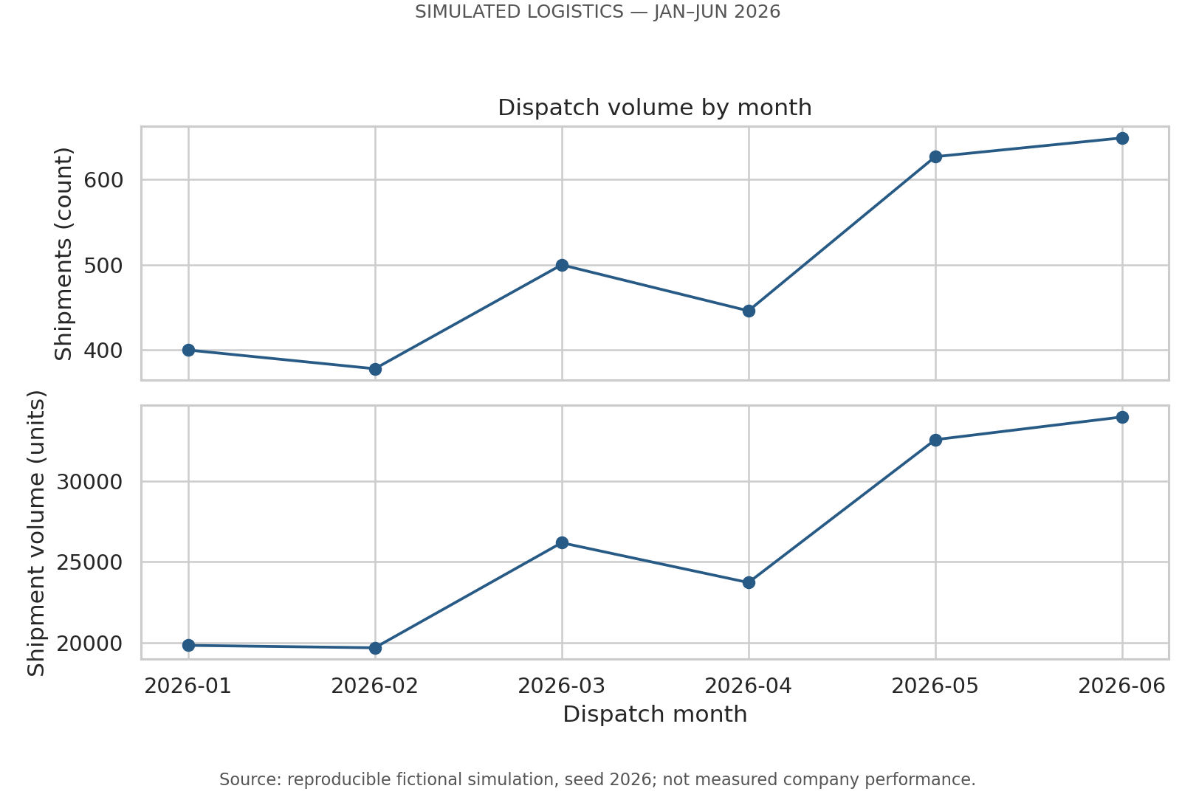
Figure 1. Shipment count and goods volume by dispatch month.
Why this visualization: aligned line charts show temporal changes without mixing shipment counts and goods units on a dual-axis plot. All six dispatch months are represented; no delivery-month regrouping is used.
Finding: January contained 400 shipments and 19,859 units; June contained 649 shipments and 33,937 units. Shipment count increased 62.25% between these endpoints. The pattern is not perfectly monotonic; sampling and calendar length affect realized counts.
Interpretation and boundary: the generator intentionally assigns higher later-month demand weights. The figure illustrates capacity planning under a rising-demand scenario; it does not prove actual seasonality or demand growth. Nor does volume cause delays in this model: monthly volume is not an input to the delivery-time equation.

4.2 Delivery-time distribution
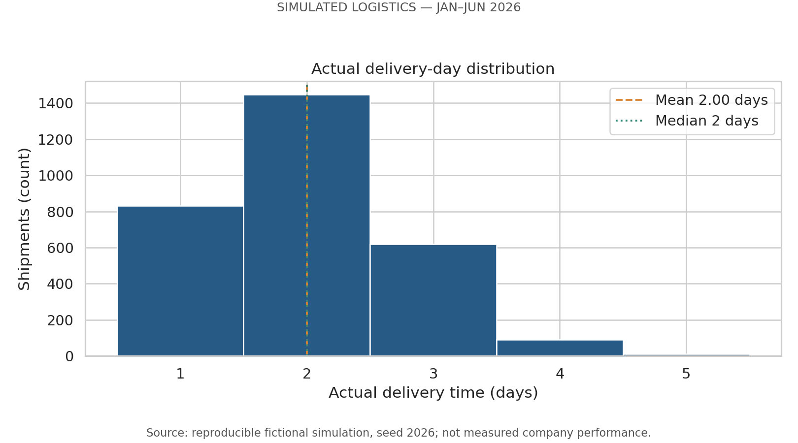
Figure 2. Integer-day histogram with mean and median reference lines.
Why this visualization: one-day-width bins centered on integer outcomes reveal typical performance and the delivery tail. Mean and median reference lines prevent the average alone from hiding the shape. Matplotlib hist() computes frequency counts in the chosen bins. [2]
Finding: delivery times range from 1 to 5 days. The mean is 2.00 days, the median and first reported mode are 2 days, and the 90th percentile is 3 days. Sample standard deviation is 0.80 days; skewness is 0.53. The modest right tail indicates that a typical two-day shipment does not describe every customer experience.
Interpretation: monitor the tail and promise adherence as well as average speed. A 3-day 90th percentile does not imply 90% on-time service because each shipment has its own promised time. The 101 delivery-day IQR flags are consistent with valid longer-distance or higher-dwell records and are not removed.
desc = df[NUMERIC].describe().T
desc['mode_first'] = df[NUMERIC].mode().iloc[0]
desc['skewness'] = df[NUMERIC].skew()
bins = np.arange(0.5, df.delivery_days.max() + 1.5, 1)
ax.hist(df.delivery_days, bins=bins, edgecolor='white')

4.3 Delivery-time spread by service
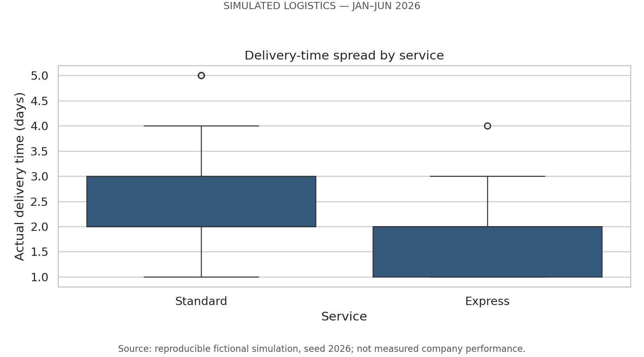
Figure 3. Service-level delivery distributions; visible fliers are retained.
Why this visualization: a boxplot summarizes the median, interquartile range and unusually distant points for each service. It highlights variability rather than only a mean. Integer data can produce overlapping quartiles and repeated fliers; the full data remain in the analysis.
Finding: Express contains 913 shipments and averages 1.71 days. Standard contains 2087 and averages 2.13 days. Express is faster by 0.42 days on average, but both have a median of 2 days.
Interpretation and boundary: the Express speed parameter was deliberately set higher. The comparison is descriptive and does not control for all route and load characteristics. Before making real service-design decisions, compare matched distance bands and regions, and verify actual carrier timestamps.
sns.boxplot(data=df, x='service', y='delivery_days',
order=['Standard', 'Express'], ax=ax)
service = grouped(df, 'service')

4.4 Service promise adherence and cost
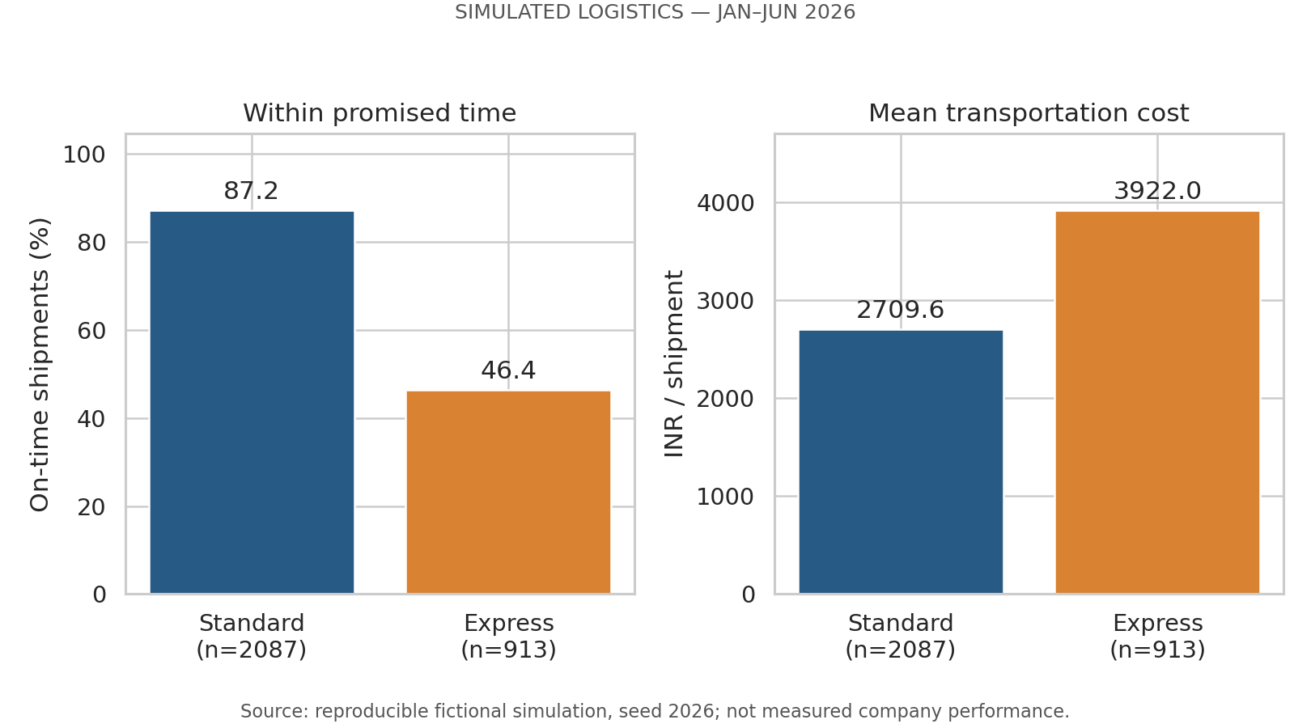
Figure 4. On-time percentage and mean cost, with service sample sizes.
Why this visualization: separate bar panels compare rates and currency in their original units. Zero baselines avoid exaggerating differences, and group counts show the denominators. These are exact descriptive summaries of the simulated dataset, not estimated population rates with inferential error bars.
Finding: Standard is 87.16% on-time and costs INR 2,709.62 per shipment on average. Express is 46.44% on-time and costs INR 3,922.03. The mean Express premium is 44.74%, while its on-time rate is lower by 40.72 percentage points.
Interpretation: faster transit does not guarantee greater adherence to a stricter promise. The simulation sets Express promises to ceil(distance/900), while actual time uses distance/850 plus warehouse dwell and noise. It is therefore a designed mismatch worth explaining, not evidence that real express carriers perform poorly. Investigate promise feasibility and dispatch dwell before recommending a switch of service.
table['late_rate_pct'] = table.late_shipments / table.shipments * 100
table['on_time_rate_pct'] = 100 - table.late_rate_pct
table['cost_per_unit_inr'] = table.total_cost_inr / table.units

4.5 Distance–transport cost relationship
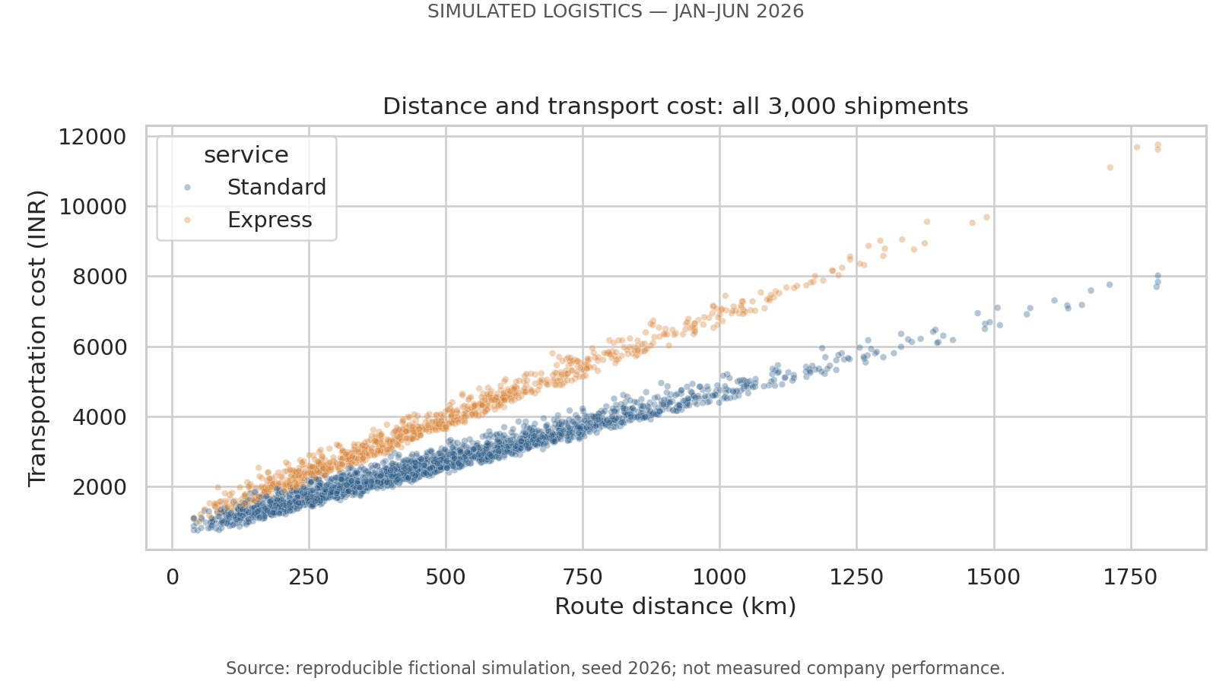
Figure 5. All shipments plotted by route distance and transport cost.
Why this visualization: a scatterplot shows individual observations, spread and service-specific bands. Small, transparent markers reduce overplotting; all 3,000 shipments are shown, not a selectively chosen sample.
Finding: overall Pearson distance–cost correlation is 0.899; Spearman correlation is 0.914. At comparable route lengths, Express generally occupies a higher cost band. The route-distance term contributes 74.49% of simulated total cost.
Interpretation and boundary: this relationship follows substantially from the formula (distance × INR 4 or 6/km). Correlation here confirms the implemented scenario, not an independently identified real-world cost driver. Weight, handling and random variation explain remaining spread. In real operations, distance should be validated alongside tolls, fuel, utilization and service commitments before claiming savings from route consolidation.
sns.scatterplot(data=df, x='distance_km',
y='transport_cost_inr', hue='service',
alpha=0.35, s=12, ax=ax)

4.6 Correlation structure
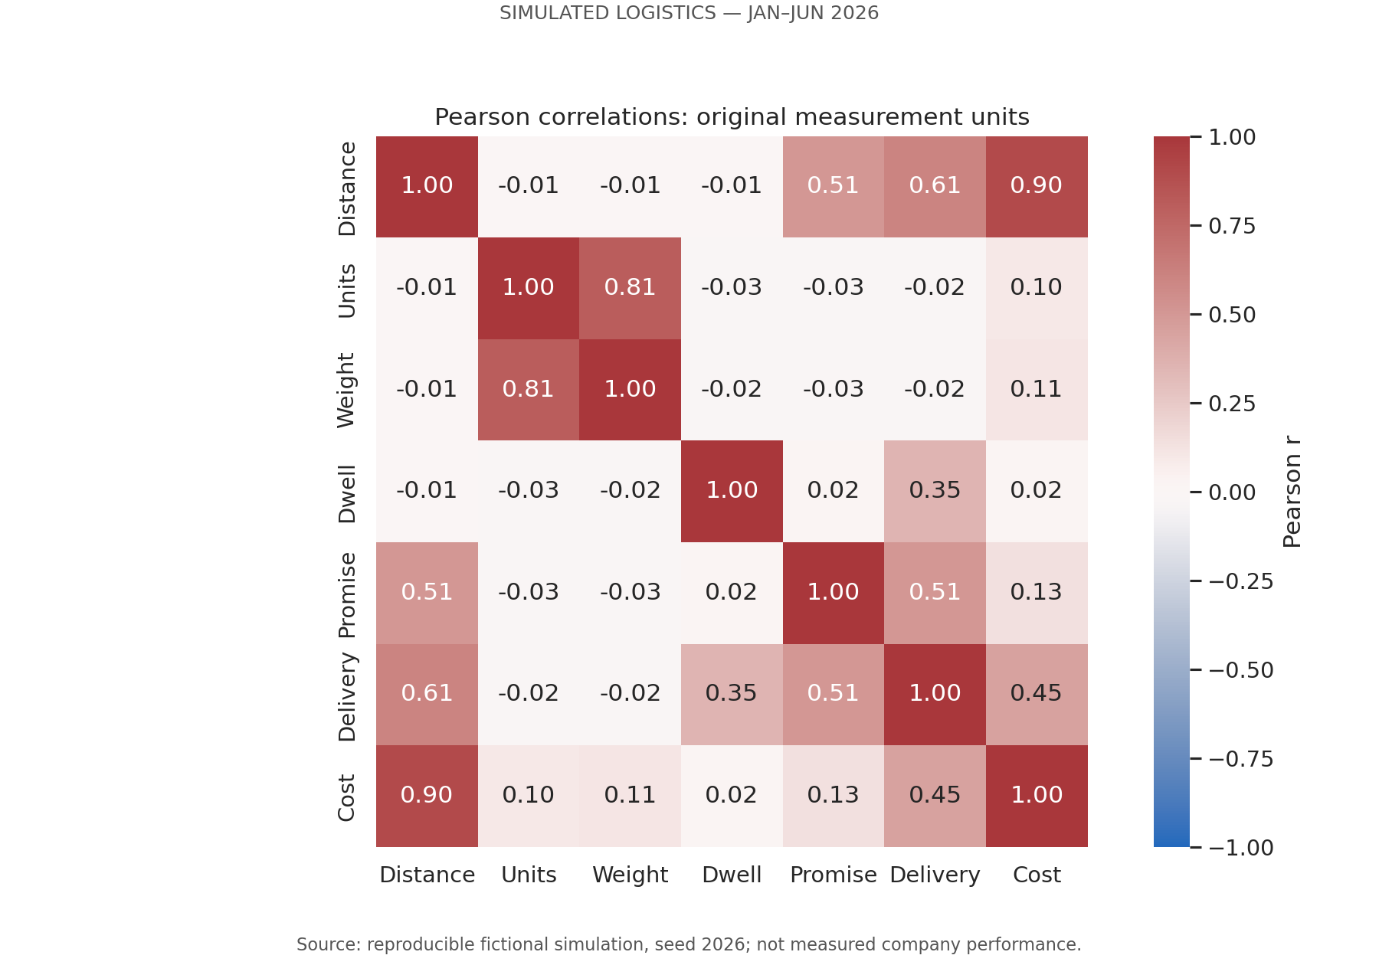
Figure 6. Pearson matrix; detailed values and Spearman matrix are supplied.
Why this visualization: an annotated heatmap makes multiple relationships easy to compare on a common −1 to +1 scale. Labels and numbers avoid reliance on color alone. IDs are excluded; late and delay flags are not treated as independent measurement variables.
Finding: distance and cost show r = 0.899, while dwell and delivery days show r = 0.354. Units and weight show approximately r = 0.81 because weight is generated from units times a sampled per-unit weight. Distance and delivery show approximately r = 0.61.
Interpretation: focus on a small set of meaningful relationships rather than treating every colored cell as an actionable discovery. Some associations are structurally built into the generator, including units–weight and distance–promise. A low overall dwell–cost correlation does not remove handling cost from the formula; route cost dominates overall variation. No multivariable causal effect or significance test is inferred.
pearson = df[NUMERIC].corr(method='pearson')
spearman = df[NUMERIC].corr(method='spearman')
sns.heatmap(pearson, annot=True, fmt='.2f',
vmin=-1, vmax=1, center=0, ax=ax)

4.7 Regional dwell and missed promises
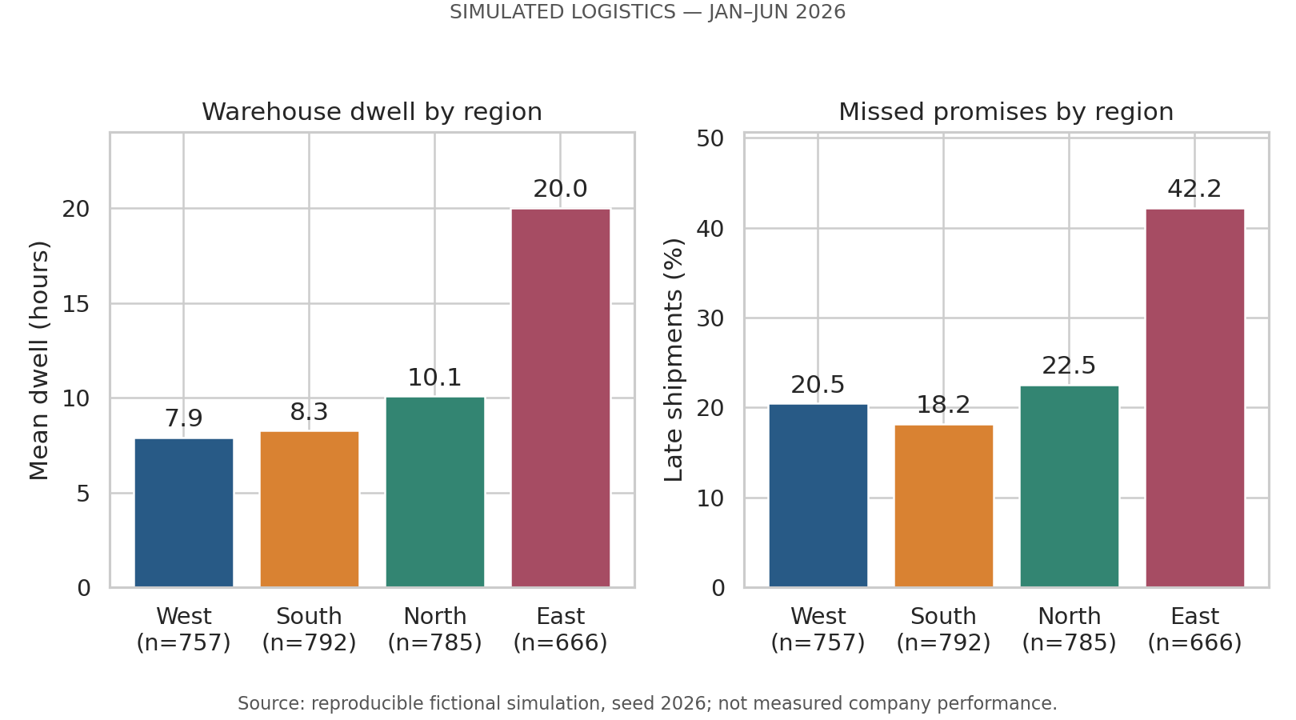
Figure 7. Regional mean dwell and late percentage, with group counts.
Why this visualization: paired regional bars expose a plausible bottleneck and its coincident service outcome. Ordering by dwell makes the largest delay visible, while group counts make unequal samples explicit. The panels do not estimate a causal effect.
Finding: East has 666 shipments, mean dwell 20.00 hours and late rate 42.19%. South has 792 shipments, dwell 8.27 hours and late rate 18.18%. The East–South late-rate difference is 24.01 percentage points.
Interpretation and boundary: East’s additional 12-hour dwell is a declared simulation rule. The figure shows how a regional process delay could surface in EDA, but real investigations would need warehouse scan logs, service mix and distance-band controls. A recommended dwell audit is therefore a validation step, not a claim that staffing changes will deliver a quantified improvement.
region = grouped(df, 'region')
region = region.sort_values('mean_dwell_hours')
ax.bar(region.index, region['late_rate_pct'])

4.8 Simulated cost composition
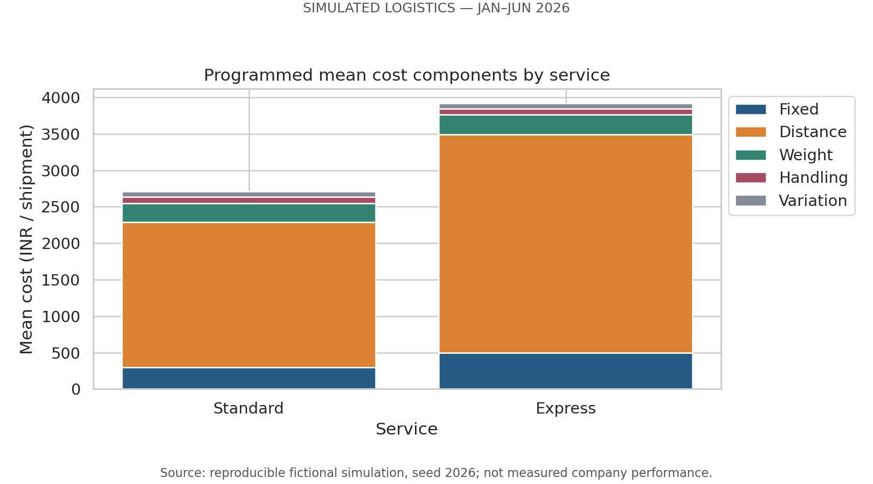
Figure 8. Mean cost components by service; totals reconcile to mean cost.
Why this visualization: stacked bars show each cost component’s contribution to a service’s total mean cost. The composition is interpretable because components use the same currency and sum to the plotted total. Components should not be mistaken for independently measured invoices.
Finding: distance contributes 74.49% of total cost, fixed charges 11.72%, weight 8.47%, handling 2.92% and variation 2.39%. The corresponding totals reconcile to INR 92,35,792.37 across all shipments.
Interpretation: in this scenario, distance and service-rate design are the largest cost levers. Handling accounts for a smaller direct monetary share but can still matter to promise adherence. A real cost ledger could differ substantially; route savings and service-mix changes require measured rates and a feasibility study, not proportional extrapolation from these invented components.
components = df.groupby('service')[cost_columns].mean()
# In the full script, each component is plotted on the
# accumulated bottom of the preceding components.
df['transport_cost_inr'] = df[cost_columns].sum(axis=1).round(2)

5. Recommendations and decision safeguards
The recommendations below are investigation priorities for the fictional scenario. None is presented as a proven real-company intervention or guaranteed saving. A future operational dataset should be used to validate them before decisions are implemented.
Priority and proposed action | Evidence | Validation before action
1. Review Express promise design and dispatch process | Express 46.44% on-time despite 1.71-day mean delivery. | Check service-specific deadlines, dwell inclusion and distance bands. Pilot feasible promises; compare speed, on-time rate and customer requirements.
2. Audit East warehouse dwell | East 20.00 hours dwell and 42.19% late. | Use scan events to separate picking, queue and dock time. Compare matched routes/services. Record baseline and post-pilot outcomes.
3. Investigate route and rate efficiency | Distance share 74.49%; Pearson r 0.899. | Verify real distance, vehicle utilization, toll/fuel rates and carrier contracts. Test consolidation without violating promises.
4. Plan capacity for the demand scenario | January 400 to June 649 shipments. | Use actual historical bookings before forecasting. Establish capacity constraints; simulated volume alone does not determine delay.
5. Monitor tail and balanced KPIs | Median 2 days; 90th percentile 3 days; aggregate on-time 74.77%. | Track delivery percentiles, deadline adherence, cost/shipment and cost/unit together. Keep shipment denominators and dispatch cohort consistent.

Suggested review cadence: inspect weekly service and regional dashboards, with monthly reconciliation of shipment counts, units and cost components. This cadence is a proposed management practice, not an empirically evaluated intervention. For real data, assess missing timestamps, cancellations and right-censoring before calculating on-time percentages.

Limitations and reflection
The exercise demonstrates reproducible analysis and clear interpretation, but simulation realism is limited. Regions and services are sampled independently; distance and weight are not calibrated to geography or a product portfolio; month weights are not historical evidence; there is no capacity-driven delay, weather, carrier availability or observed traffic. Associations reproduce the equations rather than prove operational mechanisms.
A useful methodological lesson is that a premium service can look good on mean delivery time and poor on promise adherence. Another is that visually strong correlation can be partly tautological when the variables share a generation formula. Keeping those distinctions explicit protects logistics decisions from overconfident conclusions.

6. Execution and reproducibility
The included folder is self-contained. No DataCo file or original Week 2 script is required. Use Python 3.11 or newer and the tested versions in requirements.txt. Internet is needed for the first dependency installation. The Windows launcher creates a local virtual environment, installs packages, runs tests and executes the complete Week 3 pipeline.

VS Code command
cmd /c RUN_WEEK3.bat

Run this in the VS Code terminal after opening the extracted Week3_Logistics folder. If the terminal is elsewhere, first change to the actual extracted folder. Keep the window open until SUCCESS. The Windows launcher was prepared but has not been executed on the student’s laptop.

Direct Python command
python run_week3.py

Use the direct command only after installing requirements into your selected environment. simulation.py and analysis.py are imported by the runner; they do not need separate execution. The Word report is supplied as a completed document and is not rebuilt by the Python runner. Changes to seed or formulas will require report updates.
Evidence file | What it verifies
data/simulated_shipments.csv | Full 3,000-row, 19-column simulated dataset.
data/simulation_assumptions.json | Seed, date period, distributions, formulas and caveats.
results/descriptive_statistics.csv | Central tendencies, quartiles, SD, range, mode and skew.
results/monthly_summary.csv; service_summary.csv; region_summary.csv | Group counts, total units, SLA, delivery, dwell and costs.
results/*correlations.csv; cost_components_by_service.csv | Pearson/Spearman matrices and cost reconciliation.
results/figures/01–08 PNG files | Actual Python-rendered visualization outputs.
results/test_results.txt; dataset_sha256.txt; environment.json | 15 passing package tests, dataset checksum and software versions.

The package tests cover equal-seed output, different-seed variation, invalid size, duplicate/missing IDs, invalid measurements, dates, categories, late flags, cost reconciliation, integer days, hand-calculated group rates and symmetric correlation matrices. Full-run output was separately checked for repeated CSV hash equality. Save your own real terminal screenshot after running; do not present the included test log as local execution evidence.

7. Evaluation evidence and sources
Week 3 evaluation criterion | Evidence in this submission
Depth and clarity of EDA | Section 3; descriptive statistics, distribution/tails, group analysis, Pearson and Spearman outputs.
Quality and relevance of visualizations | Eight embedded charts; trend, histogram, boxplot, SLA/cost bars, scatter, heatmap, regional panels and composition.
Correct Python tools and techniques | Runnable NumPy/pandas/matplotlib/seaborn scripts, reproducibility checks and 15 tests.
Insights and recommendations | Each figure states a quantitative finding, chart choice, logistics implication and limitation; Section 5 prioritizes validation.
Structure and professionalism | Dataset declaration, consistent units, labeled charts, code excerpts, evidence files and transparent limitations.

Methodological references
[1] pandas documentation. DataFrame.corr: Pearson and Spearman correlation methods. https://pandas.pydata.org/docs/reference/api/pandas.DataFrame.corr.html
[2] Matplotlib documentation. matplotlib.pyplot.hist: histogram counts and binning. https://matplotlib.org/stable/api/_as_gen/matplotlib.pyplot.hist.html
Data source: simulation.py, seed 2026, and data/simulation_assumptions.json. All empirical-looking numeric claims in this report refer only to that generated dataset. Software references support methods; they do not validate the scenario parameters or provide a real-world logistics benchmark.
Submission review: confirm the cover details, run the pipeline, inspect the charts, and be prepared to explain how promises differ from actual speed. No marks or assessment outcome are guaranteed.

