LOGISTICS DATA ANALYST INTERNSHIP
WEEK 3
Advanced Data Analysis and Visualization in Logistics
A reproducible shipment-level simulation with Python
Submitted by: Pulipati Keerthana
Programme: B.Tech — CSE (AI & ML)
Institution: KITS College, Markapur
Scenario: Fictional regional road-logistics operator
Dispatch period: January–June 2026
Dataset: 3,000 simulated shipments × 19 variables
Reproducibility: NumPy seed 2026
Revised: 19 October 2026
Data-integrity declaration
Every shipment, rate and operational pattern in this report is hypothetical. Numerical findings are computed from the included simulation, not observed company records. The scenario is new Week 3 work and does not represent a continuation of the DataCo records used in Week 2.
Deliverables: runnable Python scripts, dataset, eight chart outputs, EDA tables, 19 tests (15 core + 4 supplementary) and this Word report.

1. Executive findings and analytical questions
The pipeline generated and validated 3,000 unique shipments carrying 1,55,954 units. 2,243 shipments met their promised transit time: an on-time rate of 74.77%. Mean delivery time was 2.00 days, with a median of 2 days and a 90th percentile of 3 days. These are executed simulation results, not performance estimates for an employer.
Total hypothetical transportation cost was INR 92,35,792.37; mean cost was INR 3,078.60 per shipment and the aggregate cost-to-volume ratio was INR 59.22 per unit. The programmed distance component accounted for 74.49% of total cost.
Express averaged 1.71 days versus 2.13 for Standard, but its on-time rate was lower (46.44% versus 87.16%). This is not contradictory: Express promises a tighter deadline. The result demonstrates why delivery speed and promise adherence must be reported separately.
East had the highest mean dwell (20.00 hours) and late rate (42.19%). The simulator intentionally adds 12 hours of East-region dwell, so this is a demonstration of how EDA exposes a designed bottleneck—not an independently discovered real-world cause.

Questions guiding the analysis
Report map: Sections 2–3 define the simulation and EDA; Section 4 interprets eight figures; Sections 5–7 give recommendations, reproducibility and evaluation evidence.

2. Hypothetical dataset and collection simulation
The fictional operator uses North, South, East and West service regions and offers Standard and Express road delivery. One row represents one shipment; shipment_units counts goods carried, not additional shipments. There are no cancellations, split shipments, observed routes or company identifiers. This deliberately clean schema supports Week 3 analysis rather than repeating Week 2 preprocessing.
Collection is simulated as a dispatch-system extract. A shipment identifier, dispatch date, service and region represent booking data; distance and weight represent manifest measurements; dwell represents time before line-haul movement; delivery date represents completion. In a real project these fields would require joins between the transport-management system, warehouse events and cost ledger, with reconciled units and timestamps. Here they are generated in Python and exported to CSV.
Table 1. Hypothetical dataset variables.
Table 1 provides the exact hypothetical dataset variables used in this section; values and definitions should be checked together rather than treated as interchangeable measures.
Variable group | Fields and interpretation
Identity and timing | shipment_id; dispatch_date; delivery_date. Dispatch dates run 1 January–30 June 2026; some June shipments arrive by 3 July.
Segmentation | region (North/South/East/West); service (Standard/Express).
Load and route | distance_km; shipment_units (integer); weight_kg.
Operational performance | warehouse_dwell_hours; promised_days; delivery_days; delay_days; late_flag.
Cost components (INR) | cost_fixed_inr; cost_distance_inr; cost_weight_inr; cost_handling_inr; cost_variation_inr.
Total (INR) | transport_cost_inr = sum of five components. Rates are entirely illustrative.

The dataset has 19 columns: 3 identity/date fields, 2 categorical fields, 3 route/load fields, 5 operational fields and 6 cost fields. No external dataset is portrayed as the source. The source is simulation.py plus simulation_assumptions.json.
Monthly sampling weights are 1.0, 1.0, 1.1, 1.2, 1.4 and 1.6. Because sampling occurs across individual calendar days, month length also affects expected counts. Region probabilities are 28%, 26%, 22% and 24%; Express probability is 30%. Realized counts need not exactly equal these proportions.

2.1 Transparent generative assumptions
Table 2. Declared simulation rules.
Table 2 provides the exact declared simulation rules used in this section; values and definitions should be checked together rather than treated as interchangeable measures.
Quantity | Simulation rule
Distance and load | Distance ~ Gamma(3,170), clipped to 40–1,800 km. Units ~ integer Uniform(5,100). Weight = units × Uniform(1,4).
Warehouse dwell | Gamma(2,4) hours + 12 hours in East + 2 hours in North.
Promised transit days | Standard: ceil(distance/600) + 1. Express: ceil(distance/900).
Actual transit days | max(1, ceil(distance/speed + dwell/24 + Normal(0.15,0.45))); speed parameter 500 Standard or 850 Express.
Fixed and route cost | Fixed INR 300 Standard / 500 Express; distance × INR 4/km Standard / 6/km Express.
Other cost | Weight × INR 2/kg; dwell × INR 8/hour; variation ~ Uniform(0,150) INR.
Dates and SLA | Delivery date = dispatch + delivery_days; delay = actual − promised; late_flag = 1 only if delay > 0.

The speed parameters are effective daily-distance assumptions, not measured vehicle speeds or travel-time models. Integer rounding approximates day-level reporting. Cost component rounding is applied before summation, allowing totals to reconcile exactly to the supplied ledger-style columns. No calibrated fuel, toll, staffing, inventory, tax or profit model is included.

Practical Python excerpt: reproducible generation
rng = np.random.default_rng(2026)
distance = np.round(np.clip(rng.gamma(3, 170, n), 40, 1800), 1)
units = rng.integers(5, 101, n)
weight = np.round(units * rng.uniform(1, 4, n), 2)
dwell = np.round(rng.gamma(2, 4, n)
+ 12 * (region == 'East')
+ 2 * (region == 'North'), 2)

These excerpts are selected from the runnable scripts; they depend on surrounding variables defined in those scripts. They are not intended to be run alone. The full simulator fixes the sequence of random draws, which is necessary for matching the included seed-2026 dataset.

3. EDA methodology and data-quality checks
Validation found 0 missing cells and 0 duplicate shipment IDs. All 3,000 records passed positive-measurement, categorical, date, cost-sum and late-flag checks. No valid rows were dropped or imputed. Repeated complete runs reproduced the CSV checksum, and 19 automated tests passed. This log records package verification, not execution on the student’s laptop.
Descriptive analysis uses count, mean, median, first reported mode, sample standard deviation (ddof=1), quartiles, range and pandas skewness. Modes of rounded continuous fields can be tied and weakly informative; the full output reports the first tied mode returned by pandas. Mode is most interpretable for integer delivery days.
Shipment-level on-time percentage = 100 × count(actual days ≤ promised days) / total shipments. Aggregate cost per unit = total cost / total shipment units. This ratio differs from an unweighted average of shipment-specific cost/unit ratios. Dispatch-month grouping keeps the timing basis consistent across volume, cost and SLA summaries.
$On-time percentage = \frac{100 × on-time shipments}{all shipments}$
On-time means actual days ≤ promised days for the same dispatch cohort. Both counts use one shipment per row; this definition supplies the service bars in Figure 4.
Pearson r describes linear association; Spearman rho describes rank-monotonic association. Both matrices use seven numeric operational measurements, not identifiers or late flags. No missing-value pairwise deletion affects this dataset. Raw units remain interpretable: correlation does not require min–max normalization. No predictive model or causal-effect estimate is claimed. [1]

Central tendencies and dispersion
Table 3. Central tendencies and dispersion.
Table 3 provides the exact central tendencies and dispersion used in this section; values and definitions should be checked together rather than treated as interchangeable measures.
Variable | Mean | Median | SD | Mode*
Distance (km) | 497.41 | 443.05 | 284.06 | 40.00
Units / shipment | 51.98 | 53.00 | 27.39 | 15.00
Weight (kg) | 130.33 | 111.73 | 86.80 | 16.40
Dwell (hours) | 11.26 | 9.57 | 7.40 | 4.74
Promised days | 1.95 | 2.00 | 0.73 | 2.00
Delivery days | 2.00 | 2.00 | 0.80 | 2.00
Cost (INR) | 3,078.60 | 2,778.42 | 1,460.36 | 1,658.82

*First reported mode; see descriptive_statistics.csv for precision and ties policy. Distance’s minimum-bound mode partly reflects clipping, not a naturally observed route preference.
The 1.5 × IQR rule flags tails for investigation, not automatic deletion: distance 66, weight 10, dwell 35, promised days 47, delivery days 101 and cost 101. These counts overlap across variables and must not be added as unique shipments. All records are retained because their values are consistent with the documented generator. Cost skewness is 1.32 and distance skewness 1.07, supporting use of medians as well as means.

4. Visualization findings

4.1 Dispatch volume trend
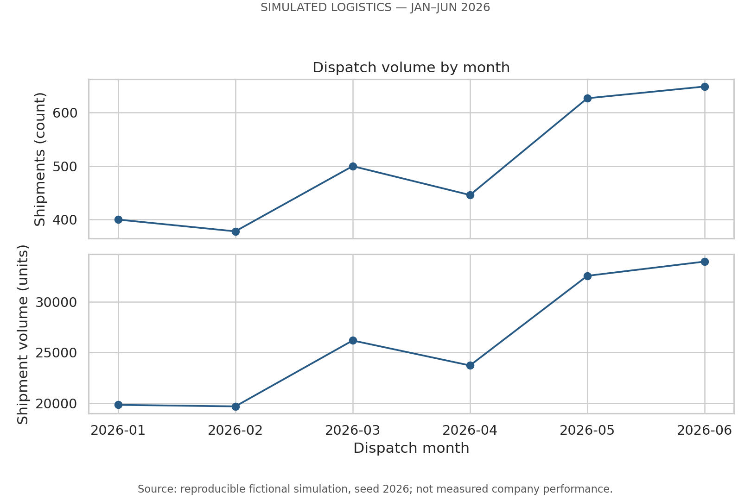
Figure 1. Shipment count and goods volume by dispatch month.
Why this visualization: aligned line charts show temporal changes without mixing shipment counts and goods units on a dual-axis plot. All six dispatch months are represented; no delivery-month regrouping is used.
Finding: January contained 400 shipments and 19,859 units; June contained 649 shipments and 33,937 units. Shipment count increased 62.25% between these endpoints. The pattern is not perfectly monotonic; sampling and calendar length affect realized counts.
Interpretation and boundary: the generator intentionally assigns higher later-month demand weights. The figure illustrates capacity planning under a rising-demand scenario; it does not prove actual seasonality or demand growth. Nor does volume cause delays in this model: monthly volume is not an input to the delivery-time equation.
Figure 1 uses connected observations because calendar months are ordered; a pie chart would hide order and a dual axis could manufacture parallel-looking trends. January’s 400 shipments over 31 calendar days equal 12.90/day; February’s smaller total (378) over 28 days equals 13.50/day. Thus the apparent February dip reverses after day normalization. June reaches 21.63/day. Calendar days are a transparent exposure denominator, not measured operating shifts, and six points cannot establish seasonality.

4.2 Delivery-time distribution
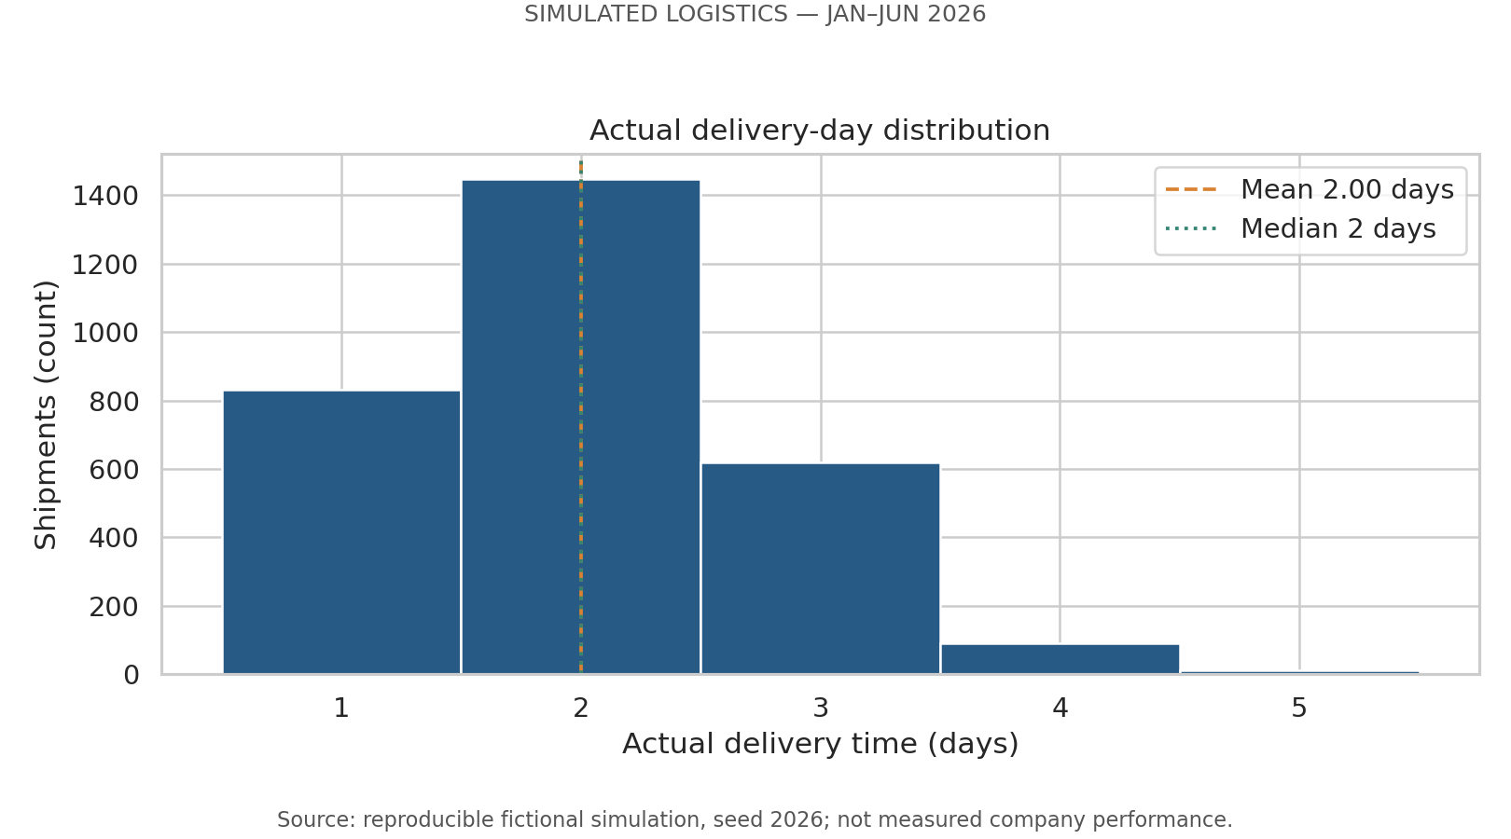
Figure 2. Integer-day histogram with mean and median reference lines.
Why this visualization: one-day-width bins centered on integer outcomes reveal typical performance and the delivery tail. Mean and median reference lines prevent the average alone from hiding the shape. Matplotlib hist() computes frequency counts in the chosen bins. [2]
Finding: delivery times range from 1 to 5 days. The mean is 2.00 days, the median and first reported mode are 2 days, and the 90th percentile is 3 days. Sample standard deviation is 0.80 days; skewness is 0.53. The modest right tail indicates that a typical two-day shipment does not describe every customer experience.
Interpretation: monitor the tail and promise adherence as well as average speed. A 3-day 90th percentile does not imply 90% on-time service because each shipment has its own promised time. The 101 delivery-day IQR flags are consistent with valid longer-distance or higher-dwell records and are not removed.
desc = df[NUMERIC].describe().T
desc['mode_first'] = df[NUMERIC].mode().iloc[0]
desc['skewness'] = df[NUMERIC].skew()
bins = np.arange(0.5, df.delivery_days.max() + 1.5, 1)
ax.hist(df.delivery_days, bins=bins, edgecolor='white')

Figure 2 uses integer-centered histogram bins instead of a smooth density curve, which would imply fractional outcomes not present here. The verified frequencies are 831 one-day, 1,448 two-day, 620 three-day, 90 four-day and 11 five-day shipments. The four/five-day tail is 101/3,000 = 3.37%; a mean-only bar hides these cases. The plotted mean (2.0007) and median (2) nearly overlap, so their lines are not independent visible evidence of a substantial difference.

4.3 Delivery-time spread by service
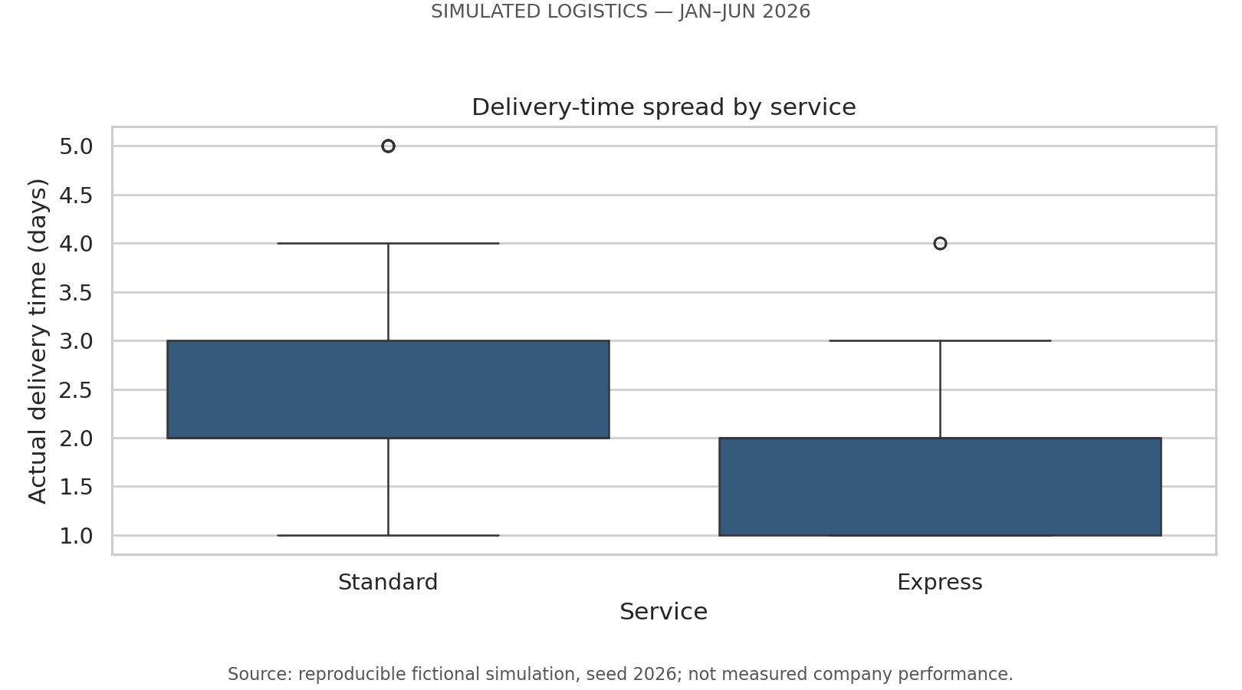
Figure 3. Service-level delivery distributions; visible fliers are retained.
Why this visualization: a boxplot summarizes the median, interquartile range and unusually distant points for each service. It highlights variability rather than only a mean. Integer data can produce overlapping quartiles and repeated fliers; the full data remain in the analysis.
Finding: Express contains 913 shipments and averages 1.71 days. Standard contains 2087 and averages 2.13 days. Express is faster by 0.42 days on average, but both have a median of 2 days.
Interpretation and boundary: the Express speed parameter was deliberately set higher. The comparison is descriptive and does not control for all route and load characteristics. Before making real service-design decisions, compare matched distance bands and regions, and verify actual carrier timestamps.
sns.boxplot(data=df, x='service', y='delivery_days',
order=['Standard', 'Express'], ax=ax)
service = grouped(df, 'service')

Figure 3 is preferable to a mean-only bar because it reveals distribution spread. Both medians are 2, so ranking services by median alone misses the 0.4182-day mean difference. However, a boxplot hides discrete frequencies and overlapping fliers; the histogram and frequency table supply that context. A violin plot would add smoothing and may suggest unsupported intermediate delivery times.

4.4 Service promise adherence and cost
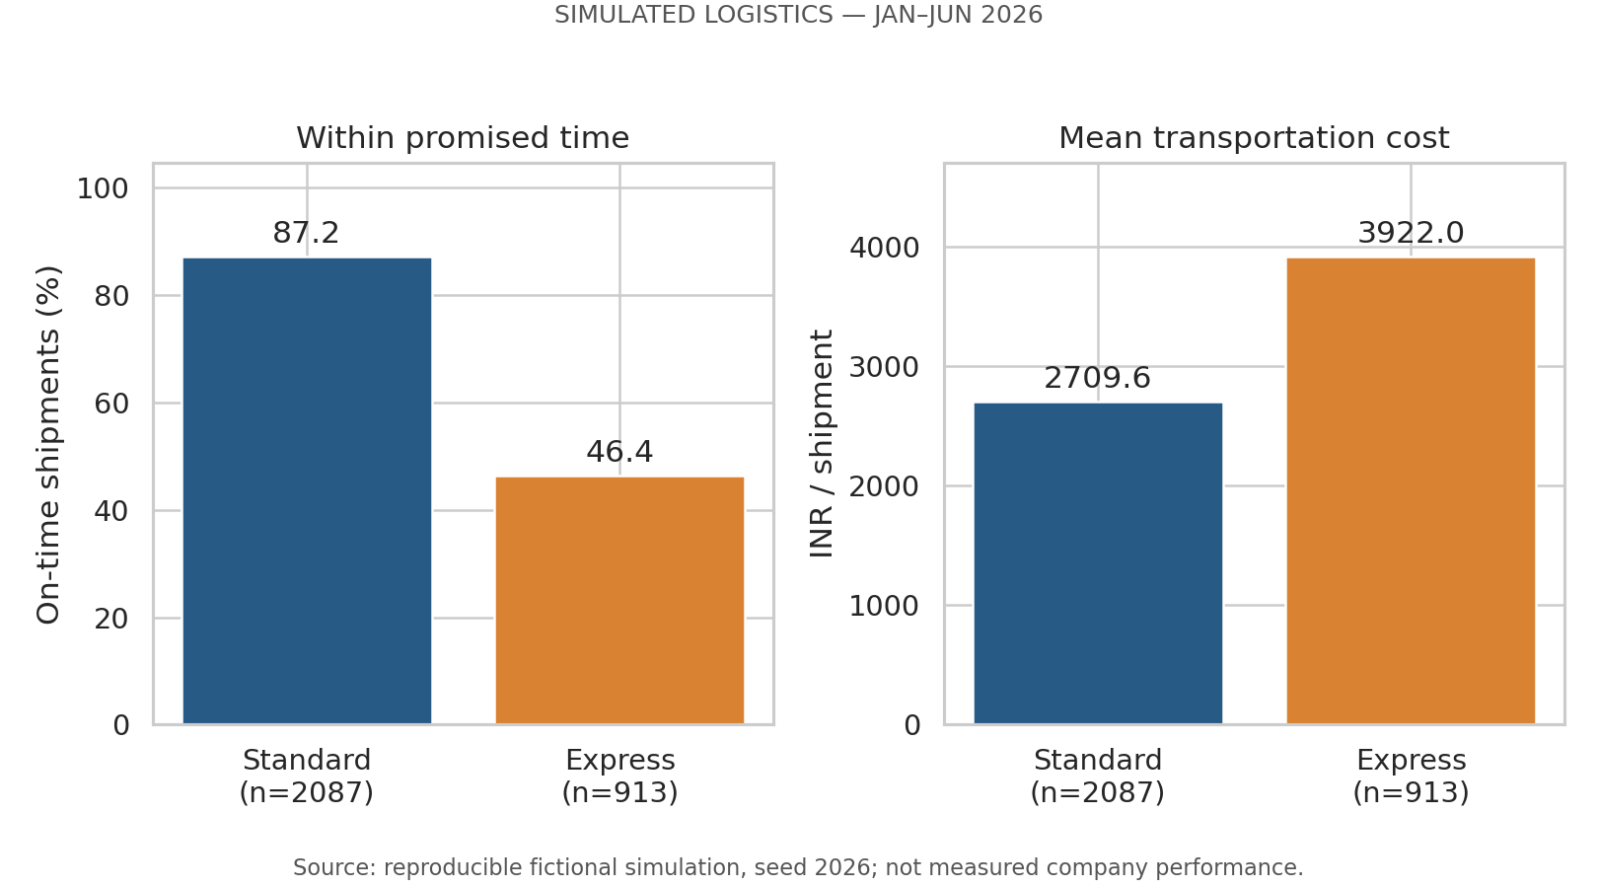
Figure 4. On-time percentage and mean cost, with service sample sizes.
Why this visualization: separate bar panels compare rates and currency in their original units. Zero baselines avoid exaggerating differences, and group counts show the denominators. These are exact descriptive summaries of the simulated dataset, not estimated population rates with inferential error bars.
Finding: Standard is 87.16% on-time and costs INR 2,709.62 per shipment on average. Express is 46.44% on-time and costs INR 3,922.03. The mean Express premium is 44.74%, while its on-time rate is lower by 40.72 percentage points.
Interpretation: faster transit does not guarantee greater adherence to a stricter promise. The simulation sets Express promises to ceil(distance/900), while actual time uses distance/850 plus warehouse dwell and noise. It is therefore a designed mismatch worth explaining, not evidence that real express carriers perform poorly. Investigate promise feasibility and dispatch dwell before recommending a switch of service.
table['late_rate_pct'] = table.late_shipments / table.shipments * 100
table['on_time_rate_pct'] = 100 - table.late_rate_pct
table['cost_per_unit_inr'] = table.total_cost_inr / table.units

Figure 4’s separate zero-baseline panels preserve percentage and INR units; plotting them on one numeric axis or normalizing both to 0–1 would erase business meaning. Express accounts for 489 of 757 late shipments (64.60%), despite only 30.43% of volume. Counts accompany the rates because a high percentage and a high workload contribution are different prioritization questions.

4.5 Distance–transport cost relationship
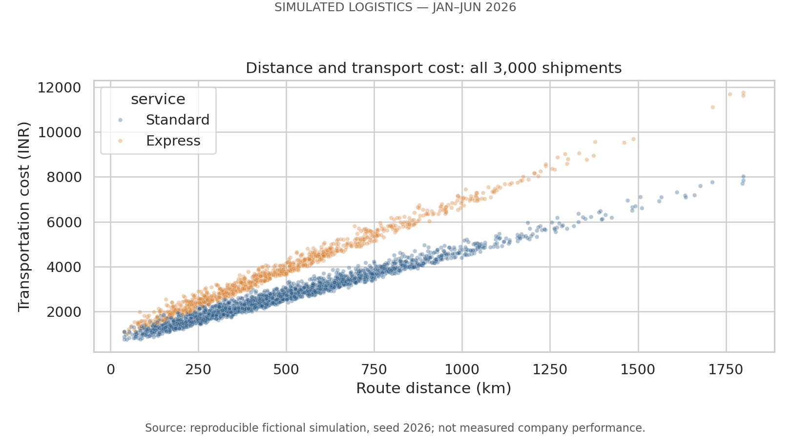
Figure 5. All shipments plotted by route distance and transport cost.
Why this visualization: a scatterplot shows individual observations, spread and service-specific bands. Small, transparent markers reduce overplotting; all 3,000 shipments are shown, not a selectively chosen sample.
Finding: overall Pearson distance–cost correlation is 0.899; Spearman correlation is 0.914. At comparable route lengths, Express generally occupies a higher cost band. The route-distance term contributes 74.49% of simulated total cost.
Interpretation and boundary: this relationship follows substantially from the formula (distance × INR 4 or 6/km). Correlation here confirms the implemented scenario, not an independently identified real-world cost driver. Weight, handling and random variation explain remaining spread. In real operations, distance should be validated alongside tolls, fuel, utilization and service commitments before claiming savings from route consolidation.
sns.scatterplot(data=df, x='distance_km',
y='transport_cost_inr', hue='service',
alpha=0.35, s=12, ax=ax)

Figure 5 retains individual points because an aggregate mean-cost bar cannot show service bands or spread at similar distances. Transparent markers reduce but do not eliminate overplotting. No fitted causal line is added: the route price is already a simulation input. Table 4 later checks whether pooled correlation masks those two cost slopes.

4.6 Correlation structure
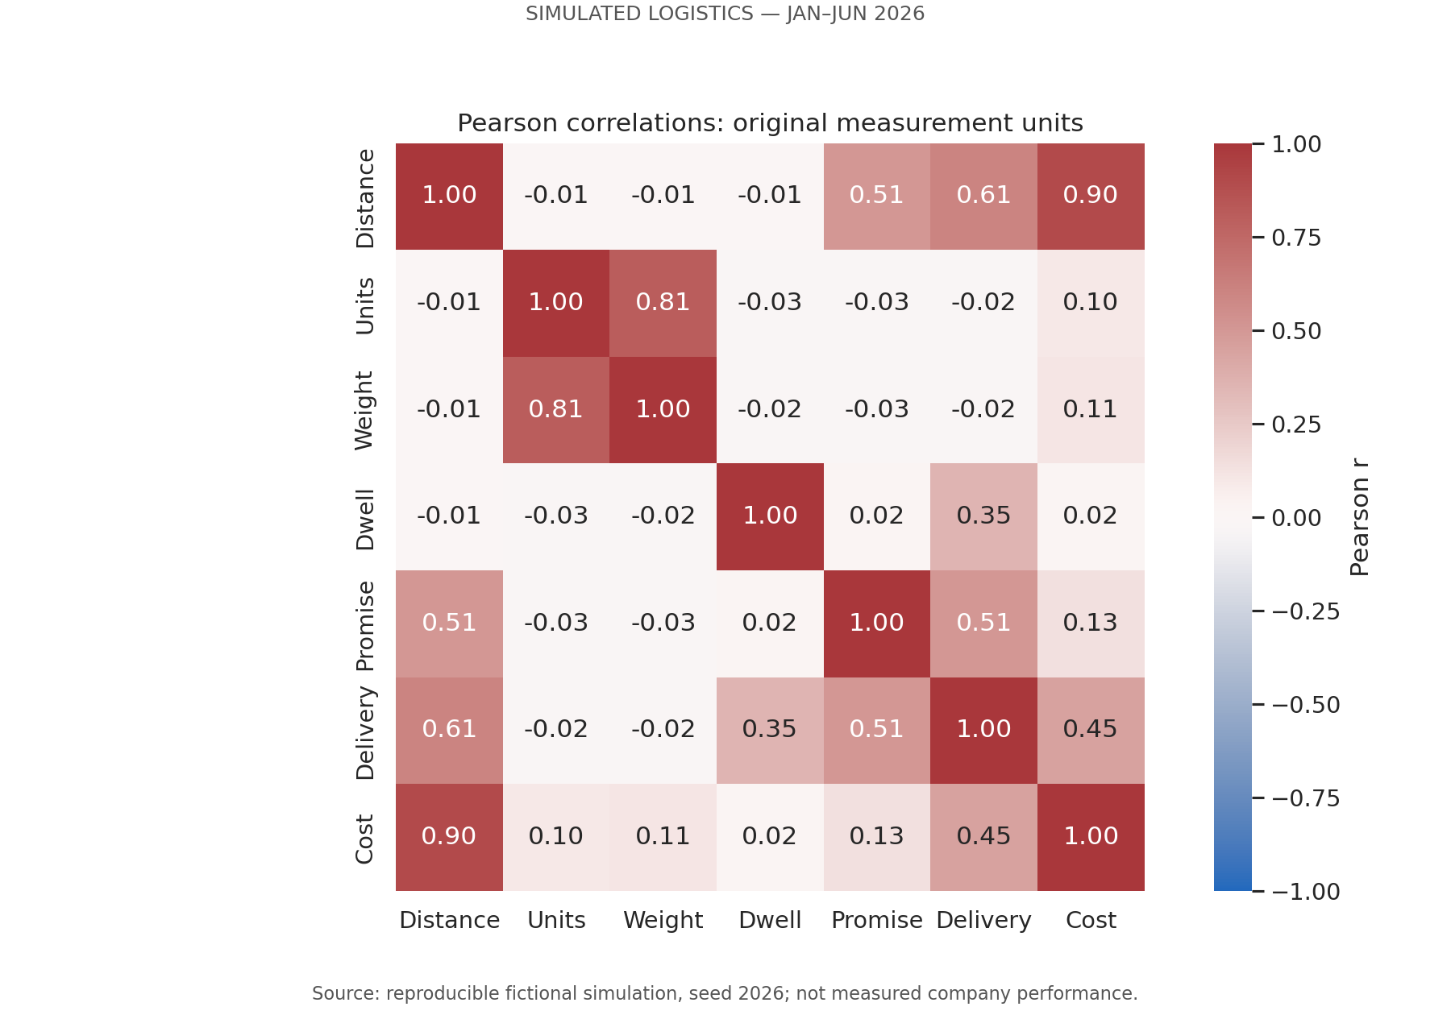
Figure 6. Pearson matrix; detailed values and Spearman matrix are supplied.
Why this visualization: an annotated heatmap makes multiple relationships easy to compare on a common −1 to +1 scale. Labels and numbers avoid reliance on color alone. IDs are excluded; late and delay flags are not treated as independent measurement variables.
Finding: distance and cost show r = 0.899, while dwell and delivery days show r = 0.354. Units and weight show approximately r = 0.81 because weight is generated from units times a sampled per-unit weight. Distance and delivery show approximately r = 0.61.
Interpretation: focus on a small set of meaningful relationships rather than treating every colored cell as an actionable discovery. Some associations are structurally built into the generator, including units–weight and distance–promise. A low overall dwell–cost correlation does not remove handling cost from the formula; route cost dominates overall variation. No multivariable causal effect or significance test is inferred.
pearson = df[NUMERIC].corr(method='pearson')
spearman = df[NUMERIC].corr(method='spearman')
sns.heatmap(pearson, annot=True, fmt='.2f',
vmin=-1, vmax=1, center=0, ax=ax)

Figure 6 is a screening matrix rather than a recommendation engine. Its symmetric −1 to +1 scale preserves sign; a sequential 0–1 scale would hide negative associations. Because an annotated matrix cannot show nonlinearity, ties or group composition, Figure 5 and Tables 4–5 supply necessary observation-level and stratified checks.

4.6.1 What the correlation values do—and do not—mean
Table 4 extends Figure 6 by comparing pooled and within-service correlations. Values are recalculated from the unchanged 3,000-row simulation by feedback_analysis.py; each service has its own cost-per-kilometer parameter. The comparison holds service category fixed, not every other variable.
Table 4. Pooled and service-specific correlations.
Relationship / population | Pearson r | Spearman rho
Distance–cost, all (n=3,000) | 0.8990 | 0.9139
Distance–cost, Express (n=913) | 0.9940 | 0.9914
Distance–cost, Standard (n=2,087) | 0.9867 | 0.9818
Dwell–delivery, all | 0.3540 | 0.3400
Dwell–delivery, Express | 0.4138 | 0.3757
Dwell–delivery, Standard | 0.3380 | 0.3252
Weight–cost, all | 0.1138 | 0.1356
Units–weight, all | 0.8123 | 0.8476

Distance–cost becomes stronger within each service because the two route-price slopes (INR 4 and 6/km) are no longer mixed. For a declared like-for-like 100 km difference, the programmed route component rises by INR 400 Standard or INR 600 Express; this arithmetic follows the generator and is not an estimated real carrier tariff. A pooled r of 0.8990 does not mean “89.90% of cost is caused by distance.” Its square is approximately 0.8082, the descriptive R-squared of an in-sample single-predictor linear fit with an intercept, not the distance component’s 74.49% ledger share. Correlation strength, regression fit and accounting contribution answer different questions. No forecasting validation is performed in Week 3.
Dwell–delivery is positive but only moderate: Pearson 0.3540 and Spearman 0.3400. Express remains more dwell-associated (0.4138) than Standard (0.3380) when analyzed separately, so the pooled association is not solely an artifact of mixing the two services. However, service stratification does not remove region, distance, rounding or noise. The delivery formula already includes dwell/24, meaning six extra hours add 0.25 days before rounding; the reported integer day can stay unchanged or cross a boundary. Therefore neither coefficient supplies a causal “days saved per hour” estimate.
Weight–cost is weak (r = 0.1138) even though each additional kilogram contributes INR 2 in the cost formula. Route costs dominate total variation, so a low pooled r is not evidence that load weight is free or should be excluded from a cost ledger. Similarly, units–weight (r = 0.8123, rho = 0.8476) follows weight = units × sampled per-unit weight: heavier item mixes create dispersion. Counting both as independent discoveries would overstate what the simulation teaches.
Pearson and Spearman agreement supports a broadly increasing distance–cost pattern, while their differences for integer delivery days reflect ranks, ties and nonlinear day thresholds. Spearman is not automatically “more accurate,” and neither is a causal test. The diagonal equals 1 by definition and each off-diagonal pair appears twice; seven variables yield 21 distinct pairs, not 49 independent findings. This analysis emphasizes preselected logistics relationships and does not claim statistical significance from inspecting many cells. [1]
for service, group in df.groupby('service'):
r = group.distance_km.corr(group.transport_cost_inr)
rho = group.distance_km.corr(
group.transport_cost_inr, method='spearman')
print(service, len(group), r, rho)

4.6.2 Distance bands expose deadline risk hidden by averages
Table 5 groups routes using right-closed bands (300 km belongs to the first band). These are descriptive strata, not perfectly matched routes; weight, region, noise and within-band distance can still differ. Nevertheless, Express is faster but has more missed promises in every band, so the overall paradox is not merely caused by having a greater share of long routes. Source: feedback/distance_service.csv.
Table 5. Delivery and lateness by distance band.
Distance km | Express n / days / late % | Standard n / days / late %
0–300 | 253 / 1.375 / 35.18 | 561 / 1.538 / 3.21
>300–600 | 383 / 1.601 / 54.57 | 888 / 2.039 / 20.61
>600–900 | 186 / 2.032 / 80.65 | 455 / 2.545 / 5.05
>900 | 91 / 2.440 / 45.05 | 183 / 3.328 / 24.04

The >600–900 km Express band is the first promise-review priority: 150/186 shipments are late, despite faster average delivery than Standard. Above 900 km, ceil(distance/900) increases the Express promise from one to two days for this dataset; its late rate drops to 45.05%, even though its mean transit increases. That discontinuity is why a general recommendation to prioritize only the longest routes would miss the severe one-day-promise band. A saved illustrative record from the simulated data has distance 797 km, dwell 9.61 hours, promise 1 day and actual 2 days: a one-day miss. This is an actual simulated row, not evidence from a carrier.

4.7 Regional dwell and missed promises
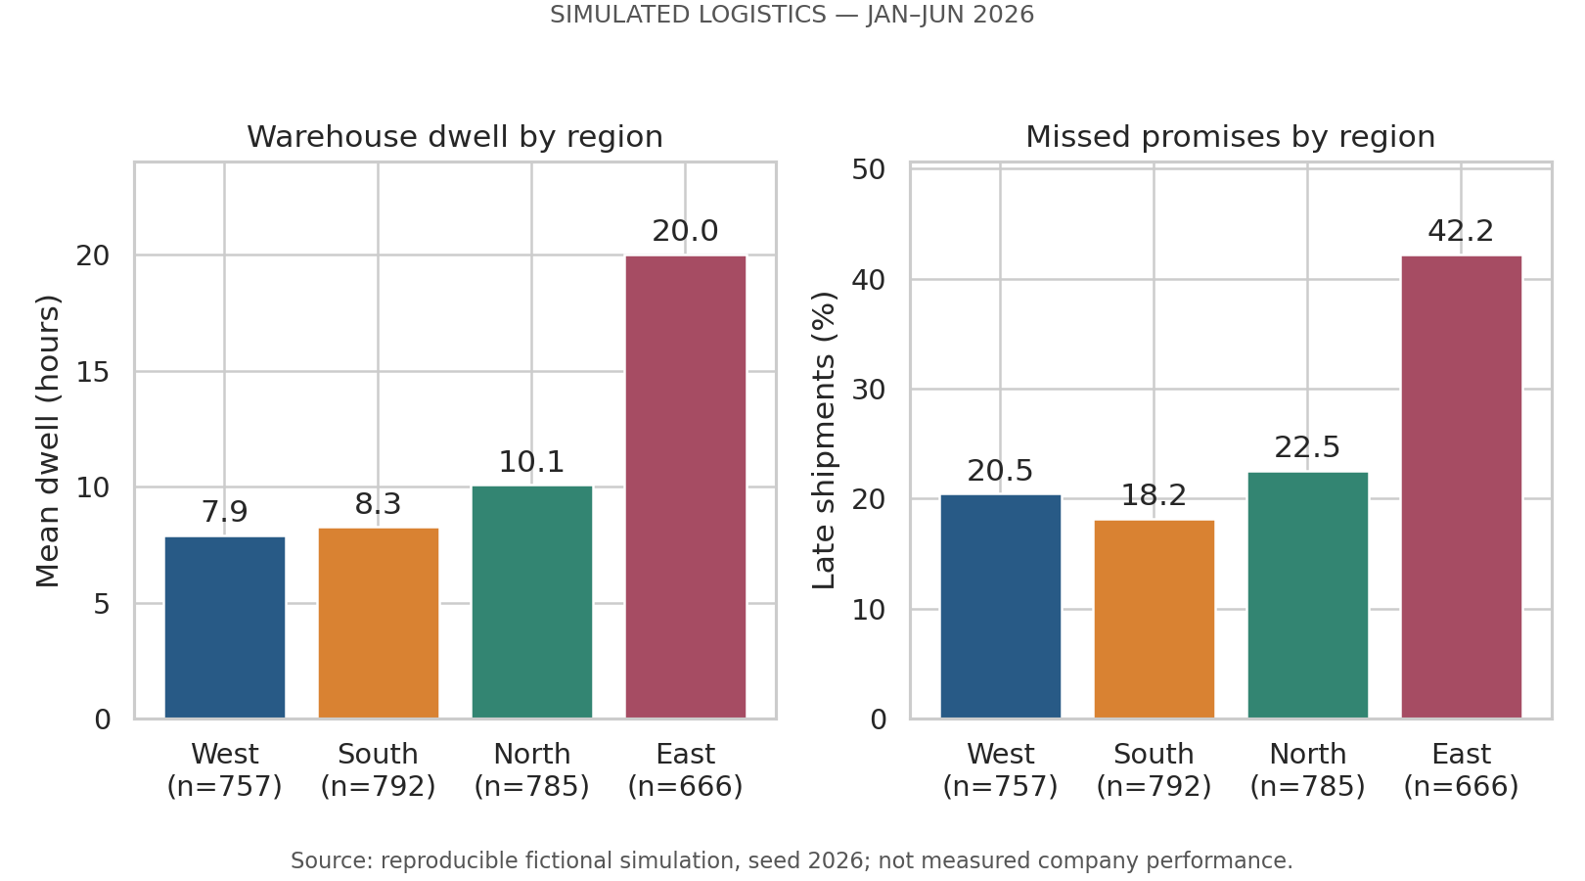
Figure 7. Regional mean dwell and late percentage, with group counts.
Why this visualization: paired regional bars expose a plausible bottleneck and its coincident service outcome. Ordering by dwell makes the largest delay visible, while group counts make unequal samples explicit. The panels do not estimate a causal effect.
Finding: East has 666 shipments, mean dwell 20.00 hours and late rate 42.19%. South has 792 shipments, dwell 8.27 hours and late rate 18.18%. The East–South late-rate difference is 24.01 percentage points.
Interpretation and boundary: East’s additional 12-hour dwell is a declared simulation rule. The figure shows how a regional process delay could surface in EDA, but real investigations would need warehouse scan logs, service mix and distance-band controls. A recommended dwell audit is therefore a validation step, not a claim that staffing changes will deliver a quantified improvement.
region = grouped(df, 'region')
region = region.sort_values('mean_dwell_hours')
ax.bar(region.index, region['late_rate_pct'])

Figure 7 aligns regions in both panels, so the reader can compare dwell and late outcomes without mixing hours and percentages. A geographic map would be misleading because the regions are fictional labels with no real coordinates. Region averages can conceal service mix; Table 6 therefore tests East within each service before defining the audit priority.

4.7.1 Check the regional finding within each service
Table 6 tests whether East’s higher lateness disappears when service is held fixed. It does not: Express East is 79.37% late versus 46.82% elsewhere (32.54 points); Standard East is 27.46% versus 8.51% (18.95 points). Mean distances are slightly lower in East for both services, so longer average routes alone do not explain this descriptive pattern. However, this is not a matched-route or causal analysis; East’s +12 hours dwell is a declared input assumption.
Table 6. East comparison within service.
Service / location | n / dwell hours | Mean km / late %
Express / East | 189 / 20.32 | 487.60 / 79.37
Express / Non-East | 724 / 8.45 | 501.90 / 46.82
Standard / East | 477 / 19.88 | 489.71 / 27.46
Standard / Non-East | 1,610 / 8.90 | 498.83 / 8.51

The operational lesson is to audit East queue and dock events before changing service mix. East contains 22.20% of all shipments but 37.12% of all late shipments, while Express contains 30.43% of shipments but 64.60% of late shipments. These groups overlap and their late counts must not be added. The priority dashboard should cross-classify region, service and distance band to avoid double-counting the same problem.

4.8 Simulated cost composition
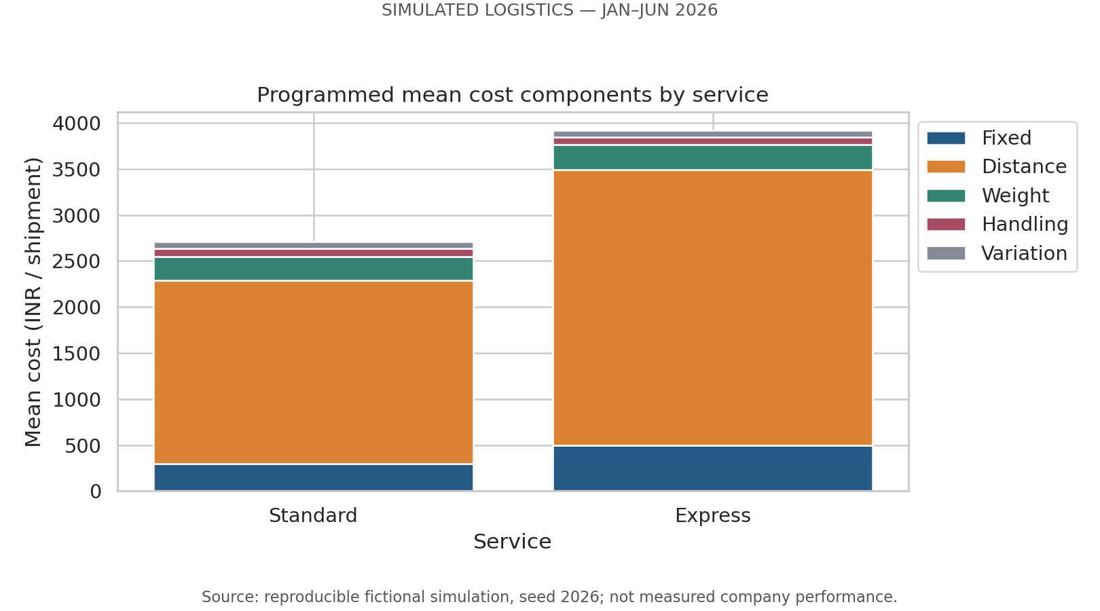
Figure 8. Mean cost components by service; totals reconcile to mean cost.
Why this visualization: stacked bars show each cost component’s contribution to a service’s total mean cost. The composition is interpretable because components use the same currency and sum to the plotted total. Components should not be mistaken for independently measured invoices.
Finding: distance contributes 74.49% of total cost, fixed charges 11.72%, weight 8.47%, handling 2.92% and variation 2.39%. The corresponding totals reconcile to INR 92,35,792.37 across all shipments.
Interpretation: in this scenario, distance and service-rate design are the largest cost levers. Handling accounts for a smaller direct monetary share but can still matter to promise adherence. A real cost ledger could differ substantially; route savings and service-mix changes require measured rates and a feasibility study, not proportional extrapolation from these invented components.
components = df.groupby('service')[cost_columns].mean()
# In the full script, each component is plotted on the
# accumulated bottom of the preceding components.
df['transport_cost_inr'] = df[cost_columns].sum(axis=1).round(2)

Figure 8 uses additive INR components on one baseline because the components genuinely reconcile to total cost. A pie chart would be poor for comparing two service totals, while stacked bars make middle-segment comparison less precise; the saved component table is the exact-value companion. A 10% reduction in the distance term would arithmetically reduce total cost by 7.4493% (INR 688,002.36) if every other term stayed fixed. This is a scenario calculation only: there is no feasible route plan or measured saving behind it.

5. Recommendations and decision safeguards
The recommendations below are investigation priorities for the fictional scenario. None is presented as a proven real-company intervention or guaranteed saving. A future operational dataset should be used to validate them before decisions are implemented.
Table 7 turns findings into a proposed four-week validation plan. Owners and review gates are proposed responsibilities and safeguards, not actions already performed. Baselines are simulation results; target changes are not invented.
Table 7. Proposed validation and action plan.
Action / proposed owner | Evidence and monitoring gate
1. Promise audit: service-design analyst | Start with Express >600–900 km: 150/186 late (80.65%), mean 2.032 days versus a one-day promise. Reconcile deadline and warehouse-cutoff rules. Track late percentage and actual duration together; merely lengthening promises is not proof of faster service.
2. Dwell investigation: East warehouse supervisor | East Express 79.37% late vs 46.82% non-East; East Standard 27.46% vs 8.51%. For two weeks, collect queue/pick/dock scan times and compare identical service/distance bands. Pilot staffing only if scans identify a controllable queue, then monitor dwell, late rate and overtime.
3. Route-cost review: transport procurement analyst | Distance component is 74.49% of cost; within-service distance–cost r is 0.9940/0.9867. Verify loaded distance, rates, load utilization and tolls. Accept a consolidation pilot only after a feasible route and unchanged promises are documented; record total cost and cost/unit.
4. Capacity review: operations planner | June 21.63 shipments/calendar day vs January 12.90. Collect operating-day and shift capacity records before setting staffing. Track bookings per staffed hour and queue backlog; the simulator has no congestion equation, so it cannot predict overtime or delay reductions.

Suggested review cadence: inspect weekly service and regional dashboards, with monthly reconciliation of shipment counts, units and cost components. This cadence is a proposed management practice, not an empirically evaluated intervention. For real data, assess missing timestamps, cancellations and right-censoring before calculating on-time percentages.

Limitations and reflection
The exercise demonstrates reproducible analysis and clear interpretation, but simulation realism is limited. Regions and services are sampled independently; distance and weight are not calibrated to geography or a product portfolio; month weights are not historical evidence; there is no capacity-driven delay, weather, carrier availability or observed traffic. Associations reproduce the equations rather than prove operational mechanisms.
A useful methodological lesson is that a premium service can look good on mean delivery time and poor on promise adherence. Another is that visually strong correlation can be partly tautological when the variables share a generation formula. Keeping those distinctions explicit protects logistics decisions from overconfident conclusions.

6. Execution and reproducibility
The included folder is self-contained. No DataCo file or original Week 2 script is required. Use Python 3.11 or newer and the tested versions in requirements.txt. Internet is needed for the first dependency installation. The Windows launcher creates a local virtual environment, installs packages, runs tests and executes the complete Week 3 pipeline.

VS Code command
cmd /c RUN_WEEK3.bat

Run this in the VS Code terminal after opening the extracted Week3_Logistics folder. If the terminal is elsewhere, first change to the actual extracted folder. Keep the window open until SUCCESS. The Windows launcher was prepared but has not been executed on the student’s laptop.
After the baseline run, use python feedback_analysis.py or RUN_FEEDBACK.bat to rebuild the new stratified evidence. The unchanged simulator and chart generator still produce the original eight charts.

Direct Python command
python run_week3.py

Use the direct command only after installing requirements into your selected environment. simulation.py and analysis.py are imported by the runner; they do not need separate execution. The Word report is supplied as a completed document and is not rebuilt by the Python runner. Changes to seed or formulas will require report updates.

The package tests cover equal-seed output, different-seed variation, invalid size, duplicate/missing IDs, invalid measurements, dates, categories, late flags, cost reconciliation, integer days, hand-calculated group rates and symmetric correlation matrices. Full-run output was separately checked for repeated CSV hash equality. Save your own real terminal screenshot after running; do not present the included test log as local execution evidence.

7. Evaluation evidence and sources

Methodological references
[1] pandas documentation. DataFrame.corr: Pearson and Spearman correlation methods. https://pandas.pydata.org/docs/reference/api/pandas.DataFrame.corr.html
[2] Matplotlib documentation. matplotlib.pyplot.hist: histogram counts and binning. https://matplotlib.org/stable/api/_as_gen/matplotlib.pyplot.hist.html
Data source: simulation.py, seed 2026, and data/simulation_assumptions.json. All empirical-looking numeric claims in this report refer only to that generated dataset. Software references support methods; they do not validate the scenario parameters or provide a real-world logistics benchmark.
Submission review: confirm the cover details, run the pipeline, inspect the charts, and be prepared to explain how promises differ from actual speed. No marks or assessment outcome are guaranteed.

