WEEK 4 · LOGISTICS SYSTEMS
Predictive Modeling and Optimization
A hypothetical delivery-time forecasting study
KITS College, Markapur
Python implementation · Model validation · Operational recommendations
Study identity: reproducible simulation
All records, economic assumptions and operational gains are hypothetical.
October 17, 2026

1. Problem definition and study identity
This Week 4 simulation asks: can shipment information available at warehouse release predict total delivery duration, and can those predictions support economically defensible Express upgrades? The unit of analysis is one shipment. The target is delivery_days, measured in integer calendar days, rather than daily shipment volume. The model estimates a continuous duration for new shipments. It is a shipment-level forecast, not a time-series demand forecast.
The analysis reuses the unchanged Week 3 generator: 3,000 fictional shipments dispatched from January 1 through June 30, 2026, seed 2026. Every result describes this programmed scenario, not a logistics company. Training, validation, and optimization were actually executed on simulated data. No real carrier tariffs, field trials, weather records, road network, or operational savings were collected. The goal is a reproducible decision workflow, not proof of company performance.
Prediction is defined at warehouse release, assuming accumulated warehouse dwell, destination region, planned distance, shipment size, weight, and chosen service are known then. The target includes dwell already incurred. Therefore predictions are total duration, not remaining transit time. For a remaining-time application, the target and timestamps must be redesigned. At booking time, actual final dwell would be unavailable and would constitute leakage [1].

2. Hypothetical dataset and preparation
Table 1 identifies the six permitted predictors and the target. ID and dates support traceability and chronological splitting; they are not features. Customer promises are used only in the optimization loss, not regression. Actual delivery date, delay_days, late_flag, transportation cost and cost components are excluded: several directly encode the outcome or information unavailable at the stated decision point. A whitelist prevents accidental inclusion.
Table 1. Data dictionary and prediction-time roles
Field | Unit / values | Role and availability
distance_km | 40–1,800 km | Known planned distance; predictor
shipment_units | 5–100 units | Known quantity; predictor
weight_kg | Positive kg | Known shipment weight; predictor
warehouse_dwell_hours | Nonnegative hours | Accumulated dwell known at release; predictor
region | North/South/East/West | Known destination category; predictor
service | Standard/Express | Chosen service at release; predictor
delivery_days | Integer days ≥ 1 | Target; known after delivery
dispatch_date / delivery_date | Calendar dates | Split and label-availability audit only
promised_days | Integer days | Original SLA; optimization only
The simulator samples dispatch dates with increasing monthly weights, selects Express for approximately 30% of shipments, and generates distances from a clipped Gamma distribution. Warehouse dwell follows Gamma(shape=2, scale=4) hours plus 12 hours for East and 2 for North. Weight is units multiplied by a uniform 1–4 kg factor. These distributions and regional differences are assumptions, not observed demand or measured bottlenecks.
Equation (1) describes the programmed duration mechanism. It explains why distance, dwell and service matter, while rounding and random noise make exact predictions impossible.
$y = max(1, ceil(\frac{d}{v} + \frac{w}{24} + ε))$ (1)
Here y is total simulated delivery_days, d is distance in km, v is 500 km/day for Standard or 850 km/day for Express, w is dwell in hours, and ε is normally distributed with mean 0.15 days and standard deviation 0.45 days. The generator uses ceil and clips the duration to at least 1 day. The model is not given this formula as an input.
All generated records pass consistency checks for unique shipment IDs, nonmissing required fields, positive measurements, date-duration reconciliation and cost totals. No outliers are removed simply because a delivery is long; valid tails are informative. No cancellations or split shipments exist. The reused seed reproduces the Week 3 CSV exactly. In the modeling pipeline, median numeric imputation, most-frequent categorical imputation, scaling and one-hot encoding are fitted inside each training fold. The clean default data needs no imputation, but the pipeline supports missing numeric inputs and unfamiliar category labels. Unfamiliar categories can be processed; their accuracy is not validated.

3. Model choice, training and validation
Four model families are compared: a mean-only dummy baseline, linear regression, a decision tree, and a random forest. The dummy checks whether predictors improve on a constant forecast. Linear regression is inexpensive and interpretable but assumes additive effects. A tree can capture threshold structure and service-distance interactions, but deep trees overfit. A forest averages many trees and can represent nonlinear interactions, with greater computational cost and less direct interpretability. More complex models are candidates, not presumed winners.
The declared search contains 12 candidate configurations. Linear and dummy models have no tuned hyperparameters. Trees use depths 3, 6 or 10 crossed with minimum leaf sizes 5 or 20. Forests use 100 trees, depth 6 or unlimited, and minimum leaf size 2 or 8. Random states are 2026; forests use one CPU. All candidates share identical folds and preprocessing. modeling.py implements this modest grid explicitly using clone rather than GridSearchCV, making each training/validation pass easy to inspect.
Model choice uses the unweighted mean MAE over three expanding monthly validation folds: March, April and May. This favors predictable average day error rather than a large squared-error penalty. Chronological evaluation emulates deployment on later shipments [2]. Unlike a row-count TimeSeriesSplit, this custom splitter keeps calendar months intact despite unequal shipment counts. Records whose delivery date is on or after a fold cutoff are purged because their labels would not yet be available. Table 2 documents the resulting split sizes.
Table 2. Chronological validation and final holdout
Validation / test | Training n | Evaluation n | Purged n
March | 755 | 500 | 23
April | 1,248 | 446 | 30
May | 1,694 | 627 | 30
June final test | 2,319 | 649 | 32
For June, the final model is refitted only on shipments dispatched before June 1 and delivered before June 1. Of 2,351 pre-June dispatches, 32 unresolved labels are excluded, leaving 2,319 training shipments. The 649 June dispatches are untouched by selection; June deliveries extending into July remain in the eventual evaluation. Historical snapshots should implement the same label-availability rule. No model is retuned after viewing June results. The CV standard deviation measures variation among three monthly errors; it is not a confidence interval.

3.1. Code excerpt: leakage-safe feature and fold handling
# modeling.py — actual package functions
x = features(df) # strict six-column whitelist
folds, train, test, info = chronological_splits(df)
for train_idx, valid_idx in folds:
fitted = clone(estimator).fit(
x.iloc[train_idx], df.delivery_days.iloc[train_idx])
pred = fitted.predict(x.iloc[valid_idx])
score = metrics(df.delivery_days.iloc[valid_idx], pred)
# Winner uses CV MAE only; June is evaluated afterward.
Pipelines matter because splitting alone does not prevent leakage if scaling or imputation was learned on the full dataset. Here every clone fits its preprocessing on its own training rows, following the official leakage guidance [1]. The runner saves every candidate mean, every fold score, and every split count.

4. Evaluation metrics and executed results
The three regression metrics in Equations (2)–(4) are computed on continuous, unrounded predictions [3]. MAE describes average absolute duration error; RMSE gives larger errors more weight; R-squared compares squared error with a constant test-mean prediction. R-squared is not an accuracy percentage and may be negative.
$MAE = \frac{\sum_{i=1}^{n}{\sqrt{{(y_{i} − ŷ_{i})}^{2}}}}{n}$ (2)
$RMSE = \sqrt{\frac{\sum_{i=1}^{n}{{(y_{i} − ŷ_{i})}^{2}}}{n}}$ (3)
$R^{2} = 1 − \frac{\sum_{i=1}^{n}{{(y_{i} − ŷ_{i})}^{2}}}{\sum_{i=1}^{n}{{(y_{i} − ȳ)}^{2}}}$ (4)
In Equations (2)–(4), n is the evaluated shipment count, y_i is actual simulated duration, ŷ_i is the prediction, and ȳ is the mean actual duration in the evaluation set. MAE and RMSE are in days; R-squared is dimensionless. A hand-check fixture y=[1,2,3], ŷ=[1,2,2] gives MAE=1/3, RMSE=sqrt(1/3), and R-squared=0.5.
Linear regression wins development selection with mean CV MAE 0.4295 days and monthly SD 0.0044 days. The best forest uses depth 6 and minimum leaf size 2; its CV MAE is 0.4406 days. The selected linear model has June MAE 0.4418 days, RMSE 0.5495 days and R-squared 0.5363. Table 3 and Figure 1 compare each family’s CV-chosen configuration on the same June holdout.
Table 3. June test results, n=649 fictional shipments
Model | MAE days | RMSE days | R²
Linear regression | 0.4418 | 0.5495 | 0.5363
Random forest | 0.4508 | 0.5538 | 0.5289
Decision tree | 0.4780 | 0.5893 | 0.4667
Dummy mean | 0.5654 | 0.8076 | −0.0016
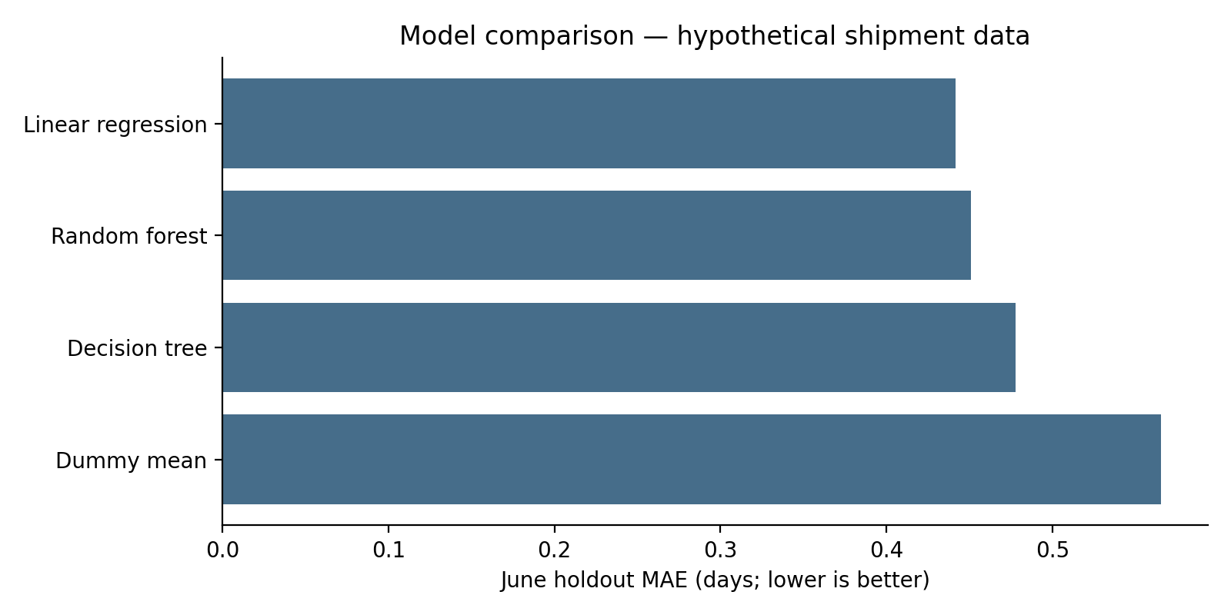
Figure 1. Holdout MAE by CV-selected model family. Source: executed hypothetical simulation.
The linear model reduces test MAE by about 21.86% relative to the dummy. Its advantage over the forest is only 0.0090 days, approximately 13 minutes; no statistical superiority test was performed. Simplicity and CV results justify the choice, not a claim that linear models are universally best. The additive programmed structure, limited data, and random rounding noise can favor a simple approximation even though the simulator contains interactions.
Figure 2 shows predicted versus actual simulated duration and the residual distribution. Mean residual is +0.0305 days, indicating slight average underprediction. About 94.14% of shipments have absolute error no larger than 1 day; the 90th percentile absolute error is 0.8814 days. These are empirical frequencies on the simulated holdout, not guaranteed future coverage or calibrated prediction intervals. Continuous predictions should not be read as exact arrival dates.
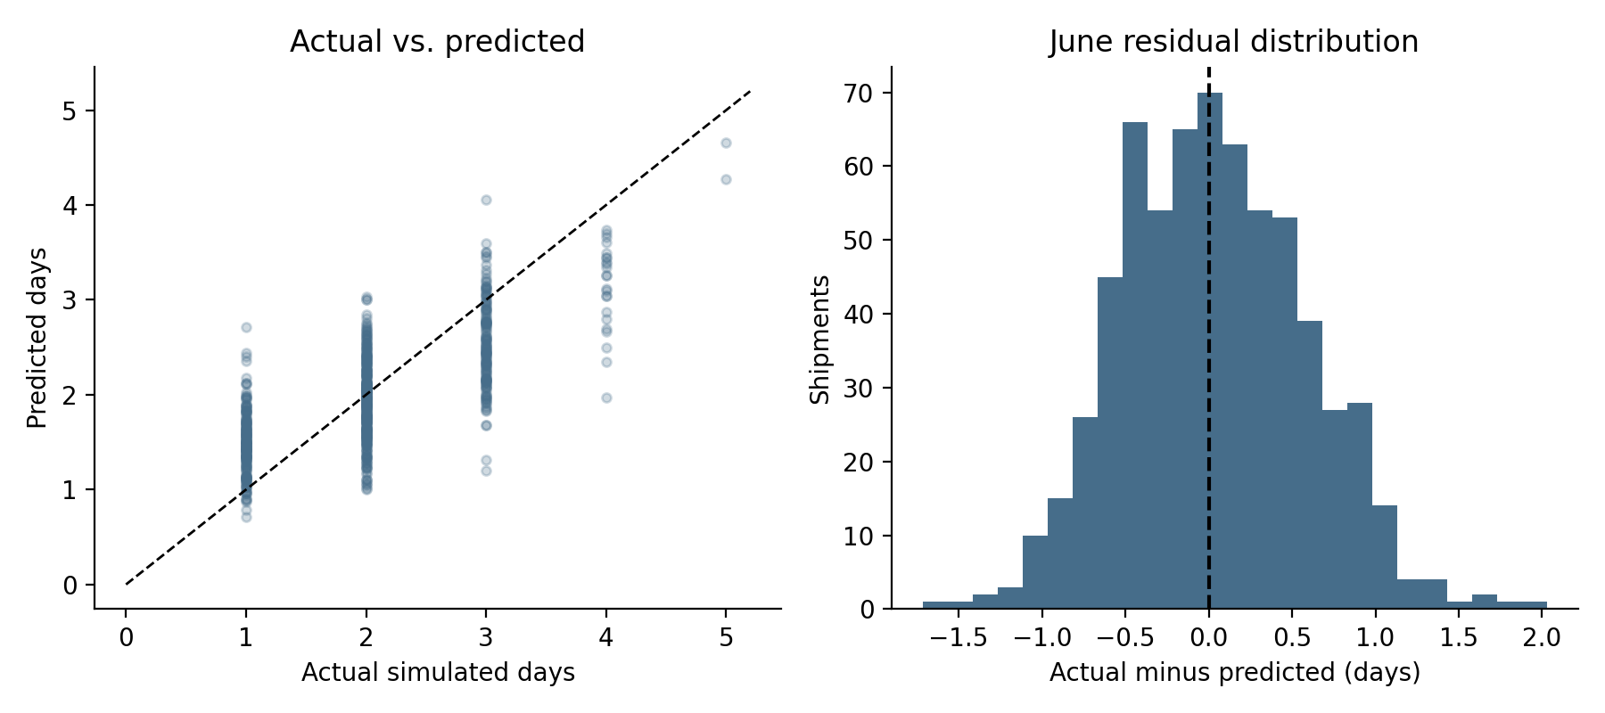
Figure 2. Actual-versus-predicted durations and June residuals. Source: simulated holdout predictions.
Subgroup checks show region MAE from 0.4159 days in East to 0.4625 in West. Express MAE is 0.4427 days versus 0.4414 for Standard. Express mean residual is +0.0968 days, suggesting underprediction worth monitoring. Express R-squared is only 0.3298, despite similar MAE, illustrating why R-squared depends on subgroup outcome variance. subgroup_metrics.csv contains sample sizes and full diagnostics. No subgroup tuning was performed on June.
Figure 3 permutes each raw feature ten times while holding the fitted model fixed. Distance raises MAE by 0.2541 days on average and dwell by 0.1075; service adds 0.0392. Region adds little after dwell is included, while units and weight are near zero. These are model-reliance diagnostics, not causal effects. Correlated inputs may mask importance. Holdout importance is used for interpretation only and does not trigger feature reselection.
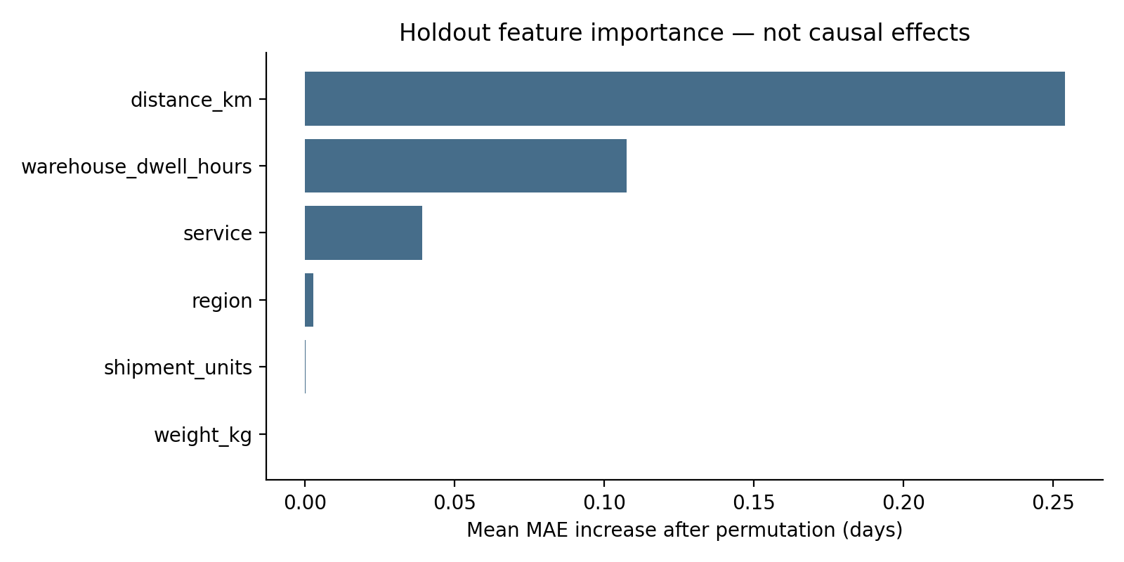
Figure 3. Mean holdout MAE increase after feature permutation; ten repeats. Source: executed simulation.

5. Prediction-informed optimization
The implemented decision is which already-Standard June shipments to upgrade to Express at release. Existing Express shipments cannot be downgraded, and the original promised_days values never change. Upgrading is a hypothetical feature substitution, not a measured intervention. The optimization is an offline monthly batch: all June shipment inputs are assumed known. A deployable dispatcher would need a rolling budget and uncertainty about future arrivals. No vehicle-routing problem is solved.
Express has an assumed INR 200 extra fixed cost and INR 2/km extra distance cost, so incremental cost c_i=200+2d_i. Weight, dwell handling and random cost variation are assumed unchanged. Predicted total durations are floored at 1 day for this decision stage only. Existing and Express predictions are each compared with the unchanged original promise. Equation (5) defines the optimization using only these predicted quantities.
$min \sum_{i=1}^{n}{(c_{i} − λg_{i})z_{i}} , \sum_{i=1}^{n}{c_{i}z_{i}} ≤ B$ (5)
Here z_i is 1 for an upgrade and 0 otherwise; c_i is incremental INR cost; λ is an assumed INR loss per tardiness day; g_i is the nonnegative reduction in positive-part predicted tardiness; and B is the monthly extra-spend budget. Tardiness is max(0, predicted duration − original promised days). Each dispatch date also constrains the sum of z_i to at most K additional upgrades; z_i is binary and may be nonzero only for Standard shipments. Equation (5) minimizes extra spend minus modeled avoided loss, equivalent to maximizing modeled net benefit.
The default policy sets B=INR 30,000, λ=INR 1,500/day and K=4 extra upgrades per day. These are arbitrary learning assumptions, not real contractual penalties or measured spare capacity. SciPy milp solves the binary linear model [4]. Nonprofitable options are excluded because there is no mandatory service target and all constraints are upper bounds. Zero upgrades are always feasible. Solver failures stop the pipeline rather than returning an unsupported allocation.

5.1. Code excerpt: constrained binary allocation
# optimization.py — core solver call
result = milp(
c=cost-benefit, integrality=np.ones(len(cost)),
bounds=Bounds(0, 1),
constraints=LinearConstraint(
matrix, lower_bounds, upper_bounds),
options={'time_limit': 60, 'mip_rel_gap': 0.0})
# benefit = assumed_penalty * predicted_days_avoided
# matrix rows: monthly cost, then each dispatch-day cap
# Check success, budget and daily capacity after solving.
This excerpt abbreviates local variable names; the executable allocate function contains full checks and sparse constraint construction. A brute-force four-item fixture verifies the optimizer’s objective independently. Additional tests cover zero budget, zero capacity, invalid inputs, no profitable action, and preservation of original deadlines. A feasible greedy benefit-per-cost comparator provides another check; it is not claimed to be globally optimal.

6. Optimization results, sensitivity and decision limits
The default allocation selects only 1 of 445 Standard shipments, spending INR 457.80. Predicted aggregate tardiness across all 649 June shipments decreases from 159.3915 to 159.0672 days: just 0.3243 predicted days avoided, about 0.20% of the original predicted tardiness total. Modeled net benefit is INR 28.69. The solver reports zero MIP gap, but that proves optimality only for the stated surrogate objective, not real operational effectiveness. The greedy comparator obtains the same objective in this scenario.
Table 4 isolates the effects of budget, penalty and daily capacity. Figure 4 shows that larger budgets do not create additional profitable actions at λ=1,500. Budget and capacity are not binding under the default policy. At half the penalty, no upgrades are selected. At INR 3,000/day, 17 upgrades spend INR 17,678.80, avoid 6.9639 predicted days and produce INR 3,212.77 modeled net benefit. This strong assumption sensitivity is more important than the presence of an optimization solver.
Table 4. Hypothetical policy sensitivity; original SLA preserved
Budget INR | Loss INR/day | Daily cap | Upgrades | Spend INR | Days avoided
0 | 1,500 | 4 | 0 | 0.00 | 0.0000
15,000 | 1,500 | 4 | 1 | 457.80 | 0.3243
30,000 | 1,500 | 4 | 1 | 457.80 | 0.3243
60,000 | 1,500 | 4 | 1 | 457.80 | 0.3243
30,000 | 750 | 4 | 0 | 0.00 | 0.0000
30,000 | 3,000 | 4 | 17 | 17,678.80 | 6.9639
30,000 | 1,500 | 2 | 1 | 457.80 | 0.3243
30,000 | 1,500 | 8 | 1 | 457.80 | 0.3243
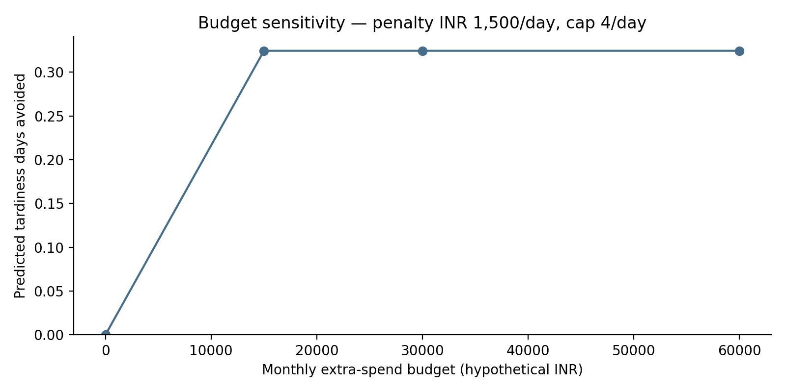
Figure 4. Predicted tardiness reduction versus hypothetical budget; default loss and capacity.
The model predicts duration, not expected tardiness loss. Applying max(0, predicted mean − deadline) does not generally equal the expected positive tardiness of a random delivery time. The objective is therefore a point-forecast surrogate, not a calibrated expected-cost model. Furthermore, changing the service feature does not establish a causal delivery improvement. The simulated holdout verifies baseline duration prediction only; no post-upgrade durations are evaluated. Predicted gains smaller than model error, particularly the 0.3243-day default gain versus 0.4418-day holdout MAE, should not support automatic spending decisions. This comparison is a caution, not a formal significance test.

7. Actionable logistics recommendations
1. Use the selected linear pipeline as a transparent release-stage ETA aid, with human review near deadline boundaries. Operations staff should monitor weekly MAE, high-error percentiles and service/region residuals after true deliveries occur. Do not publish a guaranteed arrival promise from a raw point estimate. Reassess on future months before rollout.
2. Do not expand Express spending simply because a budget is available. The default optimization barely pays for one upgrade; unused budget is economically sensible under this objective. Finance must replace assumed penalties and incremental charges with genuine contracted values. Dispatch teams must validate actual spare capacity and use a conservative minimum benefit margin before a small controlled pilot.
3. Investigate warehouse dwell first: it is the second most relied-on predictor, and the Week 3 scenario deliberately adds East dwell. Potential actions include measuring queue time, improving shift overlap and staging high-risk shipments before release. These are proposed interventions, not optimized staffing assignments or quantified savings. Collect labor hours, workload and intervention outcomes before estimating an effect. Actual dwell cannot be rewritten as if reduced after release.
4. For route planning, collect origin/destination coordinates, travel-time matrices, driver-hour limits, vehicle capacities and customer time windows. Then formulate a vehicle-routing model and compare feasible routes against current operations. This report does not contain those inputs, so it cannot claim optimized routes, fuel savings or fleet reduction.
5. Extend the loss model to calibrated tardiness probabilities or expected late days, and test service changes prospectively. Real deployment needs prediction-time snapshots, late/missing outcome handling, delivery-event timestamps, drift checks and an online allocator. Test robustness across simulation seeds or real seasonal cohorts before transferring the recommendation. Only one simulation seed and one future-month holdout are evaluated here.

8. Reproducibility, code documentation and conclusion
The package includes simulation.py, modeling.py, optimization.py and run_week4.py, requirements.txt, 21 automated tests, a Windows launcher, data, fitted model, full validation tables, predictions, sensitivity results and four figures. The run_week4.py entry point regenerates analysis artifacts; it does not rebuild this Word report. The exact preparation environment and data/code SHA-256 checksums are stored with the results. Included logs document actual execution in the preparation environment, not on the student’s laptop. Never load an untrusted joblib model.
cmd /c RUN_WEEK4.bat
In VS Code, extract the ZIP completely, open Week4_Logistics as the folder, choose Terminal → New Terminal, and run the command above. Use 64-bit Python 3.11–3.13; Python 3.13 was used for verification. The pinned scikit-learn version must not be assumed compatible with Python 3.14. The launcher selects a supported installation, installs packages, runs tests and then the pipeline. Save genuine terminal output locally. Linux execution and extracted-package reproduction were checked; the Windows launcher itself has not been run on the laptop.
The simulation answers the predictive question with an auditable linear baseline that improves MAE over the dummy while retaining meaningful error. It also shows why predictive modeling and optimization are separate: a reasonable forecast does not ensure useful spending decisions. Under the default invented economic assumptions, broad upgrades are not justified. The defensible recommendation is to retain a low-cost ETA aid, validate real costs and service effects, and pilot operational changes cautiously rather than claim large savings.
This is a conservative technical-report layout, not a verified KITS institutional template. No legal student name or roll number was supplied, so none is invented. Confirm submission formatting and the institution’s AI-assistance/disclosure policy before submitting, and ensure the explanation reflects your own understanding. No grade is guaranteed.

References
[1] scikit-learn developers, “Common pitfalls and recommended practices,” scikit-learn 1.6 documentation, sec. 10.2. [Online]. Available: https://scikit-learn.org/1.6/common_pitfalls.html. Accessed: Oct. 17, 2026.
[2] scikit-learn developers, “Cross-validation: evaluating estimator performance,” scikit-learn 1.6 documentation, secs. 3.1 and 3.1.2.6. [Online]. Available: https://scikit-learn.org/1.6/modules/cross_validation.html. Accessed: Oct. 17, 2026.
[3] scikit-learn developers, “Model evaluation: quantifying the quality of predictions,” scikit-learn 1.6 documentation, regression metrics. [Online]. Available: https://scikit-learn.org/1.6/modules/model_evaluation.html. Accessed: Oct. 17, 2026.
[4] SciPy developers, “scipy.optimize.milp,” SciPy API reference. [Online]. Available: https://docs.scipy.org/doc/scipy/reference/generated/scipy.optimize.milp.html. Accessed: Oct. 17, 2026.

