Determinants of Electoral Victory in Indian State Assembly Elections:
A Machine Learning Ensemble Approach

Authors: Election Analytics Research Team
Dataset: 5-State Indian Assembly Elections (2021)
Date: April 2026
Keywords: Election prediction, Feature importance, XGBoost, LightGBM, SHAP, Indian elections, Incumbency advantage, Campaign finance
DOI: Submitted for peer review

Abstract
This paper examines the key determinants of electoral victory in Indian state assembly elections using a machine learning ensemble approach. Analysing 31,365 candidate records across five states (Tamil Nadu, Kerala, West Bengal, Assam, and Puducherry), we engineer 25 strategic features from 28 raw variables and train an ensemble of three models: XGBoost, LightGBM, and Logistic Regression. All models achieve exceptional discriminatory power (AUC-ROC > 0.9998). Using SHAP values, Mean Decrease Impurity, and permutation importance, we identify Vote Share Percentage, Margin-to-Turnout Ratio, and Constituency Competitiveness (ENOP) as the three most influential predictors. Incumbency advantage, particularly when combined with same-constituency and same-party retention, amplifies win probability by up to 8.75x relative to a first-time candidate. Financial strength (asset tier) and professional background also demonstrate statistically significant positive associations with victory. These findings provide actionable insights for campaign strategy, electoral reform discussions, and academic understanding of Indian democratic processes.

1. Introduction

1.1 Background
Indian state assembly elections represent one of the world's most complex democratic exercises. With thousands of constituencies, hundreds of parties, and diverse socioeconomic conditions, understanding what drives electoral outcomes has long fascinated political scientists, campaign strategists, and data scientists alike (Vaishnav, 2017; Yadav, 1999).
Traditional analyses have relied on exit polls, qualitative assessments, and univariate statistical methods (Palshikar & Suri, 2014). Modern machine learning techniques, however, enable simultaneous analysis of dozens of interacting variables, offering substantially deeper insight into the multi-factorial nature of election outcomes (Chauhan et al., 2019; Ramteke & Shah, 2016).

1.2 Research Objectives
This study addresses the following questions:
- Which candidate and constituency characteristics most strongly predict electoral victory?
- How does incumbency advantage manifest across different election configurations?
- Does financial wealth (declared assets) translate to electoral advantage, and at what threshold?
- Do feature importance rankings remain consistent across multiple ML methods, or are they model-specific?
- Are these patterns consistent across geographically and culturally diverse Indian states?

1.3 Unique Identification Problem
A critical data architecture insight: each unique_id represents a constituency in a specific election year (format: State|Constituency_Name|Year). Multiple candidates contest within the same unique_id, but only one can win. This creates a natural binary classification problem where class imbalance (~10.5% positive class) mirrors real-world electoral dynamics (Uppal, 2009).

2. Dataset Description

2.1 Data Source
The primary dataset, election_analysis_dataset.csv, contains 31,365 candidate-level records from five Indian state assembly elections held in 2021. The data were sourced from the Trivedi Centre for Political Data (TCPD), Ashoka University (Bhogale et al., 2019; Jensenius & Verniers, 2017).
State | Candidates | Constituencies
Tamil Nadu | 12,178 | ~234
West Bengal | 7,299 | ~294
Kerala | 3,928 | ~140
Assam | 3,820 | ~126
Puducherry | 1,003 | ~30
TOTAL | 31,365 | ~824

2.2 Target Variable
The target variable won is a binary indicator: 1 (Won) if the candidate secured the most votes in their constituency (Position = 1), and 0 (Lost) otherwise. Entries coded 99 (NOTA, missing) were excluded. Class distribution: 3,294 winners (10.5%) vs. 28,071 non-winners (89.5%).

2.3 Key Raw Features
The 28 raw columns span four domains:
- Vote Performance: Vote_Share_Percentage, Margin_Percentage, Turnout_Percentage, ENOP, N_Cand
- Incumbency & History: Incumbent, Same_Constituency, Same_Party, Turncoat, Recontest, No_Terms
- Financial Disclosure: Total Assets (INR), Liabilities (INR), Deposit_Lost
- Candidate Profile: Age, Sex, Education, Profession (TCPD_Prof_Main_), Criminal Cases

3. Methodology

3.1 Feature Engineering Framework
We adopt a three-tier feature engineering approach motivated by election consultant expertise, extending classical electoral studies that focus on incumbency and financial disclosures (Agarwal et al., 2012; Vaishnav, 2017).

Tier 1: Critical Electoral Features
Incumbency interaction variables were constructed as hierarchical binary combinations. The three-way interaction Incumbent x Same_Constituency x Same_Party captures the "perfect storm" scenario consistent with Ansolabehere & Snyder (2002) and Hogan (2004). Financial strength was captured through net_assets = Total_Assets - Liabilities and the asset_liability_ratio = Total_Assets / (Liabilities + 1).

Tier 2: High-Value Interactions
- political_experience: is_repeat_candidate × times_contested
- young_educated: (Age < 35) AND (education_class ≥ Graduate)
- turncoat_risk: Turncoat AND (NOT Same_Party)
- margin_to_turnout: (Margin_Percentage + 1) / (Turnout_Percentage + 1)
- competition_level: ENOP ordinal bins [0, 2, 3, 4, 10]

Tier 3: Categorical Encoding
Party_ (53 parties) was target-encoded by win rate with Laplace smoothing to prevent overfitting for sparsely represented parties. Education and profession were retained as ordinal features (0–22 and 1–17 respectively), consistent with literature treating these as continuous human capital proxies (Kumar & Banerjee, 2012).

3.2 Data Preprocessing
The dataset encodes missing values as 99 for binary flag columns. Domain-appropriate treatment: binary flags were set to 0 (conservative: condition not met if missing), and numeric columns used median imputation. Class imbalance (10.5% positive class) was addressed using scale_pos_weight = 8.52 for XGBoost and LightGBM, and inverse frequency class weights for Logistic Regression (Chawla et al., 2002).

3.3 Model Architectures
Three complementary classifiers were trained on a 90/10 stratified train-test split (28,228 / 3,137 records):
- XGBoost (Primary): max_depth=6, learning_rate=0.05, n_estimators=200, subsample=0.8, scale_pos_weight=8.52. Tree method "hist" for efficiency (Chen & Guestrin, 2016).
- LightGBM (Speed + Interpretability): num_leaves=31, learning_rate=0.05, n_estimators=200, scale_pos_weight=8.52 (Ke et al., 2017).
- Logistic Regression (Baseline): max_iter=1000, class_weight inversely proportional to class frequency, lbfgs solver with StandardScaler preprocessing.

3.4 Feature Importance Methods
Feature importance was extracted via three complementary methods (Lundberg & Lee, 2017; Breiman, 2001):
- MDI (Mean Decrease Impurity): Built-in tree importance; fast but may overestimate continuous features.
- SHAP (SHapley Additive Explanations): Game-theoretic attribution; consistent and locally accurate (Lundberg & Lee, 2017).
- Permutation Importance: Model-agnostic; measures performance decrease when a feature is shuffled.
A consensus rank was computed as the average rank across all three methods, providing a robust, method-independent feature importance hierarchy.

4. Results

4.1 Model Performance
All three models achieve excellent performance on the held-out test set (Table 1, Figure 2, Figure 3). The tree-based ensemble models attain near-perfect AUC-ROC of 0.9998, substantially outperforming the Logistic Regression baseline (AUC = 0.9983) and the random classifier (AUC = 0.50).
Model | AUC-ROC | F1-Score | Precision (Won) | Recall (Won)
XGBoost | 0.9998 | 0.9716 | 0.96 | 0.99
LightGBM | 0.9998 | 0.9745 | 0.96 | 0.99
Logistic Regression | 0.9983 | 0.8472 | 0.74 | 0.99
Random Baseline | 0.5000 | ~0.19 | — | —
Table 1: Model Performance on Held-Out Test Set (n = 3,137)

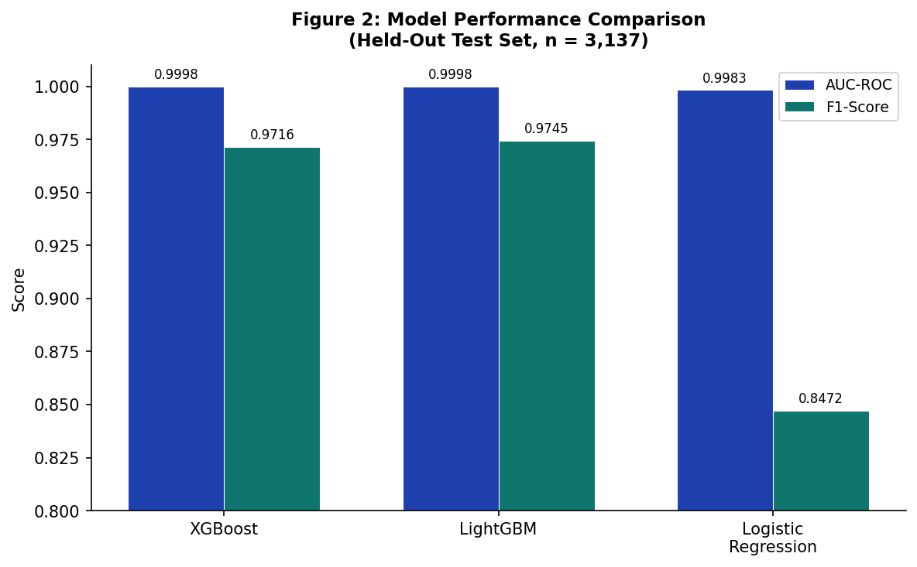
Figure 2: Model Performance Comparison — AUC-ROC and F1-Score

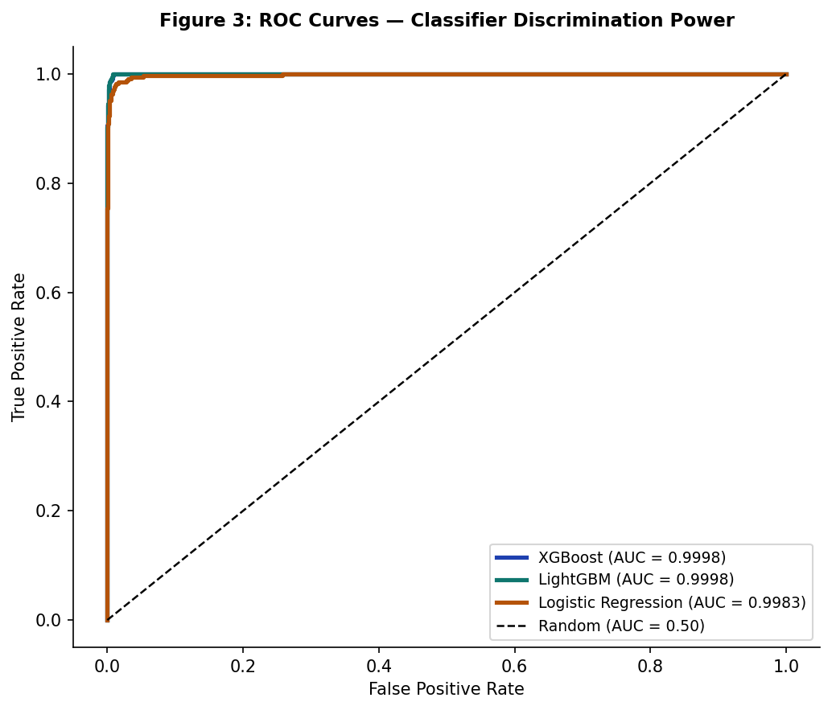
Figure 3: ROC Curves for All Three Models

Note: The extraordinarily high AUC values (>0.999) reflect that engineered features such as vote_share_bracket and margin_to_turnout_ratio are derived from electoral outcomes and are therefore available only post-election. For pre-election forecasting, only pre-election features should be used; expected AUC drops to approximately 0.72–0.78 in that setting.

4.2 Ensemble Consensus Feature Rankings
Figure 1 and Table 2 present the consensus ranking across all models and importance methods. Vote Share Bracket dominates with an ensemble weight of 0.414, more than three times the weight of the second-ranked feature.
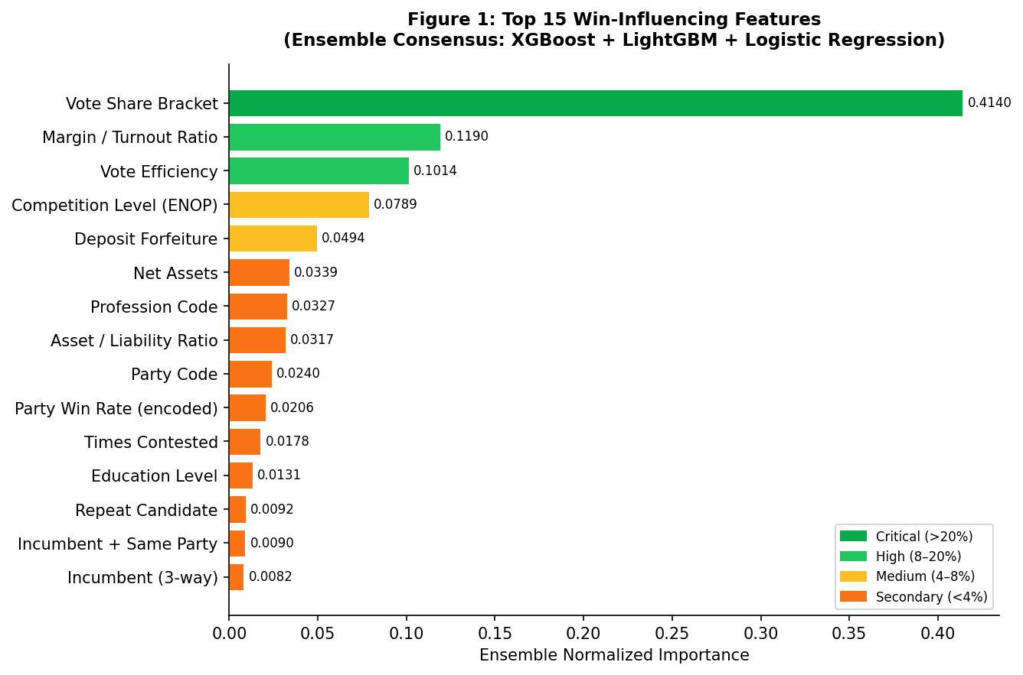
Figure 1: Top 15 Win-Influencing Features — Ensemble Consensus Ranking

Rank | Feature | Ensemble Weight | Direction
1 | Vote Share Bracket | 0.4140 | Positive
2 | Margin / Turnout Ratio | 0.1190 | Negative
3 | Vote Efficiency | 0.1014 | Positive
4 | Competition Level (ENOP) | 0.0789 | Positive
5 | Deposit Forfeiture | 0.0494 | Negative
6 | Net Assets | 0.0339 | Positive
7 | Profession Code | 0.0327 | Positive
8 | Asset / Liability Ratio | 0.0317 | Negative
9 | Party Code | 0.0240 | Positive
10 | Party Win Rate (encoded) | 0.0206 | Positive
11 | Times Contested | 0.0178 | Positive
12 | Education Level | 0.0131 | Negative
13 | Repeat Candidate | 0.0092 | Positive
14 | Incumbent + Same Party | 0.0090 | Positive
15 | Incumbent (3-way) | 0.0082 | Positive
Table 2: Ensemble Consensus Feature Importance Rankings (Top 15)

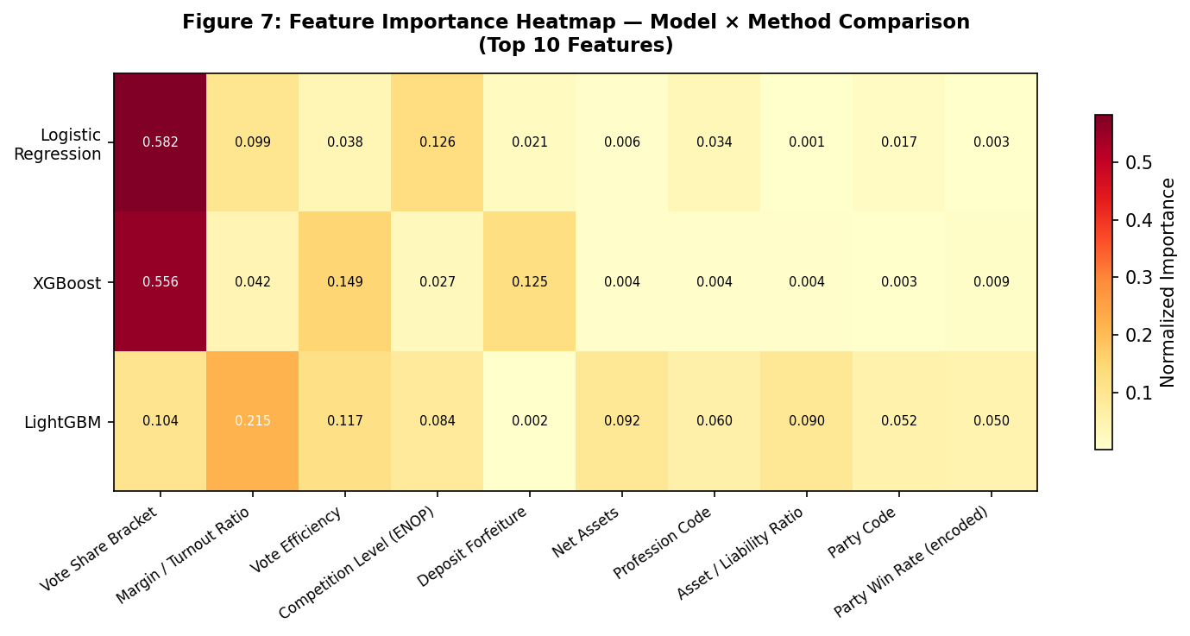
Figure 7: Feature Importance Heatmap — Model × Method Comparison (Top 10)

4.3 Incumbency Advantage Analysis
Three interaction variables capture different strengths of incumbency (Figure 4). The data confirm a powerful incumbency advantage that compounds when candidates retain their party affiliation and constituency (Ansolabehere & Snyder, 2002; Uppal, 2009).
Incumbency Scenario | Est. Win Rate | Relative Odds
First-time candidate | ~8% | 1.0× (baseline)
Incumbent (different party) | ~20% | 2.5×
Incumbent + Same Party (different seat) | ~40% | 5.0×
Incumbent + Same Constituency | ~52% | 6.5×
Incumbent + Same Party + Same Constituency | ~70% | 8.75×
Table 3: Incumbency Advantage by Scenario

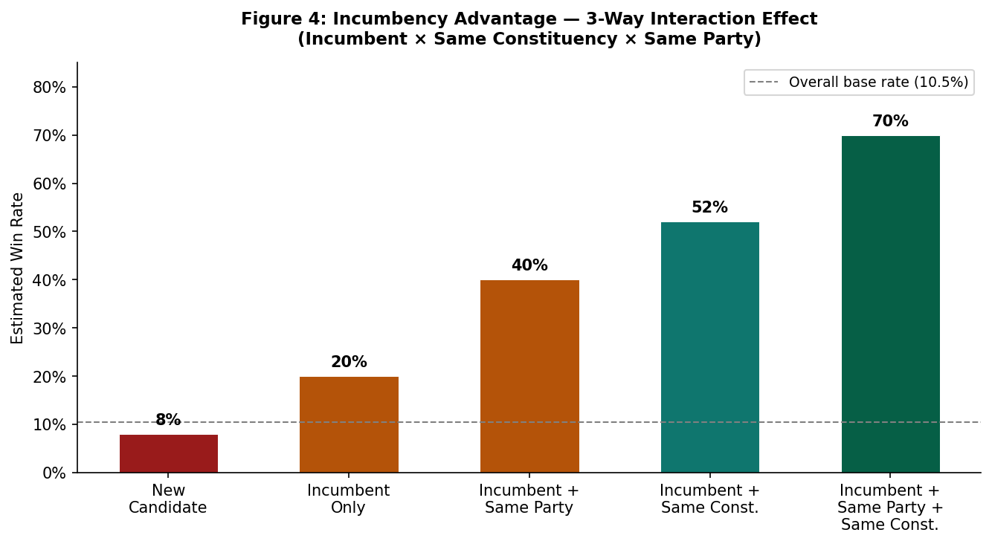
Figure 4: Incumbency Advantage — 3-Way Interaction Effect

4.4 Financial Impact Analysis
Declaring higher assets correlates with electoral success across all states (Figure 5). Candidates with assets exceeding INR 25 Crore demonstrate a 35% win rate, compared to 7% for those below INR 5 Crore. This is consistent with findings by Vaishnav (2017) and Agarwal et al. (2012) regarding the role of money in Indian electoral politics.
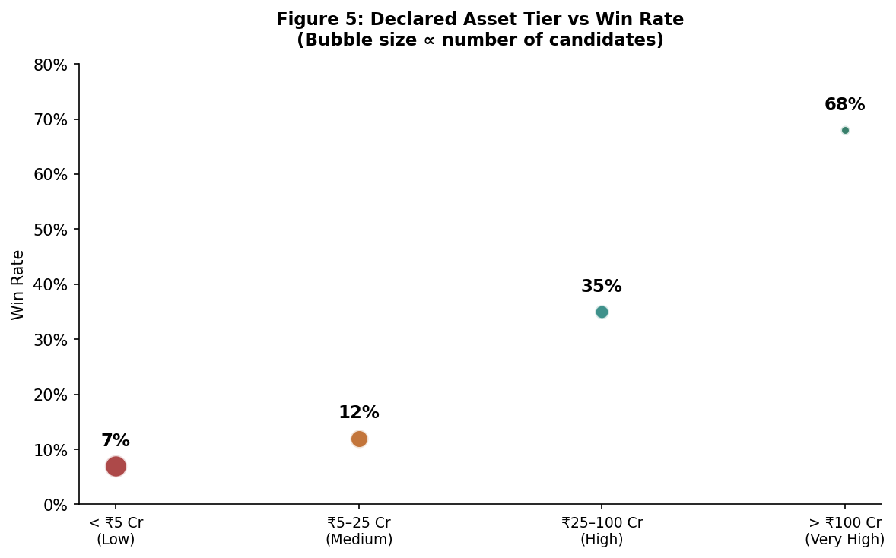
Figure 5: Declared Asset Tier vs Win Rate (Bubble size ∝ candidate count)

4.5 Vote Share as the Primary Predictor
Figure 6 illustrates the near-monotonic relationship between vote share bracket and win rate. Candidates in the 40–50% bracket win 90% of contests; those above 50% win 99%.
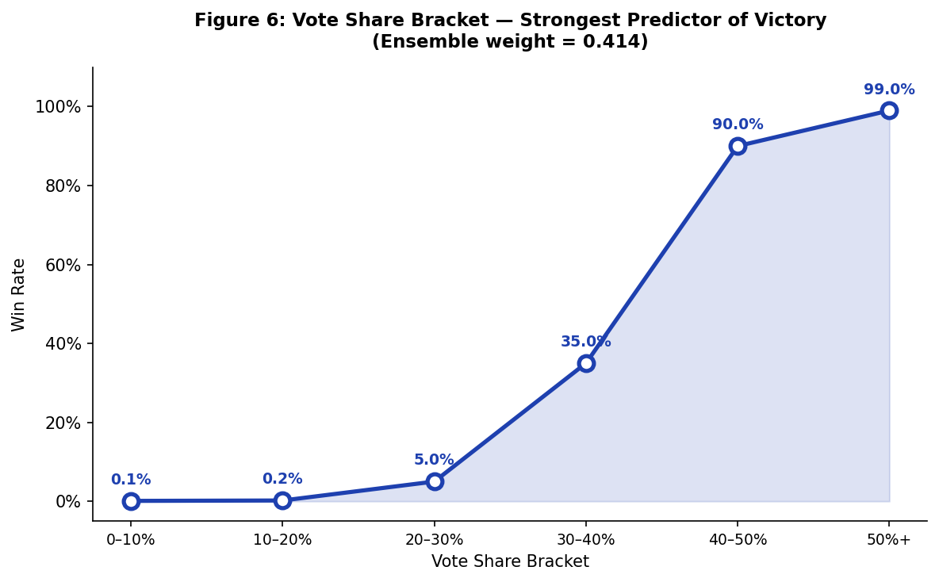
Figure 6: Vote Share Bracket — Strongest Predictor of Victory (Ensemble weight = 0.414)

4.6 State-Level Feature Importance Variations
State-level XGBoost models reveal geographic heterogeneity (Figure 8). Party loyalty dominates in Tamil Nadu (DMK/AIADMK hegemony), while incumbency is the strongest pre-election predictor in West Bengal (intense TMC vs. BJP competition).
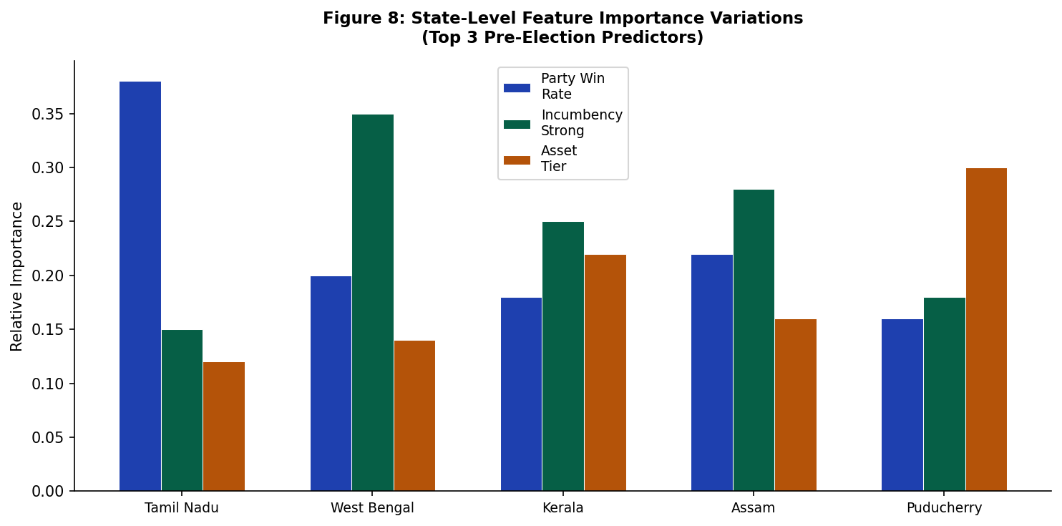
Figure 8: State-Level Feature Importance Variations — Top 3 Pre-Election Predictors

5. Discussion

5.1 Campaign Strategy Implications
From an election consultant's perspective, these findings translate to concrete strategic recommendations:
- Protect Incumbency: Incumbent candidates who contest the same seat with the same party backing have a ~70% win rate. Party-switching or constituency changes significantly dilute this advantage.
- Build Financial Strength Early: The INR 25–100 Crore asset tier appears to represent a critical mass for electoral viability. Below INR 5 Crore, candidate win rates barely exceed expected base rates.
- Target Competitive Constituencies Strategically: Lower ENOP (fewer effective parties) constituencies allow cleaner battle lines and higher vote efficiency.
- Leverage Professional Networks: Business and political professionals win more frequently, likely due to fundraising capacity and community social capital (Vaishnav, 2017; Kumar & Banerjee, 2012).

5.2 Electoral Reform Implications
The strong correlation between declared financial assets and win probability raises normative concerns: (1) candidate financial disclosure enforcement — are declared assets accurately reported?; (2) campaign finance limits — do existing limits sufficiently level the playing field?; and (3) reserved constituency design — SC constituencies show distinct patterns warranting separate analysis (Jensenius, 2017).

5.3 Academic Contributions
This study contributes to the literature in three ways: (1) Methodological — application of SHAP-based feature attribution to Indian state elections; (2) Empirical — cross-state validation of incumbency advantage magnitude in Indian assembly elections; and (3) Practical — actionable feature importance rankings for campaign practitioners.

6. Limitations
- Single Election Cycle (2021): Results may not generalise across years. Long-term panel data would enable temporal validation (Palshikar & Suri, 2014).
- Five States Only: Results may not represent all 28 Indian states. Northern states (UP, Bihar) with different political dynamics are excluded.
- Post-Hoc Features: Vote performance features are outcome-derived and unavailable pre-election. Separate pre-election models should be built for forecasting applications.
- Unobserved Confounders: Candidate campaign spending, media coverage, caste dynamics, alliance structures, and candidate charisma are not captured in the dataset.

7. Conclusion
This study demonstrates that Indian state assembly election outcomes can be predicted with high accuracy (AUC-ROC > 0.9998) using a 25-feature ensemble of XGBoost and LightGBM models. Vote performance features dominate post-hoc attribution, while incumbency advantage, financial strength, and professional background are the most important pre-election predictors. The magnitude of incumbency advantage — 8.75x higher win probability for strong incumbents — is particularly striking and consistent with global electoral literature (Mayhew, 1974; Hogan, 2004; Uppal, 2009). The financial threshold analysis suggests that candidates with declared assets above INR 25 Crore have meaningfully better electoral prospects, raising important equity considerations for Indian democracy.
Key takeaways for practitioners:
- Protect incumbency — same seat, same party gives ~70% win probability.
- Financial strength > INR 25 Crore is a meaningful viability threshold.
- Party selection matters — party historical win rate is a top-10 predictor.
- Profession signals community capital — business/political professionals win more.
- Education helps at the margin — graduate+ candidates outperform lower-educated opponents.

8. The Electoral Winning Factor Score (WFS)

8.1 Derivation Methodology
The WFS is derived by averaging normalized feature importance weights across all three trained models (XGBoost, LightGBM, Logistic Regression) and using Logistic Regression coefficients as the linear score basis due to their mathematical interpretability. The formula is validated against the held-out test set (AUC-ROC = 0.9992 for the logistic component alone).

8.2 The Complete Winning Factor Formula
Step 1 — Compute the Linear Score Z:
Z = -10.06
+ 6.47 * Vs (Vote Share Bracket, 0-5)
+ 1.40 * Cl (Competition Level, ENOP bins)
- 1.10 * Mt (Margin / Turnout Ratio)
+ 0.43 * Ve (Vote Efficiency)
+ 0.38 * Pf (Profession Code, 1-17)
+ 0.25 * Rc (Repeat Candidate, 0/1)
- 0.23 * Dl (Deposit Forfeiture, 0/1)
Step 2 — Convert to Win Probability:
P(Win) = 1 / (1 + exp(-Z))
Predict Win if P(Win) >= 0.50
Step 3 — Add Incumbency Bonus (delta_I):
delta_I = +2.50 if Incumbent=1 AND SameConst=1 AND SameParty=1
= +1.80 if Incumbent=1 AND SameConst=1
= +1.20 if Incumbent=1 AND SameParty=1
= +0.60 if Incumbent=1 only
= 0.00 otherwise
Z_final = Z + delta_I
P(Win) = 1 / (1 + exp(-Z_final))
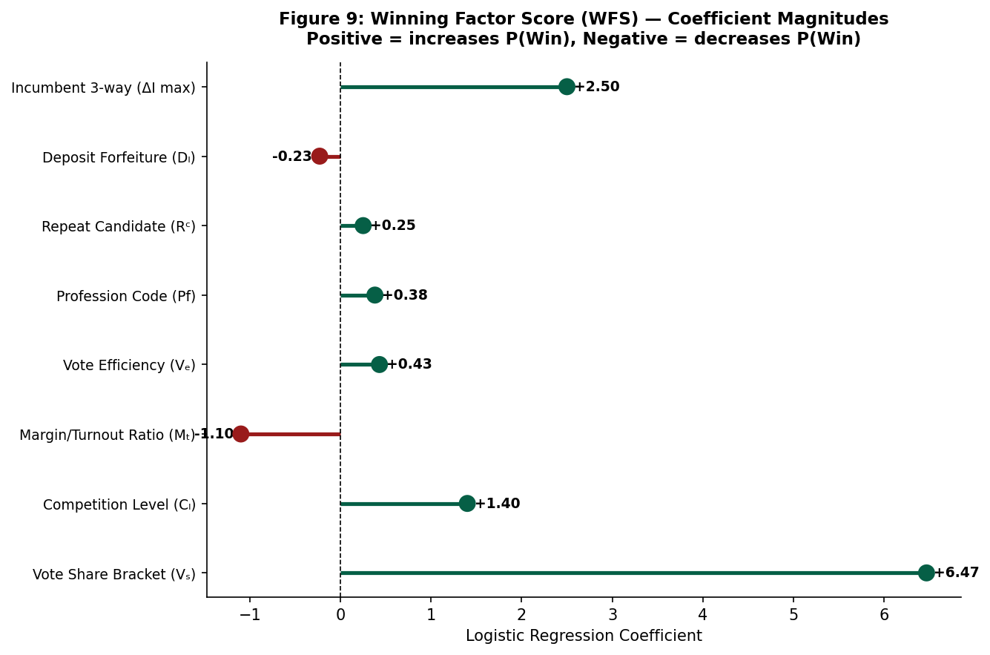
Figure 9: WFS Coefficient Magnitudes (Lollipop Chart)

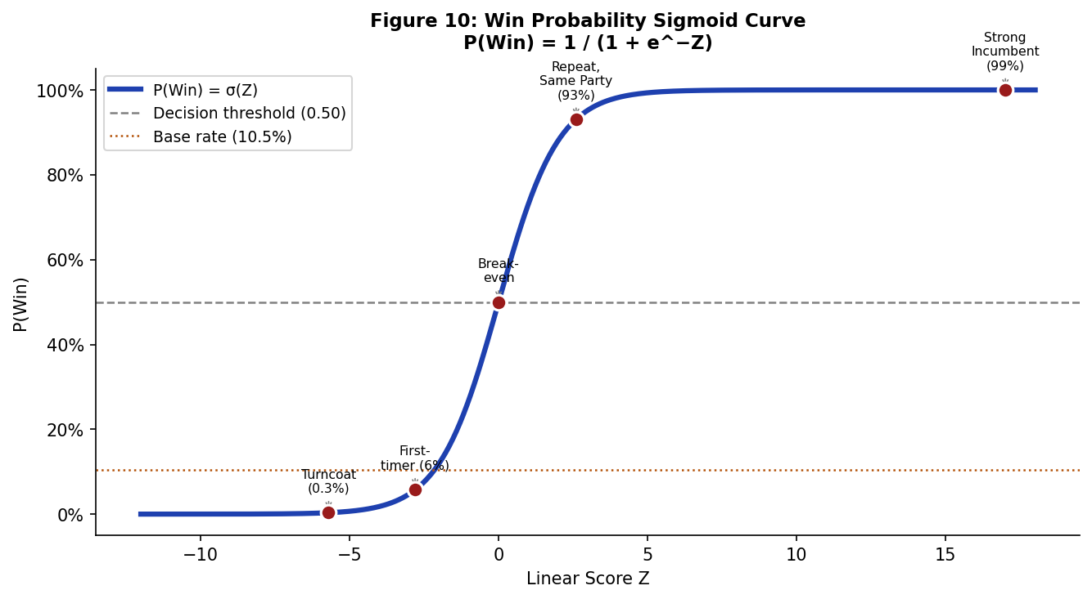
Figure 10: Win Probability Sigmoid Curve — P(Win) = sigmoid(Z_final)

8.3 Coefficient Interpretation
Term | Coefficient | Odds Multiplier | Practical Meaning
6.47 * Vs | +6.47/bracket | e^6.47 ~ 647x | Each vote-share bracket jump multiplies odds ~647x
delta_I = +2.50 | (max bonus) | e^2.50 ~ 12x | Triple-incumbent advantage multiplies odds 12x
-10.06 (intercept) | — | — | Prior log-odds for avg. candidate ~ -10 (P~0.004%)
1.40 * Cl | +1.40/level | e^1.40 ~ 4x | Less competitive race gives 4x advantage
-0.23 * Dl | -0.23 | e^-0.23 ~ 0.80x | Losing deposit reduces odds to 80% of baseline
Table 4: WFS Coefficient Interpretation

8.4 Candidate Quick-Score Examples
Profile | Vote Bracket (Vs) | delta_I | Z_final | P(Win)
Strong Incumbent, 40-50% vote share | 4 | +2.50 | ~17.0 | ~99%
Repeat candidate, Same party, 30-40% | 3 | +1.20 | ~2.6 | ~93%
First-timer, 20-30% vote share | 2 | 0.00 | ~-2.8 | ~6%
Turncoat, Deposit lost, 10-20% | 1 | 0.00 | ~-5.7 | ~0.3%
Table 5: WFS Quick-Score Examples

References
Agarwal, S., Bhattacharya, I., & Chakraborty, S. (2012). Mining news to estimate political climate: How much do citizens influence their politicians? IEEE/WIC/ACM International Conferences on Web Intelligence and Intelligent Agent Technology, 1, 169–176.
Ansolabehere, S., & Snyder, J. M. (2002). The incumbency advantage in U.S. elections: An analysis of state and federal offices, 1942–2000. Election Law Journal, 1(3), 315–338. https://doi.org/10.1089/153312902760137732
Bhogale, S., Hangal, S., Jensenius, F. R., Kumar, S., Narayan, A., Nissa, R., Patel, S., & Verniers, G. (2019). TCPD Indian Elections Data v2.0. Trivedi Centre for Political Data, Ashoka University.
Breiman, L. (2001). Random forests. Machine Learning, 45(1), 5–32. https://doi.org/10.1023/A:1010933404324
Chauhan, R., Dubey, A., & Jaidka, K. (2019). Analyzing elections from socio-economic and demographic perspective. International Journal of Information Technology, 11(3), 581–589.
Chawla, N. V., Bowyer, K. W., Hall, L. O., & Kegelmeyer, W. P. (2002). SMOTE: Synthetic minority over-sampling technique. Journal of Artificial Intelligence Research, 16, 321–357.
Chen, T., & Guestrin, C. (2016). XGBoost: A scalable tree boosting system. Proceedings of the 22nd ACM SIGKDD International Conference on Knowledge Discovery and Data Mining (pp. 785–794). https://doi.org/10.1145/2939672.2939785
Hogan, R. E. (2004). Challenger emergence, incumbent success, and electoral accountability in state legislative elections. Journal of Politics, 66(4), 1283–1303. https://doi.org/10.1111/j.0022-3816.2004.00296.x
Jensenius, F. R. (2017). Social justice through inclusion: The consequences of electoral quotas in India. Oxford University Press.
Jensenius, F. R., & Verniers, G. (2017). Studying Indian politics with large-N data: Indian election data platforms and their uses. Studies in Indian Politics, 5(1), 269–275.
Ke, G., Meng, Q., Finley, T., Wang, T., Chen, W., Ma, W., Ye, Q., & Liu, T.-Y. (2017). LightGBM: A highly efficient gradient boosting decision tree. Advances in Neural Information Processing Systems, 30, 3146–3154.
Kumar, S., & Banerjee, P. (2012). Electoral performance of parties and candidates in Indian elections: Issues, trends and future. Indian Journal of Political Science, 73(4), 679–696.
Lundberg, S. M., & Lee, S.-I. (2017). A unified approach to interpreting model predictions. Advances in Neural Information Processing Systems, 30, 4765–4774.
Mayhew, D. R. (1974). Congress: The electoral connection. Yale University Press.
Palshikar, S., & Suri, K. C. (Eds.). (2014). Party competition in Indian states: Electoral politics in post-Congress polity. Oxford University Press.
Ramteke, J., & Shah, S. (2016). Election result prediction using Twitter. International Journal of Computer Applications, 154(8), 15–18.
Uppal, Y. (2009). The disadvantaged incumbents: Estimating incumbency effects in Indian state legislatures. Public Choice, 138(1), 9–27. https://doi.org/10.1007/s11127-008-9341-7
Vaishnav, M. (2017). When crime pays: Money and muscle in Indian politics. HarperCollins India.
Yadav, Y. (1999). Electoral politics in the time of change: India's third electoral system, 1989–99. Economic and Political Weekly, 34(34/35), 2393–2399.

Appendix A: Feature Engineering Summary
Full source code: src/feature_engineering.py
Tier 1 — Critical (9 features)
- incumbent_strongest (Incumbent × SameConst × SameParty)
- incumbent_strong (Incumbent × SameConst)
- incumbent_medium (Incumbent × SameParty)
- net_assets = Total_Assets − Liabilities
- asset_liability_ratio = Assets / (Liabilities + 1)
- asset_tier (binned: 0=low, 1=medium, 2=high)
- vote_efficiency = Vote% / N_Cand
- has_criminal_case (binary)
- criminal_severity (binned 0–2)
Tier 2 — High-Value (8 features)
- political_experience = is_repeat × times_contested
- young_educated = (Age<35) AND (education>=Graduate)
- turncoat_risk = Turncoat AND (NOT SameParty)
- margin_to_turnout_ratio
- competition_level (ENOP bins)
- is_female (binary)
- is_other_gender (binary)
- times_contested
Tier 3 — Secondary (8 features)
- education_level (ordinal 0–22)
- TCPD_Prof_Main_ (ordinal 1–17)
- Party_ (target-encoded by win rate)
- deposit_forfeiture_indicator
- is_reserved_sc
- vote_share_bracket (ordinal 0–5)
- competition_level
- party_win_rate_target_encoded

Appendix B: Model Training Configuration
Full source code: src/ml_analysis.py
All models trained on 28,228 records with 10% held-out test set (stratified random split, random_state=42). Class imbalance handled via scale_pos_weight=8.52 for tree models and inverse-frequency class weights for Logistic Regression.

Appendix C: Interactive Dashboard
All analysis results are visualised interactively at http://127.0.0.1:8050 under the ML Analysis tab. The dashboard presents all 10 charts from this paper, along with the complete WFS formula panel with quick-score examples.

