Tharun Project — Automated Comparative Analysis of Code Generated by a Beginner, an LLM, and an Expert
Author: Tharun; Institution: University of Roehampton; Date: 2026-11-10
This report is generated automatically by runanalysis.py. Every figure, table and statistic below is read directly from outputs/metrics.csv and outputs/stats.json; no value is entered by hand. Where a value could not be computed it is shown as N/A.
________________________________________

1. Executive Summary
This study compares Python solutions from three sources — beginner, LLM, and expert — across 30 benchmark tasks, using static-analysis metrics, functional testing and non-parametric statistics. Headline findings, all computed from the data:
- Mean Cyclomatic Complexity — best (lowest median) was llm at 3.000.
- Maintainability Index — best (highest median) was llm at 93.385.
- Halstead Volume — best (lowest median) was expert at 13.932.
- Source LOC — best (lowest median) was beginner at 8.500.
- Pylint Score (/10) — best (highest median) was beginner at 10.000.
- Bandit Total Findings — best (lowest median) was beginner at 0.000.
Overall visible-test pass rate: beginner 43.3%, llm 100.0%, expert 100.0%. A paired task-level Cochran Q test using LLM sample 1 gives: differences in pass rate across sources are statistically significant (Cochran Q p=4e-08). These results are not independently unseen-test estimates.

2. Introduction & Background
Large Language Model (LLM) coding assistants now sit between two long-standing reference points in software engineering: the novice programmer who is still acquiring idiom and rigour, and the experienced expert who writes concise, maintainable, secure code. Most published comparisons are binary — human versus AI — which collapses the very real gap between a beginner and an expert into a single 'human' category.
This project takes a three-way view. It asks not only whether LLM output differs from human output, but *where on the novice-to-expert spectrum it sits*. To do that objectively it applies the same automated pipeline of complexity, maintainability, style and security metrics to every solution, then tests each one for functional correctness and compares the groups statistically.

3. Dataset & Methodology

3.1 Benchmark dataset
The benchmark comprises 30 self-contained, pure-function programming tasks (no I/O, no external dependencies) spread across three difficulty tiers:
Difficulty tier | Number of tasks
introductory | 10
intermediate | 10
advanced | 10
Total | 30
Honest framing — please read. This is a *curated, representative benchmark*. For each task the beginner and expert solutions are single authored reference implementations chosen to embody the characteristics typically associated with each source: a beginner style (works on the common cases but with poor naming, little decomposition, higher complexity, weak edge-case handling, and occasional sloppy or insecure patterns) and an expert style (idiomatic, decomposed, fully type-hinted, documented, low-complexity, edge-complete). The LLM solutions are labelled as model-generated in the archived dataset, sampled 5 times per task under controlled prompting; the author-reported model name, version, date and prompt are recorded in dataset/LLMPROVENANCE.md. None of the code was scraped from real students, real assistants, or real professionals.
Results therefore characterise this benchmark only and must not be generalised to any wider population, to real beginner or expert programmers, or to other programming languages. It is intended — and deliberately left unchanged — that the beginner solutions fail some edge-case tests on the harder tasks. That monotonic decline is the experimental signal: it demonstrates that the automated pipeline can *detect* such quality and correctness differences. It is not an empirical finding that real beginner programmers fail at these rates.

3.2 Tools and metrics
Static metrics are extracted by invoking each tool's documented JSON/command-line interface (never an unverified Python API):
- radon — cyclomatic complexity (McCabe), maintainability index, raw size (LOC/LLOC/SLOC/comments) and Halstead volume.
- pylint — style/standards score (out of 10) and issue count.
- bandit — security findings by severity (low / medium / high).
- pytest — functional correctness: each solution is run in a separate process against the task's core and edge tests.

3.3 Statistical methods
Because samples are small and not assumed normal, analysis is non-parametric. For each numeric metric we report Shapiro-Wilk per group (normality diagnostic), a Friedman omnibus test across the three sources, paired Wilcoxon tests with within-metric Bonferroni correction (factor 3), and rank-biserial as a distribution-free effect size. Functional correctness (binary) is summarised by pass rate; matched inference uses Cochran Q on the preselected LLM sample 1 per task plus exact paired McNemar tests. Functional correctness also uses the unbiased pass@k estimator of Chen et al. (2021): the LLM arm is sampled 5 times per task so its pass@k (k>1) is a descriptive visible-test multi-sample estimate, while the single-sample beginner and expert arms report pass@1.
For the static-metric tests, each source contributes one observation per task — its per-task median across samples — so the multi-sampled LLM arm is weighted equally with the single-sample human arms rather than 5-fold. The per-sample data feed only the pass@k estimator and the per-sample pass rate; the full per-sample table is retained in the appendix.

4. Results
Scope: the results below characterise this benchmark only and do not generalise to wider populations of programmers or to other programming languages.
Median value of each metric per source (computed from outputs/metrics.csv):
Metric | median (beginner) | median (llm) | median (expert)
Mean Cyclomatic Complexity | 3.500 | 3.000 | 3.000
Max Cyclomatic Complexity | 3.500 | 3.000 | 3.000
Maintainability Index | 68.636 | 93.385 | 90.937
Halstead Volume | 31.500 | 27.764 | 13.932
Lines of Code (LOC) | 8.500 | 17.500 | 23.500
Source LOC | 8.500 | 10.000 | 9.000
Comment Lines | 0.000 | 0.000 | 0.000
Pylint Score (/10) | 10.000 | 10.000 | 10.000
Pylint Issue Count | 0.000 | 0.000 | 0.000
Bandit Total Findings | 0.000 | 0.000 | 0.000

4.1 Figures
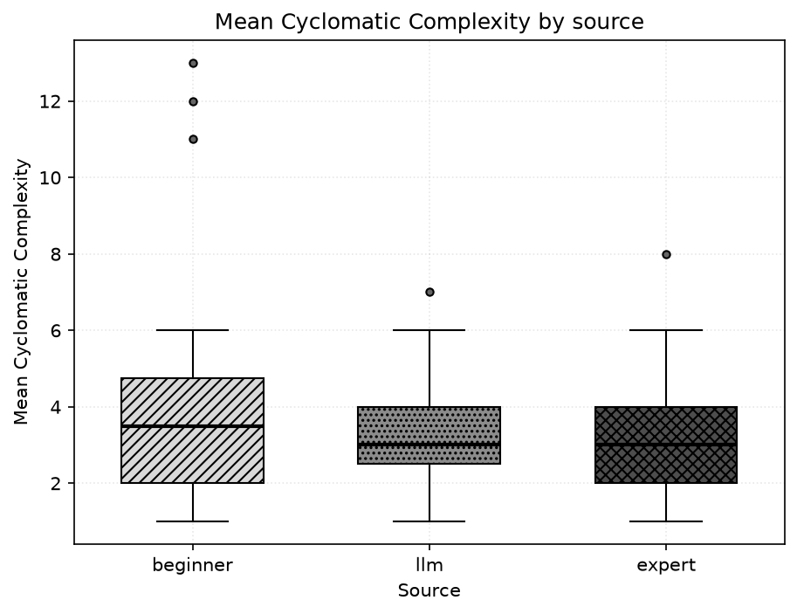
Distribution of mean cyclomatic complexity per source (lower is better).
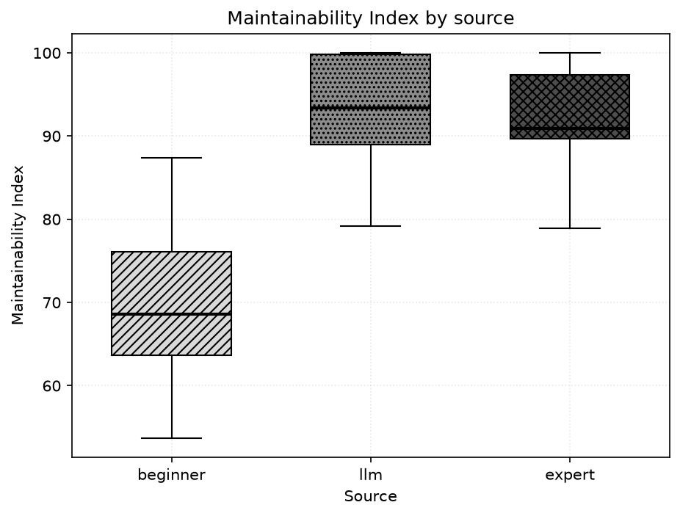
Distribution of maintainability index per source (higher is better).
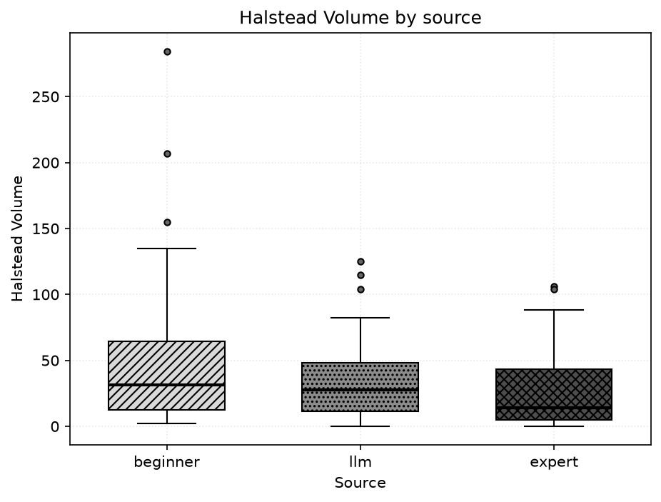
Distribution of Halstead volume per source (lower is better).
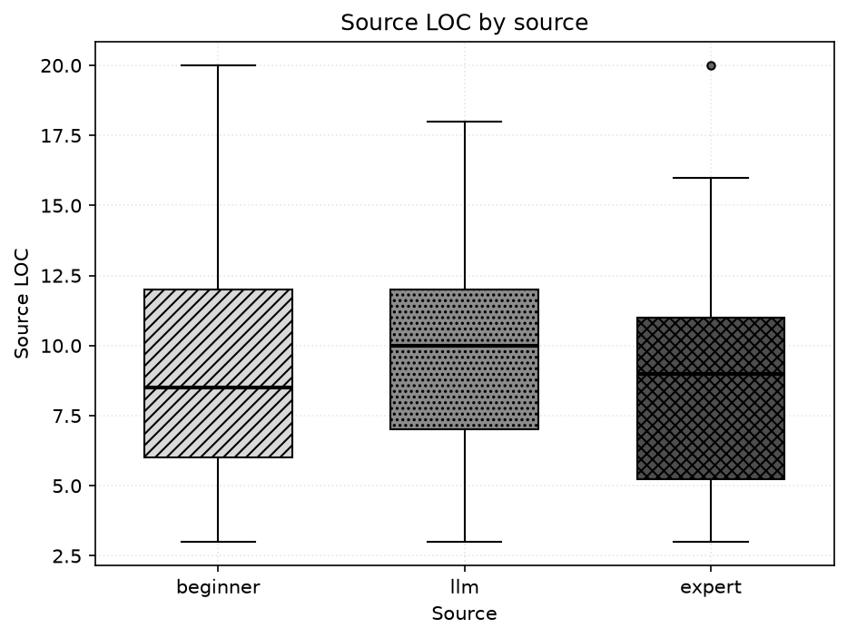
Distribution of source lines of code per source (lower is leaner).
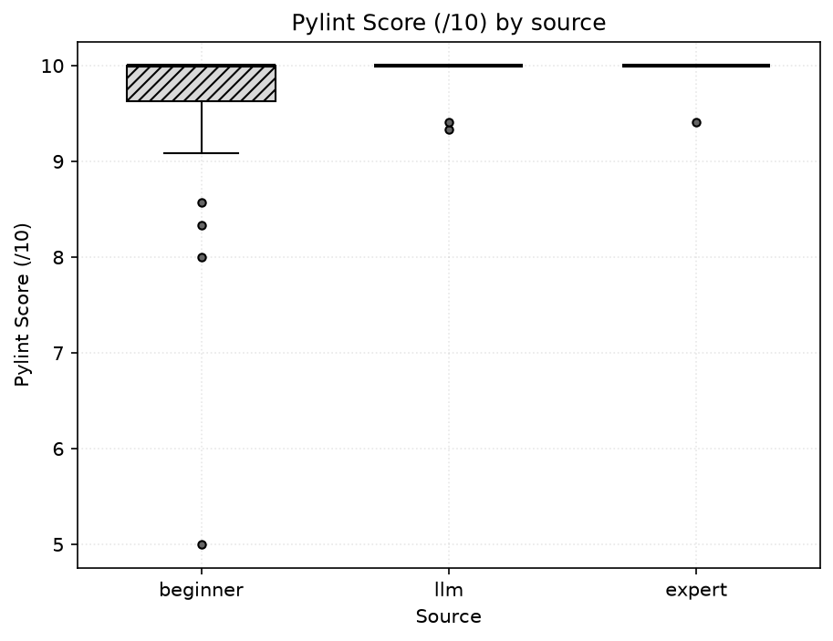
Distribution of pylint score per source (higher is better).
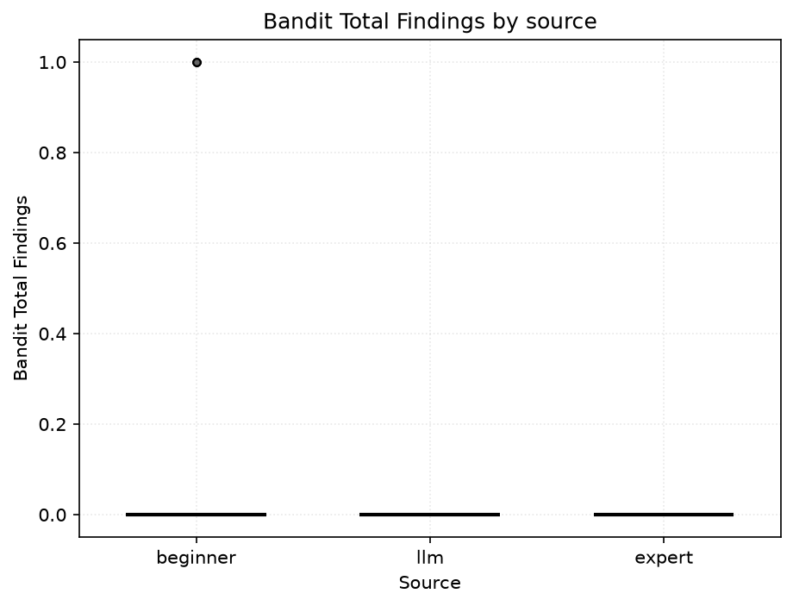
Distribution of total bandit security findings per source (lower is better).
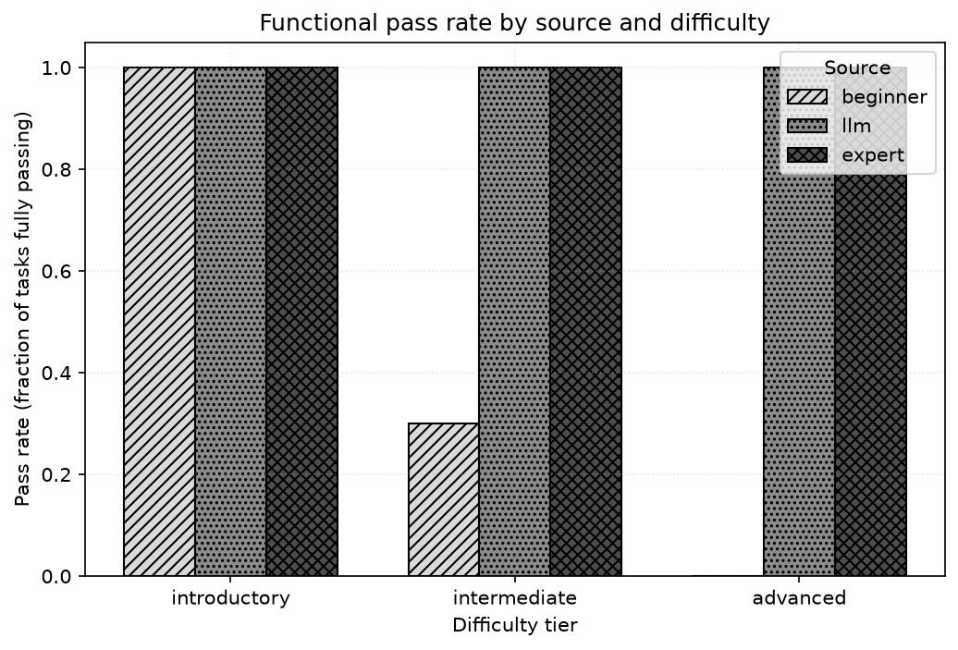
Functional pass rate by source and difficulty tier.
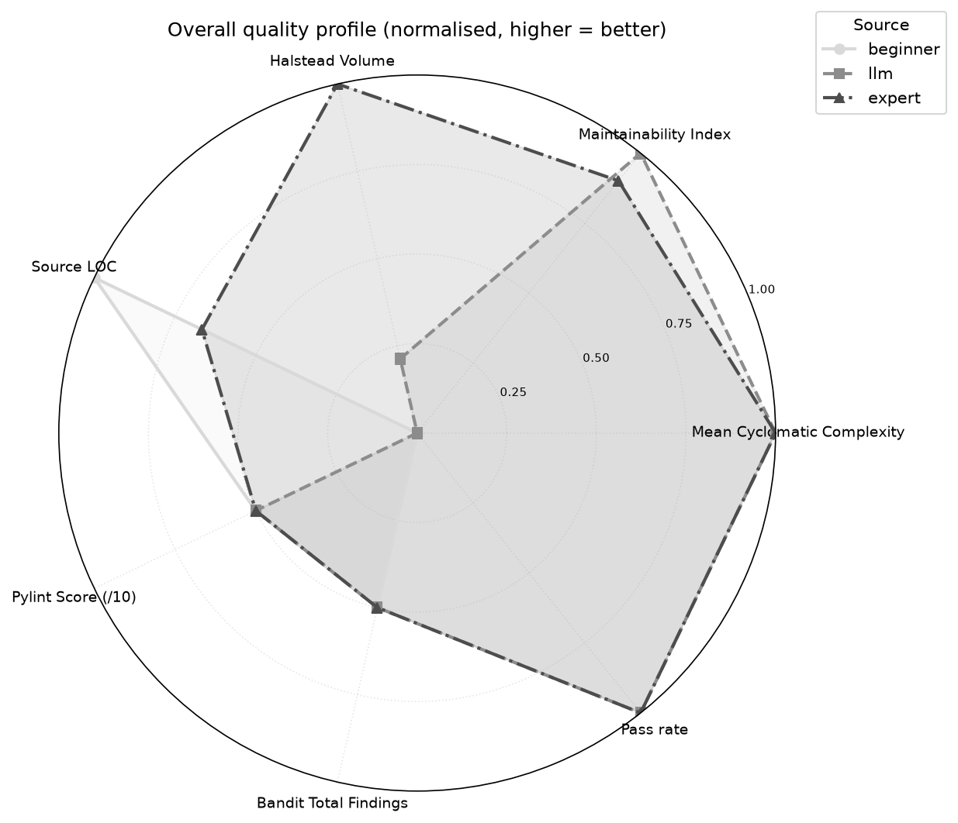
Overall normalised quality profile (every axis oriented so that further out = better).

5. Statistical Analysis

5.1 Omnibus tests (Friedman)
Matched-task group medians and the Friedman omnibus test for every metric. A significant result means at least one source differs.
Metric | median (beginner) | median (llm) | median (expert) | Friedman chi2 | Friedman p | significant
Mean Cyclomatic Complexity | 3.500 | 3.000 | 3.000 | 5.128 | 0.0770 | no
Max Cyclomatic Complexity | 3.500 | 3.000 | 3.000 | 6.432 | 0.0401 | yes
Maintainability Index | 68.636 | 93.385 | 90.937 | 43.655 | 3.31e-10 | yes
Halstead Volume | 31.500 | 27.764 | 13.932 | 14.126 | 0.000856 | yes
Lines of Code (LOC) | 8.500 | 17.500 | 23.500 | 55.580 | 8.53e-13 | yes
Logical LOC | 8.500 | 12.000 | 11.000 | 2.673 | 0.2628 | no
Source LOC | 8.500 | 10.000 | 9.000 | 4.784 | 0.0914 | no
Comment Lines | 0.000 | 0.000 | 0.000 | 2.000 | 0.3679 | no
Pylint Score (/10) | 10.000 | 10.000 | 10.000 | 6.889 | 0.0319 | yes
Pylint Issue Count | 0.000 | 0.000 | 0.000 | 10.750 | 0.0046 | yes
Bandit Low-severity | 0.000 | 0.000 | 0.000 | 8.000 | 0.0183 | yes
Bandit Medium-severity | 0.000 | 0.000 | 0.000 | N/A | N/A | N/A
Bandit High-severity | 0.000 | 0.000 | 0.000 | N/A | N/A | N/A
Bandit Total Findings | 0.000 | 0.000 | 0.000 | 8.000 | 0.0183 | yes
Tests Passed | 5.000 | 7.000 | 7.000 | 34.000 | 4.14e-08 | yes

5.2 Pairwise comparisons (paired Wilcoxon, Bonferroni) with effect size
Pairwise tests with Bonferroni-adjusted p-values and rank-biserial effect sizes. 'sig' = adjusted p < 0.05.
Metric | Pair | W | p (adj) | sig | Rank-biserial | paired effect
Mean Cyclomatic Complexity | beginner vs expert | 111.000 | 0.2866 | no | 0.368 | paired
Mean Cyclomatic Complexity | beginner vs llm | 77.000 | 0.2921 | no | 0.391 | paired
Mean Cyclomatic Complexity | expert vs llm | 71.500 | 0.9766 | no | -0.247 | paired
Max Cyclomatic Complexity | beginner vs expert | 113.500 | 0.3262 | no | 0.353 | paired
Max Cyclomatic Complexity | beginner vs llm | 94.500 | 1.0000 | no | 0.182 | paired
Max Cyclomatic Complexity | expert vs llm | 27.000 | 0.1383 | no | -0.550 | paired
Maintainability Index | beginner vs expert | 2.000 | 1.68e-08 | yes | -0.991 | paired
Maintainability Index | beginner vs llm | 0.000 | 5.2e-06 | yes | -1.000 | paired
Maintainability Index | expert vs llm | 134.000 | 0.8756 | no | -0.236 | paired
Halstead Volume | beginner vs expert | 122.500 | 0.1197 | no | 0.437 | paired
Halstead Volume | beginner vs llm | 131.000 | 0.4904 | no | 0.307 | paired
Halstead Volume | expert vs llm | 53.000 | 0.0096 | yes | -0.674 | paired
Lines of Code (LOC) | beginner vs expert | 0.000 | 5.1e-06 | yes | -1.000 | paired
Lines of Code (LOC) | beginner vs llm | 1.500 | 5.91e-06 | yes | -0.994 | paired
Lines of Code (LOC) | expert vs llm | 1.500 | 8.48e-06 | yes | 0.993 | paired
Logical LOC | beginner vs expert | 126.000 | 0.2325 | no | -0.379 | paired
Logical LOC | beginner vs llm | 99.000 | 0.0524 | no | -0.512 | paired
Logical LOC | expert vs llm | 173.000 | 1.0000 | no | -0.085 | paired
Source LOC | beginner vs expert | 103.000 | 1.0000 | no | 0.186 | paired
Source LOC | beginner vs llm | 179.500 | 1.0000 | no | -0.116 | paired
Source LOC | expert vs llm | 75.000 | 0.0899 | no | -0.500 | paired
Comment Lines | beginner vs expert | 0.000 | 0.9519 | no | -1.000 | paired
Comment Lines | beginner vs llm | 0.000 | 0.9519 | no | -1.000 | paired
Comment Lines | expert vs llm | 0.000 | 1.0000 | no | 0.000 | paired
Pylint Score (/10) | beginner vs expert | 1.000 | 0.0515 | no | -0.944 | paired
Pylint Score (/10) | beginner vs llm | 3.000 | 0.0623 | no | -0.867 | paired
Pylint Score (/10) | expert vs llm | 0.000 | 0.9519 | no | 1.000 | paired
Pylint Issue Count | beginner vs expert | 0.000 | 0.0422 | yes | 1.000 | paired
Pylint Issue Count | beginner vs llm | 3.500 | 0.1011 | no | 0.806 | paired
Pylint Issue Count | expert vs llm | 0.000 | 0.9519 | no | -1.000 | paired
Bandit Low-severity | beginner vs expert | 0.000 | 0.1365 | no | 1.000 | paired
Bandit Low-severity | beginner vs llm | 0.000 | 0.1365 | no | 1.000 | paired
Bandit Low-severity | expert vs llm | 0.000 | 1.0000 | no | 0.000 | paired
Bandit Medium-severity | beginner vs expert | 0.000 | 1.0000 | no | 0.000 | paired
Bandit Medium-severity | beginner vs llm | 0.000 | 1.0000 | no | 0.000 | paired
Bandit Medium-severity | expert vs llm | 0.000 | 1.0000 | no | 0.000 | paired
Bandit High-severity | beginner vs expert | 0.000 | 1.0000 | no | 0.000 | paired
Bandit High-severity | beginner vs llm | 0.000 | 1.0000 | no | 0.000 | paired
Bandit High-severity | expert vs llm | 0.000 | 1.0000 | no | 0.000 | paired
Bandit Total Findings | beginner vs expert | 0.000 | 0.1365 | no | 1.000 | paired
Bandit Total Findings | beginner vs llm | 0.000 | 0.1365 | no | 1.000 | paired
Bandit Total Findings | expert vs llm | 0.000 | 1.0000 | no | 0.000 | paired
Tests Passed | beginner vs expert | 0.000 | 0.000771 | yes | -1.000 | paired
Tests Passed | beginner vs llm | 0.000 | 0.000771 | yes | -1.000 | paired
Tests Passed | expert vs llm | 0.000 | 1.0000 | no | 0.000 | paired

5.3 Functional correctness
Cochran Q test of task-matched binary correctness across sources: Q = 34.000, dof = 2, p = 4e-08, significant = yes. Note: LLM sample 1 only; source matched by task; all-sample rates remain descriptive.

5.4 Functional pass@k (Chen et al. 2021)
Unbiased pass@k averaged over tasks. pass@k is only defined for k <= the number of samples, so single-sample sources show N/A beyond pass@1; the LLM arm is sampled multiple times per task, giving a descriptive multi-sample estimate rather than pass@1 (independence unverified).
Source | Samples/task | pass@1 | pass@5
beginner | 1 | 0.433 | N/A
llm | 5 | 1.000 | 1.000
expert | 1 | 1.000 | N/A

6. Findings by Research Question

RQ1 — How does code quality compare (complexity, maintainability, size, style)?
- Mean Cyclomatic Complexity (best→worst by median): llm (3.000) > expert (3.000) > beginner (3.500). No pairwise difference reached significance after Bonferroni correction.
- Maintainability Index (best→worst by median): llm (93.385) > expert (90.937) > beginner (68.636). Significant pairwise differences: beginner vs expert (padj=1.68e-08, paired rank-biserial=-0.991, paired effect size); beginner vs llm (padj=5.2e-06, paired rank-biserial=-1.000, paired effect size).
- Source LOC (best→worst by median): beginner (8.500) > expert (9.000) > llm (10.000). No pairwise difference reached significance after Bonferroni correction.
- Pylint Score (/10) (best→worst by median): beginner (10.000) > llm (10.000) > expert (10.000). No pairwise difference reached significance after Bonferroni correction.

RQ2 — How do correctness and security compare?
- Overall pass rate — beginner: 43.3%, llm: 100.0%, expert: 100.0%.
- Introductory tier — beginner: 10/10 (100.0%), llm: 50/50 (100.0%), expert: 10/10 (100.0%).
- Intermediate tier — beginner: 3/10 (30.0%), llm: 50/50 (100.0%), expert: 10/10 (100.0%).
- Advanced tier — beginner: 0/10 (0.0%), llm: 50/50 (100.0%), expert: 10/10 (100.0%).
- Security — median total bandit findings (fewest→most): beginner (0.000), llm (0.000), expert (0.000). No pairwise security difference reached significance.
- The pass-rate difference across sources is statistically significant (Cochran Q p=4e-08).

RQ3 — Does the LLM resemble the beginner or the expert?
- Across 10 metrics overall, the LLM's median was closer to the beginner on 1, closer to the expert on 5, and tied on 4. Verdict: the LLM most resembles the expert.
- Introductory tier — closer to beginner on 2, to expert on 4, tied on 4 → resembles expert.
- Intermediate tier — closer to beginner on 2, to expert on 4, tied on 4 → resembles expert.
- Advanced tier — closer to beginner on 2, to expert on 4, tied on 4 → resembles expert.

RQ4 — What are the limits of automated metrics?
- Concrete disagreement found in the data: task secondlargest (beginner) attains a maintainability index of 87.350 and a pylint score of 10.000/10, yet it still fails functional tests (4/6 passing). Static quality scores looked acceptable while the code was, in fact, wrong.
- In total 17 (source, task) solution(s) failed at least one test; static metrics alone would not have flagged the functional defects.
- Static metrics measure *form*, not *behaviour*: maintainability index, complexity and style score say nothing about whether output is correct.
- Security scanners such as bandit detect known insecure patterns, not logic errors or missing edge-case handling.
- These caveats are why this study pairs every static metric with executed functional tests rather than relying on metrics alone.

7. Limitations
- Curated benchmark. The beginner and expert solutions were authored to typify each source and the LLM solutions are archived model-labelled files without authenticated generation logs; none are sampled from real populations. Findings describe this benchmark only and do not generalise. The monotonic decline in the beginner pass rate across tiers shows that the pipeline can *detect* such differences; it is not a claim that real beginner programmers fail at these rates.
- Sampling. The beginner and expert arms use a single authored reference per task; the LLM arm is sampled 5 times per task, so pass@k (k>1) is defined for the LLM on the visible-generation tests; within-source variance is observable in its metrics, while the human arms remain single-sample. Statistical power is still bounded by the benchmark size; effect sizes are reported alongside p-values for transparency.
- Model provenance. The archive identifies Claude as the sole model family, but independent model-response receipts and original generation logs are absent. Its use of the visible evaluation tests during generation prevents treating the original 100% pass rate as unseen accuracy. A multi-vendor comparison that also includes a GPT-4-class model is left as future work.
- Python only. All tasks are Python; results may not transfer to other languages or paradigms.
- Static-metric limits (see RQ4). Maintainability, complexity, style and security scores capture form and known patterns, not functional correctness; this is why executed tests are included.

8. Conclusion
On this benchmark, the automated pipeline cleanly separates the three sources. The llm source led on maintainability, llm on (lowest) complexity, and beginner on style score, while overall functional pass rates were beginner 43.3%, llm 100.0%, expert 100.0%. The three-way framing makes visible where LLM output falls relative to beginner and expert code (RQ3), and the surfaced metric/correctness disagreements (RQ4) reinforce that static analysis must be paired with execution. All conclusions are drawn solely from the computed outputs and characterise this benchmark only; they do not generalise to wider populations of programmers or to other programming languages.

9. References
1. Chen, M. et al. (2021) Evaluating Large Language Models Trained on Code. arXiv:2107.03374. https://arxiv.org/abs/2107.03374
2. Chuang, Y. T. and Chang, H. Y. (2024) Analyzing novice and competent programmers' problem-solving behaviors using an automated evaluation system. Science of Computer Programming, 237, 103138. https://doi.org/10.1016/j.scico.2024.103138
3. Cotroneo, D., Improta, C. and Liguori, P. (2025) Human-Written vs. AI-Generated Code: A Large-Scale Study of Defects, Vulnerabilities, and Complexity. arXiv:2508.21634. https://arxiv.org/abs/2508.21634
4. Fan, A. X. et al. (2024) Evaluating the Quality of Code Comments Generated by LLMs for Novice Programmers. arXiv:2409.14368. https://arxiv.org/abs/2409.14368
5. Fawareh, H. J., Al-Shdaifat, H. M. and Samara, G. (2025) Comparing Open Source with Software Code Generated by AI Tools from Software Maintainability Quality Factor Perspective. WSEAS Transactions on Computer Research, 13, 653-659. https://wseas.com/journals/cr/2025/b185118-377.pdf
6. Hou, W. and Ji, Z. (2025) Comparing Large Language Models and Human Programmers for Generating Programming Code. Advanced Science, 12, 2412279. https://doi.org/10.1002/advs.202412279
7. Licorish, S. A. et al. (2025) Comparing Human and LLM Generated Code: The Jury is Still Out! arXiv:2501.16857. https://arxiv.org/abs/2501.16857

Appendix

A. Tool versions and run metadata
Component | Version
Python | 3.13.7
radon | 6.0.1
pylint | pylint 4.1.3
bandit | bandit 1.9.4
Run timestamp: 2026-11-10 16:12:45. Random seed: 42.

B. Full per-task metrics
taskid | difficulty | source | sample | meancc | maxcc | mi | halsteadvolume | sloc | comments | pylintscore | pylintissues | bandittotal | functionalpass | testspassed | teststotal
countvowels | introductory | beginner | 1 | 12.000 | 12.000 | 65.198 | 206.819 | 6 | 0 | 5.000 | 3 | 0 | True | 7 | 7
countvowels | introductory | llm | 1 | 3.000 | 3.000 | 100.000 | 15.510 | 7 | 0 | 10.000 | 0 | 0 | True | 7 | 7
countvowels | introductory | llm | 2 | 3.000 | 3.000 | 90.578 | 4.755 | 2 | 0 | 10.000 | 0 | 0 | True | 7 | 7
countvowels | introductory | llm | 3 | 2.000 | 2.000 | 100.000 | 0.000 | 4 | 0 | 10.000 | 0 | 0 | True | 7 | 7
countvowels | introductory | llm | 4 | 1.000 | 1.000 | 100.000 | 0.000 | 4 | 1 | 10.000 | 0 | 0 | True | 7 | 7
countvowels | introductory | llm | 5 | 3.000 | 3.000 | 100.000 | 15.510 | 7 | 0 | 10.000 | 0 | 0 | True | 7 | 7
countvowels | introductory | expert | 1 | 3.000 | 3.000 | 78.919 | 4.755 | 3 | 0 | 10.000 | 0 | 0 | True | 7 | 7
countwords | introductory | beginner | 1 | 3.000 | 3.000 | 72.825 | 15.510 | 7 | 0 | 10.000 | 0 | 0 | True | 6 | 6
countwords | introductory | llm | 1 | 1.000 | 1.000 | 100.000 | 0.000 | 2 | 0 | 10.000 | 0 | 0 | True | 6 | 6
countwords | introductory | llm | 2 | 1.000 | 1.000 | 100.000 | 0.000 | 3 | 0 | 10.000 | 0 | 0 | True | 6 | 6
countwords | introductory | llm | 3 | 4.000 | 4.000 | 98.366 | 11.610 | 10 | 0 | 10.000 | 0 | 0 | True | 6 | 6
countwords | introductory | llm | 4 | 3.000 | 3.000 | 100.000 | 0.000 | 3 | 0 | 10.000 | 0 | 0 | True | 6 | 6
countwords | introductory | llm | 5 | 3.000 | 3.000 | 97.508 | 2.000 | 3 | 0 | 10.000 | 0 | 0 | True | 6 | 6
countwords | introductory | expert | 1 | 1.000 | 1.000 | 100.000 | 0.000 | 3 | 0 | 10.000 | 0 | 0 | True | 6 | 6
factorial | introductory | beginner | 1 | 3.000 | 3.000 | 67.716 | 38.039 | 9 | 0 | 10.000 | 0 | 0 | True | 6 | 6
factorial | introductory | llm | 1 | 3.000 | 3.000 | 99.114 | 27.000 | 7 | 0 | 10.000 | 0 | 0 | True | 6 | 6
factorial | introductory | llm | 2 | 3.000 | 3.000 | 99.123 | 38.039 | 6 | 0 | 10.000 | 0 | 0 | True | 6 | 6
factorial | introductory | llm | 3 | 2.000 | 2.000 | 100.000 | 13.932 | 6 | 0 | 10.000 | 0 | 0 | True | 6 | 6
factorial | introductory | llm | 4 | 3.000 | 3.000 | 100.000 | 11.610 | 7 | 0 | 10.000 | 0 | 0 | True | 6 | 6
factorial | introductory | llm | 5 | 3.000 | 3.000 | 95.947 | 38.039 | 9 | 0 | 10.000 | 0 | 0 | True | 6 | 6
factorial | introductory | expert | 1 | 2.000 | 2.000 | 94.282 | 13.932 | 7 | 0 | 10.000 | 0 | 0 | True | 6 | 6
findmax | introductory | beginner | 1 | 3.000 | 3.000 | 77.881 | 4.755 | 6 | 0 | 8.330 | 1 | 0 | True | 5 | 5
findmax | introductory | llm | 1 | 2.000 | 2.000 | 79.188 | 2.000 | 6 | 0 | 10.000 | 0 | 0 | True | 5 | 5
findmax | introductory | llm | 2 | 4.000 | 4.000 | 98.366 | 11.610 | 10 | 0 | 9.000 | 1 | 0 | True | 5 | 5
findmax | introductory | llm | 3 | 3.000 | 3.000 | 71.325 | 11.610 | 7 | 0 | 10.000 | 0 | 0 | True | 5 | 5
findmax | introductory | llm | 4 | 2.000 | 2.000 | 100.000 | 8.000 | 7 | 0 | 10.000 | 0 | 0 | True | 5 | 5
findmax | introductory | llm | 5 | 2.500 | 3.000 | 62.398 | 38.054 | 13 | 0 | 10.000 | 0 | 0 | True | 5 | 5
findmax | introductory | expert | 1 | 2.000 | 2.000 | 97.832 | 2.000 | 6 | 0 | 10.000 | 0 | 0 | True | 5 | 5
fizzbuzz | introductory | beginner | 1 | 6.000 | 6.000 | 59.277 | 134.886 | 14 | 0 | 10.000 | 0 | 0 | True | 7 | 7
fizzbuzz | introductory | llm | 1 | 5.000 | 5.000 | 89.020 | 77.709 | 13 | 0 | 10.000 | 0 | 0 | True | 7 | 7
fizzbuzz | introductory | llm | 2 | 3.000 | 4.000 | 95.179 | 84.000 | 6 | 0 | 10.000 | 0 | 0 | True | 7 | 7
fizzbuzz | introductory | llm | 3 | 5.000 | 5.000 | 94.673 | 28.529 | 8 | 0 | 10.000 | 0 | 0 | True | 7 | 7
fizzbuzz | introductory | llm | 4 | 7.000 | 7.000 | 58.274 | 82.045 | 17 | 0 | 10.000 | 0 | 0 | True | 7 | 7
fizzbuzz | introductory | llm | 5 | 3.500 | 6.000 | 85.661 | 120.000 | 13 | 0 | 10.000 | 0 | 0 | True | 7 | 7
fizzbuzz | introductory | expert | 1 | 3.000 | 4.000 | 90.873 | 77.709 | 11 | 0 | 10.000 | 0 | 0 | True | 7 | 7
gcd | introductory | beginner | 1 | 2.000 | 2.000 | 72.021 | 13.932 | 8 | 0 | 10.000 | 0 | 0 | True | 7 | 7
gcd | introductory | llm | 1 | 2.000 | 2.000 | 100.000 | 4.755 | 5 | 0 | 10.000 | 0 | 0 | True | 7 | 7
gcd | introductory | llm | 2 | 2.000 | 2.000 | 100.000 | 13.932 | 5 | 0 | 10.000 | 0 | 0 | True | 7 | 7
gcd | introductory | llm | 3 | 8.000 | 8.000 | 82.245 | 225.176 | 20 | 2 | 10.000 | 0 | 0 | True | 7 | 7
gcd | introductory | llm | 4 | 1.000 | 1.000 | 100.000 | 0.000 | 3 | 0 | 10.000 | 0 | 0 | True | 7 | 7
gcd | introductory | llm | 5 | 3.000 | 3.000 | 84.976 | 112.588 | 17 | 2 | 10.000 | 0 | 0 | True | 7 | 7
gcd | introductory | expert | 1 | 2.000 | 2.000 | 91.892 | 4.755 | 6 | 0 | 10.000 | 0 | 0 | True | 7 | 7
ispalindrome | introductory | beginner | 1 | 5.000 | 5.000 | 61.654 | 64.529 | 14 | 0 | 10.000 | 0 | 0 | True | 9 | 9
ispalindrome | introductory | llm | 1 | 3.000 | 3.000 | 88.318 | 11.610 | 3 | 0 | 10.000 | 0 | 0 | True | 9 | 9
ispalindrome | introductory | llm | 2 | 5.000 | 5.000 | 87.543 | 92.511 | 14 | 0 | 10.000 | 0 | 0 | True | 9 | 9
ispalindrome | introductory | llm | 3 | 1.000 | 1.000 | 100.000 | 11.610 | 5 | 0 | 10.000 | 0 | 0 | True | 9 | 9
ispalindrome | introductory | llm | 4 | 4.000 | 4.000 | 65.740 | 50.189 | 9 | 0 | 10.000 | 0 | 0 | True | 9 | 9
ispalindrome | introductory | llm | 5 | 5.000 | 5.000 | 98.940 | 15.510 | 7 | 0 | 10.000 | 0 | 0 | True | 9 | 9
ispalindrome | introductory | expert | 1 | 3.000 | 3.000 | 90.308 | 11.610 | 4 | 0 | 10.000 | 0 | 0 | True | 9 | 9
reversestring | introductory | beginner | 1 | 2.000 | 2.000 | 79.742 | 4.755 | 5 | 0 | 10.000 | 0 | 0 | True | 5 | 5
reversestring | introductory | llm | 1 | 1.000 | 1.000 | 80.699 | 2.000 | 2 | 0 | 10.000 | 0 | 0 | True | 5 | 5
reversestring | introductory | llm | 2 | 2.000 | 2.000 | 100.000 | 4.755 | 5 | 0 | 10.000 | 0 | 0 | True | 5 | 5
reversestring | introductory | llm | 3 | 1.000 | 1.000 | 100.000 | 0.000 | 2 | 0 | 10.000 | 0 | 0 | True | 5 | 5
reversestring | introductory | llm | 4 | 2.000 | 2.000 | 100.000 | 14.000 | 5 | 0 | 10.000 | 0 | 0 | True | 5 | 5
reversestring | introductory | llm | 5 | 1.000 | 1.000 | 93.029 | 4.755 | 3 | 0 | 10.000 | 0 | 0 | True | 5 | 5
reversestring | introductory | expert | 1 | 1.000 | 1.000 | 80.094 | 2.000 | 3 | 0 | 10.000 | 0 | 0 | True | 5 | 5
sumlist | introductory | beginner | 1 | 2.000 | 2.000 | 79.742 | 4.755 | 5 | 0 | 10.000 | 0 | 0 | True | 5 | 5
sumlist | introductory | llm | 1 | 1.000 | 1.000 | 100.000 | 0.000 | 4 | 0 | 10.000 | 0 | 0 | True | 5 | 5
sumlist | introductory | llm | 2 | 2.000 | 2.000 | 100.000 | 4.755 | 7 | 0 | 10.000 | 0 | 0 | True | 5 | 5
sumlist | introductory | llm | 3 | 1.000 | 1.000 | 100.000 | 0.000 | 6 | 0 | 10.000 | 0 | 0 | True | 5 | 5
sumlist | introductory | llm | 4 | 2.000 | 2.000 | 100.000 | 11.610 | 6 | 0 | 10.000 | 0 | 0 | True | 5 | 5
sumlist | introductory | llm | 5 | 4.000 | 4.000 | 100.000 | 2.000 | 9 | 0 | 10.000 | 0 | 0 | True | 5 | 5
sumlist | introductory | expert | 1 | 1.000 | 1.000 | 100.000 | 0.000 | 5 | 0 | 10.000 | 0 | 0 | True | 5 | 5
sumofdigits | introductory | beginner | 1 | 2.000 | 2.000 | 70.231 | 38.039 | 7 | 0 | 10.000 | 0 | 0 | True | 6 | 6
sumofdigits | introductory | llm | 1 | 2.000 | 2.000 | 98.206 | 38.039 | 7 | 0 | 10.000 | 0 | 0 | True | 6 | 6
sumofdigits | introductory | llm | 2 | 2.000 | 2.000 | 100.000 | 0.000 | 3 | 0 | 10.000 | 0 | 0 | True | 6 | 6
sumofdigits | introductory | llm | 3 | 2.000 | 2.000 | 99.940 | 36.000 | 5 | 0 | 10.000 | 0 | 0 | True | 6 | 6
sumofdigits | introductory | llm | 4 | 1.000 | 1.000 | 79.877 | 4.755 | 3 | 0 | 10.000 | 0 | 0 | True | 6 | 6
sumofdigits | introductory | llm | 5 | 2.000 | 3.000 | 94.901 | 33.688 | 9 | 0 | 10.000 | 0 | 0 | True | 6 | 6
sumofdigits | introductory | expert | 1 | 2.000 | 2.000 | 100.000 | 0.000 | 3 | 0 | 10.000 | 0 | 0 | True | 6 | 6
binarysearch | intermediate | beginner | 1 | 4.000 | 4.000 | 61.283 | 96.000 | 13 | 0 | 9.170 | 1 | 0 | False | 4 | 7
binarysearch | intermediate | llm | 1 | 4.000 | 4.000 | 87.019 | 104.000 | 13 | 0 | 10.000 | 0 | 0 | True | 7 | 7
binarysearch | intermediate | llm | 2 | 2.500 | 4.000 | 86.907 | 123.190 | 13 | 0 | 8.330 | 2 | 0 | True | 7 | 7
binarysearch | intermediate | llm | 3 | 3.000 | 3.000 | 98.070 | 38.054 | 7 | 0 | 10.000 | 0 | 0 | True | 7 | 7
binarysearch | intermediate | llm | 4 | 4.000 | 4.000 | 88.053 | 74.009 | 13 | 0 | 10.000 | 0 | 0 | True | 7 | 7
binarysearch | intermediate | llm | 5 | 3.000 | 4.000 | 85.172 | 125.336 | 16 | 1 | 10.000 | 0 | 0 | True | 7 | 7
binarysearch | intermediate | expert | 1 | 4.000 | 4.000 | 88.814 | 106.274 | 13 | 0 | 10.000 | 0 | 0 | True | 7 | 7
chunklist | intermediate | beginner | 1 | 2.000 | 2.000 | 70.399 | 36.000 | 6 | 0 | 10.000 | 0 | 0 | False | 3 | 5
chunklist | intermediate | llm | 1 | 3.000 | 3.000 | 98.794 | 13.932 | 5 | 0 | 10.000 | 0 | 0 | True | 5 | 5
chunklist | intermediate | llm | 2 | 3.000 | 3.000 | 93.107 | 31.020 | 10 | 0 | 10.000 | 0 | 0 | True | 5 | 5
chunklist | intermediate | llm | 3 | 4.000 | 4.000 | 93.033 | 11.610 | 13 | 0 | 10.000 | 0 | 0 | True | 5 | 5
chunklist | intermediate | llm | 4 | 5.000 | 5.000 | 92.115 | 13.932 | 14 | 0 | 10.000 | 0 | 0 | True | 5 | 5
chunklist | intermediate | llm | 5 | 3.000 | 3.000 | 96.277 | 47.549 | 7 | 0 | 10.000 | 0 | 0 | True | 5 | 5
chunklist | intermediate | expert | 1 | 3.000 | 3.000 | 83.923 | 13.932 | 6 | 0 | 10.000 | 0 | 0 | True | 5 | 5
fibonacci | intermediate | beginner | 1 | 4.000 | 4.000 | 63.249 | 64.529 | 12 | 0 | 9.170 | 1 | 0 | False | 5 | 7
fibonacci | intermediate | llm | 1 | 3.000 | 3.000 | 97.935 | 15.510 | 7 | 0 | 10.000 | 0 | 0 | True | 7 | 7
fibonacci | intermediate | llm | 2 | 2.000 | 2.000 | 93.249 | 49.829 | 10 | 0 | 10.000 | 0 | 0 | True | 7 | 7
fibonacci | intermediate | llm | 3 | 2.500 | 3.000 | 84.979 | 144.946 | 14 | 1 | 10.000 | 0 | 0 | True | 7 | 7
fibonacci | intermediate | llm | 4 | 5.000 | 5.000 | 64.110 | 46.507 | 11 | 0 | 10.000 | 0 | 0 | True | 7 | 7
fibonacci | intermediate | llm | 5 | 2.333 | 3.000 | 79.244 | 263.666 | 28 | 1 | 10.000 | 0 | 0 | True | 7 | 7
fibonacci | intermediate | expert | 1 | 3.000 | 3.000 | 90.923 | 15.510 | 8 | 0 | 10.000 | 0 | 0 | True | 7 | 7
issubsequence | intermediate | beginner | 1 | 3.000 | 3.000 | 79.608 | 4.755 | 5 | 0 | 10.000 | 0 | 0 | False | 5 | 6
issubsequence | intermediate | llm | 1 | 4.000 | 4.000 | 95.244 | 51.891 | 7 | 1 | 10.000 | 0 | 0 | True | 6 | 6
issubsequence | intermediate | llm | 2 | 2.000 | 2.000 | 87.987 | 4.755 | 3 | 0 | 10.000 | 0 | 0 | True | 6 | 6
issubsequence | intermediate | llm | 3 | 6.000 | 6.000 | 93.000 | 43.185 | 11 | 0 | 10.000 | 0 | 0 | True | 6 | 6
issubsequence | intermediate | llm | 4 | 2.500 | 4.000 | 93.704 | 57.059 | 10 | 0 | 10.000 | 0 | 0 | True | 6 | 6
issubsequence | intermediate | llm | 5 | 3.000 | 3.000 | 98.743 | 20.680 | 8 | 0 | 10.000 | 0 | 0 | True | 6 | 6
issubsequence | intermediate | expert | 1 | 2.000 | 2.000 | 78.994 | 4.755 | 4 | 0 | 10.000 | 0 | 0 | True | 6 | 6
romantoint | intermediate | beginner | 1 | 2.000 | 2.000 | 76.555 | 4.755 | 6 | 0 | 10.000 | 0 | 0 | False | 3 | 7
romantoint | intermediate | llm | 1 | 4.000 | 4.000 | 90.938 | 77.709 | 10 | 0 | 10.000 | 0 | 0 | True | 7 | 7
romantoint | intermediate | llm | 2 | 3.000 | 3.000 | 92.239 | 23.265 | 12 | 0 | 10.000 | 0 | 0 | True | 7 | 7
romantoint | intermediate | llm | 3 | 3.000 | 3.000 | 100.000 | 0.000 | 14 | 0 | 10.000 | 0 | 0 | True | 7 | 7
romantoint | intermediate | llm | 4 | 3.000 | 3.000 | 58.075 | 75.284 | 20 | 0 | 10.000 | 0 | 0 | True | 7 | 7
romantoint | intermediate | llm | 5 | 5.000 | 5.000 | 97.408 | 30.000 | 7 | 0 | 10.000 | 0 | 0 | True | 7 | 7
romantoint | intermediate | expert | 1 | 4.000 | 4.000 | 89.902 | 77.709 | 11 | 0 | 10.000 | 0 | 0 | True | 7 | 7
runlengthencode | intermediate | beginner | 1 | 4.000 | 4.000 | 58.383 | 108.000 | 17 | 0 | 10.000 | 0 | 0 | True | 7 | 7
runlengthencode | intermediate | llm | 1 | 4.000 | 4.000 | 90.744 | 24.000 | 15 | 0 | 10.000 | 0 | 0 | True | 7 | 7
runlengthencode | intermediate | llm | 2 | 2.000 | 2.000 | 100.000 | 0.000 | 3 | 0 | 10.000 | 0 | 0 | True | 7 | 7
runlengthencode | intermediate | llm | 3 | 4.000 | 4.000 | 88.496 | 96.000 | 12 | 0 | 10.000 | 0 | 0 | True | 7 | 7
runlengthencode | intermediate | llm | 4 | 3.000 | 4.000 | 89.000 | 49.829 | 12 | 0 | 10.000 | 0 | 0 | True | 7 | 7
runlengthencode | intermediate | llm | 5 | 5.000 | 5.000 | 86.270 | 59.795 | 15 | 0 | 10.000 | 0 | 0 | True | 7 | 7
runlengthencode | intermediate | expert | 1 | 4.000 | 4.000 | 90.559 | 24.000 | 16 | 0 | 10.000 | 0 | 0 | True | 7 | 7
secondlargest | intermediate | beginner | 1 | 1.000 | 1.000 | 87.350 | 2.000 | 3 | 0 | 10.000 | 0 | 0 | False | 4 | 6
secondlargest | intermediate | llm | 1 | 2.000 | 2.000 | 100.000 | 10.000 | 7 | 0 | 10.000 | 0 | 0 | True | 6 | 6
secondlargest | intermediate | llm | 2 | 9.000 | 9.000 | 84.062 | 120.000 | 15 | 0 | 10.000 | 0 | 0 | True | 6 | 6
secondlargest | intermediate | llm | 3 | 4.000 | 4.000 | 99.713 | 13.932 | 8 | 0 | 10.000 | 0 | 0 | True | 6 | 6
secondlargest | intermediate | llm | 4 | 2.000 | 2.000 | 100.000 | 4.755 | 9 | 0 | 10.000 | 0 | 0 | True | 6 | 6
secondlargest | intermediate | llm | 5 | 2.000 | 2.000 | 100.000 | 4.755 | 7 | 0 | 10.000 | 0 | 0 | True | 6 | 6
secondlargest | intermediate | expert | 1 | 2.000 | 2.000 | 97.551 | 4.755 | 7 | 0 | 10.000 | 0 | 0 | True | 6 | 6
titlecase | intermediate | beginner | 1 | 3.000 | 3.000 | 69.446 | 15.510 | 9 | 0 | 10.000 | 0 | 0 | True | 6 | 6
titlecase | intermediate | llm | 1 | 2.000 | 2.000 | 100.000 | 0.000 | 2 | 0 | 10.000 | 0 | 0 | True | 6 | 6
titlecase | intermediate | llm | 2 | 2.000 | 2.000 | 96.558 | 11.610 | 9 | 0 | 10.000 | 0 | 0 | True | 6 | 6
titlecase | intermediate | llm | 3 | 4.000 | 4.000 | 98.571 | 4.755 | 13 | 0 | 10.000 | 0 | 0 | True | 6 | 6
titlecase | intermediate | llm | 4 | 1.000 | 1.000 | 100.000 | 4.755 | 6 | 0 | 10.000 | 0 | 0 | True | 6 | 6
titlecase | intermediate | llm | 5 | 3.000 | 3.000 | 100.000 | 0.000 | 5 | 0 | 10.000 | 0 | 0 | True | 6 | 6
titlecase | intermediate | expert | 1 | 2.000 | 2.000 | 100.000 | 0.000 | 3 | 0 | 10.000 | 0 | 0 | True | 6 | 6
twosum | intermediate | beginner | 1 | 5.000 | 5.000 | 70.870 | 27.000 | 7 | 0 | 8.570 | 1 | 1 | True | 7 | 7
twosum | intermediate | llm | 1 | 3.000 | 3.000 | 97.569 | 15.510 | 9 | 0 | 10.000 | 0 | 0 | True | 7 | 7
twosum | intermediate | llm | 2 | 4.000 | 4.000 | 97.797 | 27.000 | 8 | 0 | 10.000 | 0 | 0 | True | 7 | 7
twosum | intermediate | llm | 3 | 7.000 | 7.000 | 89.672 | 34.869 | 15 | 0 | 10.000 | 0 | 0 | True | 7 | 7
twosum | intermediate | llm | 4 | 5.000 | 5.000 | 86.969 | 91.377 | 14 | 0 | 10.000 | 0 | 0 | True | 7 | 7
twosum | intermediate | llm | 5 | 2.000 | 3.000 | 97.064 | 15.510 | 10 | 0 | 10.000 | 0 | 0 | True | 7 | 7
twosum | intermediate | expert | 1 | 3.000 | 3.000 | 95.041 | 15.510 | 10 | 0 | 10.000 | 0 | 0 | True | 7 | 7
validparentheses | intermediate | beginner | 1 | 13.000 | 13.000 | 53.688 | 284.268 | 18 | 0 | 10.000 | 0 | 0 | False | 7 | 8
validparentheses | intermediate | llm | 1 | 6.000 | 6.000 | 91.911 | 55.351 | 10 | 0 | 10.000 | 0 | 0 | True | 8 | 8
validparentheses | intermediate | llm | 2 | 6.000 | 6.000 | 89.073 | 50.189 | 13 | 0 | 10.000 | 0 | 0 | True | 8 | 8
validparentheses | intermediate | llm | 3 | 2.000 | 2.000 | 100.000 | 13.932 | 7 | 0 | 10.000 | 0 | 0 | True | 8 | 8
validparentheses | intermediate | llm | 4 | 6.000 | 6.000 | 88.923 | 68.532 | 13 | 1 | 10.000 | 0 | 0 | True | 8 | 8
validparentheses | intermediate | llm | 5 | 6.000 | 6.000 | 92.095 | 74.231 | 9 | 0 | 10.000 | 0 | 0 | True | 8 | 8
validparentheses | intermediate | expert | 1 | 5.000 | 5.000 | 91.314 | 44.973 | 11 | 0 | 10.000 | 0 | 0 | True | 8 | 8
caesarcipher | advanced | beginner | 1 | 2.000 | 2.000 | 76.473 | 13.932 | 5 | 0 | 10.000 | 0 | 0 | False | 4 | 8
caesarcipher | advanced | llm | 1 | 4.000 | 4.000 | 87.083 | 159.911 | 13 | 0 | 10.000 | 0 | 0 | True | 8 | 8
caesarcipher | advanced | llm | 2 | 1.000 | 1.000 | 93.436 | 53.774 | 9 | 0 | 10.000 | 0 | 0 | True | 8 | 8
caesarcipher | advanced | llm | 3 | 2.500 | 3.000 | 91.041 | 114.694 | 9 | 0 | 10.000 | 0 | 0 | True | 8 | 8
caesarcipher | advanced | llm | 4 | 4.000 | 4.000 | 93.054 | 66.608 | 10 | 0 | 10.000 | 0 | 0 | True | 8 | 8
caesarcipher | advanced | llm | 5 | 2.500 | 4.000 | 89.395 | 138.974 | 12 | 2 | 10.000 | 0 | 0 | True | 8 | 8
caesarcipher | advanced | expert | 1 | 4.000 | 4.000 | 87.936 | 88.000 | 13 | 0 | 10.000 | 0 | 0 | True | 8 | 8
coinchange | advanced | beginner | 1 | 4.000 | 4.000 | 65.972 | 46.507 | 10 | 0 | 10.000 | 0 | 0 | False | 5 | 6
coinchange | advanced | llm | 1 | 6.000 | 6.000 | 91.207 | 158.325 | 9 | 0 | 8.890 | 1 | 0 | True | 6 | 6
coinchange | advanced | llm | 2 | 10.000 | 10.000 | 79.899 | 108.418 | 21 | 0 | 10.000 | 0 | 0 | True | 6 | 6
coinchange | advanced | llm | 3 | 3.000 | 4.000 | 86.996 | 64.725 | 16 | 0 | 9.330 | 1 | 0 | True | 6 | 6
coinchange | advanced | llm | 4 | 6.000 | 6.000 | 89.280 | 125.336 | 12 | 1 | 9.170 | 1 | 0 | True | 6 | 6
coinchange | advanced | llm | 5 | 4.500 | 7.000 | 84.069 | 194.950 | 15 | 0 | 10.000 | 0 | 0 | True | 6 | 6
coinchange | advanced | expert | 1 | 5.000 | 5.000 | 87.305 | 104.000 | 10 | 0 | 10.000 | 0 | 0 | True | 6 | 6
dijkstra | advanced | beginner | 1 | 11.000 | 11.000 | 54.801 | 155.115 | 20 | 0 | 9.500 | 1 | 1 | False | 5 | 7
dijkstra | advanced | llm | 1 | 6.000 | 6.000 | 90.457 | 27.000 | 17 | 1 | 9.410 | 1 | 0 | True | 7 | 7
dijkstra | advanced | llm | 2 | 9.000 | 9.000 | 82.825 | 87.568 | 22 | 2 | 9.520 | 1 | 0 | True | 7 | 7
dijkstra | advanced | llm | 3 | 7.000 | 7.000 | 84.262 | 68.532 | 18 | 0 | 9.410 | 1 | 0 | True | 7 | 7
dijkstra | advanced | llm | 4 | 6.000 | 6.000 | 91.406 | 27.000 | 14 | 1 | 10.000 | 0 | 0 | True | 7 | 7
dijkstra | advanced | llm | 5 | 3.500 | 4.000 | 84.456 | 28.529 | 24 | 1 | 8.950 | 2 | 0 | True | 7 | 7
dijkstra | advanced | expert | 1 | 6.000 | 6.000 | 89.550 | 27.000 | 20 | 1 | 9.410 | 1 | 0 | True | 7 | 7
lengthoflis | advanced | beginner | 1 | 4.000 | 4.000 | 64.978 | 36.541 | 12 | 0 | 10.000 | 0 | 0 | False | 4 | 6
lengthoflis | advanced | llm | 1 | 6.000 | 6.000 | 90.999 | 83.399 | 11 | 0 | 10.000 | 0 | 0 | True | 6 | 6
lengthoflis | advanced | llm | 2 | 3.000 | 3.000 | 99.771 | 4.755 | 11 | 0 | 10.000 | 0 | 0 | True | 6 | 6
lengthoflis | advanced | llm | 3 | 5.000 | 5.000 | 85.964 | 66.608 | 16 | 0 | 10.000 | 0 | 0 | True | 6 | 6
lengthoflis | advanced | llm | 4 | 3.000 | 3.000 | 90.779 | 34.869 | 14 | 0 | 10.000 | 0 | 0 | True | 6 | 6
lengthoflis | advanced | llm | 5 | 4.000 | 4.000 | 94.572 | 15.510 | 12 | 0 | 10.000 | 0 | 0 | True | 6 | 6
lengthoflis | advanced | expert | 1 | 3.000 | 3.000 | 97.711 | 4.755 | 12 | 0 | 10.000 | 0 | 0 | True | 6 | 6
longestcommonprefix | advanced | beginner | 1 | 3.000 | 3.000 | 74.838 | 8.000 | 6 | 0 | 10.000 | 0 | 0 | False | 5 | 6
longestcommonprefix | advanced | llm | 1 | 5.000 | 5.000 | 94.616 | 20.680 | 11 | 0 | 10.000 | 0 | 0 | True | 6 | 6
longestcommonprefix | advanced | llm | 2 | 6.000 | 6.000 | 93.663 | 38.054 | 10 | 0 | 10.000 | 0 | 0 | True | 6 | 6
longestcommonprefix | advanced | llm | 3 | 4.000 | 4.000 | 91.958 | 51.806 | 11 | 0 | 10.000 | 0 | 0 | True | 6 | 6
longestcommonprefix | advanced | llm | 4 | 4.000 | 4.000 | 97.264 | 11.610 | 11 | 0 | 10.000 | 0 | 0 | True | 6 | 6
longestcommonprefix | advanced | llm | 5 | 3.500 | 5.000 | 84.815 | 60.944 | 17 | 0 | 10.000 | 0 | 0 | True | 6 | 6
longestcommonprefix | advanced | expert | 1 | 5.000 | 5.000 | 90.951 | 38.054 | 10 | 0 | 10.000 | 0 | 0 | True | 6 | 6
maxprofit | advanced | beginner | 1 | 2.000 | 2.000 | 79.142 | 11.610 | 4 | 0 | 10.000 | 0 | 0 | False | 3 | 6
maxprofit | advanced | llm | 1 | 3.000 | 3.000 | 98.501 | 11.610 | 10 | 0 | 10.000 | 0 | 0 | True | 6 | 6
maxprofit | advanced | llm | 2 | 2.000 | 2.000 | 99.752 | 15.510 | 8 | 0 | 10.000 | 0 | 0 | True | 6 | 6
maxprofit | advanced | llm | 3 | 5.000 | 5.000 | 92.037 | 43.020 | 12 | 0 | 9.170 | 1 | 0 | True | 6 | 6
maxprofit | advanced | llm | 4 | 3.000 | 3.000 | 96.155 | 18.095 | 10 | 2 | 10.000 | 0 | 0 | True | 6 | 6
maxprofit | advanced | llm | 5 | 3.000 | 3.000 | 100.000 | 11.610 | 7 | 0 | 10.000 | 0 | 0 | True | 6 | 6
maxprofit | advanced | expert | 1 | 5.000 | 5.000 | 90.260 | 64.529 | 11 | 0 | 10.000 | 0 | 0 | True | 6 | 6
maxsubarray | advanced | beginner | 1 | 4.000 | 4.000 | 67.827 | 25.266 | 10 | 0 | 8.000 | 2 | 0 | False | 4 | 7
maxsubarray | advanced | llm | 1 | 3.000 | 3.000 | 97.706 | 11.610 | 9 | 0 | 10.000 | 0 | 0 | True | 7 | 7
maxsubarray | advanced | llm | 2 | 5.000 | 5.000 | 92.457 | 38.039 | 13 | 0 | 8.460 | 2 | 0 | True | 7 | 7
maxsubarray | advanced | llm | 3 | 2.333 | 3.000 | 82.073 | 169.644 | 26 | 0 | 10.000 | 0 | 0 | True | 7 | 7
maxsubarray | advanced | llm | 4 | 3.000 | 3.000 | 97.741 | 11.610 | 11 | 0 | 10.000 | 0 | 0 | True | 7 | 7
maxsubarray | advanced | llm | 5 | 1.500 | 2.000 | 97.191 | 11.610 | 11 | 0 | 10.000 | 0 | 0 | True | 7 | 7
maxsubarray | advanced | expert | 1 | 3.000 | 3.000 | 96.680 | 11.610 | 10 | 0 | 10.000 | 0 | 0 | True | 7 | 7
mergeintervals | advanced | beginner | 1 | 5.000 | 5.000 | 65.743 | 66.608 | 9 | 0 | 10.000 | 0 | 0 | False | 6 | 8
mergeintervals | advanced | llm | 1 | 4.000 | 4.000 | 92.805 | 19.651 | 13 | 0 | 10.000 | 0 | 0 | True | 8 | 8
mergeintervals | advanced | llm | 2 | 4.000 | 4.000 | 94.100 | 36.000 | 10 | 0 | 10.000 | 0 | 0 | True | 8 | 8
mergeintervals | advanced | llm | 3 | 4.000 | 4.000 | 91.837 | 11.610 | 15 | 0 | 10.000 | 0 | 0 | True | 8 | 8
mergeintervals | advanced | llm | 4 | 2.000 | 3.000 | 90.257 | 36.000 | 12 | 0 | 10.000 | 0 | 0 | True | 8 | 8
mergeintervals | advanced | llm | 5 | 4.000 | 4.000 | 86.621 | 64.529 | 15 | 0 | 10.000 | 0 | 0 | True | 8 | 8
mergeintervals | advanced | expert | 1 | 4.000 | 4.000 | 92.100 | 19.651 | 14 | 0 | 10.000 | 0 | 0 | True | 8 | 8
quicksort | advanced | beginner | 1 | 6.000 | 6.000 | 62.680 | 55.507 | 13 | 0 | 10.000 | 0 | 1 | False | 7 | 8
quicksort | advanced | llm | 1 | 8.000 | 8.000 | 91.844 | 66.608 | 9 | 0 | 10.000 | 0 | 0 | True | 8 | 8
quicksort | advanced | llm | 2 | 2.000 | 3.000 | 82.426 | 68.532 | 19 | 0 | 10.000 | 0 | 0 | True | 8 | 8
quicksort | advanced | llm | 3 | 7.000 | 7.000 | 78.525 | 150.117 | 22 | 0 | 10.000 | 0 | 0 | True | 8 | 8
quicksort | advanced | llm | 4 | 8.000 | 8.000 | 92.516 | 66.608 | 10 | 0 | 10.000 | 0 | 1 | True | 8 | 8
quicksort | advanced | llm | 5 | 5.000 | 5.000 | 81.844 | 80.000 | 17 | 0 | 10.000 | 0 | 0 | True | 8 | 8
quicksort | advanced | expert | 1 | 8.000 | 8.000 | 90.695 | 66.608 | 10 | 0 | 10.000 | 0 | 0 | True | 8 | 8
wordfrequency | advanced | beginner | 1 | 4.000 | 4.000 | 67.584 | 15.510 | 12 | 0 | 9.090 | 1 | 1 | False | 5 | 8
wordfrequency | advanced | llm | 1 | 2.000 | 2.000 | 100.000 | 4.755 | 7 | 0 | 10.000 | 0 | 0 | True | 8 | 8
wordfrequency | advanced | llm | 2 | 3.000 | 3.000 | 100.000 | 0.000 | 9 | 0 | 10.000 | 0 | 0 | True | 8 | 8
wordfrequency | advanced | llm | 3 | 2.000 | 2.000 | 97.076 | 15.510 | 10 | 0 | 10.000 | 0 | 0 | True | 8 | 8
wordfrequency | advanced | llm | 4 | 2.000 | 2.000 | 100.000 | 2.000 | 8 | 0 | 10.000 | 0 | 0 | True | 8 | 8
wordfrequency | advanced | llm | 5 | 3.000 | 3.000 | 96.086 | 11.610 | 11 | 0 | 10.000 | 0 | 0 | True | 8 | 8
wordfrequency | advanced | expert | 1 | 1.000 | 1.000 | 100.000 | 0.000 | 6 | 0 | 10.000 | 0 | 0 | True | 8 | 8
________________________________________
End of report. Generated from outputs/metrics.csv and outputs/stats.json.

