***Steps to Follow for Setting Up the Jenkins Free Style Job with GitHub Integration for Flipkart Automation Project***

1. Download Jenkins.war file & Run “java -jar Jenkins.war –enable-future-java “ to start the Jenkins Service on Localhost

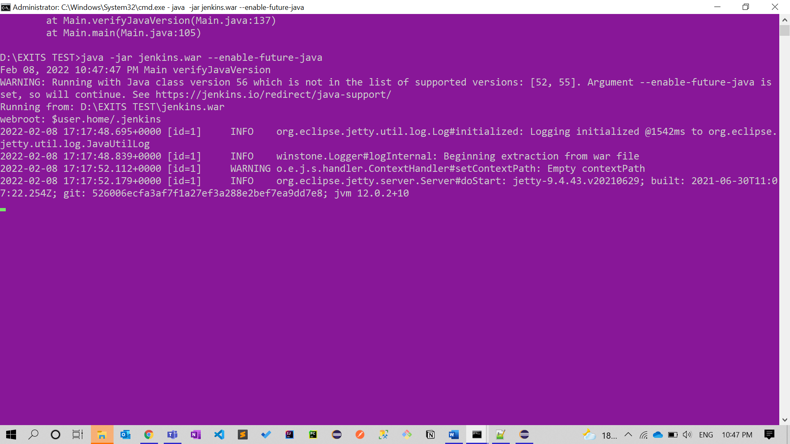

1. Next step is to Go “localhost:8080” on Browser and start creating our Free Style Job for our Flipkart Automation Project
2. As you to Jenkins & install some plugins for git integration like

1. Navigate to the Dashboard and then Click on New Item > Enter name of the Job & select Freestyle Job and click ok as shown in the below Image Graphical user interface, text, application, Word

   Description automatically generated
2. After Select this you will be navigated to the Some Config Options where you need to select the GitHub project and Enter the URL of the GitHub project and click on Save .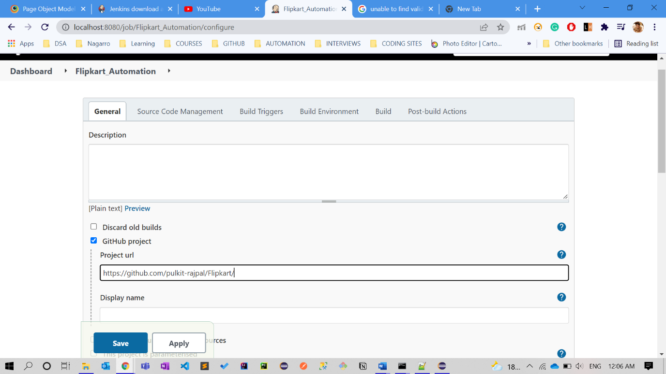
3. Scroll down to the Source Code management and select git as the source code manger and Enter the Git URL 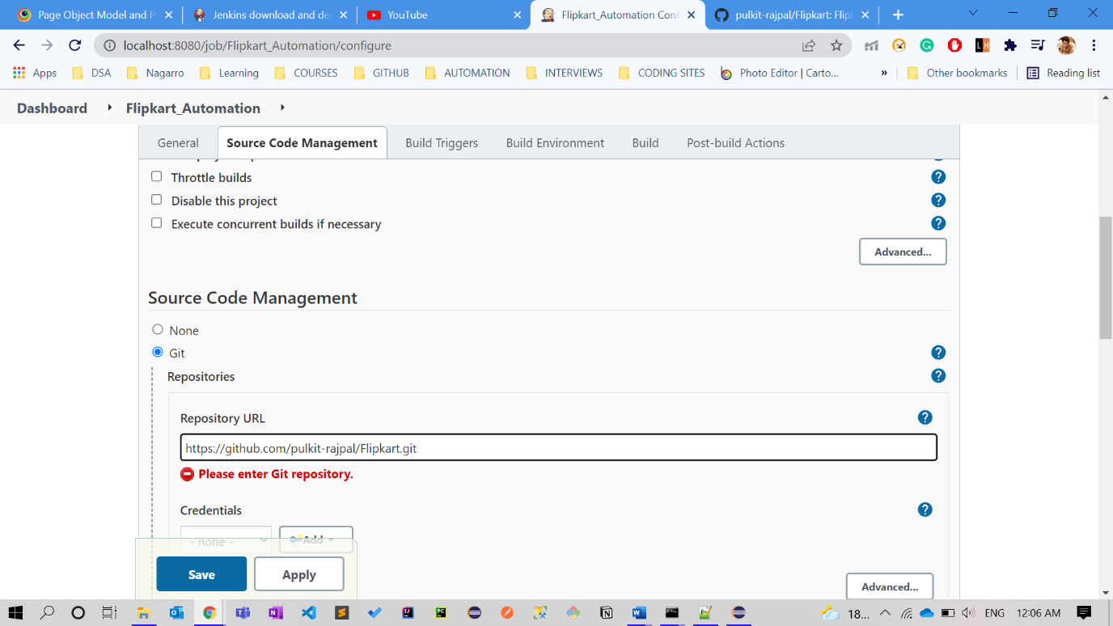
4. Also, give the Default branch of the GitHub Repository in my case it’s master but by default GitHub gives the main branchGraphical user interface, text, application, email

   Description automatically generated
5. As we want Jenkins to initiate a new Build for Our Automation Job whenever commits are made on the GitHub Repository we need to scroll and select the “**Poll SCM**” option for the Trigger & give * * * ** a which mean it should trigger a new build that very second whenever a commit is made to the repository as shown in the Below image .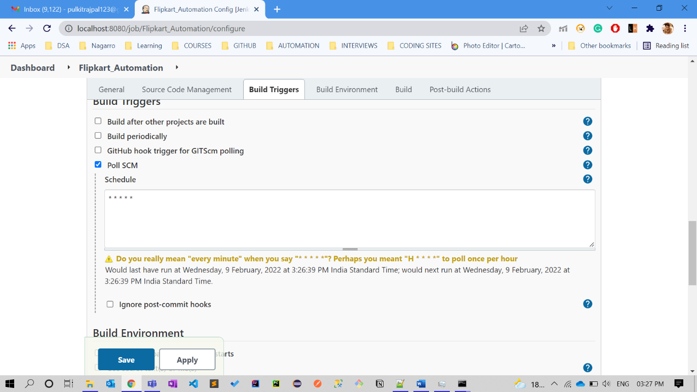
6. Now you need to Select the way you want to Build your Project as ours is a maven project we wills select maven and the maven clean install command which will run our test cases .Fill all the Conifgurations and your are done that’s it & save those Configs.
7. Now make a commit to the GitHub Repo and a new Build will be triggered in span of few seconds by hitting refresh you can see a new Build in progress. 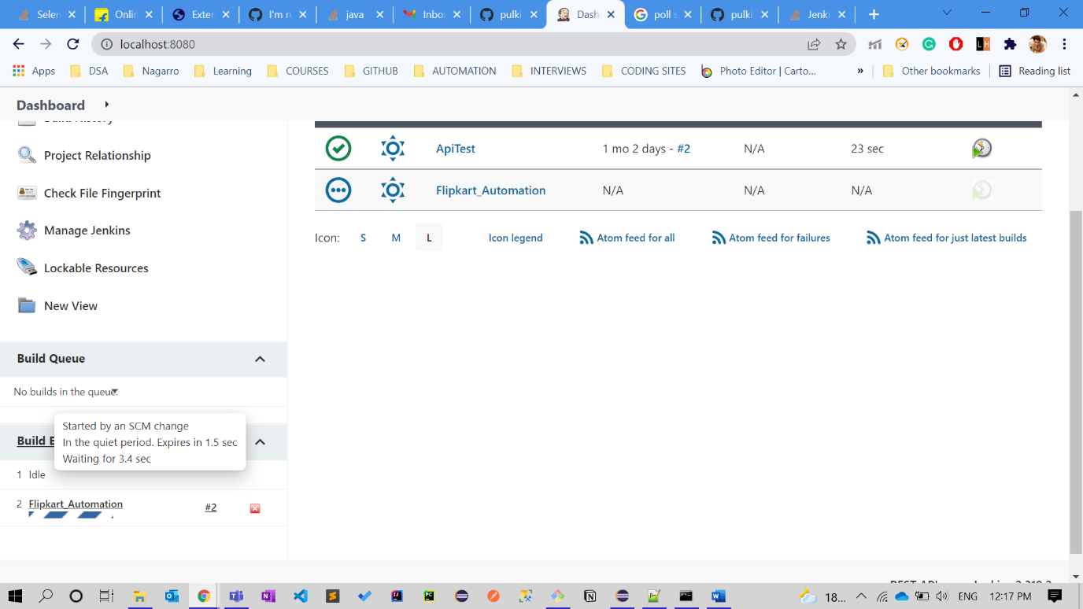
8. Console logs will show the Result of the Build as shown in the below Image.