Lab 2 — Agile Backlog Creation & Sprint Simulation in Jira
Software Engineering (UE24CS341A) — Semester 5, Section F
PULKIT BHARDWAJ — USN PES1UG24CS346
Scenario: Problem #39 — Second-Hand Product Escrow Marketplace

1. Jira setup
Project | SE Project — SCRUM (company-managed)
Board | SP board
Epic | Secure Escrow Transaction Flow
Sprint | Sprint 1 — 11 Sep – 13 Sep 2026 (1-week timebox)
Estimation | Planning Poker on the Fibonacci scale
Prioritisation | High / Medium / Low by user impact

User stories created from the Lab 1 functional requirements (status at the mid-sprint snapshot):
Issue | User story | Traces to | Status
SP-7 | Story 1.1 — Lock Payment in Escrow | FR-001 | In Progress
SP-8 | Story 1.2 — Order State Transition | FR-001 | To Do
SP-9 | Story 1.3 — Inspector Sign-Off | FR-002 | To Do
SP-10 | Story 1.4 — Fund Release on Approval | FR-003 | Done
SP-11 | Story 1.5 — Dispute Freeze | FR-005 / NFR-001 | Done

2. Reflection questions

Q1. Did your estimations reflect the actual effort?
Only partly. The estimates were derived from the happy path of each story, so the stories that looked conceptually simple were sized low. In practice the effort in the escrow domain lives in edge cases — dual-condition verification before release, rollback when settlement fails, and the tamper-evident audit write on every state change — none of which were visible when the cards were first estimated. Sprint 1 finished with only two of five stories in Done, with the core escrow locking story (SP-7) still In Progress. That is direct evidence that the money-handling stories were estimated optimistically; the gap was in unestimated edge-case work, not in the features themselves.

Q2. Was your backlog well-prioritized?
At the epic level, yes. The Secure Escrow Transaction Flow epic sequences the stories in strict dependency order — lock funds → transition order state → inspector sign-off → release funds → dispute freeze — so no story depends on work scheduled later in the backlog, and the two stories tied to the hard NFRs (fund release, dispute freeze) were prioritised High. The weakness is housekeeping: the backlog still carried unused example/template items (the coffee-ordering “Story 1.1 / 1.2” cards first surfaced by the Jira tutorial) alongside the real escrow stories. They should have been deleted during grooming — leaving them in inflates the backlog and makes priority ordering ambiguous.

Q3. How did your simulated sprint align with your plan?
The timebox and the sprint goal were respected: the sprint ran its fixed 1-week window and the goal (“deliver the escrow transaction flow incrementally”) was clear and singular. Where plan and reality diverged was scope vs. capacity. The plan committed all five stories to Sprint 1, but the snapshot shows two completed, one in progress and two untouched. Progress did move through the correct flow (To Do → In Progress → Done) as work was simulated, so the board mechanics matched the plan; the velocity assumption did not. The realistic throughput was closer to two stories per sprint than five.

Q4. What insights did the burndown chart give about your team's capacity?
The burndown line stayed almost flat early in the sprint and then dropped in discrete steps, rather than declining smoothly toward the grey ideal-progress guide. A stepped burndown means work is only recognised as done in batches (stories were closed together after review), and a line that sits above the guideline means the committed scope was larger than capacity. The actionable insight is that the team's sustainable velocity is below what Sprint 1 committed: the next sprint should pull fewer points than the raw backlog total and explicitly reserve capacity for the escrow stories that keep slipping, instead of assuming every high-priority story fits in one timebox.

3. Traceability to Lab 1
Lab 1 requirement | Jira user story
FR-001 Lock payment / state — Under Inspection | SP-7, SP-8
FR-002 Inspection certification (approve / reject) | SP-9
FR-003 Release funds on dual verification | SP-10
FR-004 Escrow service fee + digital receipt | (carried to next sprint)
FR-005 Buyer dispute freezes funds | SP-11
NFR-001 Immediate freeze / no withdrawals | SP-11
NFR-002 Tamper-evident audit log | cross-cutting (SP-7…SP-11)

4. Evidence (screenshots)
- Sprint 1 Burndown Chart (Story Points vs. time)
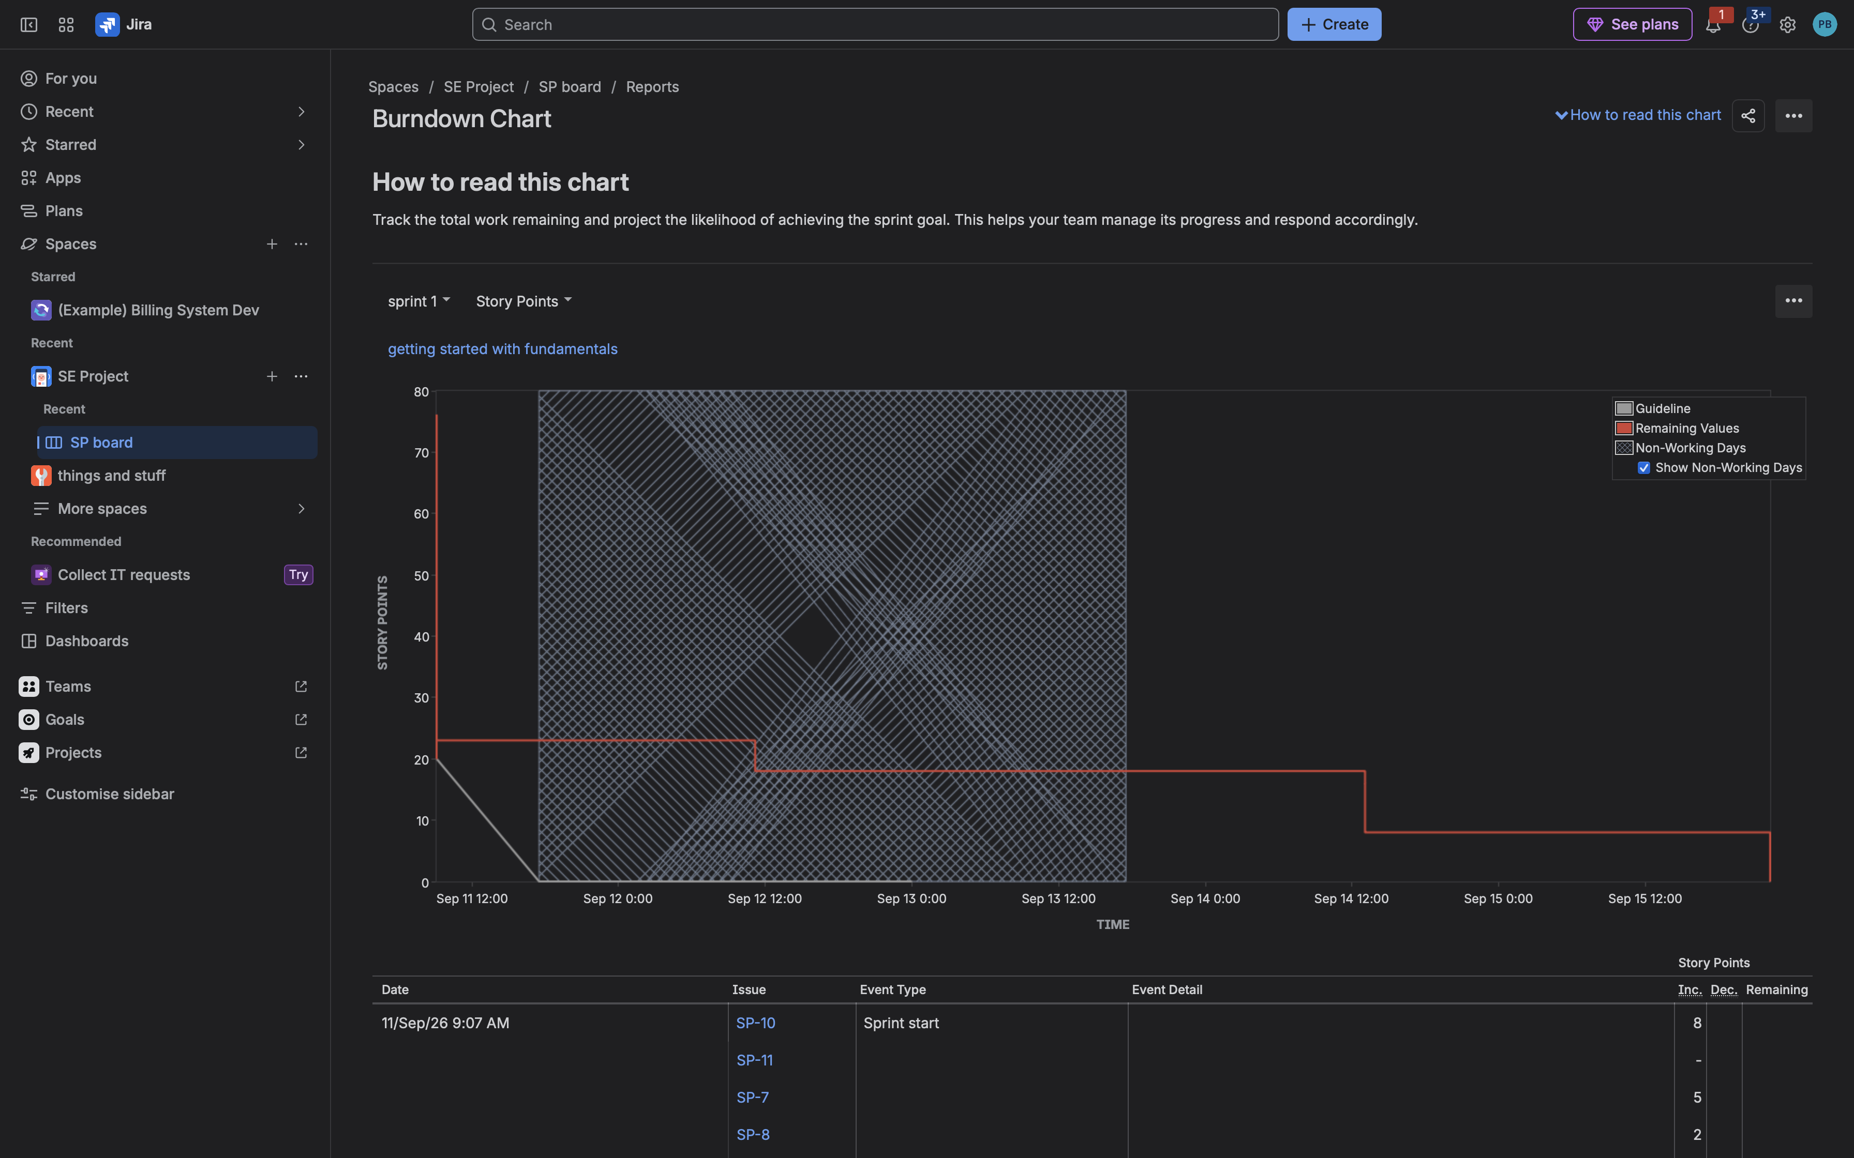
- Active Sprint board — Done 2 / In Progress 1 / To Do 2
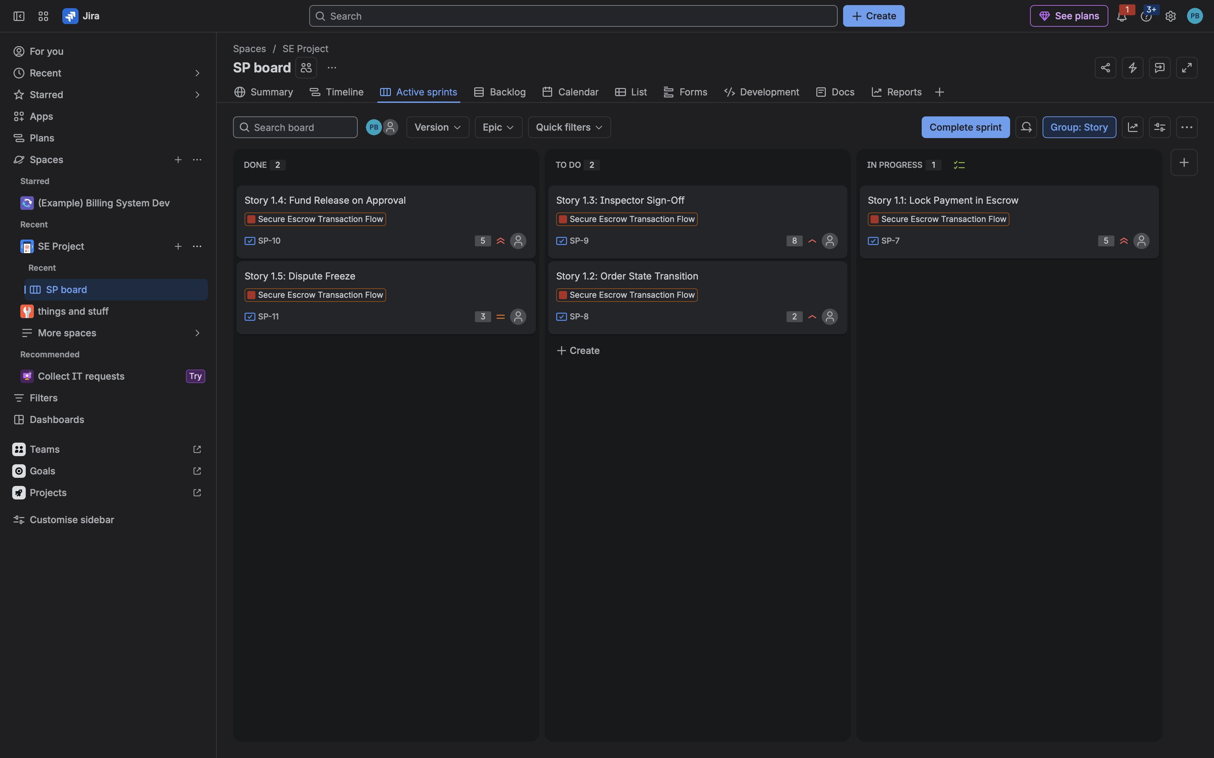
- Backlog — Epic + user stories (SP-7 … SP-11) and story points
