NAME – PULKIT VERMA
BRANCH & SEC – CSE 5D
REGISTRATION NUMBER – 202401100200247

DEVOPS ASSESMENT – CONTINOUS INTEGRATION WITH GITHUB ACTIONS
REPOSITORY - https://github.com/pulkit1245/github-skills-challenge
PR LINK - https://github.com/pulkit1245/github-skills-challenge/pull/2

successful workflow
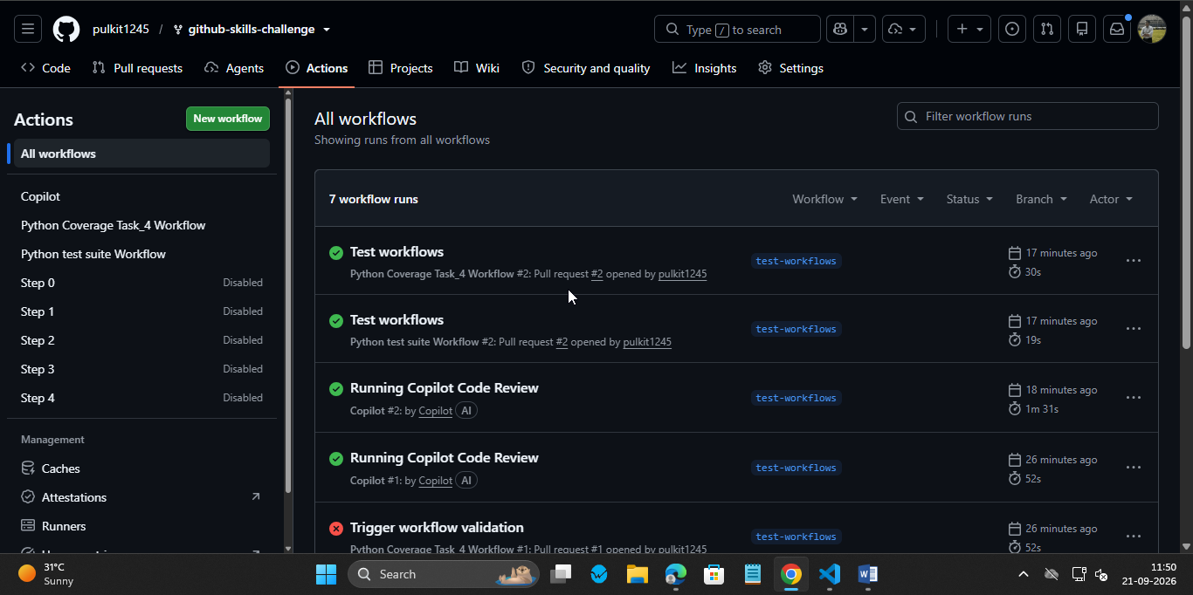

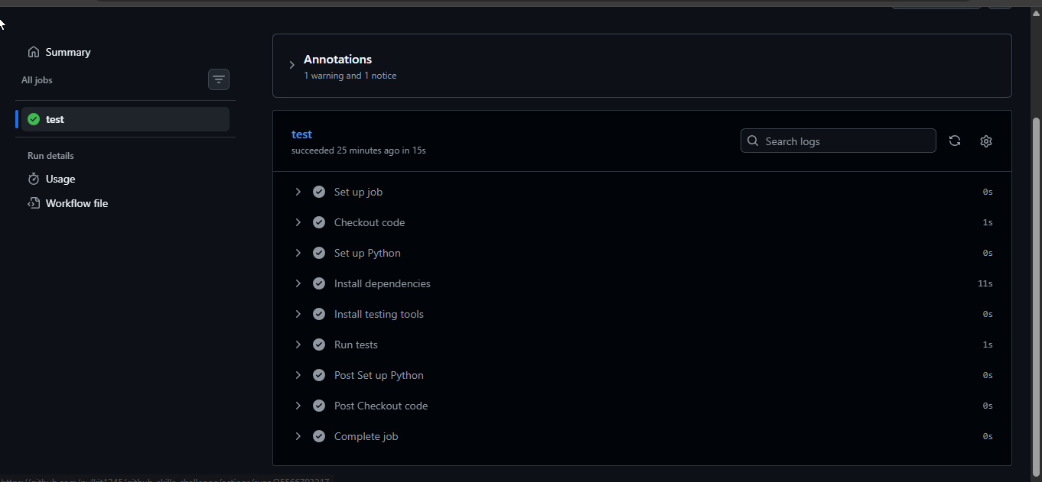
Both workflows
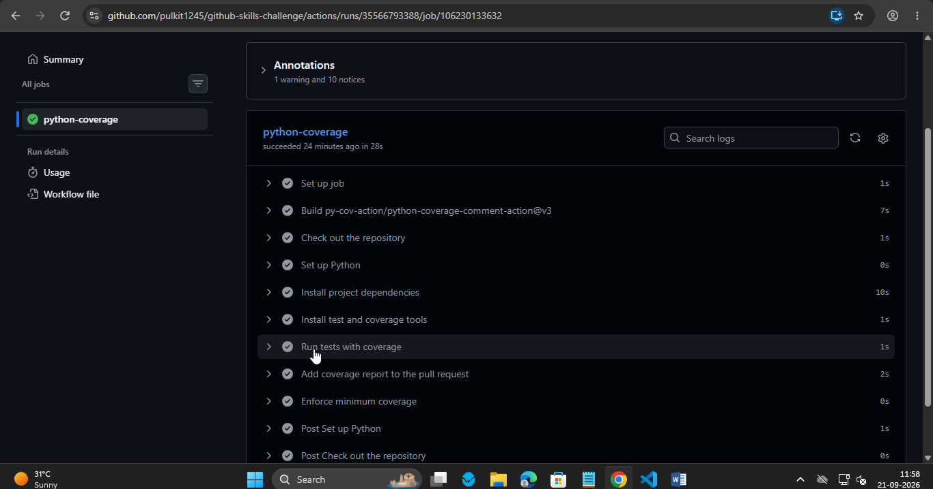
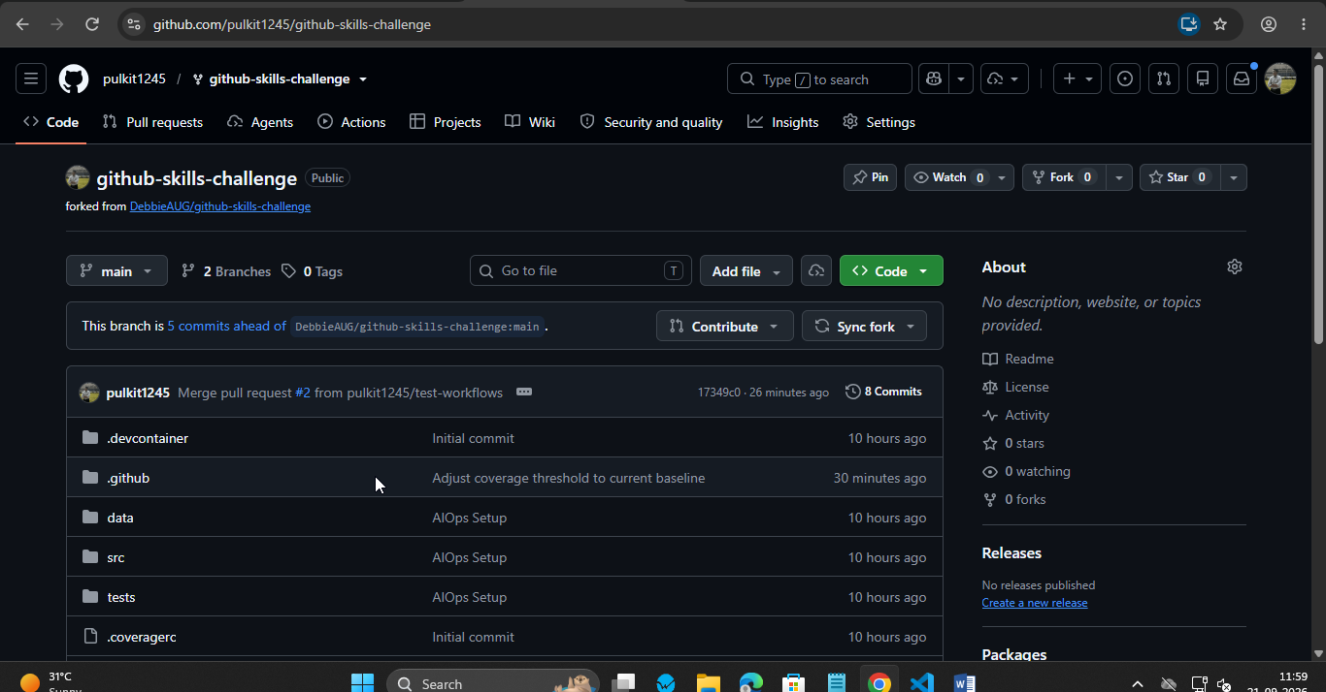
FINAL REPO

