Answer sheet

Contents

IG Teaching Hubs Chemistry Worksheets 2

Lesson 38 – Worksheet 1 2

Lesson 38 – Worksheet 2 2

IG Teaching Hubs Chemistry Homework sheets 3

Lesson 38 – Homework 3

IG Teaching Hubs Chemistry Worksheets

Lesson 38 – Worksheet 1

**1** If there are more particles, the reactant particles are closer together, therefore collisions occur more frequently.

**2** Collisions occur more frequently.

More particles have enough energy to react when they collide.

**3** Increasing the surface area (decreasing the lump size of the solid) while keeping the total volume/mass constant makes the reaction faster because there is more surface for collisions and so collisions occur more frequently.

**4**

* Increasing the concentration increases the rate of reaction because more collisions occur.
* Increasing the temperature increases the rate of reaction, because more collisions occur and more reactant particles have enough energy to react when they collide.
* Decreasing the size of pieces of solid increases the rate of reaction, because the surface area to volume ratio is greater/more surface area is exposed and so more collisions occur.

Lesson 38 – Worksheet 2

**1 a** concentration, temperature, surface area.

**b** The missing information is: mass, carbon dioxide, flask, reactants, volume, decrease.

**2 a** The loss in mass of the reactants (and flask).

**b** The concentration decreases.

**c** the volume of gas produced.

**3 a** temperature.

**b** Three of: the form/surface area/size of the chips of calcium carbonate, the mass of calcium carbonate, the concentration of the acid and the volume of the acid.

**c** As the temperature increases the time to produce the set loss in mass decreases quickly, so increasing temperature greatly increases the rate of the reaction.

IG Teaching Hubs Chemistry Homework sheets

Lesson 38 – Homework

**1** Mark scheme:

**1 mark** for both axes the correct way around and labelled with units

**2 marks** for accurate plotting of the points

Allow for half a square tolerance, and award **1 mark** if at least 8 plots are correct

**1 mark** for a suitable curve of best fit

**1 mark** for each tangent drawn correctly

**1 mark** for accurately deducing a value for change in *x* and change in *y* per tangent

**1 mark** for each gradient calculated correctly

**1 mark** if all final answers are given with the correct units for rate

[14 marks total]

A sample graph with gradients calculated is below.

Gradients may not be exactly the same, work from the students’ tangents and allow error carried forward.

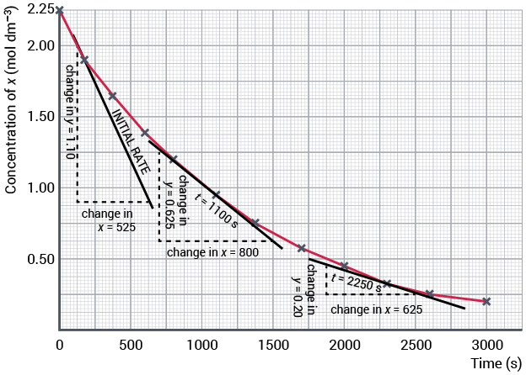

The gradient can now be calculated at each point:

Initial rate  1.10 ÷ 525  2.10 × 10−3 mol dm−3/s

Rate at 1100s  0.625 ÷ 800  7.81 × 10−4 mol dm−3/s

Rate at 2250s  0.20 ÷ 625  3.2 × 10−4 mol dm−3/s

**2 Mark scheme**

Use a best-fit approach to marking, similar to a **6-mark** quality-of-written-communication question in an exam.

1–2 marks

* Some key words are used.
* An attempt is made to explain some of the key words given.
* Student states that some collisions are successful, and others are not.
* Student attempts to relate frequency of collisions to rate but may have said number of collisions instead.
* Explanation is brief and not logical.
* Spelling, punctuation and grammar are poor.
* No diagram is provided, or the diagram that is provided is poor.

3–4 marks

* Most key words are used.
* An attempt is made to explain the key words.
* Student describes the requirements for a collision to be successful.
* Student relates frequency of successful collisions to rate of reaction.
* Explanation is mostly present with a few parts that are confused or brief.
* Spelling, punctuation and grammar are mostly correct.
* A diagram is provided but may not be clearly labelled or in the appropriate context.

5–6 marks

* All key words are used.
* Key words are all clearly explained.
* Student explains why some collisions are successful and others are not.
* Student relates frequency of successful collisions to rate of reaction.
* Explanation is in a logical sequence.
* Spelling, punctuation and grammar is near perfect.
* Relevant labelled diagrams are given with the explanation.