Worksheet 1

Name Class Date

**1** The diagram below shows an experimental set-up to investigate the effect of changing conditions on the **rate** of reaction. Complete the missing information in the sentences below.

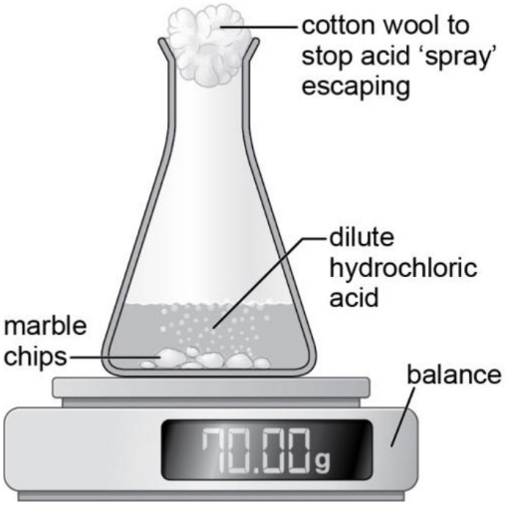**a** Three variablesthat could be investigated are:

c _____________________________________

t _____________________________________

s _______________ a ____________________

These words may help you to answer question **1**.

| carbon dioxide | | concentration | decreases | flask |
| --- | --- | --- | --- | --- |
| mass | reactants | surface area | temperature | volume |

**b** The rate of a reaction can be followed by measuring the loss in m ______________. As the reaction takes place, c __________________ d __________________ gas is given off and the mass of the conical f ___________________ and the   
r ___________________ decreases. To follow this reaction, we could also measure the v ___________________ of gas produced or the d ______________________ in concentration of acid.

**2** Look at the reaction in the diagram above.

**a** What is being measured in this experiment?

____________________________________________________________________

**a** What happens to the concentration of the acid as the reaction proceeds?

____________________________________________________________________

**b** What other change could be measured to follow this reaction?

____________________________________________________________________

**3** The table shows the results of an investigation into the reaction of calcium carbonate and acid using the apparatus on the previous page.

| Trial | Temperature (°C) | Time for 0.5 g loss in mass  (s) |
| --- | --- | --- |
| 1 | 21 | 60 |
| 2 | 33 | 28 |
| 3 | 42 | 13 |
| 4 | 50 | 7 |

**a** Name the variable being investigated. _____________

**b** Name three variables that would need to be controlled.

____________________________________________________________________

____________________________________________________________________

____________________________________________________________________

**c** Explain what these results tell us about rates of reaction.

____________________________________________________________________

____________________________________________________________________