Worksheet 3

Name Class Date

**1** Look at each of the reactions below.

Each reaction is at equilibrium and any other pieces of information about the reaction are presented.

For each condition changed, predict which direction the position of equilibrium might shift. Choose from the following:

|  |  |  |
| --- | --- | --- |
| shift to left | shift to right | no change |
|  |  |  |

|  |  |  |  |
| --- | --- | --- | --- |
| Reaction | Additional information | Change in condition | Equilibrium shift |
| A(g)  B(g)  C(g) | forward reaction endothermic | increase in temperature |  |
| A(g)  B(g)  C(g) | forward reaction exothermic | increase in temperature |  |
| A(g)  B(g)  C(g) | forward reaction exothermic | adding a catalyst |  |
| A(g)  B(g)  C(g) | forward reaction endothermic | increase pressure |  |
| 3A(g)  B(g)  C(g) | forward reaction exothermic | increase pressure |  |
| 3A(g)  2B(g)  C(g) | forward reaction exothermic | increase pressure |  |
| 3A(g)  2B(g)  C(g) | forward reaction exothermic | decrease temperature |  |
| 3A(g)  B(g)  C(g) | forward reaction exothermic | decrease pressure |  |
| 3A(g)  B(g)  2C(g) | forward reaction endothermic | adding a catalyst |  |
| 3A(g)  B(g)  2C(g) | forward reaction endothermic | decrease pressure |  |
| A(g)  B(g)  C(g) | forward reaction endothermic | increase in temperature |  |

**2** The image below shows a reversible reaction. Both vessels are sealed, but the vessel on the right has been placed into a beaker of ice cubes.

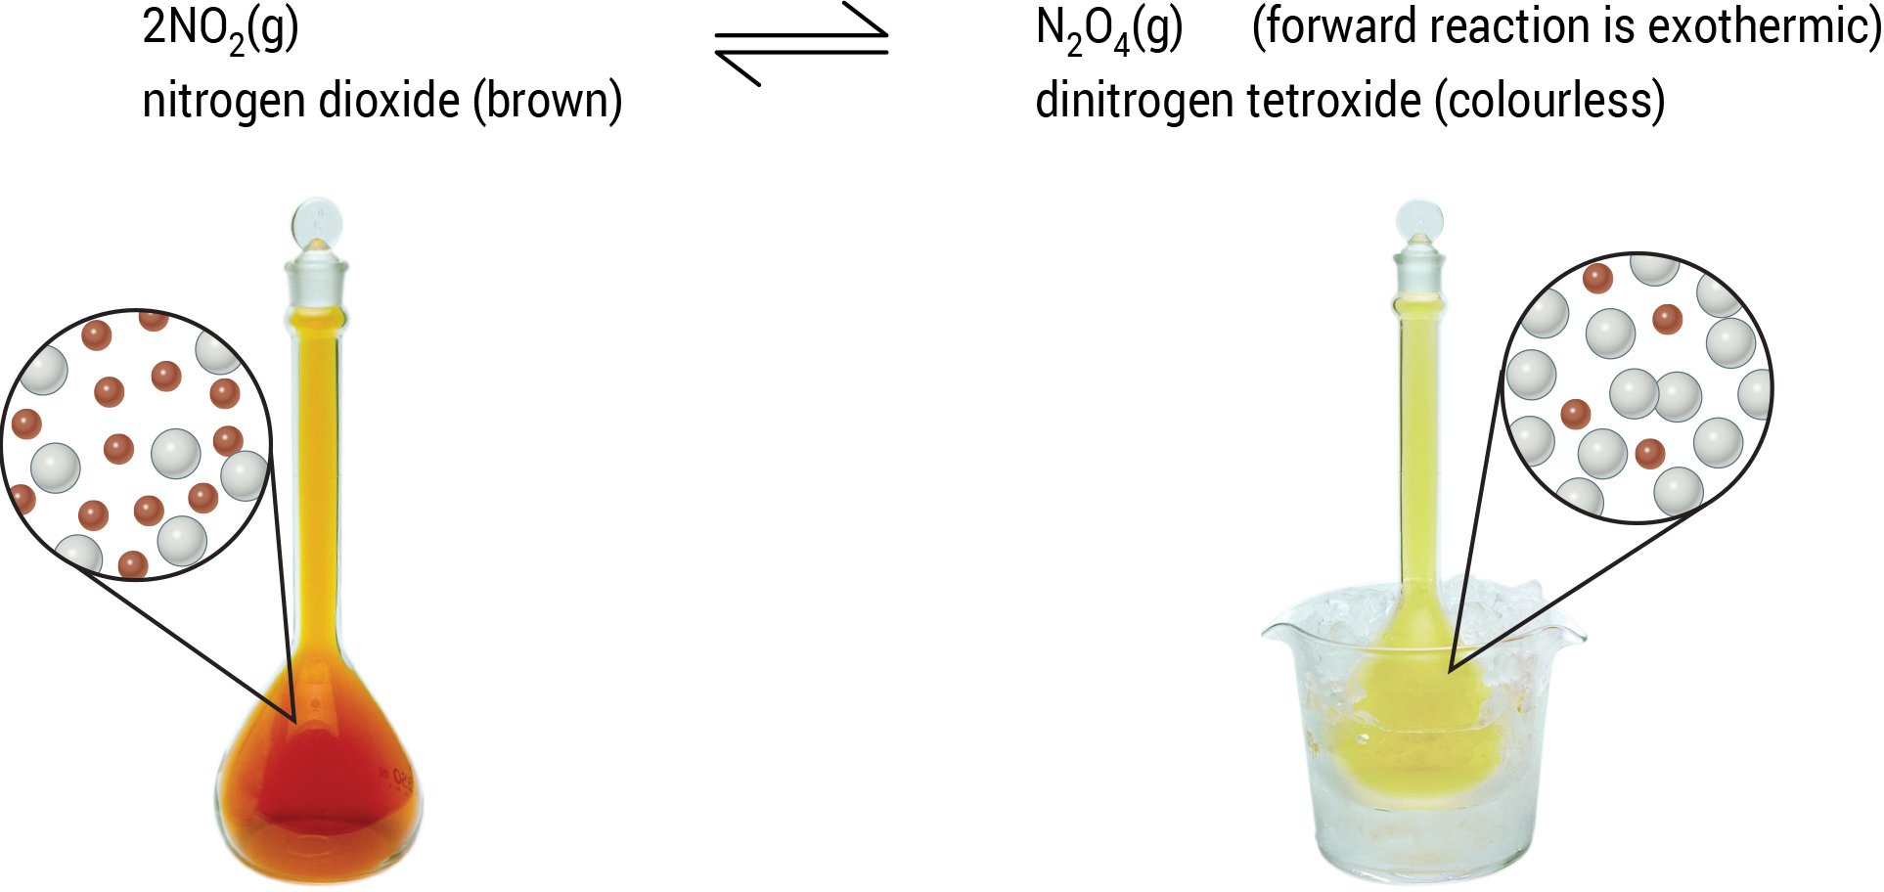

Complete the section below about the reaction.

As the temperature is decreased, the equilibrium shifts to the _____________________ so the colour gets lighter. This changes brown NO2 molecules into colourless N2O4 molecules as this is the exothermic direction, which increases the _____________________.

If the pressure is increased, the equilibrium position shifts _____________________ to form more N2O4 as this _____________________ the pressure again. When this happens, the colour gets lighter as N2O4 is _____________________.