Worksheet 4

Name Class Date

**1** Look at each of the reactions below.

Each reaction is at equilibrium and any other pieces of information about the reaction are presented.

For each condition changed, predict which direction the position of equilibrium might shift. Choose from the options provided by circling your chosen answer.

|  |  |  |  |
| --- | --- | --- | --- |
| Reaction | Additional information | Change in condition | Equilibrium shift |
| A(g)  B(g)  C(g) | forward reaction endothermic | increase temperature | **shift to left shift to right** |
| A(g)  B(g)  C(g) | forward reaction exothermic | increase temperature | **shift to left shift to right** |
| A(g)  B(g)  C(g) | forward reaction exothermic | add a catalyst | **no change shift to right** |
| A(g)  B(g)  C(g) | forward reaction endothermic | increase pressure | **no change shift to left** |
| 3A(g)  B(g)  C(g) | forward reaction exothermic | increase pressure | **no change shift to right** |
| 3A(g)  2B(g)  C(g) | forward reaction exothermic | increase pressure | **no change shift to right** |
| 3A(g)  2B(g)  C(g) | forward reaction exothermic | decrease temperature | **shift to left shift to right** |
| 3A(g)  B(g)  C(g) | forward reaction exothermic | decrease pressure | **shift to left shift to right** |
| 3A(g)  B(g)  2C(g) | forward reaction endothermic | add a catalyst | **no change shift to left** |
| 3A(g)  B(g)  2C(g) | forward reaction endothermic | decrease pressure | **no change shift to right** |
| A(g)  B(g) + C(g) | forward reaction endothermic | increase temperature | **shift to left shift to right** |

**2** The image below shows a reversible reaction. Both vessels are sealed, but the vessel on the right has been placed into a beaker of ice cubes.

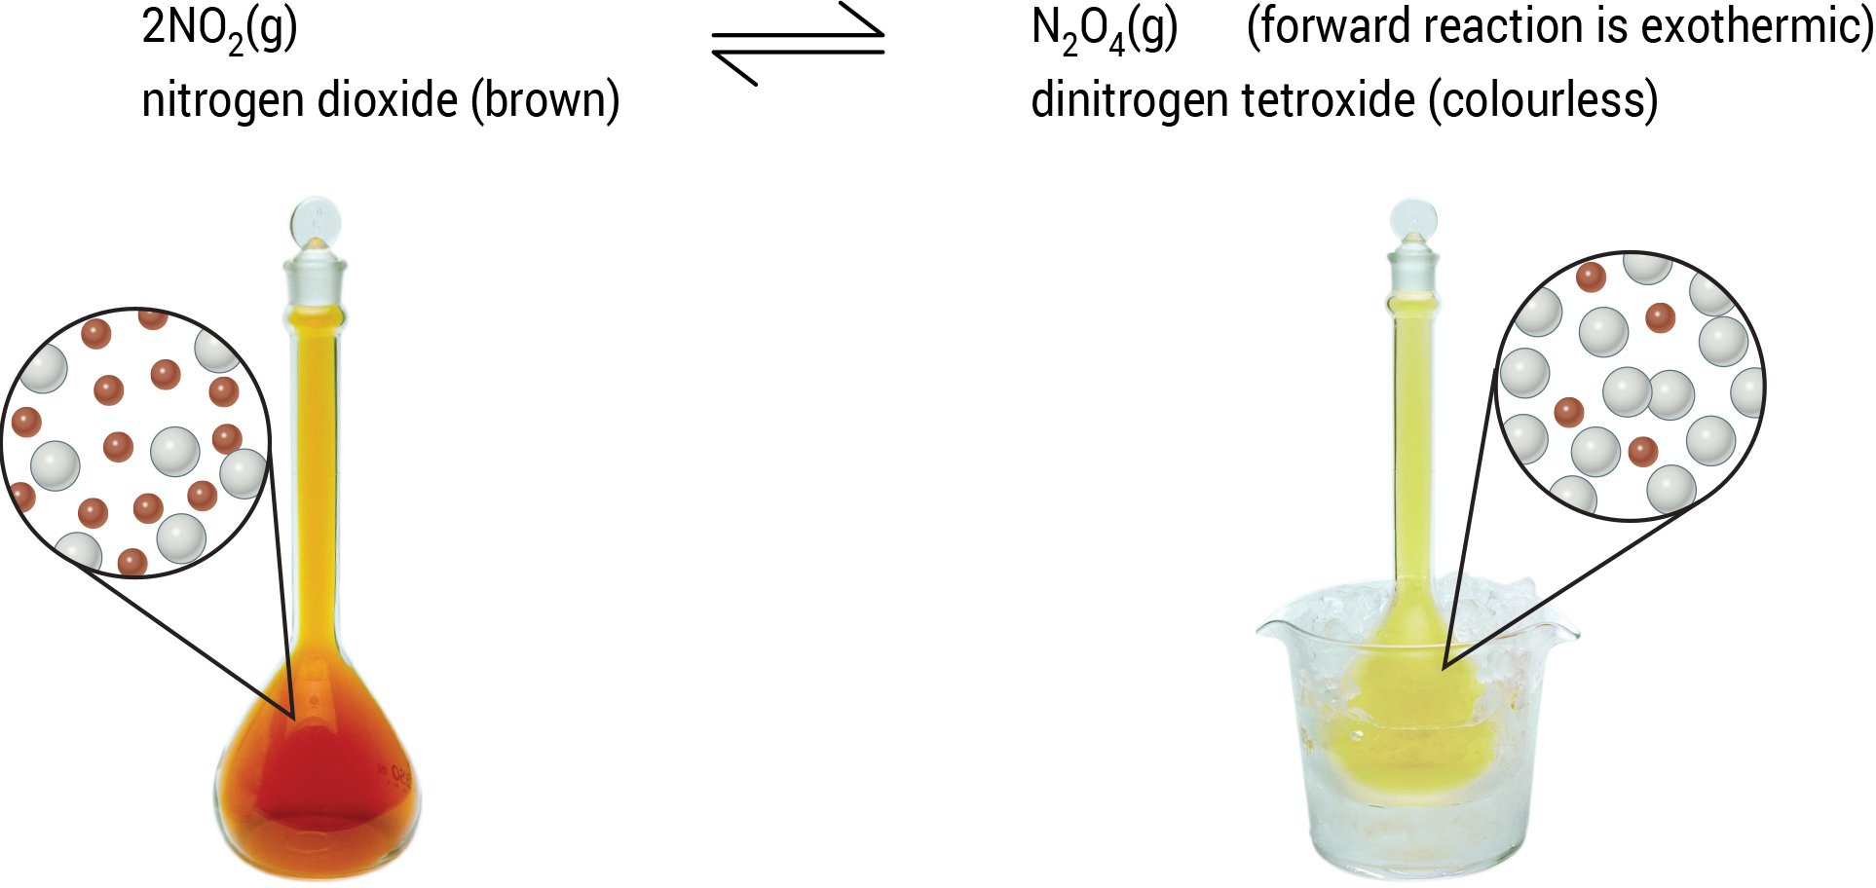

Complete the section below about the reaction using words from the word bank. A word may be used once, more than once or not at all.

Word bank

|  |  |  |  |  |  |
| --- | --- | --- | --- | --- | --- |
| brown | colourless | decreases | left | right | temperature |

As the temperature is decreased, the equilibrium shifts to the _____________________ so the colour gets lighter. This changes brown NO2 molecules into colourless N2O4 molecules as this is the exothermic direction, which increases the _____________________.

If the pressure is increased, the equilibrium position shifts _____________________ to form more N2O4 as this _____________________ the pressure again. When this happens, the colour gets lighter as N2O4 is _____________________.