Answer sheet

Contents

IG Teaching Hub Business Worksheets 2

Lesson 2 – Worksheet 1 2

Lesson 2 – Worksheet 2 2

Lesson 2 – Worksheet 3 3

Lesson 2 – Worksheet 4 3

IG Teaching Hub Business Homework sheets 4

Lesson 2 – Homework sheet 4

Worksheet 1

**1**

|  |  |  |  |
| --- | --- | --- | --- |
|  | Financial | Non-financial | Both |
| **a** You work when you want to work |  | ✓ |  |
| **b** You are your own boss |  | ✓ |  |
| **c** It is interesting |  | ✓ |  |
| **d** It is not difficult |  | ✓ |  |
| **e** You meet new people |  | ✓ |  |
| **f** There is no need to commute if you work from home |  |  | ✓ |
| **g** You can make good money | ✓ |  |  |
| **h** There is plenty of variety |  | ✓ |  |
| **i** It is challenging |  | ✓ |  |
| **j** Your dream of success could become a reality |  |  | ✓ |

**2** Students’ own ideas. For example:

Financial: My business could become the market leader and our brand be recognised globally

Non-financial: I can balance my family responsibilities with my workload

Both: I can afford a luxurious lifestyle and make decisions about how hard I want to work if my business is successful.

Worksheet 2

**1** Students’ own responses.

Worksheet 3

**1** Q1 possible answer: Starbucks will increase their sales of Fairtrade coffee to customers who would prefer to buy ethically sourced coffee rather than coffee which is not.

**2** Q2 possible answer: Starbucks will have higher costs than if it bought the coffee from cheaper non-Fairtrade coffee suppliers. This is because Fairtrade suppliers are given a higher price for their coffee.

**3** Q3: 55  218  11  94  173  551. The market leader sells 218 so  × 100  39.6 (1 decimal place)

**4** Q4: Setting an objective relating to an environmental goal may attract more customers. **(1 mark)** People who are concerned about social issues such as global warming may decide to buy from the business **(1 mark)** and may also inform their friends of the ‘green credentials’ of the firm, further increasing its sales. **(1 mark)**

Worksheet 4

For example:

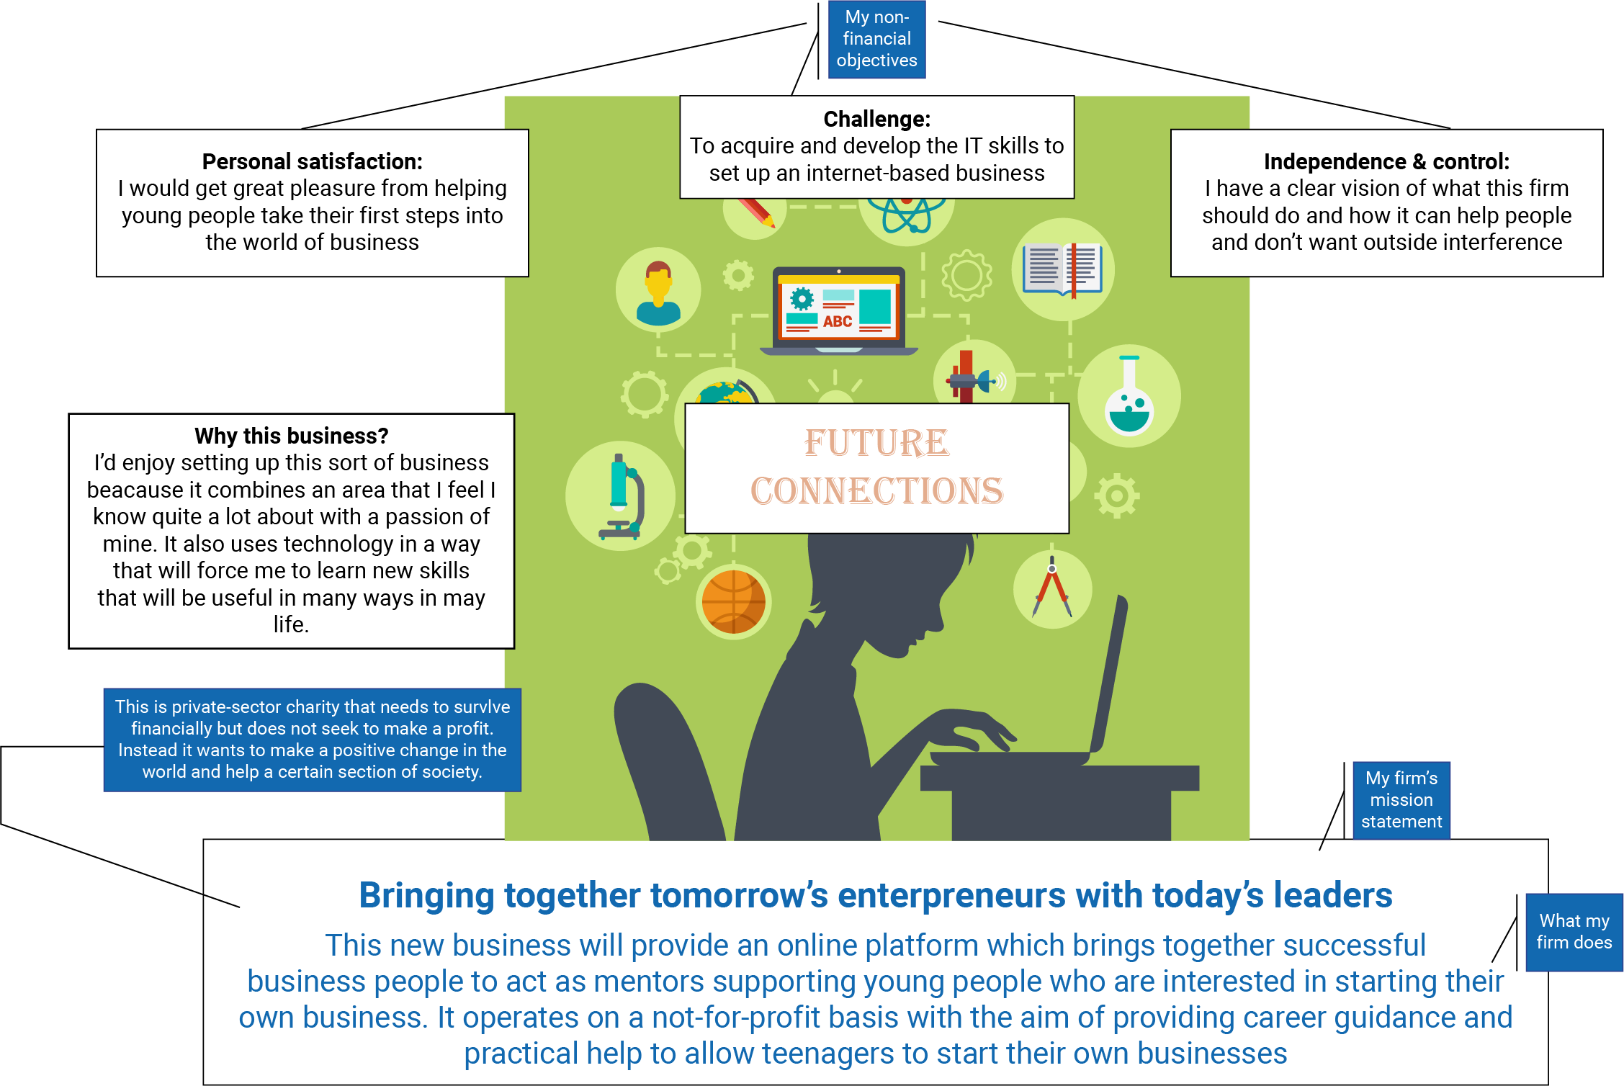

Homework sheet

**1 Why is independence and control an important objective in this case?**

Some people want to be 'their own boss' — they want to be in control. This is an important non-financial objective for many business owners, such as Ornar Hassan. These entrepreneurs are driven by the desire to be independent and to take control Of their own futures. The freedom to make all the decisions when running a business is very appealing. Some people often resent being told what to do at work. Omar was employed by a large hotel working in the kitchen. However, he did not like following instructions and being told what to do all day. He set up in business mainly because he valued independence very highly. He wanted to take complete control of his life and also thought he could improve on some of the inflight meals offered by airlines. Omar also had an offer to sell his business – he would also be kept on as the managing director. However, Omar declined; he wanted to keep control because it was very important to him.

**2** Omar may have had the financial objective of survival in the first year **(1 mark)** because the case study says that ‘after breaking even in the first year (he) started to make a profit (in year two). **(1 mark)**

**3** Omar may have set up his business for the personal challenge **(1 mark)** because he felt that he could prepare better quality ‘inflight’ meals than those offered by the other airlines. **(1 mark)**

**4** The independence offered by running their own business may allow some entrepreneurs to choose how and when they work **(1 mark)** which might allow them to balance family responsibilities (such as caring for children) with their work commitments. **(1 mark)** This means that they can fit their work around their personal lives in a way they could not do if they were working for a large business that would not allow them flexibility to take time off during the day (for example, to collect children from school. **(1 mark)**