IT 440

FINAL PORTFOLIO

* BY PULKIT AGARWAL

CONTENTS

1. INTRODUCTION
2. SALES DATABASE QUERIES
3. IN CLASS QUERIES ON OWN DATABASE
4. PL/SQL QUERIES ON OWN DATABASE
5. PROCEDURES ON OWN DATABASE

Introduction

This portfolio has been compiled by me using the in-class assignments and homework. Most of the work has been done on my own database with the exception of one assignment where I used the sales database. My portfolio folder also contains the following:

* Excel Worksheet of my database
* SQL Files of all the queries, procedures and functions
* Data model of the database
* Word file of portfolio
* PDF of portfolio

The questions or the concerned queries have been commented.

ASSIGNMENT 1 : 30 QUERIES ON SALES DATABASE WITH RESULTS

SELECT SNAME //Supplier name supplying maximum quantity of parts

FROM S

WHERE S# IN (SELECT S# FROM SP

WHERE QTY =(SELECT MAX(QTY) FROM SP));

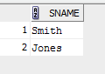

SELECT DISTINCT SNAME // supplier whose supplies red parts and whose

FROM S,SP,P // weight is greater than 10

WHERE S.S#=SP.S# AND SP.P#=P.P# AND P.COLOR='Red' and weight>10;

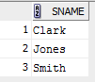

SELECT P1.P#, P2.P# // parts from the same city with no duplicates

FROM P P1, P P2

WHERE P1.P# < P2.P#

AND P1.CITY=P2.CITY;

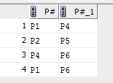

SELECT SNAME,PNAME // supplier and part from the same city

FROM S,SP,P

WHERE S.S#=SP.S# AND SP.P#=P.P# AND P.CITY = S.CITY;

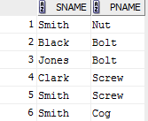

SELECT PNAME // part name that has min total quantity shipped

FROM P

WHERE P# IN (SELECT P# FROM SP

WHERE QTY =(SELECT MIN(QTY) FROM SP));



SELECT SNAME,COUNT(P#) // parts shipped by each supplier

FROM S,SP

WHERE S.S#=SP.S#

GROUP BY SNAME;

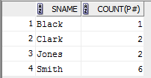

SELECT PNAME,SUM(QTY) // total quantity of all blue parts

FROM P,SP

WHERE P.P#=SP.P# AND P.COLOR='Blue'

group by PNAME

ORDER BY PNAME;



SELECT S.CITY, S.SNAME // suppliers not from the city from which smith is.

FROM S

WHERE S.CITY NOT IN

(SELECT CITY

FROM S

WHERE SNAME LIKE 'Smith');

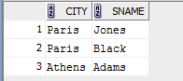

SELECT * FROM P // parts that are not from London and whose color is not blue

WHERE CITY <>'London' AND COLOR <>'Blue';



SELECT DISTINCT SNAME // name of the suppliers that supply a red part.

FROM S,SP,P

WHERE S.S#=SP.S# AND SP.P#=P.P# AND P.COLOR='Red';

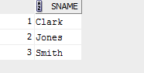

SELECT P.PNAME // name of parts from supplier from Paris with qty>100 and

FROM P,SP,S // part is from Paris

WHERE S.S#=SP.S# AND SP.P#=P.P# AND S.CITY='Paris'

AND SP.qty > 100 AND P.CITY='Paris';



SELECT SUM(WEIGHT) // total weight of all the red parts

FROM P

WHERE COLOR='Red';



SELECT DISTINCT S1.SNAME,S2.SNAME

FROM S S1,S S2 // names of the suppliers that are from the same city

WHERE S1.S# < S2.S#

AND S1.CITY=S2.CITY;



SELECT SNAME

FROM S // supplier name that supplies the minimum quantity of parts

WHERE S# IN (SELECT S# FROM SP

WHERE QTY =(SELECT MIN(QTY) FROM SP));



SELECT S#,SUM(QTY) // total quantity shipped for each part

FROM P,SP

WHERE SP.P#=P.P#

GROUP BY S#;

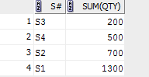

SELECT PNAME // part name that has the maximum quantity

FROM P

WHERE P# IN (SELECT P# FROM SP

WHERE QTY =(SELECT MAX(QTY) FROM SP));

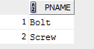

SELECT SNAME,PNAME // suppliers and parts that come from the London

FROM S,P,SP

WHERE S.S#=SP.S# AND SP.P#=P.P# AND P.CITY='London' AND S.CITY='London';

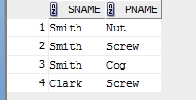

SELECT S.S#,SNAME,COUNT(distinct P#)

FROM S,SP // max number of unique parts supplied by every supplier

WHERE S.S#=SP.S#

GROUP BY S.S#,SNAME;

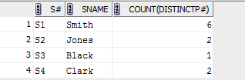

// name of the supplier that supplies both red part and weight is 14.

SELECT SNAME

FROM S,P,SP

WHERE S.S#=SP.S# AND SP.P#=P.P# AND WEIGHT=14 AND P.COLOR='Red';



// Top 2 and bottom 2 parts based on their quantity

SELECT 'TOP LIST',P#,QTY, RANKS

FROM(SELECT P#, SUM( QTY) AS QTY, ROW_NUMBER () OVER ( ORDER BY SUM(QTY) DESC ) AS RANKS

FROM SP

GROUP BY P#)

WHERE RANKS < 3

UNION

SELECT 'BOTTOM',P#,QTY, RANKS

FROM(

SELECT P#, SUM( QTY) AS QTY, ROW_NUMBER () OVER ( ORDER BY SUM(QTY) ASC ) AS RANKS

FROM SP

GROUP BY P#)

WHERE RANKS < 3;

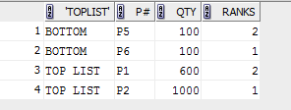

// Names of the suppliers who supplies the most parts and least parts

SELECT 'Top_supplier', S#

FROM(

SELECT S#, COUNT( P#) , ROW_NUMBER() OVER ( ORDER BY COUNT( P#) DESC) AS RANKS

FROM SP

GROUP BY S# )

WHERE RANKS < 2

UNION

SELECT 'Least_Supplier',S#

FROM(

SELECT S#, COUNT( P#) , ROW_NUMBER() OVER ( ORDER BY COUNT( P#) ASC) AS RANKS

FROM SP

GROUP BY S# )

WHERE RANKS < 2;

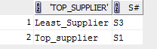

// Names of the suppliers who supplies the most parts and least parts

SELECT PNAME,city,DECODE(CITY,'London','Mankato')

FROM P

where city ='London';

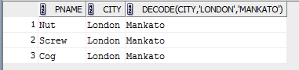

// Top and bottom suppliers based on the quantity they supply.

SELECT 'Top_supplier', qty

FROM(

SELECT S#, SUM(QTY) AS qty, ROW_NUMBER() OVER ( ORDER BY S# ASC) AS RANKS

FROM SP

GROUP BY S# )

WHERE RANKS < 2

UNION

SELECT 'Least_supplier',qty

FROM(

SELECT S#, SUM(QTY) AS qty, ROW_NUMBER() OVER ( ORDER BY S# DESC) AS RANKS

FROM SP

GROUP BY S# )

WHERE RANKS < 2

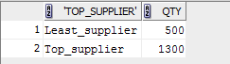

// Give the top 3 parts that weigh the most.

SELECT PNAME,WEIGHT,Top_Ranks

FROM (SELECT PNAME,WEIGHT,

RANK() OVER (ORDER BY WEIGHT DESC) AS Top_Ranks

FROM P)

where Top_Ranks <=3;

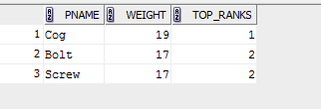

// Give the total qty for all the parts

SELECT P#,SUM(QTY)

FROM SP

GROUP BY P#;

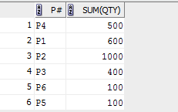

//Give the name of parts from supplier from London with qty>100 and part is from London

SELECT P.P#,PNAME

FROM SP,S,P

WHERE S.S#=SP.S# AND P.P#=SP.P# AND S.CITY='London' and qty>100;

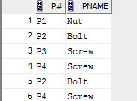

// Rank suppliers on the total quantity and number of parts

SELECT SNAME,SUM(QTY),COUNT(P.P#),RANK() OVER ( ORDER BY sum(QTY) DESC) AS RANK1,

RANK() OVER ( ORDER BY COUNT(P.P#) DESC) AS RANK2

FROM S,P,SP

WHERE S.S#=SP.S# AND P.P#=SP.P#

GROUP BY SNAME;

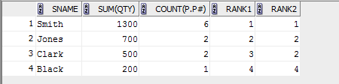

// Give the subtotals of the total part weights of the all the parts supplied by a supplier and give the final total weight.

SELECT P.P#,SNAME,SUM(WEIGHT)

FROM P,SP,S

WHERE S.S#=SP.S# AND P.P#=SP.P#

GROUP BY ROLLUP(P.P#,SNAME)

ORDER BY P.P#;

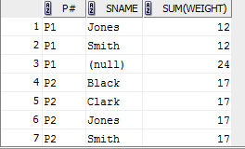

ASSIGNMENT 2: IN CLASS QUERIES ADJUSTED ON OWN DATABASE

// Count employees in the same month

SELECT COUNT(*),MONT

from (select ENO, EMP_FNAME, EMP_LNAME, EMP_DOB

,to_char(EMP_DOB, 'DD-MON-YY') as EMP_DOB_CHAR

,to_char(EMP_DOB, '"Birth year is "YY') as Birth_Year

,to_char(EMP_DOB, ' mon') as MONT

from employee )

group by MONT;

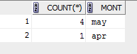

// Second method for the same

SELECT COUNT(*),MONTH

from (select ENO, EMP_FNAME, EMP_LNAME, EMP_DOB

,to_char(EMP_DOB, 'DD-MON-YY') as EMP_DOB_CHAR

,to_char(EMP_DOB, '"Birth year is "YY') as Birth_Year

,SUBSTR(EMP_DOB,4,3) MONTH

from employee )

group by MONTH



// Find retirement date of an employee

select EMP_LNAME, EMP_FNAME, EMP_DOB

,add_months(EMP_DOB, 12*65) as RETIREMENT

FROM EMPLOYEE;

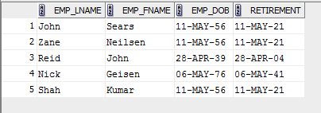

// Second method for the same

select EMP_LNAME, EMP_FNAME, EMP_DOB

,add_months(EMP_DOB, 12*65) as RETIREMENT

FROM EMPLOYEE;

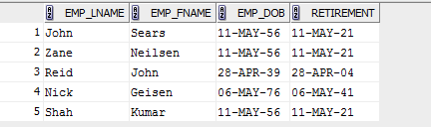

// current age of employee in months

select EMP_DOB ,ROUND(MONTHS_BETWEEN(SYSDATE,EMP_DOB))

from EMPLOYEE;

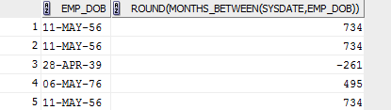

// Order employee based on their day of the week of the their birth day

SELECT EMP_DOB,TO_CHAR(EMP_DOB,'DAY') AS DAY

FROM EMPLOYEE

ORDER BY DECODE(RTRIM(TO_CHAR(EMP_DOB,'DAY'),' '),'SUNDAY',1, 'MONDAY',2,

'TUESDAY',3,'WEDNSDAY',4,

'THURSDAY',5,'FRIDAY' ,6,'SATURDAY',7);

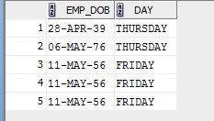

// total sales by month

select sum(ORDER_QTY*UNIT_PRICE),substr(to_char(CUST_order_date),4,3) as monn

from orders o ,PRODUCT l

where o.PNO=l.PNO

group by substr(to_char(CUST_order_date),4,3);

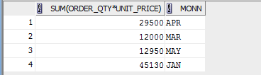

// Total sales for employee

USING RLL UP

select sum(ORDER_QTY*UNIT_PRICE),ENO,substr(to_char(CUST_ORDER_DATE),4,3) MONTH

from orders o ,PRODUCT l

where o.PNO=l.PNO

group by ROLLUP(ENO,substr(to_char(CUST_ORDER_DATE),4,3))

ORDER BY ENO,substr(to_char(CUST_ORDER_DATE),4,3);

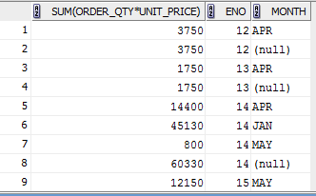

// Total sales for employee using cube method

select sum(ORDER_QTY*UNIT_PRICE),ENO,substr(to_char(CUST_ORDER_DATE),4,3) MONTH

from orders o ,PRODUCT l

where o.PNO=l.PNO

group by CUBE(ENO,substr(to_char(CUST_ORDER_DATE),4,3))

ORDER BY ENO,substr(to_char(CUST_ORDER_DATE),4,3);

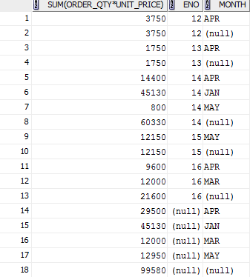

// Total sales for employee using group by method

select sum(ORDER_QTY*UNIT_PRICE),ENO,substr(to_char(CUST_ORDER_DATE),4,3) MONTH

from orders o ,PRODUCT l

where o.PNO=l.PNO

group by ENO,substr(to_char(CUST_ORDER_DATE),4,3)

ORDER BY ENO,substr(to_char(CUST_ORDER_DATE),4,3);

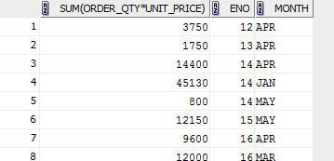

// find employee ranked 2

EMPLOYE RANK 2

SELECT RANK ,EMP_FNAME FROM (SELECT EMP_FNAME, EMP_LNAME , SALARY,

RANK() OVER ( ORDER BY SALARY Desc) AS RANK

FROM EMPLOYEE)

WHERE RANK =2;



// Using union to find both bottom and top at a time

SELECT EMP_FNAME, EMP_LNAME ,SALARY, Bottom_Ranks

FROM (SELECT EMP_FNAME, EMP_LNAME ,SALARY,

RANK() OVER ( ORDER BY SALARY ASC) AS Bottom_Ranks

FROM EMPLOYEE)

where Bottom_Ranks <=3;

UNION

SELECT EMP_FNAME, EMP_LNAME, SALARY, Top_Ranks

FROM (SELECT EMP_FNAME, EMP_LNAME ,SALARY,

DENSE_RANK() OVER (ORDER BY SALARY DESC) AS Top_Ranks

FROM EMPLOYEE)

where Top_Ranks <=3;

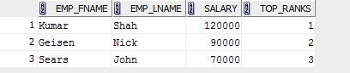

// finding ntile 90

SELECT EMP_FNAME, EMP_LNAME , SALARY AS SALARY,

NTILE(3) OVER ( ORDER BY SALARY DESC NULLS LAST) Tertile

FROM EMPLOYEE S;

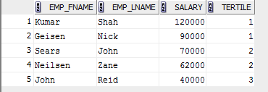

// TOTAL SALES FOR EVERY MONTH USING PERCENTAGE TO RATTIO

select ROUND(RATIO_TO_REPORT(sum(ORDER_QTY*UNIT_PRICE)) OVER(),2) AS SALES,ENO,substr(to_char(CUST_ORDER_DATE),4,3) MONTH

from orders o ,PRODUCT l

where o.PNO=l.PNO

group by ENO,substr(to_char(CUST_ORDER_DATE),4,3)

ORDER BY 3,substr(to_char(CUST_ORDER_DATE),4,3);

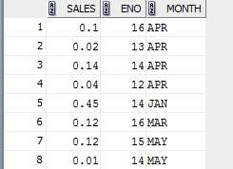

ASSIGNMENT 3: PL/SQL QUERIES ON OWN DATABASE

// PL/SQL hello world program

set serveroutput on;

DECLARE

BEGIN

DBMS_OUTPUT.PUT_LINE(' ***** Hello World *****');

DBMS_OUTPUT.PUT_LINE(' SUMMER CLASS IN ONE WEEK IS WONDERFUL AND UNBLIEBLE');

END;



// simple employee count program

SET SERVEROUTPUT ON;

declare

var1 varchar(24);

begin

select 'Number of Employees: ' || count(*)

into var1

from employee;

dbms_output.put_line (var1);

exception

when others then dbms_output.put_line('ERROR OCCURRED');

end;



// Employee count program with error handling

SET SERVEROUTPUT ON;

declare

var1 varchar(24);

begin

select 'Number of Employees: ' || count(*)

into var1

from employee;

dbms_output.put_line (var1);

exception

when others then dbms_output.put_line('ERROR OCCURRED');

end;

/



// Finding retirement date using PL/SQL

SET SERVEROUTPUT ON;

DECLARE

retirement_date date;

emp_var employee%rowtype;

BEGIN

SELECT min(EMP_DOB)

INTO emp_var.EMP_DOB

FROM employee;

retirement_date := add_months(emp_var.EMP_DOB, 12*65);

dbms_output.put_line ('Retirement date is '|| to_char(retirement_date,'dd/mm/yyyy'));

END;

/



// Current month program

set serveroutput on;

declare

current_month char(3);

begin

select to_char(sysdate, 'MON') into current_month from dual;

if current_month = 'JAN' then

dbms_output.put_line ('My daughter Jane was born in Jan');

elsif current_month = 'FEB' then

dbms_output.put_line ('My good friend Ron was born in Feb');

elsif current_month = 'MAR' then

dbms_output.put_line ('My father was born in March');

elsif current_month = 'APR' then

dbms_output.put_line ('I was born in April');

elsif current_month = 'MAY' then

dbms_output.put_line ('My son Matt was born in May');

elsif current_month = 'OCT' then

dbms_output.put_line ('My wife was born in October');

else

dbms_output.put_line ('I do not have any relatives

born in '||current_month);

end if;

end;



// finding oldest employee

set serveroutput on;

DECLARE

oldest_birth_date date;

EMP_LNAME employee.EMP_LNAME%type;

EMP_FNAME employee.EMP_FNAME%type;

cursor find_old_b_day is select min(EMP_DOB) from employee;

cursor id_emp is select EMP_LNAME, EMP_FNAME from employee where EMP_DOB = oldest_birth_date;

BEGIN

open find_old_b_day;

fetch find_old_b_day into oldest_birth_date;

close find_old_b_day;

open id_emp;

fetch id_emp into EMP_LNAME, EMP_FNAME;

close id_emp;

dbms_output.put_line ('The Oldest employee Is ' ||EMP_FNAME||' '||EMP_LNAME);

END;

/



// finding oldest employee program 2

set serveroutput on;

DECLARE

cursor find_old_b_day is

select min(EMP_DOB) day from employee;

old_date find_old_b_day%rowtype;

cursor id_emp is select EMP_LNAME, EMP_FNAME from employee where EMP_DOB = old_date.day;

id id_emp%rowtype;

BEGIN

open find_old_b_day;

fetch find_old_b_day into old_date;

close find_old_b_day;

open id_emp;

fetch id_emp into id;

close id_emp;

dbms_output.put_line ('The Oldest Employee Is ' ||id.EMP_FNAME||' '||id.EMP_LNAME);

END;

/



// Printing first three employees

set serveroutput on;

declare

counter_variable number := 1;

cursor a is select EMP_LNAME, EMP_FNAME from employee;

cur_var a%rowtype;

begin

open a;

loop

exit when counter_variable = 4;

fetch a into cur_var;

dbms_output.put_line (cur_var.EMP_LNAME || ', '||cur_var.EMP_FNAME);

counter_variable := counter_variable +1;

end loop;

end;

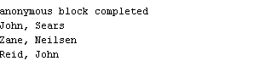

// printing all employees

set serveroutput on;

declare

cursor a is select EMP_LNAME, EMP_FNAME from employee;

cur_var a%rowtype;

begin

open a;

fetch a into cur_var;

while a%found

loop

dbms_output.put_line (cur_var.EMP_LNAME|| ', '||cur_var.EMP_FNAME);

fetch a into cur_var;

end loop;

end;

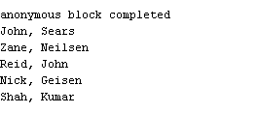

// Printing all employees born in Mankato

set serveroutput on ;

declare

cursor a is select employee_no, EMP_LNAME, EMP_FNAME, EMP_DOB from employee where lower(city) = 'mankato';

cur_var a%rowtype;

begin

dbms_output.put_line('EMP Last First Date');

dbms_output.put_line('NO Name Name of Birth');

dbms_output.put_line('---- --------------- ---------- ---------');

open a;

fetch a into cur_var;

while a%found

loop

dbms_output.put_line (cur_var.employee_no|| ' '||rpad(cur_var.EMP_LNAME,15)|| ', '||rpad(cur_var.EMP_FNAME,10)|| ' '||cur_var.EMP_DOB);

fetch a into cur_var;

end loop;

end;

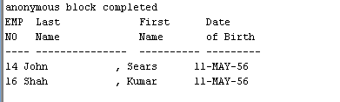

// Prinitng all products with their names and category

set serveroutput on

declare

cursor a is select PNO, prod_name, prod_category from product;

prod_var a%rowtype;

begin

open a;

for cnt_var in 1..5

loop

fetch a into prod_var;

dbms_output.put_line(to_char(cnt_var)

||' '||prod_var.PNO

||' '||prod_var.prod_name

||' '||prod_var.prod_category);

end loop;

close a;

end;

/

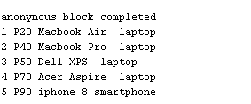

// Printing product numbers along with their unit prices

set serveroutput on ;

BEGIN

dbms_output.put_line('PNO '||' '|| 'UNIT_PRICE');

for cnt_var in (SELECT PNO, UNIT_PRICE from product)

LOOP

dbms_output.put_line(cnt_var.PNO

||' --------------- '||cnt_var.UNIT_PRICE);

END LOOP;

END;

/

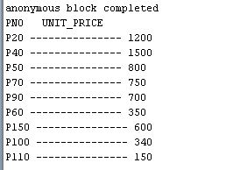

ASSIGNMENT 4: PROCEDURS ON OWN DATABASE

// Hello world procedure with name

Set serveroutput on;

create or replace procedure firstproc is

begin

dbms_output.put_line ('Hello to you from Stored Procedure by PULKIT ');

end;

/

execute firstproc ;

drop procedure firstproc ;

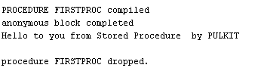

// Printing employees from Mankato and their date of births

Set serveroutput on;

create or replace procedure list_emp (city2 in varchar2) is

begin

for a in (select e.EMP_LNAME, e.EMP_FNAME, e.EMP_DOB

from employee e

where upper(e.city1) = upper(city2) )

loop

dbms_output.put_line('Name='||a.EMP_LNAME||' '||a.EMP_FNAME);

dbms_output.put_line('EMP_DOB='||a.EMP_DOB);

end loop;

end;

/

exec list_emp('Mankato');

drop procedure list_emp;

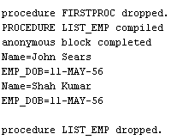

Set serveroutput on;

declare

procedure Hello is

begin

dbms_output.put_line ('Hello to you from Stored Procedure');

end;

procedure list_position (position1 in varchar2) is

begin

for a in (select * from employee where city1=position1)

loop

dbms_output.put_line (a.city1);

end loop;

end;

begin

dbms_output.put_line ('*** Results of the first procedure');

hello;

dbms_output.put_line ('*');

dbms_output.put_line ('*** Results of the second procedure');

dbms_output.put_line ('position ');

dbms_output.put_line ('---------');

list_position('Manager');

end;

/

