**Name: Pulkit Arora Roll No.: 102103267 Group: 2CO10**

**Assignment Tasks:**

***Note: Each student must attach separate sheet for submitting the below mentioned Assignment Task A.***

1. Using Tinkercad, Illustrate the pin configuration and verify the truth table of IC 74HC08 and IC 74H73

**IC 74HC08:**

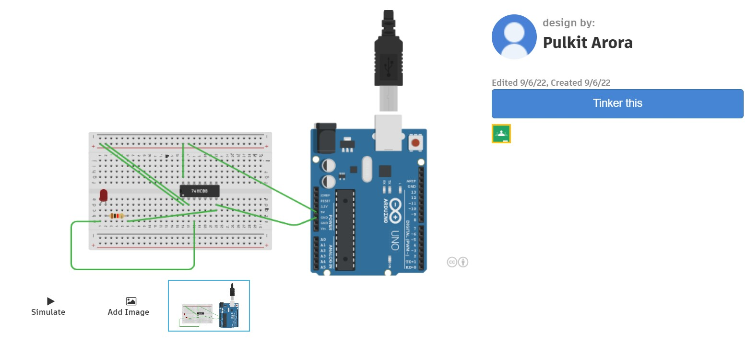

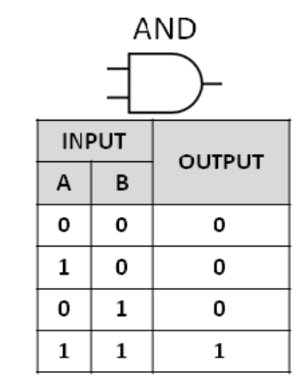

**Name: Pulkit Arora Roll No.: 102103267 Group: 2CO10**

**IC 74H73:**

