# Assignment-6

**Write queries to:**

1. **Display the system date**

select sysdate from dual;

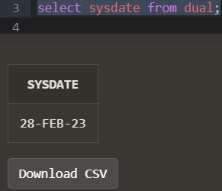

1. **Display current day**

select to_char(sysdate,'day') from dual;

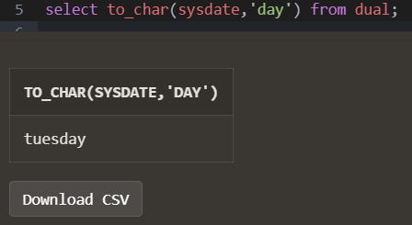

1. **Display current month and spell out year**

select to_char(sysdate,'MM year') from dual;

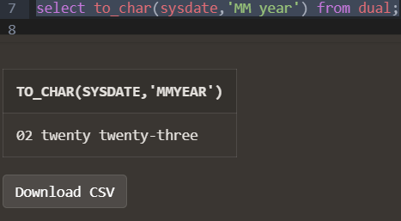

1. **Display spell out current date**

select to_char(sysdate,'Ddspth') from dual;

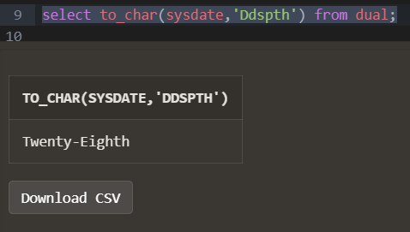

1. **Check whether it is AM or PM right now**

alter session set time_zone='+5:30';

select to_char(current_timestamp,'AM') from dual;

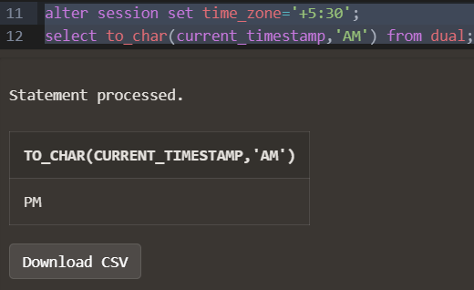

1. **Display the date of next Friday**

select Next_day(sysdate,'friday') from dual;

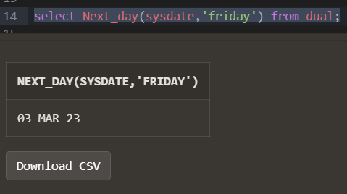

1. **Round the system date on month**

select round(sysdate,'MM') from dual;

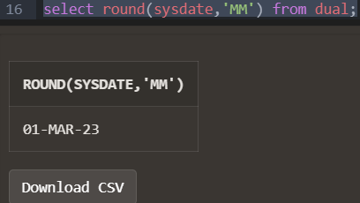

1. **Truncate the system date on month**

select trunc(sysdate,'MM') from dual;

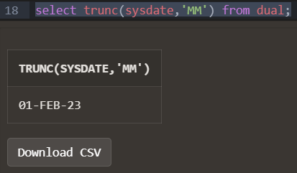

1. **Round the system date on year**

select round(sysdate,'YYYY') from dual;

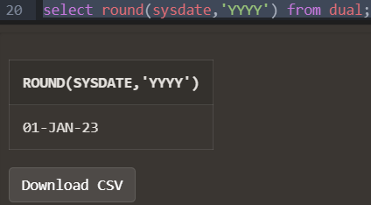

1. **Truncate the system date on year**

select trunc(sysdate,'YYYY') from dual;

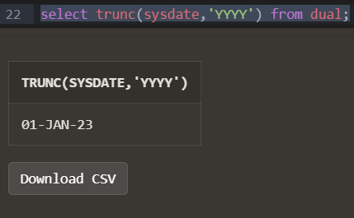

1. **Find the day after three days**

select to_char(sysdate+3,'day') from dual;

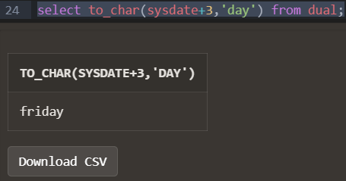

**Table Emp from Assignment 2:**

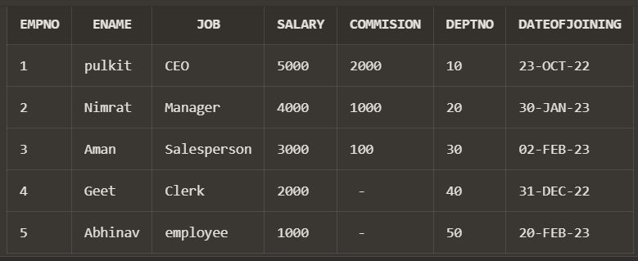

1. **Display day of date of joining column**

select to_char(dateofjoining,'DAY') from emp;

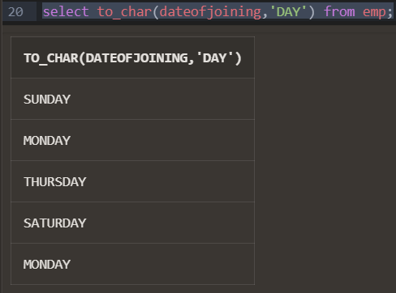

1. **Display those employees who join the company on Monday**

select ENAME from emp where trim(TO_CHAR(dateofjoining,'DAY'))='MONDAY';

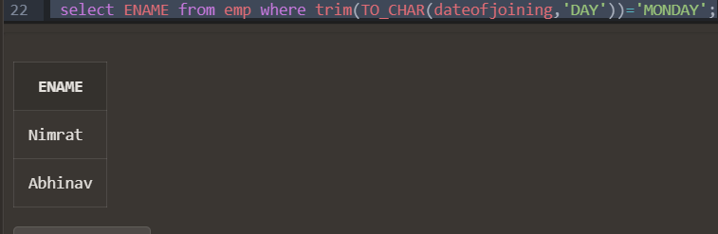

1. **Display those employees who join the company this month**

select ename from emp where to_char(dateofjoining,'MON')=to_char(sysdate,'MON');

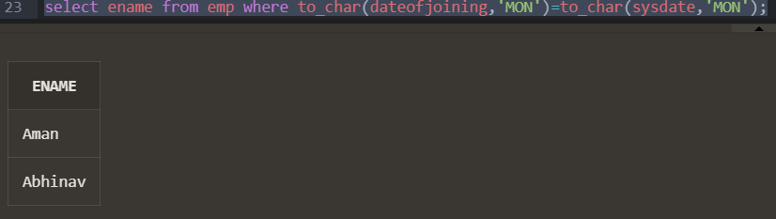

1. **Display those employees who join the company in last 30 days**

select ename from emp where dateofjoining BETWEEN sysdate-30 AND sysdate;

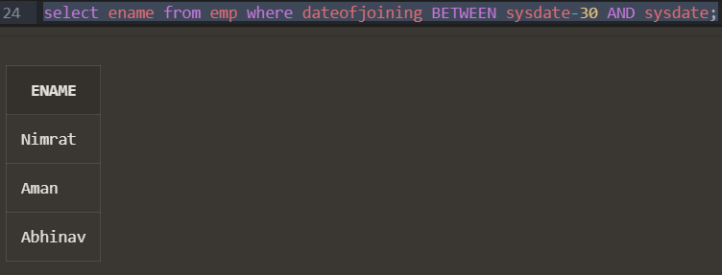

# Create a table train having three four columns

1. Train Number, date of Departure, time of departure, time of arrival

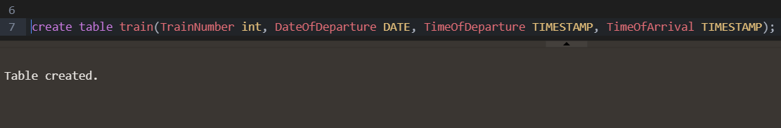

1. **Insert five columns in train table**

insert into train values(14532, '28-FEB-2023 12:57:06 PM', '28-FEB-2023 6:50:09 PM');

insert into train values(12028, '03-MAR-2023 02:27:00 AM', '04-MAR-2023 3:50:49 PM');

insert into train values(21125, '12-MAY-2023 10:57:06 AM', '12-MAY-2023 2:50:00 PM');

insert into train values(12546, '01-MAR-2023 07:40:00 PM', '01-MAR-2023 09:50:09 PM');

insert into train values(18954, '27-FEB-2023 09:19:09 PM', '28-FEB-2023 09:18:09 PM');

1. **Display all the records**

select * from train;

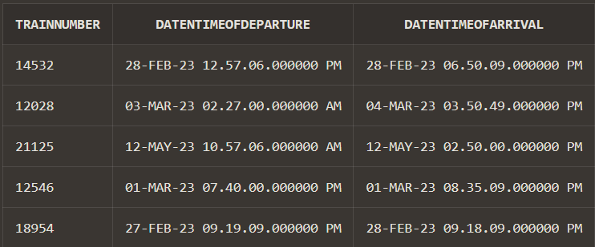

1. **Display the time values inserted in the columns**

select TO_CHAR(DateNTimeOfDeparture,'hh:mm:ss'), TO_CHAR(DateNTimeOfArrival, 'hh:mm:ss') from train;

1. **Display those trains which arrived on PM**

select * from train where TO_CHAR(DateNTimeOfArrival, 'PM') = 'PM';

1. **Display train number who are going to depart in next on hour.**

select TrainNumber from train where DateNTimeOfDeparture between sysdate and (sysdate +1/24);



`

**Lab Assignment–7**

**(Continued from Lab Assignbment-4)**

Q1) Check the structure of tables.

Desc emp;

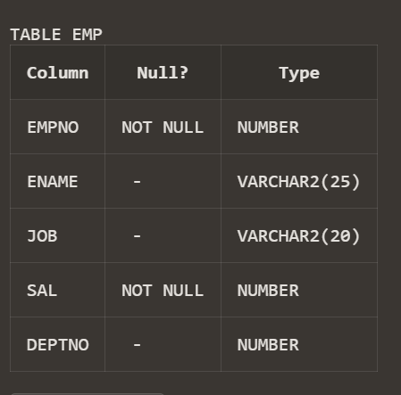

Desc book;

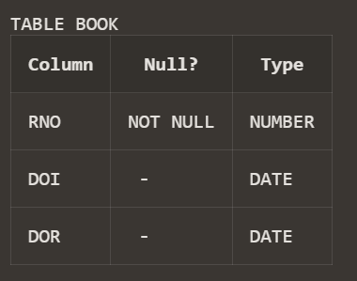

Desc st;

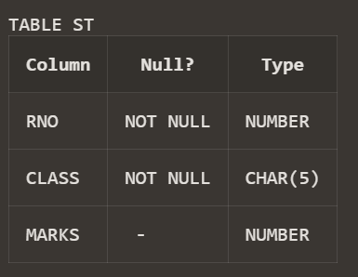

Desc s;

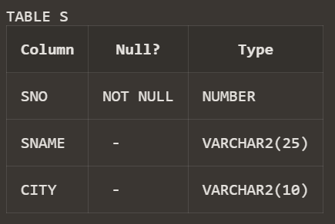

Desc p;

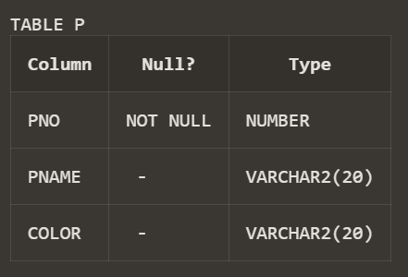

Desc sp;

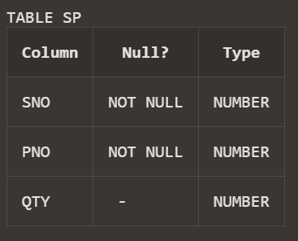

Desc dept;

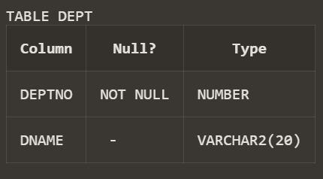

Q2) Check the constraint name for applied constraints?

select CONSTRAINT_NAME,CONSTRAINT_TYPE,TABLE_NAME,SEARCH_CONDITION,STATUS from user_constraints;

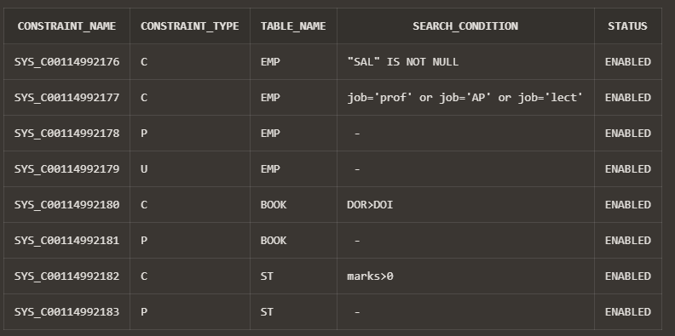

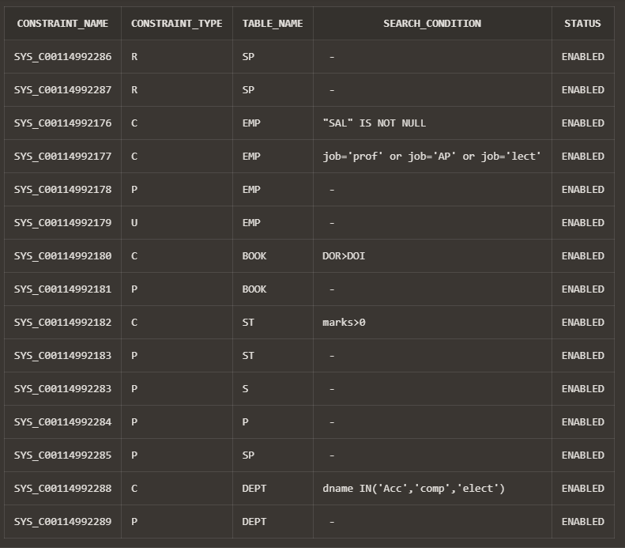

Q3) Drop the unique constraint on ENAME

ALTER TABLE EMP

DROP UNIQUE(ENAME);

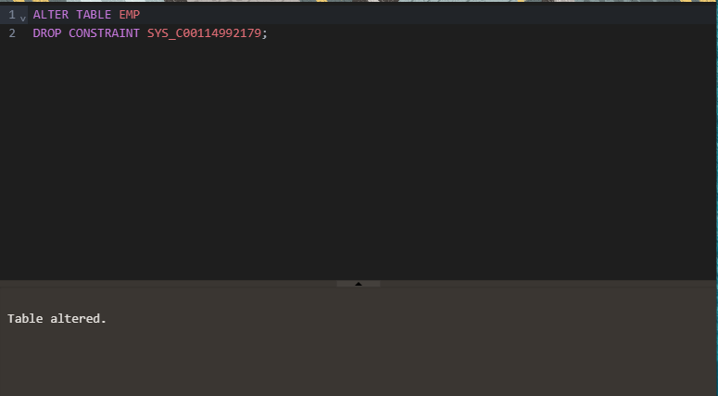

Q4) Drop the Foreign Key constraint on DEPTNO

ALTER TABLE EMP

DROP constraint emp_deptno_FOREIGN KEY;



Q5) Add Foreign Key constraint on DEPTNO

alter table emp add constraint EMP_DEPTNO_FK foreign key

(deptno) references dept(deptno);

Q6) Change Data type of ENAME

ALTER TABLE EMP

modify ename char(25);



Q7) Change width of DNAME

ALTER TABLE dept

modify dname varchar(50);



Q8) Add COMM column in EMP table

alter table emp add comm int;



Q9) Drop CITY column from P table

alter table s drop column city;



Q10) Create duplicate copy of EMP table

create table emp_copy as select * from emp;



Q11) Copy structure of DEPT table in another table with different column names

create table dept_copy as select deptno as deptno2,dname as dname2 from dept;



Q12) Change the name and job of the employee whose EMPNO =100

update emp set ename='Eakansh',job='ceo' where empno=2;

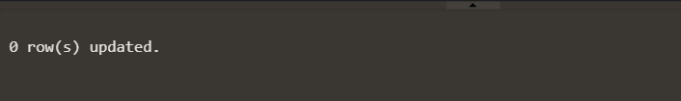

Q13) Delete the record of employee who belongs to computer department

delete from emp where deptno=12;

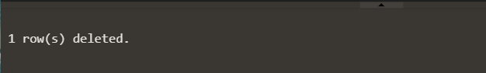

Q14) Drop DEPT Table

Drop table dept;

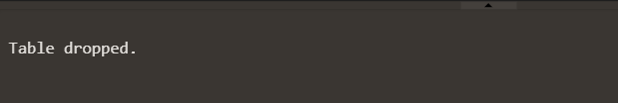

Q15) Drop duplicate table of EMP table

Drop table emp_copy;

