UCS310: PL/SQL

Lab Assignment 1

1. WAP to find the greatest of three numbers.

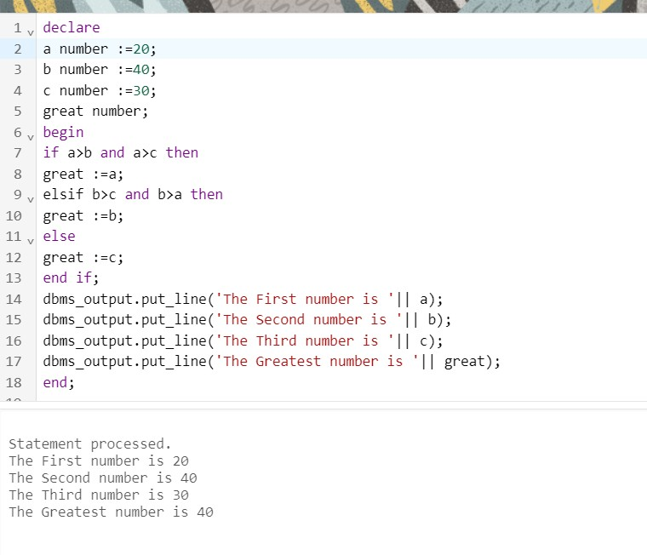

1. WAP to check whether number is odd or even.

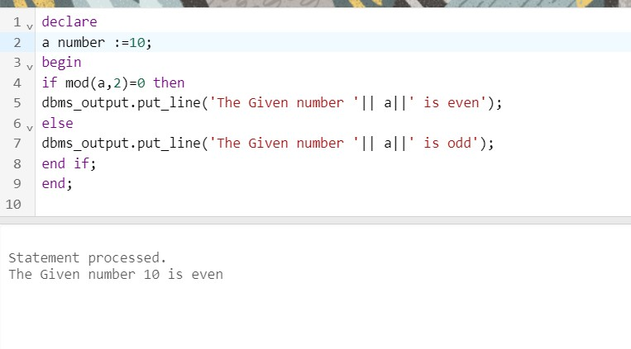

1. WAP to find the grade. Consider the following: Marks > 80 A grade

Marks >70 B grade Marks >50 C grade Marks > 40 D grade Marks < 40 E grade

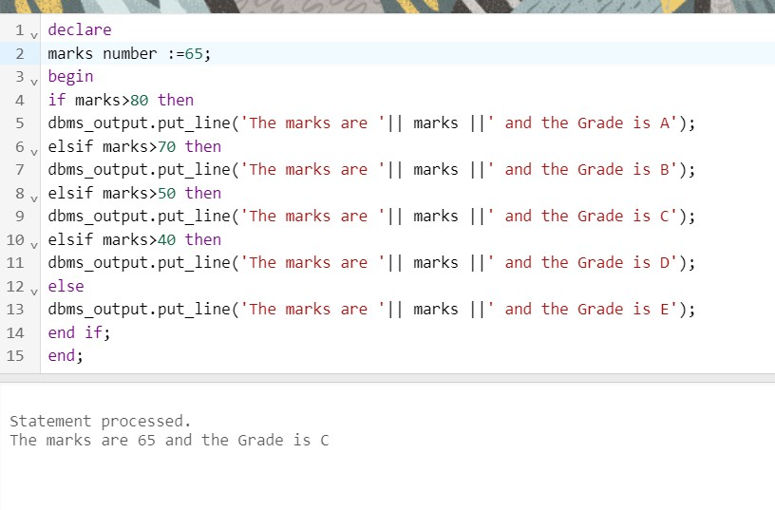

1. 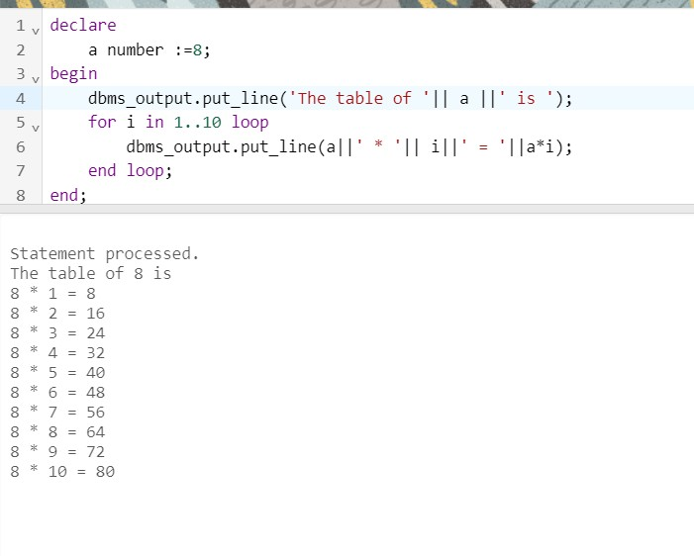WAP to print the table of a given number.(use for loop)
2. 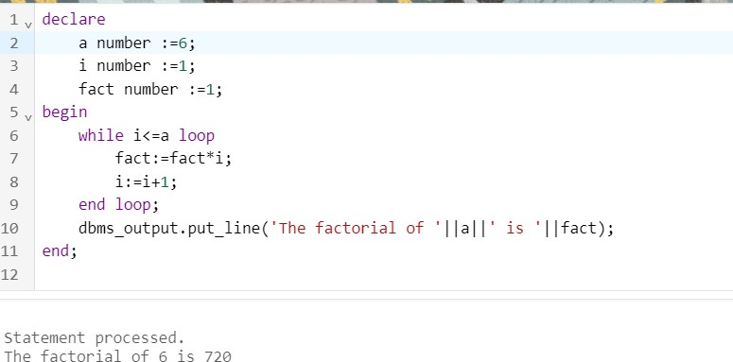WAP to find out the factorial of a given number.(use while loop)
3. WAP to find out the Fibonacci series.
4. 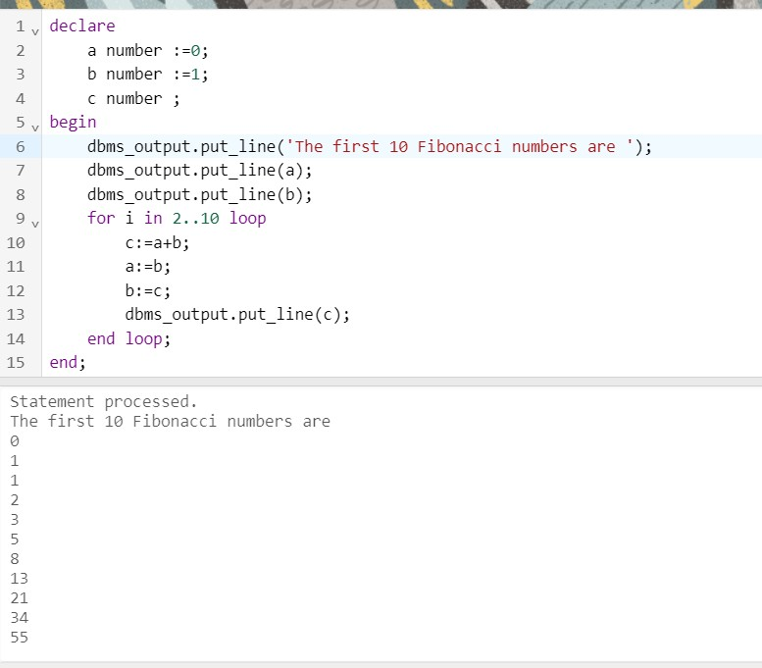
5. WAP to find the reverse of a number

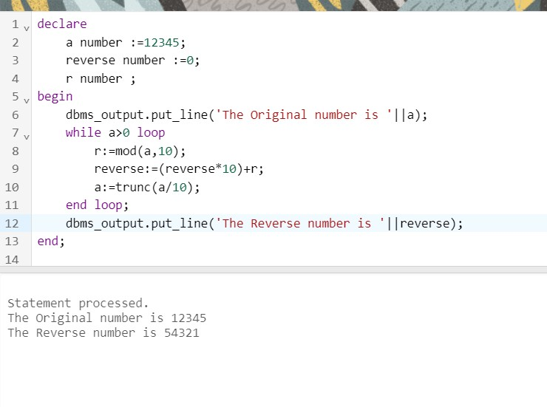

1. Write PL/SQL block that performs addition (+), subtraction (-), multiplication (\*) and division (/) of two numbers as choice by the user.

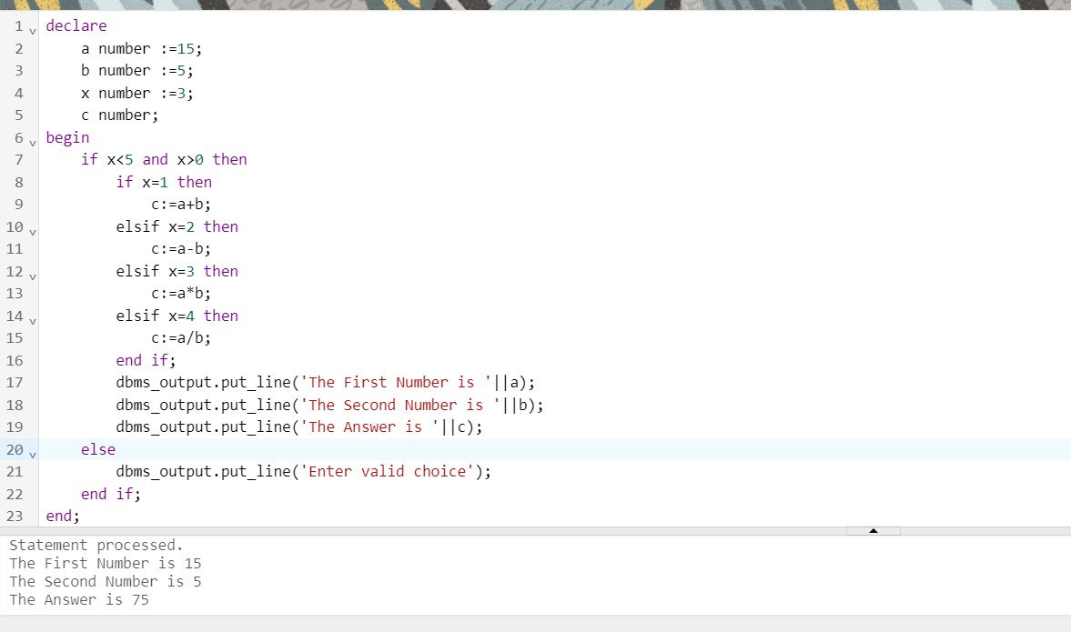

1. Write PL/SQL block to print 5, 10, 15,20 by using For Loop.

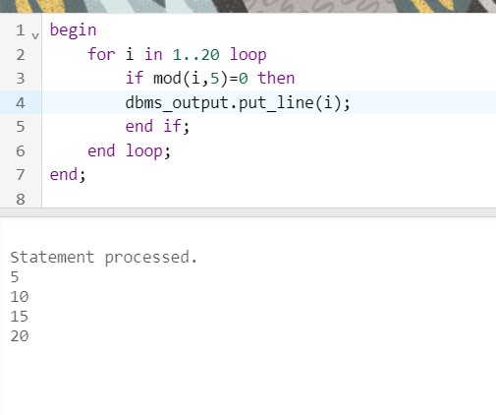

1. Write Pl/SQL block to display welcome message like good morning, good afternoon, good night depending on system time.

