UCS310: Lab Assignment 5

1. Create the following tables and insert some tuples in these tables shown below. Where *sid* is the *primary key* for the *Sailors* table, *bid* is the primary key for the *Boats* table and *sid* and *bid* are the *foreign keys* for the *Reserves* table referencing to the *Sailors* and *Boats* table, respectively.

Sailors(*sid:* integer, *sname:* string, *rating:* integer, *age:*real) Boats(*bid:* integer, *bname:* string, *color:* string) Reserves(*sid:* integer, *bid:* integer, *day:* date)

Ans:

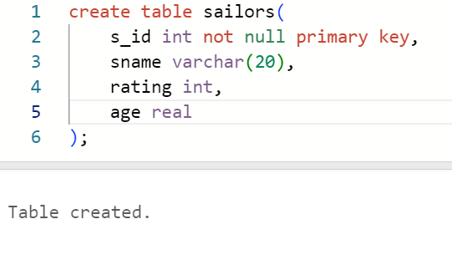

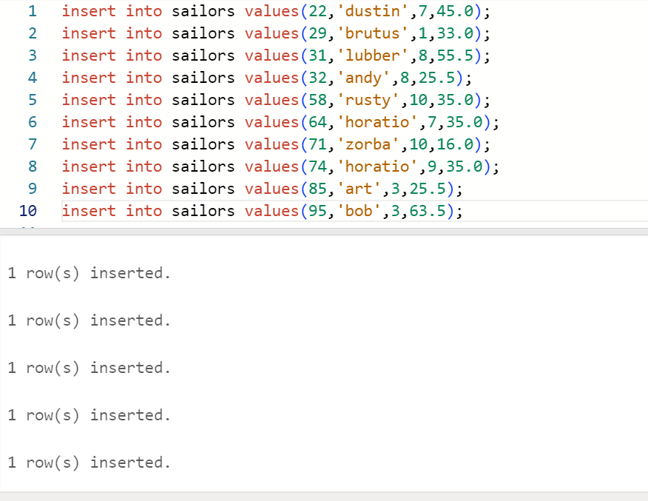

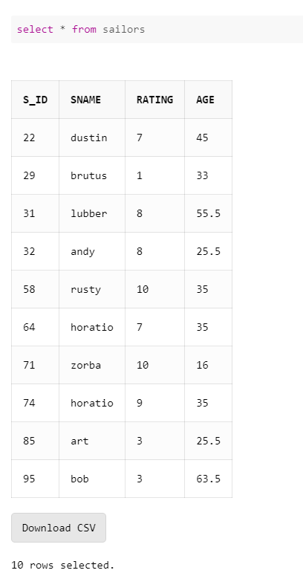

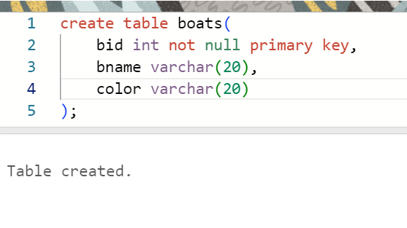

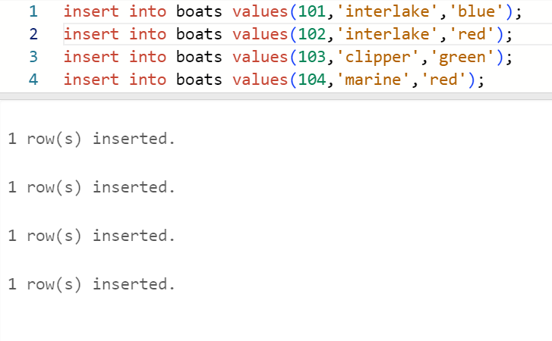

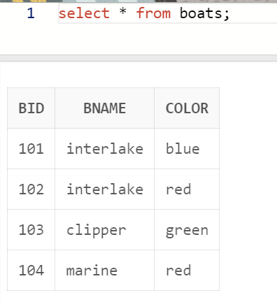

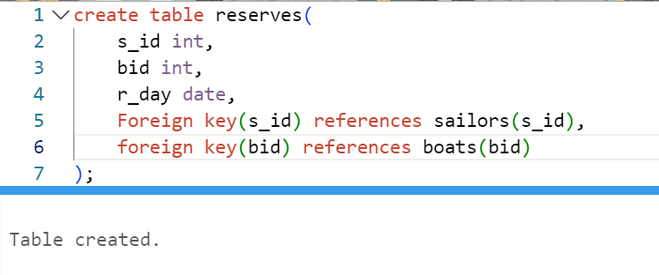

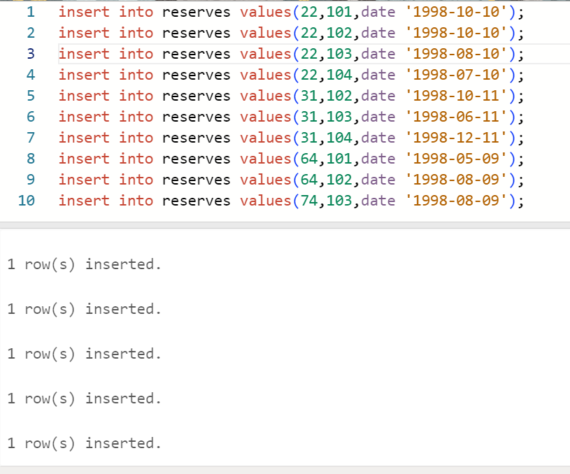

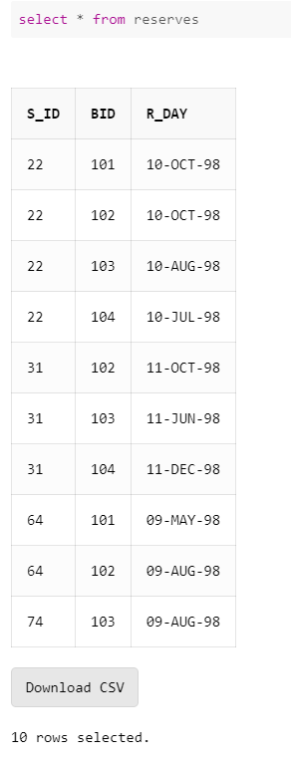

1. Write SQL command for the following:
   1. Show the names and ages of all sailors.

Ans:

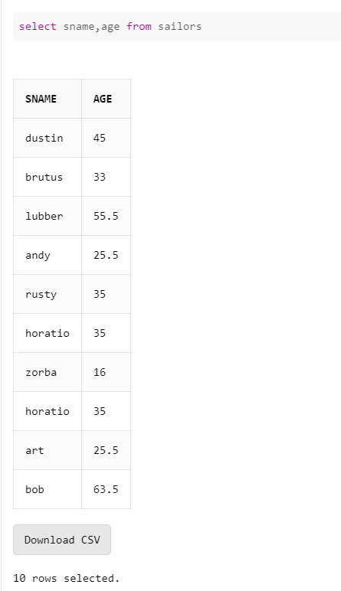

* 1. Show the details of the boats which are red and blue in color.

Ans:

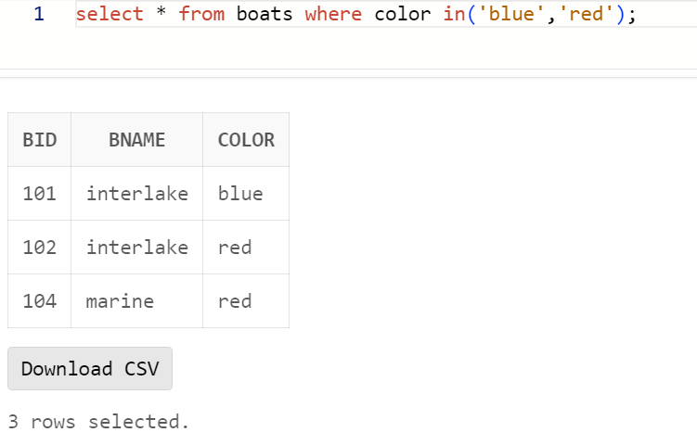

* 1. Find the oldest and youngest sailors’ age.

Ans:

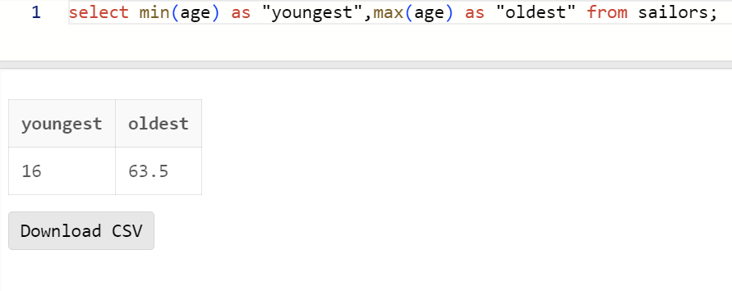

* 1. Find the ages of sailors whose name begins and ends with B and has at least three characters.

Ans:

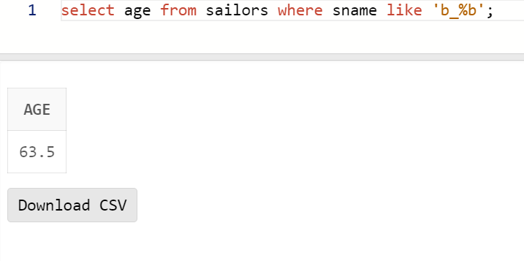

* 1. Show the average rating of the sailors.

Ans:

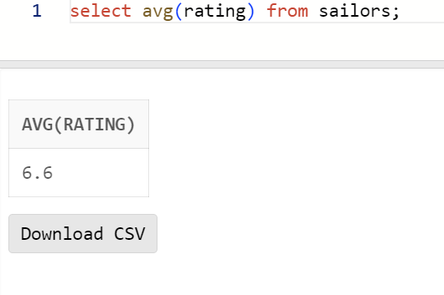

* 1. Find all sailors with a rating above 7.

Ans:

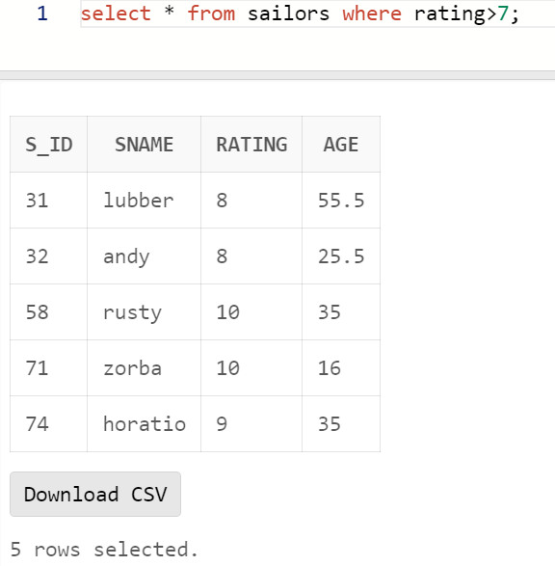

* 1. Find the number of boats reserved by the sailor named Horatio.

Ans:

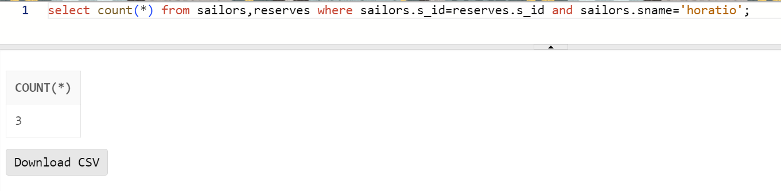

* 1. Find the colors of boats reserved by Lubber.

Ans:

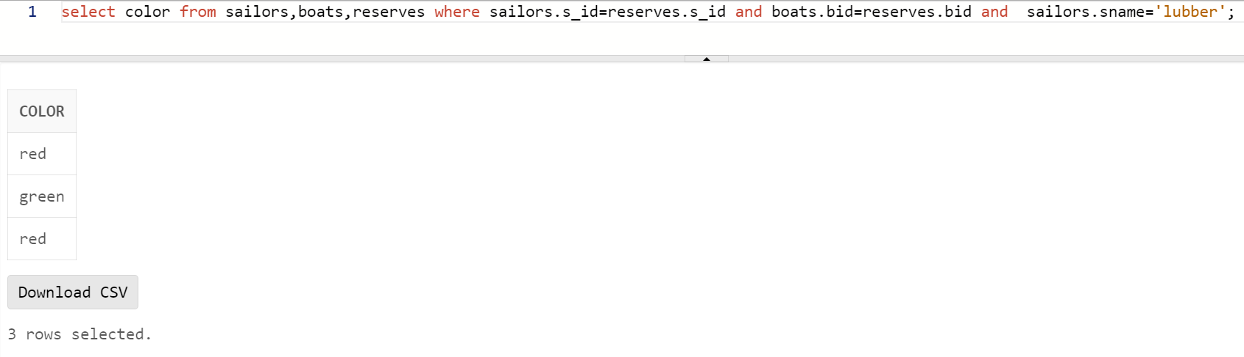

* 1. Show the details of the sailors who have reserved the boat with bid 102.

Ans:

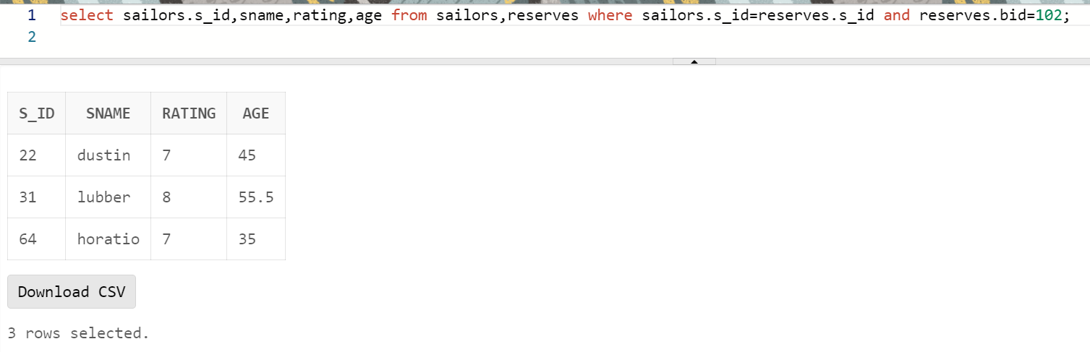

* 1. Find the sid of sailors who have reserved green boats.

Ans:

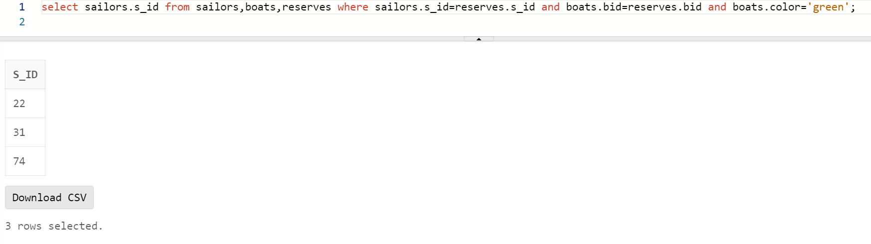

* 1. Find the names of sailors who have reserved boat number 103.

Ans:

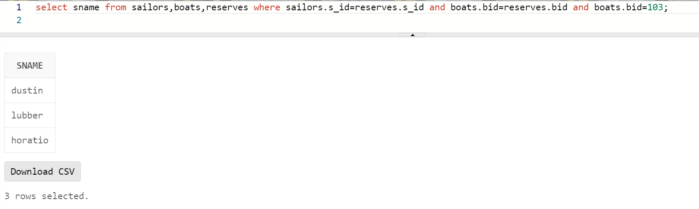

* 1. Find the sids and names of sailors who have reserved a red boat.

Ans:

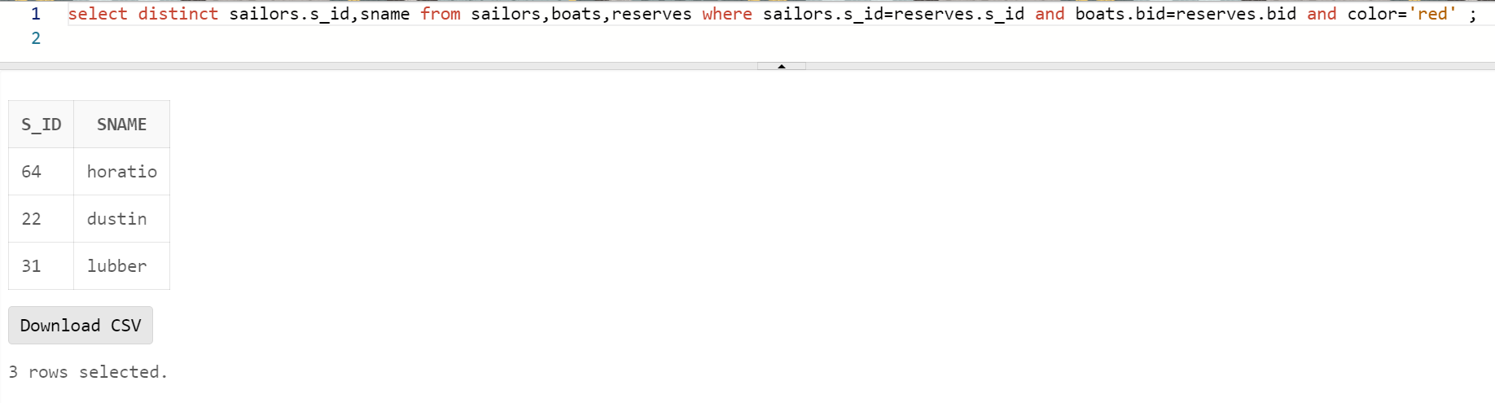

* 1. Find the names of the sailors who have reserved a green or a blue boat.

Ans:

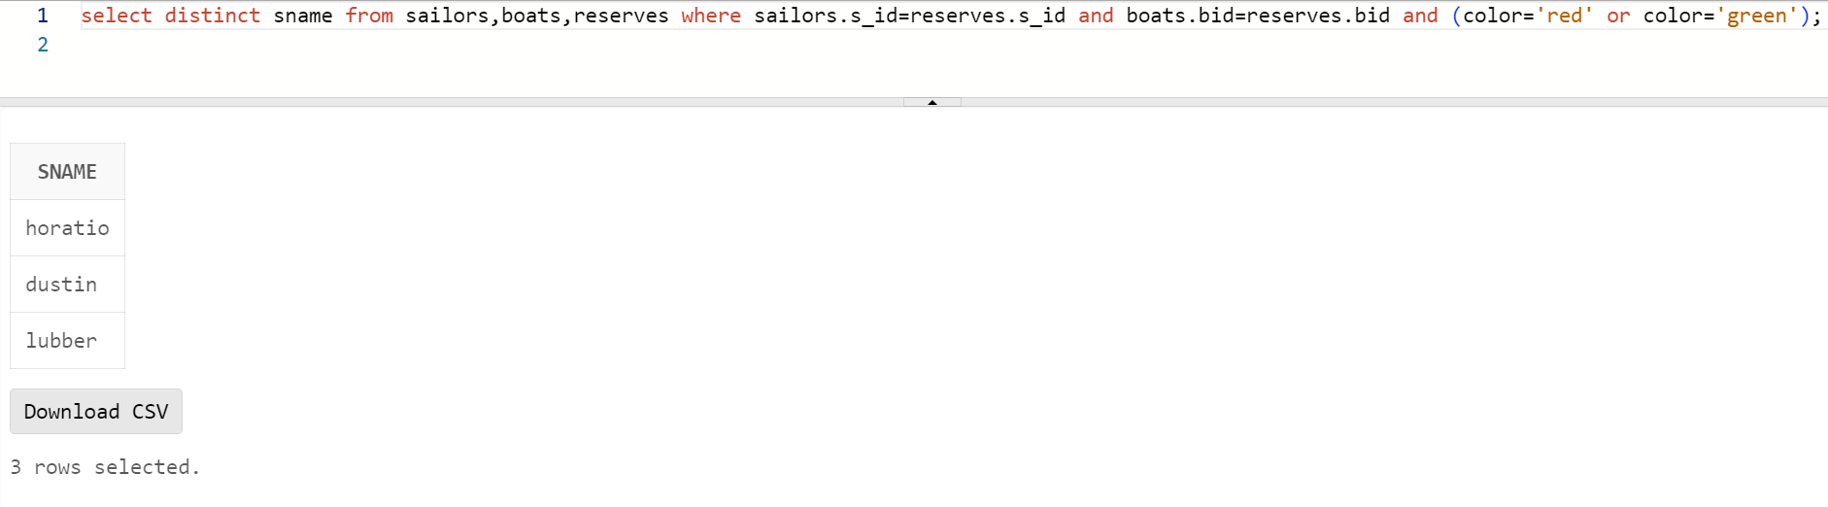

* 1. Find the names of sailors who have reserved both a red and a green boat.

Ans:

* 1. Find the names of sailors who have reserved at least one boat.

Ans:

