UCS310: Lab Assignment 1

Q1: Create table Student (Rno, Name, DOB, Gender, Class, College, City, Marks)

Ans:

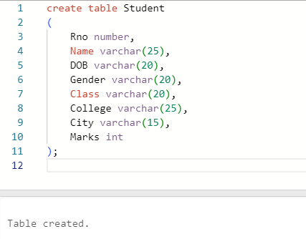

Q2: Insert 5 records in student table Ans:

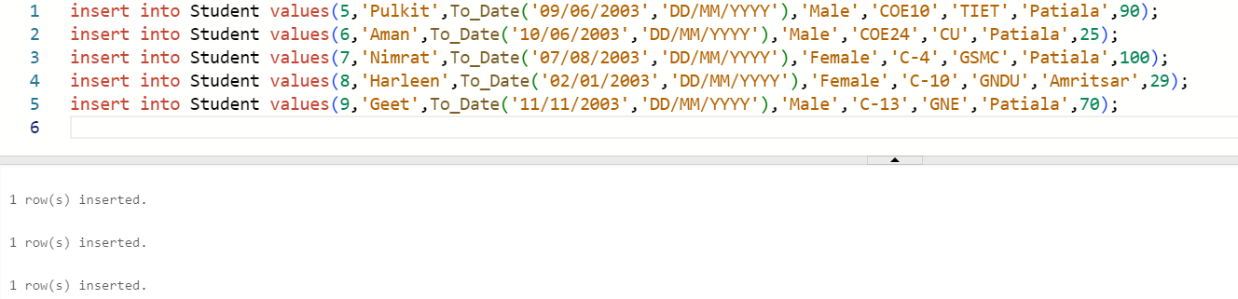

Q3: Display the information of all the students Ans:

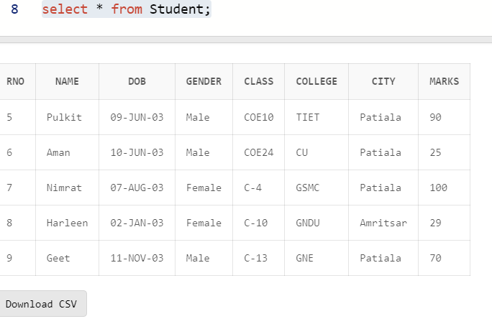

Q4: Display the detail structure of student table Ans:

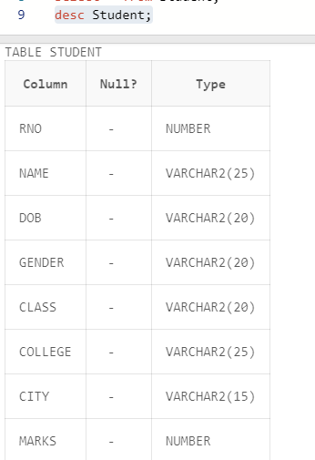

Q5: Display Rno, Name and Class information of ‘Patiala’ students.

Ans:

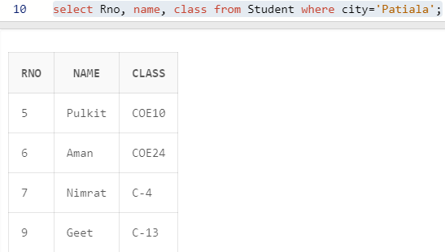

Q6: Display information on ascending order of marks Ans:

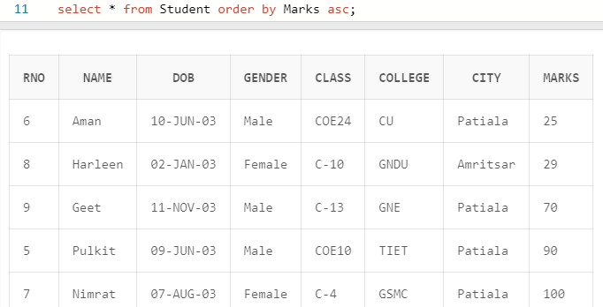

Q7: Change the marks of Rno 5 to 89. Ans:

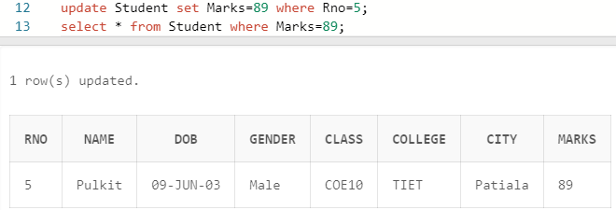

Q8: Change the name and city of Rno 9. Ans**:**

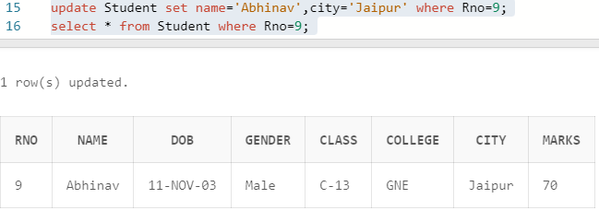

Q9: Delete the information of ‘Amritsar’ city records Ans:

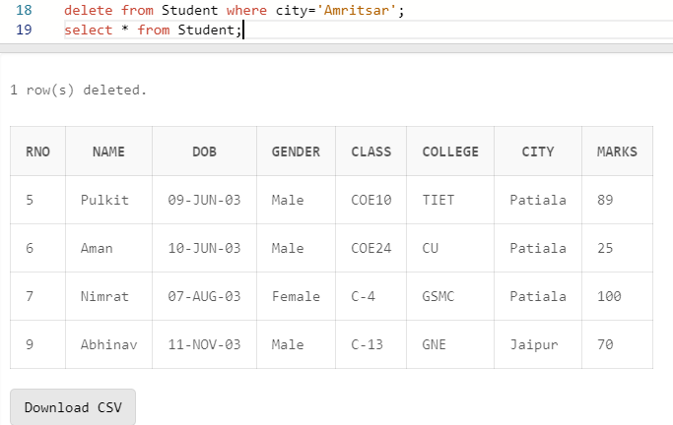

Q10: Delete the records of student where marks<30. Ans:

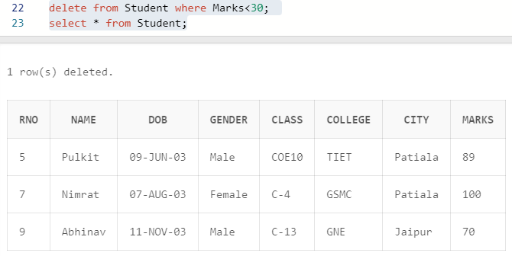

UCS310: Lab Assignment 2

Based on Emp table

Columns are EmpNo, Ename, Job, Salary, Commission, DeptNO.

Insert 5 records by stroring Null value in some records for commission column

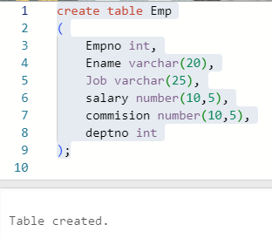

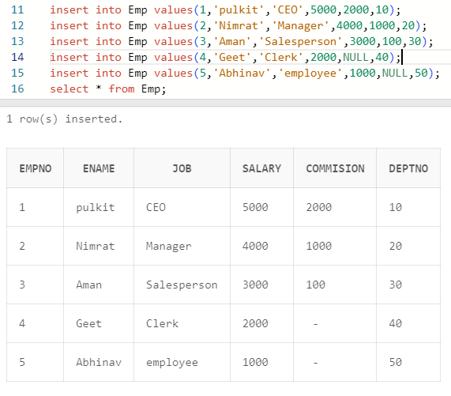

Q1: Get employee no and employee name who works in dept no 10 ?

Ans:

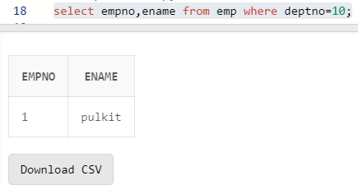

Q2: Display the employee names of those clerks whose salary> 2000 ?

Ans:

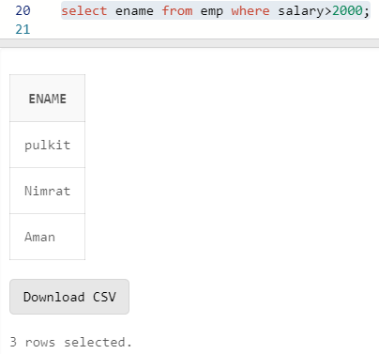

Q3 Display name and job of Salesperson & Clerks ?

Ans:

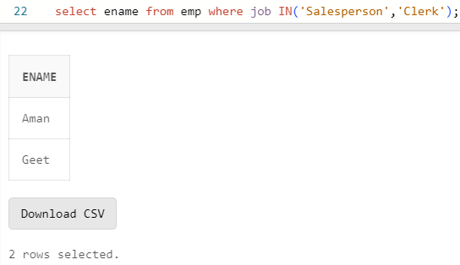

Q4: Display all details of employees whose salary between

2000 and 3000 ?

Ans:

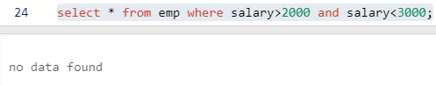

Q5: Display all details of employees whose dept no is 10,

20, or 30 ?

Ans:

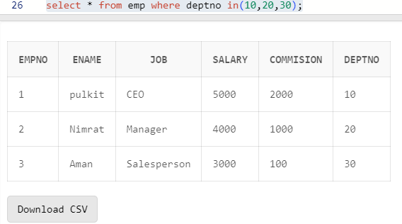

Q6) Display name of those employees whose commission is

NULL ?

Ans:

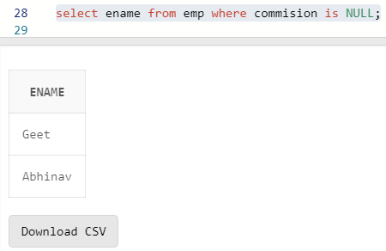

Q7) Display dept no & salary in ascending order of dept no

and with in each dept no salary should be in descending

order ?

Ans:

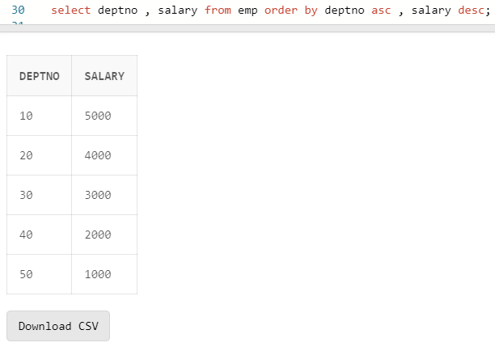

Q8) Display name of employees having two ‘a’ or ‘A’ chars

in the name ?

Ans:

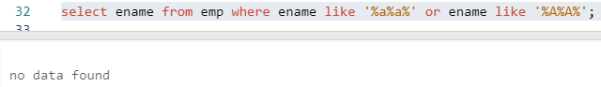

Q9) Display the name of the employees whose second char is

‘b’ or ‘B’ ?

Ans:

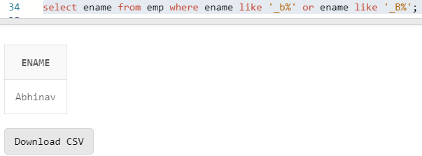

Q10) Display the name of the employees whose first or last

char is ‘a’ or ‘A’ ?

Ans:

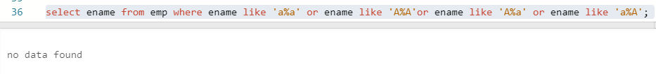

Q11) Display maximum, minimum, average salary of deptno 10

employees.

Ans:

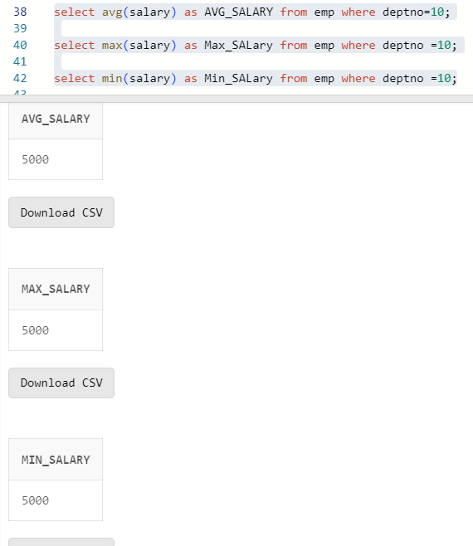

Q12) Display total number of employees working in deptno 20

Ans:

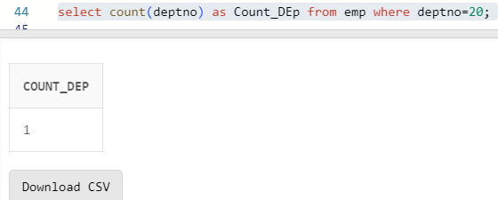

Q13) Display total salary paid to clerks

Ans:

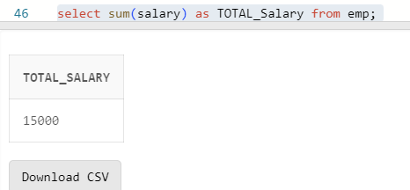

Q14) Display system date

Ans:

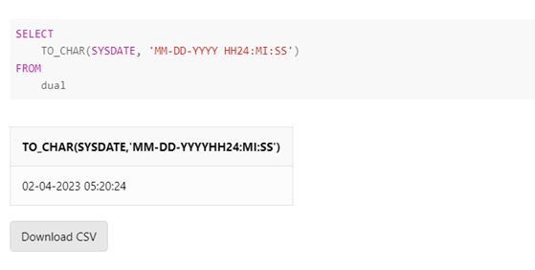

Q15) Display the result of (12*12)/13

Ans:

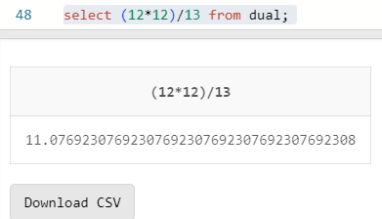

**Lab Assignment–3**

Q1) Use the following functions

1. chr (n):

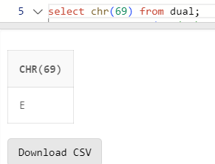

1. cancat(char1,char2):

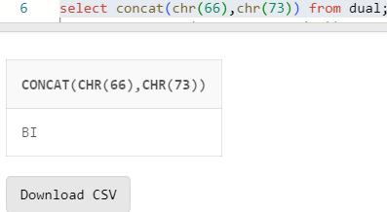

1. instr(string,char):

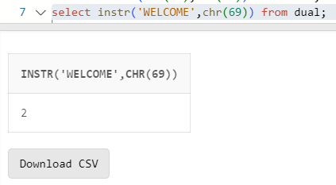

1. length(n):

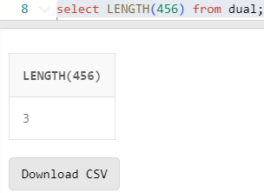

1. lpad(char1 ,n [,char2]):

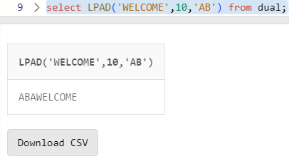

1. ltrim(string [,char(s)]):

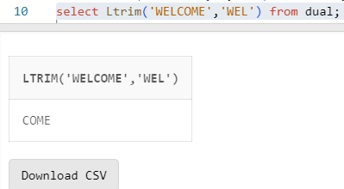

1. rpad(char1 ,n [,char2]):

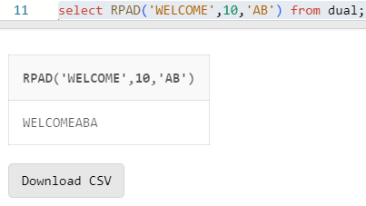

1. rtrim(string [,char(s)]):

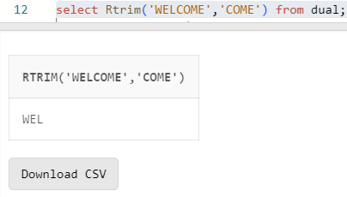

9. replace(char ,search_string , replacement_string):

10. substr(string ,position ,substring length):

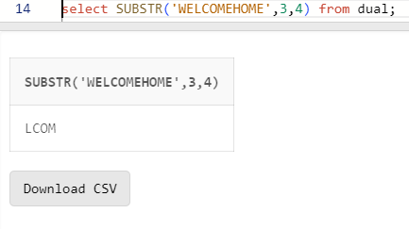

11. initcap(char):

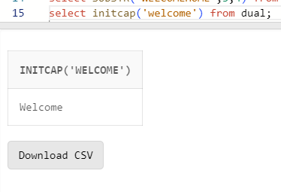

12. lower(string):

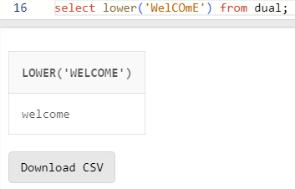

13. upper(string):

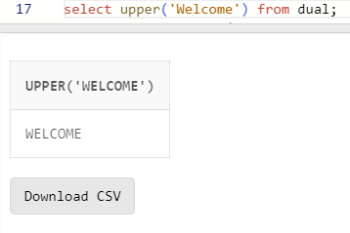

14. translate(char ,from string ,to string):

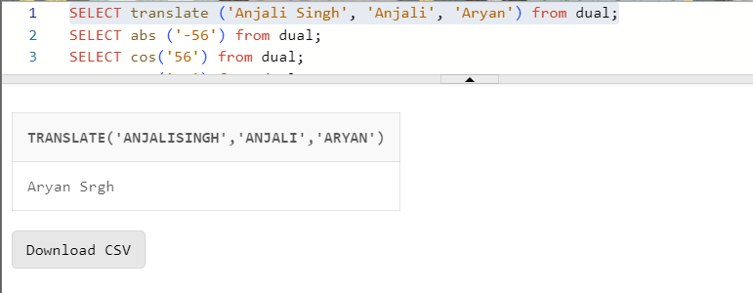

15. abs(n):

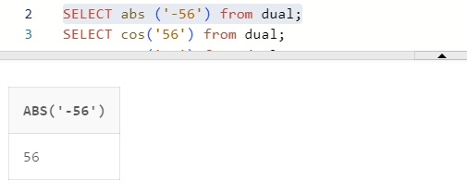

16. ceil(n):

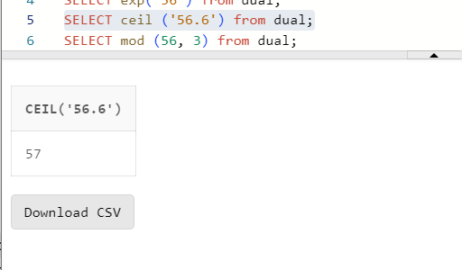

17. cos(n):

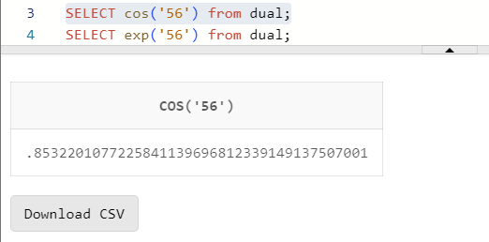

18. exp(n):

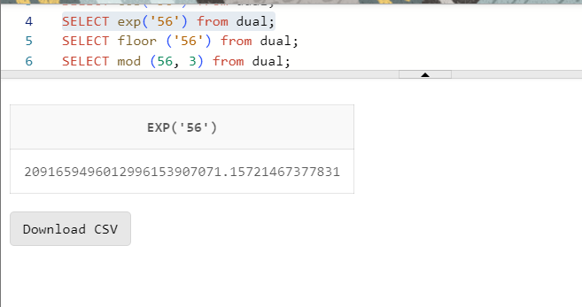

19. floor(n):

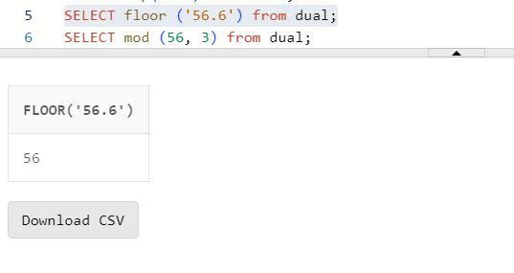

20. mod(m ,n):

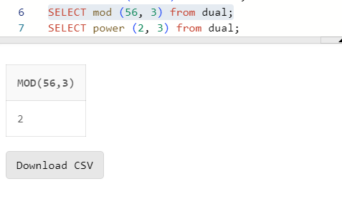

21. power(x ,y):

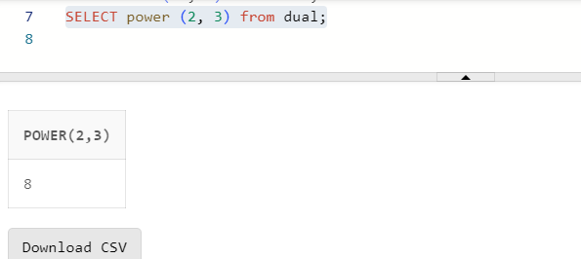

22. round(x [,y]):

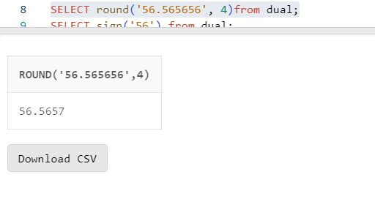

23. sign(n):

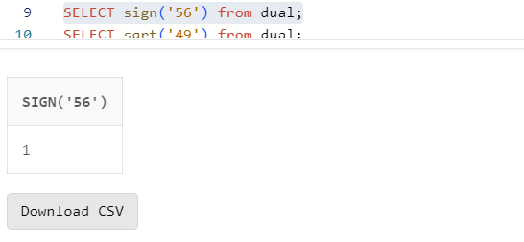

3

24. sqrt(n);

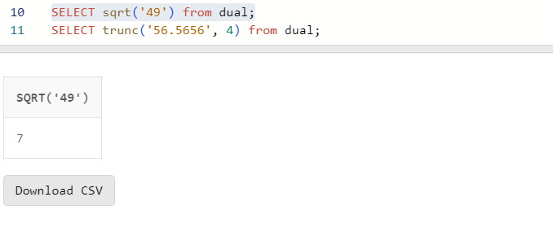

25. trunc(x ,n):

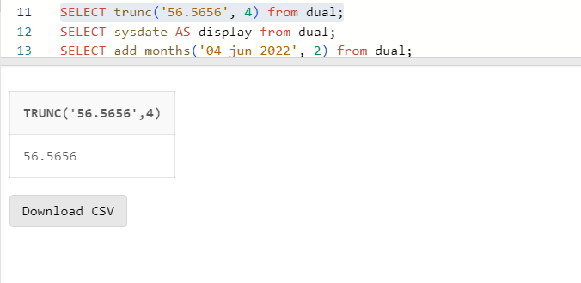

26. sysdate:

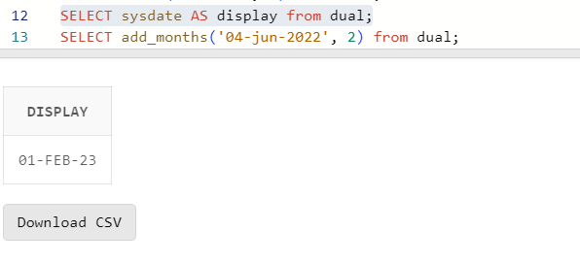

27. add_months(d ,n):

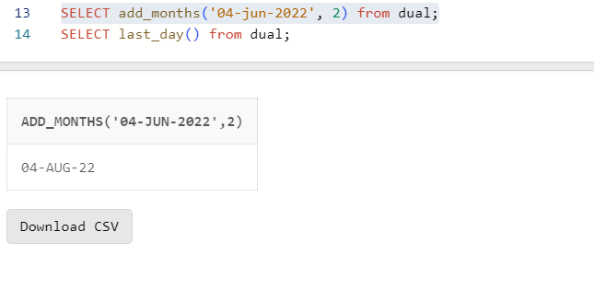

28. last_day():

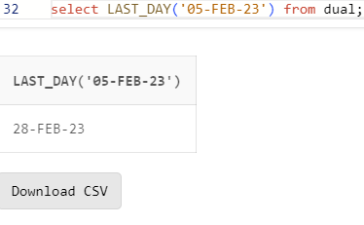

29. months_between(date1 ,date2):

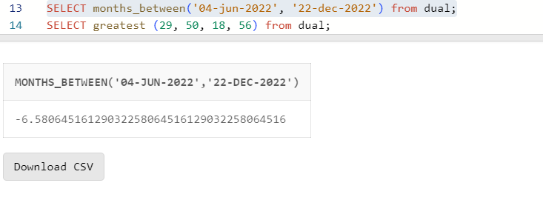

30. next_day(date ,char):

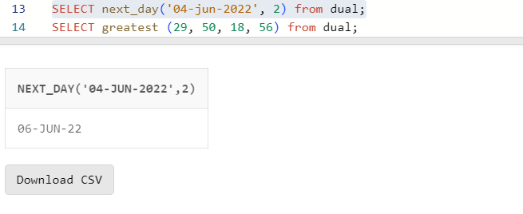

31. greatest(expr):

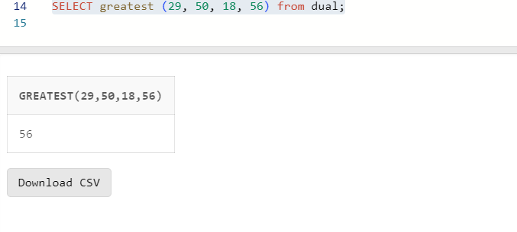

32. least(expr):

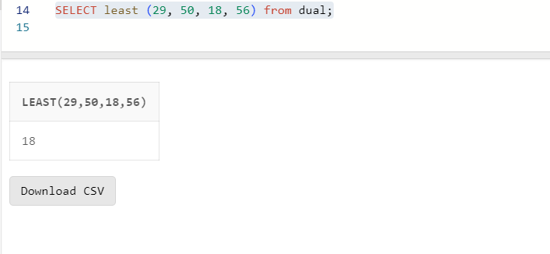

Q2) Display current time in hour : min : sec format

Q3) Display salary + commission of emp table

Q4) Store any date value in hiredate column of table ?

Q5) Display name of employee(s) who join the company in

1985 ?

Q6) Display name of the employee(s) who join the company

this year ?

UCS310: Lab Assignment 5

1. Create the following tables and insert some tuples in these tables shown below. Where *sid* is the *primary key* for the *Sailors* table, *bid* is the primary key for the *Boats* table and *sid* and *bid* are the *foreign keys* for the *Reserves* table referencing to the *Sailors* and *Boats* table, respectively.

Sailors(*sid:* integer, *sname:* string, *rating:* integer, *age:*real) Boats(*bid:* integer, *bname:* string, *color:* string) Reserves(*sid:* integer, *bid:* integer, *day:* date)

Ans:

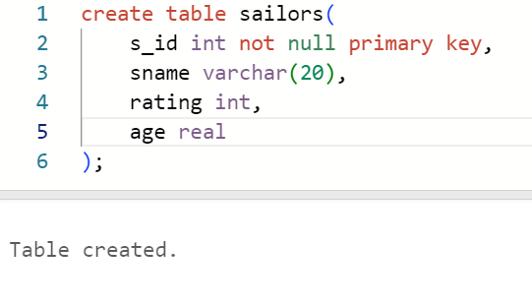

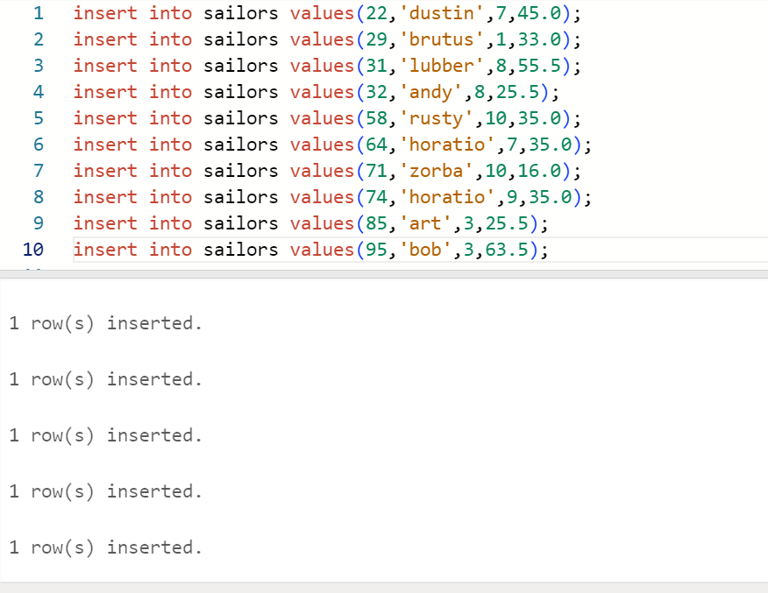

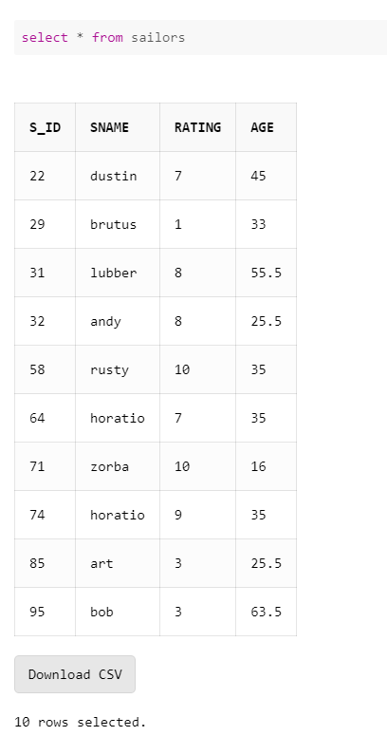

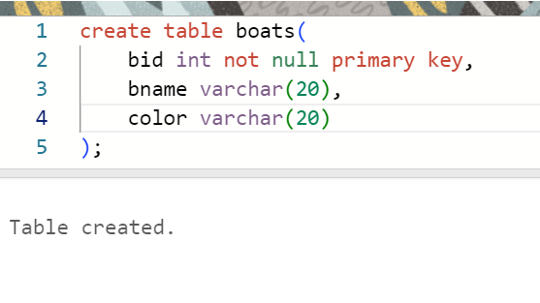

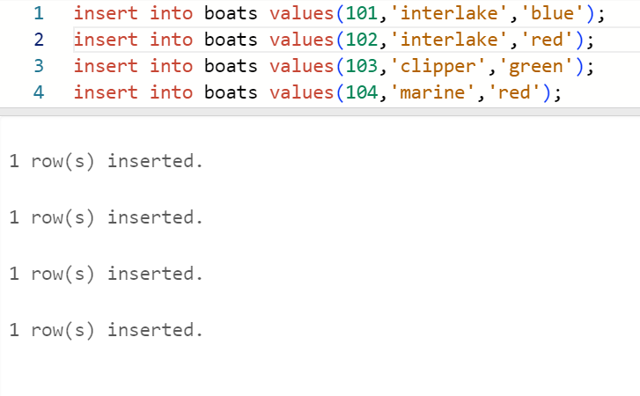

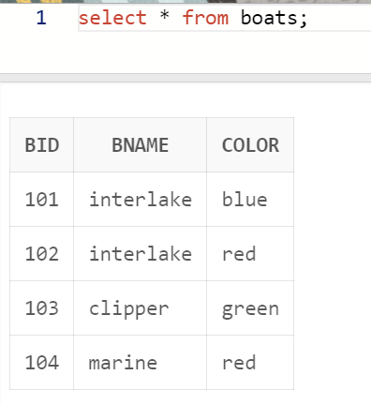

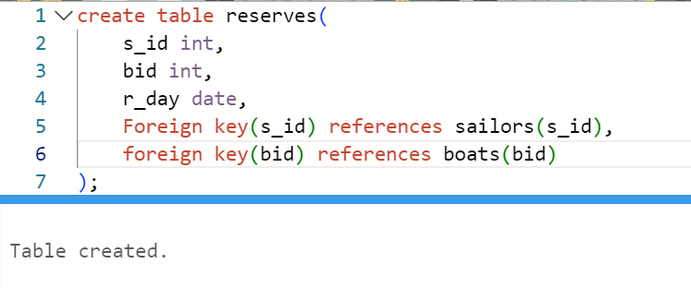

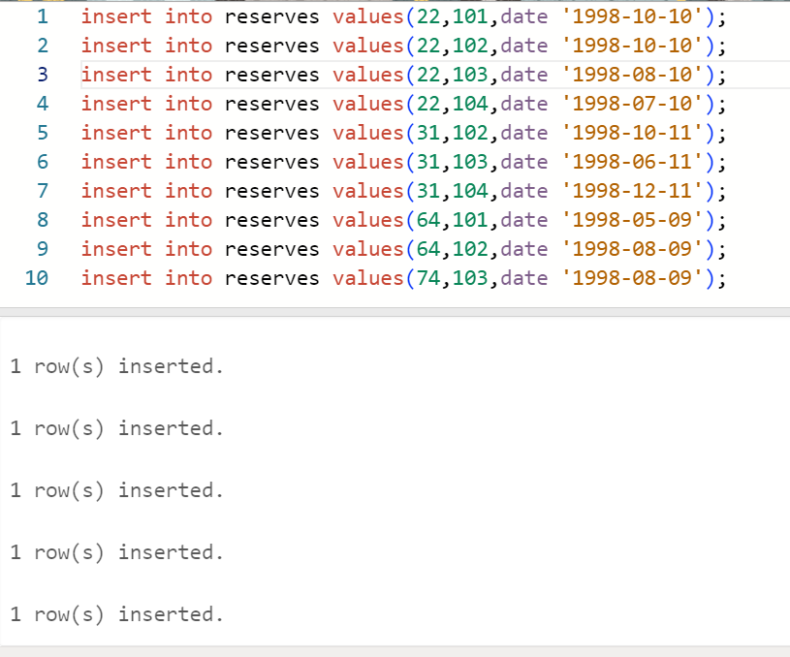

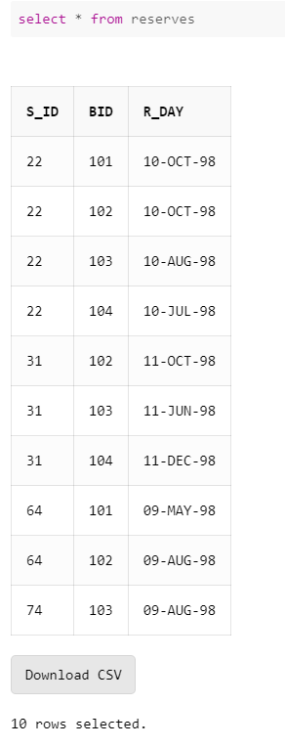

1. Write SQL command for the following:
   1. Show the names and ages of all sailors.

Ans:

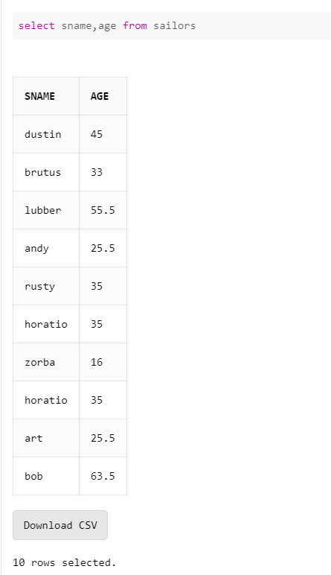

* 1. Show the details of the boats which are red and blue in color.

Ans:

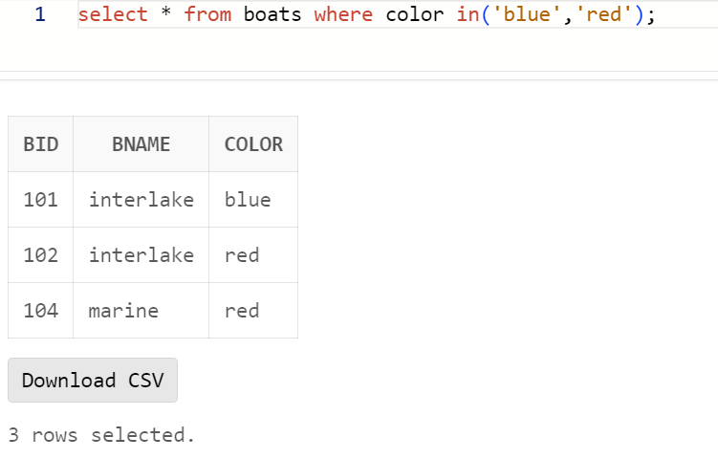

* 1. Find the oldest and youngest sailors’ age.

Ans:

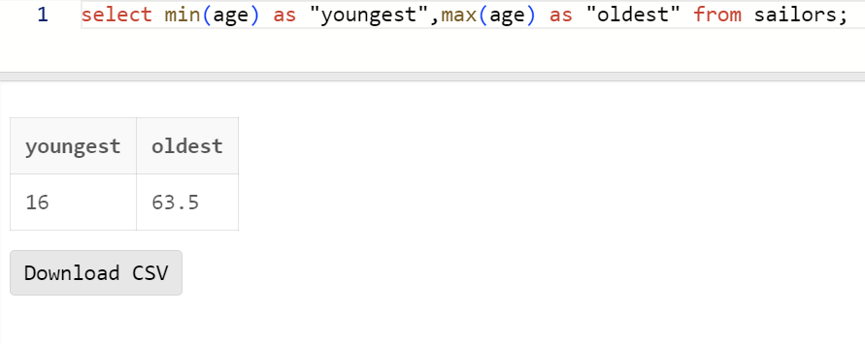

* 1. Find the ages of sailors whose name begins and ends with B and has at least three characters.

Ans:

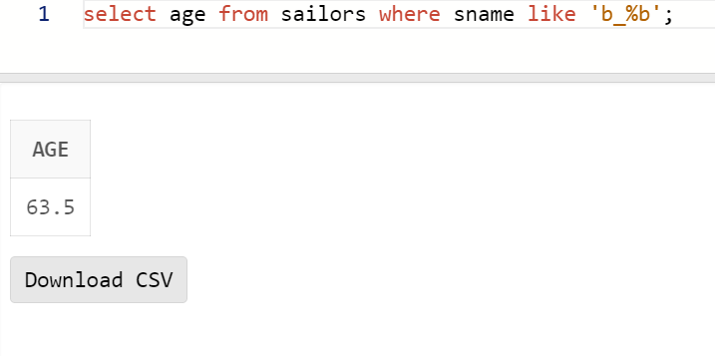

* 1. Show the average rating of the sailors.

Ans:

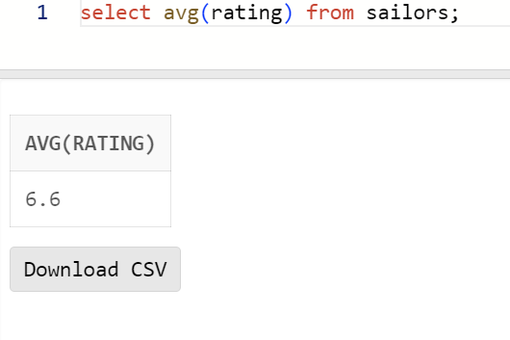

* 1. Find all sailors with a rating above 7.

Ans:

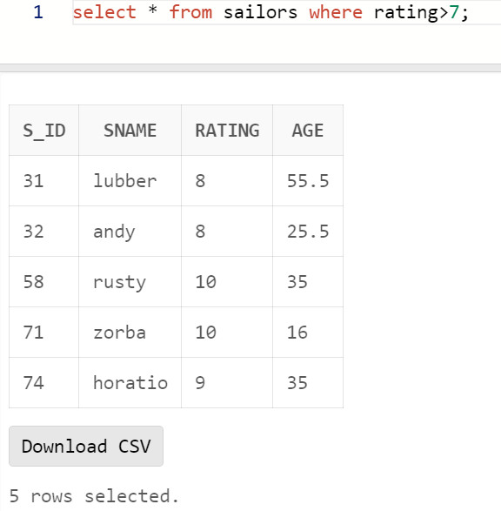

* 1. Find the number of boats reserved by the sailor named Horatio.

Ans:

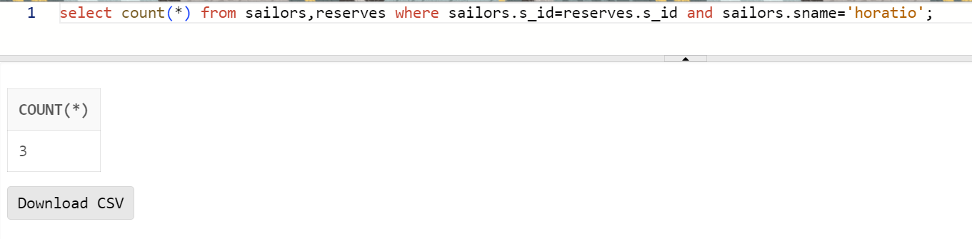

* 1. Find the colors of boats reserved by Lubber.

Ans:

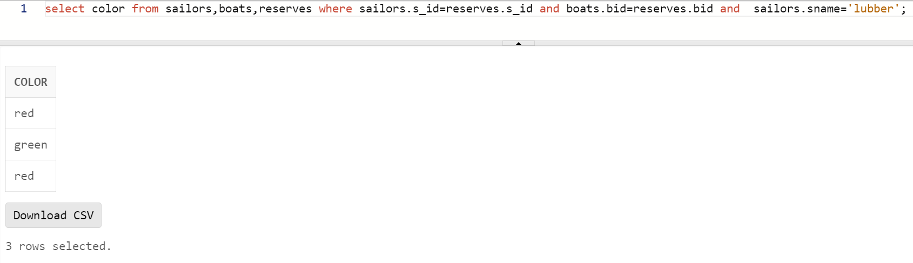

* 1. Show the details of the sailors who have reserved the boat with bid 102.

Ans:

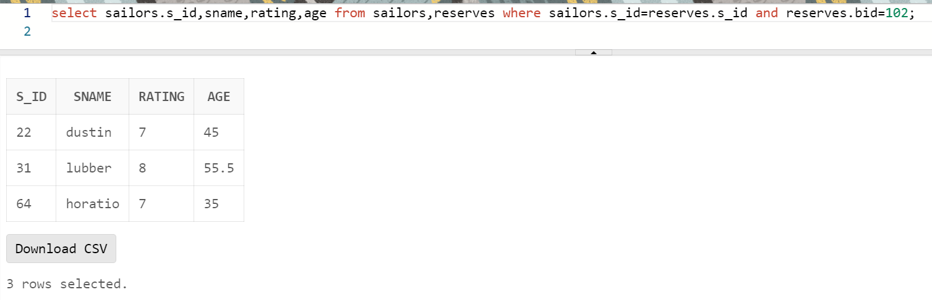

* 1. Find the sid of sailors who have reserved green boats.

Ans:

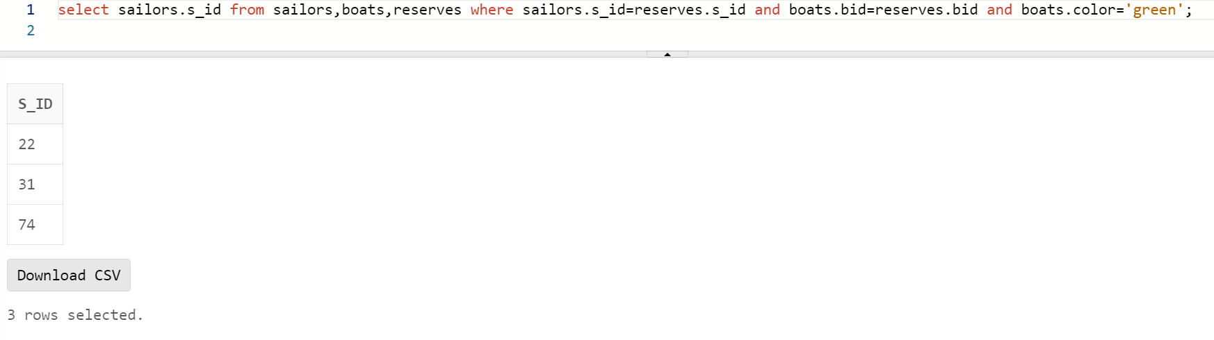

* 1. Find the names of sailors who have reserved boat number 103.

Ans:

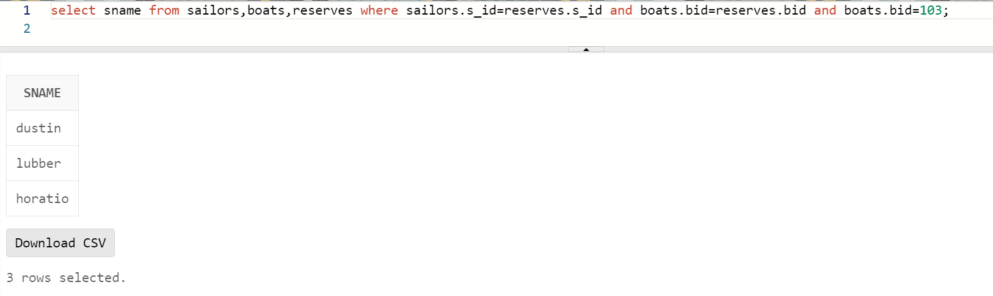

* 1. Find the sids and names of sailors who have reserved a red boat.

Ans:

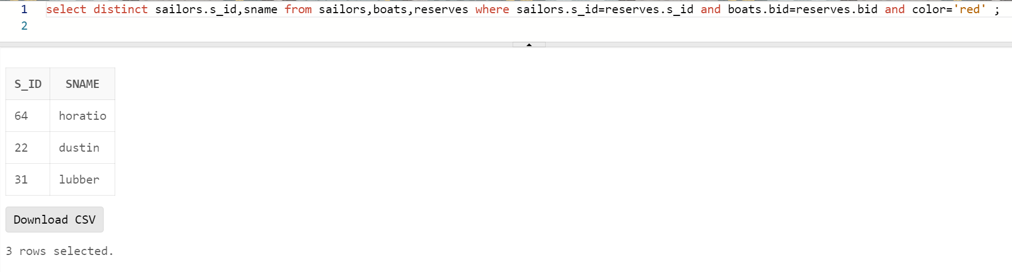

* 1. Find the names of the sailors who have reserved a green or a blue boat.

Ans:

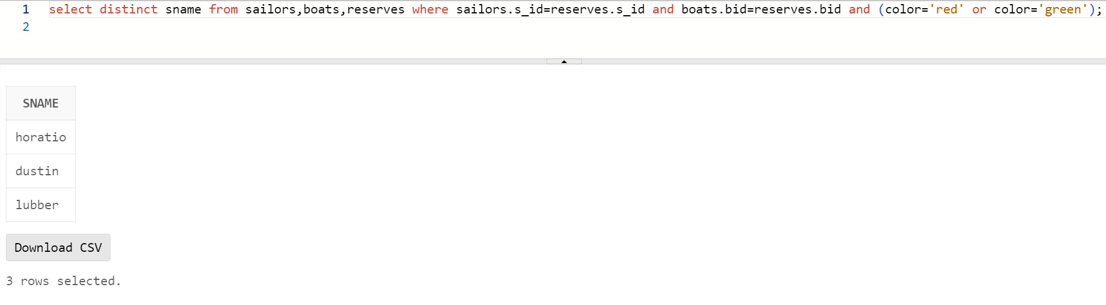

* 1. Find the names of sailors who have reserved both a red and a green boat.

Ans:

* 1. Find the names of sailors who have reserved at least one boat.

Ans:

