UCS310: Lab Assignment 1

Q1: Create table Student (Rno, Name, DOB, Gender, Class, College, City, Marks)

Ans:

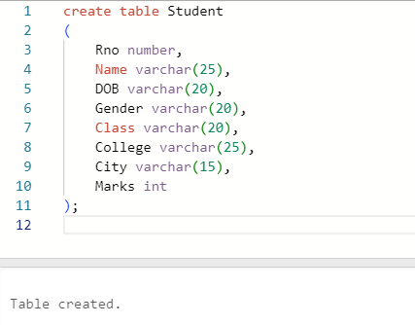

Q2: Insert 5 records in student table Ans:

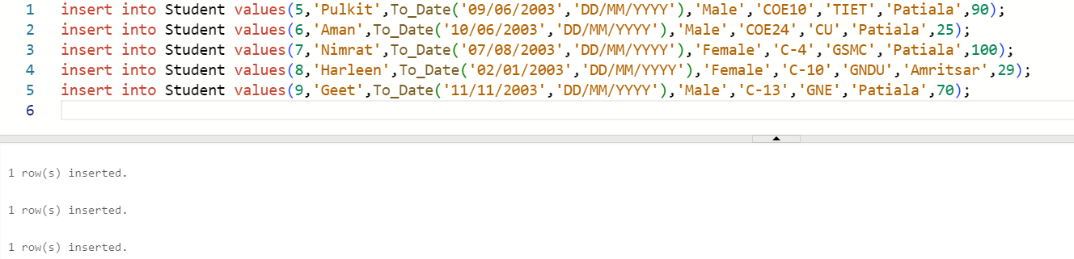

Q3: Display the information of all the students Ans:

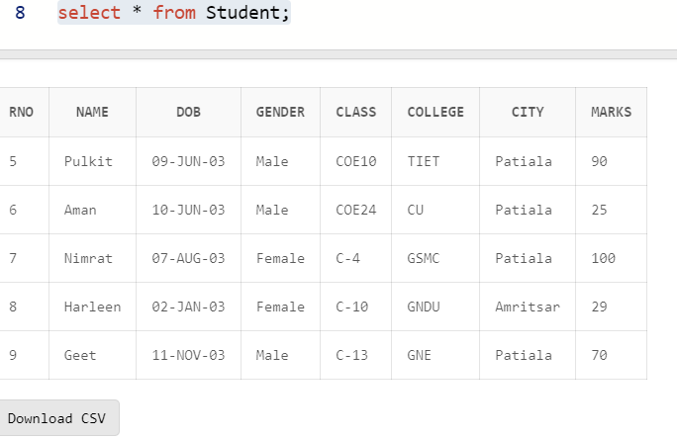

Q4: Display the detail structure of student table Ans:

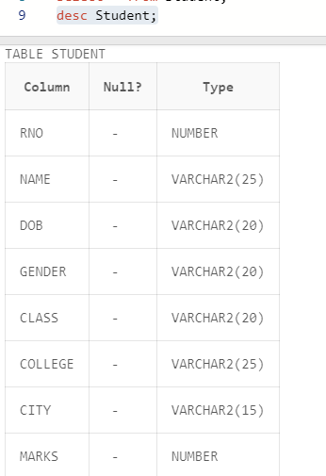

Q5: Display Rno, Name and Class information of ‘Patiala’ students.

Ans:

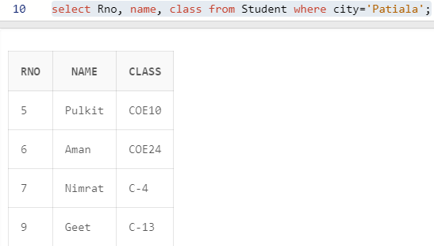

Q6: Display information on ascending order of marks Ans:

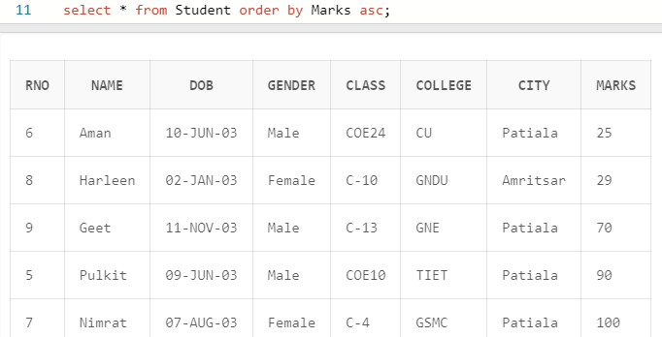

Q7: Change the marks of Rno 5 to 89. Ans:

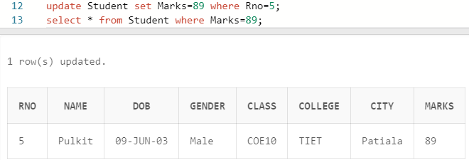

Q8: Change the name and city of Rno 9. Ans**:**

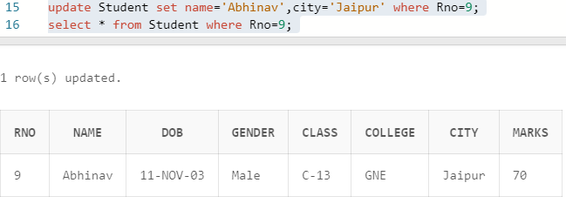

Q9: Delete the information of ‘Amritsar’ city records Ans:

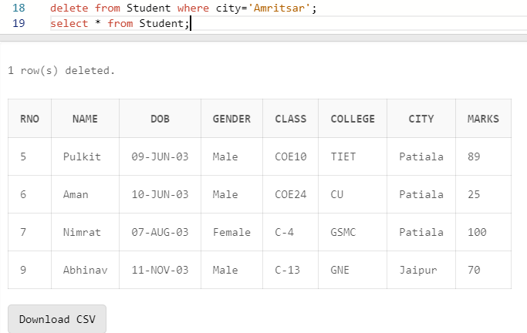

Q10: Delete the records of student where marks<30. Ans:

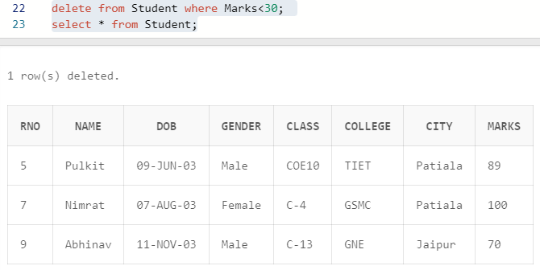

UCS310: Lab Assignment 2

Based on Emp table

Columns are EmpNo, Ename, Job, Salary, Commission, DeptNO.

Insert 5 records by stroring Null value in some records for commission column

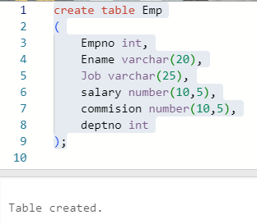

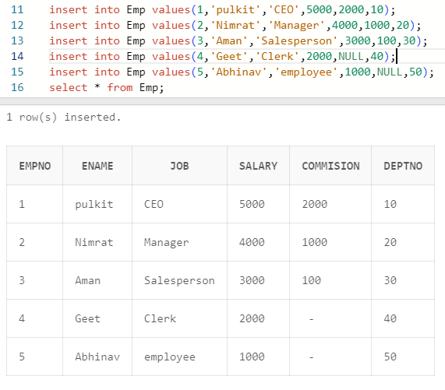

Q1: Get employee no and employee name who works in dept no 10 ?

Ans:

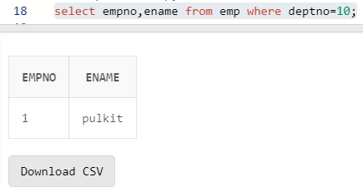

Q2: Display the employee names of those clerks whose salary> 2000 ?

Ans:

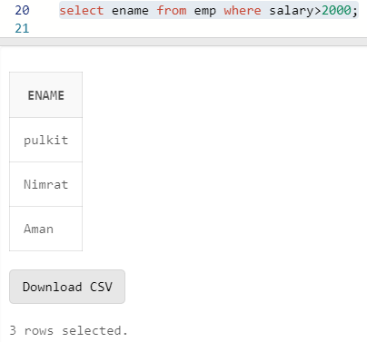

Q3 Display name and job of Salesperson & Clerks ?

Ans:

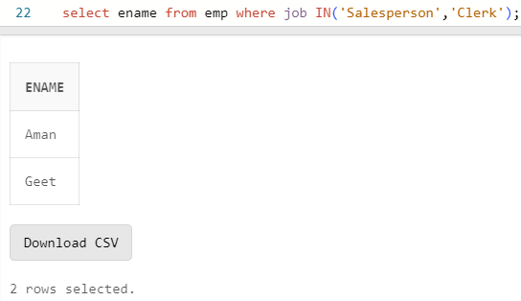

Q4: Display all details of employees whose salary between

2000 and 3000 ?

Ans:

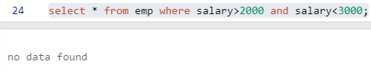

Q5: Display all details of employees whose dept no is 10,

20, or 30 ?

Ans:

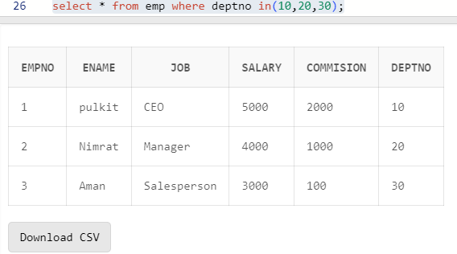

Q6) Display name of those employees whose commission is

NULL ?

Ans:

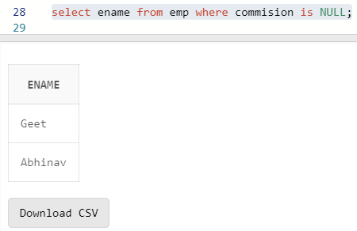

Q7) Display dept no & salary in ascending order of dept no

and with in each dept no salary should be in descending

order ?

Ans:

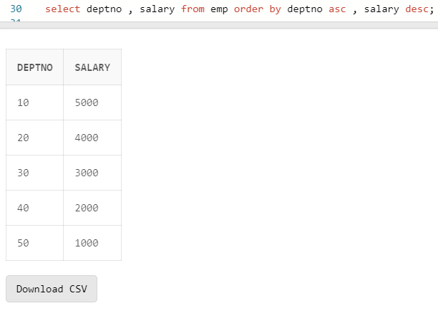

Q8) Display name of employees having two ‘a’ or ‘A’ chars

in the name ?

Ans:

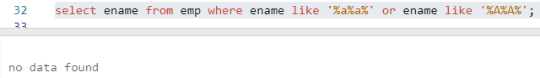

Q9) Display the name of the employees whose second char is

‘b’ or ‘B’ ?

Ans:

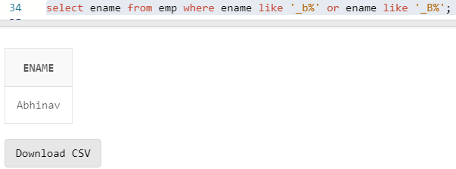

Q10) Display the name of the employees whose first or last

char is ‘a’ or ‘A’ ?

Ans:

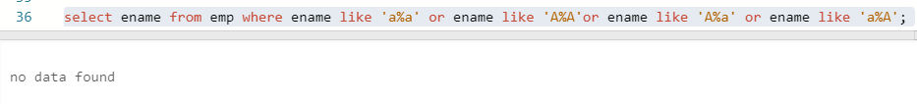

Q11) Display maximum, minimum, average salary of deptno 10

employees.

Ans:

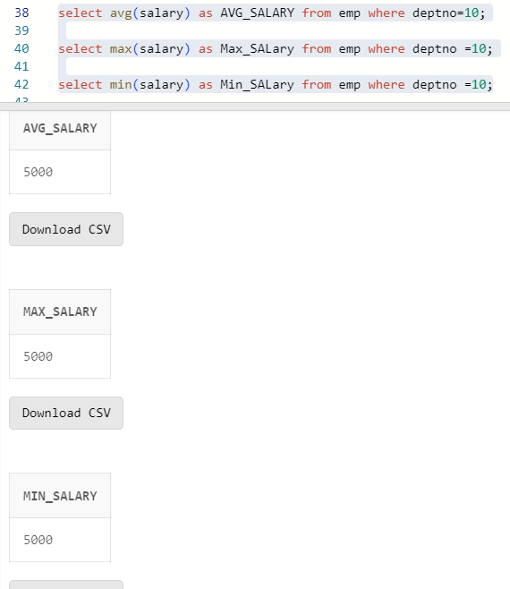

Q12) Display total number of employees working in deptno 20

Ans:

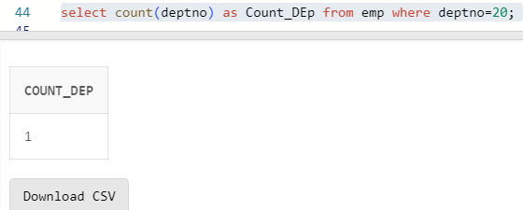

Q13) Display total salary paid to clerks

Ans:

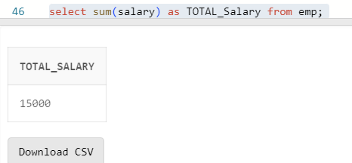

Q14) Display system date

Ans:

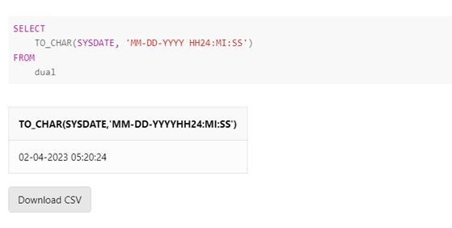

Q15) Display the result of (12*12)/13

Ans:

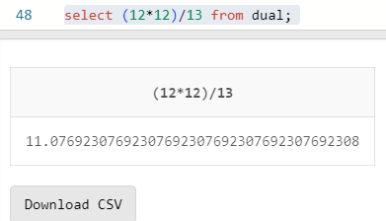

**Lab Assignment–3**

Q1) Use the following functions

1. chr (n):

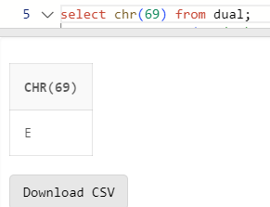

1. cancat(char1,char2):

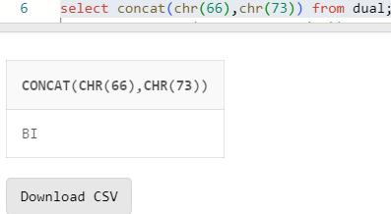

1. instr(string,char):

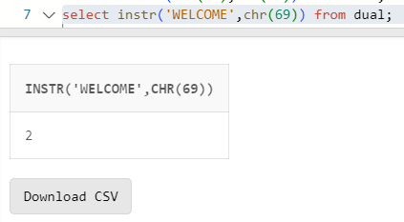

1. length(n):

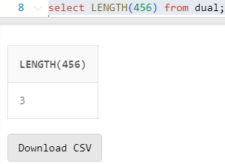

1. lpad(char1 ,n [,char2]):

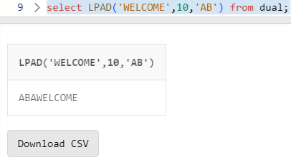

1. ltrim(string [,char(s)]):

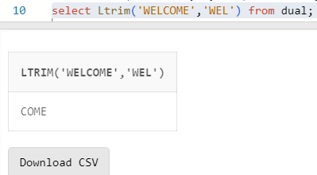

1. rpad(char1 ,n [,char2]):

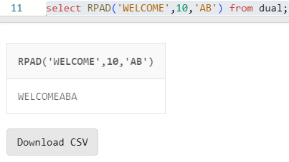

1. rtrim(string [,char(s)]):

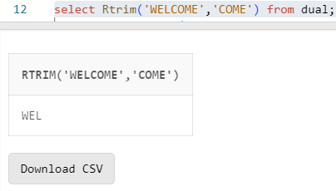

9. replace(char ,search_string , replacement_string):

10. substr(string ,position ,substring length):

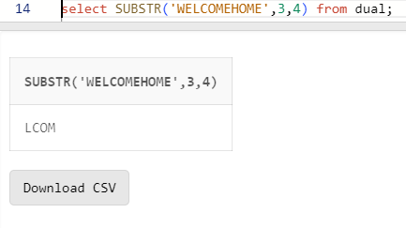

11. initcap(char):

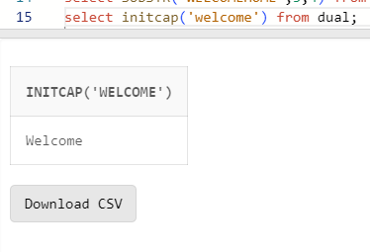

12. lower(string):

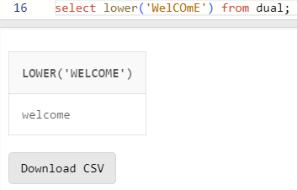

13. upper(string):

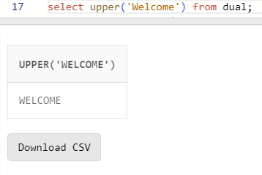

14. translate(char ,from string ,to string):

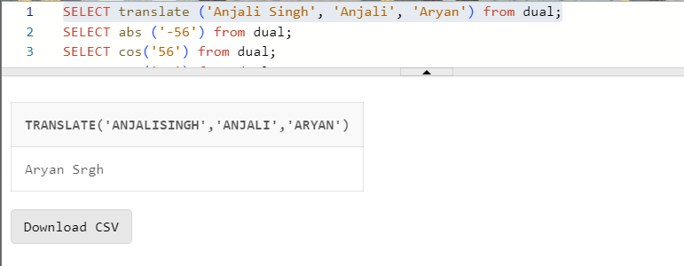

15. abs(n):

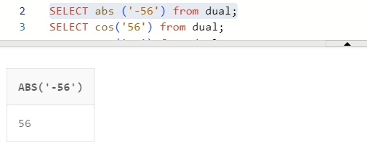

16. ceil(n):

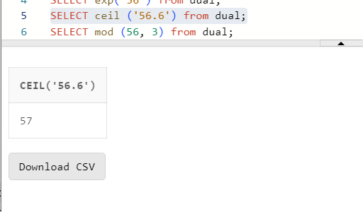

17. cos(n):

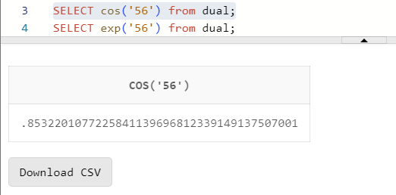

18. exp(n):

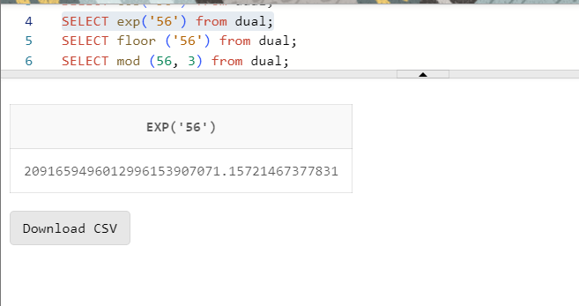

19. floor(n):

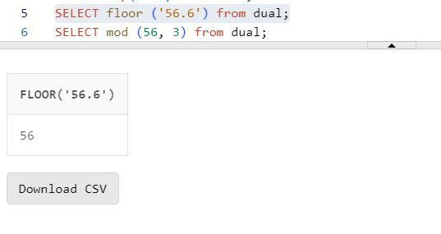

20. mod(m ,n):

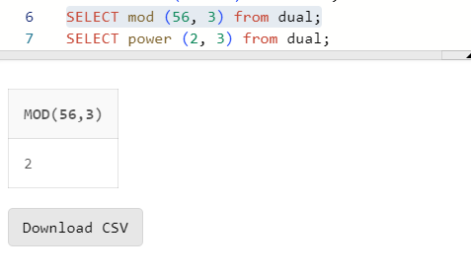

21. power(x ,y):

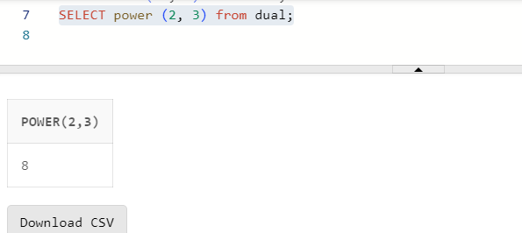

22. round(x [,y]):

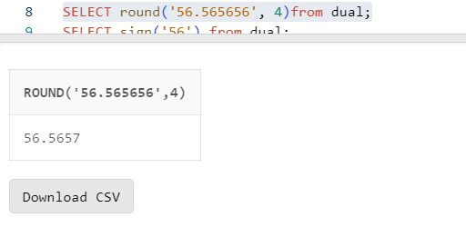

23. sign(n):

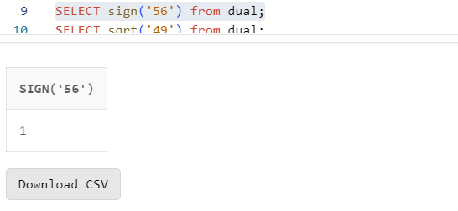

3

24. sqrt(n);

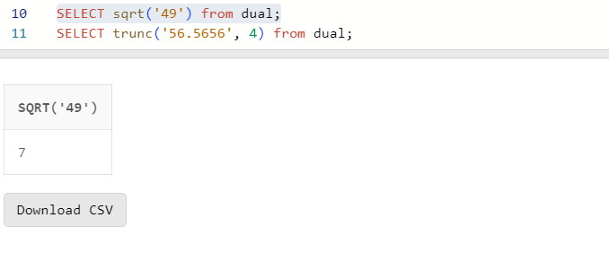

25. trunc(x ,n):

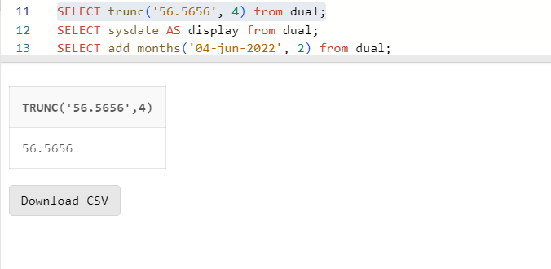

26. sysdate:

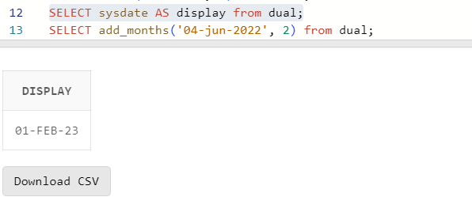

27. add_months(d ,n):

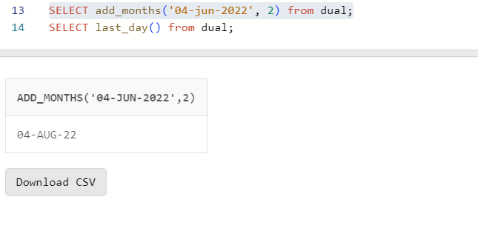

28. last_day():

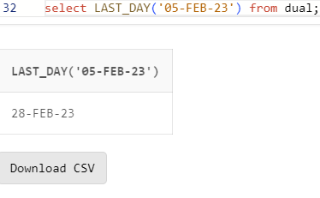

29. months_between(date1 ,date2):

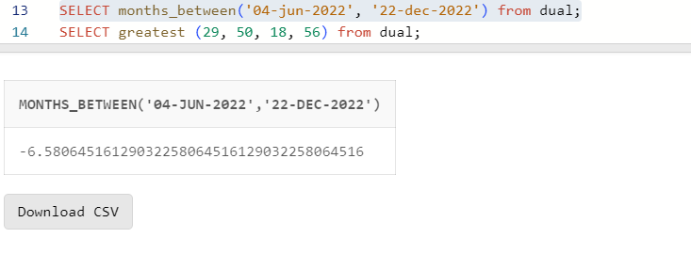

30. next_day(date ,char):

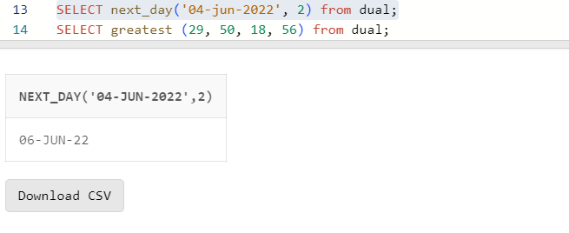

31. greatest(expr):

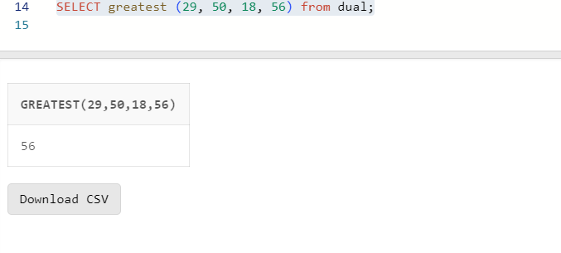

32. least(expr):

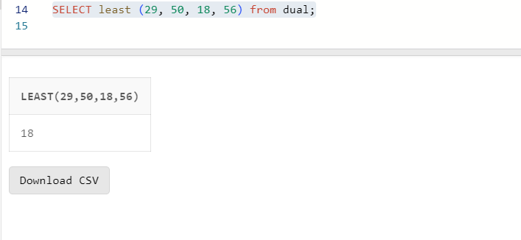

LAB ASSIGNMENT – 4

1.Create table emp which has the following attributes (employee

table)

*(@empno, ename, job, sal, deptno)*

Where empno is primary key, ename is unique, job in (Prof, AP,

and Lect), sal is not NULL, and deptno default is 10.

Insert appropriate records, check error messages in case of

violation and list all the constraint names for given table.

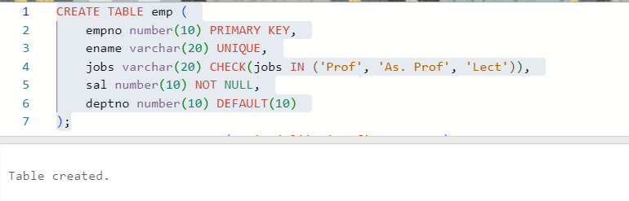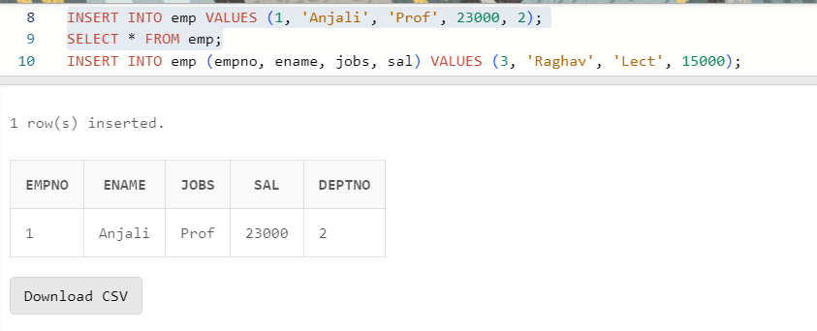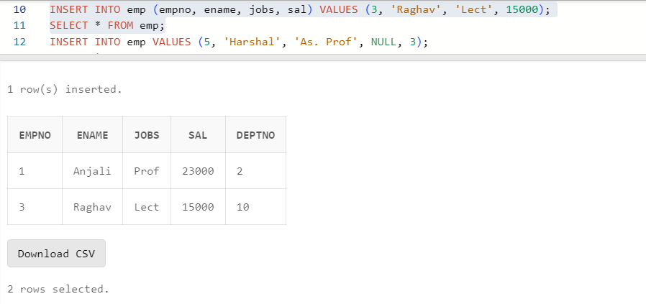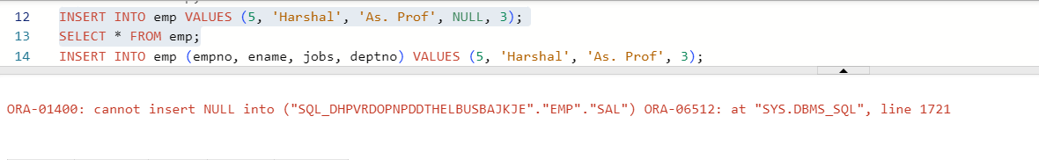

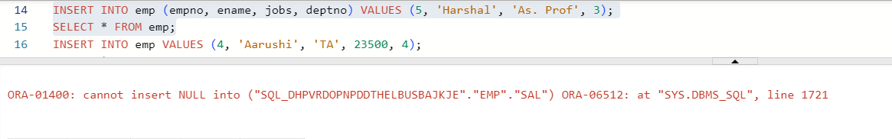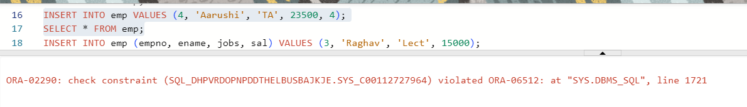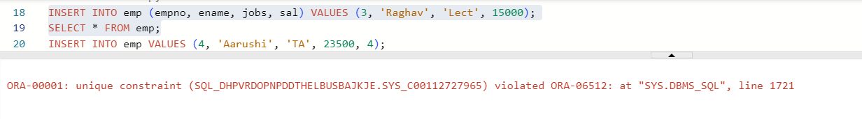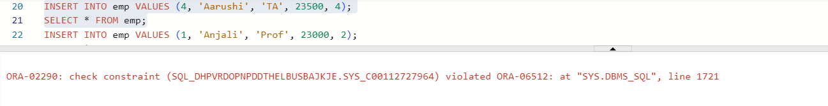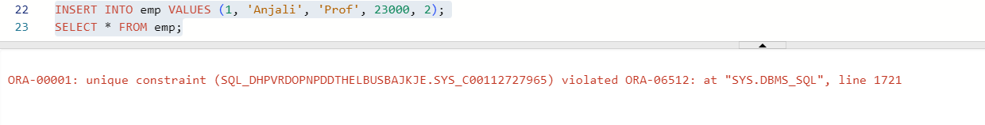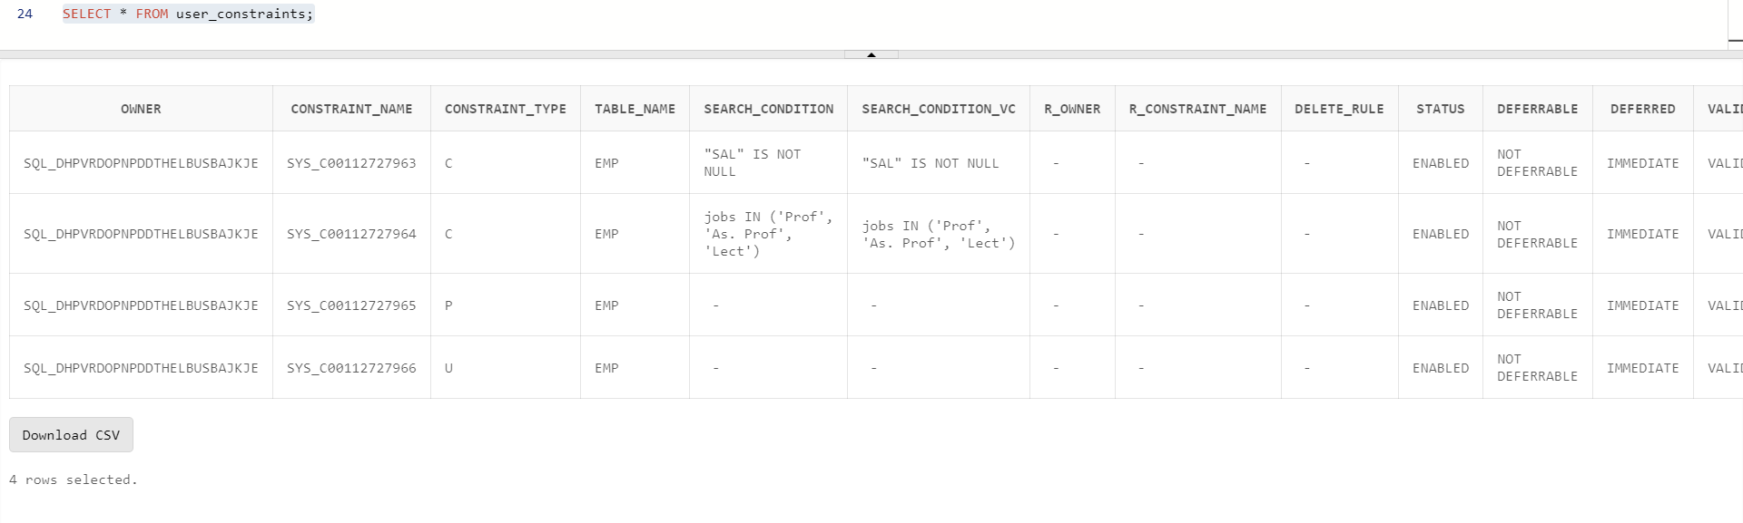

2. Create table book:

Rno number—PK

DOI-date

DOR-date

DOR>DOI

Insert appropriate records, check error messages in case of

violation and list all the constraint names for given table.

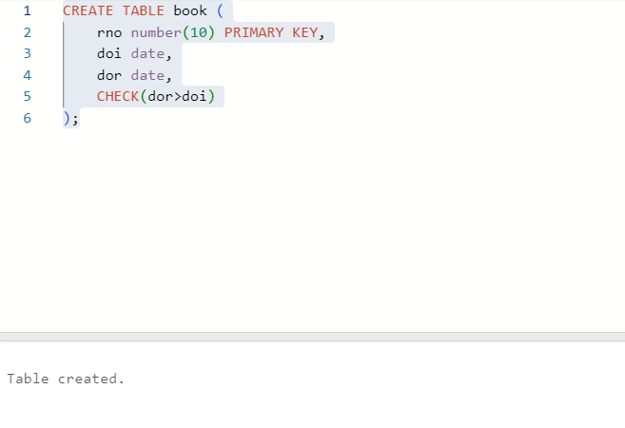

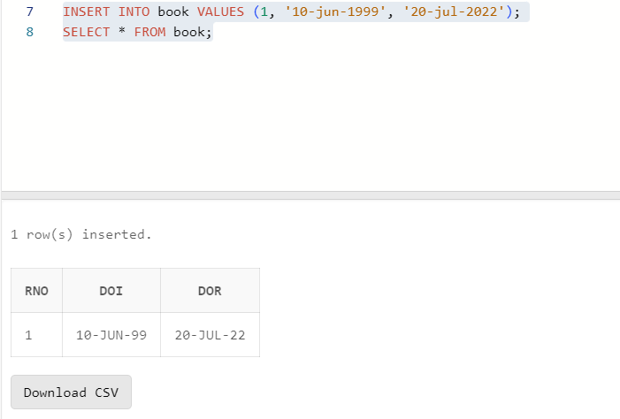

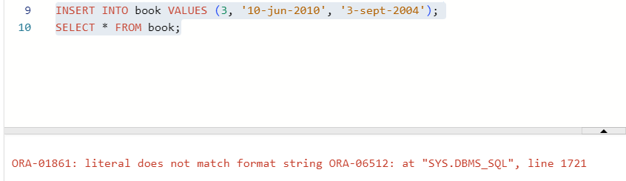

3. Create table st

Rno-Number

Class-Char

Marks-Number

Primary key(rno,class)

Marks>0

Insert appropriate records, check error messages in case of

violation and list all the constraint names for given table.

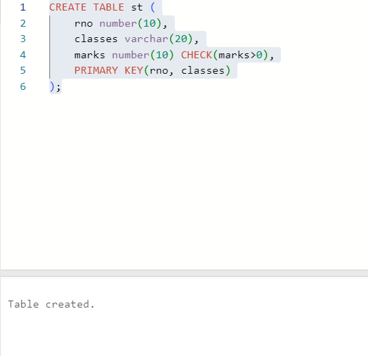

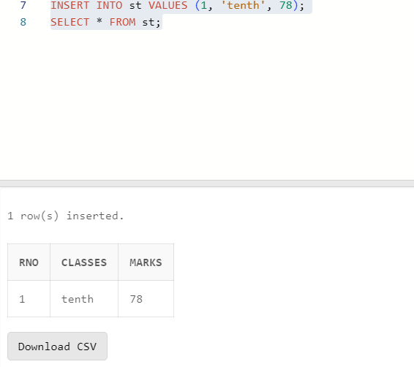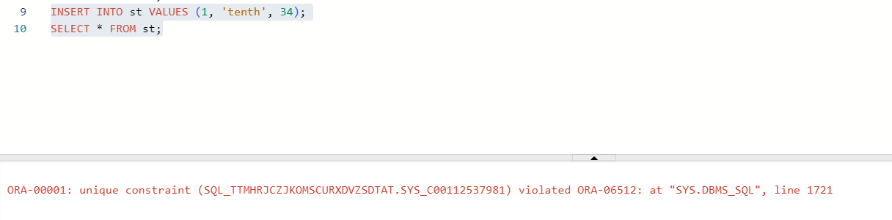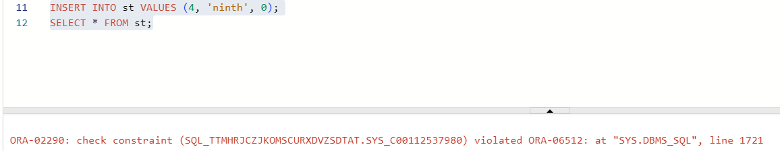

4. Create table S which has the following attributes (Salesperson

table)

*(sno, sname, city)*

Where sno is primary key

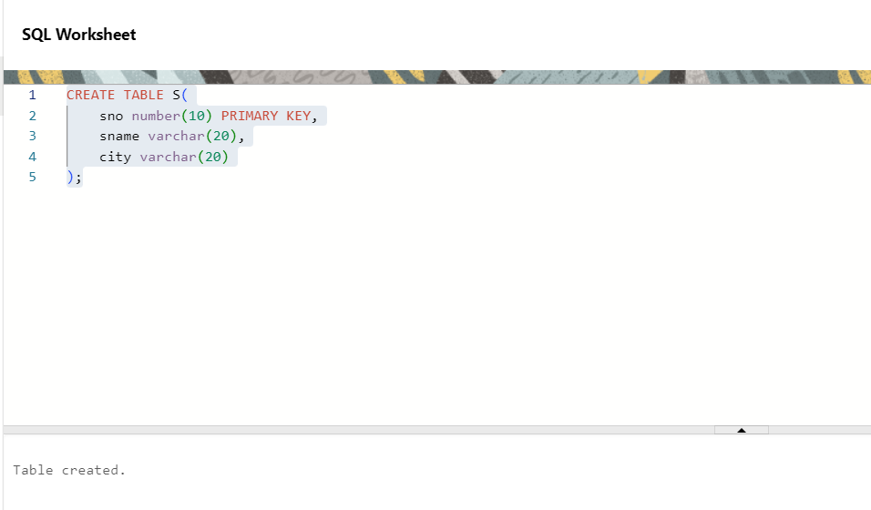

5. Create table P which has the following attributes (Part table)

*(pno, pname, color)*

Where pno is primary key

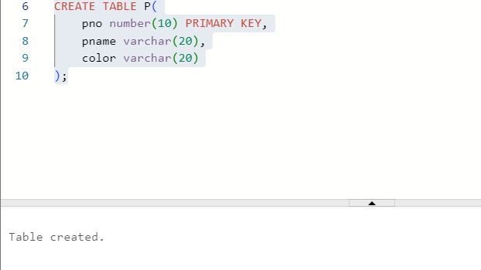

6. *Create table SP which has the following attributes*

*(sno, pno qty)*

Where combination of (sno, pno) is primary key, also sno and

pno are foreign keys

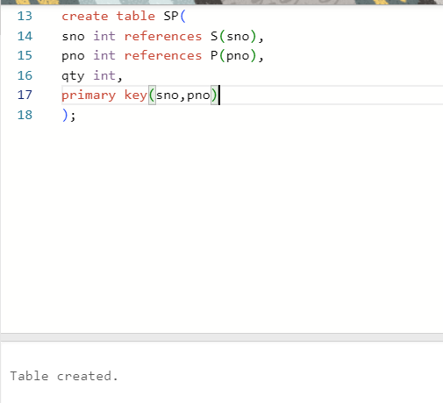

7. Create table dept which has the following attributes

(department table)

*(deptno, dname)*

Where deptno is primary key, dname in (Acc, comp, elect)

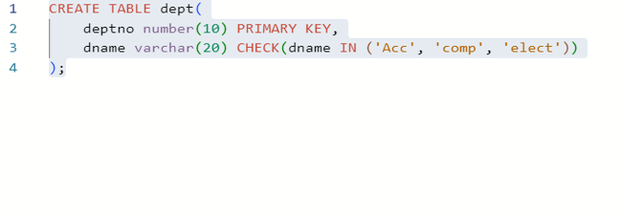

8. Create table emp which has the following attributes (employee

table)

*(@empno, ename, job, sal, deptno)*

Where empno is primary key, ename is unique, job in (Prof, AP,

and Lect), sal is not NULL, and deptno is foreign key

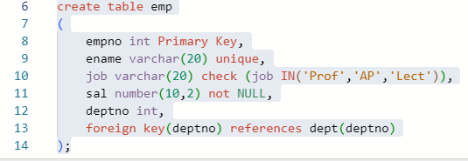

UCS310: Lab Assignment 5

1. Create the following tables and insert some tuples in these tables shown below. Where *sid* is the *primary key* for the *Sailors* table, *bid* is the primary key for the *Boats* table and *sid* and *bid* are the *foreign keys* for the *Reserves* table referencing to the *Sailors* and *Boats* table, respectively.

Sailors(*sid:* integer, *sname:* string, *rating:* integer, *age:*real) Boats(*bid:* integer, *bname:* string, *color:* string) Reserves(*sid:* integer, *bid:* integer, *day:* date)

Ans:

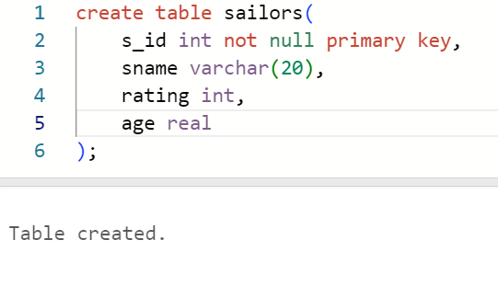

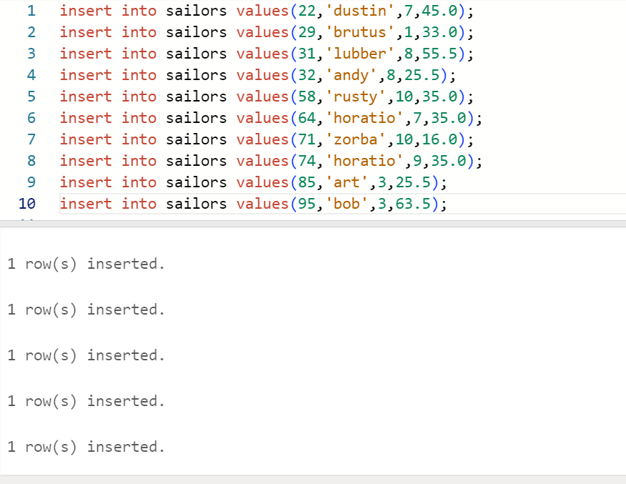

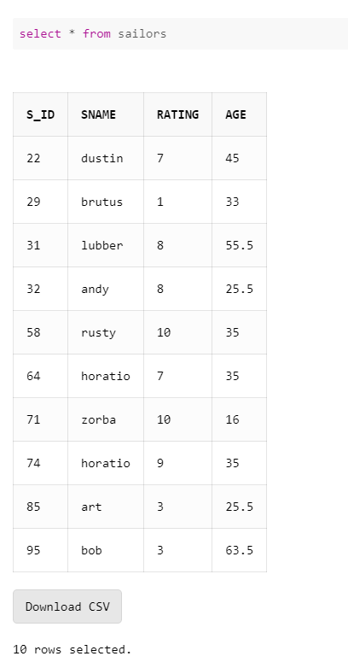

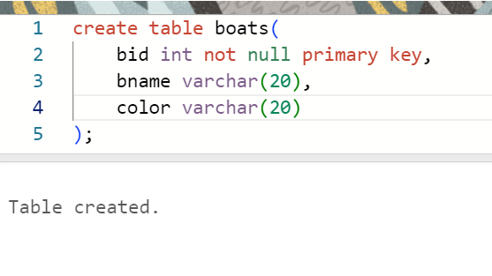

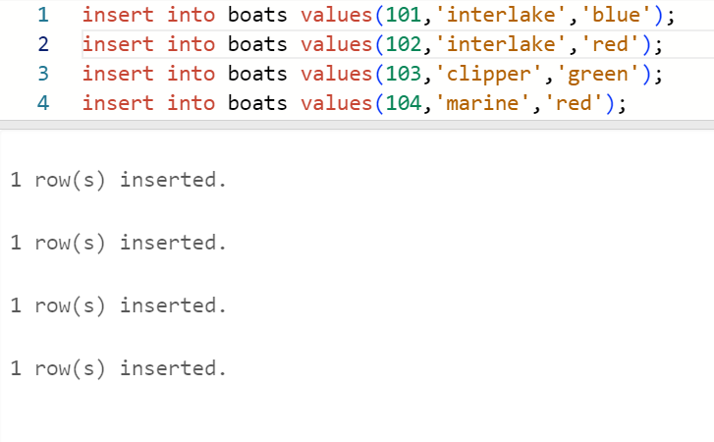

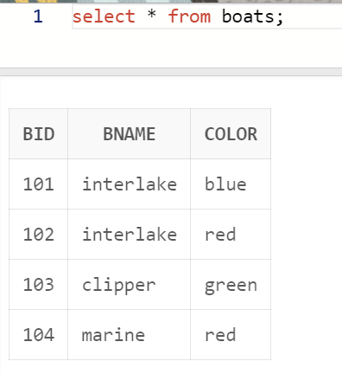

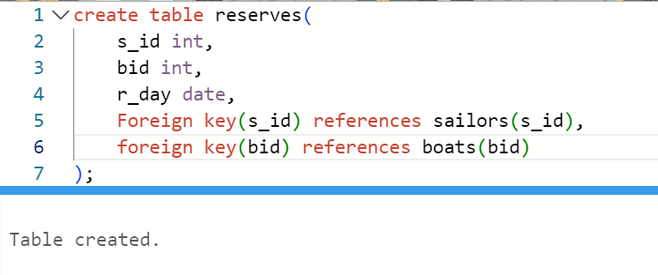

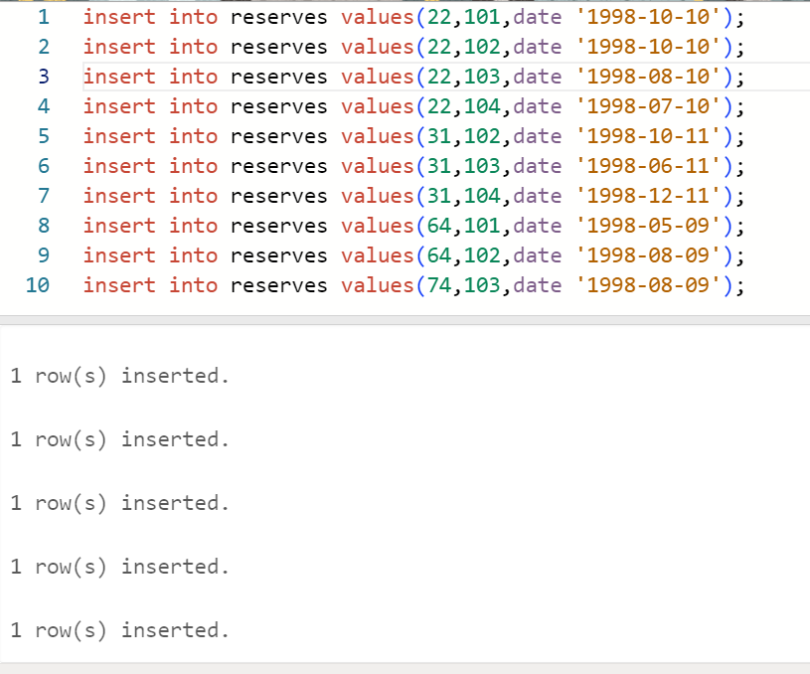

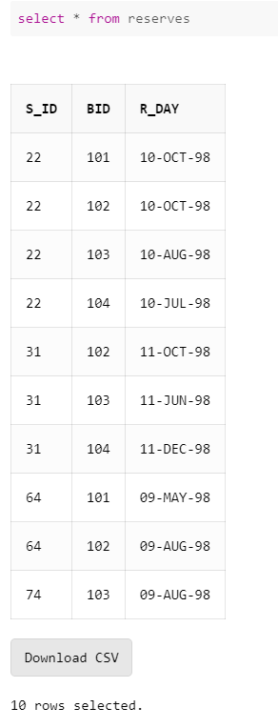

1. Write SQL command for the following:
   1. Show the names and ages of all sailors.

Ans:

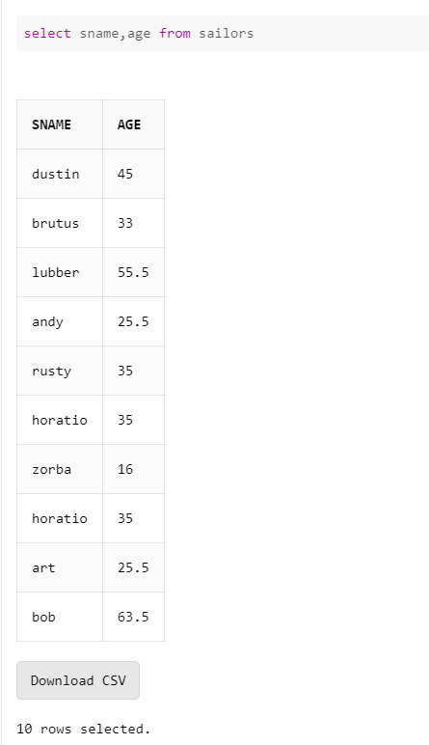

* 1. Show the details of the boats which are red and blue in color.

Ans:

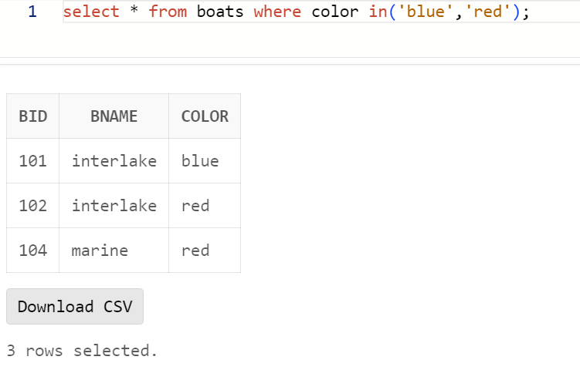

* 1. Find the oldest and youngest sailors’ age.

Ans:

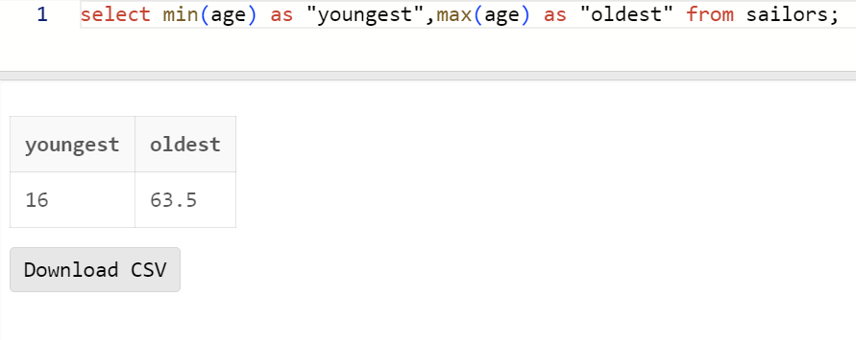

* 1. Find the ages of sailors whose name begins and ends with B and has at least three characters.

Ans:

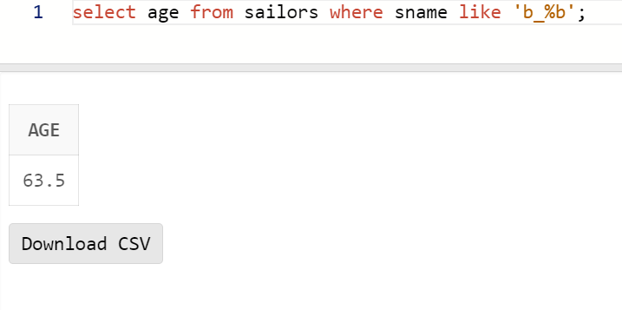

* 1. Show the average rating of the sailors.

Ans:

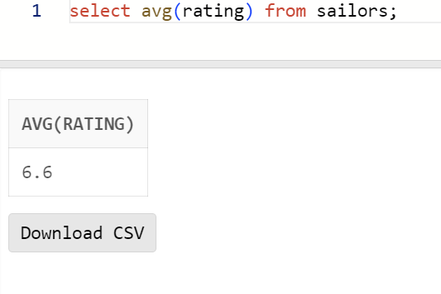

* 1. Find all sailors with a rating above 7.

Ans:

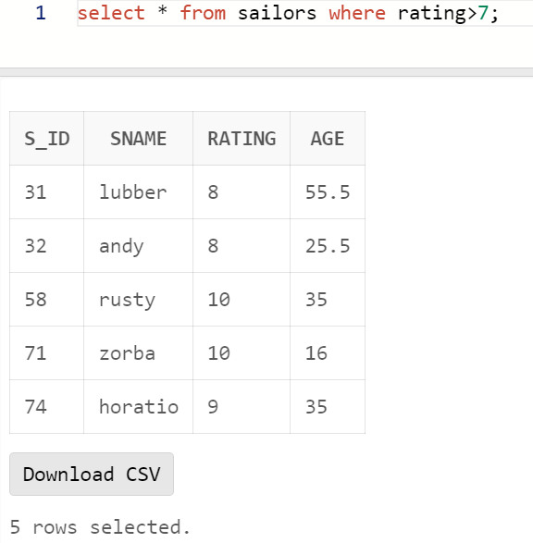

* 1. Find the number of boats reserved by the sailor named Horatio.

Ans:

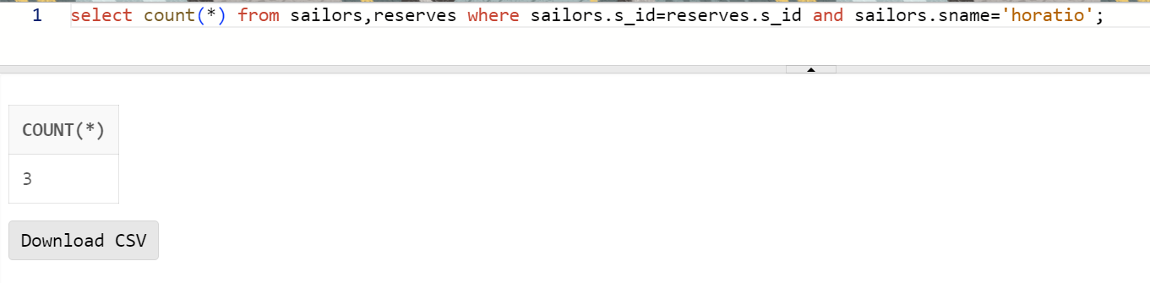

* 1. Find the colors of boats reserved by Lubber.

Ans:

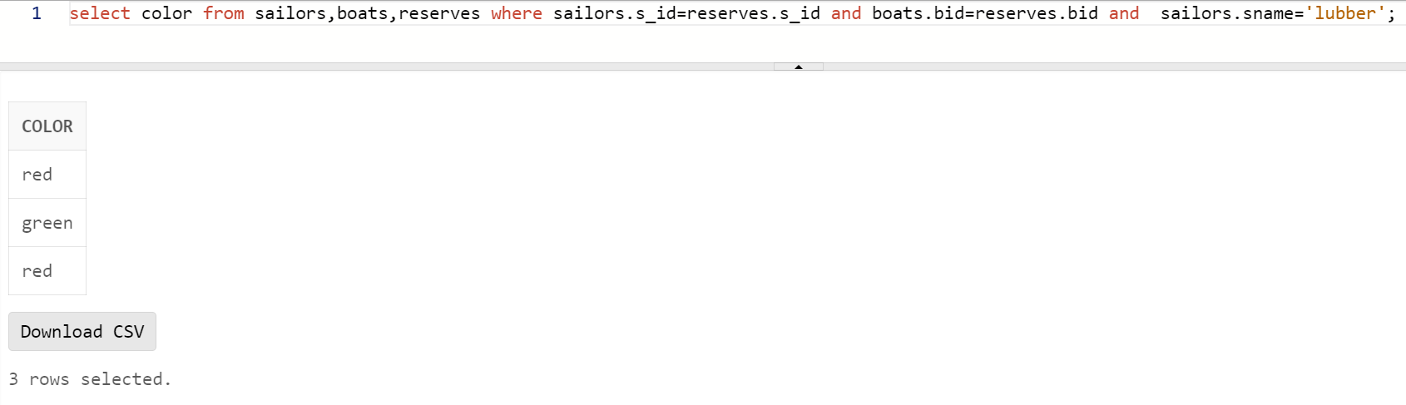

* 1. Show the details of the sailors who have reserved the boat with bid 102.

Ans:

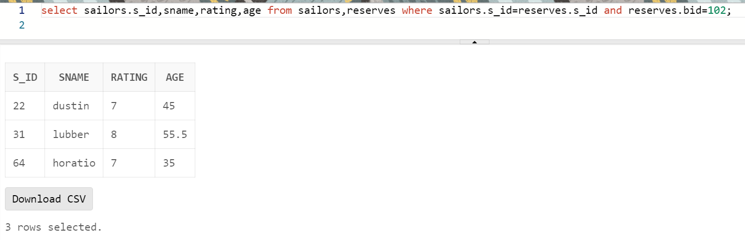

* 1. Find the sid of sailors who have reserved green boats.

Ans:

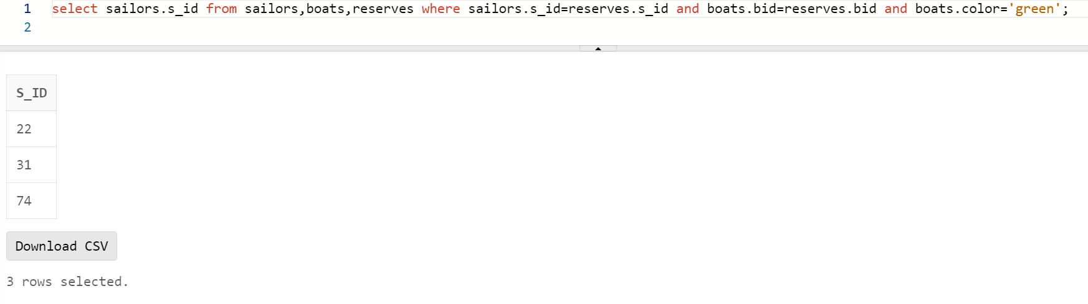

* 1. Find the names of sailors who have reserved boat number 103.

Ans:

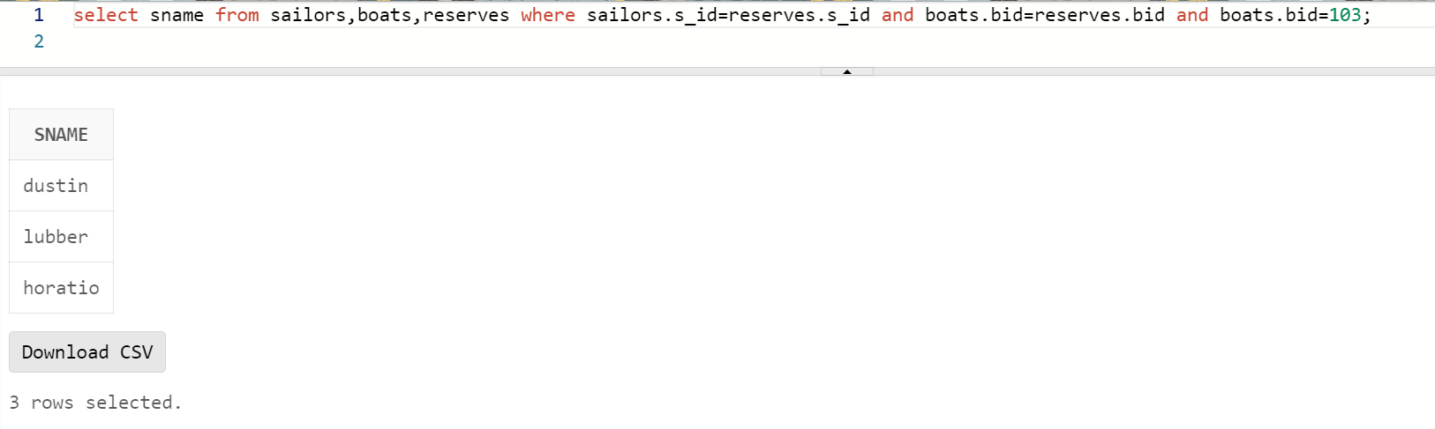

* 1. Find the sids and names of sailors who have reserved a red boat.

Ans:

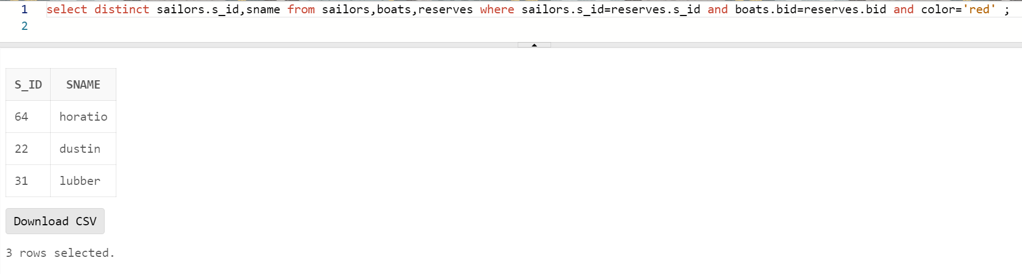

* 1. Find the names of the sailors who have reserved a green or a blue boat.

Ans:

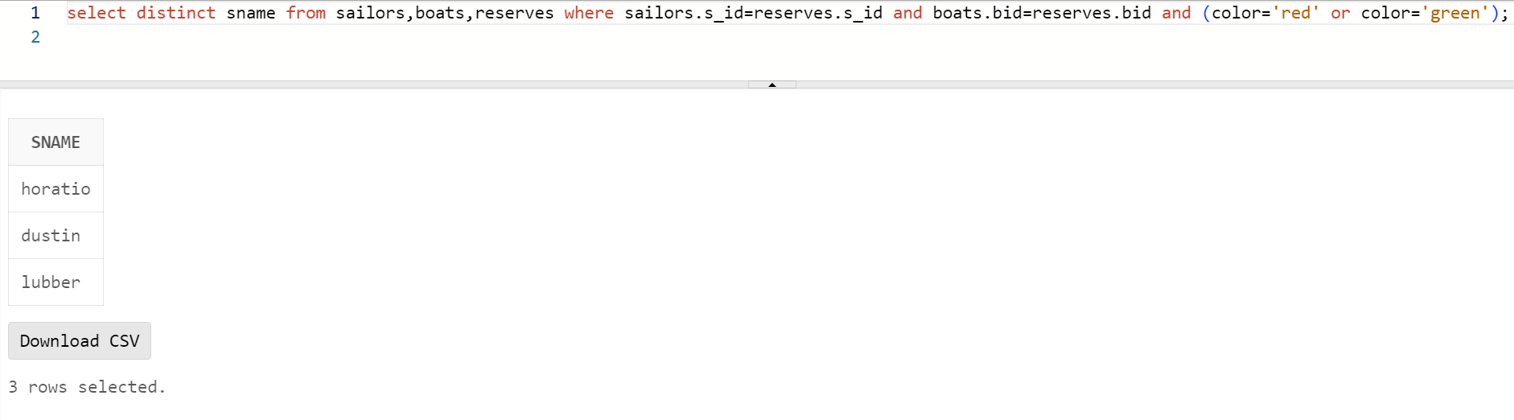

* 1. Find the names of sailors who have reserved both a red and a green boat.

Ans:

* 1. Find the names of sailors who have reserved at least one boat.

Ans:

