UCS310: Lab Assignment 2

Based on Emp table

Columns are EmpNo, Ename, Job, Salary, Commission, DeptNO.

Insert 5 records by stroring Null value in some records for commission column

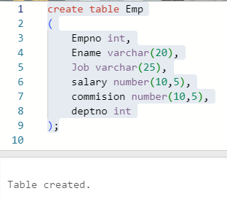

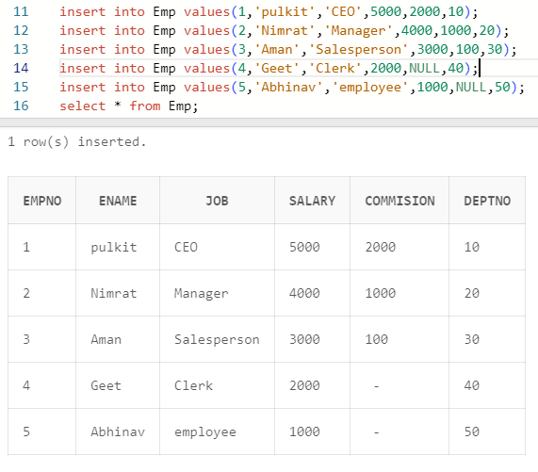

Q1: Get employee no and employee name who works in dept no 10 ?

Ans:

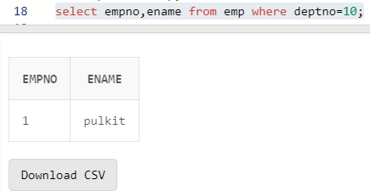

Q2: Display the employee names of those clerks whose salary> 2000 ?

Ans:

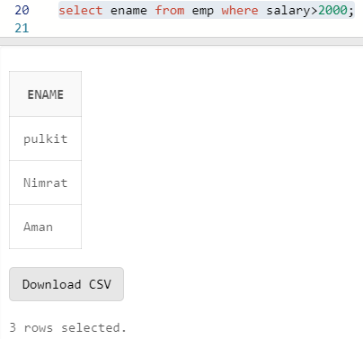

Q3 Display name and job of Salesperson & Clerks ?

Ans:

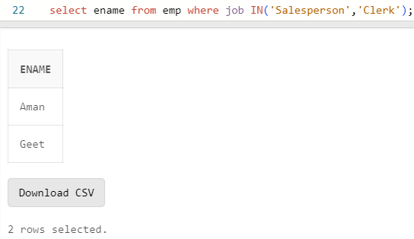

Q4: Display all details of employees whose salary between

2000 and 3000 ?

Ans:

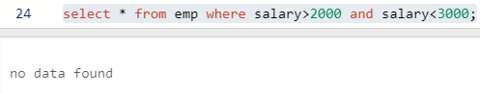

Q5: Display all details of employees whose dept no is 10,

20, or 30 ?

Ans:

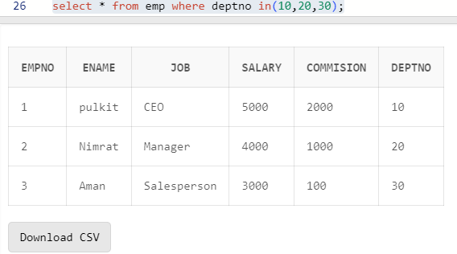

Q6) Display name of those employees whose commission is

NULL ?

Ans:

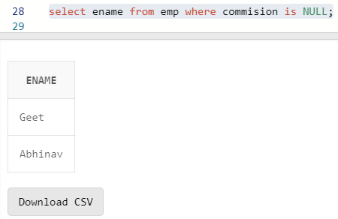

Q7) Display dept no & salary in ascending order of dept no

and with in each dept no salary should be in descending

order ?

Ans:

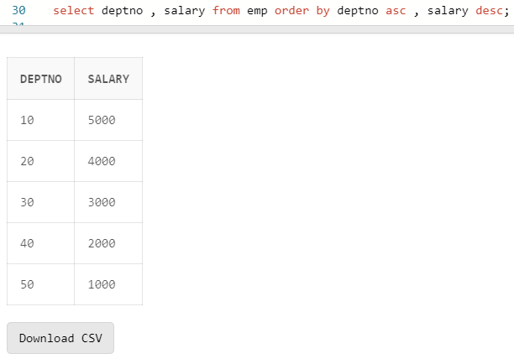

Q8) Display name of employees having two ‘a’ or ‘A’ chars

in the name ?

Ans:

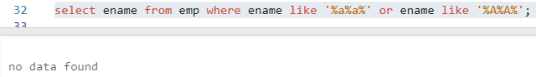

Q9) Display the name of the employees whose second char is

‘b’ or ‘B’ ?

Ans:

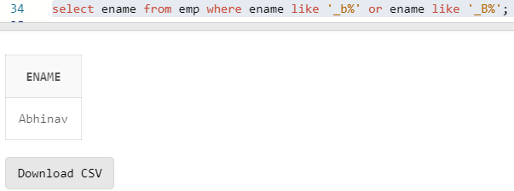

Q10) Display the name of the employees whose first or last

char is ‘a’ or ‘A’ ?

Ans:

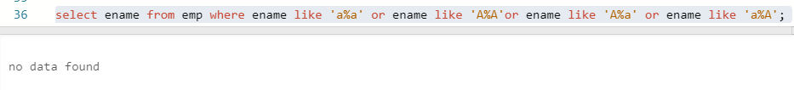

Q11) Display maximum, minimum, average salary of deptno 10

employees.

Ans:

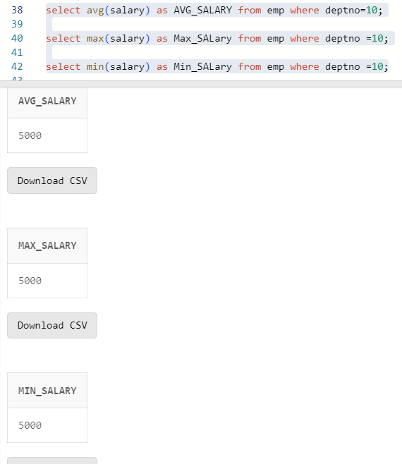

Q12) Display total number of employees working in deptno 20

Ans:

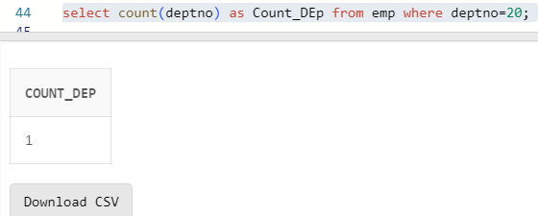

Q13) Display total salary paid to clerks

Ans:

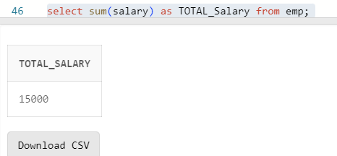

Q14) Display system date

Ans:

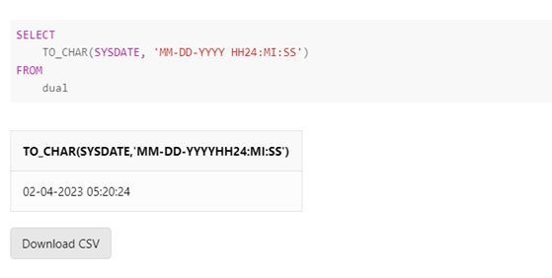

Q15) Display the result of (12\*12)/13

Ans:

