**Lab Assignment–3**

Q1) Use the following functions

1. chr (n):

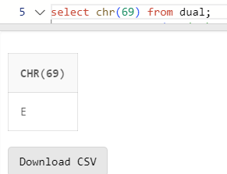

1. cancat(char1,char2):

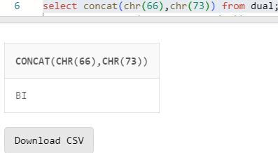

1. instr(string,char):

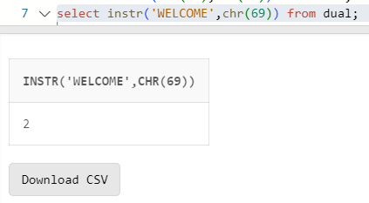

1. length(n):

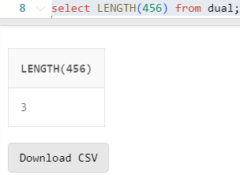

1. lpad(char1 ,n [,char2]):

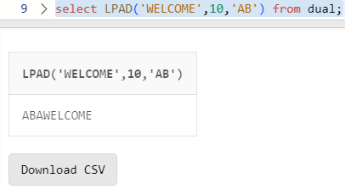

1. ltrim(string [,char(s)]):

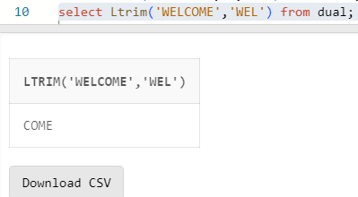

1. rpad(char1 ,n [,char2]):

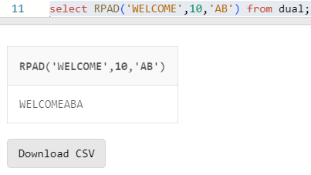

1. rtrim(string [,char(s)]):

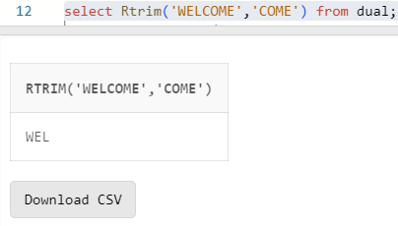

9. replace(char ,search_string , replacement_string):

10. substr(string ,position ,substring length):

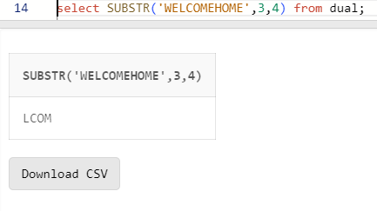

11. initcap(char):

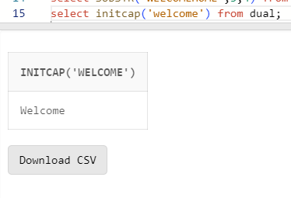

12. lower(string):

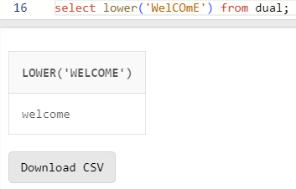

13. upper(string):

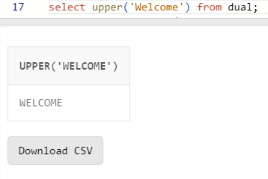

14. translate(char ,from string ,to string):

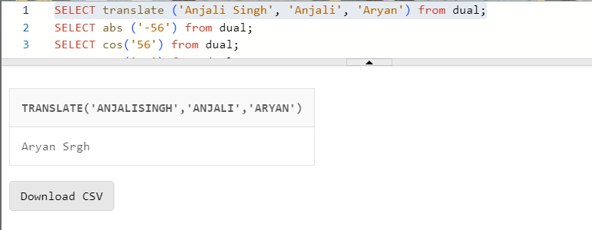

15. abs(n):

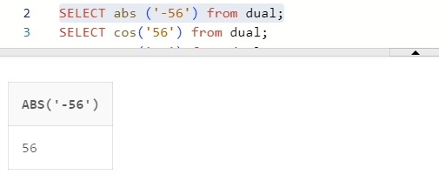

16. ceil(n):

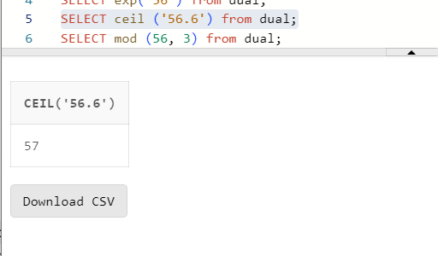

17. cos(n):

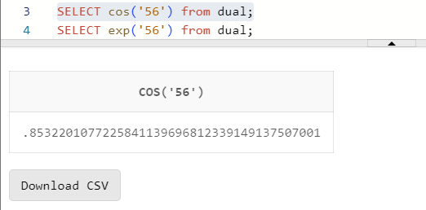

18. exp(n):

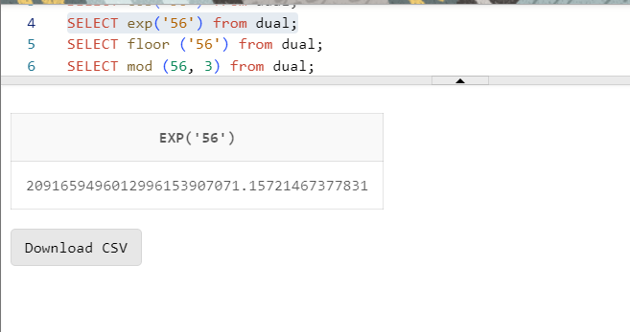

19. floor(n):

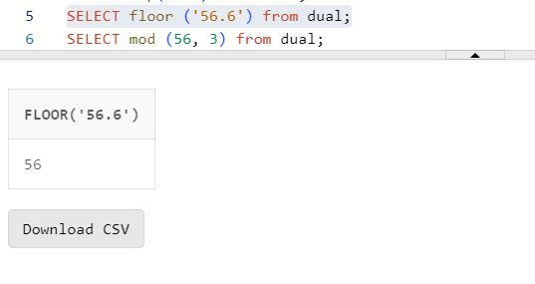

20. mod(m ,n):

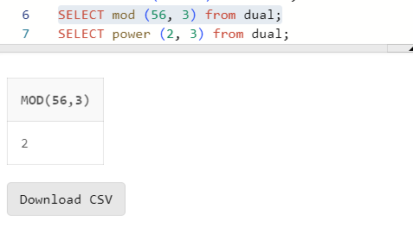

21. power(x ,y):

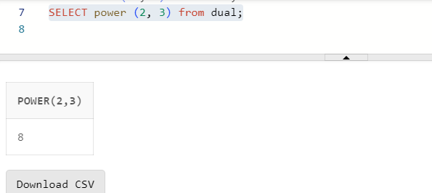

22. round(x [,y]):

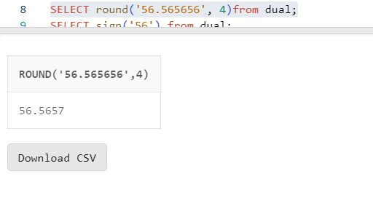

23. sign(n):

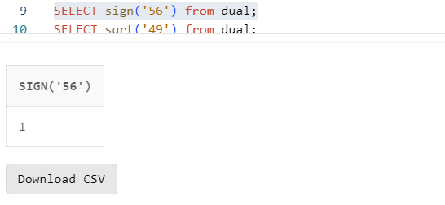

3

24. sqrt(n);

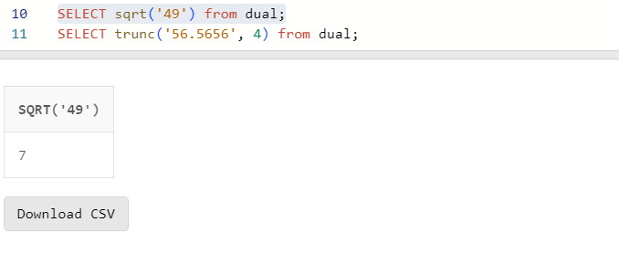

25. trunc(x ,n):

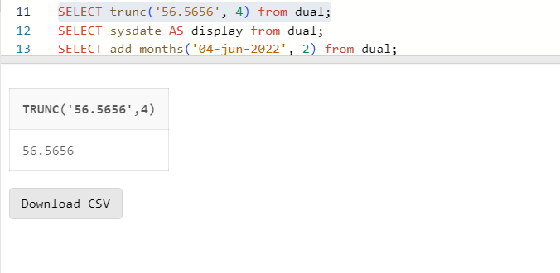

26. sysdate:

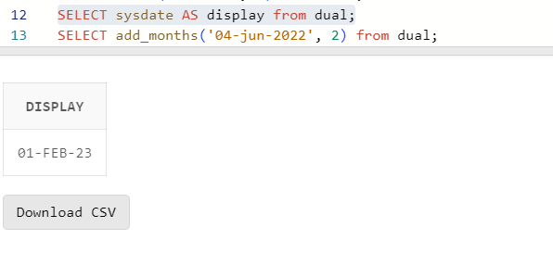

27. add_months(d ,n):

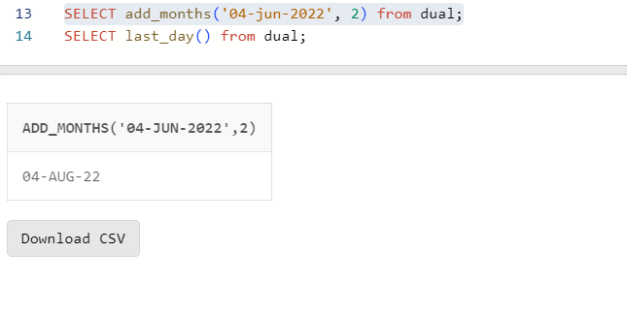

28. last_day():

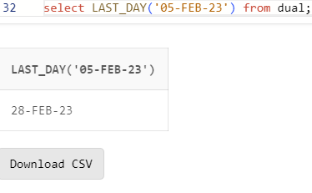

29. months_between(date1 ,date2):

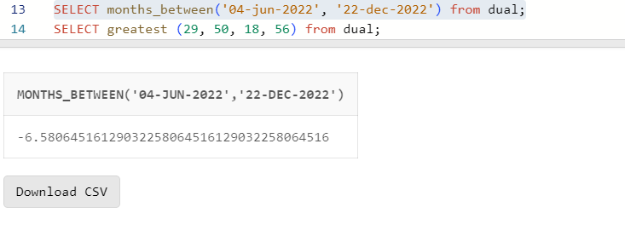

30. next_day(date ,char):

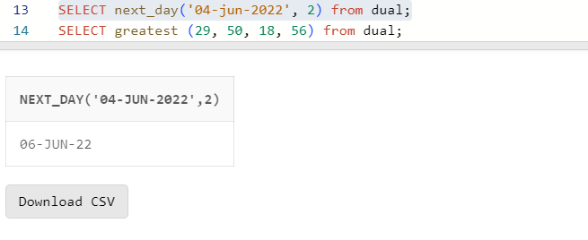

31. greatest(expr):

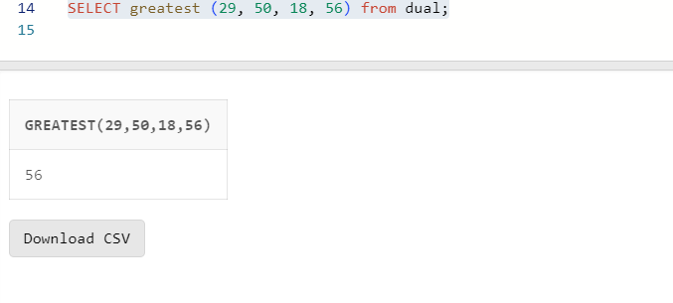

32. least(expr):

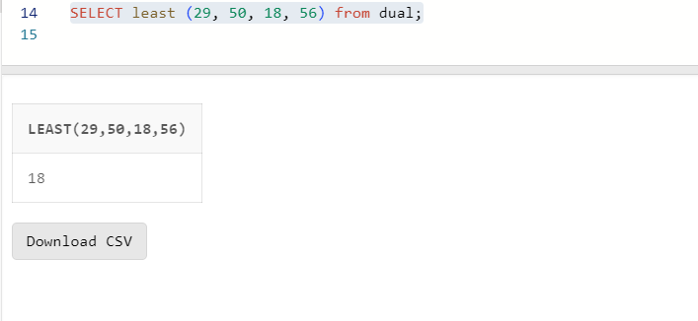

Q2) Display current time in hour : min : sec format

Q3) Display salary + commission of emp table

Q4) Store any date value in hiredate column of table ?

Q5) Display name of employee(s) who join the company in

1985 ?

Q6) Display name of the employee(s) who join the company

this year ?