**ANALOGY**

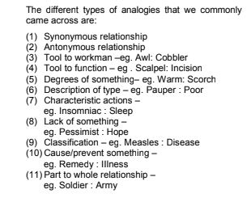

DIRECTIONS

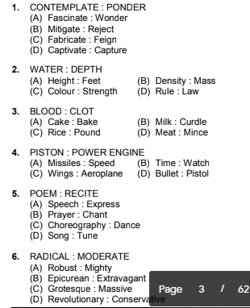

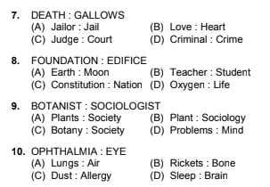

Directions for questions 1 to 15: In each of the following

questions a capitalized pair of words is given followed by

four numbered pairs of words. Three of the numbered

pairs exhibit the same relation between the words as the

capitalised pair of words does. Identify the numbered pair

which does not exhibit the same relationship as the

capitalised pair and make its corresponding letter your

answer.

1. TYRANT : DESPOTISM

(A) Misanthrope : Hatred

(B) Traitor : Betrayal

(C) Irony : Sarcasm

(D) Debonair : Elegance

2. PEDAGOGUE : TEACHER

(A) Mendicant : Poet

(B) Peasant : Farmer

(C) Mentor : Guide

(D) Buffoon : Clown

3. SAW : CARPENTER

(A) Knife : Butcher

(B) Sickle : Farmer

(C) Scalpel : Surgeon

(D) Axe : Hammer

4. WORD : SENTENCE

(A) Verse : Poem

(B) Language : Vocabulary

(C) Tree : Forest

(D) Cell : Organ

5. CAT : KITTEN

(A) Horse : Foal

(B) Deer : Fawn

(C) Goat : Kid

(D) Elephant : Cub

6. BALDNESS : WIG

(A) Wrinkle : Cream

(B) Greyness : Dye

(C) Obesity : Exercise

(D) Toothlessness : Denture

7. RETRENCH : EMPLOYEES

(A) Cut : Flab

(B) Redress : Grievances

(C) Dispose : Waste

(D) Prune : Trees

8. CRICKET : SPORT

(A) Spout : Container

(B) Squash : Vegetable

(C) Cricket : Insect

(D) Maroon : Colour

9. READ : MAP

(A) Portray : Character

(B) Paint : Canvas

(C) Polish : Metal

(D) Blemish : Scar

10. GOODNESS : MALICE

(A) Generosity : Greed

(B) Hatred : Love

(C) Blackhole : Light

(D) Constancy : Fickleness

11. FLOWER : BOUQUET

(A) Page : Book

(B) Hair : Braid

(C) Spoke : Wheel

(D) Wood : Stick

12. STONE : PEBBLE

(A) Stream : Brook

(B) Boulder : Rock

(C) Tree : Shrub

(D) Tea : Drink

13. THEATRE : ENTERTAINMENT

(A) Church : Worship

(B) University : Learning

(C) Restaurant : Recreation

(D) Hospital : Treatment

14. HEARTH : WARM

(A) Igloo : House

(B) Ice : Cold

(C) Rainbow : Gorgeous

(D) Scent : Fragrant

15. ROSE : FLOWER

(A) Aubergine : Vegetable

(B) Flax : Costume

(C) Albatross : Bird

(D) Port : Drink

13. REVERSE ANALOGIES:

1. Despotism is a quality of a tyrant. So, among the choices

only option C is not similar. Irony does not indicate a person.

All other choices define a person (misanthrope, traitor and

debonair). Choice (C)

2. A mendicant is a beggar. So, option A is the odd pair.

Choice (A)

3. Carpenter, butcher, farmer and surgeon use a saw, a knife,

an axe and a scalpel respectively. Option D is the answer.

Choice (D)

4. A sentence has some words just like a poem has some

verses, a forest has trees and an organ has cells.

Choice (B)

5. The young one of a cat is called a kitten. The young one of

an elephant is a calf and not a cub. Choice (D)

6. Wig is used for baldness. Options A, C and D share the same

analogy. You can’t use exercise for obesity, you need to do

it. Choice (C)

7. We retrench employees to cut cost. We cut flab to remove

excess fat. We dispose waste which we don’t need. We

prune trees to remove extra–growth. All these relate to

elimination of what is not necessary. Redressal of

grievances does not share the same relationship.

Choice (B)

8. Cricket is a sport, squash is a vegetable, cricket is also an

insect and maroon is a colour. Spout is not a container. It is

a part of a container. Choice (A)

9. Reading a map is similar to the relationship suggested in

choices A, B and C. We can’t blemish a scar. Blemish is to

cause a damage. Choice (D)

10. Absence of malice is goodness. Absence of light is darkness

and not blackhole. So that is the answer. The other three

options are similar to the one in the question.

Choice (C)

11. In the given pair, the relationship is of the type MEMBER :

GROUP. A similar relationship is there in A, B and C. Hence,

the odd-pair is option D. Choice (D)

12. A pebble is a small stone, a brook is a small stream, a rock

– a small boulder, a shrub – a small tree. The same

relationship is not there between tea and drink.

Choice (D)

13. Here option C is the odd-pair. A restaurant is not used

primarily for recreation. Choice (C)

14. Warmth is a quality of the hearth. The same relationship is

exhibited by choices B, C and D. However, Igloo is a type of

house and hence is the odd man out. Choice (A)

15. Flax is a type of fibre, not a costume. Choice (B)