**MICROPROCESSOR-BASED SYSTEMS DESIGN**

**UCS617**

**Lab Assignment-2 (8086)**

**Submitted to:**

**Dr Manju Khurana**

**Submitted By:**

Dixant Kumar 102103017

Jagdish Agarwal 102103266

Pulkit Arora 102103267

Jeetesh Rajpal 102103268

Janardhan Singh Jadon 102103269



**BE Third Year, COE**

**Group No: 3COE10**

**Computer Science and Engineering Department**

**TIET, Patiala**

**INDEX**

|  |  |  |
| --- | --- | --- |
| **Sr. No.** | **Title** | **Page** |
| **1.** | Write an assembly language program to add two 16-bit numbers in 8086. |  |
| **2.** | Write an assembly language program to subtract two 16-bit numbers in 8086. |  |
| **3.** | Write an assembly language program to multiply two 16-bit numbers in 8086. |  |
| **4.** | Write an assembly language program to divide two 16-bit numbers in 8086. |  |
| **5.** | Write an assembly language program to demonstrate AAA, AAS, AAM, AAD, DAA and DAS in 8086. |  |
| **6.** | Write an assembly language program to find out the count of positive numbers and negative numbers from a series of signed numbers in 8086. |  |
| **7.** | Write an assembly language program to find out the largest number from a given unordered array of 8-bit numbers, stored in the locations starting from a known address in 8086. |  |
| **8.** | Write an assembly language program to find out the largest number from a given unordered array of 16-bit numbers, stored in the locations starting from a known address in 8086. |  |
| **9.** | Write an assembly language program to print Fibonacci series in 8086. |  |
| **10.** | Write an assembly language program to perform the division 15/6 using the ASCII codes. Store the ASCII codes of the result in register DX. |  |

**Program 1**

**Aim: Write an assembly language program to add two 16-bit numbers in 8086.**

**Sol:**

MOV AX,1234H

MOV BX,1236H

ADD AX,BX

HLT

**Output:**

Fig 1.1

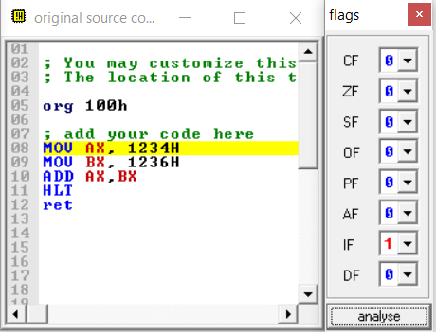

Fig 1.2

**Program 2**

**Aim: Write an assembly language program to subtract two 16-bit numbers in 8086.**

**Sol:**

MOV AX, 1234H

MOV BX, 1236H

SUB AX, BX

HLT

**Output:**

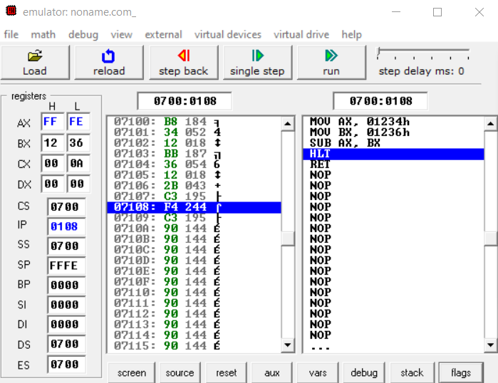

Fig 2.1

Fig 2.2

**Program 3**

**Aim: Write an assembly language program to multiply two 16-bit numbers in 8086.**

**Sol:**

MOV AX, [0301H]

MOV BX, [0303H]

MUL BX

HLT

**Input:**

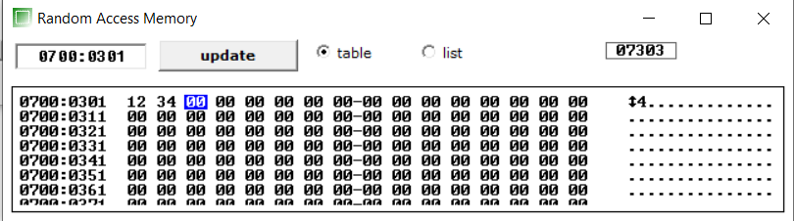

Fig 3.1

Fig 3.2

**Output:**

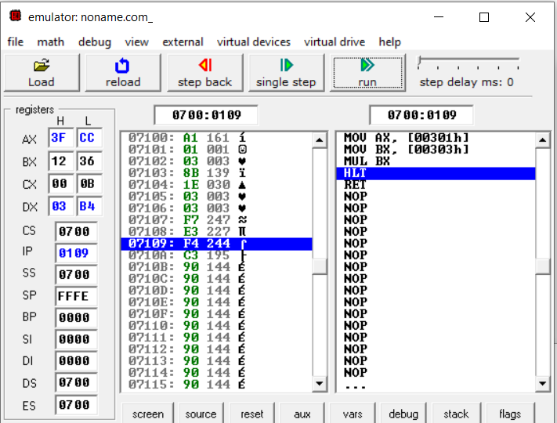

Fig 3.3

Fig 3.4

**Program 4**

**Aim: Write an assembly language program to divide two 16-bit numbers in 8086.**

**Sol:**

MOV AX,5600H

MOV BX,2500H

DIV BX

HLT

**Output:**

Fig 4.1

Fig 4.2